P:\PublicationComponents\logos\NCVER LOGOS\WMF - word\ncver left tab_mono.wmfEnabling the effective   
take-up of e-learning by custodial officers

Malcolm Reason

Corrective Services NSW

Participant in the NCVER Building Researcher Capacity Community of Practice Program 2010

The views and opinions expressed in this document are those of the author/  
project team and do not necessarily reflect the views of the Australian Government,   
state and territory governments or NCVER.

Any interpretation of data is the responsibility of the author/project team.

### NATIONAL VOCATIONAL EDUCATION AND TRAINING RESEARCH AND EVALUATION PROGRAM

### **OCCASIONAL PAPER**

|  |
| --- |
| As part of the National Centre for Vocational Education Research (NCVER) Building Researcher Capacity Scheme, a Community of Practice Scholarship Program has been created to encourage a culture of research in vocational education and training (VET) organisations. With the guidance of an experienced mentor, VET practitioners without any formal research experience undertake their own work-based research project. The scholarships also provide participants with an opportunity to have their research peer-reviewed and published by NCVER.  For more information see: <<http://www.ncver.edu.au/research/opportunities.html# Community_of_practice_scholarships_for_VET_practitioners>>. |

About the research

© Commonwealth of Australia, 2011

G:\pub_prod\PublicationComponents\logos\Creativecommons\CC BY logo.eps

With the exception of the Commonwealth Coat of Arms, the Department’s logo, any material protected by a trade mark and where otherwise noted, all material presented in this document is provided under a Creative Commons Attribution 3.0 Australia <http://creativecommons.org/licenses/by/3.0/au> licence.

The details of the relevant licence conditions are available on the Creative Commons website   
(accessible using the links provided) as is the full legal code for the CC BY 3.0 AU licence <http://creativecommons.org/licenses/by/3.0/legalcode>.

The Creative Commons licence conditions do not apply to all logos, graphic design, artwork and photographs. Requests and enquiries concerning other reproduction and rights should be directed to the National Centre for Vocational Education Research (NCVER).

This document should be attributed as Reason, M 2011, *Enabling the effective take-up of e-learning by custodial officers*, NCVER.

This work has been produced by NCVER under the National Vocational Education and Training Research and Evaluation (NVETRE) Program, which is coordinated and managed by NCVER on behalf of the Australian Government and state and territory governments. Funding is provided through the Department of Education, Employment and Workplace Relations.

The NVETRE program is based upon priorities approved by ministers with responsibility for vocational education and training (VET). This research aims to improve policy and practice in the VET sector. For further information about the program go to the NCVER website <http://www.ncver.edu.au>. The author/project team was funded to undertake this research via a grant under the NVETRE program. These grants are awarded to organisations through a competitive process, in which NCVER does not participate.

The views and opinions expressed in this document are those of the author/project team and do not necessarily reflect the views of the Australian Government, state and territory governments or NCVER.

ISBN 978 1 921955 59 4 web edition  
 978 1 921955 60 0 print edition  
TD/TNC 104.47

Published by NCVER, ABN 87 007 967 311

Level 11, 33 King William Street, Adelaide SA 5000   
PO Box 8288 Station Arcade, Adelaide SA 5000, Australia

**P** +61 8 8230 8400 **F** +61 8 8212 3436 **E** [ncver@ncver.edu.au](mailto:ncver@ncver.edu.au) **W** http://www.ncver.edu.au

Enabling the effective take-up of e-learning by custodial officers

### Malcolm Reason, Corrective Services NSW

The use of e-learning is dramatically increasing, due to its cost effectiveness, flexibility and appeal to the younger tech-savvy generation now entering the workforce. In line with this trend, e-learning is being introduced into development programs for custodial officers working in Corrections NSW.

Malcolm Reason used an NCVER scholarship to uncover how and whether e-learning works in the corrections environment. Malcolm’s scholarship was awarded through the community of practice program, whereby VET practitioners without research experience are given the opportunity to undertake their own research to address a workplace problem. Scholarship recipients are supported by a mentor, and NCVER publishes their research results.

Malcolm Reason, who is the Director of Non-Custodial Training at the Brush Farm Corrective Services Academy in New South Wales, drew on relevant literature and combined survey data with information drawn from semi-structured interviews to investigate e-learning in Corrections NSW.

Key messages

* Face-to-face learning is still highly valued by learners. E-learning should be used in conjunction with, not as a substitute for, face-to-face learning.
* A number of factors can combine to block effective engagement with e-learning:
* Internal factors can include attitudes and self-efficacy, the skills of the learner and their learning style.
* External factors can include e-learning design, computer access and the provision of support to learners, as well as a corrections-specific issue associated with the security of personal information entered into e-learning programs.
* The need for good information and communications technology (ICT) infrastructure is one of the most important enabling factors, with over 98% of those interviewed suggesting that a lack of suitable computers was a ‘deal breaker’.

Tom Karmel  
Managing Director, NCVER

Contents

Tables and figures 6

Introduction 7

Literature review 9

What is e-learning? 9

E-learning and corporate learning and development 9

Why should corrections use e-learning? 9

Why focus on learner engagement? 10

Methodology 13

Limitations 14

Findings 15

Demographics of respondents 15

Experience with e-learning 16

Attitudes to e-learning 18

E-learning enablers 19

Conclusions 21

What are the e-learning enablers for custodial officers? 21

References 23

Appendix 1 24

# Tables and figures

## Tables

1 Respondent attitudes towards currently available e-learning materials 18

2 Respondent attitudes towards e-learning as a method of staff   
development 18

3 Enablers to assist in the uptake of e-learning by custodial officers 20

## Figures

1 Ages of survey respondents 15

2 Number of years of experience of survey respondents 16

3 Survey respondents’ experience with e-learning 17

# Introduction

This paper aims to contribute to the implementation of e-learning in corrections centres by identifying the key enablers to assist correctional officers to adopt e-learning strategies. Findings from this research will inform current and future projects in a number of correctional jurisdictions. The research draws on a review of the relevant literature, a survey of custodial officers in New South Wales and the author’s own knowledge and experience of the corrections industry.

This research is targeted to custodial officers (that is, uniformed officers) working within Corrective Services NSW. Corrective Services NSW is Australia’s largest provider of corrections, employing around 8000 staff, approximately 3600 of whom are custodial officers. Custodial officers were chosen as the target audience for this research that addresses the potential of e-learning in prisons because they represent a large group of prison staff and also because, being the only paramilitary component of Corrective Services NSW, they are culturally unique within the organisation. The unique nature of their role was identified as worthy of further research as it presented a good opportunity to see if the enablers identified in previous research, which tends to be focused on ‘white collar’ workers, were relevant to a paramilitary work environment.

Over the past 18 months Corrective Services NSW has developed a range of informal e-learning materials, mainly as a means to support changes in corporate systems. These materials are made available via the corporate intranet site and receive approximately 1000 visits each month. At the time of conducting this research formal e-learning courses were in the piloting phase only.

An investigation of the use of e-learning as a tool for the delivery of staff development clearly shows that this style of learning is now a long way from the learning ‘novelty’ it represented 20 years ago. The recent national e-learning survey conducted by the Australian Flexible Learning Framework (2010) showed that 50% of all employers surveyed now use e-learning as part of the learning and development provided to their staff, with 60% expecting to use it over the coming two years. Not only does this survey show that the use of e-learning as a staff development tool is growing, but also that this growth has been very rapid. (The number of employers using e-learning in the 2009 survey was 18%.)

Corrections is a significant activity within Australia, with on average 23 000 gaoled offenders at any given time and a further 54 000 managed within the community (ABS 2011). An examination of the industry’s training practices shows that it has a strong history of and commitment to the provision of learning and development to its staff. This is no more strongly demonstrated than through the operation of the Corrective Services Training Package, which has been in place since 2001. This training package, which is currently in its third iteration, has a 100 per cent uptake by the providers of corrections within Australia (Government Skills Australia 2011). The establishment and operation of formal training academies in the Western Australian, Queensland and New South Wales jurisdictions is a further indication of a commitment to the provision of learning and development to staff.

Despite a substantial commitment to staff development, the growth in the popularity of e-learning has not been reflected in the corrections industry, with its take-up as a mechanism for delivering learning to correctional staff lagging significantly behind the figures shown in the Australian Flexible Learning Framework survey (2010). That said, e-learning has not gone unnoticed within the industry and many Australian correctional jurisdictions are embarking, or are about to embark, on the full-scale implementation of e-learning for staff learning and development. Given this, it seems timely to examine the correctional environment to determine whether current research in relation to the implementation of e-learning as a tool for delivering learning and development to staff is applicable to corrections or whether the uniqueness of the environment presents its own challenges in relation to the effective uptake of e-learning.

# Literature review

## What is e-learning?

From the outset of this research project it was obvious that the term ‘e-learning’ is interpreted in a very diverse range of ways by the target group for this research, with answers to the question, ‘what is e-learning?’ producing a wide range of responses. The only theme common to all answers was that there was a computer involved in the process.

The same diversity of definition applies in the current literature on e-learning and there appears to be no standardised definition of the concept. The key distinction between e-learning and more traditional learning in the literature is that e-learning involves the use of information and communication technologies (ICT) (Sulcic & Lesjak 2009), although a number of researchers drill down further to draw a clear distinction between learning that occurs only within the confines of a computer, which they refer to as online learning, and learning which uses technology to enhance it, which they refer to as e-learning (Lim, Ripley & O’Steen 2009).

What is also clear from the research is that the idea of e-learning has changed, and continues to change, from something that is limited to self-paced learning on a computer, to something more fluid, embracing a range of technologies as a way of enhancing learning (Lim, Ripley & O’Steen 2009). In many ways this process has seen the gap between learning and e-learning narrow, and many now argue that e-learning is a redundant term, as all learning now involves technology.

The key conclusion drawn from the review of current literature is that there is no agreement on what constitutes e-learning and that, as a result, the use of the term is likely to lead to a range of interpretations, based on personal experience and perceptions. Consequently, given the lack of a clear definition, this became a strong consideration in the formulation of data-gathering tools for this research.

## E-learning and corporate learning and development

A review of the literature was unable to identify any previous research relating specifically to the use of e-learning for staff development in the correctional environment, although the review identified a growing body of research that focuses on e-learning within the corporate learning and development environment (Waight 2005, p.1118).

## Why should corrections use e-learning?

As noted in the introduction, over the past ten years corrections in Australia has demonstrated a strong commitment to learning and development for its staff, although apparently with little investment in e-learning. Apart from a desire to ‘follow the pack’, are there compelling reasons for corrections to adopt this approach to delivery? The research in the field of corporate learning and development identifies a number of core benefits flowing from e-learning.

The central driver behind e-learning is the desire to overcome the limitations of the ‘classroom-based’ model of teaching (Oiny 2009, p.113), an issue of particular relevance to corrections, with its large number of people spread across a wide geographic area. In this context, a reliance on the face-to-face delivery of training represents a high-cost option, with large amounts of travel required by the participants and/or the facilitator, which can make access to training more difficult, particularly for those in more remote areas.

Cost is not the only driver relevant to the take-up of e-learning, with e-learning also demonstrating benefits in terms of the effectiveness of training. By putting the control of learning into the hands of the learner, training can be tailored to the needs of individuals in terms of content, timing, location and speed of delivery. As McCormack and Jones (1997) put it, e-learning ‘allows all learners to train whenever they want, when their own professional and/or personal constraints allow them to do so most efficiently’ (cited in Oiny 2009, p.113). This idea of ‘empowerment’ comes through strongly in the literature as one of the more indirect benefits being enjoyed by organisations that have implemented e-learning. Empowerment is becoming more and more important for organisations, because having staff with the ability to adapt and change quickly represents a great asset in today’s rapidly changing world (Ali & Magalhaes 2008).

A final consideration is the need to attract and retain staff. As more and more members of Generation Y enter the workforce, it is necessary for organisations themselves to adapt if they are to attract this cohort. While generalisations across an entire generation are dangerous, the research clearly shows that Generation Y generally has higher expectations in relation to the use of technology in the workplace and the ongoing provision of relevant learning and development (Polimeni, Burke & Benyaminy 2009). To ensure that it can continue to attract new employees, corrections must adapt its learning and development processes to meet the needs of this new group of potential employees.

Clearly, if an industry such as corrections is to maintain its strong commitment to learning and development within a climate of increasing financial constraint and changing demographics in the workforce, it needs to embrace e-learning for the delivery of at least some of its learning and development offerings.

## Why focus on learner engagement?

Central to the research undertaken into e-learning in the corporate learning and development field is the notion of learner engagement or learner motivation. As Frankola (2001) puts it, ‘to take advantage of e-learning and the opportunity it presents, it is essential to develop an understanding of how to get employees engaged’ (cited in Rabak & Cleveland-Innes 2006, p.118). Bartz (2010) takes this idea even further, stressing that the ultimate success of any e-learning project will be the level of learner engagement. With this is mind, it is important to identify what the potential barriers to this engagement might be and how they can be addressed and/or overcome.

### Learner engagement blocks and enablers

The literature identifies a number of enablers and/or barriers to effective engagement with   
e-learning. These factors can generally be divided into external factors (those outside the individual learner) and internal factors (those relating to the learner) (Rabak & Cleveland-Innes 2006).

Internalfactors, because they occur within the learner, are the hardest to identify. Rabek and Cleveland-Innes (2006) identified the foremost internal factor as being the learner’s attitude or perceptions about e-learning. Learners who have a negative attitude to e-learning are unlikely to want to engage with it and, if they do engage, are unlikely to succeed. This is what Waight (2005, p.1121) calls ‘low self-efficacy’, and because it is not easy to identify, it is difficult to overcome. Self-efficacy is a complex notion and is dependent on factors such as the learner’s level of confidence, their attitude to change and their fear of failure (Mungania & Reio 2005). Learner   
self-efficacy is an important consideration because, as Mungania and Reio’s (2005) research demonstrates, ‘the relationship between e-learning barriers and e-learning self-efficacy was statistically significant’ (p.1115).

The skills of the learner are also critical to effective e-learning. The study by Simmering, Posey and Piccoli (2009) showed a ‘positive relationship between computer self-efficacy and learning’ (p.114). While low-level computer skills may be easily addressed through training, they are often also accompanied by a level of anxiety and/or discomfort which is less easy to overcome and which can have an adverse impact on successful engagement with e-learning. This is because the cost of engaging with e-learning (in this case the anxiety that the learner experiences) is perceived to be much greater than the benefits to be gained (Chien 2008).

A final internal factor is learning style. Some learners have a learning style that naturally suits the self-directed nature of e-learning, whereas others do not (Mungania & Reio 2005). Overcoming this barrier will require not only educating learners in how to navigate e-learning, but also how to learn via e-learning. This is also a significant consideration in the design of e-learning (which will be discussed further below).

External factors affecting engagement are easier for an organisation to identify and to control. These factors include e-learning design, access to computers, the allocation of sufficient time to learn and the provision of support to learners.

The design of e-learning has to take into account a number of potential barriers. Mungania and Reio (2005) separate these barriers into two groups: instructional barriers and content suitability barriers. Instructional barriers are concerned with how e-learning is designed and delivered and include factors such as ease of navigation, validity of assessment, levels of interaction and clarity of course expectations. As Kushnir (2009) points out, ‘the organization of e-learning environments can have a tremendous impact on learning’ (p.291). Content suitability barriers arise when the content in   
e-learning is not relevant to the learner and the way the learner learns. Considering all these design factors is therefore crucial because ‘learners [who] can quickly access and navigate courses and see the relevance of what they are learning with their jobs will be more likely to become engaged with   
e-learning’ (Waight 2005, p.1121).

Mungania and Reio (2005) identify a further set of external factors and label them ‘situational barriers’. These include any factors within the learner’s ‘situation’ that will act as a barrier to engagement with e-learning. The major situational factor is time. As Misko et al. (2004) put it, ‘an individual’s time commitment and motivation are the major barriers to completing online learning programs’ (p.74). Ensuring that learners have enough time to complete the learning and are able to manage their time while learning will greatly enhance their capacity to engage with e-learning and avoid ‘turning the e-learning feature of “any time anywhere” to “no time” and “nowhere”’ (Wang, Foucar-Szocki & Griffin 2006, p.1260).

Technological barriers represent a significant external factor (Mungania & Reio 2005), access to technology being the foremost consideration here. Misko et al. (2004) examined the use of e-learning at Qantas and identified lack of access to technology as a ‘major challenge’ in the effective delivery of e-learning (p.76). In relation to this research, this is a particularly relevant point, since access to computers varies greatly between correctional centres.

Related to technological barriers is the ability of the technology to support the learning process.   
E-learning that does not run correctly or which puts up technological barriers to the user will hamper effective engagement. Ali and Magalhaes (2008) identified this as a significant barrier, with some elements of e-learning ‘taking far too long for the user to access’ (p.45).

The final external factor to consider is organisational barriers (Mungania & Reio 2005), which include the level of support offered to learners, the ease of access to learning and the recognition of any   
e-learning which has occurred. These factors are very closely linked to the culture of an organisation and say a lot about the value that the organisation places on learning, and e-learning in particular. Situations where e-learning is seen as the ‘poor cousin’ of face-to-face training, either through a lack of support and/or recognition, will struggle to attract and engage learners.

Beyond identifying the specific barriers that may affect engagement with e-learning, the literature on e-learning within the corporate setting has also identified a number of important general points. The first of these is that there is no single barrier to effective engagement. Rather, a lack of engagement with e-learning is generally the ‘culmination of a series of small individual problems’ (Schilke 2001, cited in Mungania & Reio 2005, p.1115). And in relation to this point, the ‘culmination of individual problems’ is not the same in all organisations and situations. Instead, there is a specific set of factors unique to each environment. This is important because it means that issues relating to engagement with e-learning can only be addressed once the specific set of issues for that environment is clearly identified.

The other key point is that barriers to e-learning engagement must be addressed systematically. Simply addressing one or two factors will not be effective because the factors are interrelated and interdependent. As Munganuia and Reio (2005, p.1115) write, ‘Clearly, the multi-dimensional nature of these barriers demands a systemic approach to best manage them’.

What came through most clearly in the literature is the overwhelming focus on e-learning barriers, as opposed to the actions that could be taken to encourage engagement. This appears to reflect this relatively new area where few examples of successful implementation exist. With this in mind, this research seeks to identify some general enabling actions that could be taken to promote e-learning engagement and overcome the identified barriers, and test their perceived merits within the correctional environment.

# Methodology

This research project employed a mixed methods approach, combining the collection of quantitative data through a survey and an analysis of these data through qualitative methods. The use of a survey alone was not deemed appropriate for the research question because surveys are not effective at clearly identifying the ‘why’ of a situation (Bell 2009). It was hoped that, by combining the breadth of data gathering offered by surveys with the depth of analysis offered by semi-structured interviewing, the ‘why’ would be more clearly identified and examined.

One important decision made early in the project was to not define e-learning for respondents, which might influence their responses, but rather to collect their ideas of what constituted e-learning. This decision was made because, as the literature review had established, e-learning was not a widely recognised methodology in learning and development programs; furthermore, there appeared to be no widely acknowledged definition to act as a reference point for the participants. By keeping the definition open, it was also hoped to better understand the ‘reaction’ of learners when they were told they would be learning via e-learning.

The research commenced with the distribution of a survey to existing custodial officers (appendix 1). The survey was designed to capture data in four key areas:

* demographics
* experience with e-learning
* attitudes to e-learning
* enablers to participation in e-learning.

The design and development of the survey was directly informed by the literature review, with the final survey seeking to capture information across all the key barriers identified within previous research in the corporate sector. The aim was to identify the specific mix of enablers required for this context. Speaking to custodial staff also showed, from the barriers, security of information to be a core issue: they are very protective of their personal information due to the nature of their work. Given the importance of this issue to this group, security of information was added as a potential barrier, despite this not being identified in the literature review.

As the ability to use a computer was a commonly identified barrier to engagement with e-learning, it was considered important that the survey distribution and collection methods allowed staff who did not regularly utilise a computer to have an equal opportunity to participate. To this end it was decided to use both an online and paper-based survey, with physical and automated distribution methods being employed for their distribution. As a result of these decisions, three methods were selected for survey distribution.

The primary method of survey distribution was via the organisational email 'broadcast'.  This broadcast is received by all staff, making the survey available to all 3600 custodial officers within Corrective Services NSW. The email contained both a copy of the paper-based survey and a link to the electronic survey.

Two more targeted methods of distribution were also used, in an attempt to increase the rate of return. These methods provided an additional method of distribution to the broadcast email and were designed to target specific groups within the total pool of 3600. These methods were:

* Copies of the paper-based survey were given to all custodial officers who participated in training activities during the research period. Approximately 250 custodial officers were targeted via this method of distribution.
* A copy of both surveys was emailed to all custodial officers who had participated in any training activity in the preceding 12 months. Approximately 1200 custodial officers were targeted via this method of distribution.

The survey was open for six weeks in total.

To allow the data gathered during the survey process to be analysed more comprehensively, and to test and confirm some of the findings, the survey was followed by a series of interviews. The interviews were semi-structured and used the survey questions as a conversation starter. Twenty-five staff members were approached to participate in the interview process. These staff were selected as a consequence of their ongoing participation in a pilot e-learning course, which gave them direct experience with e-learning in the correctional context. They were also selected because they were all supervisors of custodial staff, and therefore could comment not only on their own experience but on the challenges of getting their staff to engage.

The interviews were conducted during December 2010.

## Limitations

This research has a number of limitations. Firstly, it looks specifically at custodial officers working within correctional centres. While this group represents the majority of staff within the corrections industry, there are other distinct groups within corrections with their own unique culture. A clear understanding of the e-learning enablers for this broader group would require further study.

A large number of the target group for the survey had no experience with e-learning. Given this, responses were generally based on what they imagined e-learning was. While this gives an excellent insight into personal perspectives on e-learning, it may have been at the expense of potential external influencers of e-learning implementation. That said, the ability to probe the data via the semi-structured interviews with custodial officers with a direct experience with e-learning in the correction environment did allow this data to be validated, and a clearer picture developed of the external factors. Further clarity should be sought via further study once e-learning is better established within the context.

# Findings

## Demographics of respondents

In total, approximately 3600 custodial officers were given the opportunity to complete the survey. Of this number, 225 completed the survey (31 completing the paper version of the survey and 194 completing the online version).

The majority of respondents were male (72%), which is closely representative of the gender balance within the total target audience, where males represent 81% of the population.

Most respondents were aged between 36 and 55. The distribution of ages is shown in figure 1.

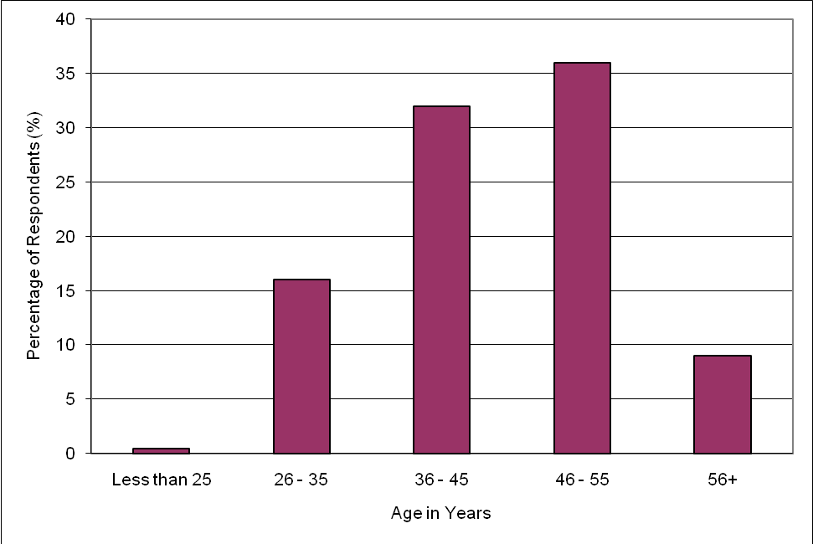Figure 1 Ages of survey respondents

Respondents represented a wide range of experience levels, with most respondents having worked in the organisation for between 11 and 20 years. The distribution of experience levels is shown in figure 2.

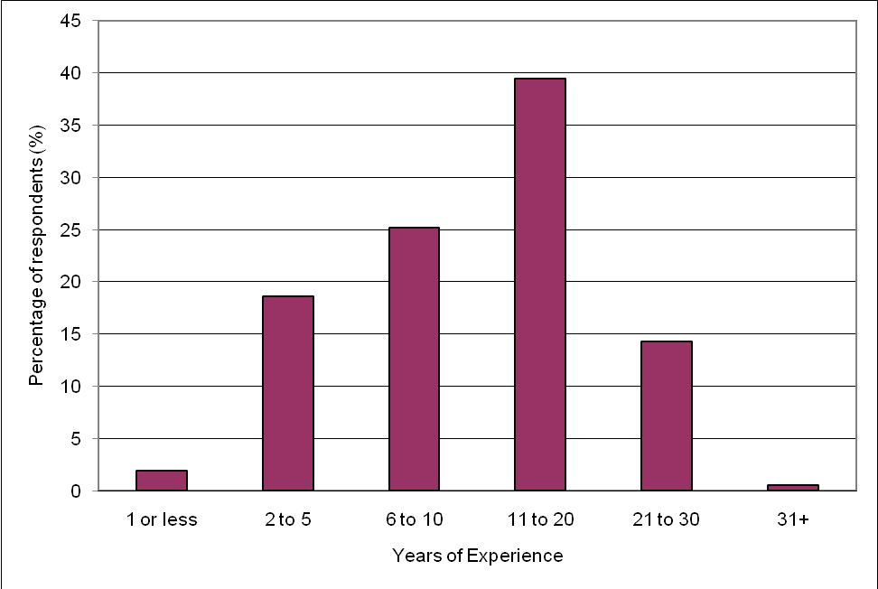Figure 2 Number of years of experience of survey respondents

For the qualitative component of the study, five individuals agreed to participate in a semi-structured interview. All participants in the interview process were male. The age breakdown of interview participants is shown below:

* Interviewee 1: 26—35 years of age with 6—10 years experience
* Interviewee 2: 36—45 years of age with 11—20 years experience
* Interviewee 3: 36—45 years of age with 11—20 years experience
* Interviewee 4: 36—45 years of age with 11—20 years experience
* Interviewee 5: 46—55 years of age with 11—20 years experience

## Experience with e-learning

Participants were asked three questions in relation to their experience with e-learning. These questions were aimed at identifying their level of experience with e-learning, the extent of e-learning experience offered by their current organisation, and the nature of this experience (positive or negative).

The majority of respondents had no exposure to e-learning (95 out of 182 respondents). The distribution of experience levels is shown in figure 3.

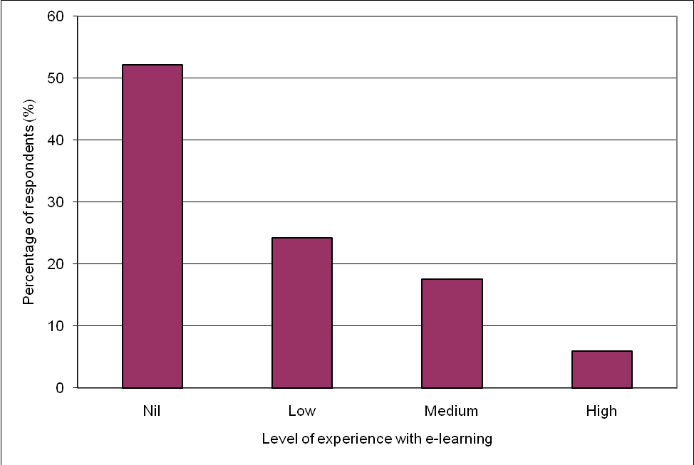Figure 3 Survey respondents’ experience with e-learning

A total of 72 respondents had used the e-learning currently available through the organisation. Those who had not (62% of all respondents) were asked to elaborate on the reasons for this; 106 respondents commented, with comments focused on a lack of knowledge of the availability of the resources:

Didn't know about it. (Survey respondent)

Not aware of them. (Survey respondent)

Never offered to staff. (Survey respondent)

I was not aware of e-learning before now. (Survey respondent)

During the interview process this issue was further examined and reinforced as a real barrier to effective engagement, with all interviewees expressing the importance of communication to the effective take-up of e-learning:

If they don’t know about it, they won’t use it. (Interviewee 3)

I don’t think most staff know that this stuff is available. (Interviewee 2)

Those who had used the materials were asked to respond to a number of statements about their experience of using these materials on a five-point scale, ranging from ‘strongly agree’ to ‘strongly disagree’, as outlined in table 1.

Table 1 Respondent attitudes towards currently available e-learning materials

|  |  |  |  |  |  |
| --- | --- | --- | --- | --- | --- |
| Statement | Agreement (%) | | | |  |
|  | Strongly  agree | Agree | Disagree | Strongly  disagree | Response count |
| I found the materials to be useful | 16.7 | 77.8 | 4.1 | 1.4 | 72 |
| The materials gave me the information that I needed | 12.8 | 72.8 | 11.5 | 2.9 | 70 |
| The materials were easy to use | 14.3 | 64.3 | 18.6 | 2.8 | 70 |
| The materials worked correctly | 10.0 | 70.0 | 18.6 | 1.4 | 70 |
| The materials were easy to access | 14.6 | 57.4 | 25.0 | 3.0 | 68 |
| I would use more of these materials if they were available | 29.7 | 62.2 | 6.8 | 1.3 | 74 |

The vast majority of those who had used the materials indicated that the experience had been a positive one and they were interested to learn more via this methodology (92% of all respondents).

I found it easy and convenient to use. Assistance was made available when needed.  
 (Survey respondent)

The positive reaction to the existing content was also echoed in the interviews, with all interviewees indicating that they believed the existing materials were serving their intended purpose (to support staff learning and change) well.

The stuff online at the moment is fantastic. (Interviewee 1)

## Attitudes to e-learning

As outlined in table 2, respondents’ attitudes to e-learning were judged across five areas:

* effectiveness of e-learning as a way to learn
* effectiveness of e-learning as a way of making learning more accessible
* their desire to use e-learning
* their like or dislike for learning via e-learning
* attitude towards e-learning as an alternative to face-to-face learning.

Table 2 Respondent attitudes towards e-learning as a method of staff development

|  |  |  |  |  |  |
| --- | --- | --- | --- | --- | --- |
| Statement | Agreement (%) | | | |  |
|  | Strongly  agree | Agree | Disagree | Strongly  disagree | Response count |
| E-learning is an effective way to learn | 26.6 | 67.8 | 4.9 | 0.7 | 143 |
| E-learning would make it easier for me to access learning | 35.8 | 59.3 | 3 | 1.9 | 152 |
| If e-learning was available, I would use it | 41 | 55.8 | 2.6 | 0.6 | 154 |
| I like learning via e-learning | 23.7 | 62.6 | 12.2 | 1.5 | 131 |
| E-learning offers the same quality of learning as face-to-face training | 10.9 | 38.7 | 45.9 | 4.5 | 137 |

What came through clearly in the responses was a generally positive attitude towards the concept of e-learning, as well as a recognition of the benefits that e-learning offered to learners. The final statement was included deliberately to test the respondent’s reaction to the substitution of face-to-face learning with e-learning — that its quality was similar to other forms of delivery. Responses clearly indicate that this is an area where attitudes differ quite strongly from other attitudes to   
e-learning and will need to be a focus of any e-learning implementation if it is to succeed.

Those who disagreed with any of the statements were given the opportunity to provide details in the form of a free-text comments box. In total, 56 participants provided free-text feedback, which was generally focused on the issue of e-learning not being as effective as face-to-face learning; and the feedback also reflected a belief that e-learning was not interactive and did not support the exchange of questions/answers with the facilitator (28 out of 56):

Face-to-face learning is still better, unless you can access someone online to answer questions.  
 (Survey respondent)

My previous experience with distance education showed me that no matter how much material you have in front of you, nothing compares with having that teacher in front of you to ask questions of. (Survey respondent)

Someone correcting you while you learn is the better way for me to gain results.  
 (Survey respondent)

Questions cannot be easily asked or quickly answered. (Survey respondent)

You are not able to ask questions of the course facilitators. (Survey respondent)

This issue was examined further in the interviews and reinforced as a view strongly held by many custodial staff.

You don’t get the interaction with other people, so you don’t get the ideas coming from other people. (Interviewee 1)

## E-learning enablers

In the final section of the survey, participants were asked to rate a number of suggested enabling actions the organisation might take to encourage and promote the uptake of e-learning (see table 3). These enablers were selected because they were believed to directly address one or more of the potential barriers to effective e-learning engagement identified either via the literature review or through discussions with staff in the organisation.

What these responses clearly indicate is that all the listed enablers are considered important or very important by the majority of respondents. Of particular interest was the fact that assistance with computer skills was not identified as a prominent barrier to e-learning, as anecdotal evidence from the organisation had suggested. In fact, it had the lowest percentage of ‘very important’ responses. This was further reinforced through the interview process which saw the computerisation of the job overcoming many of the stereotypes of custodial officers having poor PC skills.

Table 3 Enablers to assist in the uptake of e-learning by custodial officers

|  |  |  |  |  |  |
| --- | --- | --- | --- | --- | --- |
| Statement | Agreement | | | |  |
|  | Very important | Important | Somewhat important | Not important | Response count |
| Provide increased access to PCs | 61.5 | 32.9 | 2.5 | 3.1 | 161 |
| Make the e-learning user-friendly | 66 | 30.3 | 3.7 | 0 | 162 |
| Allow me to access e-learning from home | 61.3 | 27.3 | 6.9 | 4.5 | 160 |
| Provide time to complete e-learning | 59.6 | 31.1 | 8.7 | 0.6 | 161 |
| Ensure that the network is capable of running e-learning without issues | 73.6 | 24.6 | 1.8 | 0 | 163 |
| Provide me with training in how to use e-learning | 57.8 | 31.7 | 8.1 | 2.4 | 161 |
| Provide me with training in how to best learn using e-learning | 54.7 | 35.8 | 7.6 | 1.9 | 159 |
| Ensure that e-learning is of a high quality | 71.6 | 26.5 | 1.9 | 0 | 162 |
| Ensure that e-learning is secure | 63.7 | 29.4 | 5.6 | 1.3 | 160 |
| Provide me with training to improve my PC skills | 39.4 | 34.4 | 15.0 | 11.2 | 160 |
| Ensure that e-learning covers topics that are relevant to my role | 69.6 | 28.1 | 2.3 | 0 | 160 |
| Provide opportunities to work and learn with others who are completing the same course as me | 49.7 | 38.5 | 10.6 | 1.2 | 161 |
| Provide me with regular support before, during and after e-learning | 55.5 | 38.3 | 6.2 | 0 | 162 |

The capability of the network to run e-learning was the highest rated of all enablers, with 98.2% of all respondents rating it as important or very important. Issues with ICT infrastructure was also a common theme through the interview process. While this is not a concern confined to corrections, it does seem to be more significant in this context than in others.

The deal breaker is having PCs that are able to run the courses. (Interviewee 2)

Has the PC got the programs that you need? (Interviewee 1)

It is also important to note that all respondents were given the opportunity to suggest any additional enablers if they wished. Despite being given this opportunity, no additional enablers were identified. This is reassuring, because it validates this list as representing the key enablers for the corrections industry.

# Conclusions

## What are the e-learning enablers for custodial officers?

What came through very strongly in the research was that the barriers to engagement with e-learning for custodial officers were generally no different from the general barriers identified in the literature. This was particularly reinforced by the fact that no respondents suggested the addition of other enablers to the list provided. The uniqueness of corrections enablers appears to be in their mix, which is consistent with the findings from the literature, which suggest that the mix will generally be different in different settings.

The custodial ‘mix’ of barriers strongly focuses on the technology side of e-learning, with the need to provide access to computers that were capable of running the e-learning being a major concern. Security of information was also a key issue and appears to be somewhat unique to this setting. It should be noted that both concerns are not confined to consideration of e-learning but are highly reflective of the general operating environment in which custodial officers operate.

Another key concern for the implementation of e-learning is the strong perception that e-learning does not offer the same learning experience as face-to-face learning. If staff are to effectively engage with and benefit from e-learning, this will be a significant factor to address during implementation, While some of the identified enablers will assist in this regard — through the design of the e-learning program and the provision of training in how to be an ‘e-learner’ — a more general marketing and communication response also seems to be required, particularly to address negative perceptions about e-learning as a substitute for face-to-face learning.

The need for effective communication is a theme which came through strongly throughout the research, with many respondents stating that they did not use e-learning because they did not know about it and/or understand it. Communicating the benefits of e-learning is considered to be one of the key enablers identified by this research. It is also, surprisingly, an area of concern that was not specifically identified or addressed in either the literature review or in discussion with staff prior to the research. Perhaps the need to tell staff about what is available was considered too obvious to need articulation, but it does appear to be a critical factor in the success of e-learning initiatives.

Finally, the findings also strongly reinforce the idea that there is no single enabler that, if addressed, will immediately increase engagement with e-learning. Instead, a number of enablers were identified as important to the research participants, supporting Schilke’s (2001) notion of the ‘culmination of a series of small individual problems’ (cited in Mungania & Reio 2005, p.1115).

This research set out to determine whether the e-learning barriers identified in other industry learning contexts were applicable to the correctional context and if the suggested enabling actions could help overcome them. While it is fair to say that the barriers to e-learning within corrections are generally no different to other contexts, this research clearly adds weight to the ideas that (i) each context will have its own unique mix of barriers/enablers and (ii) these barriers/enablers need to be addressed systematically if they are to be overcome.

Having identified the specific mix of enablers for corrections, the challenge is now for the industry to come up with appropriate solutions to their implementation. This issue was not the subject of this research so a follow-up study would be required — after e-learning has been implemented — to test the validity of the findings and identify the effectiveness of any strategies applied to address the identified barriers.

While the findings of this research may not be directly applicable to other jurisdictions, the research clearly shows that the barriers to the successful implementation of e-learning within the correctional environment are not significantly different from those of any other industry. What is now required is for other jurisdictions to take the findings of this research and test their broader application across the industry.

# References

ABS (Australian Bureau of Statistics) 2011, *Corrective services, Australia, December 2010*, cat.no.4512.0, ABS, Canberra.

Ali, G & Magalhaes, R 2008 ‘Barrier to implementing e-learning: a Kuwaiti case study’, *International Journal of Training & Development*, vol.12, issue 1, pp.36—53.

Australian Flexible Learning Framework 2010, ‘2010 Benchmarking Report’, viewed February 2011, <http://e-learningindicators.flexiblelearning.net.au/survey\_results\_all.htm>.

Bartz, J 2010, ‘The learner’s place in e-learning project management’, *Journal of Distance Education*, vol.24, no.1, pp.43—54.

Bell, J 2009, ‘Doing your research project’, Open University Press, Maidenhead.

Chien, T 2008, ‘Factors influencing computer anxiety and its impact on e-learning effectiveness: a review of literature’, online submission, paper presented at the Academy of Human Resource Development International Research Conference in the Americas, Panama City, FL, 20—24 February 2008, viewed January 2011, <<http://www.eric.ed.gov/PDFS/ED501623.pdf>>.

Government Skills Australia 2011, ‘2011 environmental scan’, viewed March 2011, <http://www.governmentskills.com.au/images/file\_groups/10088/escan\_2011.pdf>.

Kushnir, LP 2009, ‘When knowing more means knowing less: understanding the impact of computer experience on e-learning and e-learning outcomes’, *Electronic Journal of e-Learning*, vol.7, issue 3, pp.289—300.

Lim, D, Ripley, D & O’Steen, B 2009, ‘E-learning methodologies in practice: similarities and difference between North American countries and New Zealand’, *Human Resources Development International*, vol.12, issue 2, pp.209—24.

Misko, J, Choi, J, Hong, S & Lee, I 2004, ‘E-learning in Australia and Korea: learning from practice’, NCVER, Adelaide.

Mungania, P & Reio, TG 2005, ‘If e-learners get there, will they stay? the role of e-learning self-efficacy’, online submission, paper presented at the Academy of Human Resource Development International Conference (AHRD), Estes Park, CO, 24—27 February 2005, viewed January 2011, <http://www.eric.ed.gov/PDFS/ED492287.pdf>.

Oiny, E 2009, ‘Electronic human resource management: organizational responses to role conflicts created by e-learning’, *International Journal of Training and Development*, vol.13, issue 2, pp.111—23.

Polimeni, RS, Burke, JA & Benyaminy, D 2009, ‘Using computer simulations to recruit and train Generation Y accountants’, *The CPA Journal*, vol.79, issue 5, pp.64—8.

Rabak, L & Cleveland-Innes, M 2006, ‘Acceptance and resistance to corporate e-learning: a case from the retail sector’, ***The Journal of Distance Education****, North America*, vol.21, November.

Simmering, M, Posey, C & Piccoli, G 2009, ‘Computer self-efficacy and motivation to learn in a self-directed online course’, *Science Journal of Innovative Education*, vol.7, issue 1, pp.99—121.

Sulcic, V & Lesjak, D 2009, ‘E-learning and study effectiveness’, *Journal of Computer Information Systems*, Spring, vol.40, issue 3, pp.40—7.

Waight, C 2005, ‘Valuing the adult learner in e-learning: a conceptual model for corporate settings’, *The Journal of Workplace Learning*, vol.17, nos.5—6, pp.398—414.

Wang, G, Foucar-Szocki, D & Griffin, O 2006, ‘HRD learning participation: an empirical study of e-learning completion’, online submission, paper presented at the Academy of Human Resource Development International Conference (AHRD), Columbus, OH, 22—26 February, viewed January 2011, <http://www.eric.ed.gov/PDFS/ED492830.pdf>.

# Appendix 1

**INVITATION LETTER TO RESEARCH PARTICIPANTS (SURVEY)**

You are invited to participate in a research project, which is being conducted as part of a National Centre for Vocational Education Research (NCVER) scholarship program. Details of this project are below:

**PROJECT TITLE:**

Custodial Officer 2.0: Identifying the enablers to the effective take up of e-learning by custodial officers.

**PROJECT PURPOSE:**

The aim of this project is to identify the things that can be done to help custodial officers to adapt to learning using e-learning materials.

**RESEARCHER:**

This project is being conducted by Mal Reason. His contact details are below:

Email: mal.reason@dcs.nsw.gov.au

**PARTICIPATION:**

If you choose to participate in this project, you will be asked to complete a survey. This survey can be completed either on paper or on-line (accessed via the Broadcast). The survey will take approximately 10 minutes to complete.

Participation in this project is voluntary. If you choose to participate, you are free to:

* Not answer any question on the survey that you do not wish to .
* Withdraw from further participation at any time without giving a reason and with no negative consequences.
* Ask for any information which identifies you to be withdrawn from the study.

**CONFIDENTIALITY:**

The information that you provide will be used to complete the requirements for the project above, and only the researcher will have access to the information.

Any information or details given for this study will be kept confidential and will only be used for the purposes of this project. You will not be identified in any written reports or presentation of the results of this project.

For further information about this project please contact the researcher, using the contact details above.

**RESEARCH SURVEY**

**RESEARCH PROJECT**: Custodial Officer 2.0: Identifying the enablers to the effective take up of e-learning by custodial officers.

**Consent:**

I have read the information letter about this project and freely agree to participate 🞏

**Part 1: Information about you.**

* 1. What is your gender? 🞏 Male 🞏 Female
  2. What is your age?

🞏 Less than 25

🞏 25–35

🞏 36–45

🞏 46–55

🞏 56+

* 1. What is your current rank?
  2. How many years experience do you have with Corrective Services NSW?

🞏 1 or less

🞏 2–5

🞏 6–10

🞏 11–20

🞏 21–30

🞏 31+

**Part 2: Your experiences with e-learning.**

* 1. What level of experience do you have with e-learning:

🞏 High – I have done a lot of learning this way

🞏 Medium – I have done some learning this way

🞏 Low – I have done a small amount of learning this way

🞏 Nil – I have never learned this way before

* 1. Which of the following e-learning offered by BFCSA have you used?

🞏 On-line courses such as the Certificate IV in TAA toolbox

🞏 Interactive Demonstrations (Courselettes) offered on the CSNSW Intranet

* None (If you choose this answer can you please explain why you have not used these materials in the box below)
  1. If you have used the e-learning materials offered by BFCSA please rate the below statements.

|  |  |  |  |  |
| --- | --- | --- | --- | --- |
|  | Strongly Agree | Agree | Disagree | Strongly Disagree |
| (a) I found the materials to be useful | 🞏 | 🞏 | 🞏 | 🞏 |
| (b) The materials gave me the information that I needed | 🞏 | 🞏 | 🞏 | 🞏 |
| (c) The materials were easy to use | 🞏 | 🞏 | 🞏 | 🞏 |
| (d) The materials worked correctly | 🞏 | 🞏 | 🞏 | 🞏 |
| (e) The materials were easy to access | 🞏 | 🞏 | 🞏 | 🞏 |
| (f) I would use more of these materials if they were available | 🞏 | 🞏 | 🞏 | 🞏 |

If you said that you would not use more of these materials, can you please explain why in the box below:

**Part 3: Attitudes to e-learning**

3.1 Please read each statement below and place a tick in the column that best describes your response to the statement.

|  |  |  |  |  |
| --- | --- | --- | --- | --- |
|  | Strongly Agree | Agree | Disagree | Strongly Disagree |
| (a) e-learning is an effective way to learn | 🞏 | 🞏 | 🞏 | 🞏 |
| (b) e-learning would make it easier for me to access learning | 🞏 | 🞏 | 🞏 | 🞏 |
| (c) If e-learning was available, I would use it | 🞏 | 🞏 | 🞏 | 🞏 |
| (d) I like learning via e-learning | 🞏 | 🞏 | 🞏 | 🞏 |
| (e) e-Learning offers the same quality of learning as face to face training | 🞏 | 🞏 | 🞏 | 🞏 |

If you answered 'Disagree' or 'Strongly Disagree' to any of the above can you please provide more information in the box below.

**Part 4: e-learning enablers**

4.1 Listed below are some of the things that can be done to help you learn via e-learning. Please look at each item and rate its importance to you in helping you adapt to learning via e-learning.

|  |  |  |  |  |
| --- | --- | --- | --- | --- |
|  | Very Important | Important | Somewhat Important | Not Important |
| (a) Provide increased access to PCs | 🞏 | 🞏 | 🞏 | 🞏 |
| (b) Make the e-learning user-friendly | 🞏 | 🞏 | 🞏 | 🞏 |
| (c) Allow me to access e-Learning from home | 🞏 | 🞏 | 🞏 | 🞏 |
| (d) Provide time to complete e-learning | 🞏 | 🞏 | 🞏 | 🞏 |
| (e) Ensure that the network is capable of running e-learning without issues | 🞏 | 🞏 | 🞏 | 🞏 |
| (f) Provide me with training in how to use e-learning | 🞏 | 🞏 | 🞏 | 🞏 |
| (g) Provide me with training in how to best learn using e-learning | 🞏 | 🞏 | 🞏 | 🞏 |
| (h) Ensure that e-learning is of a high quality | 🞏 | 🞏 | 🞏 | 🞏 |
| (i) Ensure that e-learning is secure | 🞏 | 🞏 | 🞏 | 🞏 |
| (j) Provide me with training to improve my PC skills | 🞏 | 🞏 | 🞏 | 🞏 |
| (k) Ensure that e-learning covers topics that are relevant to my role | 🞏 | 🞏 | 🞏 | 🞏 |
| (l) Provide opportunities to work and learn with others who are completing the same course as me | 🞏 | 🞏 | 🞏 | 🞏 |
| (m) Provide me with regular support before, during and after e-learning | 🞏 | 🞏 | 🞏 | 🞏 |

Other (please specify)

**Part 5: Any other comments:**

5.1 Please add any other comments that you would like to make in relation to e-learning below:

Thank you for participating in this survey. Please return the completed survey using one of the means below:

1. Email to [mal.reason@dcs.nsw.gov.au](mailto:mal.reason@dcs.nsw.gov.au)
2. Fax to the attention of Mal Reason on 02 9804 5428
3. Mail to Mal Reason at 66 Terry Road, EASTWOOD 2122.