**GOOD**

**PRACTICE**

**GUIDE**



**Supporting tertiary students with a disability or mental illness**

# INTRODUCTION

Having a disability or ongoing ill health (including mental health conditions) can significantly disrupt an individual’s educational attainment and employment prospects, potentially creating lifelong social and economic disadvantage. These students may need additional support to help them successfully complete their studies. In addition, education providers are required to ensure that these students are able to access and participate in education on the same basis as other students, in accordance with the Disability Discrimination Act 1992 (Commonwealth of Australia 1992) and the Disability Standards for Education (Commonwealth of Australia 2005).

This good practice guide is designed to assist teaching staff and disability services staff in both vocational education and training (VET) and higher education institutions to offer individualised or institution-level adjustments in teaching, learning and assessment methods to support students with disabilities or ongoing ill health. It is based on research that considers the viewpoints of these tertiary students, as well as specialist disability services workers and teaching staff. The adoption of these principles aims to improve the educational experience and rate of course completions for these students.

## This good practice guide is based on the following reports:

* ***Unfinished business: student perspectives on disclosure of mental illness and success in VET* by Annie Venville and Annette Street, 2012**
* ***Supporting tertiary students with disabilities: individualised and institution-level approaches in practice* by Ellie Fossey, Lisa Chaffey, Annie Venville, Priscilla Ennals, Jacinta Douglas and Christine Bigby, 2015**

## Full reports can be downloaded from [www.ncver.edu.au](http://www.ncver.edu.au/)

P:\PublicationComponents\logos\NCVER LOGOS\Print\NCVER_CMYK.wmf

**WHAT KIND OF SUPPORTS SHOULD YOU OFFER STUDENTS?**

Decisions about what supports/adjustments to offer should focus on the needs of the individual student. You may need to consult with a range of people, such as teachers, support workers and/or technical experts, as well as the student to decide what is appropriate for the individual.

The lines are also blurred between individualised reasonable adjustments, the institution-level learning supports available to all students, and students’ own strategies for managing their studies. When selecting which support mechanisms that are most appropriate for an individual, collaboration is key.

Understanding the perspectives of teachers, support workers, technical experts and students will enable you to identify where reasonable adjustments are necessary or where institution-level learning supports may be equally useful. The two can be seamlessly paired to provide effective support to the student.

Students and disability services staff define the effectiveness of learning supports in different ways:

* For students, the markers of effective learning support are a better understanding of their own needs, an increased ability to cope, more enjoyment and doing their best work.
* For disability services staff and teachers, students completing their courses or postponing study until they are

better prepared are indicators of success.

In deciding which particular reasonable adjustment to use for a specific student, you should:

* consider the reasonable adjustment that is least disruptive or intrusive but equally beneficial for the student
* consider whether the learning supports routinely provided for all students could be useful either in addition to,

or instead of, the identified adjustment

* assess whether the adjustment may need to be changed over the period of a student’s education or training, as

their needs change.

# WHAT ARE REASONABLE ADJUSTMENTS?

## A reasonable adjustment is:

* + an individualised modification made to the learning environment, training delivery or assessment method
  + used to enable a student with a disability or an ongoing health condition to access and participate in education and training on an equal footing with other students.

It should not:

* + advantage students with disabilities above other students
  + alter course standards or outcomes
  + guarantee success
  + weaken the integrity of the qualification.

**Institution-level learning supports** on the other hand are the various forms of learning assistance and support provided for all students.

**SUPPORTING TERTIARY STUDENTS WITH A DISABILITY OR MENTAL ILLNESS**

**2**

**EXAMPLES OF SUPPORTS TO CONSIDER**

**Reasonable adjustments**

Given the diversity of the student population and the array of learning environments available, a wide range of different reasonable adjustments have been used for different students. These adjustments may include (but are not limited to):

* provision of a computer rather than writing by hand

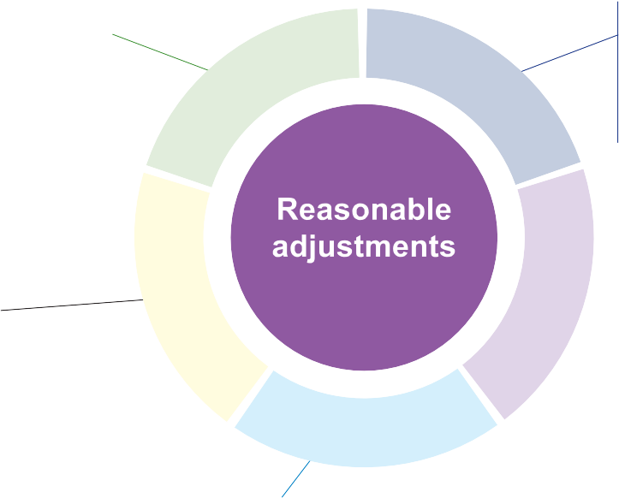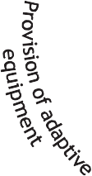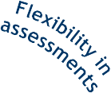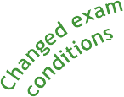

* use of a scribe
* allowance of food and beverages
* extended exam time
* location moved to a quiet room to decrease anxiety
* extended assessment due dates
* changed assessment formats (for example, oral instead of written presentation)
* submission of assessment tasks via

email rather than at the institution

* screen reader
* audio recorder
* adjustable seating
* mobility scooter
* specialist software
* regular monitoring, encouragement and empowerment
* individual tutoring or training in the development of study skills
* the provision of course information in varied formats (for example, audio books, online)
* online course materials, enabling more flexible access
  + note takers (who may sit either with the student or separately, depending on the student’s preference)
  + re-formatting of course materials to accommodate specific impairments (for example, large print, audio recording)
  + the provision of recordings of classes online, enabling more flexible access

## Institution-level learning supports

Institutions often rely on the students themselves to disclose their illness or disability, which then enables them to access reasonable adjustment supports. This can be problematic, as many students are concerned about the risks to their reputation that accompany disclosure.

The creation of inclusive learning environments and providing institution-level supports that do not necessitate disclosure can be beneficial. These supports may include (but are not limited to):

* extended assessment due dates
* options to enable students to undertake learning activities or assessment in different formats (for example, oral or written presentation), which can be negotiated with teaching staff
* submission of assessment tasks via email rather than at the institution, following negotiation with teaching staff
* stress management and coping

mechanisms taught in class

* recordings of classes provided online, enabling more flexible access and revision
* additional classes provided

to supplement regular teaching sessions.

**NATIONAL CENTRE FOR VOCATIONAL EDUCATION RESEARCH**

* course information provided in varied formats (for example, online and printed)

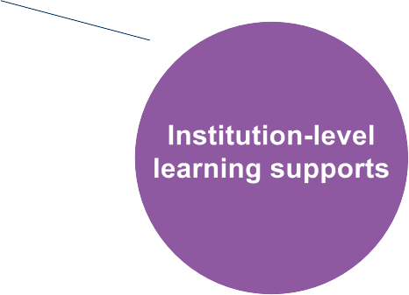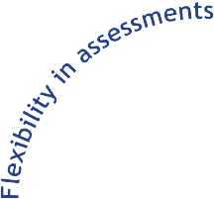

* online course materials provided, enabling more flexible access
* teachers making themselves accessible (for example, through regular emphasis

of an ‘open door’ policy) to assure students of the availability of ready help.

A noted barrier to this

may include the predominance of part-time and casual teaching staff.

**3**

## Student-initiated study management strategies

Students may also develop strategies that help them manage their studies, which can be used in conjunction with individualised reasonable adjustments or institution-level learning supports. These supports include:

* using non-specialist equipment (for example, bags with wheels for carrying books)
* using mobile devices to organise their schedules, develop study skills, or record, watch and listen to lessons
* searching online for information and resources/tools to assist with their studies
* listening to audio books, where available, instead of using printed books
* adjusting study loads, such as studying part-time or taking study breaks
* developing and using stress management strategies.

It may be useful to encourage students to actively use any strategies they have identified.

In addition, the development of peer networks should be fostered to promote students’ sharing of experiences and learning from each other.

# REFERENCES

Commonwealth of Australia 1992, *Disability Discrimination Act*, Australian Government, Canberra.

——2005, *Disability standards for education*, Australian Government, Canberra.

# FOR MORE INFORMATION

These findings are based on two research reports published by NCVER:

* *Unfinished business: student perspectives on disclosure of mental illness and success in VET* by Annie Venville and [Annette Street available at www.ncver.edu.au/publications/2465.html](http://www.ncver.edu.au/publications/2465.html)
* *Supporting tertiary students with disabilities: individualised and institution-level approaches in practice* by Ellie Fossey, Lisa Chaffey, Annie Venville, Priscilla Ennals, Jacinta Douglas and [Christine Bigby available at www.ncver.edu.au/publications/2832.html](http://www.ncver.edu.au/publications/2832.html)



P:\PublicationComponents\logos\NCVER LOGOS\Print\NCVER_CMYK.wmf



**© Commonwealth of Australia, 2015**

This work has been produced by the National Centre for Vocational Education Research (NCVER) under the National Vocational Education and Training Research (NVETR) Program, which is coordinated and managed by NCVER on behalf of the Australian Government and state and territory governments. Funding is provided through the Australian Department of Education and Training.

TD/TNC 122.07

Published by NCVER ABN 87 007 967 311

Level 11, 33 King William Street, Adelaide SA 5000

PO Box 8288, Station Arcade, Adelaide SA 5000, Australia P +61 8 8230 8400 F +61 8 8212 3436

E [ncver@ncver.edu.au](mailto:ncver@ncver.edu.au) W [www.ncver.edu.au](http://www.ncver.edu.au/)

twitter.com/ncver [www.linkedin.com/company/ncver](http://www.linkedin.com/company/ncver)

