P:\PublicationComponents\logos\NCVER LOGOS\WMF - word\No lines\NCVER_Floating_Mono.wmfG:\pub_prod\PublicationComponents\logos\LSAY\LSAY logo B&W.eps

The impact of increasing university participation on the pool of apprentices

Tom Karmel  
David Roberts  
Patrick Lim

National Centre for   
Vocational Education Research

The views and opinions expressed in this document are those of the author/project   
team and do not necessarily reflect the views of the Australian Government or state and territory governments.

### LONGITUDINAL SURVEYS OF AUSTRALIAN YOUTH

### **RESEARCH REPORT 67**

**© Commonwealth of Australia, 2014**

G:\pub_prod\PublicationComponents\logos\Creativecommons\CC BY logo.eps

With the exception of the Commonwealth Coat of Arms, the Department’s logo, any material protected by a trade mark and where otherwise noted all material presented in this document is provided under a Creative Commons Attribution 3.0 Australia <http://creativecommons.org/licenses/by/3.0/au> licence.

The details of the relevant licence conditions are available on the Creative Commons website (accessible using the links provided) as is the full legal code for the CC BY 3.0 AU licence <http://creativecommons.org/licenses/by/3.0/legalcode>.

The Creative Commons licence conditions do not apply to all logos, graphic design, artwork and photographs. Requests and enquiries concerning other reproduction and rights should be directed to the National Centre for Vocational Education Research (NCVER).

This document should be attributed as Karmel, T, Roberts, D & Lim, P 2014, *The impact of increasing university participation on the pool of apprentices*, NCVER, Adelaide.

This work has been produced by NCVER through the Longitudinal Surveys of Australian Youth (LSAY) Program, on behalf of the Australian Government and state and territory governments, with funding provided through the Australian Department of Education.

ISBN 978 1 922056 94 8  
TD/TNC 116.01

Published by NCVER, ABN 87 007 967 311

Level 11, 33 King William Street, Adelaide, SA 5000  
PO Box 8288 Station Arcade, Adelaide SA 5000, Australia

**Phone** +61 8 8230 8400 **Fax** +61 8 8212 3436

**Email** [ncver@ncver.edu.au](mailto:ncver@ncver.edu.au) **Web** <http://www.ncver.edu.au> <<http://www.lsay.edu.au>>

**Follow us:**  <http://twitter.com/ncver>  <http://www.linkedin.com/company/ncver>

About the research

The impact of increasing university participation on the pool of apprentices

### Tom Karmel, David Roberts and Patrick Lim, NCVER

In recent years, Australian governments have placed considerable emphasis on the importance of both university participation and undertaking an apprenticeship. This paper looks at whether there is a relationship between the two and, in particular, whether the expansion of university participation (for example, the uncapping of university undergraduate places following the Bradley Review [Bradley   
et al. 2008]) is likely to have an impact on the pool of those undertaking a trade apprenticeship. The authors consider certain aspects of an apprentice’s background: reading and mathematics achievement at age 15 years and socioeconomic status. The potential impact of an expansion in university participation on the pool of apprentices is examined by comparing two cohorts from the Longitudinal Surveys of Australian Youth (LSAY): the Y95 cohort who were in Year 9 in 1995 and the Y06 cohort who were aged 15 years in 2006.

Key messages

* The likelihood of undertaking an apprenticeship is affected by the propensity to go to university.
* Young men are less likely to undertake an apprenticeship if they are academically inclined.
* Apprenticeships are more likely to be undertaken by young men from a lower socioeconomic status background.
* LSAY shows that participation in both university and apprenticeships grew between 1995 and 2006.
* Young men who were less academically inclined and from low socioeconomic status backgrounds contributed to this growth in apprenticeships.
* The growth in university participation has come from academically lower-performing young men with a higher socioeconomic status background.

The authors note that any educational expansion (whether through apprenticeships or attendance at university) will also have an impact on that part of the population who previously were neither undertaking an apprenticeship nor going to university. They also observe that those who are in the best position to take advantage of opportunities in both apprenticeships and university places do so, irrespective of whether position is measured by mathematics and reading achievement or socioeconomic status.

Rod Camm  
Managing Director, NCVER

Contents

Tables and figures 6

Executive summary 8

Introduction 9

Descriptive statistics 12

Statistical methodology 17

Results 20

Discussion 28

Final comments 35

References 36

Appendices

A: Description of the data used 37

B: Models 40

C: Regression results 42

# Tables and figures

## Tables

1 Descriptive statistics of achievement and SES variables (mean and standard deviation) 12

2 Variables used for predicting probability of going to university or undertaking an apprenticeship 17

3 AIC values for the four alternative models 18

4 Variables included in interactions with cohort dummy variable 18

5 Regression results for predicting apprenticeship: coefficients 19

A1 Common variables for both cohorts 38

A2 Correlation matrix 39

A3 Model fit information 39

A4 R-squared 39

B1 Variables used for regression predicting university attendance   
by wave 5 40

B2 Variables used for regression predicting apprenticeship by wave 5 41

C1 Regression results for predicting university attendance: model fit statistics and type III analysis of effects 42

C2 Regression results for predicting university attendance: coefficients 43

C3 Regression results for predicting apprenticeship: model fit statistics   
and type III analysis of effects 44

C4 Regression results for predicting apprenticeship: coefficients 45

## Figures

1 Distributions of mathematics achievement for 19-year-old males   
across the three options of: undertaking an apprenticeship, neither undertaking an apprenticeship nor going to university, and going to university, Y95 cohort 13

2 Distributions of reading achievement for 19-year-old males across   
the three options of: undertaking an apprenticeship, neither   
undertaking an apprenticeship nor going to university, and going to university, Y95 cohort 14

3 Distributions of socioeconomic status for 19-year-old males across   
the three options of: undertaking an apprenticeship, neither   
undertaking an apprenticeship nor going to university, and going to university, Y95 cohort 15

4 Predicted probability of being an apprentice by achievement scores,   
Y95 males 21

5 Predicted probability of being an apprentice by socioeconomic   
status, Y95 males 22

6 Change in predicted probabilities by mathematics achievement   
scores, Y95 males 23

7 Change in predicted probabilities by reading achievement scores,   
Y95 males 23

8 Change in predicted probabilities by socioeconomic status,   
Y95 males 24

9 Relative change in predicted probability between cohort 1 and   
cohort 2 of being an apprentice, going to university, or neither, by mathematics and reading achievement, calculated for Y95 sample 26

10 Relative change in predicted probability between cohort 1 and   
cohort 2 of being an apprentice, going to university, or neither, calculated for Y95 sample 27

11 Synthetic distributions of apprentices across mathematics quintiles,   
all Y95 males 29

12 Synthetic distributions of apprentices across reading achievement quintiles, all Y95 males 29

13 Synthetic distributions of apprentices across SES quintiles, all   
Y95 males 30

14 Synthetic distributions of those going to university across   
mathematics achievement quintiles, all Y95 males 31

15 Synthetic distributions of those going to university across reading achievement quintiles, all Y95 males 31

16 Synthetic distributions of those going to university across SES   
quintiles, all Y95 males 32

17 Synthetic distributions of neither going to university nor   
undertaking an apprenticeship across mathematics achievement   
quintiles, Y95 males 33

18 Synthetic distributions of neither going to university nor   
undertaking an apprenticeship across reading achievement   
quintiles, Y95 males 33

19 Synthetic distributions of neither going to university nor   
undertaking an apprenticeship across SES quintiles, Y95 males 34

# Executive summary

The purpose of this paper is to provide an analysis of the impact of increasing university participation on the intake quality of apprentices. In this paper, we use two cohorts of the Longitudinal Surveys of Australian Youth (LSAY), separated by 11 years, and compare male trade apprentices. In particular, we investigate whether their academic ability measured at age 15 years and their socioeconomic (SES) backgrounds have changed over this time period, and whether the increase in the probability of going to university has impacted on these characteristics.

The results from this paper show that over this 11-year period the probability of undertaking both apprenticeships and university has increased. This paper shows that, between the 1995 and 2006 cohorts, the increase in the probability of going to university impacted on the quality of apprentices unambiguously. More apprentices come from the bottom two quintiles in relation to mathematics and reading achievement. However, given the expansion of apprenticeships, there has been very little movement in the number of apprentices who have mathematics and reading achievement in the top two quintiles.

In terms of university participation, this paper also found that the expansion of higher education has resulted in a noticeable shift in the proportion of male university students in the top academic achievement quintiles.

A further finding from this paper is that with the expansion of both higher education and apprenticeships the growth in higher education has come from individuals with middle to high socioeconomic status backgrounds, whereas apprentices are likely to have come from those who have lower SES.

It should be noted, however, that apprenticeships are quite different from university places. While the government can easily increase the latter, and has by uncapping undergraduate places, the former depend on the willingness of employers to offer them. This willingness primarily depends on the labour market and the opportunity it offers in terms of activity in the trades. When we think in these terms there is a certain symmetry in the impact of expansion in both apprenticeships and student places. Those who are in the best position to take advantage of opportunities do so, irrespective of whether position is measured by mathematics and reading achievement or socioeconomic status.

# Introduction

The purpose of this paper is to provide an analysis of the impact of increasing university participation on the intake of apprentices. Our starting point is that the proportion of young people going to university is increasing and this potentially may impact on those young people who otherwise would have undertaken an apprenticeship.[[1]](#footnote-1) Those choosing to go to university are unlikely to be the ‘average’ apprentice, and therefore it is likely that there will be a decline in the number of ‘high ability’ apprentices. This is an eminently plausible argument, unless the population of potential apprentices is completely separate from the population of potential university students, and this seems most unlikely.

Thus our goal is to investigate how the expansion of higher education has affected the apprenticeship cohort. However, we have an immediate problem, that of ‘simultaneity’: it is a joint decision to go to university, undertake an apprenticeship or do neither. One possibility would be to model these three outcomes as a function of the usual background variables (academic ability, socioeconomic status and the like) and see how this model has changed over time. The problem with such a standard approach is that we would end up with a description of how the overall distribution of apprentices and university students has changed but it would not help in separating out the impact of increasing higher education on the apprenticeship cohort. To do so, we need greater structure in the model, such that the likelihood of going to university impacts on the probability of undertaking an apprenticeship.

An obvious response to such an approach is that if you assume that the probability of going to university impacts on the probability of undertaking an apprenticeship, should not you also assume the converse: that the probability of undertaking an apprenticeship impacts on the probability of going to university? However, if we were to do that, we would have an identification problem, unless somehow the variables feeding into the probability of going to university are different from those feeding into the probability of undertaking an apprentice. There are no obvious reasons for using different variables.

The way we resolve this dilemma is to test both possibilities against each other. That is, we see whether the probability of going to university feeding into the probability of undertaking an apprenticeship fits the data better than the converse model. *A priori* our belief was that the former model would dominate the latter on the basis that there is a difference in status between going to university and undertaking an apprenticeship (see for example, Laming 2012, who argues the dominance of university as the aspiration of choice for school leavers; also Alloway et al. 2004 on the academic paradigm at school impacting on choice). While we could proceed on this assumption, it is more satisfactory to test the proposition statistically.

Our focus is on two aspects of apprentices. The first is ‘quality’, which for the purposes of this paper we define as the level of academic achievement as measured at roughly age 15 years. The second is socioeconomic status. We apply the focus on academic quality for two reasons: the practical reason is that our dataset, the Longitudinal Surveys of Australian Youth, collects such data, and the additional reason is that complaints about the poor preparation of apprentices tend to focus on academic rather than practical attributes.

We compare two cohorts of apprentices, specifically male trade apprentices, in order to see how ‘quality’ and socioeconomic status have changed over time and how the change in the probability of going to university has impacted on the distribution of apprentices against these variables.

Our choice of cohorts is limited by the available datasets.[[2]](#footnote-2) The earliest cohort readily available is Y95 (respondents entered the survey when they were in Year 9 in 1995), while the latest is Y06, when the students entered the survey at age 15 years in 2006, over ten years later.

We proceed as follows. In the next section, we describe the data and look at the relationship between the distributions of apprentices and those going to university. We look at three dimensions: mathematics achievement score, reading achievement score and socioeconomic status. The following section describes our modelling methodology. We then present the results in a number of ways before some final comments.

Descriptions of the data are given in appendix A.

We find a strong negative relationship between the high probability of going to university and the probability of undertaking an apprenticeship. That is, those with a high probability of going to university are much less likely to undertake an apprenticeship. Moreover, statistical testing justifies the assumption that going to university is the dominant decision and that the probability of undertaking an apprenticeship is affected by the probability of going to university, not vice versa. This result allows us to trace how changes in the probability of going to university have flowed through to the probability of undertaking an apprenticeship. We find that the increase in the probability of going to university has had an effect on the distribution of apprentices (across ability and socioeconomic status). However, a confounding effect is that the probability of being an apprentice has also increased between the two cohorts. We also find that there has been an overall increase in both university attendance and the uptake of apprenticeships between the Y95 and Y06 cohorts, and that a decrease in the probability of neither going to university nor undertaking an apprenticeship is an important part of the story.

It is clear that the increase in the probability of going to university has a differentially greater effect on those of high academic achievement and those from a higher socioeconomic status background. The analysis also illustrates that any impact on the distribution of apprentices (by academic ability and socioeconomic status) is complicated. This is because the change in the distribution depends upon not only the differential increase in the probability of going to university but also on the underlying distribution; for example, the biggest impact on the probability of going to university may occur in the part of the distribution where there are very few apprentices, and vice versa.

The results show that for males, between the 1995 and 2006 cohorts, the increase in the probability of going to university impacted on the quality of apprentices unambiguously. More apprentices come from the bottom two quintiles in relation to mathematics and reading achievement. However, the expansion in the number of apprentices has had an offsetting effect to some extent, so the proportion of apprentices in the top two quintiles is little changed. Of some interest is the additional finding that, perhaps not surprisingly, the expansion of higher education has resulted in a noticeable decline in the proportion of (male) university students in the top quintile.

The analysis also suggests that an expansion in the university sector had a negative effect on equity. The distribution of socioeconomic status shifted towards higher-SES individuals for those going to university and towards lower-SES individuals for those undertaking apprenticeships. The expansion of the university sector, taken with the increase in apprenticeships, has had a compounding effect on the proportion of the lowest-SES individuals undertaking neither an apprenticeship nor going to university.

# Descriptive statistics

We now move to our analysis of the two LSAY cohorts.

We provide a simple description of the distribution of those undertaking an apprenticeship and those going to university against the three variables of interest: mathematical achievement at age 15 years, reading achievement at age 15 years and socioeconomic status. Each of the three variables has been constructed such that the underlying overall distribution is the same. The SES variable has been built from relevant variables in LSAY (specifically mother’s and father’s education and occupation). There is a wide range of background factors that can be used to derive an SES measure. However, the variables chosen to measure socioeconomic status needed to be consistent across the two cohorts.

Table 1 provides some simple descriptive statistics of the achievement and SES variables for the two cohorts we are considering.

Table 1 Descriptive statistics of achievement and SES variables (mean and standard deviation)

|  |  |  |  |  |  |  |  |  |
| --- | --- | --- | --- | --- | --- | --- | --- | --- |
| Activity | Per cent  in cohort | | Mathematics | | Reading | | SES | |
| Y95 | Y06 | Y95 | Y06 | Y95 | Y06 | Y95 | Y06 |
| Apprenticeship | 14.8 | 25.4 | -0.26 (0.95) | -.343 (0.99) | -0.43 (1.02) | -0.55 (0.97) | -0.30 (0.54) | -0.04 (0.50) |
| University | 26.0 | 39.5 | 0.73 (0.86) | 0.80 (0.82) | 0.44 (0.86) | 0.53 (0.79) | 0.02 (0.58) | 0.30 (0.53) |
| Neither | 59.2 | 35.1 | -0.12 (1.01) | -0.17 (0.89) | -0.28 (1.01) | -0.41 (0.84) | -0.29 (0.57) | -0.02 (0.54) |

Figures 1 to 3 show the distribution of mathematics and reading achievement and socioeconomic status for those who undertook an apprenticeship, university, or neither, by age 19 years. A smoothed representation of the distribution is also shown. For brevity, we only present the results for the Y95 cohort (noting that the distributions are similar for the Y06 cohort).

Figure 1 Distributions of mathematics achievement for 19-year-old males across the three options of: undertaking an apprenticeship, neither undertaking an apprenticeship nor going to university, and going to university, Y95 cohort

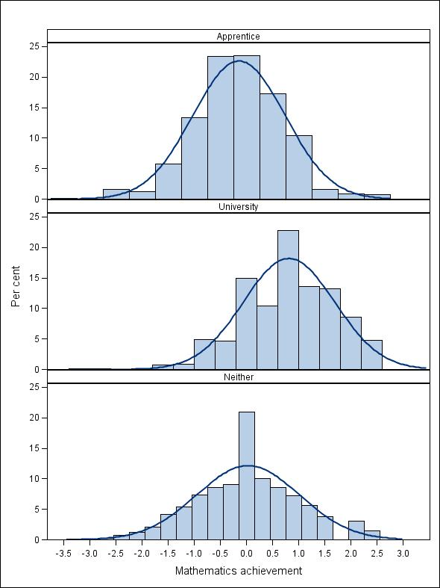

Figure 2 Distributions of reading achievement for 19-year-old males across the three options of: undertaking an apprenticeship, neither undertaking an apprenticeship nor going to university, and going to university, Y95 cohort

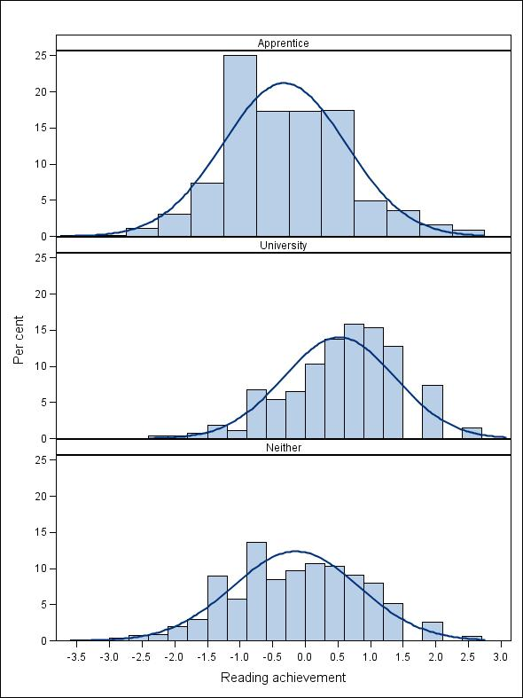

Figure 3 Distributions of socioeconomic status for 19-year-old males across the three options of: undertaking an apprenticeship, neither undertaking an apprenticeship nor going to university, and going to university, Y95 cohort

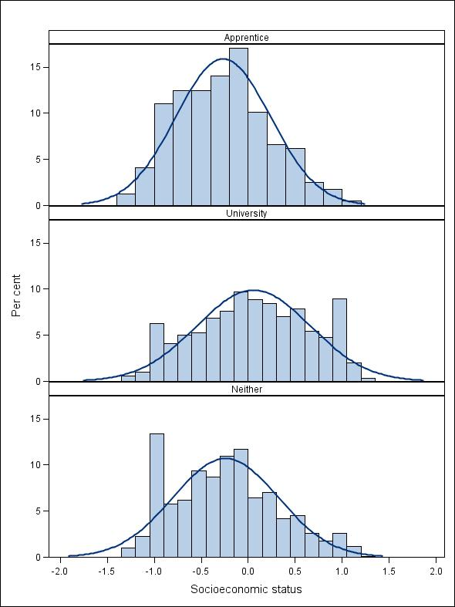

The observation from these graphs is that those attending university have higher average mathematics achievement than the other two groups. A further point is that mathematics achievement for the university group has a slightly smaller variation than the other two groups. However, there is a large degree of overlap in the distributions across all three groups, suggesting that at least to some extent university and apprenticeships are drawing on similar populations. This suggests that changes to the probability of going to university are likely to impact on the probability of undertaking an apprenticeship. From this it would seem likely that a change in university participation will impact on the distribution of apprentices over the mathematical achievement. Similar arguments apply to reading achievement and socioeconomic status.

The relationships between socioeconomic status and participation at university and undertaking an apprenticeship and socioeconomic status are weaker than for mathematics and reading achievement but in the same direction. While there are differences between the three groups, it is clear that there is considerable overlap.

The above distributions are descriptive and do not take into account factors other than academic achievement and socioeconomic status that impact on the probability of undertaking an apprenticeship or going to university. This is remedied in the next section.

# Statistical methodology

Our initial task is to test the assumption that going to university is the dominant decision for young people. In a statistical sense, this assumption says that the probability of undertaking an apprenticeship is affected by the probability of going to university more than the probability of undertaking an apprenticeship is influenced by the probability of going to university.

The methodology we employed to test this assumption was to fit the following statistical models:

* probability of going to university against explanatory background variables, without the probability of apprenticeships
* probability of going to university against explanatory background variables, with the probability of apprenticeship
* probability of undertaking an apprenticeship against explanatory background variables, without the probability of university
* probability of undertaking an apprenticeship against explanatory background variables, with the probability of university.

The explanatory variables were as in table 2.

Table 2 Variables used for predicting probability of going to university or undertaking an apprenticeship

|  |  |
| --- | --- |
| Variable | Levels |
| Cohort | Y95, Y06 |
| State | NSW, Vic., Qld, SA, WA, Tas., NT, ACT |
| Sector | Government, Private, Catholic |
| Employed at age 15 years | Yes, No |
| Year 12 aspiration (plan to complete Year 12) at age 15 | Yes, No, Undecided/unknown |
| Born outside Australia | Yes, No |
| Speaks a language other than English at home | Yes, No |
| Father is a trades worker | Yes, No, Unknown |
| SES | (continuous) |
| Trades workers concentration in home suburb1 | (continuous, mean-centred) |
| Normalised maths score | (continuous, mean-centred) |
| Normalised reading score | (continuous, mean-centred) |
| Probability of going to uni | For apprenticeship model |
| Probability of undertaking an apprenticeship | For university model |

1 Derived by linking census data from 1996 and 2006 on occupations by postcode. The variable is a mean centred version of percentage of the population in that postcode area employed in the trades.

We then compared these models using Akaike’s Information Criteria (AIC;[[3]](#footnote-3) Kutner et al. 2004). Models with smaller AICs are selected. The AICs for the models outlined above appear in table 3. (Details on the regression models are available from the authors on request.)

Table 3 AIC values for the four alternative models

|  |  |  |  |
| --- | --- | --- | --- |
| Model | AIC | Difference | Relative  difference (%) |
| 1a Probability of university without the probability of apprenticeships | 14 076 | - | - |
| 1b Probability of university with the probability of apprenticeship | 14 073 | 3 | 0.02 |
| 2a Probability of apprenticeship without the probability of university | 6 006 | - |  |
| 2b Probability of apprenticeship with the probability of university | 6 104 | 98 | 1.63 |

The criteria used in determining the importance of apprenticeships on university enrolment and vice versa is the relative size of the difference in AICs between the models. In particular, we note that the inclusion of apprentices in model 1b for university enrolment gives very little improvement in the fit of model 1a (0.02% change in AIC). However, when the probability of attending university is included in the apprenticeship model 2b, the improvement over the model without the probability of apprenticeships (2a) is substantially larger.

These results give credence to the assumption that going to university is the dominant decision for young people, over and above any arguments about the status of apprenticeships relative to going to university. Thus our modelling strategy is a two-stage procedure, whereby the estimated propensity for going to university (obtained from the first stage) is fed into the second stage, which models the probability of undertaking an apprenticeship. The idea is that, while going to university is endogenous, the predicted probability for going to university is not.

Having justified the underlying structure of the model, we first model the probability of going to university and then the probability of undertaking an apprenticeship, given the probability of going to university.

We model the likelihood of an individual going to university by wave 5; that is, by two years after completing Year 12 for the Y95 cohort and by age 19 years for the Y06 cohort. This model includes a range of background characteristics, including socioeconomic status, aspiration to complete Year 12, achievement scores and other background characteristics (table 2). The data from the two cohorts are pooled, and we include an intercept term for the cohort and interactions between the cohort and variables listed in table 4.

Table 4 Variables included in interactions with cohort dummy variable

|  |  |
| --- | --- |
| Interaction variable | Reason for inclusion |
| Sex | To see whether there is a difference in the increase in university uptake by males |
| Employed at age 15 | Workforce participation by high school students has increased |
| SES | To see whether there is a difference in the increase in university uptake by SES |
| Year 12 aspiration | General expectations for completing Year 12 may have changed in the decade between the cohorts |
| Father’s trades status | This is to see if there is any change in social mobility, at least as far as measured by occupation (trades vs white-collar jobs) |

Notable for their absence from table 4 are the interactions between the cohort and the two achievement variables. This is because we tested these interactions and found them not to be statistically significant at even the 0.15 level. That is, the probability of attending university increases as an individual’s achievement level increases, but this relationship has a similar pattern for both cohorts. The details of the final model are provided in tables C1 and C2.

We then model the likelihood that an individual will undertake an apprenticeship (also by wave 5) as a function of background characteristics and the probability of going to university, as predicted in the first step. This model also includes the cohort interactions outlined above, as well as the added interaction of the probability of going to university with the cohort. The coefficients of predicting apprenticeships are presented in table 5. The full details of the final model are in tables C3 and C4.

Table 5 Regression results for predicting apprenticeship: coefficients

| Variable | Level | Estimate | Wald Chi-Square | Pr > Chi-Square |
| --- | --- | --- | --- | --- |
| Intercept | - | -0.9394 | 47.2132 | <.0001 |
| Cohort | Y95 | Reference category | | |
|  | Y06 | 1.6366 | 65.8634 | <.0001 |
| Year 12 aspiration | No | Reference category | | |
|  | Undecided/unknown | -0.2919 | 4.466 | 0.0346 |
|  | Yes | -0.5144 | 12.398 | 0.0004 |
| Born outside Australia | No | Reference category | | |
|  | Yes | -0.649 | 15.5153 | <.0001 |
| Father is a trades worker | No | Reference category | | |
|  | Unknown | -0.2756 | 3.3044 | 0.0691 |
|  | Yes | 0.5709 | 29.2924 | <.0001 |
| Cohort\* Employed at age 15 | Y06|Yes | -0.3143 | 5.3445 | 0.0208 |
| Cohort\* Father in trades | Y06|Unknown | 0.0711 | 0.1318 | 0.7166 |
|  | Y06|Yes | -0.3225 | 4.1973 | 0.0405 |
| Cohort\* Yr 12 aspiration | Y06|Undecided/unknown | -0.2015 | 0.7991 | 0.3714 |
|  | Y06|Yes | -0.4467 | 3.8861 | 0.0487 |
| Cohort\* Propensity for university | Y06|(continuous) | -0.00807 | 0.0003 | 0.9866 |
| Cohort\* SES | Y06| (continuous) | 0.1037 | 0.5077 | 0.4761 |
| Normalised maths score | (continuous) 1 | 0.0852 | 2.245 | 0.134 |
| Normalised reading score | (continuous) 1 | 0.00953 | 0.032 | 0.858 |
| Trades workers concentration | (continuous) 1 | 0.0645 | 41.9864 | <.0001 |
| Propensity for university | (continuous) 2 | -3.462 | 48.3956 | <.0001 |
| SES | (continuous) 3 | 0.1193 | 1.3508 | 0.2451 |

Note 1 Variables are mean-centred.

2 Variable ranges from 0 to 1.

3 Population mean for SES is 0.

Our interest in table 5 lies in the sign and magnitude of the coefficients of the probability of university (p-value < 0.0001) and the interaction of probability of going to university and the cohort. The former is highly significant but the latter is not. This means that the impact of an expansion in university places (that is, an increased probability of going to university) has had an effect on the probability of undertaking an apprenticeship, but the relationship has not changed between the two cohorts. The cohort-achievement interactions were not statistically significant and were omitted from the model.

In this model, it is interesting to note that none of the mathematics, reading achievement or SES variables is significant at conventional levels.[[4]](#footnote-4) The closest is mathematics achievement, which is significant at the 0.15 level. This suggests that the impact of these variables is largely seen through the impact on the probability of going to university (which, as expected, is highly significant).

# Results

Our interest is in the relationship between academic achievement (and socioeconomic status) and the probability of undertaking an apprenticeship, and the role played by the probability of going to university. These relationships can be seen from the model results in tables C2 and C4, but it is useful to provide a graphical representation. Figures 5 and 6 have been developed for the Y95 cohort (noting that similar patterns are seen for the Y06 cohort). The unbroken lines in the figures present the probability of undertaking an apprenticeship in Y95 against the range of mathematics, reading achievement and SES values.[[5]](#footnote-5) They are obtained by predicting the probability of undertaking an apprenticeship for each individual, based on that individual’s background characteristics, including the estimated propensity of that individual going to university, and then averaging the data over individuals with, for example, a particular mathematics achievement score.

As can be seen from the figures, the probability of undertaking an apprenticeship declines with mathematics and reading achievement and with socioeconomic status.

However, one of the things we are interested in is how the probability of going to university affects the probability of undertaking an apprenticeship. We show this with the dotted lines, which are obtained by holding the probability of going to university at a constant. In each of these curves the probability of undertaking an apprenticeship now increases, illustrating the importance of university participation in the apprenticeship decision. From the actual models we saw that there was no significant relationship between the probability of undertaking an apprenticeship and achievement or socioeconomic status, once we have controlled for the probability of going to university. These graphs show that indeed there is a relationship, but it is seen through the relationship between achievement and socioeconomic status and the probability of going to university. So we see that the greatest difference between the unbroken and broken lines is at high levels of achievement and socioeconomic status, reflecting that the probability of going to university is high for individuals with those characteristics.

We note that the relationship between socioeconomic status and the probability of undertaking an apprenticeship (figure 5) is weaker than for the achievement variables. We also note that the impact of the probability of going to university is not so differentiated between high- and low-SES individuals, relative to high and low academic achievement.

Figure 4 Predicted probability of being an apprentice by achievement scores, Y95 males

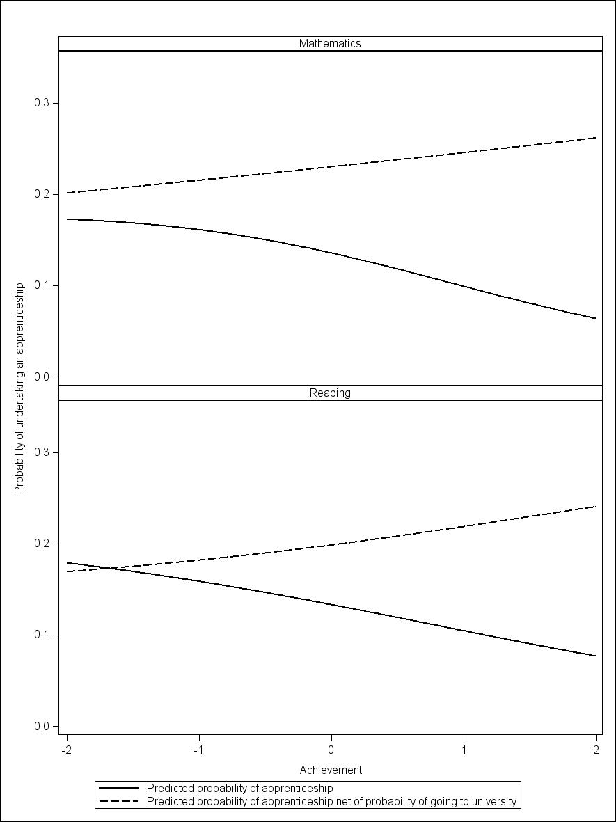

Note: Predictions are calculated using the average of the background characteristics. In particular, the probabilities are calculated for an individual with average reading or mathematics achievement and SES.

Figure 5 Predicted probability of being an apprentice by socioeconomic status, Y95 males

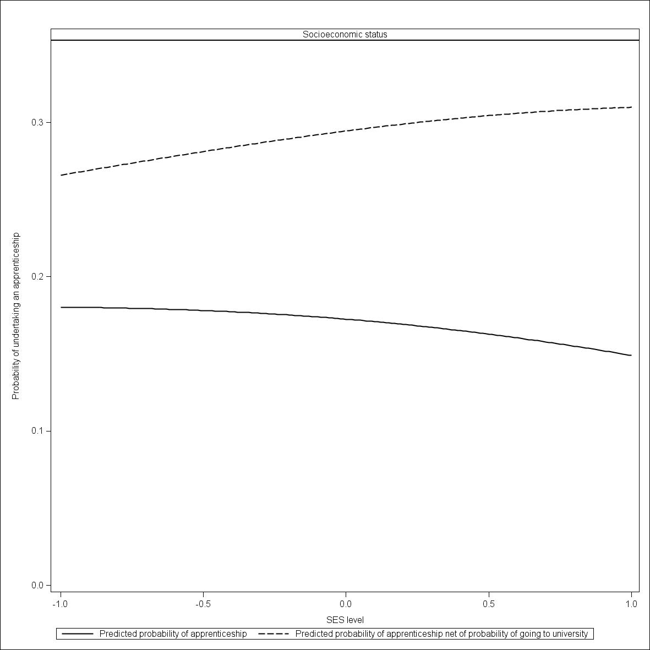

Note: Predictions are calculated using the average of the background characteristics. In particular, the probabilities are calculated for an individual with average mathematics and reading achievements.

We now look at the change in probabilities between the two cohorts, which is the essence of the paper. For each person in our sample the models enable us to calculate the probability of being an apprentice as if they were from the Y95 cohort; and the probability as if they were from the Y06 cohort. We also undertake the analogous calculation for the probability of going to university. In figures 6 to 8, we show the differences between the probabilities at the two points of time for the Y95 cohort.[[6]](#footnote-6) The calculations for the group undertaking neither an apprenticeship nor going to university (the ‘no study’ group) are obtained by subtraction (1—probability of undertaking an apprenticeship — probability of going to university).

Figure 6 Change in predicted probabilities by mathematics achievement scores, Y95 males

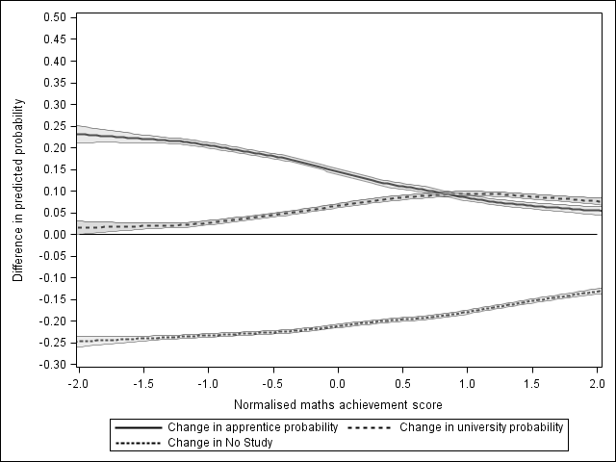

Figure 7 Change in predicted probabilities by reading achievement scores, Y95 males

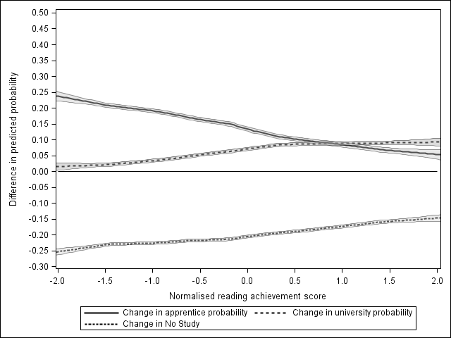

Figure 8 Change in predicted probabilities by socioeconomic status, Y95 males

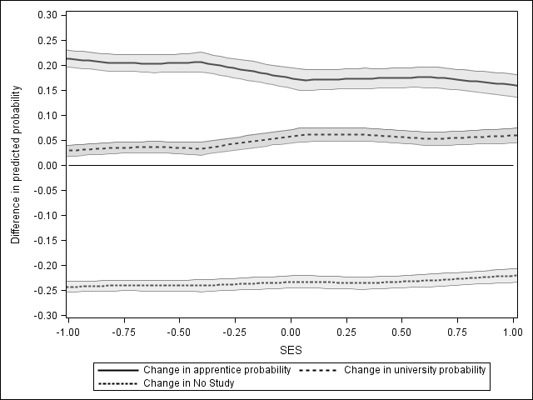

The figures show that the changes in probabilities are related to academic achievement and socioeconomic status (apart from the decline in the probability of neither undertaking an apprenticeship nor going to university, which is pretty constant in relation to socioeconomic status). As a generalisation, the increase in the probability of being an apprentice is less for those with higher academic achievement or higher SES scores, and the probability of going to university is correspondingly higher.

The first thing to note is that the probability of being an apprentice and going to university has increased over the whole range of mathematical ability. So part of the story is that undertaking an apprenticeship or going to university has been supply-constrained. If there were more apprenticeships, then it would be likely that the probability of becoming an apprentice would increase right across the academic ability range. The same is true for going to university, suggesting that the uncapping of university places will increase the number of individuals going to university who otherwise would have undertaken an apprenticeship.

The second thing to note is that the apprenticeship and university curves are in opposite directions. That is, an expansion in apprenticeships is likely to result in a greater increase in the probability of undertaking an apprenticeship among those of lower mathematical ability, while an expansion in university is likely to result in a greater increase in the probability of going to university for those with more mathematical ability. There is an upper bound here, with the increase in probability of going to university peaking at around 1.0 standard deviations. This is most likely a boundary effect, with the probability of going to university already very high for those of high achievement.

However, the impact of these changes in the probabilities on the distribution of apprentices and university students (and the remainder) across mathematics and reading achievement and socioeconomic status depends not only on these probabilities but the numbers of individuals in the relevant group at each achievement and SES level (with apprentices, university students and the remainder, respectively). Thus we also look at the *relative* change in probabilities (figures 9 and 10). The relative change is calculated as the change in probabilities between 1995 and 2006 divided by the predicted probability in 1995. For example, a value of 0.5 would indicate that the probability had increased by 50% between the two cohorts. Similarly a value of 0 indicates no change and a value of   
-0.5 would indicate a decline in the probability between the two cohorts.

From figure 9 we see that the relative increase in the probability of going to university or undertaking an apprenticeship is close to a constant across the range of mathematical achievement scores. If anything, the relative increase in the probability of undertaking an apprenticeship is a little higher at the higher achievement levels (and the relative increase in the probability of going to university a little lower).

When it comes to socioeconomic status (figure 10), we note that the relative changes show a negative slope for the probability of undertaking an apprenticeship and a positive slope for the probability of going to university. This indicates that, for apprenticeships, the growth has come more from individuals who have a lower-SES background, while the increase in the probability of going to university had been relatively higher for high-SES individuals. Given the increase in the probabilities of going to university or undertaking an apprenticeship, by definition the probability of doing neither has declined. What is interesting is that the decline is relatively large for high-SES individuals. Thus the source of the expansion in higher education, at least for high-SES individuals, is those who previously were neither going to university nor undertaking an apprenticeship.

Figure 9 Relative change in predicted probability between cohort 1 and cohort 2 of being an apprentice, going to university, or neither, by mathematics and reading achievement, calculated for Y95 sample

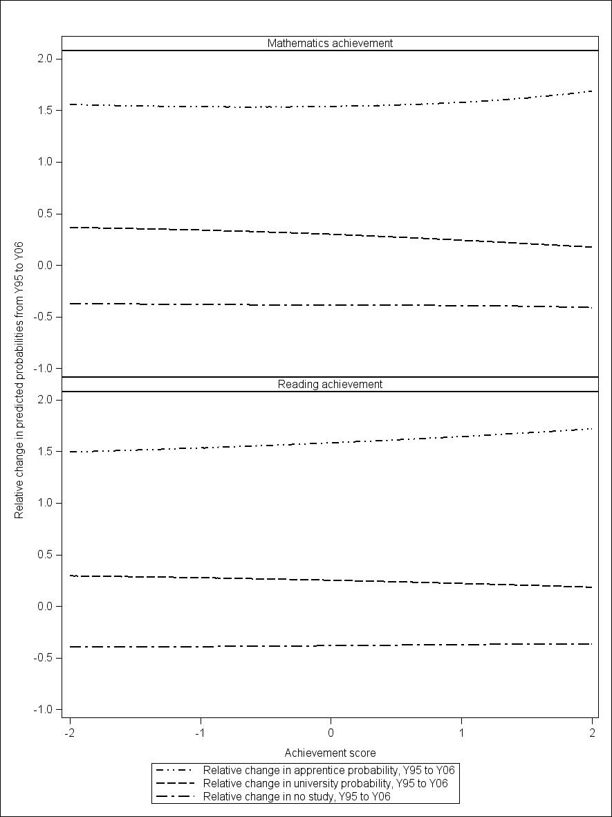

Figure 10 Relative change in predicted probability between cohort 1 and cohort 2 of being an apprentice, going to university, or neither, calculated for Y95 sample

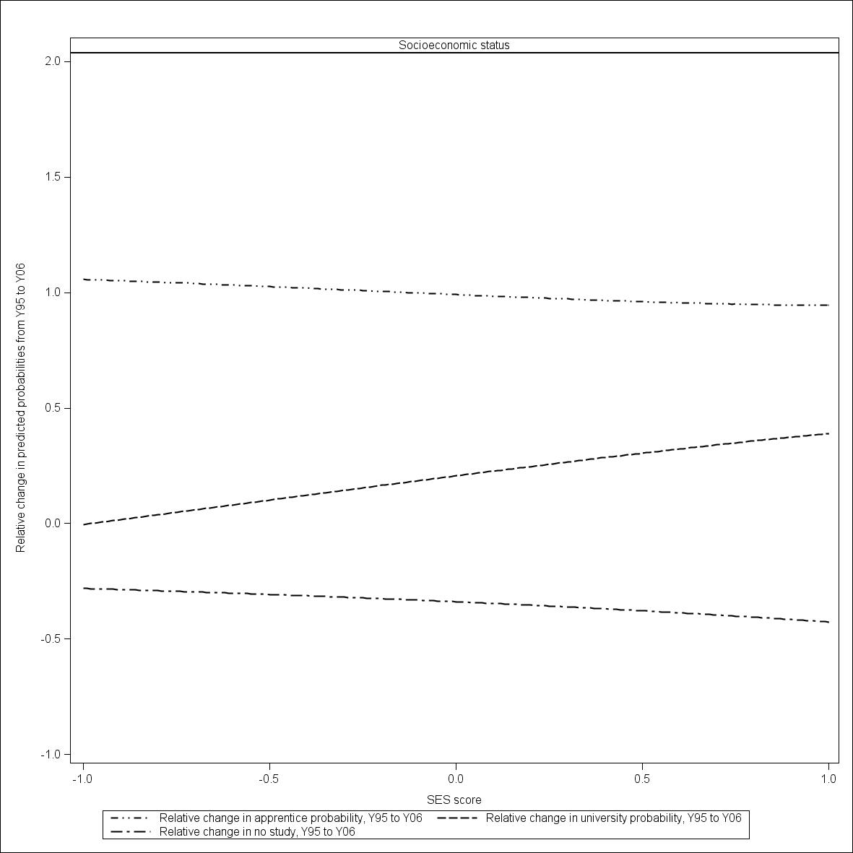

## 

## Discussion

We have seen that both the probability of undertaking an apprenticeship and the probability of going to university increased between the Y95 and Y06 cohorts. These increases have not been uniform and have varied by academic achievement and socioeconomic status. The implication of these relationships is that the expansion of the higher education sector is likely to have an impact on the quality and socioeconomic status of apprentices. However, the relationships also suggest that an expansion (or contraction) in apprenticeships will have an impact.

Our final task is to try to illustrate the magnitude of these effects. We do this by constructing a number of synthetic distributions, as follows:

* Our benchmark distribution is based on the predicted probabilities of being an apprentice and the probability of going to university for the Y95 cohort. These probabilities are converted into a distribution by aggregating them, conditional on academic achievement or socioeconomic status.[[7]](#footnote-7)
* Our first perturbation is to show what happens as the probability of being an apprentice increases (to the Y06 value) but keeping the probability of going to university at its Y95 value.
* Our second perturbation is to show what happens as the probability of going to university increases (to the Y06 value) but keeping the probability of being an apprentice at its Y95 value.
* Our final perturbation is to show what happens as the probability of going to university and the probability of being an apprentice increase to their Y06 level.

These synthetic distributions are constructed for undertaking an apprenticeship, going to university or doing neither.[[8]](#footnote-8) It should be noted that the first perturbation is degenerate for the ‘going to university’ distribution — for the simple reason that the probability of going to university does not depend on the probability of undertaking an apprenticeship.

The purpose of constructing these synthetic distributions is to convert the regression findings into distributions, the aim being to answer the question of how an expansion of university places is likely to impact on the ‘quality’ of apprentices and their distribution across socioeconomic status. The idea is that a comparison of the second perturbation with the benchmark distribution will show the impact of the increase in the probability of going to university in an ‘everything else equal’ world. This should give some indication of the likely impact of any future expansion. However, the first and final perturbations are also important because they show that ‘everything else equal’ is a strong assumption, and there may well be offsetting developments.

Figure 11 Synthetic distributions of apprentices across mathematics quintiles, all Y95 males

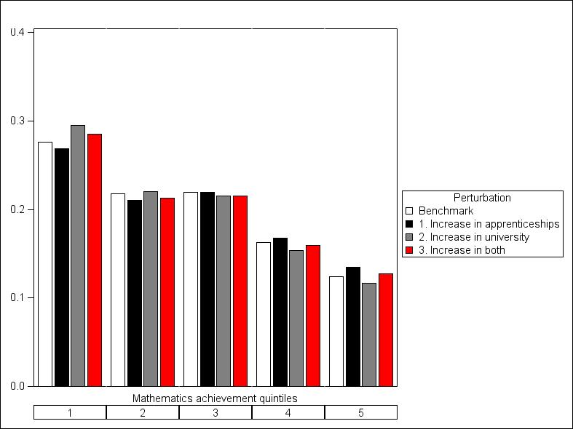

Figure 12 Synthetic distributions of apprentices across reading achievement quintiles, all Y95 males

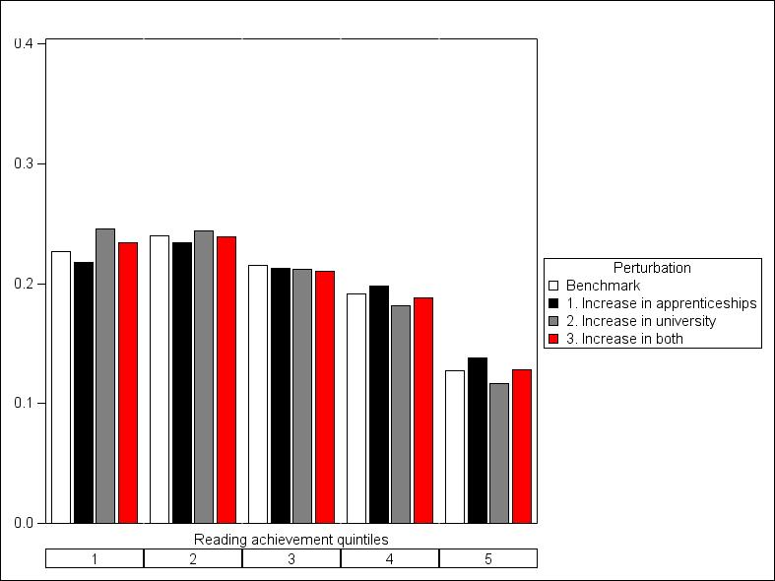

Figure 13 Synthetic distributions of apprentices across SES quintiles, all Y95 males

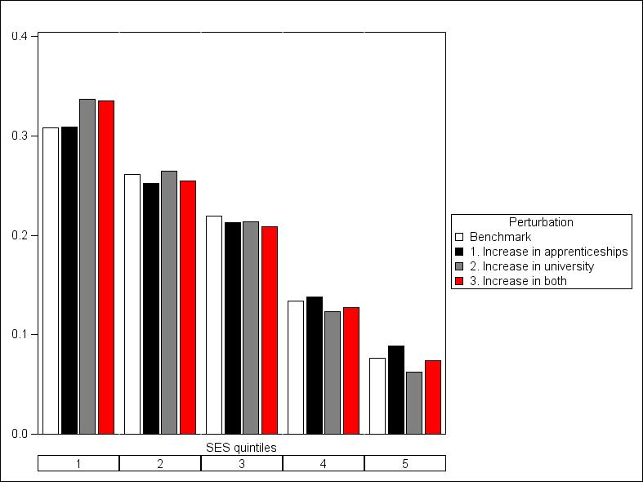

Figures 11 to 13 show how the expansion of access to university places and apprenticeships has changed the ‘quality’ of apprentices from Y95 to Y06. The first (white) columns show the ‘as-is’ in Y95, that is, the distribution (by mathematics, reading and SES) for apprentices in Y95. The second column (black) shows the impact on the distribution of achievement had we only seen an increase in the probability of undertaking an apprenticeship between Y95 and Y06. The third column (grey) shows the distribution of achievement/socioeconomic status had we only seen an increase in the probability of going to university. Finally, the red bars show the distribution accounting for both the increase in the probability of undertaking an apprenticeship and going to university.

We see that the expansion of university has led to a shift in distribution to the left (grey columns compared with the white ones). That is, there are fewer high academic achievement and high-SES apprentices and more low-achieving apprentices. However, looking at the black bars, we can see that an expansion in the number of apprentices only has the opposite effect; that is, a greater number of higher-achieving and high-SES apprentices. Taken together, expanding both university and apprentices between Y95 and Y06 shows a small decrease in the quality of apprentices, particularly through the greater participation in apprenticeships of individuals in the lower-quality quintiles.

In a similar way, we construct synthetic distributions for university participants (figures 14 to 16). However, for university, there are only two scenarios, the Y95 level and the increased Y06 university participation. (Changes to the probability of undertaking an apprenticeship have no influence on the probability of going to university.)

Figure 14 Synthetic distributions of those going to university across mathematics achievement quintiles, all Y95 males

Figure 15 Synthetic distributions of those going to university across reading achievement quintiles, all Y95 males

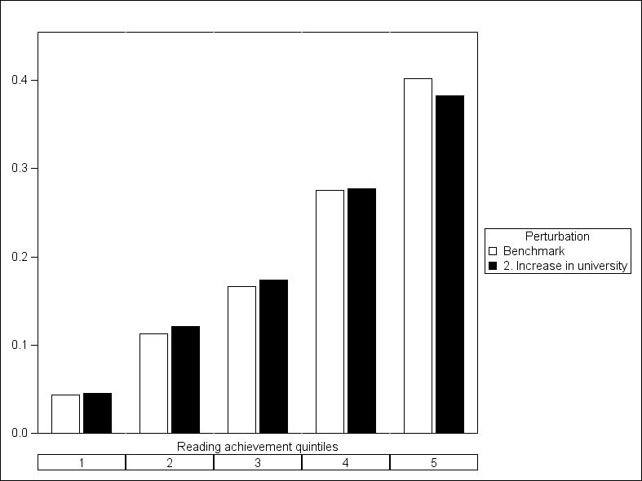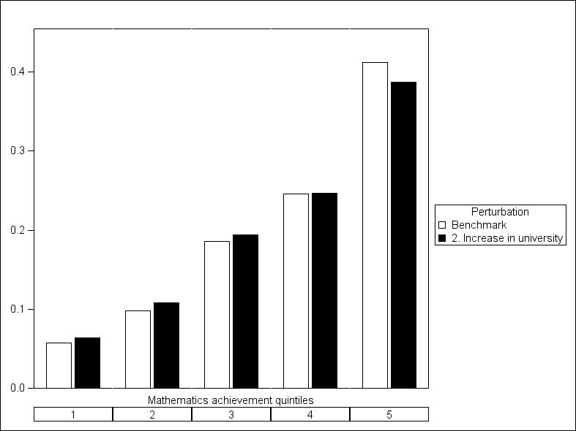

Figure 16 Synthetic distributions of those going to university across SES quintiles, all Y95 males

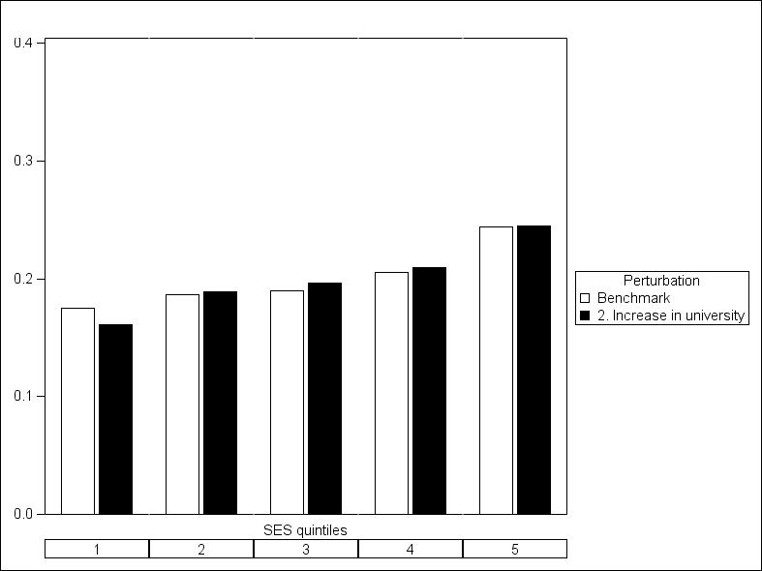

Again, we get a very consistent picture for the academic achievement distributions: the distribution of university students moves to the left, with relatively fewer high-achievement students (fifth quintile) and relatively more students from the middle and bottom quintiles. That is, with an expansion in university participation, the quality of the university cohort has also decreased between Y95 and Y06. The picture for the distribution by socioeconomic status is a little different. Here, there is a modest shift to the right, with relatively fewer students coming from the lowest-SES quintile after the increase in the probability of going to university.

Underlying these results is the fact that apprenticeships and going to university are not the only options for individuals: there is a large group doing neither. Thus, we complete the picture by conducting the mind experiment for the ‘neither’ group (figures 17—19).

Figure 17 Synthetic distributions of neither going to university nor undertaking an apprenticeship across mathematics achievement quintiles, Y95 males

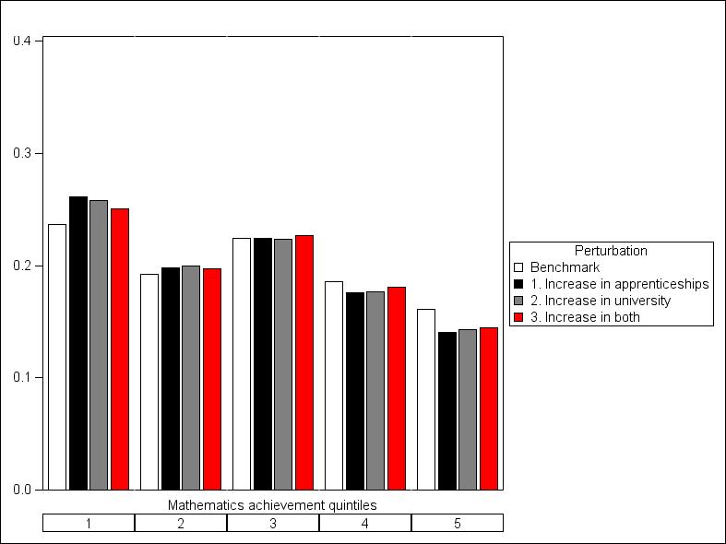

Figure 18 Synthetic distributions of neither going to university nor undertaking an apprenticeship across reading achievement quintiles, Y95 males

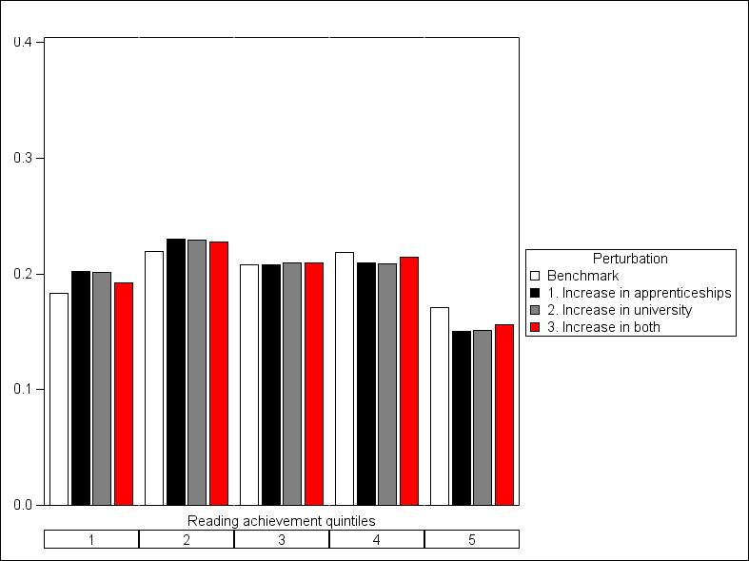

Figure 19 Synthetic distributions of neither going to university nor undertaking an apprenticeship across SES quintiles, Y95 males

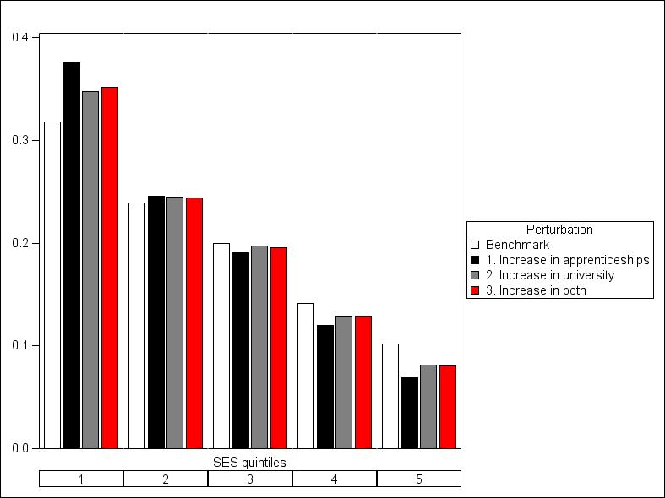

The results are again quite consistent, with a shift in the academic achievement distributions to the left, with a decline in the proportion of the ‘neither’ group in the top two quartiles and increases in the first two quintiles. The shift in the socioeconomic status distribution is also to the left. What is very noticeable is the strong (negative) relationship between socioeconomic status and neither going to university nor undertaking an apprenticeship, and this relationship has increased with an expansion in both higher education and apprenticeships.

The finding that it is the ‘neither’ group that is affected by an expansion in university participation is consistent with a quite different approach considered in Karmel and Lim (2013). Using LSAY data they predicted who goes to university, and then argued that an expansion in university participation would be most likely to affect those with a high probability of going to university but currently do not. Such individuals tended to be those neither going to university nor undertaking an apprenticeship and the group contained few apprentices. Their conclusion was that an expansion in higher education would have little effect on the socioeconomic distribution of apprentices.

# Final comments

The analysis has shown quite clearly that for males the probability of going to university does impact on the probability of undertaking an apprenticeship. We see that mathematics and reading achievement and socioeconomic status all play an important part, although there are a number of other characteristics that also impact on the probabilities. Moreover, the increase we observed between the 1995 and 2006 cohorts in the probability of going to university impacted on the quality of apprentices unambiguously: more apprentices come from the bottom two quintiles in relation to mathematics and reading achievement and socioeconomic status.

Of course, it is inappropriate to think of socioeconomic status as measuring quality. However, from an equity perspective, the analysis suggests that an expansion in the university sector had a negative effect on equity, with the distribution of apprentices shifting toward low-SES individuals and away from low-SES individuals in relation to going to university (although we acknowledge that this is a normative judgment, which privileges going to university over undertaking an apprenticeship). The reason for this relates to those who neither undertake an apprenticeship nor go to university.

The above comments are on ‘an everything else being equal’ basis. But everything else is not equal and indeed we observed a substantial increase in the probability of undertaking an apprenticeship between the two cohorts. If an expansion in university places didn’t occur, then an expansion in apprenticeships acts as a way to ‘improve’ the quality of apprentices in terms of mathematics and reading achievement. In this scenario, it also shows some increase in the proportion of apprentices coming from the top two SES quintiles.

It should be noted, however, that apprenticeships are quite different from university places. While the government can easily increase the latter, and has by uncapping undergraduate places, the former depends on the willingness of employers to offer them. This willingness primarily depends on the labour market and the opportunity it offers in terms of activity in the trades. When we think in these terms, there is a certain symmetry in the impact of expansion in both apprenticeships and university places. Those who are in the best position to take advantage of opportunities do so, regardless of whether position is measured by mathematics and reading achievement or socioeconomic status.

This phenomenon is also revealed in the distribution across socioeconomic status of those undertaking neither university nor an apprenticeship. An expansion in apprenticeships or university places leads to a concentration of those doing neither in the lower part of the SES distribution.

# References

Alloway, N, Dalley, L, Patterson, A, Walker, K & Lenoy, M 2004, *School students making education and career decisions: aspirations, attitudes and influences: final report*, Department of Education, Science and Training, Canberra.

Bradley, D, Noonan, P, Nugent, H & Scales, B 2008, *Review of higher education: final report*, Department of Education, Employment and Workplace Relations, Commonwealth of Australia, Canberra, viewed 20 December 2013, <[http://www.innovation.gov.au/highereducation/ResourcesAndPublications/ ReviewOfAustralianHigherEducation/Pages/ReviewOfAustralianHigherEducationReport.aspx](http://www.innovation.gov.au/highereducation/ResourcesAndPublications/%20ReviewOfAustralianHigherEducation/Pages/ReviewOfAustralianHigherEducationReport.aspx)>.

Cleveland, WS 1979, ‘Robust locally weighted regression and smoothing scatterplots’, *Journal of the American Statistical Association*, vol.74, no.368, pp.829—36.

Cleveland, WS, Devlin, SJ & Grosse, E 1988, ‘Regression by local fitting’, Journal of Econometrics, vol.37, pp.87—114.

Hooper, D, Coughlan, J & Mullen, MR 2008, ‘Structural equation modelling: guidelines for determining model fit’, *The Electronic Journal of Business Research Methods,* vol.6, no.1, pp.53—60, available online at <http://[www.ejbrm.com](http://www.ejbrm.com)>.

Karmel, T & Lim, P 2013, *Socioeconomic disadvantage and participation in tertiary education: preliminary thoughts*, NCVER, Adelaide.

Kutner, MH, Hachtsheim, CJ, Neter, J & Li, W 2005, *Applied linear statistical models*, 5th edn, ch.9, McGraw-Hill Irwin, New York.

Laming, M 2012, *The new inheritors: transforming young people’s expectations of university*, Sense Publishers, Rotterdam.

Lim, P 2011, *Weighting the LSAY Programme of International Student Assessment cohorts*, LSAY technical report 61, NCVER, Adelaide.

Lim, P & Gemici, S 2011*, Measuring the socioeconomic status of Australian youth*, NCVER, Adelaide.

Marks, G & Long, M 2000, *Weighting the 1995 Year 9 cohort sample for differential response rates and sample attrition,* LSAY technical paper 15, Australian Council for Educational Research, Melbourne.

Muthén, LK & Muthén, BO 1998—2011, *Mplus user’s guide*, 6th edn, Muthén & Muthén, Los Angeles.

Rothman, S 2009, *Estimating attrition bias in the Year 9 cohorts of the Longitudinal Surveys of Australian Youth*, LSAY technical paper 48, Australian Council for Educational Research, Melbourne.

# Appendix A: Description of the data used

The core of this study uses data from the Longitudinal Surveys of Australian Youth (LSAY), which are a series of longitudinal surveys covering the education, training and employment of young people aged 15—25 years. Each survey is called a cohort and is named after its commencing year, for example, the Y95 cohort started in 1995, and each year’s survey for a given cohort is called a wave. In this study we use data from the Y95 and Y06 cohorts, spaced roughly ten years apart, so we can see the study/ training choices of participants by wave 5, when they are approximately 19 years old.

The three most recent cohorts (Y03, Y06 and Y09) have been conducted in conjunction with the Programme of International Student Assessment (PISA) and are known collectively as PISA cohorts. All cohorts submit to, as part of their first wave, a test to measure general academic ability in mathematics and reading; however, the PISA cohorts and the earlier cohorts have different methodologies in testing the general underlying academic abilities of respondents.

## Attrition and weighting

Because LSAY consists of longitudinal surveys, they necessarily have to deal with attrition; that is, some participants leaving the survey. As a result, it is necessary to use weights in the analysis. A further complication is that attrition introduces a bias, in that those who leave the survey have characteristics skewed in certain directions. For example, it is well known that young people who have high achievement scores tend to stay in the survey longer (Lim 2011). This effect is largely accounted for by applying weights to the respondents in later waves. For details and discussion see Marks and Long (2000), Rothman (2009) and Lim (2010).

## Achievement scores

We are using two waves of the survey; these were conducted in slightly different ways. Aside from smaller issues such as coding occupations to different standards (see below), the major issue is that the achievement scores, corresponding to the reading and mathematics tests conducted in the first wave of each cohort, are not synchronised. To get around this we ranked and normalised the achievement scores, using the assumption that the underlying trait of academic ability has a normal distribution across the population. Denote by $a_{i}$ the academic achievement score (maths or reading) of the *i*th person. Let ${F(a}_{i})$ be the cumulative distribution, found by ranking people and scaling the rankings to lie between 0 and 1.

Then our measure of the underlying trait is ${z_{i}=Φ^{-1}F(a}_{i})$*,* where $Φ$ is the cumulative distribution of N(0,1).

## Deriving common variables

The two cohorts we use for this study were conducted almost independently from one another, even though they follow the same conceptual pattern. As a result, the structures of the two resulting datasets are not aligned, but there is an overlap in the information they capture. Some variables are identical and only need the levels to be renamed so as to coincide. Other variables need some regrouping on both sides so that the resulting variable is a common simplification of the original variables (for example, mother’s and father’s highest education). The common variables are detailed in table A1.

Table A1 Common variables for both cohorts

|  |  |
| --- | --- |
| Variable | Levels |
| Female | Yes, No |
| State | NSW, Vic., Qld, SA, WA, Tas., NT, ACT |
| Sector | Government, Private, Catholic |
| Employed at age 15 | Yes, No |
| Year 12 aspiration (plan to complete Year 12) at age 15 | Yes, No, Undecided/unknown |
| Born outside Australia | Yes, No |
| Speaks a language other than English at home | Yes, No |
| Father is employed in the trades | Yes, No, Unknown |
| Father’s highest education | University, Trade or technical qualification, Year 12,  Less than Year 12, Unknown |
| Mother’s highest education | University, Trade or technical qualification, Year 12,  Less than Year 12, Unknown |
| Father’s occupation | Manager, Professional, Associate professional, Trades worker, Clerical/service/sales worker, Blue collar worker, Unknown |
| Mother’s occupation | Manager, Professional, Associate professional, Trades worker, Clerical/service/sales worker, Blue collar worker, Unknown |
| Trades workers concentration in home suburb | (continuous, mean-centred) |
| Normalised maths score | (continuous, mean-centred) |
| Normalised reading score | (continuous, mean-centred) |

The variable relating to trades workers concentration deserves a mention, as it is derived by linking census data from 1996 and 2006 to occupations by postcode. The variable here is a mean-centred version of the percentage of the population in that postcode area who is employed in the trades. The other common variable we derive is an SES measure, detailed in the next section.

## Derivation of an socioeconomic status measure

There is no common measure of socioeconomic status between the two cohorts we are using, but there are a number of variables that *are* common, and are known to be proxies for SES, namely, parental occupation and education, for mother and father separately (Lim & Gemici 2011). There are other variables available in each of the cohorts separately that are measures of SES, such as occupational prestige in Y06, but none that could be found in both.

We used the software package Mplus (Muthén & Muthén 1998) to run Confirmatory Factor Analysis to extract a numeric measure of socioeconomic status as far as it is measured by the variables of parental occupation and parental highest education (Lim & Gemici 2011). Our measures of parental occupation and education are a synthesis of the available variables from the Y95 and Y06 cohorts, as outlined in table A2.

Table A2 Correlation matrix

|  |  |  |  |  |
| --- | --- | --- | --- | --- |
|  | Mother’s education | Father’s education | Father’s occupation | Mother’s occupation |
| Mother’s education |  |  |  |  |
| Father’s education | 0.553 |  |  |  |
| Father’s occupation | -0.191 | -0.317 |  |  |
| Mother’s occupation | -0.422 | -0.219 | 0.325 |  |

Table A3 contains model fit information. In our analysis we use the Root Mean Square Error of Approximation (RMSEA), and the Comparative Fit Index (CFI) as fit statistics, both of which are given by a number in the range 0 to 1. The former measures the difference between the expected model (in our case that parental education and occupation load onto socioeconomic status) and the observed data. The latter is a measure of how the model compares with one with no relationships between the variables. The high value of the CFI (close to 1) indicates that the continuous variable is a good fit to the discrete data, whereas the estimate of RMSEA of approximately 0.17 indicates a relatively poor fit, as it should be roughly less than 0.06, suggested by Hooper, Coughlan and Mullen (2008) as a good model fit.

Table A3 Model fit information

|  |  |  |  |  |  |  |  |
| --- | --- | --- | --- | --- | --- | --- | --- |
| Chi-square | |  | RMSEA | |  | CFI | |
| Value | 858.918\* |  | Estimate | 0.168 |  | Value | 0.929 |
| Degrees of freedom | 2 |  | 90% confidence interval | 0.159–0.178 |  |  |  |
| p-value | 0.0000 |  | Prob(RMSEA<0.05) | 0.000 |  |  |  |

We note that the chi-squared p-value is extremely small — undesirable in general — and is solely due to the large sample size, rather than a poor reflection on our measure.

Table A4 contains R-squared values for the discrete variables that load onto the SES measure, and we can see that parental education is the main driver for the measure we have constructed.

Table A4 R-squared

|  |  |  |  |  |  |
| --- | --- | --- | --- | --- | --- |
| Observed variable | Estimate | S.E. | Est./S.E. | Two-tailed  p-value | Residual variance |
| Mother’s education | 0.589 | 0.013 | 43.811 | 0.000 | 0.411 |
| Father’s education | 0.435 | 0.012 | 36.676 | 0.000 | 0.565 |
| Father’s occupation | 0.196 | 0.008 | 24.792 | 0.000 | 0.804 |
| Mother’s occupation | 0.284 | 0.009 | 32.112 | 0.000 | 0.716 |

# Appendix B: Models

Our particular interest is the impact of participation in higher education on the decision to take an apprenticeship. We operationalise this by predicting for each person the probability of going to university; we then look at the relationship between whether an individual takes up an apprenticeship and his or her probability of going to university. If apprenticeships and university study are interchangeable, then there will be a negative relationship. If they are not, there will be no relationship. The latter possibility is unlikely, but the strength of the relationship may well depend on the characteristics of the individual, particularly their academic achievement at school.

Let $X_{i}$ represent the vector of background characteristics (shown in table A1) and ${p(u)}_{i}$ the probability of going to university by wave 5 for the *i*th individual. We use a logistic model such that

$$ln\frac{{p(u)}_{i}}{1-{p(u)}_{i}}=X_{i}β+error term (1)$$

Table B1 Variables used for regression predicting university attendance by wave 5

|  |  |
| --- | --- |
| Variable | Levels |
| Cohort | Y95, Y06 |
| State | NSW, Vic., Qld, SA, WA, Tas., NT, ACT |
| Sector | Government, Private, Catholic |
| Employed at age 15 | Yes, No |
| Year 12 aspiration (plan to complete Year 12) at age 15 | Yes, No, Undecided/unknown |
| Born outside Australia | Yes, No |
| Speaks a language other than English at home | Yes, No |
| Father is a trades worker | Yes, No, Unknown |
| SES | (continuous) |
| Trades workers concentration in home suburb | (continuous, mean-centred) |
| Normalised maths score | (continuous, mean-centred) |
| Normalised reading score | (continuous, mean-centred) |

Denote by $\hat{β}$ our estimate of $β$. Then the prediction of the log odds of going to university is $X\hat{β}$. We can thus derive the probability for the *i* th individual to attend university by wave 5; denote this as ${\hat{p(u)}}_{i}$. The results of this regression are shown in table B2.

We now look at the impact of ${\hat{p(u)}}_{i}$ on the probability of commencing an apprenticeship, again using a logistic model:

$$\log{\frac{{p(a)}_{i}}{1-{p(a)}_{i}}}=γ_{0}+ γ_{1}{\hat{p(u)}}_{i}+γ_{2}{\hat{p(u)}}_{i}^{2}+Y_{i}μ (2)$$

Where *Y* is a vector of the characteristics which might affect the uptake of an apprenticeship, detailed in table B1. The squared term allows for flexibility in the relationship between university participation and the uptake of an apprenticeship. However, the coefficient for this term turned out to be non-significant, so it was dropped from the final model.

Table B2 Variables used for regression predicting apprenticeship by wave 5

|  |  |
| --- | --- |
| Variable | Levels |
| Cohort | Y95. Y06 |
| Employed at age 15 | Yes, No |
| Year 12 aspiration (plan to complete Year 12) at age 15 | Yes, No, Undecided/unknown |
| Born outside Australia | Yes, No |
| Father is a trades worker | Yes, No, Unknown |
| SES | (continuous) |
| Trades workers concentration in home suburb | (continuous, mean-centred) |
| Normalised maths score | (continuous, mean-centred) |
| Normalised reading score | (continuous, mean-centred) |
| Propensity to attend university | (continuous, ranges 0 to 1) |

The results of this regression are shown in tables C3 and C4.

Given these models, we can make out-of-sample estimates for the Y95 cohort, by changing the cohort variable’s value from ‘Y95’ to ‘Y06’, running the university model first to find the out-of-sample probability ${\hat{p\left(u\right)}}_{i}^{Y06}$, then the apprentice model to get ${\hat{p\left(a\right)}}_{i}^{Y06}$. Heuristically, this considers what might happen to the apprentices from the Y95 cohort if they had been in the Y06 cohort, and we can see the shift in the likelihood of their becoming an apprentice, as well as the shift in likelihood of attending university.

# Appendix C: Regression results

Appendix C gives the results of the regression models described in appendix B.

Table C1 Regression results for predicting university attendance: model fit statistics and type III analysis of effects

|  |  |  |  |  |
| --- | --- | --- | --- | --- |
| Test | Chi Sq | DF | | Prob Chi square |
| Likelihood ratio | 5477.3569 | 29 | | <.0001 |
| Score | 4503.5922 | 29 | | <.0001 |
| Wald | 3063.6437 | 29 | | <.0001 |
| Criterion | Intercept only | | Intercept and covariates | |
| AIC | 19494.986 | | 14075.629 | |
| SC | 19502.582 | | 14303.501 | |
| -2 Log L | 19492.986 | | 14015.629 | |
| R-square | 0.311 | Max-rescaled  R-square | | 0.4235 |
|  | Type III analysis of effects | | |  |
| Effect | DF | Wald Chi square | | Prob Chi square |
| Cohort | 1 | 1.9539 | | 0.1622 |
| Sector | 2 | 157.3062 | | <.0001 |
| State | 7 | 75.1444 | | <.0001 |
| Employed at age 15 | 1 | 23.6005 | | <.0001 |
| Year 12 aspiration | 2 | 154.1692 | | <.0001 |
| Born outside Australia | 1 | 24.9922 | | <.0001 |
| Speaks a language other than English  at home | 1 | 159.5105 | | <.0001 |
| Father is a trades worker | 2 | 15.3116 | | 0.0005 |
| Sex | 1 | 100.1528 | | <.0001 |
| Cohort\*Sex | 1 | 0.1747 | | 0.6759 |
| Cohort\*Employed at age 15 | 1 | 9.7613 | | 0.0018 |
| Cohort\*Father in trades | 2 | 13.7262 | | 0.001 |
| Cohort\*SES | 1 | 9.2715 | | 0.0023 |
| Cohort\*Yr 12 aspiration | 2 | 36.7929 | | <.0001 |
| Normalised maths score | 1 | 495.71 | | <.0001 |
| Normalised reading score | 1 | 226.4153 | | <.0001 |
| Trades workers concentration | 1 | 62.5652 | | <.0001 |
| SES | 1 | 56.7256 | | <.0001 |

Table C2 Regression results for predicting university attendance: coefficients

| Variable | Level of variable | Coefficient | Wald Chi-Square | Pr > Chi-Square |
| --- | --- | --- | --- | --- |
| Intercept | - | -3.6692 | 172.6174 | <.0001 |
| Cohort | Y95 | Reference category | | |
|  | Y06 | 0.5969 | 1.9539 | 0.1622 |
| Sector | Government | Reference category | | |
|  | Catholic | 0.5864 | 134.5219 | <.0001 |
|  | Independent | 0.463 | 55.3531 | <.0001 |
| State | ACT | -0.4426 | 8.7533 | 0.0031 |
|  | NSW | Reference category | | |
|  | NT | -0.4966 | 3.3691 | 0.0664 |
|  | Qld | 0.0615 | 1.0005 | 0.3172 |
|  | SA | 0.034 | 0.1696 | 0.6804 |
|  | Tas. | -0.1961 | 1.862 | 0.1724 |
|  | Vic. | 0.3457 | 38.6054 | <.0001 |
|  | WA | -0.1087 | 1.939 | 0.1638 |
| Employed at age 15 | No | Reference category | | |
|  | Yes | -0.3251 | 23.6005 | <.0001 |
| Year 12 aspiration | No | Reference category | | |
|  | Undecided/unknown | 1.5968 | 31.2386 | <.0001 |
|  | Yes | 2.373 | 73.3971 | <.0001 |
| Born outside Australia | No | Reference category | | |
|  | Yes | 0.3908 | 24.9922 | <.0001 |
| Speaks a language other  than English at home | No | Reference category | | |
|  | Yes | 0.9936 | 159.5105 | <.0001 |
| Father is a trades worker | No | Reference category | | |
|  | Unknown | -0.0962 | 0.9456 | 0.3309 |
|  | Yes | -0.2881 | 15.2495 | <.0001 |
| Sex | Male | Reference category | | |
|  | Female | 0.5729 | 100.1528 | <.0001 |
| Cohort\*Sex | Y06|Female | 0.0355 | 0.1747 | 0.6759 |
| Cohort\*Employed at age 15 | Y06|Yes | 0.2911 | 9.7613 | 0.0018 |
| Cohort\*Father in trades | Y06|Unknown | -0.4324 | 11.1471 | 0.0008 |
|  | Y06|Yes | 0.104 | 0.8304 | 0.3622 |
| Cohort\*Yr 12 aspiration | Y06|Undecided/unknown | -1.186 | 6.6166 | 0.0101 |
|  | Y06|Yes | -0.0411 | 0.0093 | 0.9231 |
| Cohort\*SES | Y06| (continuous) | 0.2457 | 9.2715 | 0.0023 |
| Normalised maths score | (continuous)1 | 0.6886 | 495.71 | <.0001 |
| Normalised reading score | (continuous)1 | 0.4607 | 226.4153 | <.0001 |
| Trades workers concentration | (continuous)1 | -0.0479 | 62.5652 | <.0001 |
| SES | (continuous)2 | 0.3979 | 56.7256 | <.0001 |

Note: 1 Variables are mean-centred.

2 Population mean for SES is 0.

Table C3 Regression results for predicting apprenticeship: model fit statistics and type III analysis of effects

|  |  |  |  |  |
| --- | --- | --- | --- | --- |
| Test | Chi Sq | DF | | Prob Chi square |
| Likelihood ratio | 1237.6157 | 19 | | <.0001 |
| Score | 1226.5376 | 19 | | <.0001 |
| Wald | 918.1411 | 19 | | <.0001 |
| Criterion | Intercept only | | Intercept and covariates | |
| AIC | 7205.208 | | 6005.592 | |
| SC | 7212.063 | | 6142.697 | |
| -2 Log L | 7203.208 | | 5965.592 | |
| R-square | 0.1618 | Max-rescaled R-square | | 0.252 |
|  | Type III analysis of effects | | |  |
| Effect | DF | Wald Chi square | | Prob Chi square |
| Cohort | 1 | 65.8634 | | <.0001 |
| Employed at age 15 | 1 | 31.916 | | <.0001 |
| Year 12 aspiration | 2 | 12.4285 | | 0.002 |
| Born outside Australia | 1 | 15.5153 | | <.0001 |
| Father is a trades worker | 2 | 40.4882 | | <.0001 |
| Cohort\*Employed at age 15 | 1 | 5.3445 | | 0.0208 |
| Cohort\*Father in trades | 2 | 5.0941 | | 0.0783 |
| Cohort\*Yr 12 aspiration | 2 | 4.2111 | | 0.1218 |
| Cohort\*Propensity for university | 1 | 0.0003 | | 0.9866 |
| Cohort\*SES | 1 | 0.5077 | | 0.4761 |
| Normalised maths score | 1 | 2.245 | | 0.134 |
| Normalised reading score | 1 | 0.032 | | 0.858 |
| Trades workers concentration | 1 | 41.9864 | | <.0001 |
| Propensity for university | 1 | 48.3956 | | <.0001 |
| SES | 1 | 1.3508 | | 0.2451 |

Table C4 Regression results for predicting apprenticeship: coefficients

| Variable | Level | Estimate | Wald Chi-Square | Pr > Chi-Square |
| --- | --- | --- | --- | --- |
| Intercept | - | -0.9394 | 47.2132 | <.0001 |
| Cohort | Y95 | Reference category | | |
|  | Y06 | 1.6366 | 65.8634 | <.0001 |
| Year 12 aspiration | No | Reference category | | |
|  | Undecided/unknown | -0.2919 | 4.466 | 0.0346 |
|  | Yes | -0.5144 | 12.398 | 0.0004 |
| Born outside Australia | No | Reference category | | |
|  | Yes | -0.649 | 15.5153 | <.0001 |
| Father is a trades worker | No | Reference category | | |
|  | Unknown | -0.2756 | 3.3044 | 0.0691 |
|  | Yes | 0.5709 | 29.2924 | <.0001 |
| Cohort\* Employed at age 15 | Y06|Yes | -0.3143 | 5.3445 | 0.0208 |
| Cohort\* Father in trades | Y06|Unknown | 0.0711 | 0.1318 | 0.7166 |
|  | Y06|Yes | -0.3225 | 4.1973 | 0.0405 |
| Cohort\* Yr 12 aspiration | Y06|Undecided/unknown | -0.2015 | 0.7991 | 0.3714 |
|  | Y06|Yes | -0.4467 | 3.8861 | 0.0487 |
| Cohort\* Propensity for university | Y06|(continuous) | -0.00807 | 0.0003 | 0.9866 |
| Cohort\* SES | Y06| (continuous) | 0.1037 | 0.5077 | 0.4761 |
| Normalised maths score | (continuous) 1 | 0.0852 | 2.245 | 0.134 |
| Normalised reading score | (continuous) 1 | 0.00953 | 0.032 | 0.858 |
| Trades workers concentration | (continuous) 1 | 0.0645 | 41.9864 | <.0001 |
| Propensity for university | (continuous) 2 | -3.462 | 48.3956 | <.0001 |
| SES | (continuous) 3 | 0.1193 | 1.3508 | 0.2451 |

Note 1 Variables are mean centred.

2 Variable ranges from 0 to 1.

3 Population mean for SES is 0.

1. By an apprentice we mean an apprentice or trainee in a trades occupation. To simplify matters, and to acknowledge the domination of males in the trades, we consider only males. [↑](#footnote-ref-1)
2. Our intention had been to use cohorts further apart, but data availability precluded this. [↑](#footnote-ref-2)
3. AICp = n.ln(SSEp)-n.ln(n) + 2p. [↑](#footnote-ref-3)
4. This implies that academic achievement at age 15 years and individual SES don’t have an impact on the probability of undertaking an apprenticeship after considering the impact they have on the probability of undertaking university. [↑](#footnote-ref-4)
5. The curves are local regression lines, also known as LOESS plots (Cleveland 1979; Cleveland, Devlin & Grosse 1988), which are generated by taking the weighted mean of the y-variable over a narrow interval on the x axis. [↑](#footnote-ref-5)
6. As in figures 5 and 6 these are LOESS plots. [↑](#footnote-ref-6)
7. The aggregation is over a quintile. This gives the expected number of individuals in the quintile. The distribution is then obtained by dividing by the expected total number of individuals across the five quintiles. [↑](#footnote-ref-7)
8. The ‘doing neither’ probabilities are derived from the other two (the three probabilities add to one for an individual). [↑](#footnote-ref-8)