

**When one door closes:**

**VET’s role in helping displaced**

**workers find jobs**

Bridget Wibrow and Michelle Circelli

NATIONAL CENTRE FOR VOCATIONAL EDUCATION RESEARCH

This *At a glance* brings together findings from research commissioned by the National Centre for Vocational Education Research (NCVER) that investigates the concept of skills transferability between declining and growing occupations. Key points highlighted at the national research forum ‘When one door closes: VET’s role in re-skilling displaced workers’, hosted by NCVER in November 2015, are also addressed.

All the work presented in this *At a Glance* highlight the critical role vocational education and training (VET) can play in helping retrenched workers find new jobs. In particular, the research on skills transferability, undertaken by Dr Darryn Snell, Dr Victor Gekara and Dr Krystle Gatt, demonstrates the potential benefit cross-occupational skills transfer can have in mediating the impact of job loss. Here, cross-occupational skills transfer refers to situations where workers can use the skills from their current job to find work in a completely different job without the need for further significant upskilling or re-skilling.

**HIGHLIGHTS**

* Greater effort is required to help workers identify and understand their transferable skills in order to find alternative employment; this is a role that support workers can play.
* Improved knowledge of local labour markets can help to more accurately identify potential job opportunities, or areas for retraining displaced workers.
* P:\PublicationComponents\logos\NCVER LOGOS\Print\NCVER_CMYK.wmfWithin the VET sector, an occupational cluster framework approach could be applied to training packages, which would enable units of competency to be more readily shared across occupations. In turn, it would allow for greater mobility between jobs.

**INTRODUCTION**

**A door closes…**

Changing economic conditions, brought about by factors such as fluctuations in financial markets, natural disasters and changes to the terms of trade, impact on the viability of industries. In some instances, it can result in company closures in turn leading to mass job loss.

Losing one’s job, or the prospect of losing a job, is a major stressor for any individual. At such times, people generally take stock of their skills and expertise so that they can look for new employment with some confidence. However, some individuals may struggle to either identify the skills they have, and/or place those skills in another occupational context.

It is in these situations where vocational education and training may have a role.



# DISPLACED WORKERS: WHERE ARE THEY?

The 2015 Australian Industry Report highlights that the 2014-15 financial year marked 24 years of consecutive economic growth, but that growth is slowing (Department of Industry, Innovation & Science 2015). For some sectors the slowing down has had a significant impact on jobs.

Motor vehicle manufacturing is widely recognised as a sector in decline in Australia with General Motors Holden, the Ford Motor Company of Australia and the Toyota Motor Corporation Australia all ceasing car manufacturing in Australia by 2017. Estimates of the total number of jobs lost and not created due to these closures have been put at just under 200 000 jobs nationally, indicating the significance of this manufacturing sector to Australia (Barbaro, Spoehr & National Institute of Economic and Industry Research 2014).

While these closures attract a lot of media interest due to the number of workers affected, there are other manufacturing sectors that have also suffered notable job losses in recent years such as the textile, leather, clothing and footwear manufacturing sector and the food product manufacturing

sector (ABS 2015a). Other industries affected include information media and telecommunications, wholesale trade and retail trade (ABS 2015b).

On the other hand, the fastest growing industry is health care and social assistance (ABS 2015b). As highlighted at the forum however, the skills acquired and used in other industries or sectors, such as manufacturing, may not easily transfer to the health care and social assistance industry.

## But not all doors are closed…

Declining industries contain a variety of occupations, and not all are necessarily at risk of diminishing along with the industry. Through their analysis of 2006 and 2011 Census data, Snell, Gekara & Gatt (2016) identified particular occupations that were either in decline or growing. They established significant job loss among livestock farmers, crop farm workers, sewing machinists and product assemblers, all within either the agriculture and forestry industry or manufacturing. However, the occupation to endure the most decline within this time period—in terms of actual jobs lost—was secretaries (-30 234), which is not within a declining industry (see table 1). Many functions previously performed by secretaries such as typing, filing and data entry are now either computerised or absorbed by individual workers as a part of their role.

Registered nurses, aged and disabled carers and child carers were some of the fastest growing occupations in Australia along with chefs, checkout operators and office cashiers, general sales assistants and fast food cooks. These results accord with research published by the Committee for Economic Development

### Manufacturing, information media and telecommunications, wholesale and retail

**trade have all had**

**notable job losses in**

**recent years.**

**40% of jobs in**

**Australia are likely to be highly susceptible to**

**computerisation and automation in the near future.**

of Australia in 2015 which found that 40% of jobs in Australia are likely to be highly susceptible to computerisation and automation in the near future. Durrant-Whyte et al. (2015) highlighted administration jobs and those in some services are particularly susceptible, whereas jobs in personal service areas, technical and creative industries and the professions are the least susceptible to computerisation and automation.

### Table 1 Occupational growth and decline by skill levels, 2006, 2011

**Skill   
level 1**

|  |  |  |  |  |  |
| --- | --- | --- | --- | --- | --- |
|  | **Occupation** | *Persons* | *Persons* | *Difference* | *%* |
|  | *employed*  *2006* | *employed*  *2011* | *in persons*  *employed 2006-11* | *change*  *2006-11* |
| Registered nurses | 172 565 | 206 916 | 34 351 | 19.9% |
| Growing | Accountants | 123 373 | 138 298 | 14 925 | 12.1% |
|  | ICT managers | 29 964 | 42 451 | 12 487 | 41.7% |
|  | Mixed crop and livestock farmers | 41 349 | 34 724 | -6 625 | -16.0% |
| Declining | Livestock farmers | 83 804 | 75 113 | -8 691 | -10.4% |
|  | Corporate services managers | 21 804 | 7 365 | -14 439 | -66.2% |
|  | Contract, program and project administrators | 83 902 | 104 658 | 20 756 | 24.7% |
| Growing | Office managers | 92 274 | 108 230 | 15 956 | 17.3% |
|  | Architectural, building and | 34 601 | 49 236 | 14 635 | 42.3% |

**Skill level 2**

surveying technicians

|  |  |  |  |  |
| --- | --- | --- | --- | --- |
| Electronic engineering draftspersons and technicians | 5 253 | 4 569 | -684 | -13.0% |
| Enrolled and mothercraft nurses | 19 396 | 17 892 | -1 504 | -7.8% |
| Safety inspectors | 5 844 | 3 365 | -2 479 | -42.4% |
| Electricians | 90 242 | 110 713 | 20 471 | 22.7% |
| Chefs | 44 552 | 57 613 | 13 061 | 29.3% |

Declining

**Skill level**

Growing

Carpenters and joiners 87 032 98 249 11 217 12.9%

|  |  |  |  |  |  |
| --- | --- | --- | --- | --- | --- |
| Telecommunications trades 19 128 16 709 -2 419 -12.6% | | | | | |
| **3** | workers |  |  |  |  |

Declining

|  |  |  |  |  |
| --- | --- | --- | --- | --- |
| Printers | 15 312 | 12 498 | -2 814 | -18.4% |
| Secretaries | 94 403 | 64 169 | -30 234 | -32.0% |
| Aged and disabled carers | 77 413 | 108 215 | 30 802 | 39.8% |
| General clerks | 206 292 | 236 382 | 30 090 | 14.6% |
| Child carers | 85 258 | 107 926 | 22 668 | 26.6% |
| Credit and loans officers | 24 346 | 22 133 | -2 213 | -9.1% |
| Sewing machinists | 13 314 | 10 706 | -2 608 | -19.6% |
| Keyboard operators | 52 923 | 48 910 | -4 013 | -7.6% |
| Checkout operators and office  cashiers | 95 681 | 110 904 | 15 223 | 15.9% |

**Skill level**

Growing

|  |  |
| --- | --- |
| **4** |  |
|  | Declining |

**Skill**

Growing

General sales assistants 442 894 456 914 14 020 3.2%

**level 5**

Fast food cooks 25 092 32 178 7 086 28.2%

Declining

|  |  |  |  |  |
| --- | --- | --- | --- | --- |
| Crop farm workers  Shelf fillers | 25 540 | 19 855 | -5 685 | -22.3% |
| 51 103 | 44 662 | -6 441 | -12.6% |
| Product assemblers | 32 669 | 24 887 | -7 782 | -23.8% |

Source: ABS 2006, 2009 & 2011 in Snell, Gekara & Gatt 2016.

# UNLOCKING DISPLACED WORKERS’ SKILLS

A common response to industry restructuring and the impact on displaced workers is to focus on the re-skilling of workers. One approach is to provide displaced workers with the opportunity to receive accreditation for their current skills through recognition of prior learning (RPL). However, this approach may not appeal to workers as they perceive they are being accredited for skills that are becoming obsolete. Others find RPL to be a rather daunting or complex process so are less likely to engage with it (Snell, Gekara

& Gatt 2016).

An alternative is to focus on the transferable skills of workers to help them find employment in other areas. Snell, Gekara & Gatt (2016) considered transferable skills to be those which encompassed ‘soft’ skills such as communication and team work as well as generic technical skills such as knowledge of workplace health and safety. Snell, Gekara & Gatt (2016) found that retrenched, or soon-to-be retrenched, workers do not have a good grasp of their transferable skills, particularly if they have been with the same employer for many years. Many individuals focus only on their technical skills when applying for jobs and do not give due consideration to the other soft skills they have developed. They often struggle to see that they may be able to use these skills in totally different occupations. Transition programs and jobactive providers could play a more active role in helping these workers to understand their transferable skills.

Undertaking a local labour market analysis or skills needs analysis would enable jobactive providers (and other agencies supporting displaced workers) to help workers decide which areas to train in (Callan & Bowman 2015). This

is echoed by Snell, Gekara & Gatt (2016) who suggest that regular regional labour market analyses could:

* better identify viable job and career opportunities
* make more informed decisions about how best to approach RPL
* provide knowledge on where to retrain and upskill to deliver the best job

outcomes.

### Many individuals focus only on their

**technical skills when**

**applying for jobs and do not give due consideration to the other soft skills they have developed.**

|  |  |  |
| --- | --- | --- |
|  |  | |
|  | **Skill sets versus qualifications** |  |
|  | Many commentators would argue that any sort of training, such as the development of skill sets, is better than no training when looking for a job. However, Snell, Gekara & Gatt (2016) argue that the development of skills through in-house training, which is specific to the company, is of little value for workers who find themselves displaced. The development of skills in this manner decreases their ability to be transferred into other workplaces.  In a labour market where qualifications are becoming increasingly important, undertaking formally recognised accredited training is far more beneficial for workers as it results in qualifications that are recognised nationally. Employers are more likely to be able to recognise the transferable skills of workers if they have formally recognised qualifications. | |

**VET can play a greater role in**

**skills transferability**

**through the**

**improved sharing of units of**

**competencies across**

**qualifications.**

**VET’s role in skills transferability**

In their research, Snell, Gekara & Gatt (2016) analysed the skills shared across units of competency in declining and growing occupations to see how transferable the skills were. They found that many skills, even those that are meant to be more generic, such as the employability skills embedded into training packages, were developed in an occupation-specific way that limits their transferability. One way to overcome this is to use an occupational cluster framework (see figure 1) to allow better mapping of skills across occupations. If occupations sharing similar skills, knowledge, tasks and

attributes are classified into ‘families’ or ‘clusters’, such as in this framework, workers may find it easier to move between occupations within this skill cluster. It will also help to identify roles where a retrenched worker’s skills

will be of use. Another key benefit of an occupational cluster framework is that it will also improve sharing of unit of competencies across qualifications contributing to increased transition possibilities in the labour market.

### Figure 1 Occupational clusters

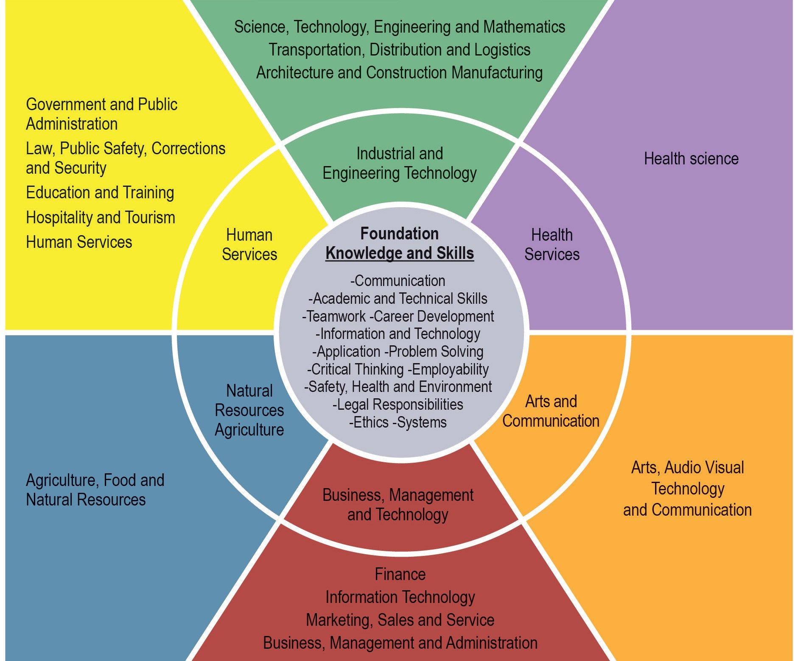

Source: Jared (2008); O\*Net website in Snell, Gekara & Gatt 2016.

An occupational cluster framework is similar in concept to vocational streams. Vocational streams involve occupations being grouped according to their shared knowledge, skills and practices, rather than on specific workplace tasks and roles, with the aim to promote a more adaptable and flexible workforce (Wheelahan, Buchanan & Yu 2015).

**POLICY IMPLICATIONS FOR TRAINING AND SERVICES**

**Support workers could play a**

**greater role in**

**educating workers about their transferable skills.**

So, what is needed to create more mobility between occupations?

**Reconfiguring training packages**

The work of Snell, Gekara & Gatt (2016) suggests that training packages could be reconfigured into clusters based on the occupational cluster framework. This will enable greater sharing of units of competencies across qualifications, which will encourage more transferability in the labour market. Another aspect of this will allow the mapping of how different occupations draw upon the skill sets.

While such a process may help increase cross-occupational mobility for workers in the future, it will not help workers who are currently displaced. What can be done now to improve their situation?

## Increasing awareness of transferable skills

A common issue identified in Snell, Gekara & Gatt (2016) and the ‘*When one door closes*’ research forum, is the lack of understanding of transferable skills among workers. Many workers did not realise or appreciate the wider

application of the array of ‘soft’ and generic technical skills they had acquired during their current employment, and instead focused on their specific technical skills when applying for new jobs. Support workers could play a greater role in educating workers about their transferable skills and helping them recognise how these skills can help them when finding alternative employment.

## Improving knowledge of local labour markets

Both Callan & Bowman (2015) and Snell, Gekara & Gatt (2016) point to the need for improved local labour market analyses as part of worker transition programs. With greater knowledge of the local labour market conditions, career counsellors and support services staff can more accurately identify potential job opportunities or encourage retraining in growth areas for displaced workers.

# REFERENCES

ABS (Australian Bureau of Statistics) 2015a, *Australian Industry, 2013- 14*, Manufacturing industry, table 1, 81550DO003\_201314, viewed 22 March 2016, [<http://ww](http://www.abs.gov.au/AUSSTATS/abs%40.nsf/)w[.abs.gov.au/AUSSTATS/abs@.nsf/](http://www.abs.gov.au/AUSSTATS/abs%40.nsf/) DetailsPage/8155.02013-14?OpenDocument>.

—— 2015b *Australian Industry, 2013-14*, Australian industry by division, tables 1 & 4, 81550DO001\_201314, viewed 22 March 2016, [<http://ww](http://www.abs.gov/)w[.abs.gov.](http://www.abs.gov/) au/AUSSTATS/abs@.nsf/DetailsPage/8155.02013-14?OpenDocument>.

Australian Department of Industry, 2015, *Australian industry report*, Department of Industry, Canberra.

Barbaro, B, Spoehr, J & National Institute of Economic and Industry Research 2014, *Closing the motor vehicle industry: the impact on Australia*, Australian Workplace Innovation and Social Research Centre and NIEIR, University of Adelaide, Adelaide.

Callan, VJ & Bowman, K 2015, *Industry restructuring and job loss: helping older workers get back into employment*, NCVER, Adelaide.

Durrant-Whyte, H, McCalman, L, O’Callaghan, S, Reid, A & Steinberg, D 2015, *The impact of computerisation and automation on future employment* in Australia’s future workforce, CEDA, Melbourne.

Snell, D, Gekara, V & Gatt, K 2016, *Cross-occupational skills transferability: challenges and opportunities in a changing economy*, NCVER, Adelaide.

Wheelahan, L, Buchanan, J & Yu, S 2015, *Linking qualifications and the labour*

*market through capabilities and vocational streams*, NCVER, Adelaide.



**© Commonwealth of Australia, 2016**

With the exception of the Commonwealth Coat of Arms, the Department’s logo, any material protected by a trade mark and where otherwise noted all material presented in this document is provided under a Creative Commons Attribution 3.0 Australia [<http://creativecommons.org/licenses/by/3.0/](http://creativecommons.org/licenses/by/3.0/) au> licence.

The details of the relevant licence conditions are available on the Creative Commons website (accessible using the links provided) as is the full legal code for the CC BY 3.0 AU licence [<http://creativecommons.org/licenses/by/3.0/legalcode>.](http://creativecommons.org/licenses/by/3.0/legalcode)

The Creative Commons licence conditions do not apply to all logos, graphic design, artwork and photographs. Requests and enquiries concerning other reproduction and rights should be directed to the National Centre for Vocational Education Research (NCVER).

This document should be attributed as Wibrow, B, Circelli, M 2016, *When one door closes: VET’s role in helping displaced workers find jobs*, NCVER, Adelaide.

This work has been produced by the National Centre for Vocational Education Research (NCVER) under the National Vocational Education and Training Research (NVETR) Program, which is coordinated and managed by NCVER on behalf of the Australian Government and state and territory governments. Funding is provided through the Australian Department of Education and Training.

P:\PublicationComponents\logos\NCVER LOGOS\Print\NCVER_CMYK.wmfThe NVETR program is based upon priorities approved by ministers with responsibility for vocational education and training (VET). This research aims to improve policy and practice in the VET sector. For further information about the program go to the NCVER website [<http://www.ncver.edu.au>.](http://www.ncver.edu.au/)

The views and opinions expressed in this document are those of the author/project team and do not necessarily reflect the views of the Australian Government, or state and territory governments.

An *At a glance* is a synthesis of research focused on a particular topic of interest, drawing on information from various sources.

IMAGES: GETTY IMAGES/ISTOCK ISBN 978 1 925173 51 2

TD/TNC 124.03

Published by NCVER ABN 87 007 967 311

Level 11, 33 King William Street, Adelaide SA 5000

PO Box 8288, Station Arcade, Adelaide SA 5000, Australia P +61 8 8230 8400 F +61 8 8212 3436

E [ncver@ncver.edu.au](mailto:ncver@ncver.edu.au) W [www.ncver.edu.au](http://www.ncver.edu.au/)

twitter.com/ncver www.linkedin.com/company/ncver