OCCASIONAL PAPER

What’s wrong with a career in hospitality? An examination of student choice

Simon Hamm
William Angliss TAFE
Participant in the NCVER Building Researcher Capacity Community of Practice Scholarship Program 2008



The views and opinions expressed in this document are those of the author/project team and do not necessarily reflect the views of the Australian Government or state and territory governments.
Any interpretation of data is the responsibility of the author/project team

As part of the National Centre for Vocational Education Research (NCVER) Building Researcher Capacity Scheme, a Community of Practice Scholarship Program has been created to encourage a culture of research in vocational education and training (VET) organisations. With the guidance of an experienced mentor, VET practitioners without any formal research experience undertake their own work-based research project. The scholarships also provide participants with an opportunity to have their research peer-reviewed and published by NCVER.
For more information see: <http://www.ncver.edu.au/research/opportunities.html# Community_of_practice_scholarships_for_VET_practitioners>.
© Commonwealth of Australia, 2009
This work has been produced by the National Centre for Vocational Education Research (NCVER) under the National Vocational Education and Training Research and Evaluation (NVETRE) Program, which is coordinated and managed by NCVER on behalf of the Australian Government and state and territory governments. Funding is provided through the Department of Education, Employment and Workplace Relations. Apart from any use permitted under the Copyright Act 1968, no part of this publication may be reproduced by any process without written permission. Requests should be made to NCVER.
The views and opinions expressed in this document are those of the author/project team and do not necessarily reflect the views of the Australian Government, state and territory governments or NCVER.
ISBN 978 1 921413 56 8
TD/TNC 97.29
Published by NCVER
ABN 87 007 967 311
Level 11, 33 King William Street, Adelaide SA 5000
PO Box 8288 Station Arcade, Adelaide SA 5000, Australia
ph +61 8 8230 8400 fax +61 8 8212 3436
email ncver@ncver.edu.au
<http://www.ncver.edu.au>
<http://www.ncver.edu.au/publications/2217.html>

About the research

What’s wrong with a career in hospitality? An examination of student choice

Simon Hamm, William Angliss TAFE
Building the research capacity of the vocational education and training (VET) sector is a key concern for the National Centre for Vocational Education Research (NCVER). To assist with this objective, NCVER supports a community of practice scholarship program, where VET practitioners without research experience are given the opportunity to undertake their own work-based research project. Scholarship recipients are supported by a mentor, and NCVER publishes their research results.
Simon Hamm participated in the 2008 community of practice program. Simon is a teacher in Event Management at William Angliss TAFE. His research explores why, despite more labour market demand for skills in hospitality, students prefer a career in events management to hospitality. He also investigates factors influencing decision-making.
The study comprised interviews with event management and hospitality students to examine the different influences on students when choosing their particular career path.

Key messages
Students reported working conditions, such as long hours and poor pay, as deterring them from a career in hospitality.
Because they often rely on information from parents and friends rather than on those with greater knowledge about the sector, students had unrealistic expectations about the job status and pay of the events industry.
The author points to a greater role for employers in informing students about their industries and the career opportunities available to them.

Tom Karmel
Managing Director, NCVER

Contents
Figures 6
Introduction 7
Literature review and methodology 9
Skill shortages 9
Student career choice research 10
Modelling student course choice 11
Method 12
Findings and discussion 14
Theme 1 14
Theme 2 15
Theme 3 15
Modelling student career choice (hospitality versus
event management) 17
Current and proposed models 17
Conclusion 21
References 23
Appendix 1 25

Figures
1 The Tinto model 12
2 Kember model 12
3 Model 1 18
4 Model 2 19

Introduction
This paper is concerned with the question of how better to align student course choice with labour market demand for skills and the reasons for students selecting some courses over others. A small number of student case studies in the hospitality industry are presented as examples of why a career in hospitality doesn’t appear to be as popular to students as a career in events management. These case studies are also used to develop a model for decision-making, which identifies the various stages of the decision-making process and the types of information and assistance that are required at each stage or combination of stages.
The particular focus is a popular event management diploma course that has maintained healthy enrolments over the last five years. The hospitality course also offered alongside the event management diploma is now directly competing for student enrolments.
This paper is concerned with an investigation into the dynamics of student alignment from postsecondary education to a meaningful career in the hospitality industry. Rather than being a logical, controlled and process-driven activity to effect a smooth transition, it appears at present to be a more haphazard exercise. Ultimately, a greater understanding of student career choice, as indicated by course selection, may assist key stakeholders in re-adjusting their strategic planning and implementation. This may lead to a better alignment of participants, resources, and conditions.
As well as student choice, another key theme in this paper is the imbalance in supply and demand for technical and further education (TAFE) courses offering hospitality and events. This exacerbates industry’s ongoing problem with high supply levels for hospitality jobs and low demand interest from emerging graduates. The importance of the hospitality sector not only to the tourism industry but as an employer for the Australian economy as a whole is vital. There is also the troubling issue of a lack of job opportunities for events graduates in the events industry. Data from a recent events industry survey paints a bleak picture of job opportunities within the industry. As noted by mice.net magazine, ‘The majority of respondents (62 per cent) believed that the biggest challenge they faced when job hunting was that there were not enough opportunities available’ (2009, p.72).
The opposite exists for the hospitality industry.
The tourism and hospitality sector currently employs over 480 000 Australians and contributes approximately 3.7% to Australia’s gross domestic product (ABS 2008). Even though the current world economic climate is experiencing unprecedented turmoil, the predictions of continued growth in the Australian population should equate to more jobs and therefore the requirement of skilled workers to fill these roles in tourism and hospitality. The 2008 Organisation for Economic Co-operation and Development (OECD) report, Learning for jobs, notes similar concerns to the general themes discussed in this paper. This OECD report has strong messages of misalignment and disagreement between the various stakeholders involved in education and training pathways for young adults entering the workforce and highlights the complexity of what is sometimes portrayed as a ‘skill shortage’. The report equates skill shortages with industries that exhibit high vacancy rates. Interesting is the idea held by some sectors who believe they have a ‘comparative advantage’ by comparison with those who consider they ‘may be doomed to decline’ (OECD, 2008, p.26). This type of reasoning is also a major focus of this paper, which examines the differences between hospitality and event management courses and why one course (events) has exhibited strong growth and popularity and another (hospitality) shows signs of stagnation. A number of negative issues relating to skill shortages raised in the OECD report are concerned with job conditions, pay levels and employee dissatisfaction with their career prospects. These issues are fundamental when considering an industry such as hospitality and this sector’s current difficulty in attracting qualified graduates.
Federal and state governments (in consultation with industry employers and educational institutions) have recognised the need for increased numbers of trained and qualified hospitality graduates from the VET sector and higher education. Jobs within the hospitality sector such as chefs, cooks and hospitality managers are in high demand and short supply. Keating (2008) in his report, Current VET strategies and responsiveness to emerging skills, highlights the failure of the training market to adequately understand and relate to the demand from individuals for particular courses. This is further complicated by a system of skilling in areas where there are obvious shortages in supply to industries, but an unfulfilled demand by students. Keating (2008, p.16) describes this as a ‘mismatch between individual demand and industry skill needs’. Hospitality is one of those industries mentioned as being problematic when recruiting or attracting skilled workers.
Central to this discussion will be the use of models to describe the influences that affect student choice for a course. Previous models by Tinto (1975) and Kember (1989) are used as the basis to develop a model which describes the current situation (Model 1). A second model is introduced that proposes changes designed to streamline, reinforce and stabilise the students’ transition from school to a career in a particular industry sector.
This paper will also examine topics relating to the overall characteristics that influence student career choice. These include:
current research of student course choice within the TAFE environment (with respect to the hospitality and tourism sector)
government policy and planning strategy related to skills shortages
popularity of students enrolling in TAFE event management courses and what this might mean for the hospitality industry.
Juxtaposed with the above issues will be an examination of data collected from a number of student case examples (13 TAFE students enrolled in an event management course). These examples provide information about student enrolment choices for particular courses and respondents’ views of the advantages and disadvantages of choosing a career in hospitality.
The paper’s main finding is that employers could play a greater role in informing young people about their industries and the career opportunities in them.

Literature review and methodology
The review of the literature covers a number of key areas. These include skills shortages in the hospitality and tourism industry, the motivation for student career choice generally and within VET, and modelling student career choice.

Skill shortages
Both government and industry in Australia have made a concerted effort to reduce skill shortages in particular industries. Mining, construction, engineering, health and hospitality are some of the main industries that up until recently were experiencing skill shortages (Department of Education, Employment and Workplace Relations 2008a, 2008b). With the incredible growth in countries such as China and India over the last five years and the concomitant demand for resources, the Australian economy has experienced skill shortages in industries mainly related to the resource export boom. In sectors such as health and hospitality, skill shortages relate more to increases in the Australian population, an export of skilled labour to other countries experiencing rapid growth, a lack of resources to create more educational places at related institutions and an ageing population (Department of Employment and Workplace Relations 2005; Department of Education and Training [Victoria] 2006: Keating 2008; Richardson 2007; Shah & Burke 2006). It appears that the Victorian Government sees a shrinking birth rate and an ageing population as a driver for action to address this key area in the Victorian economy. This means a shift in government strategy to tackle these dilemmas of age and falling population, and skills shortages in industries important to Victoria. Greater emphasis will be placed on providing resources and funds to areas where there are noticeable skill shortages. The hospitality industry is one of those industries mentioned as being affected by a lack of ‘supply’ of qualified workers (Department of Education and Training [Victoria] 2006, p.7).
Even with the current global economic slowdown acting as a major brake on financial and economic activity, within the next five to ten years there should be a ‘righting’ of this disorder within markets. Once this realignment or ‘correction’ gathers pace, the same issues of skill shortages, infrastructure gaps and a weak knowledge and training platform will be at centre stage. For governments and industry this requires investing now rather than waiting until the economic cycle changes for the better.
In the short term the federal government had countered skill shortages in certain industries by reducing visa restrictions to allow for greater flexibility for foreign workers to study and work in Australia (Department of Immigration and Citizenship 2008a, 2008b). This policy has now been curtailed. Given the current global economic situation, there is less of an urgency to resume this practice. Governments, both federal and state, have also invested in greater awareness of those industries affected by the current skills shortages in order to attract the young labour market. In certain industry sectors there has been greater attention to increasing apprenticeships. Smith and Wilson in their examination of apprenticeships within the school system argue that the continued financial support of this strategy by government is necessary, especially when dealing with skill shortages, high jobless rates and school non-completion figures (Smith & Wilson 2004). In the longer term both federal and state governments have committed educational funding and training places to deal with issues such as human resource retention and attraction, infrastructure, equipment and technology improvements. Mitchell and McKenna (2008) in their report, Productivity and participation enhanced by VET, stress the importance of a close and strategic role for VET and government and note that these types of strategy and planning decisions need to be made regardless of the cyclical nature of the economy (2008 world financial crisis and the global recession) because they target future growth in labour markets and population expansion across Australia.
Writers such as Keep (2009) and Keep, Mayhew and Payne (2006) highlight a similar, difficult and complex outlook, given industry’s need for qualified graduates willing to move into employment environments that are not highly paid and entail unglamorous work involving long hours and stressful conditions. Keep especially has examined a number of situations (such as hospitality) within the United Kingdom and countries, including Australia, that have strategic planning based around education models closely aligned to industry demands. Gleeson and Keep (2004) maintain that these strategic decisions by government and industry tend to overlook and underestimate the needs and expectations of the student’s intrinsic goals before, during and after academic course involvement. This short-sighted approach by these stakeholders, Gleeson and Keep (2004) argue, is driven by economic and political pressures that tend to undermine possible successful and realistic outcomes that could favour all parties.
For the hospitality industry there is also the more complex issue of a perceived (anecdotal) lack of interest from school leavers enrolling in a hospitality course with a qualification such as a diploma. While numbers overall for VET courses have been generally steady across the last five years, some courses within the tourism and hospitality training package have consistently shown a healthy growth (Department of Innovation, Industry and Regional Development 2008; Victorian Tertiary Admissions Centre 2008). The Diploma of Event Management is a case in point. This particular course also has some unique characteristics. Firstly it is extremely popular with female students (at a city TAFE where the case studies are taken from) with females making up over 90 per cent of the total event management diploma population (Slaughter, Reid & Arcodia 2003: Arcodia & Barker 2003). Secondly, based on my own teaching experience of over ten years in this area, well over 80 per cent of the students enrolled in the events program work either part-time or casually in the hospitality sector. Lastly, students in this course have indicated that there is a big difference between working in hospitality to pay for living expenses and enrolling in a course such as hospitality in order to develop a career path for that particular industry. This is of particular concern for educational institutions, government and the hospitality industry. TAFE student places that would traditionally have flowed to hospitality diploma courses are now being converted into event management diploma enrolments. The concern of the three main stakeholders (government, industry and providers) about this trend relates to the limited number of jobs for ‘event managers’ in the tourism and hospitality industry. Conversely, there is a shortage of qualified hospitality graduates entering the hospitality industry. This mismatch of supply and demand is at the heart of this current situation. A strong demand for event management jobs by graduates is not sustained by a very small supply side from the events industry.

Student career choice research
The research in this particular field is extensive. Some of the areas covered deal with the two main stakeholders (the student and the career advisor); what this relationship means in the context of the learning environment; the profile of the student (the ‘consumer’); and the potential career or education pathway chosen (Elsworth et al. 1999). Harvey-Beavis and Elsworth (1998) focused on the importance of the ‘interests’ of the student and how this may conflict with the stated policy strategy imposed to control or direct specific enrolments in student courses. Central to their study was the influence of a ‘cost benefit’ strategy applied by students. The researchers said this related back to the students’ ‘intrinsic interest’ in wanting to do a particular course rather than what types of jobs or salaries the graduate may end up with. Other researchers focus on the more theoretical aspects of the field. Herr, Cramer and Niles (2004) examine the concept of ‘student career choice’ as being fixed between a complex range of competing pressures on the person seeking a career. These pressures are involved at different strategy levels and at different periods for the student. This, the writers maintain, causes tension and conflict for both the party seeking guidance and the agency offering the advice or direction. Leaders in the field of theoretical vocational research such as Holland (1985) explain the nature and structure of the vocational choice environment and its importance in setting models and theories that may assist career advisors with aligning students to making a more informed decision for their future career choices. Even given the time distance between then and now, Holland’s work is still seen as valid and relevant when discussing vocational career theory. Holland uses a ‘theory of career’, which consists of six personality types that can be applied within the student career environment—realistic, investigative, artistic, social, enterprising and conventional. This, Holland asserts, can be an effective way of applying a ‘model’ to vocational and work environments.
Other authors focus on issues such as career development services and tools and their effectiveness for students. Studies done by Beavis (2006) and Rainey et al. (2008) examine some of the strategies used by students when conducting their own investigation into what may assist them in making a choice or decision about further study or a career option. This investigation may be as obvious as looking at a government career website, using a school electronic notice board, reading flyers and handouts, attending career information sessions, industry and/or educational institute visits, seeking advice from family or friends or discussions with a respected teacher at school. The literature makes clear that there is no predictability or ‘best practice’ that can be applied to the complex issue of career choice (Athanasou 2008). This makes it problematic for policy-makers when allocating funding to particular sectors in order to attract students for courses. A ‘scattergun’ approach is no remedy for dealing with fundamental gaps in the course-selection process by potential students (Cornford 2005; OECD 2008).
Considerable student career choice research has centred on the higher education sector (Baldwin & James 2000; Briggs & Wilson 2007; Raposo & Alves 2007). There are also a number of studies conducted within the hospitality sector at the higher education level (Breakey & Craig-Smith 2007; Jenkins 2001; Littlejohn & Watson 2004). Although some of the research examined for this paper has been located in the international sphere, the hospitality industry there faces similar problems to the Australian hospitality environment: large numbers of job vacancies; declining student enrolment numbers; a growing dissatisfaction with the hospitality industry as a whole; low pay; unsuitable work conditions; a stressful work environment; long, unsociable work hours; and a lack of a well-defined career path for many hospitality employers (Chuang et al. 2007: Jogaratnam & Buchanan 2004; Kusluvan 2003; Lin 2005; Wilkinson 2005). Research done by Moogan and Baron in the United Kingdom (2003) investigated ‘students’ considerations for choosing a course while still at school’ and examined some of the materials, information and sources of advice that were available. The study found that the students’ interests and choices when enrolling in a particular course were affected by the ‘quality of the information at hand’. They argued for greater intervention and guidance to assist the student in clarifying exactly what they were seeking when making a decision to enrol in a course.

Modelling student course choice
There has been considerable modelling done in a number of educational environments that looks at the student decision-making process pre-, during and post-qualification. Studies have mainly focused on the higher education field, in particular examining the drop-out rates in distance and flexible learning (Kember 1989; Tinto 1975). While the focus of Tinto’s and Kember’s models is different from that of this paper, the elements they use to describe how a student arrives at a decision to drop out are similar to those used when deciding between an events or hospitality course. Figures 1 and 2 below show the models developed by Tinto (1975) and Kember (1989).
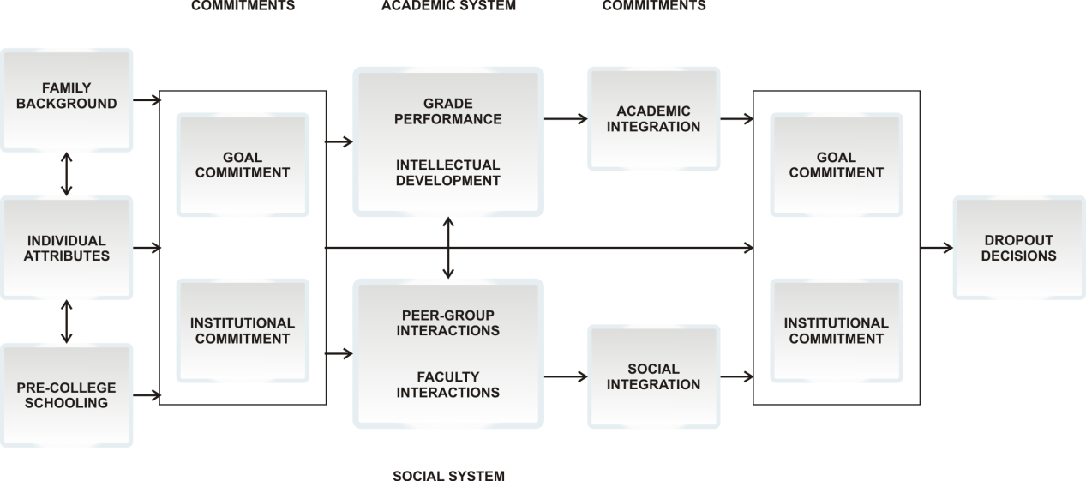
Figure 1 The Tinto model
Source: Kember (1989, p.284).
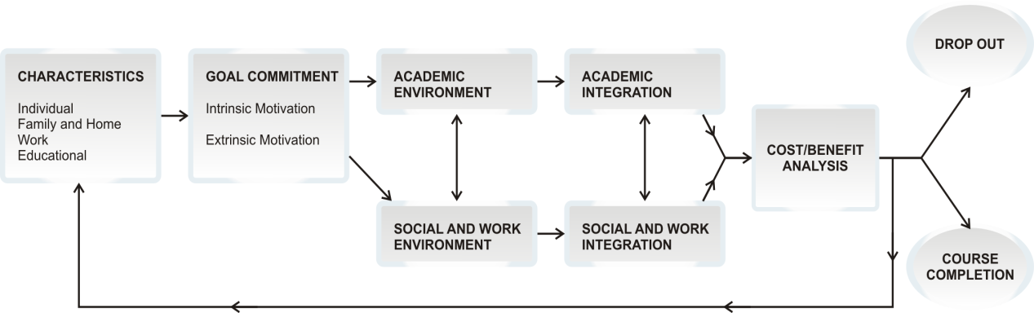
Figure 2 Kember model

Source: Kember (1989, p.286).
The modelling that has been done is both helpful and thought-provoking as it can assist the reader to visualise the overall context and flow of the model’s purpose. Kember put this quite succinctly when describing the use of models to present student attrition with regard to distance education.
Models can be judged by their usefulness. A model of the attrition process should contain sufficient constructs to explain what is undoubtedly a complex process and yet be sufficiently simple to be understandable and usable. It should be able to explain collected descriptive data, and it should provide a framework against which predictions can be hazarded and judgements made about potential interventions. (Kember 1989, pp.279–80)

Method
A small number of semi-structured interviews were conducted. In total 13 students, comprising 11 females and two males, were interviewed. Ages ranged from 19 to 25 years. All students were enrolled in the Diploma of Event Management at a Melbourne city TAFE (William Angliss Institute) that specialises in tourism and hospitality education. Interviews were recorded and then summarised. Strict privacy protocols were observed to ensure that the identities of the participants (other than their age and other background information) remained confidential. All names included in this project are fictitious, with the gender indicated by the name.
Participants have been given the following names: Ruth, Stephanie, Jasmine, Fiona, Amanda, Jess, Lanie, Lisa, Bec, Jake, Kylie, Sari, Michael.
The questions that were used in the interviews with the students covered areas relating to: reasons for choosing a particular course; how and where students source information regarding a course; where the students currently worked; and what were the students’ short- and long-term goals. Refer to appendix 1 for the questions used in the interviews.
Based upon the findings of the interviews and the models of Tinto (1975) and Kember (1989) I developed my own theoretical model to depict the current situation of how and why students choose one course over another. A second model illustrating the ideal situation has also been developed.

Findings and discussion
Based on the interviews three main themes became evident. These are:
There is a lack of an organised, structured and strategic approach when deciding on what course and location the student finally chose.
The majority of students interviewed currently work in hospitality on a casual/part-time basis, but none of them wanted to pursue a career in hospitality for various reasons.
Student expectations for their future and job-related issues were positive. However, they were not based on reasoned or careful analysis of all available information, undertaken before enrolling.
These themes also shed light on the main thrust of the paper, which are the issues of increased demand for the Diploma of Event Management versus a lack of supply of event management industry positions; shortage of supply of qualified hospitality graduates versus increased supply of jobs for hospitality management positions.

Theme 1

There is a lack of an organised, structured and strategic approach when deciding on what course and location the student finally chose
The majority of participants (ten out of 13) who were enrolled in the Diploma of Event management at the city TAFE said that the reason they chose this particular TAFE was because of its reputation as a centre for tourism and hospitality. More importantly for this paper is how the students arrived at the decision to enrol in this field of study.
Participants said that they based their decision on information sourced from a number of different locations, places such as career websites, school career counsellors, parents, friends, work colleagues, TAFE open days and advice from industry employers.
Believe it or not I found about this course when I was listening to the radio. It also reminded me of what my school counsellor said about the course and William Angliss. (Ruth)
My mum told me about the events course because she was doing a cake decorating course at the city TAFE and got some brochures about the events course because she knows that I am interested in organising events. (Stephanie)
I found about the course through reading the VTAC Guide. Also I had heard from friends that the city TAFE had a good reputation, plus I like the fact that it is in the city and close to public transport. (Fiona)
Participants noted that they found the career websites limited. These websites included federal and state education department sites, Centrelink, Victorian Tertiary Admissions Centre, Career Advice Australia, Youth Central, myfuture and Job Guide. Also mentioned were individual TAFE institutes and university websites. All of the students said that ‘face to face’ interviews or counselling would be of greater benefit to them rather than career websites. These websites tended to be more fact-based rather than dealing with the more complex issues that the participants faced when deciding on a course at a particular institution. Only a small number of the participants relied on printed materials such as newspapers or magazines for guidance. This they related to their own personal lack of interest in reading newspapers and other printed materials. Based on what was noted in the participant interviews, there was no formal, structured or uniform strategy of course choice. The participants said that the two greatest influences on the final choice of a course were family and friends. Participants commented that their own personal involvement with school career guidance counsellors was haphazard and disjointed. They felt that the approach used was ‘generalist’ rather than ‘specific’ for them and this could have been why they sought other sources of information to assist them to choose a course.

Theme 2

The majority of students interviewed currently work in hospitality in a casual/part-time basis, but none of them wanted to pursue a career in hospitality for various reasons
All but three of the participants work in the hospitality industry. For the majority of the participants this work was currently casual. The total hours for a normal week ranged from ten to 30 hours. Only four of the participants did not live at home with their parents. The participants who were independent of their parents worked the larger number of hours per week. Participants had 20 hours of class contact per week at TAFE and said that they were physically and mentally ‘stretched’ by their work and college requirements. Many of the participants remarked that the mix between college requirements and their hospitality jobs made it difficult to focus on study.
I currently work in a bar/restaurant. The pay is not particularly great and it can be very stressful dealing with some of the customers. (Lanie)
I work for a catering company that does private functions and parties. It is physically and mentally draining. There is a lot of lugging stuff around and having to put up with very stressed and rude clients. I’m only doing it because the work is near where I live. Also the pay is not worth the stress I get. (Kylie)
Long hours, low pay and poor work conditions were typical words used to describe their current work commitments. All of the participants, who were working in hospitality to earn money, said that they would not want to seek a career in hospitality once they finished their course. The hospitality work consisted of waitering, bar work, food preparation and service and café operations. Students commented on how the unsociable hours impacted not only on their own social life but also on their ability to concentrate and enjoy their college course. Students mentioned that their employers were not interested in altering their rostering schedules to accommodate their personal, social and study requirements. Clearly, in times of labour and skills shortages employers would be better served by being more strategic when dealing with these sorts of work issues. High staff turnover that made it difficult at work was also mentioned by the students. Students were at times placed in the role of training new staff even though they were relatively new themselves.

Theme 3

Student expectations for their future and job-related issues were positive, but not based on reasoned or careful analysis of all available information, undertaken before enrolling
Eleven of the 13 participants had clearly defined short-term goals based around study, work and travel. The two participants that didn’t have short-term goals were unsure about their future in the course and whether or not they would finish the diploma. These two participants also said that they worked long hours in hospitality and that the travel time between home, college and their employment was a major factor in their being able to allocate the time and attention on their studies. They felt that perhaps the events industry was not for them. This opinion was based on the unsatisfactory experiences at their casual jobs working in hospitality, which they related back to the events industry. This is perhaps an unsatisfactory comparison given by these two participants, as the hospitality and events sectors differ considerably in structure, processes and outcomes. These participant comments are indicative of a lack of understanding and exposure to the events industry from first-hand experience. The comments, it can be argued, reflect a lack of commitment and motivation to investigate the nature and opportunities available in the events sector.
Eight of the participants had well-defined long-term goals. For these eight participants this consisted of a mixture of working overseas within the events industry and then returning to Australia, or trying to find work in the events industry in Australia once they had completed their studies.
The majority of the participants had unrealistic expectations of what they would be paid once they left college and the types of roles and responsibilities they would be given by potential employers.
No idea—I suppose it must be something like what I’m earning now [front desk in a city hotel]—not much—say around $25 000? (Fiona)
I have no idea. I am working casually in a restaurant at the moment so I can’t really compare it to that, maybe $50 000 for an Event Co-ordinator and say $60 000 for an Event Manager?
(Lisa)
Not much! The call centre where I work pays okay. More than when I was working in hospitality—the stress was awful—I had to change, it was killing me! Seriously I have no idea.
(Bec)
Clearly there is a mismatch between what employers want from graduates and what they are prepared to pay them. Pay rates for graduates are clearly lower than what students believe that they will be paid (HELP Recruitment 2008; Payscale 2009). In some cases event and hospitality pay scales for various positions can be up to $10 000 per annum lower than what students believe they might be paid.
For the students there were real concerns over the long and stressful hours, the poor pay and the unsuitable work conditions. At this stage in their career path, the students had formulated a quite negative opinion of the hospitality industry.
The participants certainly seemed confident in what they knew and the types of activities they could handle in the events industry. Based on the expectations and requirements of event industry employers, some of the graduates would certainly need to reassess their expectations of job status and pay before entering into an employment situation (Event Recruitment 2008). All of the participants did say that they were told throughout their course approximately how much the events industry pays and that as new recruits they would be ‘starting at the bottom’. What their teachers at college had told them did not seem to influence their own motivation to seek a position they believed was both interesting and offering a good salary. All the participants seemed to trust their own convictions, opinions and beliefs rather than the information—the advantages and disadvantages of the events industry—communicated to them by their teachers.

Modelling student career choice (hospitality versus event management)
Based on similarities with the Kember and Tinto models and data collected from the student interviews, it seems appropriate to apply a theoretical model to describe how students make decisions about courses in hospitality and events management. In this section two models are introduced. Model 1 represents the current situation as it operates and Model 2 extends and refines this to represent the ideal situation. Both models are longitudinal in nature, showing the students’ progress through a series of decision milestones and influences which impact on their ultimate decision to decide on either (in this case) a hospitality or events diploma course. I also use the findings from the interviews to inform the type of information and assistance that might benefit students at various stages of decision-making.
Both models used in this paper are influenced by work done by Kember (1989). I have incorporated a number of similar elements from his model to describe my own understanding of what was investigated in this research. I have also taken into account earlier work done by Tinto (1975) that follows a similar methodology. The justification for using variations to Kember and Tinto is that both incorporate elements and descriptions similar to my own findings.

Current and proposed models
The following section explains the main differences between my current model (Model 1) and the proposed model (Model 2) and those of Kember and Tinto. Firstly, the learning environment is different—TAFE in Models 1 and 2, higher education in Kember’s and Tinto’s. Also Models 1 and 2 focus not on student dropout but the student decision-making process and the various influences that affect their decisions along this pathway. I refer to the importance of ‘local filters and intrinsic factors’, whereas Kember uses the term ‘characteristics’. It could be argued that they are different in name but similar in meaning. In my models I have added the term ‘external filters, extrinsic factors’ to include the importance of external stakeholders and their potential influence on the student. These stakeholders referred to are federal and state government (resourcing and strategy and policy direction); industry, representing hospitality and events; and the educational institution (TAFE) where the student is enrolled. Their roles, it is argued, are pivotal in either assisting or hampering the student to make an informed and realistic decision when choosing between courses. The greater the input from the three stakeholders (government, industry and TAFE), the greater the benefit to the student. In this case the relevant stakeholder, whether industry or government, gains also by maintaining healthy numbers of graduates taking up careers in industries where there are skill shortages.
Models 1 and 2 show the student having to make a choice between two options, a hospitality or event management course. This decision, whether informed or not, is also affected by the student’s familial, social, academic, and work environment. Both Models 1 and 2 and those of Kember and Tinto include similar aspects, such as student goals, attitudes and motivation when moving along the models pathway. In the Kember model this is labelled as cost–benefit analysis. Tinto refers to this stage as the commitment point. The two decision-point locations in the current model illustrate crucial times for the student to make (given the right circumstances) an informed decision. The greater the level of information and help from internal and external sources, the more satisfactory the outcome for the student.
Model 1 shows the stakeholders only appearing once at the beginning of the pathway, whereas Model 2 shows the stakeholders appearing at three points (extrinsic factors). These three points all correspond with the student having to make a critical decision about their future progress. Both the events and hospitality courses portray the student in a number of settings, which include the social/work environment and integration and the academic environment/integration. These factors influence the students’ decision-making capability.
In Model 1 the student has three options when nearing the end of their course: a career in either events or hospitality; further study/other career; or dropping out. It is argued that the stronger the intervention of extrinsic factors (internal and external stakeholders), the greater the chances of the student making a satisfactory career outcome. In Model 1 this intervention is weak. In Model 2, the links and intervention between the student and the extrinsic factors are stronger. It is argued that this gives the students a more satisfactory outcome. This outcome is also of benefit to the three stakeholders, who have invested more time and resources to ensure that students follow a predictable and planned pathway into careers where there is greater supply and a shortage of skills.
The ‘how’ and ‘why’ students choose one course over another can be presented in Model 1 (figure 3), which follows the current pathway of students, from when they leave school and choose a course, until they leave postsecondary education for a career, other study or unemployment.
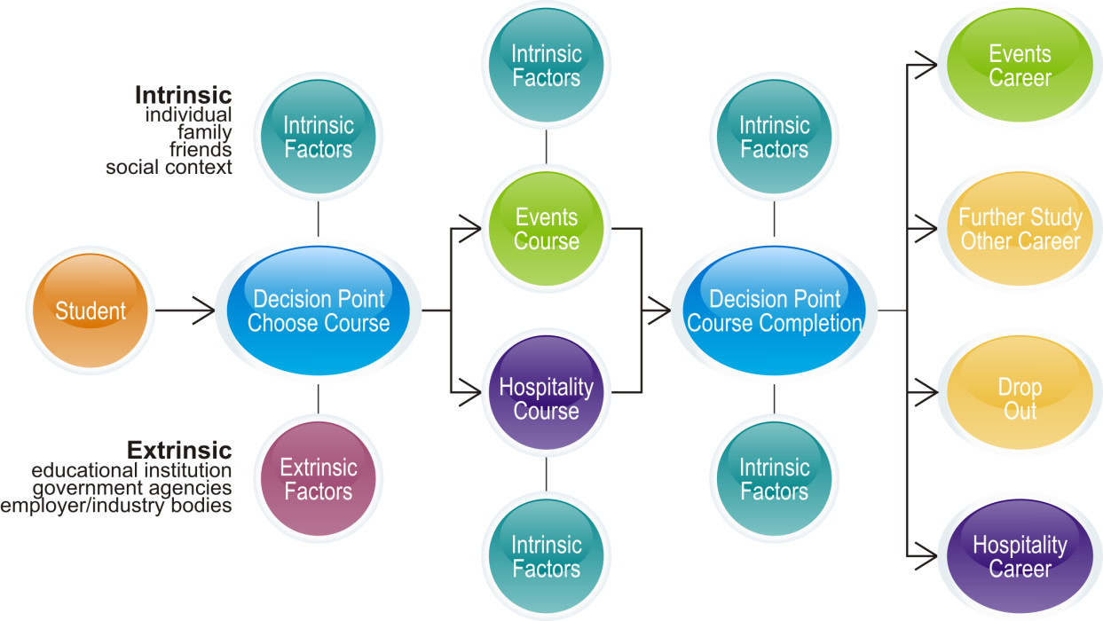
Figure 3 Model 1
Model 1 represents the current situation for students, based on the investigation carried out for this paper. Important stages for the student portrayed in this model are the decision point (course choice and course completion) milestones. For the course-completion decision point, the student reaches a stage where they need to decide which direction they will take once they have finished the course. This is usually based on the outcomes and experiences (positive/negative) during the course. For some students this can mean four possible choices, as described above. This study didn’t investigate students who dropped out during the course. Given what has been found in the interviews, students are making these decisions based on their own intrinsic thinking. Students who decide to drop out of either further education or work after their course will rely on their families and close friends to support them until they decide their next step. The evidence examined in this study shows that students reflected in Model 1 are depending on their own personal network of family and friends to guide their decision-making, rather than accessing available extrinsic resources and services offered by educational institutions, government agencies and industry bodies.
It is crucial that the student has access to and assistance from as many relevant sources of information and support to guide them in their final decision (represented by ‘extrinsic factors’). Importantly, Model 1 has two decision points, but only one (‘course choice’) has the connection to important stakeholders, including federal and state government, educational resources and, most importantly, contact with industry (extrinsic factors). When the student arrives at the second important milestone (course completion), there is no extrinsic assistance to guide their decision-making as they are about to leave the college. A common finding in this research was the students’ reliance on their own intrinsic decision-making. This led to four possible options, as shown in Model 1.
Without input or only limited involvement from external stakeholders, the student is left to make choices that will be based on intrinsic and internal factors. Instead of making a well-considered, knowledgeable, practical and realistic choice, the student relies on their own limited experiences. These decisions may relate to what they have previously been involved in and what they are currently occupied with and lack the benefits of the information offered by the main four stakeholders. Examples of this behaviour can be seen in the following quotes.
The way I went about finding about my course could have been a lot better. At times during the course I felt that I could have used some advice or help with regard to where I will end up when I finish. (Amanda)
It is such a hit and miss affair. I don’t really know if there is a job for me when and if I finish. I am a person that needs need certainty. (Michael)
They encourage us to get more involved with industry at functions and so on, but most of us are either too shy or scared to approach them. I guess we are not used to networking. (Lisa)
Based on the interviews with the students and with reference to Kember and Tinto, Model 2 is proposed. This model adds greater intervention and guidance by the three main stakeholders, represented as extrinsic factors. Earlier it was noted that students show a tendency to rely on their own cluster of experiences and knowledge (intrinsic factors), which reflects a rather insular and one-dimensional approach to utilising information for their career development. Model 2 seeks to move the student from this limited situation towards a broader, mature work/world experience that involves the expertise and resources held by stakeholders such as government and industry.
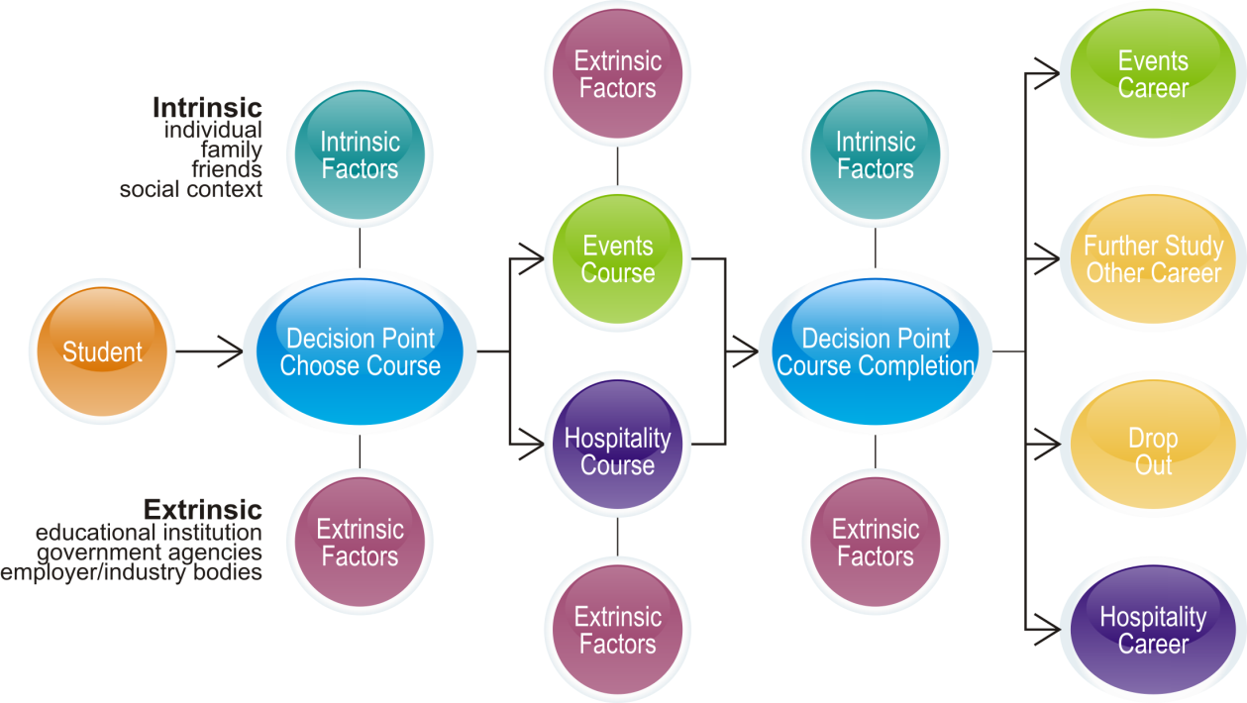
Figure 4 Model 2

By increasing the extent of involvement from the main external stakeholders from one to three occasions, students can be given access to resources, advice, guidance and mentoring at a more intense level than currently exists. This could benefit the students overall and assist them to progress into a career, confident that they have been given the help and the adequate advice and information necessary to fit the role they have been preparing for.

Conclusion
Findings from this study suggest that governments at all levels, as well as training and education providers and tourism and hospitality stakeholders, need to re-examine current strategies and policies to ensure that students’ courses are more accurately aligned to their potential career paths.
The findings are based on the 13 interviews of students at a Melbourne city TAFE institute. Student motivation to choose a course in this instance is ad hoc, superficial and lacking in careful, guided and realistic decision-making processes, which are based on expert, informed and strategically focused planning. All three major stakeholders in this particular industry have a great deal at stake, and it is not just about jobs—as participants have clearly said in their interviews—it is also about a planned, professional and satisfying career path. Work aspects such as hours, conditions and pay need to be seriously examined in order to attract motivated and interested employees. Employers need to involve themselves earlier in the career alignment process. The comments and opinions of the participants in the interviews make it clear that what is required is the adoption by all relevant stakeholders of a seamless approach through the course-choice process, and even up to job interview and selection for hospitality positions.
What do seem to be missing as part of their transition into the workforce from school, and VET, are the guidance, advice, knowledge and experience of employers that could have such a positive and perhaps career-defining influence on these young people.
As explained in the Kirby Report in 2000:
The pathways for young people are uncertain, unequal and poorly signposted. The transition process from education and training to employment has become more complex and unpredictable. (Department of Education, Employment and Training 2000, p.7)
More attention should be spent in analysing the ‘consumer’s’ motivation (in this case the school leaver entering VET) rather than trying to predict which way the economy will go. As stated in the OECD report:
When it comes to choosing fields of study, students have two advantages over planning authorities. First, they often have a clearer idea of their own skills and the characteristics that may make them better suited to one job than to another. Second, they know more about what they enjoy doing. This may mean jobs that are not in great demand in the labour market but would nevertheless be wise career choices in light of these preferences. Moreover, forecasting information takes time to be taken up by providers and prospective students and this results in a lagged response to skills shortages. (OECD 2008, p.26)
However, what also seems to be missing and is clearly shown in the 13 interviews is a lack of coordination and careful guidance for young people when deciding on a particular course of study. By bringing together the relevant stakeholders, who view these young people as potential employees, earlier on in the process, greater savings in time and other resources could be achieved. The proposed model (Model 2) describes an alternative example of what could be used to assist the various parties in this process. Further investigation of the issues raised in this paper would involve testing the two models outlined.
Based on the findings reported in this paper, it is apparent that industries such as the hospitality sector need to invest more time and resources to ensure that their employees such as casual and part-time students are engaged in the job in a positive, rewarding way. Research conducted by the Dusseldorp Skills Forum (1998, 1999) into the experiences and dynamics of young people in the workplace offers important lessons for employers. Key themes in that research are the vulnerability, unpredictability and uncertainty that surround young people. Words such as the ‘milling’ and ‘churning’ that young people ‘exhibit’ suggest just how important the roles and intervention of experienced stakeholders such as government and industry can be in ‘stabilising’ young people when it counts. This guidance from key stakeholders is represented in Model 2.
The information gathered from these 13 interviews suggests that their own individual pathways to this specific point was a very ‘hit and miss affair’. The reason for choosing their particular course was also problematic. More investigation into this area would therefore be of benefit not only to the relevant stakeholders but also to the students making those first steps towards deciding on a satisfying career path.

References
ABS (Australian Bureau of Statistics) 2008, Australian National Accounts: Tourism Satellite Account, cat.no.5249.0, viewed 5 December 2008, <http://www.abs.gov.au/ausstats/abs@.nsf/Latestproducts/5249.0Main%20 Features12006-07?opendocument&tabname=Summary&prodno=5249.0&issue=2006-07&num=&view=>.
Arcodia, C & Barker, T 2003, ‘The employability prospects of graduates in event management: Using data from job advertisements’, viewed 8 December 2008, <http://espace.library.uq.edu.au/eserv/UQ:10174/ ca_tb_jobads.pdf>.
Athanasou, J, ‘The intersection of adolescents’ interests and national needs – implications for educators’, paper presented at the Australian Council for Educational Research Conference, Brisbane, August 2008.
Baldwin, G & James, R 2000, ‘The market in Australian higher education and the concept of student as informed consumer, Journal of Higher Education Policy and Management, vol.22, no.2.
Beavis, A 2006, On track? Students choosing a career: An investigation of educational and vocational plans of Learning for Life students, The Smith Family, Sydney.
Breakey, N & Craig-Smith, S 2007, ‘Hospitality degree programs in Australia: A continuing evolution’, Journal of Hospitality and Tourism Management, vol.14, no.2, pp.102–18.
Briggs, S & Wilson, A 2007, ‘Which university? A study of the influence of cost and information factors on Scottish undergraduate choice’, Journal of Higher Education Policy and Management, vol.29, no.1, pp.57–72.
Chuang, NK, Goh, B, Stout, B & Dellman-Jenkins, M 2007, ‘Hospitality undergraduate students’ career choices and factors influencing commitment to the profession’, Journal of Hospitality & Tourism Education, vol.18, no.4, pp.45–5.
Cornford, I 2005, ‘The revolution certainly has not succeeded! Reconceptualising Australian vocational education for the 21st century’, 13th Annual International Conference on Post-compulsory Education and Training, Gold Coast, Australia, December 2005 in Vocational learning: Transitions, interrelationships, partnerships and sustainable futures: Volume 1, eds J Searle, F Bevan and D Roebuck, Australian Academic Press, Brisbane, Australia, pp.163–70.
Department of Education, Employment and Training (Victoria) 2000, Maintaining the advantage: Skilled Victorians, Victorian Government, Melbourne.
Department of Education, Employment and Workplace Relations 2008a, National Skills Needs List (NSNL), viewed 14 August 2008, <http://www.australianapprenticeships.gov.au/whatsnew/NSNL_announced.asp>.
——2008b, Skills shortage methodology 2008–09, viewed 15 August 2008, <http://www.workplace.gov.au/NR/rdonlyres/5155EAC7-0400-438F-A9B5-2DB0B89F20C0/0/ WorkplaceMethodologypaper200809.pdf>.
Department of Education and Training (Victoria) 2006, Inquiry into vocational education and training, viewed 21 August 2008, <http://www.skills.vic.gov.au/corporate/publications/research_and_reports>.
Department of Employment and Workplace Relations 2005, Workforce tomorrow: Adapting to a more diverse Australian labour market, viewed 13 October, <http://www.workplace.gov.au/workplace/Organisation/ Employer/WorkforceTomorrow-AdaptingtoamorediverseAustralianlabourmarket.htm>.
Department of Immigration and Citizenship 2008a, Visa subclass integrity review, final report, viewed 8 December, <http://www.immi.gov.au/skilled/457-integrity-review.htm#d>.
——2008b, Occupations in demand, viewed 14 August 2008, <http://www.immi.gov.au/skilled/general-skilled-migration/skilled-occupations/occupations-in-demand.htm>.
Department of Innovation, Industry and Regional Development 2007, Victoria’s vocational and educational statistics, a pocket guide, viewed 16 June 2008, <http://www.skills.vic.gov.au/__data/assets/pdf_file/ 0014/12560/VicVETStatisticsPocketGuide2007.pdf>.
Dusseldorp Skills Forum 1998, Australia’s youth: Risk and reality, Dusseldorp Skills Forum, Sydney.
——1999, Australia's young adults: The deepening divide, Dusseldorp Skills Forum, Sydney.
Elsworth, G, Harvey-Beavis, A, Ainley, J & Fabris, S 1999, ‘Generic interests and subject choice’, Educational Research and Evaluation, vol.5, no.3, pp.290–318.
Event Recruitment 2008, 2008 Events staff issues and salary survey, viewed 15 January 2009, <http://www.eventrecruitment.com.au/>.
Gleeson, D & Keep, E 2004, ‘Voice without accountability: The changing relationship between employers, the state and education in England’, Oxford Review of Education, vol.30, no.1, pp.37–63.
Harris, R, Rainey, L & Sumner, R, 2006, Crazy paving or stepping stones? Learning pathways within and between vocational education and training and higher education, NCVER, Adelaide.
Harvey-Beavis, A & Elsworth, G 1998, Individual demand for tertiary education: Interests and fields of story, Department of Employment, Education, Training and Youth Affairs, Canberra.
Help Recruitment 2008, Hospitality and, pay scales, viewed 15 January 2009, <http://www.helprecruitment.com.au/>.
Herr, E, Cramer, S, & Niles, S 2004, Career guidance and counselling through the lifespan, Pearson, Boston.
Holland, J 1985, Making vocational choices: A theory of vocational personalities and work environments, Prentice-Hall, Englewood Cliffs, NJ.
Jenkins, A 2001, ‘Making a career of it? Hospitality students’ perspectives: An Anglo-Dutch study’, International Journal of Contemporary Hospitality Management, vol.13, no.1, pp.13–20.
Jogaratnam, G & Buchanan, P 2004, ‘Balancing the demands of school and work: Stress and employed hospitality students’, International Journal of Contemporary Hospitality Management, vol.16, no.4, pp.237–45.
Keating, J 2008, Current VET strategies and responsiveness to emerging skills shortages and surpluses, NCVER, Adelaide.
Keep, E 2009, ‘Labour market structures and trends: The future of work and the implications for initial E&T’, in Beyond Current Horizons website, viewed 28 October 2009, <http://www.beyondcurrenthorizons.org.uk/ labour-market-structures-and-trends-the-future-of-work-and-the-implications-for-initial-et/>.
Keep, E, Mayhew, K & Payne, J 2006, ‘From skills revolution to productivity miracle – not as easy as it looks?’, Oxford Review of Economic Policy, vol. 22, no.4, pp.539–59.
Kember, D 1989, ‘A longitudinal-process model of drop-out from distance education’, The Journal of Higher Education, vol.60, no.3, pp.278–301.
——1995, Open learning courses for adults: A model of student progress, Educational Technology Publications, NJ.
Kusluvan, S 2003, Managing employee attitudes and behaviours in the tourism and hospitality industry, Nova Publications, Hauppauge, NY.
Lin, Li-Chun, 2005, ‘The perceptions of Afro-American students: Recruitment, retention and motivation’, Journal of Hospitality & Tourism Education, vol.17, no.2, pp.16–23.
Littlejohn, D & Watson, S 2004, ‘Developing graduate managers for hospitality and tourism’, International Journal of Contemporary Hospitality Management, vol.16, no.7, pp.408–14.
mice.net magazine, February 2009, Business and Tourism Publishing, Sydney.
Mitchell, J, & Mckenna, S 2008, Productivity and participation enhanced by VET, Department of Education, Employment and Workplace Relations, Canberra.
Moogan, Y & Baron, S 2003, ‘An analysis of student characteristics within the student decision making process’, Journal of Further and Higher Education, vol.27, no.3, pp.271–87.
OECD (Organisation for Economic Co-operation and Development) 2008, Learning for Jobs, OECD Reviews of vocational education and training, Australia, viewed 25 November 2008, <www.oecd.org/dataoecd/27/11/41631383>.
Payscale 2009, ‘Report on pay rates for the hospitality industry’, viewed 21 March 2009, <http://www.payscale.com/mypayscale.aspx>.
Raposo, M. & Alves, H 2007, ‘A model of university choice: An exploratory approach’, viewed 21 November 2008, <http://mpra.ub.uni-muenchen.de/5523/>.
Rainey, L, Simons, M, Pudney, V & Hughes, E 2008, What choice? An evaluation of career development services for young people, NCVER, Adelaide.
Richardson, S 2007, What is a skills shortage? NCVER, Adelaide.
Shah, C & Burke, G 2006, Qualifications and the future of the labour market in Australia, National Training Reform Taskforce, CEET, Clayton, Vic.
Slaughter, L, Reid, S & Arcodia, C 2003, ‘Event management in Finland’, viewed 10 December 2008, <http://espace.library.uq.edu.au/eserv/UQ:10172/ls_ca_finl.pdf>.
Smith, E & Wilson, L 2004, ‘School-based apprenticeships and traineeships in Australia’, Education and Training, vol.46, no.2, pp.64–74.
Thomson, S 2005, Pathways from school to further education or work: Examining the consequences of Year 12 course choices, Longitudinal Surveys of Australian Youth, Research report 42, ACER, Camberwell, Vic.
Tinto, V 1975, ‘Dropout from higher education: A theoretical synthesis of recent research’, Review of Educational Research, vol.45, no.1, pp.89–125.
Victorian Tertiary Admissions Centre 2008, viewed 18 December 2008, <http://www.vtac.edu.au/statistics/stats07-08.html>.
Wilkinson, R 2005, ‘Testing the model of student retention: A case study’, Journal of Hospitality & Tourism Education, vol.17, no.3, pp.46–51.
Zorbas, M, O’Neill, M & Chapman, A 2004, ‘Final straws: Factors in decisions of young males withdrawing from a vocational business course’, Journal of Vocational Education and Training, vol.56, no.2, pp.329–50.

Appendix 1

Interview questions
- What were some of the reasons for choosing this particular course at this TAFE? Explain.
What types of information, advice or other related sources did you use to make your decision to enrol in your course?
Where do you currently work (industry sector)?
What are your short-term goals (up to two years)
What are your long-term goals (more than three years)?

