NCVER_Floating_Mono

Defining ‘STEM’ skills: review and synthesis of the literature

Support document 1

Gitta Siekmann & Patrick Korbel

NCVER

This document was produced by the author(s) based on their research for the two *at a glance* publications *What is STEM? The need for unpacking its definitions and applications* and *Measuring STEM in vocational education and training*, and is an added resource for further information. The publications are available on NCVER’s Portal: <<http://www.ncver.edu.au>>.

The views and opinions expressed in this document are those of the author(s) and do not necessarily reflect the views of the Australian Government, state and territory governments or NCVER. Any errors and omissions are the responsibility of the author(s).

### ­

**© Commonwealth of Australia, 2016**

CC BY logo

With the exception of the cover design, artwork, photographs, all logos and any material protected by a trade mark and where otherwise noted all material presented in this document is provided under a Creative Commons Attribution 3.0 Australia <http://creativecommons.org/licenses/by/3.0/au> licence.

The details of the relevant licence conditions are available on the Creative Commons website (accessible using the links provided) as is the full legal code for the CC BY 3.0 AU licence <http://creativecommons.org/licenses/by/3.0/legalcode>.

The Creative Commons licence conditions do not apply to all logos, graphic design, artwork and photographs. Requests and enquiries concerning other reproduction and rights should be directed to the National Centre for Vocational Education Research (NCVER).

This document should be attributed as Siekmann, G & Korbel, P 2016, *Defining ‘STEM’ skills: review and synthesis of the literature — support document 1*, NCVER, Adelaide.

Published by NCVER, ABN 87 007 967 311

Level 11, 33 King William Street, Adelaide, SA 5000  
PO Box 8288 Station Arcade, Adelaide SA 5000, Australia

**Phone** +61 8 8230 8400 **Fax** +61 8 8212 3436  
**Email** [ncver@ncver.edu.au](mailto:ncver@ncver.edu.au) **Web** <http://www.ncver.edu.au> <<http://www.lsay.edu.au>>  
**Follow us:** <http://twitter.com/ncver> <http://www.linkedin.com/company/ncver>

Twitter_blackboxInBug-16px_0

# Contents

Tables and figures 4

Executive summary 5

Introduction 9

STEM skills are a national priority 9

STEM and VET 9

Aims of the study 10

The STEM environment 11

Origins of STEM 11

Changing work environments 11

Productivity and competitiveness 12

Influential STEM agendas 12

Criticism of STEM focus 14

Defining STEM skills - a conceptual approach 16

Definitions in the STEM family 16

Review of the underpinning literature 20

How the VET sector provides STEM skills 27

Defining STEM skills - a data driven approach 33

Defining STEM skills via standard classifications 33

Review of the underpinning literature and data 35

STEM training statistics in VET 40

Conclusions 44

Overarching STEM definition 44

STEM skills 44

Estimating STEM skill availability and demand 45

VET and STEM 46

The bigger skills picture 46

The way forward 47

References 48

Appendix A – Classification systems used for determining STEM occupations 52

ASCED and ANZSCO: a point of reference in Australia 52

O\*NET: an occupational knowledge bank in the US 52

Appendix B –Twenty-first century skills 55

# Tables and figures

## Tables

1a Cognitive STEM competencies 23

1b Non-cognitive STEM competencies 23

2 Example of STEM skills as defined in a STEM employer survey 23

3 STEM capabilities as per Australian graduates from STEM disciplines 24

4 Indicators of strong STEM education indicators based on country comparisons 25

5 Twenty-first century skills 27

6 STEM fields of education (ASCED) in Australia 36

7 Contrasting number of people with STEM qualifications based on different classification definitions 36

8 Number of people in 2011 with a STEM-related qualification by field of education and education sector 37

9 Projected growth of in STEM occupational groups 2016—20 (as of April 2015) 38

10 Unemployment among STEM and HASS disciplines 2015 38

## Figures

1 Social compact depicting the STEM strategy 13

2 HASS disciplines 15

3 How STEM components relate to each other 16

4 Organigram of educational concepts in STEM 18

5 The House of STEM 20

6 Where STEM skills are discussed – places of education, living and work 21

7 STEM output-focused process model 39

8 Program enrolment trends in government-funded VET in training package qualifications (certifcate III or higher) by field of education, 2006—2015 41

9 Subject enrolments by field of education, funding source and organisation type, 2015 42

10 Program enrolment trends in higher education by field of education, 2006—14 42

11 Program enrolments in (total) VET and higher education by field of education, 2015 43

A1 Occupational database content model 53

A2 O\*NET STEM occupation filter interface 54

B1 Twenty-first century skills encompassing foundational literacies, competencies and character qualities 56

# Executive summary

The acronym ‘STEM’ (science, technology, engineering and mathematics) frequently appears in the media, often dramatically foreshadowing an imminent shortage of the scientific and technical skills and knowledge vital to the Australian economy and its international competitiveness.

While there are conflicting reports relating to shortages of graduates and workers with STEM skills from sources such as employer surveys and labour market data, the workforce development strategies and policies responding to these ‘shortages’ are complicated by the different meanings connoted by STEM education, STEM skills and STEM occupations. Furthermore, the current STEM debate has been heavily focussed on the secondary school and higher education sectors, and pathways between the two. This is surprising, given that more than half of the population with qualifications in the STEM disciplines[[1]](#footnote-1) obtained these from the vocational education and training sector (Australian Bureau of Statistics (ABS) 2013). Correspondingly, the majority of the ‘STEM’ workforce is vocationally trained (ABS 2013).

The overall aim of this study is to clarify the definitions relating to STEM competency and to identify the place of vocational education and training (VET) in delivering the STEM skills required in the twenty-first century.

## Rationale for STEM initiatives

The research identified a number of rationales for the creation of STEM initiatives: that the Australian workforce and economy require additional STEM skills and knowledge to support the nation’s productivity and prosperity and thus remain competitive; changes in workforce patterns and downward trends in economic indicators justify STEM action; periods of economic downturn encourage technology education, for example, during the Global Financial Crisis of 2007—09 (Williams 2011).

Despite calls for more graduates in STEM fields, there seems to be an oversupply rather than a shortage of people looking for work in these disciplines. The 2015 Australian Graduate Survey reports the unemployment rate of university graduates in STEM disciplines as between 15% and 20%. However, the past and future job losses in previous ‘stronghold’ industries in Australia, such as automotive and mining, which traditionally employ a large number of STEM-educated and trained people, seem to contradict the call for more STEM graduates.

Proponents of STEM often argue that a shortfall of required STEM skills and knowledge is likely, even if currently the supply is adequate. It is argued that improvements in education and training are required now to ensure an adequate supply of labour in the future. However, it is difficult to make accurate labour market predictions, especially considering the changing nature of the workforce and the restructuring of labour and industries.

## Identifying STEM skills and their shortages

The difficulties associated with assessing shortages of STEM skills in the labour force are compounded by the generalisation of occupations within broad disciplines. Science and engineering are not occupations as such, as there are multiple fields of science and multiple fields of engineering, and they vary from one another over time and over places (Teitelbaum 2014).

Occupations and qualifications are often sorted into discipline-specific categories, which leads to the dilemma of which categories and sub-categories are considered STEM or not. In addition, the discipline grouping, and STEM itself, is not used uniformly in international educational policy or practice. While the inclusion of the core disciplines of natural and physical sciences, engineering and computer-related technology is not disputed, marked differences arise in the applied sciences such as medicine, agriculture and architecture. In Australia, various research agencies differ on the inclusion of education, health, the ‘design’ sciences and social sciences (Anlezark et al. 2008; Office of the Chief Scientist 2012; Freeman et al. 2013a).

There is also concern that a holistic education, which includes the humanities and the arts, is neglected in favour of a STEM focus in education (Spoehr et al. 2010; Zakaria 2015). Technical knowledge and training is promoted as being the only way to survive economically in an age defined by technology and shaped by global competition. There is a growing need for people who possess skills that bridge disciplinary boundaries to enable the solving of complex problems (Spoehr et al. 2010).

Skills demanded at work can be grouped into four broad categories: basic information-processing skills, advanced cognitive skills, technical job-specific skills and socio-emotional skills (Cunningham & Villasenor 2013). Existing descriptions of STEM skills usually offer a combination of the latter three of the above skill groups. A common method for identifying STEM skills and knowledge establishes the association between certain attributes and occupations in the science and technology sector (Carnevale, Smith & Melton 2011). This has led to the expansion of STEM discipline-specific skills to include the associated skills such as creative problem-solving, lifelong learning and leadership.

## Defining STEM skills

Defining the appropriate mix of skills for a broad purpose has been difficult in other areas. Current and past examples are soft skills, green skills and innovation skills. STEM skills are problematic to define as they do not exist in isolation; similar to innovation skills they are guiding, enabling or facilitating skills and borrow content from other skills groups.

Based on a synthesis of the literature and expanding on a version originally developed by the United States’ STEM Educations Caucus (2015), we propose the following overarching definition, the aim of which is to capture the concept of STEM in relation to its intended outcomes, such as improved education, workforce capacity and a nation's productivity.

STEM is an acronym for the disciplines of science, technology, engineering and mathematics taught and applied either in a traditional and discipline-specific manner or through a multidisciplinary, interconnected and integrative approach. Both approaches are outcome-focused and aim to solve real-world challenges. STEM education and training establishes relationships between the four disciplines with the objective of expanding people’s abilities by supporting technical and scientific education with a strong emphasis on critical and creative-thinking skills. This approach should be implemented from primary school to tertiary education, in order to provide a nation with four kinds of intellectual and skill based investment:

- teachers and educators who are able to successfully teach foundational STEM knowledge and skills in an integrated and inspirational manner

- scientists, engineers and digital specialists who research and develop the technological advances required for a nation's economic success and, ultimately, for solving global challenges

- technologically proficient workers who are able to create, design, support and operate complex and evolving technological innovations

- scientifically and technologically literate citizens who can critically examine/understand/respond to and improve the world around them.

For a practical or operational policy context, however, this needs to be translated into specific definitions based on detailed sub-level disciplines and types of skill grouping, that is: discipline-related technical, advanced cognitive or socio-emotional. After reviewing the literature we see merit in placing STEM skills into the category of technical skills as distinct from cognitive and social or socio-emotional skills.

Standard classifications such the Australian Standard Classification of Education (ASCED) and the Australian and New Zealand Standard Classification of Occupations (ANZSCO) at the most detailed level available are a useful proxy for technical disciplinary STEM skills for statistical purposes. The most appropriate method for identifying and quantifying skills — and giving the best approximation — for STEM discipline-related occupations is via the survey-based occupational database ‘O\*NET’ from the United States. Its content model uses an occupational coding structure very similar to ANZSCO.

## VET-inclusive

The vocational education and training (VET) system has a lot to offer in relation to foundational literacy and technical skill development. The sector provides in effect the major share of the technology and engineering workforce in Australia, and hundreds of qualifications to choose from. As these are mainly at sub-bachelor level, they are often overlooked, given that STEM skills and occupations are often equated with a university education.

Valuable links with industry and the ability to create targeted training such as skills sets for people on and off the job in a relatively short time are prime assets for responding to skill shortages or skill mismatches. Existing and new developments in VET such as the implementation of foundation skills (Department of Education and Training 2016a) and new thinking around vocational streams are effective structures for teaching and learning skills in demand (Wheelahan et al. 2015). Higher apprenticeships and Pathways in Technology (P-TECH) schools provide new avenues in technology training worth exploring.

Managing skills education in the science and technology disciplines can be divided into three distinct areas to address the different demands and match the strengths of each education sector:

* foundational scientific, mathematical, particularly financial and technical literary, for all people in their day-to-day lives: to be delivered by schools and the VET sector
* generic scientific, mathematical, technical capacity for people to function well in their workplace: to be delivered by the primarily VET sector and other accredited (industry) and non-accredited providers (adult community education)
* specific scientific and/or mathematical, engineering and technical abilities, for specific outputs, products and services and innovation in the science and technology sector: to be delivered by the VET and higher education sectors.

## Conclusion

Current definitions of STEM skills are inconsistent and not specific enough to inform education and skill policies and initiatives, potentially leading to a number of unsubstantiated and uncoordinated responses. There is a danger of generating a domestic oversupply of graduates in science, mathematics, engineering and technology while ignoring the changing nature of work and the workforce and the global mobility of STEM skills.

The policies associated with skill development need to distinguish between two different rationales in the ‘STEM’ arena and address them accordingly:

* Preparing all workers to cope with a technologically more demanding workplace: this kind of technical workplace skill needs to be considered under a general employability skills framework.
* Preparing the workforce and market for the generation of innovative, competitive, and wealth-creating ‘STEM’ products: a comprehensive skill stocktake and skill training across all fields of education (STEM disciplinary and non-STEM disciplinary) needs to be tied to expected industry/technology output, from conception to market introduction and establishment, including legislative and regulatory requirements.

In spite of the VET sector’s substantial share in the provision of engineering and technology skills, as well as employability skills, the sector’s contribution and potential are underreported and underrepresented in current STEM debates and statistics.

Based on our literature review and the conclusions drawn, the report ends with a number of suggestions for future action in relation to STEM. The suggestions cover issues of definition, STEM skills stocktake, the incorporation of STEM skills into a holistic skills framework, the identification of the skills relevant to each education sector for the purposes of their teaching and the role of the VET sector in the development of STEM skills.

This report provides an overview of the current STEM debate and a review of the literature on the various aspects and roles for STEM concepts, as well as descriptions of the knowledge and skills associated with STEM competency. The aim of this study is to clarify definitions relating to STEM competency and to identify its place in vocational education and training and in the twenty-first-century skills framework.

# Introduction

STEM (science, technology, engineering and mathematics) skills have been portrayed as vital skills for tackling the fundamental changes in how we will work in the future. STEM is currently a topic for significant discussion but there is a lack of consensus about its definition. In fact there is much debate over whether STEM is a viable construct. This report explores the concept of STEM and is proposing a succinct approach to defining STEM skills.

## STEM skills are a national priority

The acronym ‘STEM’ (science, technology, engineering and mathematics) frequently appears in the media in relation to scientific and technical skills and knowledge vital to the Australian economy. Warnings about the low score of Australian secondary students in mathematics and science by comparison with other countries also appear regularly (Marginson et al. 2013; Office of the Chief Scientist 2014). The common view is that the Australian workforce and economy require additional STEM skills and knowledge to support the nation’s productivity and prosperity and thus remain competitive on the international platform.

It is in this climate of a renewed effort in innovation and STEM competency, that in 2015 the Turnbull government introduced the National Innovation and Science Agenda (Commonwealth of Australia 2015). The agenda identifies a number of areas for improvement, including increasing the STEM and digital literacy skills of the workforce. Several international organisations also pay significant attention to STEM issues, including the OECD, the World Bank, the United Nations Educational, Scientific and Cultural Organization (UNESCO), the European Union (EU), and the International Association for the Evaluation of Educational Achievement (IEA) (Marginson et al. 2013).

## STEM and VET

The emphasis in the current STEM debate is on secondary schooling and higher education. At a tertiary level there has been a tendency to assume that the development of STEM skills are resultant from at least a bachelor’s degree through University or Higher Education Providers. This is surprising, given that more than half of the population with qualifications in the STEM disciplines[[2]](#footnote-2) obtained these from the vocational education and training sector (ABS 2013). According to ABS 2010—11 census data vocationally trained people comprised over 65% of the STEM workforce.

The VET sector makes a critical contribution to Australia’s STEM skills base, a contribution yet to be fully reflected in the evidence base for policy development (Office of the Chief Scientist 2016).

However, there are many contrasting points of view on the importance and urgency of STEM education and concomitant workforce development. Educators, practitioners and employers need to critically consider, analyse and discuss the issues that lie at the heart of the current STEM debate. This is complicated by the different meanings and applications that have been attributed to ‘STEM’. Which in turn have significant ramifications for the development of necessary skills, education and teaching approaches, literacy and programs (Gerlach 2012).

There are many definitions used in association with the term ‘STEM’ which in turn prompts many questions: What are STEM skills? What is a STEM education? Who exactly is a STEM worker — somebody with a bachelor’s degree or higher in a STEM discipline? Or somebody whose job requires use of a STEM subject? What about someone who manages STEM workers? And which disciplines and industries fall under the STEM umbrella? The difficulty in providing a fully articulated and comprehensive definition has been encountered before. Innovation skills are problematic to define (Curtin and Stanwick 2011), and a definition of STEM skills may prove to be equally elusive.

A consistent definition of what constitutes STEM ‘skills’ for all three key education sectors (school, VET and higher education) will assist in providing clarity on STEM education and in identifying STEM occupations.

## Aims of the study

To help inform the debate on STEM skills, the nature of the demand for them and to provide a definitional framework, this project addresses the following research objectives:

* to identify current national and international definitions of the STEM concept as expressed by various stakeholders (governments, industry, education providers, research)
* to collate current STEM definitions and their purposes
* to define STEM skills and abilities in a consistent and unified way across all three education sectors.

# The STEM environment

## Origins of STEM

Focus and attention on STEM is not a new phenomenon, although it has been the subject of vigorous debate and discussion over the last three years. Before 2000, the term ‘SME&T’ was used in the United States as a collective term for science, mathematics, engineering and technology. Other acronyms for scientific and technical disciplines were ‘SET’ or ‘MST’. The acronym ‘STEM’ came into common use after 1996, following an interagency meeting on science education held at the US National Science Foundation, although the new term was essentially a rebranding of previous terms used since at least the 1990s (Sanders 2009). It was suggested that the existing and less palatable acronym ‘SMET’ be changed to STEM after an intensive review of the state of undergraduate education in science, mathematics, engineering and technology in America (National Science Foundation 1996).

In Australia before 2006, the acronym ‘SET’ was used to list science, engineering and technology occupations. In 2006, the Audit of Science, Engineering and Technology Skills (Department of Education, Science and Training) identified the adequacy of SET skill supply as an ongoing concern for Australian industry, governments and the scientific research community (Langford 2006). Over the last decade STEM has evolved into a bewildering number of concepts and variants, for example, ‘S.T.E.M.’, ‘STEAM’ or ‘STEMM’.

## Changing work environments

Increasing computational power has been reshaping the labour STEM skills market for over 60 years, specifically Information Communications Technology (ICT) skills are frequently mentioned in the context of changing work environments. In the 1970s, the internet, mobile phones and social media did not exist as we know them today. Now they are integral parts of our lives, with IT-related industries employing nearly as many people in Australia as the mining industry (Intergenerational Report, Treasury 2015). The Foundation for Young Australians (2015) estimated that 90% of Australia’s current workforce will need to be at least a proficient user of technology to communicate, find information and perform transactions to accomplish their roles in a digitally enabled economy.

The capability of machines to replicate aspects of human thought is set to most radically reshape the future of work (Committee for Economic Development of Australia 2015). Jobs that involve low levels of social interaction, low levels of creativity, or low levels of mobility and dexterity are more likely to be replaced by automation. There is a high probability that 40% of Australia’s workforce, more than five million people, could be replaced by automation within the next ten to 20 years (Durrant-Whyte et al. 2015). This number may be inflated as the analysis employs a full occupation replacement approach rather than single job tasks automation. Research for the OEDC estimates the job automatibility of jobs for 21 OECD countries to be 9% on average (Arntz et al. 2016). Over the last 50 years, there have been significant changes in the skill composition of employment, with consistent growth in the employment of high-skill workers and a large decline in the share of middle-skill workers, which is expected to continue (Borland & Coelli 2015).

In addition to the high pace of digital transformation, there are a range challenges presently facing contemporary societies, which include confronting and adapting to climate change; ensuring population health and wellbeing; managing food and water assets; lifting productivity and economic growth. Fostering STEM skills is seen to be vital preparation for addressing these challenges (Office of the Chief Scientist 2013).

## Productivity and competitiveness

There are consistent publicised concerns about Australia’s position in the international market and that we are in danger of being left behind by continued change and growth overseas (Office of the Chief Scientist 2012).

Workforce surveys in Australia demonstrate that the current and future supply of adequate STEM skills for Australian businesses is an area of significant concern for business and industry groups (ABS 2013; Bell et al. 2014; Australian Industry Group 2015; Deloitte Access Economics 2014). In particular, student participation in STEM disciplines in both the school and tertiary education sectors is seen to be inadequate, while employers report difficulties in recruiting technicians and trades workers with STEM skills. There is a significant shortage in digital skills predicted and there are also indications that these skills set will become a new basic skills set (Beitz 2015, in Committee for Economic Development of Australia 2015).

In 2015 the Committee for Economic Development of Australia (CEDA) published a comprehensive report, based on expert opinion, on Australia’s workforce and economy. The report identifies information and communication technology (ICT) particularly as affecting the Australian economy through the development of new technology companies and products, although typically only in a few sectors, such as resources and agriculture, where there is a critical mass of activity, or through the adoption of technologies developed elsewhere, which will be the dominant influence (Durrant-White et al. 2015).

As a consequence, Australia needs to embrace the ICT skills that will allow businesses to rapidly adopt technological developments if they are not to fall behind international business best practice. Durrant–White et al. (2015) point out that that this does not mean greater numbers of science, technology, engineering and mathematics students. Rather than teaching basic skills sets, the focus needs to be on the deeper technical skill development of architecting, designing and analysing. These areas will generate jobs in the future for Australia, given that the major role of ICT in Australia will be to transform existing companies and existing ways of doing business (Durrant-Whyte et al. 2015).

A comprehensive country comparison was undertaken by the Australian Council of Learned Academies for the Office of the Chief Scientist (Marginson et al. 2013), with the ensuing report warning that Australia runs the risk of being left behind as it lacks the urgent national agenda to advance STEM skills, as is demonstrated in the United States, East Asia and much of Western Europe.

## Influential STEM agendas

#### Australia’s social STEM compact

The concept idea of a STEM strategy that highlights the primary purpose of STEM in the Australian community to achieve ‘a better Australia’ by addressing goals pertaining to societal challenges is depicted in figure 1 (Office of the Chief Scientist 2013).

Education, knowledge, innovation and influence are the elements underpinned by the enabling sciences, mathematics, engineering and the technological sciences. However, the importance placed on STEM through the notion of a social compact is problematic for two reasons: it places STEM disciplines above other equally important disciplines and suggests that STEM disciplines are guarantors for economic success and social welfare. As Spoehr et al. (2010) note, responding sensitively and appropriately to human needs requires collaboration between both STEM and other humanities and arts disciplines (Spoehr et al. 2010). Technological innovations have social implications vital to their successful implementation.

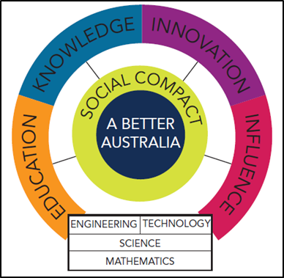Figure 1 Social compact depicting the STEM strategy

Source: Office of the Chief Scientist (2013).

The National Innovation and Science Agenda identifies a number of areas for improvement, including increasing the STEM and digital literacy skills of the workforce (Commonwealth of Australia 2015). Increasing STEM skills is often seen as critical to these kinds of initiatives and a way of dealing with technological change and the changing nature of work and industry. As the agenda states: ‘Innovation and science are critical for Australia to deliver new sources of growth, maintain high-wage jobs and seize the next wave of economic prosperity’.

#### North American approaches

As highlighted earlier, the United States’ National Science Foundation is credited to have created and described a STEM skill concept for the first time in the mid-1990s. The recommendations from their report were based on an intensive review of the state of undergraduate education in science, mathematics, engineering, and technology (SME&T) in America. The purpose of this review was to:

Consider the needs of all undergraduates attending all types of colleges and universities, addressing issues of preparation of school teachers in these fields, the needs of persons going into the technical work force, the preparation of majors in these areas, and the issue of science literacy for all.

(United States National Science Foundation 1996)

The overarching recommendation derived from this review was that all students have access to supportive, high quality education in science, mathematics, engineering, and technology, and all students learn these subjects by direct experience with the methods and processes of inquiry.

The Council of Canadian Academies (2014) defines STEM as the set of core knowledge, skills and capacities typically used for or acquired in STEM occupations and/or acquired in STEM fields of study and programs. Within this overarching definition, the panel conceptualised STEM skills in three different ways to describe the growth and evolution of STEM literacy and skills throughout the education system:

* fundamental skills for STEM, such as reasoning, mathematics, problem solving, and technological literacy needed for STEM literacy, developed from early childhood through high school
* practical STEM skills, generally associated with technical training, the trades, apprenticeships, and STEM diplomas or certificates including knowledge of established scientific principles and how to apply them to specific tasks or occupational roles
* advanced STEM skills include familiarity with scientific methods, conceptual design, as well as specialised STEM discipline-specific training, and are associated with education at the undergraduate level and above.

## Criticism of STEM focus

Other voices warn that many of the current STEM initiatives are not based on evidence and are short-sighted, too broadly conceived and disconnected, and as such are a waste of money (Blackley & Howell 2015; Charette 2013; Teitelbaum 2015; Williams 2011; Zakaria 2015).

In an exploration of the cycles of public anxiety about the STEM skills gap, Teitelbaum (2015) adopts a historic perspective and argues that frequently either the gap is exaggerated or a complex set of factors is being oversimplified, or that there is no gap at all. Shifts in workforce patterns and downward trends in economic indicators are seen as the rationales that provoke STEM action. It is not uncommon for technology education to be promoted in periods of economic downturn, for example, the Global Financial Crisis of 2007—09 (Williams 2011). Using Australia as an example, a clear correlation can be identified between the economic depressions of the 1890s, 1930s and 1980s and significant developments in technology education during these periods (Williams 2011).

Australian graduate numbers in STEM fields appear to indicate an oversupply rather than a shortage of people looking for work in these disciplines (Graduate Careers Australia 2015). The Productivity Commission (2016) highlighted the ‘STEM paradox’ in its recent report on digital disruption — a relatively high underemployment rate of STEM graduates at odds with STEM skills in high demand.

News about past and future job losses in previous ‘stronghold’ industries in Australia, such as automotive and mining, which traditionally employ a large number of STEM-educated and trained people, seems to contradict the call for more STEM graduates. Moreover, the recent CSIRO announcement on the shedding of about 350 jobs by 2017 due to budget constraints further adds to the jobs pool of the STEM-qualified workforce (ABC News, 8 March 2016).

It may pay to remember that more recently in Australia much attention was paid to 'green skills', whereby a strong focus on sustainability and environmentally safe practice in all training and education was advocated. Karmel (2010, p.1) provides an insightful caution:

To me, it seems that the whole green skills episode illustrates how easy it is for the system to be seduced by specific issues that are politically ‘hot’ … I am arguing that the 'green' movement potentially did the sector a disservice by distorting the way the education and training should naturally adapt as the economy develops. That is, the policy makers put too much emphasis on one specific issue. The fundamental skills required in the labour market evolve relatively slowly. It was wrong to think that we needed to shake up the system in any dramatic way.

### STEM and HASS

Not surprisingly, the political focus on STEM prompted a reaction from proponents of ‘non-STEM’ disciplines, commonly called HASS — humanities, arts and social sciences (figure 2) (Metcalfe et al. 2006; Tight 2012; Spoehr et al. 2010). STEM disciplines have been regarded as the primary source of innovation, with the contribution of the HASS disciplines being regarded as secondary (Spoehr et al. 2010). Spoehr et al. (2010) argue that technological innovations such as genetic modification and nuclear energy facilities are examples in which HASS disciplines are crucial in their discussion, evaluation and implementation.

Figure 2 HASS disciplines

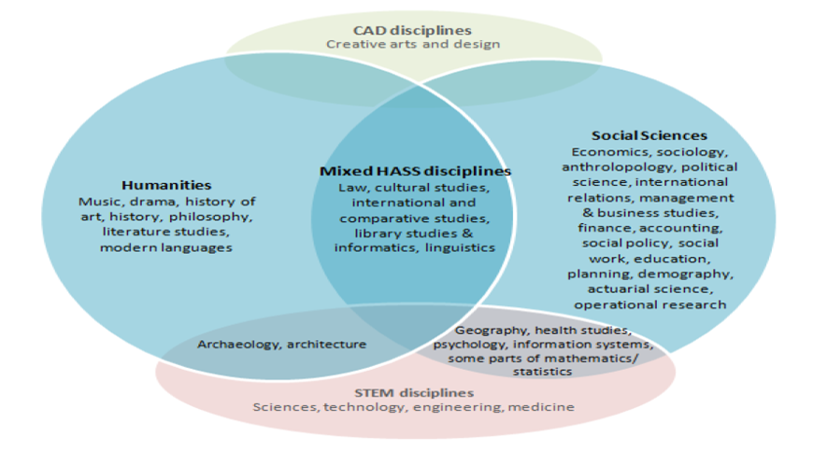

Source: London School of Economics and Political Science (2008, cited in Spoehr et al. 2010)

In its *The Future of Jobs* report, the World Economic Forum (2015, p.32) recommended a rethinking of education systems such that the value of both STEM and HASS are acknowledged:

‘…a legacy issue burdening formal education systems worldwide are [sic] the dichotomy between Humanities and Sciences and applied and pure training, on the one hand, and the prestige premium attached to tertiary-certified forms of education — rather than the actual content of learning — on the other hand.’

# Defining STEM skills - a conceptual approach

This section provides a conceptual framework beginning with a definition of STEM and STEM skills based on a review of the literature on STEM agendas, alternative descriptions of STEM skills and STEM education. The proposed approach is underpinned by a holistic skills framework in which STEM skills can be integrated and concludes with how Australia's vocational education sector can provide STEM skills.

Often asked is the question: what are the distinct functions of each of the disciplines that comprise the STEM concept and how do they logically interrelate. Figure 3 demonstrates how the various components of science, mathematics, engineering and technology relate to one another in support of societal needs. Scientists and mathematicians generate knowledge which engineers use to design technology, which in turn support needs by society and the pursuit of more scientific knowledge. For example, climate change presents a challenge to people’s daily lives on a global scale. To understand cause and effects and find solutions, scientists, mathematicians and engineers need to work together to inform politicians on how to address a myriad of issues associated with climate change. This may involve pollution-rich industries, rising sea levels or drought in agricultural regions, to name a few.

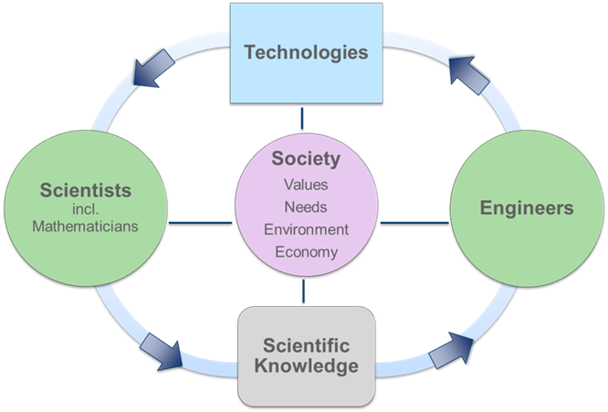Figure 3 How STEM components relate to each other

Source: Adapted from image at <http://[www.eie.org](http://www.eie.org)>.

## Definitions in the STEM family

STEM has grown to represent the family of concepts and classifications used for learning and working in the disciplines science, technology, engineering and mathematics. The focus is on a series of definitions which encompass this complexity by identifying the specific concepts and approaches encompassed by the term ‘STEM’ education.

### Definition of STEM

Box 1 Definition of the concept of STEM

STEM is an acronym of the disciplines of science, technology, engineering and mathematics. It has grown to be an umbrella term for a variety of concepts, classifications and initiatives pertaining to not only learning and working in science and technology-related disciplines but to a nation’s social contract and productivity. Principally, STEM learning is a multi- or interdisciplinary approach to learning, in which academic concepts are coupled with real-world lessons to make connections between school, community, work and business.

The STEM acronym is often used in place of a more appropriate or precise term, thereby leading to misunderstandings and its disconnection from related initiatives, as well confusion in the media and public policy. For example, a call for ‘increased funding in STEM education in schools’ could mean single maths and science subjects or interdisciplinary and integrated project work.

### Definition of STEM educational outcomes

The following overarching definition captures the meaning of STEM in relation to its intended outcomes, such as improved education, workforce capacity and a nation's productivity. It expands on a version originally developed by the STEM Education Caucus in the United States (2015).

Box 2 Defining STEM education outcomes

STEM is an acronym for the disciplines of science, technology, engineering and mathematics taught and applied either in a traditional and discipline-specific manner or through a multidisciplinary, interconnected and integrative approach. Both approaches are outcome-focused and aim to solve real-world challenges.

STEM education and training establishes relationships between the four disciplines with the objective of expanding people’s abilities by supporting technical and scientific education with a strong emphasis on critical and creative-thinking skills. This approach should be implemented from primary school to tertiary education, in order to provide a nation with four kinds of intellectual and skill based investment:

- teachers and educators who are able to successfully teach foundational STEM knowledge and skills in an integrated and inspirational manner

- scientists, engineers and digital specialists who research and develop the technological advances required for a nation's economic success and, ultimately, for solving global challenges

- technologically proficient workers who are able to create, design, support and operate complex and evolving technological innovations

- scientifically and technologically literate citizens who can critically examine/understand/respond to and improve the world around them.

In order to be useful for policy development and education initiatives, the definition has been reconsidered and expanded it into a subset of embedded definitions.

The content in and under STEM skills and knowledge lends itself to being categorised and deconstructed to represent a classification hierarchy. Figure 4 depicts the main concepts and identifies specific sub-topics.

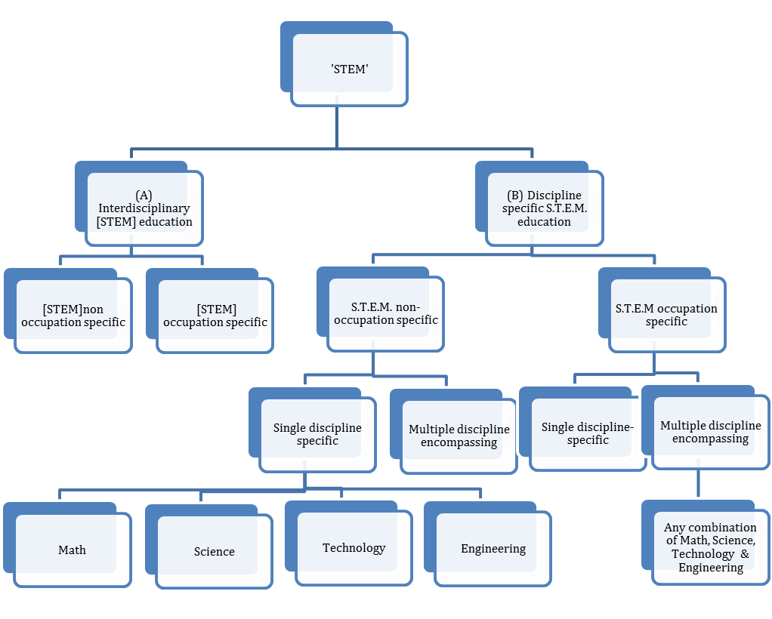Figure 4 Organigram of educational concepts in STEM

Note: [STEM] denotes interdisciplinary and integrated concept; S.T.E.M. denotes a list of single disciplines.

*Interdisciplinary or integrated STEM education* (box A in figure 4) can be explained as a fusion of disciplines and is used to understand and problem-solve real-world examples. This is accomplished with an understanding of societal needs, using critical and creative thinking skills, and research and experimentation skills. The term ‘STEM’ has evolved into a foundational competency based on inter-disciplinary knowledge of its founding disciplines, its defining characteristic being the ability to think outside the box and being able to build or construct solutions. This kind of education and learning is still rare and difficult to measure or monitor.

Interdisciplinary STEM can be further split up into occupation- and non-occupation-specific fields. This categorisation determines whether the mode of education is either focused on occupation-specific skills or on broader areas such as skills useful in day-to-day life or foundational skills for a variety of workplaces.

*In discipline-specific education* (science, technology, engineering, and mathematics or STEM disciplines) (box B in figure 4), the specific skills are of more technical or methodology nature and are related to the discipline in focus. These are not integrated STEM skills but scientific or mathematical or engineering skills. In other words, discipline-specific skills contribute to a suite of STEM skills. Discipline-specific skills can be combined where there is a need for a particular project or occupation, for example, scientific, mathematical and constructional skills for an engineering occupation.

Discipline-specific STEM education, too, can be further split into occupation- and non-occupation specific fields. This determines that the mode of education is either focused on occupation-specific skills or on broader areas such as those useful in day-to-day life or foundational skills for a variety of workplaces.

Discipline-specific education can either focus on a single discipline, for example, science, or a number of combinations of disciplines. The latter is different from interdisciplinary STEM education, as the boundaries of the STEM disciplines are kept intact. To illustrate the point in practice, an interdisciplinary STEM subject would be taught by integrating content from all disciplines into one real-life applied project (as offered by some schools as part of senior secondary certificate). A combination of discipline-specific subjects, on the other hand, applies to science, maths and IT teachers aligning their content so that students recognise a common aim or application across these subjects.

These differences at the finer detail level of the STEM education classification seem subtle on paper but are vast when applied in school and training organisations.

### Definition of STEM skills

After reviewing the literature we see merit in placing STEM skills into the category of technical skills, as distinct from cognitive and social or socio-emotional skills.

This corresponds with Cunningham and Villasenor’s (2016) model of skill grouping in relation to the labour market’s or employers’ demands. In this framework, technical skills are defined as the specific knowledge required for undertaking an occupation and which are often equated with job task skills. While the definition of technical skills overlaps with that of basic and higher-order cognitive skills, they merit separate treatment in policy-oriented discussions: to be addressed as a distinct entity and with their own specific education and training requirements. STEM skills can be taught separately from socio-emotional skills such as commitment and creativity.

Box 3 Definition of interdisciplinary STEM skills

STEM skills and knowledge are interdisciplinary in nature, being based on the integration of the formerly discrete disciplines of science, mathematics, engineering and technology. The aim of STEM skills is to enhance people’s competency in work and/or life and more generally respond to societal demands on technology.

STEM skills belong to the group of technical skills. They are a combination of the ability to produce scientific knowledge, supported by mathematical skills, in order to design and build (engineer) technological and scientific products or services. Although STEM skills overlap with basic and higher-order cognitive skills, they merit separate treatment in a policy-oriented context in order to target specific requirements in the education and labour market.

STEM skills and knowledge cannot be directly measured by current discipline-specific classifications.

These kinds of skills and knowledge are an ideal and are rare in real life. To illustrate this concept of an ideal, a person with interdisciplinary STEM competency might be expected to explain and analyse climate change, because they are familiar with the principles of science and mathematics; the person is also able to design tools for analysis and to engineer measurement technology and understand the use of other machinery and software in this area. This suite of knowledge would be complemented by an understanding of how this phenomenon affects society, and the person would understand how to collaborate with others to remedy adverse effects. In reality however the application of STEM skills and knowledge for designing and building solutions will be achieved through the collaboration of many people and teams.

For contrasting purposes we have included a definition for discipline-specific skills, as desired STEM outputs can be achieved by a combination of disciplines without the necessity to teach them in an interdisciplinary fashion.

Box 4 Definition of skills in the disciplines of science, mathematics, engineering and technology (S.T.E.M)

Discipline-specific S.T.E.M. skills and knowledge are based on the selection of and specific attention to the disciplines of science, mathematics, engineering and technology as distinct from other disciplines such as the humanities or arts. The aim is to enhance people’s capacity to understand and use disciplinary knowledge and skills in work or life. Scientific and technical skills are different from interdisciplinary STEM skills and knowledge as they are specific to a field of education. An occupation or a job can present a combination of skills and knowledge from various disciplines. These skills and knowledge are measurable via educational and occupational classification systems.

### Bringing it together – the ‘House of STEM’

To improve the understanding and application of the ‘STEM’ concept we have unpacked and identified the major components within using the analogy of a building with different rooms (figure 5). The term ‘STEM’ is the roof that covers the building which is based on a foundation of skills needed for everyday life such as literacy and numeracy.

To succeed at all levels of education and employment a sense of agency and self-efficacy is supported by socio-emotional skills such as curiosity and resilience. Further rooms are separately occupied by advanced cognitive skills such as critical and creative thinking and technical, occupation or discipline related skills. The overlapping nature of these categories are most pronounced at this level as for example scientific task work relies on analytical and logical thinking. None of these skills are exclusive to STEM but collectively they contribute to the concept of STEM. The four skill categories (‘rooms’) are targeted to satisfy the intended outcomes (e.g. educational experience, equity measures, career advice and productivity) of education in the STEM disciplines.

Figure 5 The House of STEM

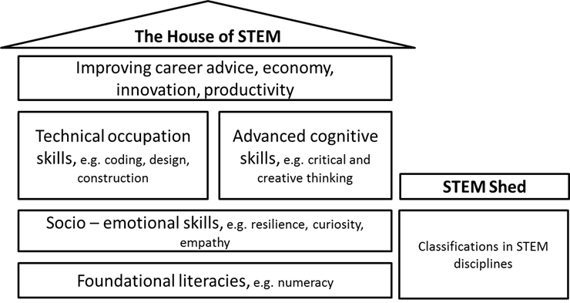

## Review of the underpinning literature

As there is a range of descriptions and definitions currently available in the literature and in the community, figure 6 provides guidance regarding where STEM skills are a focus and can be acquired in educational setting.

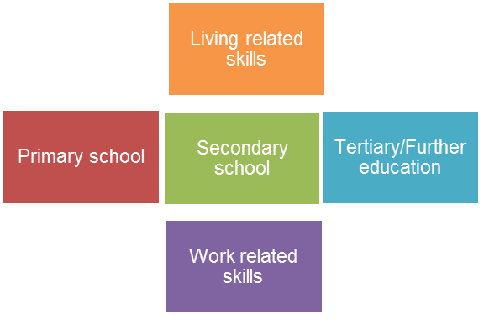Figure 6 Where STEM skills are discussed – places of education, living and work

### STEM agendas and desired outcomes

It is universally acknowledged that the discipline grouping, and STEM itself, is not used uniformly in international educational policy or practice. The acronym ‘STEM’ is used by a wide variety of interest groups with different agendas, such as governments, industry bodies, education providers and public media. Different concepts exist in education, pedagogy and workforce planning, which leads to different goals and implementation methodologies. For example, where a government aims to increase a nation’s productivity by funding more ICT engineering degrees, a school may want to increase its Year 12 retention rate to make maths subjects more achievable and engaging.

Due to its broad nature a commonly recognised and accepted description for STEM is:

STEM is defined as learning and/or work in the fields of science, technology, engineering and mathematics, including preliminary learning at school prior to entry into the specific disciplines. Marginson et al. 2014, p.30

The various anticipated outcomes of STEM education and modes of education are presented in box 5 as a summary of how these can be grouped into three major goals and two modes of education, and their relationships with one other.

Box 5 STEM goals of education and STEM modes of education

STEM education goals

'Scientific – technical' generic literacy

This goal is aimed at all people in their day-to-day lives. It involves a basic scientific understanding of phenomena, the use of day-to-day technology and financial literacy. This is ideally taught through integrated interdisciplinary STEM education using real-life examples via problem-solving and enquiry-based learning.

‘Scientific – technical' workplace-based capacity

This goal is aimed at all people in preparation or upskilling for their day-to-day 'technical' working routines. It involves basic to advanced technical skills such as operating computerised software and hardware in various forms, either in different work environments, such as the office, or in the production line. This may include the necessary understanding to troubleshoot or process-improve. This is ideally taught by imparting a basic understanding of technological processes and the operation of computerised technology.

STEM project or occupation-specific capacity

This goal applies to workers trained specifically in the disciplines of science, mathematics, engineering and technology. This includes discipline-specific skills to improve or operate complex scientific and technical work or projects. This is ideally taught by both STEM education modes: interdisciplinary to understand the 'bigger' picture, for example, the societal implications of introducing driverless cars onto the roads; and discipline-specific to enable work on a particular aspect of a STEM-specific outcome or product, for example, the software algorithm in a driverless car.

STEM modes of education

Integrated, interdisciplinary STEM education

This is where at least two or more disciplines are taught in combination to provide a holistic education in science and technology-focused environments. It is the synergistic fusion of many disciplines intro one new framework for teaching and learning across and beyond disciplines with an emphasis on scientific enquiry and problem-solving, for example, STEM as a new subject in schools teaching science and technology in combination with real-world examples and special pedagogical guidance.

Traditional single-discipline education in science, mathematics, engineering and technology

This is where STEM is only an umbrella term or convenient abbreviation of four disciplines with their disciplinary distinctions intact. This involves traditional learning with an emphasis on discipline-specific knowledge and technical skills for particular tasks, for example, in schools these would be subjects such as maths, science, coding or technology.

### Variety of STEM skills

The section investigates the specific skills that are commonly associated with STEM competency. Skills demanded at work can be grouped in four broad categories (Cunningham & Villasenor 2016):

* basic information-processing skills
* advanced cognitive skills
* technical job-specific skills
* socio-emotional skills.

Descriptions of STEM skills usually offer a combination of the last three of the above skill groups. One method for identifying STEM skills and knowledge is to establish the association between occupations in the science and technology sector and the specific attributes attached to them. Carnevale et al. (2011) explains that, in the United States, STEM competencies, including skills and knowledge are based on a detailed occupational database of incumbent workers (O\*NET). Carnevale et al.’s (2011) STEM competencies are grouped into cognitive and non-cognitive competencies (tables 1a and 1b).

Table 1a Cognitive STEM competencies

|  |  |  |
| --- | --- | --- |
| Knowledge | Skills | Abilities |
| Production and processing | Mathematics | Problem sensitivity |
| Computers and electronics | Science | Deductive reasoning |
| Engineering and technology | Critical thinking | Inductive reasoning |
| Design | Active learning | Mathematical reasoning |
| Building and construction | Complex problem-solving | Number facility |
| Mechanical | Operations analysis | Perceptual speed |
| Mathematics | Technology design | Control precision |
| Physics | Equipment selection |  |
| Chemistry | Programming |  |
| Biology | Quality control analysis |  |
|  | Operations monitoring |  |
|  | Operation and control |  |
|  | Equipment maintenance |  |
|  | Troubleshooting |  |
|  | Repairing |  |
|  | Systems analysis |  |

Source: Carnevale et al. (2011).

Table 1b Non-cognitive STEM competencies

|  |  |
| --- | --- |
| Work interests | Work values |
| Realistic | Achievement |
| Investigative | Independence |
|  | Recognition |

Source: Carnevale et al. (2011).

In Australia, Deloitte Access Economics (2015) summarised these competencies for their Australian STEM Employer Survey and described STEM skills as follows, acknowledging that consensus could not be reached among the survey panel and employers (table 2). Although many of the skills are not considered to be exclusive to STEM, they were identified throughout the survey consultation sessions as important skills for people working in STEM fields to possess. It was also noted that not every STEM person would possess each of these skills, especially those more relevant to specific occupations, such as programming (Deloitte Access Economics 2015).

Table 2 Example of STEM skills as defined in a STEM employer survey

|  |  |
| --- | --- |
| STEM skills | |
| Occupation-specific STEM skills | Active learning (i.e. learning on the job) |
| Knowledge of legislation, regulation and codes | Complex problem-solving |
| Programming | Creative problem-solving |
| System analysis and evaluation | Design thinking |
| Time management | Critical thinking |
| Interpersonal skills | Lifelong learning |

Source: Deloitte Access Economics (2015).

In his blog, ‘OECD skills and work’, Montt (2016) raised the apparent discrepancies in job advertisements between employers’ emphasis on technical skill descriptions and what they really value in their job applicants, noting that employers pay special attention to soft skills when hiring. Cunningham and Villasenor (2016, p.i), who carried out a meta-analysis of 27 surveys measuring the skills required by employers, as reported by the employers themselves, found a remarkable consistency across the world in the skills demanded by employers.

The researchers concluded that while employers value all skills sets they particularly value socio-emotional skills and higher-order cognitive skills. These results are robust across region, industry, occupation, and education level.

However, this does not mean that technical or basic skills are less important than socio-emotional skills for employers, but rather that they are taken for granted in the preselected group of candidates (Jackson 2007). Given two candidates with similar technical skills, an employer may be inclined to choose the candidate with stronger socio-emotional or analytical skills.

In the Australian context, West (2012) describes the focus of STEM education as preparing students with the knowledge and skills to function in scientific and technical roles, which are typically in ‘stem core’ settings such as academic research organisations and technology-intensive firms in engineering and computing. Table 3 highlights the STEM capabilities identified by graduates from STEM disciplines when asked what they perceived as providing most value from their science background (Harris 2012 cited in West 2012).

Table 3 STEM capabilities as per Australian graduates from STEM disciplines

|  |  |  |
| --- | --- | --- |
| Knowledge | Skills | Way of thinking |
| Scientific method, science as a process; STEM subject knowledge; foundational STEM knowledge and vocabulary | Research, learning and enquiry; problem-solving; technical skills, including observation, experimentation and quantitative skills; presentation and other work practices | Analytical, logical, critical thinking, systematic, structured; questioning, evaluative, independence, reasoning, sceptical; objective, evidence-based, rational; open-minded; innovative, creative, lateral |

Source: Harris (2012).

### Integrated STEM education

A comprehensive country comparison undertaken by the Australian Council of Learned Academies (Marginson et al. 2013) compares science, technology, engineering and mathematics education across the globe. This project investigated what other countries are doing to develop participation and performance in the disciplines of science, technology, engineering and mathematics. The key findings on the educational initiatives from countries assessed to be strong in STEM education are presented table 4.

Table 4 Indicators of strong STEM education indicators based on country comparisons

|  |  |
| --- | --- |
| Education-related | |
| **Early childhood**  Founding STEM competence in early childhood and primary education | **Breadth and depth**  Strong participation in the STEM disciplines through learning in both breadth and depth and covering the full spectrum of prior student achievement levels |
| **Inquiry-based learning**  Curriculum focus on innovation, creativity and reasoning, accompanied by a strong commitment to disciplinary knowledge | **STEM and non-STEM bifurcation**  Firm bifurcation between a comprehensive STEM track, and a non-STEM track in the final two years of secondary education. |
| **Compulsion**  Senior secondary mathematics and science education compulsory | **Standardised testing**  Standardised testing of student achievement in STEM |
| **Uni prerequisites**  Comprehensive prerequisite requirements for university programs  requiring advanced STEM knowledge | **Technical school and institutes**  Availability of STEM-heavy technical and vocational schools and tertiary institutes, alongside academic secondary schools and universities |
| **Engineering degrees**  High participation in tertiary engineering degrees | **PD**  Professional development of mathematics and science teachers |
| **Teacher status**  High status of teachers, and high entry level into the profession | **Educators’ salaries**  Differential salaries or incentives for teachers in the STEM area |
| **Out of field teaching**  No or minimal ‘out of field’ in science and maths | **Partnerships**  Important role of partnerships with science organisations, business and industry in supporting innovation in school mathematics and science |
| Labour market-related | |
| **Destinations**  Data on destinations of STEM graduates in the first 5–10 years after graduation | **Different roles of STEM education**  Identification of the respective roles of STEM education and training in relation to:  • work specific to the STEM qualification  • work that is outside field but within STEM  • work in occupations with no specific STEM requirements that may nonetheless draw on STEM  graduates’ skills and knowledge in a more generic manner. |

Source: Marginson et al. (2013).

STEM has come to be recognised as a meta-discipline — an integration of formerly separate subjects into a new and coherent field of study (Vasquez 2015). Lantz (2009) refers to STEM as ‘creation of a discipline based on the integration of other disciplinary knowledge into a new ‘whole’’. Other definitions go further, with Sanders (2009) defining ‘integrated STEM education’ as teaching and learning between two or more STEM subjects or between a STEM subject and a non-STEM subject such as ‘the arts’. He also describes a pedagogical approach of ‘purposeful design and inquiry’, which combines technical design with scientific inquiry. The rationale for this was that, in the world outside schools, ‘design and scientific inquiry are routinely employed concurrently in the engineering of solutions to real-world problems’ (Sanders 2009, p.21).

However, aligning STEM education initiatives with the needs of a STEM-skilled workforce presents a shortcoming. A number of educational researchers argue that STEM education was developed from the economic rationale of increasing the pool of engineers and scientists to maintain global economic dominance rather than from an educational rationale and then foisted upon educators to implement (Blakeley et al. 2015; Kuenzi 2008; Pitt 2009; Williams 2011). Williams (2011) concludes that calls for action for an integrated school curriculum are broad and undefined. He warns STEM educators about a number of challenges that need to be resolved, which include the rigidity of the school curriculum structure; lack of coordination of existing STEM activities; STEM approaches having both general and economic rationales; and STEM disciplines being based on different epistemological assumptions.

During the early 2000s, uncoordinated STEM educational projects burgeoned in the United States and the United Kingdom, with large amounts of money spent (Williams 2011). Blackley & Howell (2015), point to many challenges that need to be surmounted for integrated STEM education to succeed, perhaps one of the most difficult being the lack of proof-of-concept. That is to say, there is no evidence of positive outcomes with which teachers can be enticed to adopt the integrated STEM education approach.

A key issue to be addressed is the positioning of teachers and students in a regime of standardised testing (for example, NAPLAN or PISA) in relation to selected subjects such as mathematics, science and literacy. As long as the results of the tests impact upon school funding and school image, and teacher performance pay, priority will understandably be given to traditional subjects and not to new subjects or approaches such as STEM (Blakeley et al. 2015).

### Holistic skills framework

Many types of skills have been erroneously considered to be part of a suite of STEM skills or even called STEM skills when they belong elsewhere. For clarity in analyses, debate and policy work, we advise the use of the skill definitions contained within holistic skill frameworks. The most appropriate frameworks address foundations for work, employability and the future of work. Here we draw them together as they are form a vital part of our synthesis.

#### Foundation skills

‘Foundation skills’ is the term that Australian Government agencies have started to use and these are based on two skills frameworks: the Australian Core Skills Framework and Core Skills for Work Developmental Framework (Department of Education and Training 2016a). Together they cover the five core skills of learning, reading, writing, oral communication and numeracy, along with employability skills, the core non-technical skills identified by Australian employers as important for successful participation in work (Department of Education and Training 2016a).

#### Employability skills important for employers

Employers and educators have different understandings of the types of skills valued in the labour market. Earlier we noted that Cunningham and Villasenor (2014) propose four skills set definitions: socio-emotional, higher-order cognitive, basic cognitive, and technical skills. Their categorisation is based on the economics and psychology literature and a global meta-analysis on the skills required by employers. In this model STEM skills were placed under technical skills.

The skills most demanded by employers — higher-order cognitive skills and socio-emotional skills — are largely taught and refined in secondary school, which suggests the desirability of a general education until these skills are formed (Cunningham & Villasenor 2014). Rather than early technical training, education systems need to ensure that the foundational or enabling skills have formed to allow for technical skill acquisition. The VET sector’s role in developing foundation and employability skills is discussed in the following chapter.

#### The future

The term ‘twenty-first century skills’ refers to a broad set of knowledge, skills, work habits, and character traits that are critically important to success in today’s and tomorrow's world, particularly in secondary schools, tertiary education and workplaces (Binkley et al. 2012; Great School Partnerships 2015). Twenty-first century skills can be applied in all academic subject areas and in all educational, career, and civic settings throughout a student’s life. Resonating with foundation skills but casting the vision of working and living much broader, the skills can be grouped into four categories, as shown in table 5.

Table 5 Twenty-first century skills

|  |  |  |  |
| --- | --- | --- | --- |
| Ways of thinking | Ways of working | Literacy tools for working | Living in the world |
| Creativity and innovation | Communication | Information literacy (includes research on sources, evidence, biases, etc.) | Citizenship – local and global |
| Critical thinking, problem-solving, decision-making | Collaboration (teamwork) | ICT literacy | Life and career |
| Learning to learn, metacognition |  |  | Personal and social responsibility – including cultural awareness and competence |

Source: Binkley et al. (2012)

The twenty-first century skills framework appears to display all of the desirable literacies and employability skills desired by employers — although they are often confusingly assumed to be STEM skills as well. Appendix B provides more detail on the twenty-first century skills framework.

## How the VET sector provides STEM skills

The VET system has a great deal to offer in relation to foundational literacy and technical skill development and provides in effect the major share of the technology and engineering workforce in Australia, and hundreds of technically related qualifications to choose from.

The best of the VET sector delivers electricians, cardiovascular technologists, machinists, aircraft mechanics, auto technicians, dental hygienists, mechatronics engineers, air ambulance paramedics with skills that build homes and bridges, perform preventive and primary health care … keep complex IT networks running, and operate … computer controlled tools and robots.

(Fowler 2016)

### VET provides foundational and technical training

A key strength of the Australian VET system is the existence of linkages between VET and the labour market, linkages that allow employers and individuals to meet their training and skill needs. These comprise institutional linkages and formal and informal processes that lead to skills development (Knight & Mlotkowski 2009). In addition, the VET system has the capacity to respond actively to the dynamics of the labour market, for example, through occupational mobility, combining generic and specific skills, and enabling individuals to choose their training.

VET is particularly relevant to occupations involving intermediate-level knowledge and skills in the technical workforce sector in different ways: for traditional trades and technicians, there is a link to a specific VET qualification or apprenticeship, whereas many of the non-trade-related areas of study such as information technology and accountancy develop more generic skills that can apply in a wide range of occupations or industries (Knight & Mlotkowski 2009).

The strong emphasis on competency-based training allows employers and individuals to focus on skills that meet specific needs. Individuals and employers make extensive use of short focused training programs containing many specific skills; for example, technically based skills sets can be developed without the need for an extended (and costly) education or training program. In vocational education in particular, recognition of prior learning formally recognises skills and knowledge already held and as such makes skills relevant to measurable STEM outputs. Apprentices undertaking training towards occupations such as building and engineering technicians and agricultural, medical science technicians and motor mechanics were among the top five groups taking advantage of the recognition of prior learning pathway in 2012 or 2013 (Hargreaves & Blomberg 2015).

The VET system pays special attention to the integration of generic or foundational skills (for example, numeracy, communication and creative thinking) into the competency-based training framework (Knight & Mlotkowski 2009). This is done by incorporating foundation skills into training packages and the recent release of a specific training package ‘Foundations skills’.

Vocational education and training may be most affected by the automation of low to medium-skilled jobs in the technology sector. As shown earlier, job growth data by the Department of Employment for 2020 indicate that job prospects are looking most bleak for machine operators, drivers and personal assistants. In the future, training for these occupations may need to be supplemented either by broader training goals, allowing people to transfer their skills to more available jobs, or by additional and targeted training opportunities.

### Potential areas for STEM skill development

#### STEM output and innovation

STEM outputs, such as new or improved technology and underpinning skills, often comprise a substantial component in the development and creation of innovative services and products. Many of the observations on the role of VET in innovation are applicable to the outputs and services of the science and technology sector.

Stanwick and Beddie (in Curtin, Stanwick & Beddie 2011) conclude that innovation extends far beyond traditional notions of research and development, to include operational and organisational processes and marketing. As a consequence there are more broad-ranging implications for the skills required in innovation. These skills have been identified to be ‘technical and scientific and research skills’, that is, STEM skills, as well as non-technical skills such as marketing, finance and business management, in combination with ‘soft’ skills (cognitive and behavioural).

The primary form of innovation in Australia is incremental, with tradespeople and technicians identified by firms as critical to their innovation efforts. Technicians and trades workers perform a variety of skilled tasks, applying broad or in-depth technical, and trade or industry-specific knowledge, often in support of scientific, engineering, building and manufacturing activities (Toner 2011). A key role of these occupations is to design, install, commission, adapt, operate and maintain equipment, software and other technologies. Tradespeople and technicians comprise around 45% of the business research and development workforce, both in Australia and overseas (Toner 2011).

#### National Innovation and Science Agenda – without VET?

The current National Innovation and Science Agenda was released with fanfare in 2015. Urging businesses to create new products, processes and business models, the initiative poured 1.1 billion dollars into projects such as the CSIRO Innovation Fund and Biomedical Translation Fund, expanded opportunities for women to participate in STEM research and industries, and promoted STEM literacy (Australian Government 2015). The latter mainly involves boosting existing science-related activities such as the Prime Minister’s Prize for Science or events in National Science Week. (Note the use of ‘STEM’ when ‘science’ is actually meant).

Similar to the treatment of STEM agendas, the current innovation agenda is conceptually narrow as it focuses on stimulating collaboration between academics employed in research institutions and research and development production professionals in industry and does not address the need for improved collaboration between enterprise and the tertiary sector, including VET, in general (Fowler 2016).

#### Generic or foundational skills

STEM education aims to build scientifically and technologically literate human capital with the capacity to critically examine/understand/respond to and improve the world around them. There is a substantial overlap of STEM skills with the various components of functional literacy, such as numeracy, scientific literacy and civic literacy, and the so-called employability skills such as communication skills and teamwork skills. The Productivity Commission (2016) recommends that STEM skill initiatives focus on delivering a high competency in literacy and numeracy at the school level by reviewing teaching methods and improving information on employment outcomes for students to help inform student choice.

In Australia a different strategy has been used to target these foundational skills — the National Foundation Skills Strategy for Adults. It would be desirable to either supplement the existing strategy with foundational STEM literacy or create a related strategy based on the existing foundation strategy for Australians of all ages.

The Council of Australian Governments’ National Foundation Skills Strategy for Adults is a ten-year framework that brings a national focus to improving the education and employment outcomes for working-age Australians with low levels of foundation skills (language, literacy, numeracy and employability skills) (Department of Education and Training 2016a). Through the strategy, all Australian governments have committed to the aspirational target of two-thirds of working-age Australians having, by 2022, literacy and numeracy skills at a satisfactory level (level 3 or above).

Foundation skills encompass both the core skills literacies and learning contained in the Australian Core Skills Framework and the employability skills of the Core Skills for Work Developmental Framework (Department of Education and Training 2016a). Foundation skills exist on a continuum from a very basic level to a highly developed and specialist level. It is at the latter level where a foundational STEM education concept could be based.

A training package that is solely dedicated to the integrated delivery of foundation skills and vocational skills and knowledge is also available. The FSK or Foundation Skills Training Package differs from all other training packages in that it is designed to work in conjunction with them to support the achievement of vocational education and training pathways (Innovation & Business Skills Australia 2013a). All units of competency in this training package describe skills and knowledge in relation to a work context and are designed to support the achievement of vocationally relevant competencies. While these skills and knowledge are already described or implied in vocational competencies in other training packages, many learners require more support to develop the required foundation skills through their vocational training programs (Innovation and Business Skills Council 2013b). In April 2016, changes to the Certificate IV in Training and Assessment (TAE) included the addition of a core unit of competency, Address adult language, literacy and numeracy skills, to equip teachers in VET with the skills and knowledge to identify and address language, literacy and numeracy (LLN) skill requirements of the training and work environment (Australian Industry Skills Committee 2016).

#### More recently, to assist VET teachers, the Department of Education and Training (2016b) has released a pilot of an interactive online Foundation Skills Assessment Tool (FSAT) to identify and measure an individual’s foundation skill levels (English language, literacy and numeracy skills as well as employability skills).Training package content and assessment

Since the inception of training packages, there has been a requirement to embed language, literacy and numeracy (LLN) in the packages, which provides another linkage point with the provision of STEM skills. This could be done in the higher-level qualifications or skills sets (certificate IV and above). A similar approach to that utilised in LLN could be adopted, such that technical and thinking skills from science, mathematics and engineering were included, with the aim of addressing challenges in the workplace, for example, process improvement, innovative products and services or establishing a successful business.

#### Vocational streams

Foundational skills for the science and technology sector and cross-disciplinary STEM skills may fit more comfortably in broadly delivered qualifications. New research is proposing the use of ‘vocational streams’ and ‘productive capabilities’, which focus on the broad-ranging knowledge, skills and attributes that individuals need for a number of occupations within an industry (Yu et al. 2013, Wheelahan et al. 2015). It has long been recognised that the connections between qualifications and work are complex.

As Alan Finkel concludes in the Office of the Chief Scientist’s 2016 report, *Australia’s STEM workforce*:

The most striking finding in my mind is the range of occupations that people with STEM qualifications have pursued. We have people with physics doctorates working as financial analysts. We have chemistry graduates running farms and making wine. We have ICT graduates planning cities. There are no limits on what a STEM graduate can do, and we shouldn’t impose them.

Jobs created in the future will be different from those of the past. It is this reality that has long informed interest in generalist qualifications such as the arts, business and science in the higher education sector. In vocational education and training it informs the ongoing interest in ‘generic’ or ‘employability’ skills.

In their research into vocational streams Wheelahan et al. (2015) pose the question:

Is the answer to Australia’s skills paradox more ‘generalist’ degrees and more ‘generic’ or ‘employable skills’ in VET qualifications? How realistic is this solution? Take ‘problem-solving’ skills for example. Such skills are not acquired or applied in the abstract … The irony is that seemingly ‘general skills’ often require understanding the specific context for each situation — not so much the specific requirements of a particular job but rather a range of identifiable practices or other contexts relevant to the domain.

The researchers suggest reforming qualifications such that they prepare the learner for a number of related occupations rather than for a single occupation. The majority of current VET qualifications are based on competency-based training, which assumes a direct link between qualifications and jobs: individuals are trained for specific workplace tasks, and VET qualifications codify this, although the researchers note that the reality is very different (Wheelahan et al. 2015). Assuming a direct linear connection may exacerbate skills mismatches in some occupational fields because narrowly focused qualifications and training are the result (Wheelahan et al. 2015).

The applicability of vocational streams is not uniform across sectors. Whereas strong examples of potential vocational streams may exist in areas such as allied health and in nursing in health care the outlook on engineering is different. There appears to be limited scope to frame the development of engineering capability around a vocational stream due to specialised education and training and traditional silos in both the trades and professional engineering (Yu et al. 2013). In this case Yu et al. (2013) conclude that the vocational stream needs to be defined more narrowly, for example, as civil engineering, electrical engineering and mechanical engineering streams.

#### P-TECH and higher apprenticeships

Partnerships between schools and industry provide opportunities for students to engage with the world of work to better understand the relevance of their learning to jobs and post-school pathways. The STEM-focused P-TECH (Pathways in Technology Early High School) pilot will test and adapt key elements of this innovative United States approach to education—industry collaboration in the Australian context (Skilling Australia Foundation 2016). A strong relationship between the school, industry and post-school institution(s) is necessary to support a seamless pathway and continuity of support for students as they transition from school to further education to complete their post-school qualification (Department of Education and Training 2016c).

The P-TECH model will offer students studying for their senior secondary certificate an industry-supported pathway to a STEM-related diploma, advanced diploma or associate degree. It is likely that the achievement of the qualifications will involve schools partnering with other education providers (TAFEs/registered training organisations or universities) to deliver elements to the P-TECH learning (Skilling Australia Foundation 2016).

Higher apprenticeships are viewed as mechanisms for meeting skills gaps and shortages in STEM-related occupations and for providing alternative work-based pathways to the professions. Designed to meet employers’ needs for higher-level skills, higher apprenticeships aim to deliver high-grade tradespeople and technicians who possess practical skills in combination with a higher education involving a range of on- and off-the-job training (Guthrie & Dowling 2012). The United Kingdom introduced higher apprenticeships in 2009, principally in the engineering and IT sectors.

In the United Kingdom in 2016 a report was released on future growth of degree apprenticeships, whereby apprenticeships were brought into the higher education sphere (VET Development Centre 2016). Degree apprenticeships are already available in digital, automotive engineering, banking relationship manager, construction, surveying, electronic systems engineering, aerospace engineering, aerospace software development, defence systems engineering, laboratory science, nuclear, power systems, and public relations.

Currently, the majority of apprenticeships in Australia do not have a strong immediate path into higher education (Guthrie & Dowling 2012). A study of issues relating to the lack of apprentice movement between vocational or further education and higher education in the United Kingdom (Thomas, Cox & Gallagher 2012, cited by Guthrie and Dowling 2012) suggests that contributing reasons include: a low awareness of their higher education options; a dependence on their employer and their attitudes to taking such pathways; and their level of higher education readiness. In September 2016 the Australian Government commenced an industry-led, higher apprenticeship trial with opportunities to complete diploma or associate degree qualifications in areas including commerce, technology and advanced manufacturing (Department of Education and Training 2016d).

# Defining STEM skills - a data driven approach

This section provides an operational or data-driven framework beginning with a synthesis of common classifications to group and measure STEM education and occupations, followed by issues with selecting appropriate classifications and a section on STEM workforce statistics in Australia. It finishes with selected vocational education statistics in STEM related education using data collections from the National Centre for Vocational Education and Research (NCVER).

## Defining STEM skills via standard classifications

Discipline-specific skills can be measured or estimated in a variety of different ways. The two most commonly employed measures are the qualifications that individuals have previously acquired; and the occupational classification of the jobs they do. While these can be relatively simple to measure, they are not necessarily relevant to the actual skills required by employers and used by individuals.

In Australia, the highest number of science and technology-related fields of education are found in the ASCED[[3]](#footnote-3) broad fields of:

* 01 NATURAL AND PHYSICAL SCIENCES
* 02 INFORMATION TECHNOLOGY
* 03 ENGINEERING AND RELATED TECHNOLOGIES
* 04 ARCHITECTURE AND BUILDING
* 05 AGRICULTURE, ENVIRONMENTAL AND RELATED STUDIES
* 06 HEALTH (some sub-categories)
* 07 EDUCATION (some sub-categories).

However, there are also a few sub-categories found in MANAGEMENT AND COMMERCE and PERFORMING ARTS.

The highest number of science and technology-related occupations will be found in the following ANZSCO[[4]](#footnote-4) major groups:

* 1 MANAGERS
* Sub-major groups: Farmers and Farm managers; Specialist managers
* 2 PROFESSIONALS
* Sub-major groups: Design, Engineering, Science and Transport professionals; Education professionals; Health professionals; ICT professionals
* 3 TECHNICIANS AND TRADES WORKERS
* 8 MACHINERY OPERATORS AND DRIVERS.

For the purpose of overviews and generalisations, people with STEM discipline-related skills can be counted at an aggregated level but when it comes to occupations and skills in demand, information needs to be measured at the most detailed level of educational and occupational classification. Further information about the structure of classification systems is found in appendix A.

### When broad levels of classifications are not enough

Any summary groupings under 'STEM disciplines' or 'science', 'technology', 'engineering' or 'mathematics' for policy on workforce management or career advice are not useful. Groupings of occupations within a category by comparison with a single occupation can provide a totally different picture of supply and demand. On average, 'scientists' overall may be in demand in Australia, when in reality specific occupational skills or occupations such as agricultural scientists and medical laboratory scientists are in demand, but life scientists, geologists and environmental research scientists are not (Skilled Occupation List [SOL] by Department of Immigration and Border Protection 2016).

The following offers a further example that highlights the need for detail and the relevance of specific skills: a highly specialised theoretical mathematician is per se a strong example of STEM discipline occupation but their knowledge and skills may not be relevant for a technical or innovative output such as required for solar propelled car. On the other hand, automotive electricians with relevant skills to the product will be in high demand.

Calls such as ‘we need more STEM workers’ or ‘we need more chemists’ are counterproductive: demands must be presented specifically, for example, ‘we need about 600 more food technologists to create safe and new food flavours over an estimated duration of 10 years’. Formulating the precise requirements requires strong collaboration between market research, workforce development and industry agencies.

Therefore, matching statistics or metrics against all science and technology classification codes can only provide a ballpark of potential STEM discipline skills and knowledge. The ‘true’ skill-relevant statistics in education, training and occupations will be substantially lower and harder to quantify.

### Using the O\*NET application

Our research has indicated that the most appropriate method for identifying and quantifying skills — and giving the best approximation — for STEM discipline-related occupations is via the survey-based US occupational database O\*NET. O\*NET, auspiced by the US Department of Labor, Employment and Training, uses an occupational coding structure very similar to ANZSCO. (Appendix A describes the features of the application in greater detail).

O\*NET information can be mapped to other countries’ occupational classifications, as demonstrated for the United Kingdom (Dickerson et al. 2012; Hillage & Cross 2015). It was found that there is considerable scope for exploiting the O\*NET database to help fill important gaps in identifying and researching skill demand and linking skill demand to productivity at macro and micro level. It could also support better careers information for labour market entrants, people changing jobs and more efficient job design in the workplace (Hillage & Cross 2015). A first attempt to map United States occupations to Australian standard classification occupations is currently underway, with the opportunity to tap into O\*NET’s rich information databank in the future (Dickerson 2016, pers. comm.).

## Review of the underpinning literature and data

### Selecting the 'right' categories

The notion of STEM competency is conceptually complex, particularly in terms of quantifying or defining specific STEM skills, identifying the occupations to which they apply, and recognising their shortages or oversupply.

Although educational and occupational classifications systems are readily available for the analysis of fields of education and types of occupation – and thus the identification of STEM occupations — there is an issue with standard classification systems, and this is deciding which science and technology orientated disciplines and sub-disciplines are ‘in’ and which are ‘out'. Many of the operational definitions of STEM in use rely on the choice of fields of education and occupations in various classification systems.

Ultimately, these definitions rely on these classifications and the particular choice of fields within those classifications. Fields can be included in one definition, but not in another (for example, health-related fields) and this means data are not consistent or comparable.

Moreover, although conceptual definitions and classification-driven definitions of STEM fields are somewhat related, they reflect different aspects of STEM. Most notably, in data-driven definitions (that is, those that use classifications) the notion of separate disciplines is reinforced by splitting STEM into its components of science, technology, engineering and mathematics, and further into their sub-disciplines.

Different countries have different classification systems, making country comparisons of science and technology-related education and occupations not straightforward. The major fields of education/study and training are fairly similar across countries and comprise the following fields, which are usually attributed to science and technology-related study (International Standard Classification of Education, UNESCO Institute for Statistics 2011):

* natural sciences, mathematics and statistics including environmental sciences
* information technology
* engineering, manufacture, construction
* agricultural, forestry, fishery and veterinary.

As in other countries, different agencies in Australia make their own interpretation of which ASCED fields of education best approximate STEM skills and knowledge (table 6).

Table 6 STEM fields of education (ASCED) in Australia

|  |  |  |  |  |
| --- | --- | --- | --- | --- |
| Major field of education | ACOLA 1 1 | ABS 2  Office of the Chief Scientist 5  Deloitte Access Economics 6 | ACOLA 2 3 | NCVER 4 |
| Natural and physical sciences | x | x | x | x |
| Information technology | x | x | x | x |
| Engineering and related technologies | x | x | x | (x) |
| Architecture and building |  |  | x | (x) |
| Agriculture, environmental and related studies |  | x | x | (x) |
| Health |  |  | x | (x) |

Notes: ‘x’ includes all sub-fields; ‘(x)’ does not include all sub-fields.

Sources: 1 Healy et al. (2013); 2 ABS (2013); 3 Office of the Chief Scientist (2012); 4 Deloitte Access Economics (2014); 5 Freeman (2013b); 6 Anlezark et al. (2008);

Education researchers from the University of Wisconsin aptly summarise the issue of how poorly defined acronyms shape workforce policy in the United States but the key messages ring true as a global statement (Oleson et al. 2013):

* Estimates of STEM jobs in the United States can differ five-fold, depending on which occupations are included under the STEM umbrella and how occupations are defined. This results in wildly disparate projections for jobs and wages, and the required education for what may appear to be a single cluster of occupations (that is, STEM).
* Many analysts overlook blue-collar occupations that require STEM knowledge, which results in: under-counting the number of STEM-related jobs; inflating wage estimates for the STEM job category; and underestimating the value of non-baccalaureate postsecondary education.

Issues arise over the inclusion or exclusion of applied or derived STEM fields such as health care, psychology and social science and the level of education (below or above bachelor degree) (Charette 2013; Oleson et al. 2014; Rothwell 2013).

In Australia, a comparison of the number of people with STEM qualifications, as identified by the ABS and the National Institute for Labour (Healy et al. 2013), makes differences apparent (table 7).   
In original publications, classifications and the source of data are clearly stated, but often this important detail gets lost on the way into different reports and news headlines.

Table 7 Contrasting number of people with STEM qualifications based on different classification definitions

|  |  |  |  |  |  |
| --- | --- | --- | --- | --- | --- |
| Organisation | Data source | Field of education | Level of education | Number of people | Proportion of total population (>15 yrs in 2011) |
| ABS | ABS Survey of Learning and Work 2010–11 | NPS, IT, ETRS, AERS | AQF certificate III and higher | 2 718 300 | 15% |
| NILS | ABS Census 2011 | NPS, IT, ETRS | AQF bachelor and higher | 651 000 | 4% |

Notes: NPS = Natural and physical sciences; ERT = Engineering & Related Technologies; AERS = Agriculture, environment and related studies.

### STEM workforce statistics in Australia

Based on STEM statistics from the ABS Survey of Learning and Work, 2010—11 (most current data, update available in 2017—18), the majority of qualifications are obtained in the field of engineering, of which 82% are vocational (table 8). In fact, people with vocational STEM qualifications make up 65% of all people with STEM qualifications.

Table 8 Number of people in 2011 with a STEM-related qualification by field of education and education sector

|  |  |  |  |
| --- | --- | --- | --- |
| Major field of education (ASCED) | Vocational level (a) | University level (a) | Total (b) |
| Natural and physical sciences | 64,700 | 397,400 | 455,200 |
| Information technology | 191,400 | 205,900 | 388,200 |
| Engineering and related technologies | 1,403,500 | 333,700 | 1,718,500 |
| Agriculture, environmental  and related studies | 169.800 | 101.700 | 265.60000 |
| Total | 1,829,400 | 1,038,700 | 2,827.500 |

Note: (a) People with higher-level qualifications in more than one STEM field are included in each field for which they are qualified.

(b) As some people had both university and vocational qualifications in a single STEM field, the sum of those two categories exceeds the total number of people with qualifications in the field.

Source: ABS (2013).

In the ABS survey, around three-quarters of the people surveyed said that their STEM qualification was relevant to their work. Of the 2.7 million people in Australia with a certificate III or above in a STEM field in 2010—11, around 2.1 million (78%) were in paid employment, a similar proportion to those with non-STEM qualifications (77%).

The most common ANZSCO occupation group of the STEM-qualified workforce was Design, engineering, science, and transport professionals, accounting for 10% (most of whom were engineers or scientists); this was followed by Specialist managers (10%) and Automotive and engineering trades workers (9%) (ABS 2013a).

#### Supply and demand

Data from the ABS show the highest growth in STEM occupations over 2006—2011, of near 20% or above, took place in the science and engineering professions, ICT professions and STEM technicians (ABS 2013).

Projections of future demand into 2020 present a different story though. Design, engineering and science professionals no longer top the list of STEM-strong occupations, with the expected growth dropping to 6.1% (table 9). The Department of Employment projects strong growth, of over 14%, in ICT professionals. For the purpose of comparison, the strongest growth overall is expected in personal service occupations and the lowest growth in occupations prone to automation such as machine operators.

Table 9 Projected growth of in STEM occupational groups 2016–20 (as of April 2015)

|  |  |  |  |
| --- | --- | --- | --- |
| Occupational growth projections (%) | | | |
| STEM |  | OTHER |  |
| ICT professionals | 14.9 | Sports and personal service workers | 27.3 |
| Electrotechnology and telecommunications trades workers | 11.5 | Carers and aids | 22.9 |
| Education professionals | 12.5 | Health professionals | 21.7 |
| Engineering, ICT and science technicians | 9.5 |  |  |
| Design, engineering, science and transport professionals | 6.1 |  |  |
| Farmers and farm managers | -0.6 |  |  |
| Machine and stationary plant operators | -15.5 |  |  |

Note: Discipline groupings allocated based on definitions of STEM (ABS 2013).

Source: Department of Employment (2016).

The conventional argument is that graduates educated in the STEM disciplines have better chances of employment than ‘non STEM’ disciplines (Office of the Chief Scientist 2016). Table 2 provides a basic comparison of the unemployment rates of higher education graduates in 2015 (Graduate Careers Australia 2015) between STEM and HASS (humanities, arts, and social sciences) sub-disciplines; it shows not only little difference between the group of discipline, but rather variety within these categories.

The 2015 Australian Graduate Survey reports the unemployment rate (not working, seeking full-time employment) of university graduates four months after graduations, finding, for example, 17.8% in computer science and 12.8% in electronic/computer engineering (table 10) (Graduate Careers Australia 2015). The unemployment figures for STEM-related disciplines with the exception of Surveying and Building are at or above average unemployment for graduates as a whole.

Table 10 Unemployment among STEM and HASS disciplines 2015

|  |  |  |  |
| --- | --- | --- | --- |
| Seeking full-time employment, not working (%) | | | |
| STEM1 |  | HASS2 |  |
| Aeronautical engineering | 19.3 | Economics | 11.1 |
| Agriculture | 15.9 | Education – initial | 5.2 |
| Architecture | 13.0 | Education – post/other | 13.6 |
| Building | 8.0 | Social sciences | 18.8 |
| Chemical engineering | 15.5 | Business studies | 9.9 |
| Chemistry | 18.3 | Humanities | 14.7 |
| Civil engineering | 12.3 | Languages | 16.2 |
| Computer science | 17.8 | Law | 10.6 |
| Electrical engineering | 15.0 | Law – other | 11.4 |
| Electronic/computer engineering | 12.8 | Social work | 12.1 |
| Geology | 18.3 | Visual/performing arts | 18.2 |
| Life Sciences | 19.2 |  |  |
| Mathematics | 18.9 |  |  |
| Mechanical engineering | 16.1 |  |  |
| Mining engineering | 15.5 |  |  |
| Other engineering | 15.8 |  |  |
| Physical sciences | 14.5 |  |  |
| Surveying | 5.8 |  |  |
| Range STEM | 5.8 - 19.3% | Range HASS | 5.2 - 18.8% |
| Average STEM | 15.1% | Average HASS | 12.9% |
| Overall average of all disciplines, graduates not working, seeking full-time employment: 12.5 % | | | |

Notes: 1STEM disciplines defined by ABS (2013).

2 HASS disciplines defined by London School of Economics (2008).

Source: Graduate Careers Australia (2015).

### A different paradigm: consider STEM output before STEM skills

The best approach for informing policy on STEM interdisciplinary and discipline-related education and workforce management needs to be reconsidered. Rather than beginning the process to identify the relevant STEM skills required, by laboriously identifying qualifications and occupations in STEM disciplines, it should be the other way around.

STEM-relevant skills operate is a STEM output-centric environment, illustrated in figure 7. In order to create, improve or maintain scientific or technical output, a variety of STEM and non-STEM educated and trained people are needed to support the process and outcome.

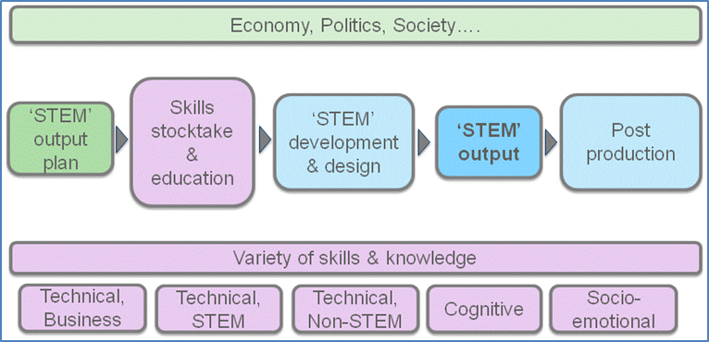Figure 7 STEM output-focused process model

This simplified map outlines a process of producing goods or services, from idea and concept, to final product or service in use. The map illustrates the various points at which STEM knowledge and skills are relevant in the production process. At each stage a thorough skill-requirement analysis needs to be conducted, and finalised once all stages have been considered.

STEM discipline-relevant knowledge and skills, obtained via formal and informal educational pathways, are needed for the basic and applied research that enables improvement, discovery and innovation; this is followed by design and development, which uses that research or idea to produce a functional output, which can be a hardware product or technology-related service or even a scientific theory. This continues with the prototyping and manufacturing of the desired output and its implementation (that is, its dissemination, marketing, sale, distribution, installation, maintenance or repair).

At each stage of the production and services process there are managers and workers with different skills and knowledge, often in different companies and locations. Note that the training and education of these people requires qualified educators and trainers, who are often overlooked in the identification of STEM occupations.

In a technology-led economy the distinction between STEM and non-STEM jobs is increasingly blurred. More and more workers will be expected to have some degree of technological literacy, as well as the capacity to work effectively with STEM specialists (Office of the Chief Scientist 2016). There is an expectation of growing demand for STEM discipline-related skills in non-STEM discipline education as a consequence.

#### Enabling services

Taking this approach a step further, the Office of the Chief Economist (2015) recommends looking beyond conventional methods of industry analysis, which typically focus on ‘what’ is being produced, to ‘who’ the production is for. The majority (45%) of services produced each year are sold to other businesses (Office of the Chief Economist 2015). Among others, these intermediary services provide businesses with access to technologies, and to specialist and technical expertise. Four broad groups of enabling services were identified: professional and support services; ICT and the digital economy; trade, transport and logistics; and utilities services.

Interviews commissioned by the Australian Council of Learned Academies with experts and thought leaders on the required mix of technical and non-technical capabilities of Australian enterprises revealed that the key to lifting productivity lay not so much in developing skills based in science and technology but more in the development of a wide range of entrepreneurial, business, management and service skills (Howard, forthcoming). It has been recognised, for example, that in the advanced manufacturing sector the source of value is shifting away from factory-based industrial production to pre-production and post-production activities (Howard, forthcoming).

## STEM training statistics in VET

National VET education statistics based in the engineering, technology and science sector can be sourced via their field of education and level of education code. Below we provide some trends at the highly aggregated level in:

* Engineering and related technologies
* Architecture and building
* Information technology
* Natural and physical sciences
* Agriculture, environmental and related studies
* Health.

The inclusion of *Health* is a contentious field in definitions of STEM disciplines because of its large number of mainly care-related sub-categories. For the purpose of comparison with other publications we have included *Health* in our graphs.

Two other fields, *Education* and *Management and commerce* include a number of sub-categories relevant to STEM educations and occupations. We have decided to exclude them as these broad fields contain a large number of sub-categories unrelated to STEM disciplines. This demonstrates how the choice of broad fields of education can give different perspectives on the same situation.

Broad groupings can only give broad estimates and are not useful for targeted workforce policy. We need to reiterate that these are summary data on the number of people undertaking vocational training based on broad field of education classifications. For example, the field of *Agriculture, environmental and related studies* includes detailed fields such as Agricultural science, Wool science, and Forestry studies, of which some but not all may be considered for scientific or technical occupations in demand. For this reason we recommend the use of the most detailed level of discipline-based classifications available when discussing skills in demand.

We have chosen the last ten years as a timeframe for observing trends in STEM discipline developments in the VET sector. Enrolments and completions in training package qualifications are shown for publicly funded training in certificates III and above. The selection of level of education was based on advanced and job-related skill level, as well as to make data comparable with ABS statistics on STEM educations and occupations.

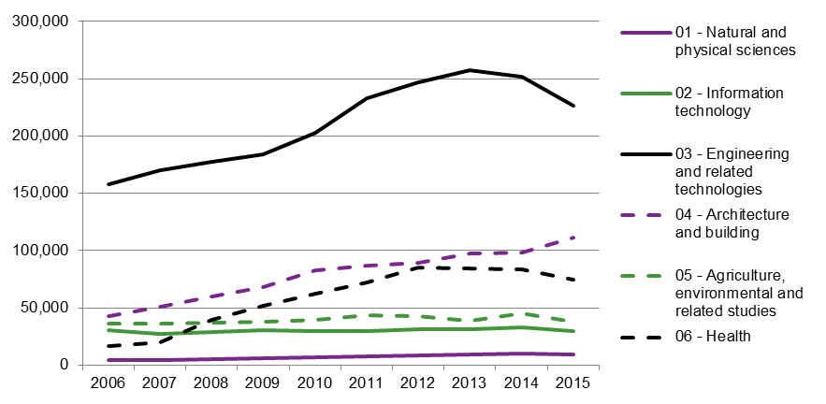Figure 8 Program enrolment trends in government-funded VET in training package qualifications (certifcate III or higher) by field of education, 2006—15

Source: National VET Provider Collection, NCVER (2016)

*Engineering and related technologies*, followed by *Architecture and building*, make up the lion’s share within selected STEM discipline-related enrolments (figure 8). Between 2005 and 2014 the number of students enrolled in the STEM disciplines almost doubled, which was slightly higher than in all major fields combined. The *Health* section grew most strongly, with a doubling of enrolments over a ten-year period. Surprisingly, enrolments in *IT* have remained more or less steady over the last ten years. While enrolments in other STEM disciplines seem to be on the rise, there was a slight downward trend for *Engineering* and *Health*-related enrolments after 2012.

Total VET activity (TVA) reporting, which includes publically and privately funded training, only commenced in 2014. For 2015 data we show separately the number of subject enrolments (units of competency and accredited units) and the type of training provider to provide a more complete picture of the VET training sector.

STEM-related disciplines have a higher proportion of government subsidised enrolments - except for the Health sector (figure 9). In the field of Engineering and related technologies about 60% of subject enrolments are subsidised by government. In terms of provider type, a higher proportion of enrolments in STEM-related disciplines is found at TAFE institutes, except for the Health sector.

Figure 9 Subject enrolments by field of education, funding source and organisation type, 2015

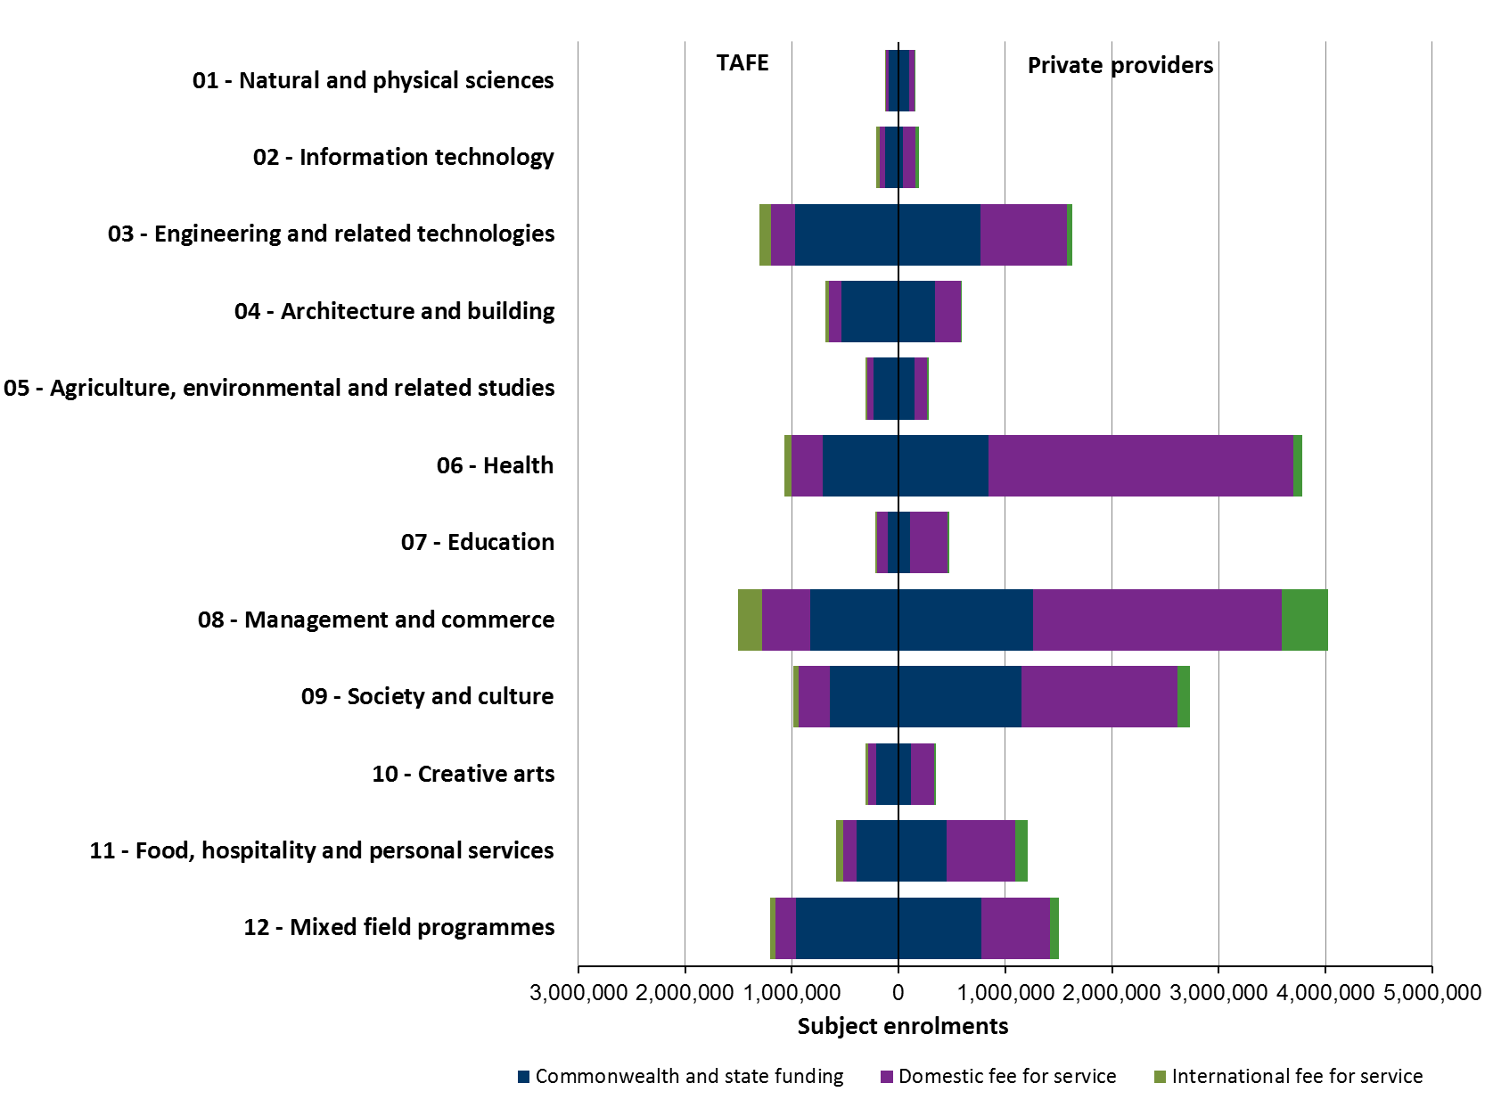

Note: TVA scope, publically and privately funded training.

Source: National VET Provider Collection 2015, NCVER (2016).

### Higher education comparison

The higher education sector is different from its VET counterpart, with its high share of study in health-related fields, followed, after a large gap, by Natural and physical sciences and Engineering (figure 10). These disciplines also showed the largest growth over the last ten years. Similar to VET is the more or less steady number of enrolments in IT.

Figure 10 Program enrolment trends in higher education by field of education, 2006–14

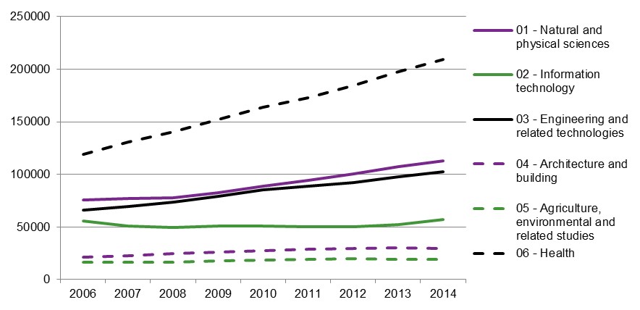

Source: Higher Education Statistics (Department of Education and Training, 2016e).

When looking at VET and higher education enrolment data in 2014, there were more VET students in the fields of Engineering and related technologies, Architecture and building and Agriculture and related studies than higher education students (figure 11). There were more of the latter in Natural and physical sciences and Health than VET students. The split in Information technology was almost even.

Figure 11 Program enrolments in (total) VET and higher education (HE) by field of education, 2015

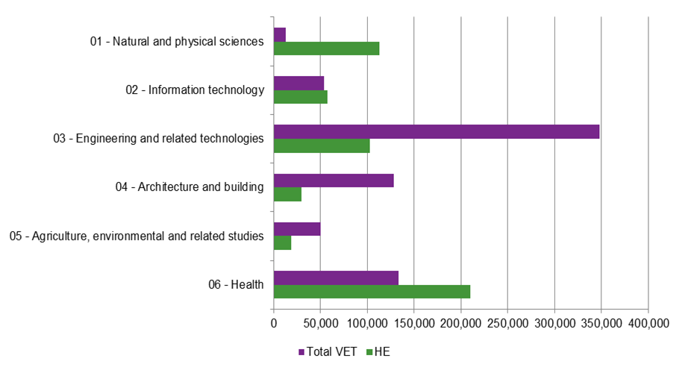

Note: VET programs are training package qualifications at certificate III and above; HE programs are qualifications and degrees at diploma and above.

Source: VET data - National VET Provider Collection 2015 , NCVER (2015); HE data 2015 - Department of Education and Training (2016e)

At least in terms of the number of students, both the VET and higher education sectors are valuable contributors to the workforce where STEM fields of education are highly aggregated. Both sectors have strengths in different fields and, in some cases, are both strong in some fields.

# Conclusion

We have described and analysed the current STEM debate and consulted the literature on how skills are defined or described in this field. We sought to clarify and recommend a definition relating to STEM skills and their place in the twenty-first century. In this concluding chapter we briefly summarise our findings and provide some suggestions on how to identify the skills and knowledge needed for scientific and technical products. The study was also prompted by an apparent lack of clarity on the role of the VET sector in the provision of the scientific, engineering and technical skills in demand.

Problematic in the current discourse on the value and impact of STEM discipline-related skills is the use of the STEM acronym to encompass a wide variety of different concepts in instances where a more precise or appropriate term is needed. In discussions of school subjects, education or study, or occupations in the scientific, technological, engineering or mathematical fields, then these precise terms must be used rather than ‘STEM’ as a convenient abbreviation.

## Overarching STEM definition

In response to the central question of: Is there a consistent and unified definition of STEM skills and knowledge?, we need to concede: ‘yes’ at a conceptual and outcome-focused level, and ‘no’ at the practical level of defining specific skills. We have developed a definition of the STEM construct that is conceptually sound and outcome-focused by combining a variety of concepts and outcomes and specifying their relationship to each other. This definition is broad and all-encompassing but not detailed enough to be useful in targeted skill development.

Box 6 Definition of STEM education

STEM is an acronym for the disciplines of science, technology, engineering and mathematics taught and applied either in a traditional and discipline-specific manner or through a multidisciplinary, interconnected and integrative approach. Both approaches are outcome-focused and aim to solve real-world challenges.

STEM education and training establishes relationships between the four disciplines with the objective of expanding people’s abilities by supporting technical and scientific education with a strong emphasis on critical and creative-thinking skills. This approach should be implemented from primary school to tertiary education, in order to provide a nation with four kinds of intellectual and skill based investment:

- teachers and educators who are able to successfully teach foundational STEM knowledge and skills in an integrated and inspirational manner

- scientists, engineers and digital specialists who research and develop the technological advances required for a nation's economic success and, ultimately, for solving global challenges

- technologically proficient workers who are able to create, design, support and operate complex and evolving technological innovations

- scientifically and technologically literate citizens who can critically examine/understand/respond to and improve the world around them.

## STEM skills

Based on our review of the literature and following the debate on STEM in the media, we define STEM skills primarily as technical skills and distinct from higher-order thinking skills and social-emotional skills.

Box 7 Definition of interdisciplinary STEM skills

STEM skills and knowledge are interdisciplinary in nature, being based on the integration of the formerly discrete disciplines of science, mathematics, engineering and technology. The aim of STEM skills is to enhance people’s competency in work and/or life and more generally respond to societal demands on technology.

STEM skills belong to the group of technical skills. They are a combination of the ability to produce scientific knowledge, supported by mathematical skills, in order to design and build (engineer) technological and scientific products or services. Although STEM skills overlap with basic and higher-order cognitive skills, they merit separate treatment in a policy-oriented context in order to target specific requirements in the education and labour market.

The term ‘STEM skills’ is used by a wide variety of interest groups from different contexts and with different requirements, for example, governments, industry bodies, education providers and public media. Moreover, different concepts and approaches exist in education, pedagogy and workforce planning, which leads to different goals and implementation methodologies. Descriptions of STEM skills usually include a combination of technical job-specific skills and advanced cognitive skills. They overlap broadly with other skills groups such as generic and cognitive skills, as well as employability skills and the twenty-first century skills. To ensure clear analysis, debate and policy work, the term ‘STEM skills’ should not be adopted; the original definition or their category, for example, cognitive skills, foundational literacies, job-related technical skills etc., should be used.

The variety and diversity of descriptions and definitions of STEM skills and knowledge — and by extension, the ambiguities inherent in the concept — can largely be attributed to the different emphases and aims placed on the STEM concept. One point of view is education-based and auspiced by the education community; the second point of view or focus is economy or productivity-based and, not surprisingly, is the province of economists and governments.

The main focus of STEM in educational communities is how to teach knowledge and skills primarily for the benefit of learners and teachers. The main focus in government-driven approaches is the identification and utilisation of the specific skills and knowledge that contribute to a nation's productivity and competitiveness. There is a widespread and somewhat simplistic understanding that people trained in scientific and technical occupations are the major contributors to successful innovation projects and that they provide solutions for economic downturns. Rather than expecting to find all STEM skills residing in one individual, the reality is that the application of STEM skills and the knowledge for designing and building solutions will be achieved by many people and teams with specific and complementary collaborative skills.

## Estimating STEM skill availability and demand

Many countries and agencies use standard classification systems to estimate STEM skill availability and demand. Subjects, qualifications and degrees are attributed to a STEM field of education and level of education. There is unity in the outcomes when any of the fields in the principal disciplines of science, mathematics, engineering and technology are selected, but differences emerge at sub-discipline levels and with derived or applied science or mathematics; for example, healthcare, social sciences and accountancy.

At the level of education there appears to be no consensus relating to the inclusion of qualifications below bachelor level. With different agencies choosing different classifications for their assessments, the resulting metrics often vary. In Australia this leads to estimates of STEM-qualified people in the population ranging from 4% (Healy et al. 2014) to 15% (ABS 2013).

As described in the report, rather than viewing STEM skills in isolation we propose to identify the need and support for STEM skills, and non-STEM skills for that matter, based on what kind of ‘STEM’ products are in demand. This is not only inclusive of a variety of skills and knowledge drawn from all disciplines but highlights skill needs at different stages of the production and implementation process. In particular, the enabling services have been identified as a key requirement for businesses to get their products to market (Office of the Chief Economist 2015).

## VET and STEM

Vocational education and training not only provides the majority of qualifications and skills sets available in the engineering and technology sector but also employs a learning model uniquely suited to teaching skills in real or simulated workplaces, in close collaboration with industry and employers. This model, in combination with the sector’s various training products, makes the VET sector an ideal provider of skill development.

In VET the engineering and technology disciplines are particularly strongly represented. They provide in effect the major share of the technology and engineering workforce in Australia and hundreds of technology-related qualifications. Technicians and tradespeople are critical to the implementation of new ideas, and advise researchers on the feasibility of design options, cost estimates, and other practical aspects of technological development.

Including and incorporating STEM skills more effectively in vocational education could be achieved by either augmenting the existing Foundation Skills Strategy with foundational STEM literacies or creating a related strategy for Australians of all ages, based on the existing strategy.

It has long been recognised in the VET sector that the connections between qualifications and work are complex. Current VET research is proposing the use of vocational streams and productive capabilities, which focus on the broad-ranging knowledge, skills and attributes that individuals need for a number of occupations within an industry.

## The bigger skills picture

The identification of scientific and technical skills, knowledge and occupations must be incorporated into a bigger skills picture. And this involves the skills and knowledge needed in the twenty-first century. The current focus on STEM obscures the need for a well-rounded education for students, one that is foundational in essence and enables students to be successful in further education and in the workplace of their choice.

The twenty-first century skills concept is motivated by the belief that teaching students the most relevant, useful, in-demand, and universally applicable skills should be prioritised in today’s education to prepare them for the complex economy and society of the future. The skill groups that suit life and work in this economy and society can be grouped under three categories: competencies to approach complex challenges (including critical thinking, learning to learn, communication and collaboration); foundational literacy to apply core skills to everyday tasks (such as scientific, cultural literacy, numeracy and digital literacy); and socio-emotional qualities such as curiosity, persistence and social awareness. In this context the development of a coordinated national strategy is suggested, not one that focuses solely on STEM skills, but one that integrates STEM education as a part of a holistic skills strategy with modern and future workplaces and requirements in mind.

## The way forward

Based on our literature review and conclusions drawn, we make the following suggestions on the analysis and development of skills in the science and technology domain:

* Acknowledge that STEM is an umbrella term and continue to identify distinct skills and knowledge at a level which is detailed enough to be useful for policy development, education and career advice.
* Incorporate STEM skills in a holistic skills framework, one that addresses societal changes and future workplaces, such as the twenty-first century skills framework, and addresses definitions and inherent weaknesses.
* Determine the skills required by STEM products or other forms of outputs that are or will be in demand and focus on a stocktake and promotion of the skills that are needed to achieve this. These will include a variety of scientific and technical skills, as well as skills from other disciplines (such as in management, human resources, marketing, law, sales and arts).
* The VET sector has been neglected and overlooked in spite of providing most of the training and most of the skills in the technical workforce. Its existing strengths need to be fostered and the following aspects built upon:
* Foundational skills: expand from a concept of basic literacy and employability skills for adults to include foundational science and technology literacy for all. Alternatively, provide a ‘sister’ science and technology foundation framework.
* VET in Schools: teach science and mathematics in an applied and relevant to day-to-day life and workplace application.
* Training packages: build in or expand scientific, digital technical literacy and capacity.
* Vocational streams development.
* Para-professional/mid-tier professional education model (for example, higher-level apprenticeships combining VET and higher education).

# References

ABC (Australian Broadcasting Corporation) 2016, ‘CSIRO management discuss “clean cut” of 120 staff including climate scientists, emails show’, viewed April 2016, <http://www.abc.net.au/news/2016-04-04/csiro-should-shed-120-climate-scientists-email-say/7297042>.

Anlezark, A, Lim, P, Semo, R & Nguyen, N 2008, *From STEM to leaf: where are Australia’s science, mathematics, engineering and technology (STEM) students heading*, NCVER, Adelaide.

ABS (Australian Bureau of Statistics) 2001, *Australian Standard Classification of Education (ASCED)*, cat.no.1272.0, viewed July 2015, <http://www.abs.gov.au/ausstats/abs@.nsf/mf/1272.0>.

——2013, *Perspectives on education and training: Australians with qualifications in science, technology, engineering and mathematics (STEM), 2010—11*, cat.no.4250.0.55.005, ABS, Canberra, viewed March 2015, <http://www.abs.gov.au/ausstats%5Cabs@.nsf/0/54B42BD3902EB8A2CA257C86000EA59A?Opendocument>.

Australian Government 2015, *National Innovation and Science Agenda*, viewed January 2016, <http://www.innovation.gov.au/>.

Australian Industry Group 2013, *Lifting our science, technology, engineering and maths (STEM) skills*, AiG, Sydney, viewed July 2015, <http://www.voced.edu.au/content/ngv%3A56724>.

——2015, *Progressing STEM skills in Australia*, AiG, Sydney.

Australian Industry Skills Committee, 2016, Communique 1 April 2016, AISC, viewed October 2016,   
<<https://www.aisc.net.au/media/aisc-communique-5>>, Department of Education and Training, Canberra.

Australian Treasury 2015, *Intergenerational report 2015*, viewed June 2016, <http://www.treasury.gov.au/PublicationsAndMedia/Publications/2015/2015-Intergenerational-Report>.

Beitz, S 2015, ‘Developing the capacity to adapt to industry transformation’, in *Committee for Economic Development of Australia (ed.) Australia's future workforce?*, CEDA, Melbourne.

Bell, J, Frater, B, Butterfield, L, Cunningham, S, Dodgson, M, Fox, K, Spurling, T & Webster, E 2014, *The role of science, research and technology in lifting Australian productivity*, Report for the Australian Council of learned Academies, Melbourne, viewed March 2016, <http://www.acola.org.au/index.php/projects/securing-australia-s-future/project-4>.

Binkley, M, Erstad, O, Herman, J, Raizen, Ripley, M, Miller-Ricci, M & Rumble, M 2012, ‘Defining twenty-first century skills’, in P Griffin, B McGaw & E Care (eds), *Assessment and teaching of 21st century skills*, Springer, Dordrecht, pp.17—66.

Blackley, S & Howell, J 2015, ‘A STEM narrative: 15 years in the making’, *Australian Journal of Teacher Education*, vol.40, no.7, p.8.

Borland, J & Coelli, M 2015, ‘Information technology and the Australian labour market’, *Australia's future workforce?*, CEDA, Melbourne.

Carnevale, A, Smith, N & Melton, M 2011, *STEM*, Georgetown University, Washington, DC.

Charette, R 2013, ‘The STEM crisis is a myth’, viewed April 2015, <http://spectrum.ieee.org/at-work/education/the-stem-crisis-is-a-myth>.

Commitee for Economic Development of Australia 2015, *Australia's future workforce*, viewed June 2015, <http://www.ceda.com.au/research-and-policy/policy-priorities/workforce>.

Commonwealth of Australia 2015, *National Innovation and Science Agenda*, viewed May 2016, <http://www.innovation.gov.au/system/files/case-study/National%20Innovation%20and%20Science%20Agenda%20-%20Report.pdf>.

——2016, *National Innovation and Science Agenda*, viewed May 2016, <http://www.innovation.gov.au/page/agenda>.

Council of Canadian Academies 2015, *Some assembly required: STEM skills and Canada's economic productivity*, viewed March 2016, <http://www.scienceadvice.ca/en/assessments/completed/stem-skills.aspx>.

Cunningham, W & Villasenor, P 2016, *Employer voices, employer demands, and implications for public skills development policy connecting the labor and education sectors*, World Bank policy research working paper, no.7582, Washington, DC.

Curtin, P & Stanwick, J 2011, ‘Overview’, in P Curtin, J Stanwick & F Beddie (eds), *Fostering enterprise: the innovation and skills nexus — research readings*, NCVER, Adelaide.

Deloitte Access Economics 2014, *Australia's STEM workforce: a survey of employers*, Deloitte Access Economics, Canberra.

Department of Education and Training 2016a, Skills information for training providers, Canberra, viewed January 2016, <<https://www.education.gov.au/skills-information-training-providers>>.

——2016b, *Foundation Skills Assessment Tool*, Canberra, viewed October 2016, <https://www.education.gov.au/foundation-skills-assessment-tool>.

——2016c, Pathways in Technology Early College High School (P-TECH) pilot, Canberra, viewed October 2016,   
<https://www.education.gov.au/pathways-technology-early-college-high-school-p-tech-pilot>.

——2016d, Two new higher apprenticeship pilot programs partner with industry, Canberra, viewed October 2016, <https://ministers.education.gov.au/andrews/two-new-higher-apprenticeship-pilot-programs-partner-industry>.

——2016e, *Selected Higher Education Statistics-2015 Student data*, Department of Education and Training, Canberra, viewed June 2016, <<https://docs.education.gov.au/node/41616>>.

Department of Education, Science and Technology (DEST) 2006, *Literature review of science, engineering and technology (SET awareness raising activities*, DEST, Canberra.

Department of Immigration and Border Protection 2016, *Skilled Occupation List*, viewed March 2016, <https://www.border.gov.au/Trav/Work/Work/Skills-assessment-and-assessing-authorities/skilled-occupations-lists/SOL>.

Dickerson A, Wilson R, Kik G & Dhillon D 2012, *Developing Occupational Skills Profiles for the UK: A Feasibility Study*, UK Commission for Employment and Skills Evidence Report 44.

Durrant-Whyte, H, McCalman, L, O’Callaghan, S, Reid, A & Steinberg, D 2015, ‘The impact of computerisation and automation on future employment’, in *Committee for Economic Development of Australia (ed.) Australia's future workforce?*, CEDA, Melbourne.

Elgin Economics 2014, *Science and maths skills in the Victorian workforce: the evidence base*, Melbourne, Elgin Economics.

Fowler, C 2016, *What the National Innovation and Science Agenda (NISA) didn’t say about skills and jobs*, NCVER opinion pieces, NCVER, Adelaide.

Foundation for Young Australians 2015, *The new work order: ensuring young Australians have skills and experience for the jobs of the future, not the past*, viewed May 2016, <http://www.fya.org.au/2015/08/23/media-release-young-people-hardest-hit-by-new-work-order/>.

Freeman, B 2013a, *Science, mathematics, engineering and technology (STEM) in Australia: practice, policy and programs*, Australian Council of Learned Academies, Melbourne.

——2013b, *Snapshots of 23 science, technology, engineering and mathematics (STEM) consultants’ reports: characteristics, lessons, policies and programs*, Australian Council of Learned Academies, Melbourne.

Gerlach, J 2012, *STEM: Defying a Simple Definition,* NSTA Reports, National Science Teacher Association, viewed June 2015, <http://www.nsta.org/publications/news/story.aspx?id=59305>.

Guthrie, H & Dowling, N 2012, *Higher Apprenticeships: Scoping report to Higher Education and Skills Group*, Higher Education and Skills Group, Melbourne.

Graduate Careers Australia 2015, *GradStats: employment and salary outcomes of recent higher education graduates*, viewed November 2016, <http://www.graduatecareers.com.au/research/researchreports/gradstats/>.

Great Schools Partnership 2015, ‘21st Century Skills’, *The glossary of education reform*, viewed February 2016, <http://edglossary.org/21st-century-skills/>.

Hargreaves, J & Blomberg, D 2015, *Adult trade apprentices: exploring the significance of recognition of prior learning and skill sets for earlier completion*, NCVER, Adelaide.

Harris, K 2012, *A background in science: what science means for Australian society*, Centre for the Study of Higher Education, for the Australian Council of Deans of Science, Melbourne.

Hillage J & Cross, M 2015, *Exploring the value of an O\*NET resource for the UK*, Report from a workshop held in London, June 2015, Institute for Employment Studies, Brighton, viewed March 2016, <http://[www.gatsby.org.uk/uploads/education/reports/pdf/onet-workshop-report.pdf](http://www.gatsby.org.uk/uploads/education/reports/pdf/onet-workshop-report.pdf)>.

Healy, J, Mavromaras, K & Zhu R 2013, ‘The STEM labour market in Australia’, *A consultant report securing Australia’s future STEM: country comparisons*, Australian Council of Learned Academies, Melbourne.

Howard, J 2016, *ACOLA SAF 10: Securing Australia's Future - Capabilities for Australian enterprise innovation: The role of government, industry and education and research institutions in developing innovation capabilities - key informant interviews*, Australian Council of Learned Academies, Melbourne.

Innovation & Business Skills Australia (IBSA) 2013a, *IBSA strengthens VET foundations*, IBSA, East-Melbourne, viewed April 2016, <https://www.ibsa.org.au/news/ibsa-strengthens-vet-foundations>.

—— 2013b, Foundation Skills Package – Implementation Guide, IBSA, East-Melbourne, viewed October 2016,   
<https://vetnet.education.gov.au/Public%20Documents/FSKv1%20Foundation%20Skills%20Implementation%20Guide.pdf>.

Jackson, M 2007, ‘How far merit selection? Social stratification and the labour market’, *The British Journal of Sociology*, vol.58, pp.367—90.

Karmel, T 2010, *Have green skills become browned off?*, NCVER opinion pieces, NCVER, Adelaide.

Knight, B & Mlotkowski, P 2009, *An overview of vocational education and training in Australia and its links to the labour market*, NCVER, Adelaide.

Kuenzi, J 2008, *Science, technology, engineering, and mathematics (STEM) education: background, federal policy, and legislative action*, Congressional Research Service, Washington, DC, viewed February 2016,   
<<http://digitalcommons.unl.edu/crsdocs/35/>>.

Langford, P 2006, *Attracting and retaining staff engaged in science, engineering and technology: a review of national and international best practice*, Department of Education, Science and Training, Canberra.

Lantz, H 2009, *Science, technology, engineering, and mathematics (STEM) education: What form? What function?* University of South Carolina, viewed March 2016, <<https://dornsife.usc.edu/assets/sites/1/docs/jep/STEMEducationArticle.pdf>>.

London School of Economics 2008, *Maximizing the social, policy and economic impacts of research in the humanities and social science*s, report to the British Academy from the LSE Public Policy Group, London School of Economics and Political Science, London.

Marginson, S, Tytler, R, Freeman, B & Roberts, K 2013, *STEM: country comparisons: final report*, Australian Council of Learned Academies, Melbourne, viewed March 2015, <http://www.acola.org.au/index.php/projects/securing-australia-s-future/project-2>

Metcalfe, J, Riedlinger, M, Pisarski, A & Gardner, J 2006, *Collaborating across the sectors: the relationships between the humanities, arts and social sciences (HASS) and science, technology, engineering and medicine (STEM) sectors*, Council for the Humanities, Arts and Social Sciences, Melbourne, viewed April 2016,   
<http://www.chass.org.au/chass-occasional-papers/>.

Montt, G 2016, ‘What skills do employers want?’, OECD Skills and Work, viewed June 2016, <https://oecdskillsandwork.wordpress.com/2016/03/23/what-skills-do-employers-want/>.

Morrison, J 2006, *Attributes of STEM education: the students, the academy, the classroom*, Teaching Institute for Excellence in STEM (TIES) STEM education monograph series, TIES, Cleveland, Ohio.

National Science Foundation 1996, *Shaping the future: new expectations for undergraduate education in science, mathematics, engineering, and technology*, Advisory Committee to the National Science Foundation Directorate for Education and Human Resources, Arlington, Virginia.

NCVER, 2016, *Australian vocational education and training statistics: total VET students and courses 2015*, NCVER, Adelaide.

Office of the Chief Economist 2015, *Australian industry report 2015*, Department of Industry, Innovation and Science, Canberra.

——2016, *Industry monitor 2016*, Canberra.

Office of the Chief Scientist 2012, *Mathematics, engineering and science in the national interest*, Office of the Chief Scientist, Canberra.

——2013, *Science, technology, engineering and mathematics in the national interest: a strategic approach*, Office of the Chief Scientist, Canberra.

——2014, *Science, technology, engineering and mathematics: Australia's future*, Office of the Chief Scientist, Canberra.

——2016, *Australia's STEM workforce*, Office of the Chief Scientist, Canberra.

Oleson, A, Hora, M & Benbow, R 2014, *STEM: How a poorly defined acronym is shaping education and workforce development policy in the United States*, WCER working paper no.2014-2, Wisconsin Center for Education Research, Madison.

Pitt, J 2009, ‘Blurring the boundaries–STEM education and education for sustainable development’, *Design and technology education: an international journal*, vol.14, no.1, pp.37-48.

Productivity Commission 2016, *Digital disruption: what do governments need to do?*, viewed June 2016, <http://www.pc.gov.au/research/completed/digital-disruption>.

Roberts, S 2010, *Report for Skills Australia: the Australian and New Zealand standard classification of occupations: scoping study*, Skills Australia, Canberra.

Rothwell, J 2013, *The hidden STEM economy*, Brookings Institution, Washington, viewed March 2015, <http://www.brookings.edu/research/reports/2013/06/10-stem-economy-rothwell>.

Sanders, M 2009, ‘STEM, STEM education, STEM mania’, *The Technology Teacher*, vol.68, no.4, pp.20—26.

Skilling Australia Foundation 2016, *P-Tech Australia - Skilling Australia Foundation*, viewed April 2016,   
<http://saf.org.au/p-tech-australia/>

Spoehr, J, Barnett, K, Molloy, S, Dev, S & Hordacre, A 2010, *Connecting ideas: collaborative innovation for a complex world*, Adelaide: Australian Institute for Social Research, University of Adelaide.

Stanwick, J & Beddie, F 2011, ‘What skills are relevant to innovation?’, in P Curtin, J Stanwick & F Beddie (eds), *Fostering enterprise: the innovation and skills nexus — research readings*, NCVER, Adelaide.

Teitelbaum, M 2014, *Falling behind? Boom, bust, and the global race for scientific talent*, Princeton University Press, Princeton, NJ.

Tight, M 2012, ‘Who decides higher education policy? MPs, VCs, STEM and HASS’, *Higher Education Review*, vol.44, no.3, pp.41—53.

Toner, P 2011, ‘Tradespeople and technicians in innovation’, in P Curtin, J Stanwick & F Beddie (eds), *Fostering enterprise: the innovation and skills nexus — research readings*, NCVER, Adelaide.

Treasury, A 2015, Intergenerational Report: Australia in 2055. Commonwealth of Australia, Canberra.

UNESCO Institute for Statistics 2011, *ISCED: International Standard Classification of Education*, viewed November 2015, <http://www.uis.unesco.org/Education/Pages/international-standard-classification-of-education.aspx>.

[US] STEM Education Caucus 2015, Why was the STEM Education Caucus created?, STEM Education Caucus, viewed July 2015, <http://stemedcaucus2.org/>.

[US] Department of Labor, Employment & Training Administration 2015, O-NET Resource Centre, viewed May 2015, from <https://www.onetcenter.org/>

Vasquez, J 2015, ‘STEM — beyond the acronym’, *Educational Leadership*, vol.72, no.4.

VET Development Centre 2016, ‘Would you like a degree with your apprenticeship’, *The VET Blog*, VET Development Centre, viewed May 2016, <http://www.vetcentre.vic.edu.au/research-and-reports/entry/would-you-like-a-degree-with-your-apprenticeship>.

West, M 2012, *STEM education and the workplace*, Office of the Chief Scientist, Canberra.

Wheelahan, L, Buchanan, J & Yu, S 2015, *Linking qualifications and the labour market through capabilities and vocational streams*, NCVER, Adelaide.

Williams, J 2011, ‘STEM education: proceed with caution’, *Design and Technology Education: An International Journal*, vol.16, no.1, pp.26-34.

World Economic Forum 2015, *New vision for education: unlocking the potential of technology*, World Economic Forum, Geneva.

Yu, S, Bretherton, T & Buchanan, J 2013, *Defining vocational streams: insights from the engineering, finance, agriculture and care sectors*, NCVER, Adelaide.

Zakaria, F 2015, ‘Why America’s obsession with STEM education is dangerous’, The Washington Post, viewed March 2015, <<https://www.washingtonpost.com/opinions/why-stem-wont-make-us-successful/2015/03/26/5f4604f2-d2a5-11e4-ab77-9646eea6a4c7_story.html>>.

# Appendix A – Classification systems used for determining STEM occupations

This appendix expands on some sections of the technical chapter, ‘Defining STEM skills - a data-driven approach’.

## A.1 ASCED and ANZSCO: a point of reference in Australia

In Australia the standard classification systems, ANZSCO and ASCED (Australian Standard Classification of Education), maintained by the ABS, are used to identify the study and qualifications pertaining to science and technology-related skills and knowledge. ANZSCO was designed to classify jobs and occupations for statistical purposes. However, in Australia it is also used as a framework for identifying and categorising occupations for administrative purposes such as identifying the skills in demand via the Skilled Occupation List. Skills shortage research is based on the rolling Survey of Employers Who Have Recently Advertised (SERA), supplemented by demand and supply data. SERA is telephone-based and collects information from employers on unfilled vacancies for selected occupations (per ANZSCO). Major employers and peak bodies are also approached where sufficient vacancies cannot be identified from advertisements. ANZSCO has over 1000 occupations listed, which are grouped hierarchically via two interim levels to eight major groups. Occupations also are conferred a skill level, ranging from 1 (high) to 5 (low). The Australian method of determining skills in demand, with its reliance on an official occupational classification, appears to be unusual among developed countries, except for the United Kingdom. Most other countries examined do not have as detailed an occupational classification as Australia and New Zealand (Roberts 2010).

The Australian Standard Classification of Education (as of 2001) is comprised of two component classifications — level of education and field of education (ABS 2015). It provides a basis for comparing administrative and statistical data relating to educational activities and attainment, classified by level and field.

The criteria used to group fields of education in ISCED 1997 (International Standard Classification of Education, UNESCO Institute for Statistics 2011) are the same as those used in ASCED. However, despite the similarities between ISCED 1997 and ASCED in the conceptual approach to field of education, the classification criteria have not been applied in exactly the same way.

The broad and narrow fields in ASCED have been designed to accurately reflect the reality of educational provision in Australia and thus differ from the groups at similar levels in ISCED 1997. Australian data classified to detailed fields in ASCED can, however, be converted to ISCED 1997 for international reporting purposes, with 12 major fields and 356 detailed fields of education.

## A.2 O\*NET: an occupational knowledge bank in the US

Every occupation requires a different mix of knowledge, skills and abilities and is performed using a variety of activities and tasks. These distinguishing characteristics of an occupation are described by the O\*NET Content Model, which defines the key features of an occupation as a standardised, measurable set of variables called ‘descriptors’ (US Department of Labor, Employment and Training 2016). The Content Model is the conceptual foundation of O\*NET and provides a framework that identifies the most important types of information about work. This hierarchical model starts with six domains that describe the day-to-day aspects of the job and the qualifications and interests of the typical worker (figure 7). The model expands to 277 descriptors.

Figure A1 Occupational database content model

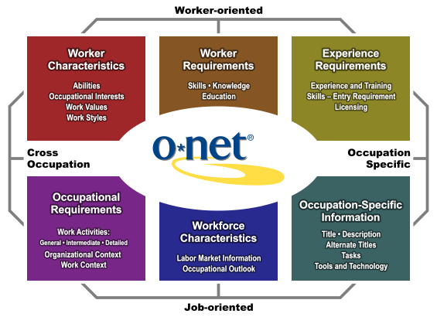

The Content Model was developed using research undertaken on job and organisational analysis. It reflects the character of occupations (via job-oriented descriptors) and people (via worker-oriented descriptors). The Content Model also allows occupational information to be applied across jobs, sectors or industries (cross-occupation descriptors) and within occupations (occupation-specific descriptors). These descriptors are organised into six major domains, which enables the user to focus on areas of information that specify the key attributes and characteristics of workers and occupations.

Users can search occupations in O\*NET by STEM discipline. This search identifies occupations that ‘require education in science, technology, engineering, and mathematics (STEM) disciplines’, specifically in chemistry, computer science, engineering, environmental science, geosciences, life sciences, mathematics, and physics/astronomy (O\*NET OnLine 2015). All STEM disciplines are paired with occupations found in 15 classification major groups, notably including occupations within the following groups: healthcare practitioners and technical occupations; production occupations; and installation, maintenance, and repair occupations. Thus, O\*NET organises STEM occupations by career cluster, whereby occupations are grouped according to similarities in the required skills within the same field of work and/or by STEM discipline. STEM discipline is organised by the required education in preselected STEM disciplines (chemistry, computer science, engineering, environmental science, geosciences, life sciences, mathematics, and physics/astronomy).

O\*NET reports a knowledge score for each US occupation across 33 domains. Of these, six domains were chosen as representing basic STEM knowledge: three for science (biology, chemistry and physics), one for technology (computers and electronics), one for engineering (engineering and technology), and one for mathematics. This allows for the following detailed reporting (see details in Brookings Report by Rothwell 2013): 1. High-STEM in any one field; 2. High-STEM across fields.

For example, network and computer systems administrators score highly only on computer knowledge and would only be considered for a job in a STEM discipline using the first definition, whereas biomedical engineers score highly in each STEM discipline and would be considered in both definitions.

Each definition has strengths and weaknesses (Rothwell 2013). Empirically, workers tend to receive higher pay if they have knowledge in more than one field, which justifies the 'Across-STEM' criteria. On the other hand, education and training programs often focus on one specific domain of knowledge, making the first criterion more attractive for practical purposes.

On the publically available O\*NET website (<onetonline.org>) is a ‘STEM Discipline’ filter, which allows users to browse occupation titles and their detailed descriptions and job prospects (figure 15).

Figure A2 O\*NET STEM occupation filter interface

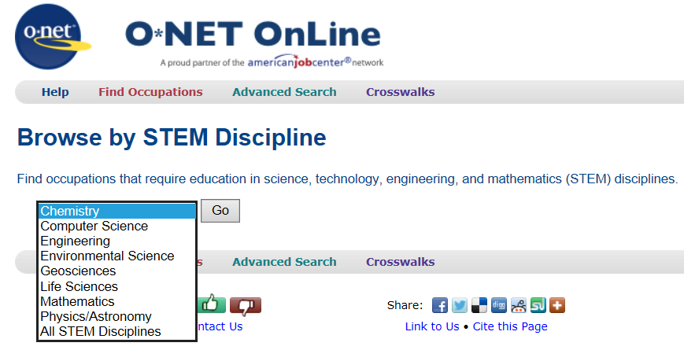

# Appendix B – Twenty-first century skills

The twenty-first century skills concept offers a comprehensive and grounded skills framework. *The Glossary of Education Reform*, created by the US-based Great Schools Partnerships notes that:

The term ‘21st century skills’ refers to a broad set of knowledge, skills, work habits, and character traits that are believed — by educators, school reformers, college professors, employers, and others — to be critically important to success in today’s world, particularly in collegiate programs and contemporary careers and workplaces.[[5]](#footnote-5)

This framework appears to display all of the desirable literacies and employability skills desired by employers, although they are often confusingly assumed to be STEM skills. However, twenty-first century skills can be applied in all academic subject areas, and in all educational, career and civic settings throughout a student’s life.

The push to prioritise twenty-first century skills is typically motivated by the belief that all students and learners should be equipped with the knowledge, skills, work habits, and character traits they will need to pursue ongoing education opportunities and challenging careers, and that a failure to adequately prepare citizens effectively denies them opportunities, with potentially significant consequences for our economy, democracy, and society (Glossary of Education Reform 2016).

The *Glossary of Education Reform* further explains:

The 21st century skills concept is underpinned by the belief that teaching students the most relevant, useful, in-demand, and universally applicable skills should be prioritised in today’s schools and by the related belief that many schools may not sufficiently prioritise such skills or effectively teach them to students. The basic idea is that students who will come of age in the 21st century need to be taught different skills from those learned by students in the 20th century, and that the skills they learn should reflect the specific demands that will placed upon them in a complex, competitive, knowledge-based, information-age, technology-driven economy and society.

A number of organisations around the world have independently developed frameworks for twenty-first century skills. Binkley et al. (2012) have analysed these, arriving at the following model, in which ten skills, grouped into four categories, are defined below.

**Twenty-first century skills**

**Ways of thinking**

* creativity and innovation
* critical thinking, problem-solving, decision making
* learning to learn, metacognition

**Ways of working**

* communication
* collaboration (teamwork)

**Tools for working**

* information literacy (includes research on sources, evidence, biases etc.)
* ICT literacy

**Living in the world**

* citizenship — local and global
* life and career
* personal and social responsibility — including cultural awareness and competence.

Source: Adapted by Binkley et al. (2012).

A different interpretation (figure 6), presented by the World Economic Forum in 2015, groups these skills into foundational literacies, capabilities and character qualities (World Economic Forum 2015).

[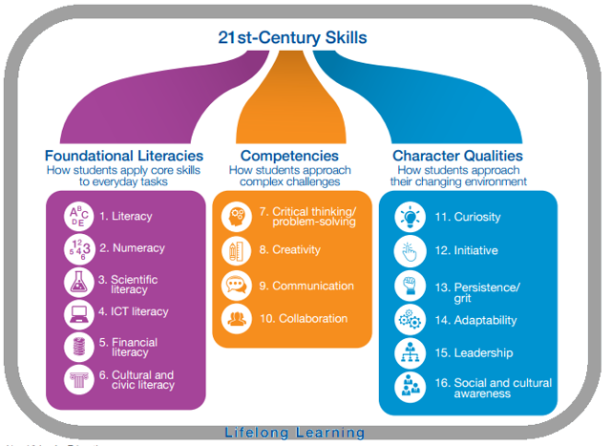](http://www.google.com.au/url?sa=i&rct=j&q=&esrc=s&source=images&cd=&cad=rja&uact=8&ved=0ahUKEwjp5LH4ovTMAhVEi5QKHVpBBtMQjRwIBw&url=http://www.enterrasolutions.com/2015/09/stem-education-helps-teach-skills-necessary-for-21st-century-success.html&psig=AFQjCNFME2Ahxc6NMnHBs3EZ-kj1RY-78g&ust=1464232947318675)Figure B1 Twenty-first century skills encompassing foundational literacies, competencies and character qualities

Source: World Economic Forum (2015).

While there is broad agreement that today’s students and learners need skills different from those perhaps taught to previous generations, and that foundational skills such as writing, critical thinking, self-initiative, group collaboration, and technological literacy are essential to success in higher education, modern workplaces and adult life, there is still a great deal of debate about twenty-first century skills — from identifying the most important skills and how such skills should be taught, to their appropriate role in public education.

(Glossary of Education Reform 2016)

1. STEM qualifications defined by the ABS are certificate III and higher in fields of education 01 NATURAL AND PHYSICAL SCIENCES, 02 INFORMATION TECHNOLOGY, 03 ENGINEERING AND RELATED TECHNOLOGIES, 05 AGRICULTURE, ENVIRONMENTAL AND RELATED STUDIES [↑](#footnote-ref-1)
2. STEM qualifications defined by the ABS are certificate III and higher in fields of education 01 NATURAL AND PHYSICAL SCIENCES, 02 INFORMATION TECHNOLOGY, 03 ENGINEERING AND RELATED TECHNOLOGIES, 05 AGRICULTURE, ENVIRONMENTAL AND RELATED STUDIES. [↑](#footnote-ref-2)
3. Australian Standard Classification for Education [↑](#footnote-ref-3)
4. Australian and New Zealand Standard Classification of Occupations [↑](#footnote-ref-4)
5. Glossary of Education Reform, <<http://edglossary.org/21st-century-skills/>>, viewed 20 June 2016. [↑](#footnote-ref-5)