OCCASIONAL PAPER

Early vocational education and training programs for young Aboriginal learners:
Perceptions of practitioners and young people

Regan Harding
North Coast TAFE
North Coast Aboriginal Learning Partnerships
Participant in the NCVER Building Researcher Capacity Community of Practice Program 2008

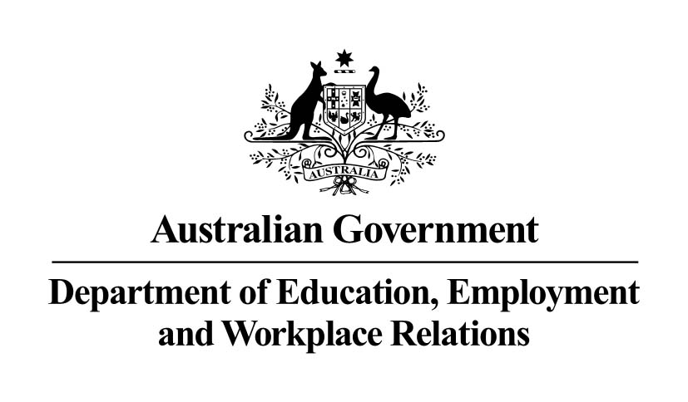

The views and opinions expressed in this document are those of the author/project team and do not necessarily reflect the views of the Australian Government or state and territory governments.
Any interpretation of data is the responsibility of the author/project team.

As part of the National Centre for Vocational Education Research (NCVER) Building Researcher Capacity Scheme, a Community of Practice Scholarship Program has been created to encourage a culture of research in vocational education and training (VET) organisations. With the guidance of an experienced mentor, VET practitioners without any formal research experience undertake their own work-based research project. The scholarship also provides participants with an opportunity to have their research peer-reviewed and published by NCVER.
For more information see: <http://www.ncver.edu.au/research/opportunities.html# Community_of_practice_scholarships_for_VET_practitioners>.
© Commonwealth of Australia, 2009
This work has been produced by the National Centre for Vocational Education Research (NCVER) under the National Vocational Education and Training Research and Evaluation (NVETRE) Program, which is coordinated and managed by NCVER on behalf of the Australian Government and state and territory governments. Funding is provided through the Department of Education, Employment and Workplace Relations. Apart from any use permitted under the Copyright Act 1968, no part of this publication may be reproduced by any process without written permission. Requests should be made to NCVER.
The views and opinions expressed in this document are those of the author(s) and do not necessarily reflect the views of the Australian Government, state and territory governments or NCVER.
ISBN 978 1 921413 46 9 web edition
TD/TNC 97.18
Published by NCVER
ABN 87 007 967 311
Level 11, 33 King William Street, Adelaide, SA 5000
PO Box 8288 Station Arcade, Adelaide SA 5000, Australia
ph +61 8 8230 8400 fax +61 8 8212 3436
email ncver@ncver.edu.au
<http://www.ncver.edu.au>
<http://www.ncver.edu.au/publications/2196.html>

About the research

Early vocational education and training programs for young Aboriginal learners: Perceptions of practitioners and young people

Regan Harding, North Coast TAFE; North Coast Aboriginal Learning Partnerships
Building the research capacity of the vocational education and training (VET) sector is a key concern for the National Centre for Vocational Education Research (NCVER). To assist with this objective, NCVER supports a Community of Practice scholarship program, whereby VET practitioners without any research experience are given the opportunity to undertake their own work-based research project.
Regan Harding participated in the 2008 Community of Practice. Regan is a Youth Project Officer at North Coast TAFE and is involved in North Coast Aboriginal Learning Partnerships. Her research investigates the perceptions of students and school and technical and further education (TAFE) staff involved in the V Tracks program.
V Tracks is a program for Year 8 to Year 10 Aboriginal school students, the aim of the program being to increase the visibility and availability of VET. The program provides opportunities for students to explore different vocational areas and identify pathways into further education and employment. It emphasises cross-cultural orientation and the involvement of education and community networks. New South Wales’s North Coast TAFE and North Coast Aboriginal Learning Partnerships implemented this program in 2008.
The study comprised a survey of students and focus group interviews with students and school and TAFE staff, and was intended to guide strategies to increase the retention and engagement of young Aboriginal learners in education, training or employment.

Key messages
- V Tracks is seen very positively by students, and school and TAFE staff.
- The challenges seen by study participants revolve around funding and resource issues. Participants see a need for more Aboriginal Education Workers, role models, cultural activities, assistance with transport, and curriculum and pastoral support.
- The author points to the need to sustain longer-term strategies and to move programs such as V Tracks to the mainstream.

Tom Karmel
Managing Director, NCVER

Acknowledgements
In 2008, the National Centre for Vocational Education Research commenced a three-year Building Researcher Capacity in the VET sector scheme, through which early-career VET researchers are supported to undertake work-based research projects. Through this scheme, ten VET practitioners received an NCVER scholarship to participate in a community of practice to develop researcher capacity. On behalf of North Coast TAFE, North Coast Aboriginal Learning Partnerships, I accepted one of these scholarships to complete this research project.
A significant feature of the NCVER Building Researcher Capacity scheme and the community of practice is the mentoring component through which the early-career researchers are matched with experienced and senior researchers from the Australian Vocational Education and Training Research Association (AVETRA). I was mentored by Associate Professor Barry Golding from the University of Ballarat, who provided support and expertise in the planning, development and review of the research. Professor Golding’s contribution is particularly appreciated, as is the support provided by Berwyn Clayton, Llandis Barratt-Pugh, Melinda Randall, Peter Haigh, Clancy Benson, Elizabeth McGregor, Tony Dreise, North Coast TAFE, North Coast Region Schools, the New South Wales Aboriginal Education Consultative Groups and NCVER.
Importantly, the research team acknowledges Aboriginal and Torres Strait Islander people as the First Peoples of Australia. It also acknowledges Elders past and present from the Bundjalung, Yaegl, Gumbayggirr, Dungutti, Biripi and Worimi nations of the North Coast of New South Wales and the significant contributions made to this research project by Aboriginal students, parents, staff and community members.

Contents
Figures 6
Introduction 7
V Tracks: Balanced vocational learning for young Aboriginal
school students 7
Methodology, purpose, scope and limitations of the research 9
Current knowledge about VET and the retention and engagement
of young people 11
Findings 15
V Tracks: Education and training pathways 15
V Tracks: Employment pathways 16
V Tracks: Attitudes to school 17
V Tracks: Self-confidence 19
V Tracks: The learning environment and student support 20
V Tracks: Cultural elements of the program 22
V Tracks: Structure of the program 24
V Tracks: Overall perceptions 26
Discussion and recommendations 28
Advice on educational pathways including better explanation of VET 28
Advice on pathways into work, including building relationships
with industry 28
Retention strategies for early school leavers 29
Increase self-confidence 29
Engage with wider support mechanisms to provide introductory
activities for younger students 29
Introduce cultural elements 30
Have flexible funding models 30
Summary 30
Glossary of terms 32
References 34
Appendix 1 35

Figures
1 V Tracks program stages 8
2 V Tracks—education and training pathways 15
3 V Tracks—employment pathways 16
4 V Tracks—attitudes to school 17
5 V Tracks—self-confidence 19
6 V Tracks—the learning environment and student support 20
7 V Tracks—cultural elements of the program 22
8 V Tracks—structure of the program 24
9 V Tracks—overall perceptions 26

Introduction

V Tracks: Balanced vocational learning for young Aboriginal school students
While research demonstrates that vocational education and training (VET) programs in the senior years of schooling can improve high school completion rates and pathways to further education, employment and training for students at risk of early school leaving, relatively little is known about the experiences of younger learners—particularly Aboriginal learners—in earlier VET programs, nor the experiences of the practitioners supporting them. This work-based research project therefore presents qualitative data and narrative from students and school and technical and further education (TAFE) staff involved in the design and implementation of V Tracks, an early-intervention program for young Aboriginal learners on the North Coast of New South Wales. The purpose of this is to guide future TAFE–school partnerships and practice to increase the retention and engagement of young Aboriginal learners in education, training or employment.
The North Coast of New South Wales is home to one of the largest regions of Aboriginal people in Australia, comprising both descendants of the traditional owners and also historic and more recent arrivals of Aboriginal people from throughout Australia. Approximately 11% of the Aboriginal population of New South Wales resides on the North Coast and, unlike wider regional areas, this population is dramatically skewed towards youth—with between 40 and 50% aged between 5 and 24 years (ABS 2007). This cohort is much more likely to leave school early, not continue with further education, training or employment, and experience related workplace and social disadvantage. In 2008, the New South Wales Government identified that Aboriginal students experience half the rate of retention to Year 12 of other students, and are over three times less likely to complete the Higher School Certificate (New South Wales Government 2008, p.9).
Retaining and engaging young Aboriginal learners in education, employment and training is therefore a key priority area for the New South Wales Government through its State Plan, its Two Ways Together Framework, and the Department of Education and Training’s Aboriginal Education and Training Policy. North Coast TAFE and schools therefore prioritise the retention and engagement of young Aboriginal learners in education and training to increase these learners’: high school completions; pathways into further education, training and employment; participation in more diversified courses; access to broader and more flexible curriculum opportunities; and access to VET in junior secondary schooling. The V Tracks program was developed by North Coast TAFE in response to these policy and priority areas and also the evidence and research presented in following sections of this paper.
The objectives of V Tracks are increased high school completions and post-school pathways for Aboriginal learners by increasing the visibility and availability of VET to Years 8 to 10 school students. V Tracks programs are locally designed with communities of schools to provide learning activities for students to develop: employment, study and communication skills, workplace readiness, cultural awareness and enhanced confidence and self-esteem. Specifically, TAFE programs and school-based planning, delivery and reflection include opportunities for students to:
- explore and experience different vocational areas
- identify transition pathways into further education, employment and training
- design, implement and evaluate individual learning plans, adding to or complementing existing school programs and activities
- work with Aboriginal mentors, role models, case managers, school tutors, Aboriginal Education Officers, Aboriginal Education Workers and community members
- experience cross-cultural orientation of programs through more equal and diverse learning contexts and strategies, including engagement and interaction with Aboriginal role models and traditional and contemporary Aboriginal culture
- prepare for and/or engage in work placement.
To provide qualitative reflection and feedback on a school VET program for younger Aboriginal learners (V Tracks), data were gathered through surveys and focus group interviews with three stakeholder groups involved in the program: young Aboriginal learners, school and TAFE staff.
In 2008, a framework for V Tracks was provided to nine local steering committees to enable discrete programs to be designed with communities of schools and therefore respond to particular local and regional needs. Further information about the design and implementation of V Tracks is included in appendix 1; an overview of the program is given below.
Figure 1 V Tracks program stages
V Tracks
Vocational learning and values
for young Aboriginal learners
Stage One
TAFE-based ‘taster’
Stage Two
TAFE and school-based learning
Stage Three
Workplace-based learning and/or work readiness
or work readiness programs

Stage One involves non-accredited ‘taster’ activities from every vocational learning area in North Coast TAFE, including:
- an open ‘Expo’ day at the TAFE campuses where students are: ‘welcomed to country’ by Elders, parents and Aboriginal community members; shown the vocational learning opportunities available to them at TAFE; introduced to the TAFE Aboriginal Student Support Officers, teaching and administration staff; and encouraged to participate in motivational sessions or ceremonies with local and cultural role models
- guest speakers, past students, employees and role models from local Aboriginal communities who engage in activities with the students and support them in the TAFE taster, which includes hands-on vocational workshops and discussions of education, training and employment pathways.
Through this stage, TAFE teachers are encouraged to provide practical, hands-on and project-based learning, whereby students not only acquire a ‘taste of TAFE’ but also create products or undertake complete meaningful processes.
Stage Two includes accredited certificate I and II units from particular vocational areas and also key learning, communication and employability competencies. Theoretical learning is introduced gradually, for example, in short cycles within teaching sessions, so that students are highly supported and guided to make a transition into ‘adult’ vocational learning. From this stage, learners also have an opportunity to articulate into certificate I and II courses, Stage 5 (Year 10 early commencement) or Stage 6 (Years 11 and 12) VET conducted at a TAFE institute (TVET).
Stage Three encourages highly supported workplace-based learning, matched to the industry areas explored by students in Stage Two. This might include simulated workplace experience, industry visits and introduction to work experience or work readiness programs designed by TAFE staff in consultation with the students, V Tracks steering committees and schools.
The V Tracks programs are strongly linked to the ‘Deadly Days’ festivals hosted by North Coast TAFE and sponsored by the Australian Government as part of the Community Festivals for Education Engagement initiative (see appendix 1). Held at three North Coast TAFE campuses, the Deadly Days Festivals provide V Tracks students with opportunities to consolidate and showcase their learning throughout the year and also explore further education, training and employment opportunities. The festivals were understood by the V Tracks students, school and TAFE staff as a core feature of the broader TAFE–schools partnership to increase the retention and engagement of young Aboriginal learners in education, training and employment and an integral component of the V Tracks program.

Methodology, purpose, scope and limitations of the research
Three methodologies were selected for the research project. The research project commenced with a review of research related to the role of VET in retaining and engaging young people otherwise at risk of early school leaving, in school or further training or employment. The purpose of this literature review was to identify what is currently known about earlier VET programs for younger Aboriginal learners, and also what might be missing from the available research. It subsequently informed the focus areas for investigation through the surveys and focus group interviews.
Secondly, a 33-question survey was completed by 80 V Tracks students from Years 8 to 10. The survey questions related to V Tracks and: education and training pathways; employment pathways; attitudes to school; self-efficacy and confidence; the learning environment and student support; cultural elements of the program; structure of the program; and overall perceptions of V Tracks (see appendix 1).
Finally, small (four to five members) focus group interviews were conducted with 25 students, 24 school staff and 22 TAFE staff within their discrete groups (see appendix 1). The school staff included principals, careers advisers, VET coordinators, Aboriginal Education Officers and Aboriginal Education Workers; the TAFE staff included V Tracks teachers, head teachers, VET coordinators and Aboriginal Student Support Officers—all of whom had significant involvement in the design, delivery and support of the V Tracks programs. Additional individual staff members also provided feedback on the program via email and telephone conversations. The research participants were selected from five of the nine V Tracks Programs implemented across the North Coast in 2008 and the research questions were again organised around the eight focus areas included in the survey. To facilitate the survey data collection and focus groups with school students, each student group included a school staff member who had been involved in the program. This provided students with assistance and support in talking with the researcher.
In inviting participants to be a part of the research, the three stakeholder groups were advised that the purpose of the research was to:
- capture narrative on students’ perceptions of the V Tracks program
- capture narrative on school and TAFE staff’s perceptions of the V Tracks program
- identify challenges in relation to the V Tracks program and explore recommendations for meeting these
- increase the capacity of TAFE and schools to meet the learning needs and aspirations of young Aboriginal learners
- encourage a culture of evaluative thinking to inform VET future program design and planning by the North Coast TAFE and the schools in the region for learners at risk of disengagement from education, training and employment.
This research project consequently focuses on the narrative gathered from these stakeholder groups included in the first year of the V Tracks program.
In 2008, nine V Tracks programs were delivered across 40 North Coast schools and 14 TAFE campuses, including more than 700 students in Stage One and 500 students in Stage Two. Stage Three was included in two of the nine programs and therefore is mentioned, but not highlighted in this paper. (It is however, a key area of design and implementation for 2009.) Eighty V Tracks students from Years 8 to 10 completed the survey, of which 47 (59%) were female and 33 (41%) were male. As the learning experiences offered to the V Tracks students were group-focused rather than designed or delivered according to year level or gender, there is no breakdown by gender or year level in the analysis of the data in this paper.

Current knowledge about VET and the retention and engagement of young people
Existing literature demonstrates that increasing the retention and engagement of young Aboriginal learners in education, employment and training has been a key priority and policy area for many Australian governments and education systems for some time. More broadly, improving education, employment and training pathways for all young Australians and those at risk of early school leaving has been a focus for almost a decade. The Adelaide Declaration on National Goals for Schooling in the Twenty-first Century (1999) states that ‘when students leave school they should have employment related skills and an understanding of the work environment, career options and pathways as a foundation for, and positive attitude towards work, vocational education and training, further education and life-long learning’ (Cited in MCEETYA Taskforce on Indigenous Education 2001, p.6).
In response to such goals, Australia has witnessed an expansion in school VET programs. Most of these have, however, targeted senior (Years 11 and 12) students and have therefore largely been evaluated in relation to, or by, senior school students. That is, an historic lack of provision of earlier school VET programs is accompanied by gaps in current literature on the experiences of younger students engaged in earlier school VET programs and, in particular, the experiences of younger Aboriginal students and the school and TAFE staff teaching and supporting them.
Anlezark, Karmel and Ong in their 2006 research Have school vocational education and training programs been successful identify the impacts of student participation in VET programs and comparative retention rates from Year 10 to Year 11 and from Year 11 to Year 12. Drawing from the Longitudinal Surveys of Australian Youth (LSAY), their study examines the characteristics of students who select, or are encouraged to select, VET programs; for example, students with real or perceived lower academic ability, students from parents with lower education or lower socioeconomic backgrounds, or students enrolled in government schools. They also explore the diversity in school VET programs and alignment, or lack of, these programs to the world of work and further study.
Their research highlights significant discord in the definition of school VET itself, the ‘success’ of such programs and the relationships between VET in Schools, retention and post-school pathways. Significant policy issues and questions are raised about the recording of accurate administrative data (such as identifying students genuinely seeking VET pathways as opposed to showing a passing interest in VET); the alignment of school VET programs and labour market or industry competencies (as opposed to a focus on broader vocational skills); and the target of school VET programs. They ask, for example, whether VET programs should re-focus on Year 10 students, rather than Years 11 and 12, given that many early school leavers do not get to Year 11. This is consistent with key messages from Polesel and Helme (2003), Pitman and Herschel (2002) and also Vickers (2005).
Polesel and Helme’s (2003) research focuses exclusively on young people’s views, experiences and expectations of VET, schooling in general, work experience, work placement, structured workplace learning (SWL), part-time work and also career (study and work) aspirations. Their report is particularly useful in its analysis of student background, including gender, academic history, socioeconomic status, disability, language background and, significantly, Indigenous status. They find, for example, that the views of Indigenous students towards school and teachers are less favourable than those of non-Indigenous students, and suggest reasons such as alienation, lack of cultural affirmation in the classroom or school environment, and feelings of insecurity.
Polesel and Helme’s (2003) classroom-based questionnaires provide descriptive analysis and articulate thinking from the ‘frontline’—young people themselves, which is not only beneficial to practitioners and policy-makers but has informed this research project and its methodological approach. For example, areas unexplored through Polesel and Helme’s Young visions report include students’ cultural and support needs in adapting to an adult (TAFE) learning environment and also young people’s ideas about programs for meeting their interests, needs and aspirations. The report is also limited to young people’s experiences and does not include other key stakeholder groups explored in this paper, and again focuses on the views of senior school students. While their national survey did include Year 10 students, Polesel and Helme state at the outset that in most states VET is not accessible to Year 10 students and that ‘the most common reason for not enrolling in VET was that it was not offered’ (Polesel & Helme 2003, p.8). Data from younger learners are therefore limited.
Vickers (2005) emphasises the need for school and school-to-work disengagement to be tackled earlier, more collaboratively and with a greater focus on providing mentoring and case management to young people. Drawing from large-scale state and national longitudinal studies, Vickers concludes that students who leave school early have often made that decision early in their high school careers, with students who stated in Year 9 or earlier that they would not be at school in Year 12, ‘seven times more likely to leave before completing school than students with higher aspirations’ (Vickers 2005, p.121). Significantly, Vickers finds three major themes emerging in young people’s motivations for wanting to leave school early. The first group of reasons relates to work, or perceptions of school as making little or no difference to employment prospects; the second are school-related, for example, not liking school or teachers, or failing to find school a happy and satisfying place to be; while the third correlates to unmet survival needs, including personal and family-related factors.
It is the second set of reasons and corresponding examination of curriculum and program issues that is most relevant to this research project, together with the observation that up to 15% of early school leavers do so because school either does not offer the course they want, or offers courses of little relevance or interest to them. Vickers states that a lack of curriculum choice in the lower secondary school leads ‘some students to lose heart, believing that high school will not offer them the job training they want in order to prepare them for work’ (Vickers 2005, p.122). This draws on research conducted by Pitman and Herschel and their corresponding examination of curriculum and program issues in schools.
Pitman and Herschel (2002) found that many Year 8 and 9 students were unaware that the senior curriculum included accredited vocational studies. Their research suggests that many early school leavers would remain in school if they could study something ‘relevant’, and that an absence of VET from the junior curriculum leads many young people to believe that school is only about academic study and will not meet their needs in terms of preparation for work (Pitman & Herschel 2002). This corresponds to the Destination and Satisfaction Survey of 2004 HSC VET students in New South Wales, where 60% of these students reported that VET played a key role in keeping them at school, a figure rising to 70% for students with the lowest Year 10 achievement profiles—those most at risk of early leaving (Polesel et al. 2005). Data such as this have led to some states introducing VET programs and ‘taster’ courses in Years 9 and 10 of school. Earlier VET programs in various stages of emergence have gained traction in curriculum and program design in education systems around Australia; however, there is little reflection and feedback for practitioners and policy-makers for developing, continuing and supporting these programs, including, in particular, Aboriginal learners.
The Exploring multiple pathways for Indigenous students: Discussion paper released by the MCEETYA Taskforce on Indigenous Education (2001) explores the disproportionately lower representation of young Aboriginal learners in transitions from primary to secondary school, school to vocational education and training, school to higher education and school to work, and finally to independence and active participation in their communities. Of particular interest is the observation that the VET sector appears to serve different purposes for young Indigenous learners than it does for young non-Indigenous learners—that for young Indigenous learners VET is principally an alternative to school completion, while for young non-Indigenous learners it complements 12 years of schooling. However, this paper points to a lack of ‘detailed advice on this disparity, on its impact on the nature of schooling for Indigenous students, [and] on whether the VET “culture” is more inclusive for Indigenous students compared to schooling’ (MCEETYA Taskforce on Indigenous Education 2001, p.23).
Helme and Hill (2004) begin to bridge this information gap in drawing from two national studies, Hands on the future and the Young visions survey discussed earlier. They identify four key roles of VET for Indigenous students: improving engagement with school and curriculum; broadening pathway options; providing workplace experience; and providing a pathway to employment. While they cite several studies which have explored the capacity of VET to improve schooling and post-schooling options for Indigenous students, these studies are once again restricted mostly to experiences of VET for senior school students, and also VET in Schools, as opposed to TAFE-delivered VET. A key recommendation made by Helme and Hill is that VET for Indigenous students requires a ‘re-invigoration of a social justice framework’, particularly to facilitate Indigenous students’ access to VET and to overcome challenges such as transport. They emphasise that a future which supports school VET programs for Indigenous students requires ‘systematic engagement with wide ranging support mechanisms, both school and system based’ (Helme & Hill 2004, p.22).
Porter’s 2006 study What makes vocational training programs in schools work? examines the objectives and expected outcomes of school VET programs for four key stakeholder groups—students, school VET coordinators, trainers and employers. Of particular interest is the identification of the competing priorities between the three delivery organisations for VET courses, in this study—schools, training organisations and employers. Porter’s exploration of these priorities and varying models of implementation, outcomes and experiences of school-based VET programs is comprehensive, yet again limited to the experiences associated with senior school VET programs. It recognises that at a broad level the two primary objectives of school VET programs—facilitating transitions between school and work, and contributing to a highly skilled workforce—are common to the four stakeholder groups. It emphasises, however, that approaches to VET are then influenced by various factors, including government policy, school or community resource availability, parental perceptions and community networks. Porter’s subsequent recommendation that coordination between stakeholder groups must be strong, for example, through local management committees, has not only informed the development of the V Tracks program upon which this research focuses, but also guided the research methodologies employed during this project. Specifically, this research paper seeks to provide data on meeting the challenges of such coordination, through narrative and evaluative thinking from three groups of stakeholders: young Aboriginal learners, school and TAFE staff.
The two final bodies of research explored in the literature review emphasise the need for clearer rationales and frameworks for implementation and evaluation of vocational learning programs for young people. Barnett and Ryan in Lessons and challenges: Vocational education in schools: Research overview (2005) provide a comprehensive yet indefinite account of research findings and policy directions in relation to school VET programs. They suggest, for example, that school VET programs have not encouraged retention or school completion, but rather have made school more attractive for students already planning to continue their studies. Furthermore, they cite research which describes the enthusiasm of many young people and their families for the inclusion of vocational learning opportunities. Caution regarding available research is subsequently recommended ‘because of both data collection and methodology issues, and because policy development and program evolution have proceeded at such a pace [that] lengthy time series comparisons of same or even similar programs are not generally available’ (Barnett & Ryan 2005, p.10). Significantly, Barnett and Ryan clearly acknowledge a lack of comment or systematic research on vocational education for younger cohorts and a ‘need to develop pathways into vocational programs from early in the secondary years … identified as crucial to the participation of disadvantaged students, particularly Indigenous young people’ (Barnett & Ryan 2005, p.8).
Finally, Patterson’s We know what to do but we don’t always do it – aligning policy and practice (2007) acknowledges the increased capacity of demonstration programs to respond to early school leaving and provide multiple pathways for young people: ‘Every year, and maybe every month or even every week, somewhere in Australia a pilot or demonstration program will commence’ (Patterson 2007, p.1). Significantly, the paper then describes failed expectations and scepticism or wariness experienced by older practitioners towards becoming involved in such pilots or demonstrations.
This paper explores how to move such initiatives from the margins to the mainstream and examines some challenges in doing so, including: inconsistent perceptions of marginal and core business; beliefs about ‘deserving’ and ‘non deserving’ young people; tensions between short-term achievements and longer-term outcomes and the inhibiting effects of such tensions on innovation; weak linkages between evidence and policy development; competing agendas within and between governments, institutions and agencies; and, finally, a need to re-think universal service provision and accommodation of individual learning needs.
Patterson identifies potential ways forward such as: developing better practice in using evidence and pilot programs to drive policy and increase capacity in people, programs and places, including young people’s voices and involvement in profiling themselves and their educational needs; bridging information and evidence gaps through action research amongst practitioners; connecting the coal face to senior levels; communicating realistic expectations and timeframes alongside high ambitions; and, ultimately, developing a culture of evaluative thinking, where clear outcomes, monitoring and evaluation can feed into policy.
The research described above clearly demonstrates the role that VET can play in retaining and engaging young people otherwise at risk of early school leaving or disengagement from further education, training or employment. It is, however, also apparent that more attention can be given to the experiences and voices of younger and, in this case, Aboriginal learners, their reflections and desired outcomes of school VET programs. Equally, discussions with the practitioners closest to the implementation of such early intervention strategies are needed, as the complexity of identifying and aligning stakeholders’ expectations and outcomes is somewhat neglected or over-simplified in research to date.

Findings
Many positive outcomes of the V Tracks program were described by the students, school and TAFE staff included in the research. Challenges were also identified and these are included below, along with the outcomes. In the following section of this paper, further discussion and recommendations are provided.

V Tracks: Education and training pathways
Figure 2 V Tracks—education and training pathways
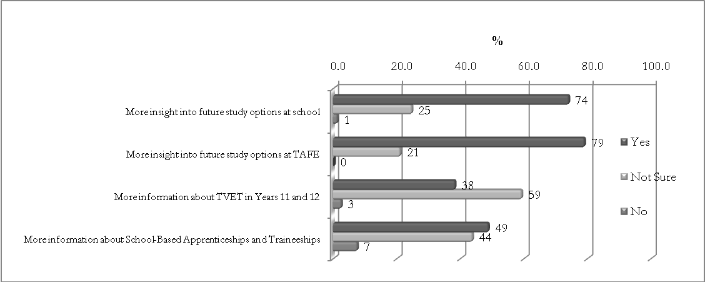
V Tracks has given me:
Students and staff clearly reported increased insight into education and training pathways, including future study options at school, TAFE and, while not included in the survey, higher education:
I can see that there’s more than one way to get somewhere, like university … so it’s good to know that doing these sorts of things [V Tracks] can keep you moving in the right direction … even if that changes and doesn’t go the way you think it will. Now I know what I definitely need to have … like my Year 10. (V Tracks student)
For the undecided it definitely helped … there are two girls who decided that they wanted to stay at school … they had a realisation of the steps they needed to get to where they wanted to go. (School careers adviser)
In relation to VET, both in school and at TAFE, and also school-based apprenticeships and traineeships, students had only a superficial understanding of the terminology for such pathways:
Students’ understanding of TVET, school VET and apprenticeships and traineeships was more accidental than designed … that’s why it’s important that teachers are given explicit instructions to actively discuss these. (TAFE VET coordinator)
The TAFE teachers described the importance of mapping the different pathways, not only for the students but also for the school staff, suggesting professional development activities to facilitate cross-sectoral understanding:
I found it really important to be mapping the pathways, including TVET and apprenticeships and jobs … all the time … It’s language they haven’t even heard of and therefore aren’t familiar with yet. (TAFE teacher)
School and TAFE staff both suggested that more work could be done ‘around’ the V Tracks program, for example, in schools before and after the TAFE-based learning activities, to strengthen the students’ improved understanding of further education pathways.

V Tracks: Employment pathways
Figure 3 V Tracks—employment pathways
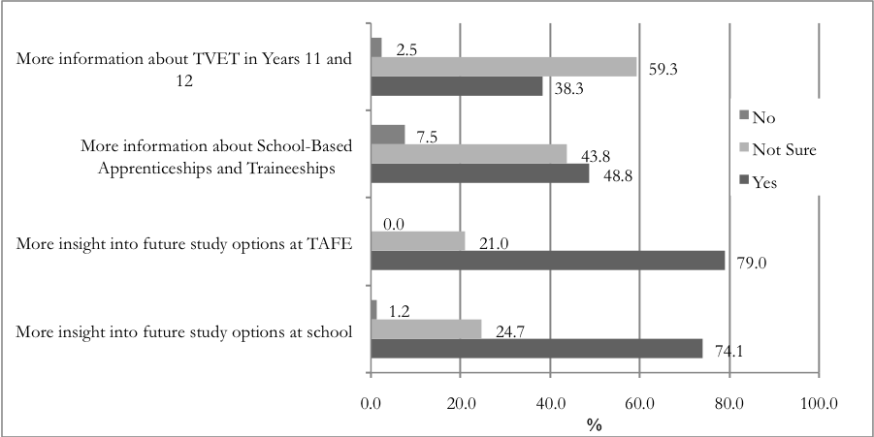
V Tracks has:
Students could more confidently describe their employment aspirations and confidence in seeking work, their identification of future career options, and links between what they were learning during V Tracks, school and the world of work:
Even though I was doing hairdressing, I also learnt customer service skills … which I can use anywhere … I also need to be good at English and Maths to write messages and talk to people … I can understand why I need to learn some things—a real reason.
(V Tracks student)
While only two of the nine V Tracks programs included work experience or an industry visit, these proved successful components and were recommended as an essential stage for such programs:
All the machines we were using at TAFE were at the work site and people were doing what we had been doing … I definitely reckon I could do the job … I want to get an apprenticeship. (V Tracks student)
It’s really important for continuity and relevance for students to at least visit a workplace in the industry area they have been studying—to get a real picture, or idea, of what to expect.
(School careers advisor)
In the absence of formal work experience, students, TAFE and school staff agreed that opportunities to simulate workplace standards and teach students about the skills needed for work were extremely valuable:
These kids have definitely got an edge over other young people going for casual work in town … they know what to expect and how to act. (TAFE teacher)
The more professional workplace simulation, where they were treated like employees, helped and seemed more linked to the real world … It was a highly structured environment where the kids signed in and then discussed what would happen during the day … and then did that. (School Aboriginal Education Officer)
TAFE staff also emphasised that their existing links with local industry could be utilised and strengthened to broker work placement opportunities for V Tracks students and also address local workforce development needs:
We have bridges with industry and employers, so it’s important to maximise these … getting in guest speakers to talk to students, particularly about Indigenous-specific job opportunities in the community. (TAFE teacher)
One young person similarly expressed the need for real transition opportunities into employment:
What’s the point in learning if there’s no job for us at the end of it? We don’t want to learn things just for the sake of it. (V Tracks student)

V Tracks: Attitudes to school
Figure 4 V Tracks—attitudes to school
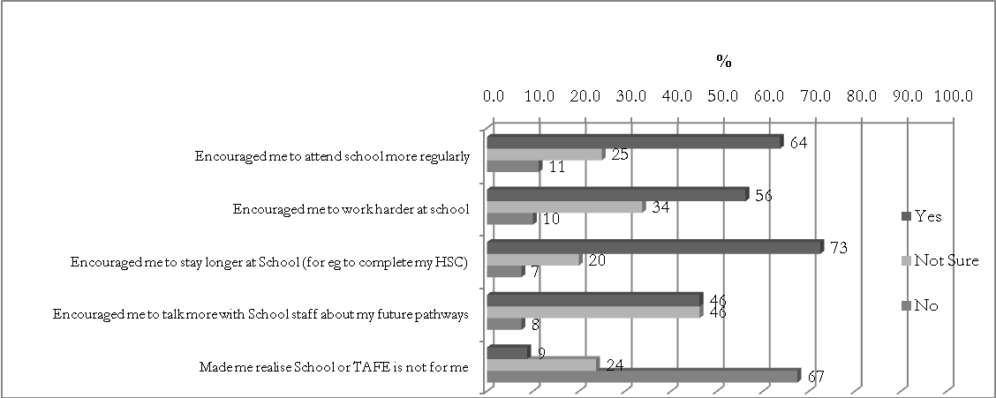
V Tracks has:
A significant proportion (64%) of students agreed that V Tracks had encouraged them to attend school more regularly, often to ensure they didn’t miss out on any news or risk being excluded from the activities. They also reported increased variety in their day-to-day schooling, while school staff described an ability to use the program to retain current ‘at risk’ students and re-engage students who hadn’t been in school for some time:
It was definitely a carrot and the students were constantly coming up to me in the school ground—checking that they were going to V Tracks tomorrow or next week … We also went out and found students who hadn’t been to school for a while and targeted them … they definitely had more reason to attend. (School Aboriginal Education Officer)
While the majority of students either agreed or were unsure whether V Tracks had encouraged them to work harder at school, many of them described feeling ‘differently’ about school:
I feel like I can do more on my own now, like it’s easier to do or learn new things. I want to get a better career and better money and I need my Year 10 for that. (V Tracks student)
School staff, however, overwhelmingly reported increased engagement at school:
So many of them came back into school the next day, so proud of what they’d done. V Tracks was an incentive to be good … there were huge improvements in attendance, behaviour and attitude. (School Aboriginal Education Officer)
Some students started to pay more attention in particular subjects, for example, maths, because the TAFE teacher said how important it was to be able to do measurements and calculations. (School coordinator)
Seventy-three per cent of students agreed that V Tracks had encouraged them to stay longer at school, for example, from Year 9 into Year 10, or from Year 10 into Years 11 and 12:
Staying would be hard if you were just doing normal school stuff. Doing more hands-on and basic skills for life and work makes me feel like there’s more options and more fun. You look forward to the days when you get to do something practical and fun. School is a bit of ‘writing and reading’ and then TAFE is some ‘doing’. I’m going into Year 10 because I want to go to Year 12 too. (V Tracks student)
School staff also reported an increased uptake of school VET programs for V Tracks students going into Year 11 and early commencement (Year 10) VET. They also felt confident in describing student outcomes they consider would otherwise have occurred:
Two girls who were really at risk at the start of the year are now going into TVET next year … another boy might be getting a hairdressing apprenticeship and he’s only going to be in Year 10! The TAFE teacher thought he was a star and is really trying to get him back … he just can’t make up his mind whether he wants to do hairdressing or aged care … decisions … decisions! (School Aboriginal Education Officer)
While students were equally divided about improved communications with school staff, this could reflect the informal nature of the interactions which took place between students and staff, for example, on buses to and from the TAFE campus and during lunch breaks. The increased opportunities for these interactions, however, led to more discussions of the ‘future’ and, from a school staff perspective, strengthened personal relationships, which young people may have more difficulty describing:
There were so many more opportunities for conversations with the kids about their future—which we normally wouldn’t have had, or they wouldn’t be interested in … they were getting to feel safe and really know various school and TAFE staff and ask questions … there was a trickle effect too … a sharing effect … they would talk in the park with other students and parents as well. (School VET coordinator)
School staff identified Work Education electives, School to Work and Personal Learning Plans as an ideal vehicle to have conversations with students before, during and after programs such as V Tracks, and across year levels, for example, from Year 8 to Year 11. They also identified that capturing such longitudinal qualitative data, together with quantitative retention data would help inform school and TAFE planning.

V Tracks: Self-confidence
Figure 5 V Tracks—self-confidence
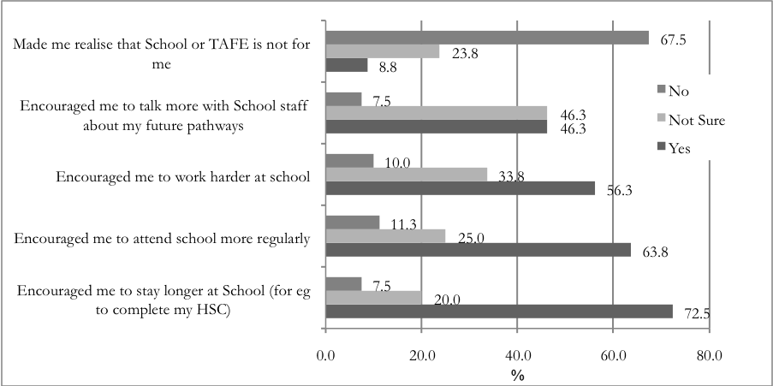
V Tracks has:
A vast majority (90%) of students agreed that V Tracks had given them confidence in learning new things, and both school and TAFE staff reported an increase in students’ self-esteem, pride and confidence. The opportunities students had to self-manage small projects contributed to their sense of accomplishment and their identification of natural aptitude, skill and confidence to try new things:
I feel like I’ve got more skills for life and for work … at first I was all shame but I got over that. (V Tracks student)
It was incredible seeing kids you never would have thought … blossom. Most of them just became so much more positive and confident, saying ‘I want to do that again’ … showing forward thinking. (School VET coordinator)
The practical and hands-on nature of the learning activities provided through V Tracks was also viewed very positively by both students and staff:
It was cool taking something home, that you’d made all on your own and in one day … I didn’t know I could do something so quickly. I made a tool box and paper holder and showed my parents. (V Tracks student)
The young people got in there, got their hands on the job and completed things. Their sense of pride and satisfaction was tremendous. (School VET coordinator)
While some students (30%) reported uncertainty about how V Tracks had increased belief in their own abilities, during the interviews many of them expressed a relationship between this and the
amount of time spent in a learning area. Staff also emphasised the importance of time, not only for the hands-on activities, but also for reflection upon the learning process:
One boy would always leave his back pack on, and I would say to him: ‘Are you ready to do the runner on me?’ As time went on, he took it off. (TAFE teacher)
It takes time for the young people to feel safe, and to get to know the teachers and ask questions. These programs need to allow time for this to happen … which can also be a part of students’ looking at their own learning styles, for example, through Personal Learning Plans. (School careers adviser)
Many students and staff described the ‘fresh beginning’ students were able to make:
They [TAFE teachers] didn’t know who we were and the [school] teachers didn’t say anything to them … so it was starting from scratch … you’d still get in trouble, but then it would be back to normal … you weren’t written off, like you can be from Year 7 at school.
(V Tracks student)
The young people and staff also reported a broadening of students’ interest in new activities or hobbies:
It’s not just about what you can learn for a job, but also about fun things for life. There’s really exciting things you can do, even at home. (V Tracks student)

V Tracks: The learning environment and student support
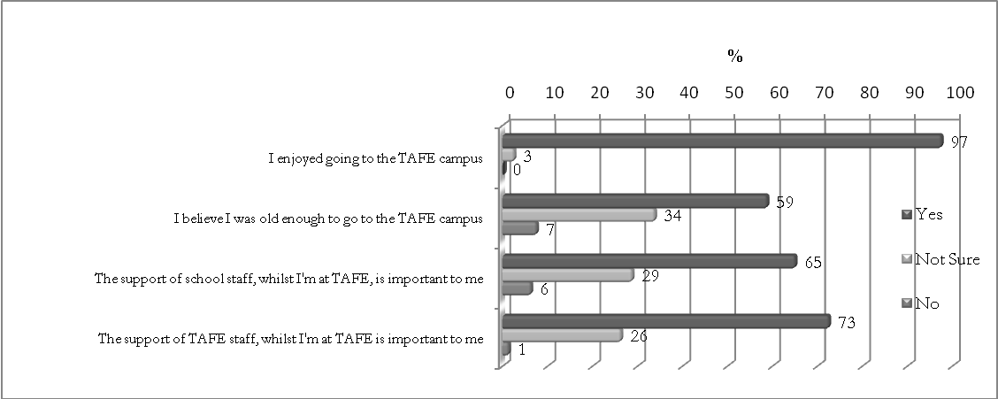
Figure 6 V Tracks—the learning environment and student support
It was very clear that students enjoyed attending the TAFE campus, with particular enthusiasm expressed for their use of sophisticated equipment, tools and resources:
It was awesome seeing these big facilities … just like workplaces, and wearing proper uniforms and head gear and stuff. (V Tracks student)
It was a bit of a culture shock at first, especially for kids coming from missions to this huge and adult TAFE environment … they were seeing tools and machinery they’d never seen before … and then to know that they could operate them and, become good at it, was a big thing for them. (TAFE Aboriginal Student Support Officer)
Many of the young people believed they were mature enough to attend the TAFE campus, although they also acknowledged challenging elements of the adult learning environment. Students
and staff identified the TAFE teachers’ high expectations and treatment of students as adults, and not ‘kids’, as being very important:
It was a great place to be … the teacher treated us like we weren’t kids and acted like a normal everyday person … you still got in trouble if you did something wrong, but then things went back to normal … it was just because the TAFE teacher was persistent in us getting things right … We were told that we were TAFE students, not kids.
(V Tracks student)
The young people were able to step up in an adult environment and … act like adults so they could be treated like adults … they weren’t there as ‘school kids’ but as ‘TAFE students’.
(School staff member)
A majority of school staff suggested that programs like V Tracks target Year 9 students for the best part of the school year, but include Year 10 students earlier in the year before their Year 11 subject selection and School Certificate exams. They largely agreed, however, that Years 7 and 8 students should be included in Open Day, ‘taster’ and Deadly Days activities, so that further education, training and employment opportunities were at least made visible to them. The young people also suggested that Years 7 and 8 are too early for students to engage in Stages Two and Three of the V Tracks program:
Younger kids wanted to know why they couldn’t do it yet, but they need to get a taste of school first … going from primary to high school is hard enough … Year 7s need to get that right before anything else. (V Tracks student)
Letting the younger [Year 7 and 8] students know what’s around the corner is equally important … they need to see that there’s lots of opportunities in the future … We can lose kids as early as Year 7. (School careers adviser)
Support provided by school and TAFE staff was identified as important, with students placing slightly more emphasis on the role of the TAFE staff. This could be attributed to the fact that there was more continuity with the TAFE teachers, whereas school staff mostly shared supervision and coordination duties with each other across a ‘roster’ system. In programs where the same school staff accompanied the students throughout the entire program, all three groups reported the value in this:
It was good being better than, or as good as, the [school] teacher … and learning together … we were the same … students together. (V Tracks student)
The roving flow of teachers from schools was wonderful—the students felt connected and proud. (TAFE teacher)
The role of school staff in discussing curriculum and pathway options with students was also emphasised by the school and TAFE staff, as was the strengthening of personal relationships which allowed young people to feel more connected to their learning, the adults supporting them and the adult learning environment. It was clear, however, that if school staff were present or dropping into workshops, it was important for them to actively participate and support the students’ learning:
Some [staff] do heaps and are active and supportive and that’s when the learning and enjoyment really takes off … others don’t do so much … thinking it’s a ‘day off’ and the kids get embarrassed by that. (TAFE teacher)
A significant challenge, however, was identified in the workload implications for staff to be released from school to provide such active support:
It’s all well and good to advocate for one or two consistent school staff members to actively participate in the program, but is this built in funding wise? The kind of student support these programs need requires wider organisational buy-in. Being there for the kids, which clearly has a huge impact, required a lot of good will from staff … we got by on ‘a wing and a prayer’ but there was a lot of catching up to do when we got back to school.
(School VET coordinator)
School staff identified that the value in supporting the young people through V Tracks balanced the challenges, but that wider school support was necessary to provide this:
This support needs to be strongly committed to by principals and put into planning and budgets. More school supervision and staff support would take the pressure off one or two people. (School careers adviser)

V Tracks: Cultural elements of the program
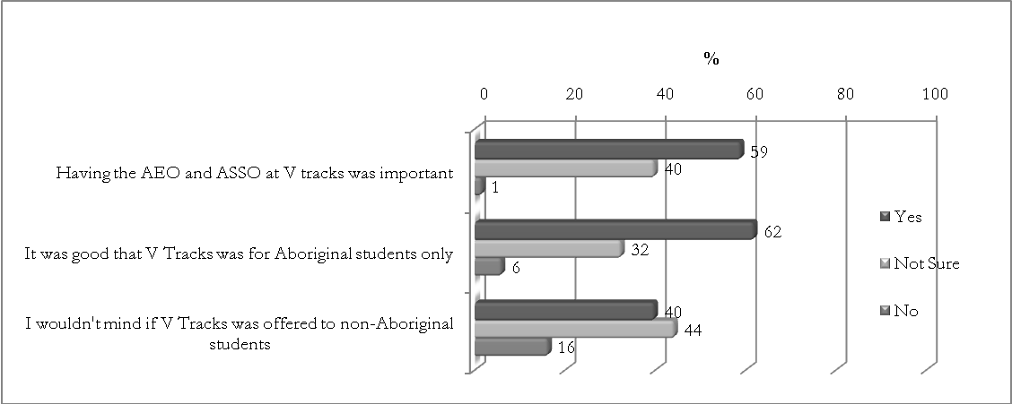
Figure 7 V Tracks—cultural elements of the program
Uncertainty regarding the value or importance of Aboriginal support staff, reflected by students during the survey, wasn’t matched during the interviews, in which students, school and TAFE staff all emphasised the role of Aboriginal adults and role models in encouraging, inspiring and supporting the young people:
Yeah it was good … especially on the first few days at TAFE, which were scary. It’s good when someone you know helps you get there and back and also knows the rest of the Kooris and parents. (V Tracks student)
One of the nine pilot sites included Aboriginal mentors, funded by a Commonwealth Government ‘Whole of School Intervention’ program and assigned to the V Tracks student groups. There was no doubt that this coordinator in the school, as a point of contact for students, parents and TAFE staff, assisted the smooth running of the program and therefore outcomes for the students:
They do everything with us, so we know them and they know us. We also know it’s the person to go to, to ask about V Tracks. (V Tracks student)
When there’s one consistent person from the school—for discipline, travel and communication with us … it’s so much easier, for students and us. (TAFE teacher)
The cultural activities and workshops, which included a range of role models, were also identified as significant:
The role models and ‘heroes’ talking with students at the Open Days and Deadly Days were amazing … it was great to move away from ‘niggerigenous’ American role models—like 50 per cent who the kids see on tele[vision] all the time—and have a more realistic and meaningful focus on being Aboriginal. I thought the cultural components of the programs were a highlight and had a huge impact on me and other staff, but importantly the kids.
(School careers adviser)
While some students (32%) indicated ambivalence about the Aboriginal focus of V Tracks, many of them (60%) appreciated an opportunity to attend a program as a discrete group and meet other Aboriginal young people from their wider communities:
I went home and told Mum about these fellas I’d met ... and it turns out they’re cousins … I met heaps of people. (V Tracks student)
It was their program … they owned it and they felt special. (School VET coordinator)
However, students and also a TAFE member observed that including non-Aboriginal students would be appropriate and mirror what happens in other school programs, going as far as to identify equity issues:
I didn’t know what to say when a couple of friends asked me why I was doing it and they weren’t … it kinda didn’t seem fair. (V Tracks student)
Everything doesn’t need to be the ‘same’ anyway. Reconciliation doesn’t mean doing everything together … parts of programs could be good for students to take a (non-Aboriginal) friend to … sharing days like the Deadly Days and V Tracks Open Days. This would facilitate better understanding across cultures but also allow our kids to celebrate and retain their own Aboriginal culture. (TAFE Aboriginal Student Support Officer)
School staff, from the coal face to those in executive or decision-making roles, nevertheless discussed the need for such targeted programs to close the gap in educational achievement for Aboriginal students:
There were a lot of non-Aboriginal students asking: ‘Why not me?’ Staff were asking questions too. But there are lots of mainstream programs for young people and these may not be so accessible to Aboriginal young people … It’s also part of our Aboriginal education priorities. (School VET coordinator)
All three stakeholder groups emphasised that a program like V Tracks shouldn’t be seen as a ‘dumping ground’ for difficult students, nor as a program for all Aboriginal students because of their Aboriginality. It was indicated, for example, that students on a clear academic pathway shouldn’t automatically be included in the program:
It’s not a program for the worst kids with the worst teachers! There can be preconceptions out there, which are pretty warped, but students, schools and we need to see the program as an opportunity to step up … not down. (TAFE coordinator)
I knew already that I wanted to finish high school and go to university, so I didn’t want to miss out on school … but for kids who don’t know what they want to do yet, it’s great.
(V Tracks student)
We shouldn’t just pick up groups of students because they’re Koori … thinking this is a Koori program so let’s put all our Koori kids in it. (School careers adviser)

V Tracks: Structure of the program
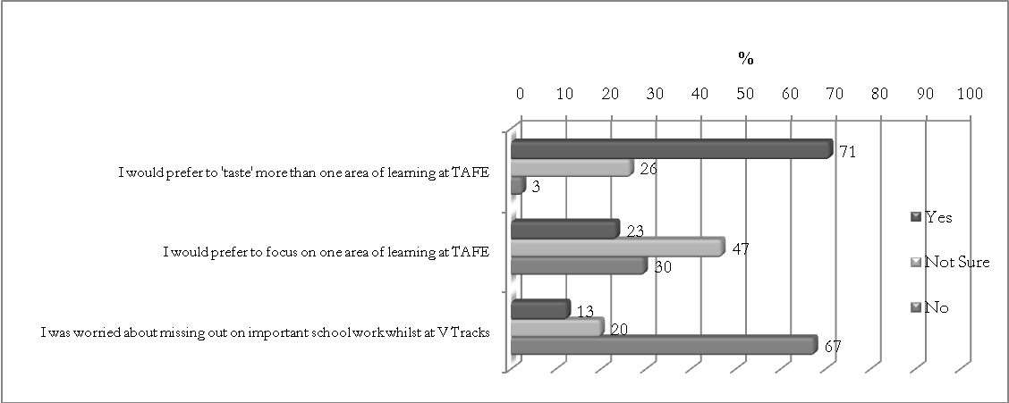
Figure 8 V Tracks—structure of the program
Given a choice, most young people (70%) expressed a preference for being able to try a few different areas of VET rather than focusing on one or two. They did, however, clarify that they would like an opportunity to do both—to sample various industry areas, before exploring at least one or two areas in more depth:
I didn’t know that I might actually like some areas … I’d never even thought about hair and beauty or child studies, but now I have … It’s good to have a bit of both—a taste of a few areas, but then time to get good at one. (V Tracks student)
The value of combining initial ‘tasters’ with more sustained activities was reiterated by school staff, not only to provide meaningful articulation into competencies and further training, but also to address the disparity between what students thought they did and didn’t want to do.
Choice and selection are very important. In some cases, if a student was put into something they didn’t choose, and the decision was made on their behalf, then they really acted up … but sometimes the opposite was true … they’d find something new and interesting.
(School VET coordinator)
TAFE teachers agreed that even though some students were reluctant participants at the beginning of ‘taster’ workshops, resistance could turn to enthusiasm, identification of natural ability and untapped interest:
A couple of girls made it very clear that they didn’t want to be there … they had very limited and negative ideas of what ‘business studies’ included. After an hour they were hooked and I couldn’t get them out of the classroom to go to morning tea. (TAFE teacher)
TAFE staff reiterated the value of delivering non-accredited activities as ‘tasters’; however, they also described the importance of relating these to further accredited VET:
It’s not just about going to TAFE and having heaps of fun … what are the skills you’ll learn for future education and the world of work? We don’t want to set them up for a fall and we don’t want to romanticise what they can do… so they turn up a year later for TVET and it’s all a lot harder. (TAFE teacher)
TAFE staff equally described the conflict presented by providing non-accredited training, specifically because of pressures to meet funding and enrolment targets. More flexibility in funding models was suggested, as was flexibility to incorporate generic learning, employability and communications competencies. Concern was expressed about a lack of systems and the time required to support such non-accredited training and cross-faculty engagement and cooperation.
You want to ease the students into TAFE and not bombard them with a heap of paper work, assessment and enrolment in units that are too much too soon … This competes against the pressure of enrolment and ASCH [actual student contact hour] targets. (TAFE coordinator)
School staff also recommended the inclusion of meaningful learning and key competencies related to further study and work, but also aligned to in-school programs:
V Tracks can be a part of the School to Work Planning and Personal Learning Plans that we’re all supposed to work on with the kids anyway. (School Aboriginal Employment Officer)
V Tracks sits beautifully in the Work Education curriculum … Work Education should be more widely offered … We should also work with the School to Work committees within schools. (School VET coordinator)
A recommendation from this was that schools and TAFE bring together consultants and learning and development officers to map school and earlier VET curricula to provide context, relevance, literacy and numeracy support and articulation pathways for the learners. That is, a preference for a multi-disciplinary and cross-sectoral approach to retention and engagement of young Aboriginal learners was clearly expressed, so that programs like V Tracks are ‘built in’ and not ‘bolted on’ to existing school or TAFE programs. This was also recommended, so that school staff recognise the value of the program for Aboriginal students:
So they [staff] don’t see it as another wishy washy black fella program.
(School Aboriginal Education Officer)
Despite the many recommendations and suggestions made regarding the structure of V Tracks, it was nevertheless emphasised that the programs be designed locally—to meet the particular needs of the schools involved and their students:
We’ve heard about other programs being run in other areas, and there’s no way that would work with the students we want to target. (School careers adviser)
Students weren’t concerned about missing out on school work because they felt they were able to catch up, through texts or special efforts made by teachers to help them cover anything they missed:
Our teacher made sure she didn’t give any tests while we were at V Tracks … most of the stuff we do at school comes out of books anyway—so it’s easy to catch up.
(V Tracks student)
This is why programming way ahead of time and factoring it into the school calendar is so important … everyone can plan for it and it just becomes another activity within the school.
(School VET coordinator)
School staff emphasised the need to encourage school executives, school-to-work committees, Aboriginal education officers, Aboriginal education workers, head teachers, careers advisers and additional school staff to accommodate the program so that students don’t miss key teaching and assessment events in their mainstream curriculum, and aren’t mistakenly thought to be truant:
As long as teachers know, ahead of time, that the students are going to be away at V Tracks, then everyone’s happy … they want to support the program and see the kids do well, but to do this they need to be ‘on side’, which means being informed. (School VET coordinator)

V Tracks: Overall perceptions
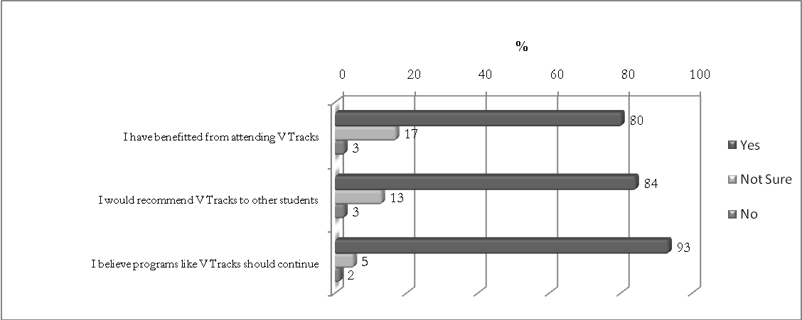
Figure 9 V Tracks—overall perceptions
Students’ overall perceptions of the program were extremely positive, with the majority of young people (80%) agreeing that they had benefited from V Tracks, would recommend it to other students and would like to see the program continue:
I’m so glad I did it … now I can get a better career, better money and hopefully still go to uni.
(V Tracks student)
We tell the younger kids … your time will come! (V Tracks student)
Staff equally described the value of V Tracks and expressed a preference for the program to continue. They did, however, describe challenges and suggestions for meeting these, which are included in the following section of this paper.
The two obstacles most commonly identified by school staff were difficulties in organising and funding travel to the TAFE campus and, again, supporting students through staff release from other in-school programs:
Travel was definitely the most challenging part of the whole program … the cost … the organisation … it was really hard work. (School VET coordinator)
Some of these kids are the most tricky to manage … but they’re the ones we need to target. They need more support, not less. (School careers adviser)
The longevity or future of such programs was a source of anxiety for school and TAFE staff, who expressed concern that V Tracks might just be another pilot program shown to work, but not supported to continue:
It would be terrible to do all this hard work, and let the kids see what is possible, and then rip it all out from under them. What happens next? (School careers adviser)
These programs need to be supported at a state and regional level to ensure that logistics such as travel and student supervision don’t prevent young people, who really need these programs, from participating. The program works … provide the funding to get the students to it. (TAFE Aboriginal Student Support Officer)
When asked about unanticipated outcomes of the V Tracks programs, TAFE staff emphasised their own professional development in working with young Aboriginal learners and understanding systems and sectors other than those within which they practise:
The students taught me a lot about myself … as a person … but also as a teacher … I basically threw everything out the window and started again! I taught differently … in twenty minute cycles—twenty minutes theory and twenty minutes practice … which is probably the way a lot of students like to learn! This helped with my TVET delivery and working with younger learners in general. (TAFE teacher)
TAFE staff also suggested that teachers on programs like V Tracks should be high-priority candidates for Aboriginal cultural awareness training implemented throughout the New South Wales Department of Education and Training as part of its Aboriginal Education and Training Policy:
I completed the Aboriginal Cultural Education Program half way through my V Tracks program, and I felt much better equipped to work with the students and also communicate with their carers and support staff. I’d highly recommend it to all staff, but staff working on these programs in particular. (TAFE teacher)
School staff described improved relationships and communication with parents and encouraged further parental and Aboriginal community ‘buy in’ in program design and implementation:
Having the parents and community there on the Open Days was really important and magical. (Aboriginal mentor)
The Personal Learning Plans were again identified as a perfect vehicle for achieving this engagement with parents:
PLPs are a conversation between a student, their parent or caregiver and their teacher, which culminates in a specific agreement being developed to support the student in their learning … [they’re] about developing relationships to understand what the parents’ goals and aspirations are for their child, for the child to express interests or challenges and for the teacher to listen with core demands of literacy and numeracy underpinning the process.
(School Aboriginal Programs Coordinator)

Discussion and recommendations

Advice on educational pathways including better explanation of VET
Consistent with the key messages from the literature, V Tracks as a program of VET for school students in Years 8 to 10 increased the visibility of multiple pathways and opportunities to students otherwise at risk of early school leaving. However, while students claimed that they had achieved greater insight into further study options at school and at TAFE, it was also clear that more could be done for both students and staff to demystify the variety of VET pathways available and also to formalise cross-sectoral understanding about such pathways. This is consistent with observations made by Vickers (2005) and Pitman and Herschel (2002) about students’ perceptions of school as only being about academic study. Recommendations therefore included delivery and implementation guides for school and TAFE staff, which incorporated discussion and mapping tools to explicitly identify and explore multiple pathways with students, including VET in Schools, TAFE-delivered VET, school-based apprenticeships and traineeships, and articulation into higher education. It was suggested that many of these activities could be undertaken within the school as part of the work that careers advisers, VET coordinators and teachers do with students in key learning areas and electives, including Work Education, or as part of students’ School to Work or Personal Learning Plans. These school activities could then be mapped against activities which TAFE teachers complete with students, in linking learning with industry and further education, training and employment pathways.

Advice on pathways into work, including building relationships with industry
All three stakeholder groups agreed that V Tracks not only increased the visibility of further education and training opportunities for students, but also pathways into the world of work. They did, however, emphasise the importance of strongly aligning V Tracks programs with work experience or work readiness activities and supported the inclusion of these as essential, not desirable, components of future programs. It was identified that these could again be mapped against the activities students undertake through their School to Work planning, which places importance on linking skills learnt in school and VET programs to the workplace and students’ career and transition plans. School and TAFE staff also recommended strengthened relationships with local industry to identify and access opportunities for V Tracks students to engage in work experience and/or work readiness activities, and develop skills in local skills shortage areas. This confirms Porter’s (2006) recommendation that facilitating transitions between school and work and contributing to a highly skilled workforce requires strong coordination between the stakeholder groups involved in such VET programs.

Retention strategies for early school leavers
Students and school staff described students’ increased engagement in school activities and also apparent retention of learners considered to be ‘at risk’ of early school leaving. It was suggested that V Tracks could target different student groups throughout the year, for example, students at ‘medium risk’ of disengagement from school earlier in the year, subsequently capitalising upon their anticipated success and enjoyment as a ‘carrot’ for ‘high risk’ students later in the year. It was identified that schools’ support of such at-risk students in their travel to, and engagement in, the TAFE environment presents time and funding challenges. It was equally recognised, however, that such challenges are outweighed by the opportunities presented to strengthen relationships with students and help young people feel more connected to the school and staff. This clearly aligns not only with Vickers’s (2005) findings regarding school-related reasons for young people wanting to leave school early and their perceptions of whether they ‘like’ or engage with teachers and staff, but also Polesel and Helme’s (2003) discussions of young people’s alienation in learning environments. Finally, school and TAFE staff expressed a preference for gathering longitudinal quantitative and qualitative data on programs such as V Tracks, in particular talking with students when they are in Years 8 to 11 and capturing their pre- and post-program perceptions of future pathways. School to Work and Personal Learning Plans were again identified as an ideal vehicle for such data collection.

Increase self-confidence
All three stakeholder groups agreed that students’ participation in non-accredited, project-based activities at the beginning of the V Tracks program provided opportunities for creativity, fun and immediately practical and hands-on activities, where students could develop confidence, resilience and interest in new learning areas. School and TAFE staff also recommended providing time for students to engage in ‘un-packing’ of their learning, so that increased self-confidence is a targeted outcome from the program. It was identified that various curricula in both schools (Personal Learning Plans) and TAFE (learning, employability and communications competencies) can support this. Staff recommended allocation of financial and human resources to create such systems to achieve this, for example, through the establishment of multi-disciplinary and cross-faculty and curricula strategies to address the affective dimensions of the young people’s learning and also to value non-accredited activities as pathways into accredited VET. This would not only complement the practical, work-based activities, but also provide a framework for young people to profile themselves and their educational needs, as recommended by Patterson (2007) and Barnett and Ryan (2003).

Engage with wider support mechanisms to provide introductory activities for younger students
The exposure to an adult learning environment was undoubtedly a positive experience for the younger learners, and all three stakeholder groups described students’ increased maturity and skills in responding to the expectations placed upon them to perceive themselves as TAFE, and therefore adult, students. It was recommended that introductory V Tracks activities include younger (Years 7 and 8) students, so that VET was at least made visible to these learners, but that more sustained delivery and programs target Years 9 and 10 students, as they prepare to transition into senior school and VET programs. It was again identified that the challenges in assisting at-risk students to adapt to such a new, and more adult, learning environment requires active and committed support from both school and TAFE staff, which has significant implications for the funding of such initiatives. The importance of this is highlighted in previous research, specifically through the work of Helme and Hill (2004), which recommends systematic engagement with wider support mechanisms to facilitate young (Indigenous) students’ access to VET. Through the narrative presented in other parts of this paper, it is clear that school support for programs such as V Tracks through staff release requires broader systems support.

Introduce cultural elements
Apart from targeting younger students, the inclusion of cultural elements such as role models, mentors, Aboriginal support staff and cultural activities set V Tracks apart from existing TAFE taster courses offered through current or previous school VET initiatives. This cultural affirmation, suggested by Polesel and Helme (2003) as often lacking in learning environments, proved successful in engaging the Aboriginal students and also their parents. In recognising the value of V Tracks as an earlier intervention VET program, school staff did welcome the idea of extending such programs to non-Aboriginal students at risk of early school leaving and disengagement from education, training and employment. It was, however, emphasised that, given the lower transitions of Aboriginal young people from junior to senior secondary school, VET, higher education and work, these students remain a higher priority or target group for such programs. Balanced against this, was the recommendation that selection processes incorporate criteria in addition to Aboriginality, for example, ‘students not on a clear academic pathway’, so that individual Aboriginal students are targeted according to their broader learning needs and aspirations.

Have flexible funding models
It was agreed by the three stakeholder groups that opportunities for the young people to taste a variety of learning areas, before focusing on one or two, allows for more meaningful outcomes and articulation pathways into further education, training or employment. The value of providing non-accredited activities was, however, identified as competing with funding and enrolment targets, which TAFE staff feel under pressure to meet. It was suggested that more flexible funding models and targets, together with time to support combinations of non-accredited VET and generic key competencies, are needed to recognise such activities as legitimate and valuable and also to support their meaningful articulation into accredited VET. It was further emphasised that programs such as V Tracks need to provide flexibility at local planning levels, so that activities can be designed to complement existing school curricula and programs, local work opportunities and industry skills areas. While a generic model is useful as a starting point, ‘one size doesn’t fit all’. It was also recommended that the programs encourage whole-of-organisation and community design and implementation, so that programs like V Tracks are seen as core business, ‘built in and not bolted on’, to what happens in schools. For example, while school staff had some concerns about the withdrawal of students from classes, they also thought the benefits outweighed the challenges and that greater communication and consultation with key staff members would address such challenges. This aligns with Porter’s (2006) recommendations vis-à-vis strong coordination between stakeholder groups.

Summary
The students and school and TAFE staff agreed that V Tracks had demonstrated positive outcomes across the key areas explored through the research: education and training pathways; employment pathways; attitudes to school; self-confidence; the learning environment and student support; cultural elements of the program; and structure of the program. Their overall perceptions reiterated the discussions and recommendations included in these focus areas. For example, while school staff emphasised the value of V Tracks, they also identified a need for longer-term funding to create and sustain systems and strategies to provide transport and pastoral and curriculum support. They also expressed a desire to work more closely with parents to design and support programs such as V Tracks, and again suggested the Personal Learning Plans as a mechanism to foster this relationship and communication. TAFE staff reported increased professional knowledge and confidence in working with more diverse learning groups and also a desire to engage in further professional development to improve this capability and better support young Aboriginal learners in particular. Finally, the learners and school and TAFE staff all wished to see the V Tracks program continue and looked forward to incorporating the recommendations revealed during the research project—to drive the capacity of programs and practitioners to respond to early school-leaving—as recommended by Patterson (2007).
This, together with recommendations raised through the interviews to include more Aboriginal Education Workers, role models, cultural activities and transport, pastoral and curriculum support, presents significant policy implications on how to resource and support such earlier VET programs.
The research project revealed a willingness of school and TAFE practitioners to identify and address such challenges and work collaboratively to improve retention and engagement of young Aboriginal school students and increase their education, training and employment pathways. The unanswered questions remain about how to fund, create and sustain longer-term systems and strategies to move such programs from the margins to the mainstream.

Glossary of terms
Aboriginal: In referring to Aboriginal people, this paper refers inclusively to all Aboriginal Australians and Torres Strait Islander people.
Aboriginal Community Liaison Officers (ACLOs): based in the NSW Department of Education and Training regions.
Aboriginal Education Consultative Groups (AECGs): New South Wales AECG Incorporated is an Aboriginal community-based organisation made up of volunteer members who are involved in local and regional AECGs throughout NSW. NSW AECG Inc. is recognised as the principal source of advice on behalf of Aboriginal communities on issues relating to education and training.
Aboriginal Education Officer (AEO): positions are allocated to New South Wales Government schools. These replaced Aboriginal Education Assistants (AEA).
Aboriginal Education Workers (AEWs): are employed by the New South Wales Government and non-government schools to assist Aboriginal students.
Aboriginal Student Support Officers (ASSOs): within North Coast TAFE provide an Aboriginal student advisory and support service.
Higher School Certificate (HSC): completed through Years 11 and 12, or Stage 6.
Local Community Partnerships (LCPs): are incorporated, not-for-profit, community-based and locally operated organisations contracted by the Australian Government through DEEWR to provide a strategic approach to the implementation of three career and transition programs. LCPs facilitate the delivery of the programs to all schools (across all government, Catholic and other non-government schooling sectors) for the benefit of all young people (aged 13–19 years).
New South Wales Department of Education and Training (DET): delivers public education and training from early childhood (pre-school), through to the compulsory years of schooling (Kindergarten to Year 10), and senior secondary education leading to the award of the Higher School Certificate (in Years 11 and 12). It also provides TAFE NSW courses, adult and community education courses, migrant English programs, post-secondary art courses and advice to the NSW Government on higher education.
North Coast Aboriginal Learning Partnerships (NCALP): an approach to Aboriginal education and employment that overtly values partnership as a way of working and which expects a whole-of-business commitment to improving outcomes; also, a business initiative of North Coast TAFE; a coordination team within North Coast TAFE established to assist the institute to achieve its 2020 Vision to diversify Aboriginal participation, deepen partnerships with industry and community organisations, develop pathways between sectors, and drive performance within the institute.
North Coast Region (NCR): of New South Wales, from Tweed Heads on the Queensland–NSW border to the Great Lakes region in the south.
North Coast TAFE: one of ten institutes in TAFE NSW, consisting of 17 campuses located between the Great Lakes region in the south to the Tweed Heads region on the Queensland border.
Personal Learning Plans (PLPs, NSW DET Schools): contain attendance, literacy and numeracy goals and strategies for Aboriginal students.
School-based apprenticeships and traineeships (SBATs): whereby students can simultaneously achieve their Higher School Certificate, Universities Admissions Index, and a nationally recognised qualification usually at certificate II or III level, while being employed part-time.
School to Work Plans (STWs, NSW DET Schools): assist student career development in Stages 5 and 6, especially targeting students at risk of early school leaving. Four key result areas are included: planning transition pathways; exploring career futures; strengthening student outcomes through vocational learning; and building networks and connections. Students are also supported to work through an Employment Related Skills Logbook:
Stage 5 – Years 9 and 10 in the NSW High School system
Stage 6 – Years 11 and 12 in the NSW High School system.
TVET: TAFE-delivered VET courses for students undertaking the NSW HSC. School students in TVET courses are concurrently entered for the HSC with the Board of Studies NSW and enrolled in a nationally recognised Australian Qualifications Framework (AQF) qualification with TAFE NSW. Students must meet requirements which satisfy both the Board of Studies and TAFE.
Universities Admission Index (UAI): is a numerical measure of a student’s overall academic achievement in the NSW Higher School Certificate in relation to that of other students. It allows the comparison of students who have completed different combinations of HSC courses and is calculated to rank and select school leavers for admission.
VET in Schools (also VETiS): is school-delivered VET courses for students undertaking the NSW Higher School Certificate. School students in these courses are concurrently entered for the HSC with the Board of Studies NSW and enrolled in a nationally recognised AQF qualification.

References
ABS (Australian Bureau of Statistics) 2007, North Coast Aboriginal Health Service Local Area Aboriginal estimated resident population, ABS, Canberra.
Anlezark, A, Karmel, T & Ong, K 2006, Have school vocational education and training programs been successful? NCVER, Adelaide.
Barnett, K & Ryan, R 2005, Lessons and challenges: Vocational education in schools—Research overview, NCVER, Adelaide.
Helme, S & Hill, A 2004, ‘Indigenous students and VET in Schools: Insights for developing good practice’, paper presented at the Australian Association for Research in Education (AARE) Conference 2004.
MCEETYA Taskforce on Indigenous Education 2001, Exploring multiple pathways for Indigenous students discussion paper, viewed May 2008, <http://www.curriculum.edu.au/verve/_resources/exploringmultiplepathways_ file.pdf>.
Ministerial Council of Education, Employment, Training and Youth Affairs 1999, The Adelaide Declaration on National Goals for Schooling in the Twenty-first Century, DEST, Canberra.
New South Wales Department of Aboriginal Affairs 2003, Two ways together: Aboriginal affairs plan, 2003–12, Dept of Aboriginal Affairs, Sydney.
New South Wales Department of Education and Training 2006, Our 15 to 19 year olds—opportunities and choice: An education and training strategy for 15 to 19 year olds in NSW 2006–2009, DET, Sydney.
——2006, School to work plan: Looking forward 2006–2010, DET, Sydney.
New South Wales Government 2007, A new direction for NSW: State plan, NSW Government, 2007.
——2008, Raising the school leaving age: Consultation paper, viewed February 2009, <http://www.bangthetable.com/document/show/244>.
Patterson, J 2007, ‘We know what to do but we don’t always do it – aligning policy and practice’, paper presented at the Australian Social Policy Conference, Sydney.
Pitman, J & Herschel, P 2002, The Senior Certificate: A new deal, Queensland Department of Education, Brisbane.
Polesel, J & Helme, S 2003, Young visions final report, prepared for the Enterprise and Career Foundation, Educational Outcomes Research Unit, University of Melbourne.
Polesel, J, Teese, R, Lamb, S, Helme, S, Nicholas, T & Clarke, K 2005, Destination and Satisfaction Survey of 2004 HSC VET students in New South Wales: Final report, NSW Department of Education and Training, Centre for Postcompulsory Education and Lifelong Learning, University of Melbourne.
Porter, J 2006, What makes vocational training programs in schools work? A study of New South Wales and Queensland Schools, NCVER, Adelaide.
Vickers, M 2005, Staying on at school in New South Wales: Sustaining quality, increasing retention, and providing transition support, New South Wales Department of Education and Training, viewed February 2009, <http://www.det.nsw.edu.au/media/downloads/reviews/futuresproject/report/m_comppaper2.pdf>.

Appendix 1

V Tracks and Deadly Days: TAFE–schools initiatives to increase the retention and engagement of young Aboriginal learners in education, employment and/or training
V Tracks is an early intervention learning program for young Aboriginal high school students on the North Coast of New South Wales, which concentrates on strategic and collaborative partnerships between TAFE and schools to increase the retention and engagement of these learners in education, employment and training. A key strategy for delivering on objectives of increased high school completions and post-school pathways is increasing the availability of VET to Stage 5, Years 9 and 10, school students. Through a focus on TAFE taster programs and school-based vocational learning in the earlier years of secondary schooling, V Tracks provides young Aboriginal learners with opportunities to taste, think about, choose and plan school and vocational pathways while exploring individual, workplace and educational and Aboriginal cultural values. Broadly speaking, V Tracks seeks to provide students with opportunities to participate in combinations of:
- TAFE-based delivery
- school-based planning, delivery and reflections
- work experience or work readiness
- cultural mentoring.
To create these opportunities, V Tracks seeks a whole-of-organisation approach and supports collaboration between TAFE, schools, government agencies, municipal councils, local community partnerships (LCP), industry and business and the wider Aboriginal community, including regional and local Aboriginal Education Consultative Groups (AECGs), Aboriginal Land Councils and other appropriate agencies. Flexible funding models, as opposed to a ‘one size fits all’ approach, invite consultation with school clusters and communities to allow for the creation of local programs and solutions which respond to local aspirations, needs and skills shortage areas. To facilitate this, V Tracks steering committees at each local program level develop, implement and review the V Tracks program. These steering committees might include: the TAFE V Tracks Coordinator; the Schools Regional Vocational Education and 15–19 Years Consultants; representatives from the individual schools including principals, careers advisers, Aboriginal Education Officers, and Aboriginal Community Liaison Officers; Aboriginal development and/or community or business development officers from municipal councils; local community partnerships and Department of Education, Employment and Workplace Relations representatives.
Significantly, the V Tracks programs align to the ‘Deadly Days’ Festivals hosted by North Coast TAFE and sponsored by the Australian Government as part of the Community Festivals for Education Engagement initiative. The initiative aims to increase education, employment and training opportunities for young Aboriginal and Torres Strait Islander people and also promote positive and healthy lifestyles. Specifically, the Deadly Days Festivals seek to increase the capacity of local communities to plan and implement festivals that meet the following objectives:
- communicate positive engagement with education
- showcase employment, training and vocational pathways
- encourage positive engagement with healthy lifestyles and reduced crime
- promote contemporary and traditional Aboriginal and Torres Strait Islander cultures
- engage partners in activities that promote and sustain culture, identity and community interaction
- include arts, music, performance and sports activities.
Held at three North Coast TAFE campuses across the Northern, Central and Southern campuses of the institute, the festivals attracted more than 1500 young Aboriginal learners and school students, mostly from Years 6 to 12 but also from the wider community. One hundred and fifty education and employment exhibitors provided workshops and demonstrations at the festivals and more than 400 Aboriginal elders and community members attended and participated in the learning activities and events, which included: hands-on vocational workshops; careers expos; healthy living activities, including Indigenous Hip Hop and Bush to BBQ sessions; sporting workshops with Aboriginal icons including Artie Beetson, Dave Peachey and George Rose (successful National Rugby League players); performances and question-and-answer sessions with Troy Cassar-Daly (a high-profile Aboriginal musician from the North Coast) and Alison Page (from the ABC’s New Inventors television program and Merrima Aboriginal Design Group).
The emphasis of the Deadly Days Festivals is to provide V Tracks students with opportunities to consolidate and showcase their learning throughout the year and also: explore further education, training and employment opportunities; experience healthy living options; enjoy contemporary and traditional Aboriginal and Torres Strait Islander cultures; participate in activities promoting and sustaining culture, identity and community interaction; and engage in arts, music, performance and sporting activities. Students, school and TAFE staff understood the Deadly Days Festivals as a core feature of the broader TAFE–schools partnership to increase the retention and engagement of young Aboriginal learners in education, training and employment and an integral component of the V Tracks program.



V Tracks Survey
Your Year Level: _______________________
Your Gender: _______________________

This survey is completely anonymous and confidential. Neither your name nor your School’s name will be provided to anyone else at any time.
The V Tracks Coordinator, Regan Harding, will read through the questions one by one with you. If you are unsure of how to respond to a question, leave it blank and you will have a chance to return to it later.
Please ask Regan, your School Aboriginal Education Officer, the TAFE Aboriginal Student Support Officer, or other support staff members to assist you in re-reading or answering any questions that are a bit tricky.
The questions have been divided into sub groups to help make them easier for you to answer.

V Tracks and future pathways …
V Tracks has given me … |  | Yes  Definitely |  | Not sure |  | No  Definitely not
1 | More insight into future study options at school
2 | More insight into future study options at TAFE
3 | More information about TVET in  Years 11 and 12
4 | More information about school-based apprenticeships and traineeships
5 | More insight into future career and job options
V Tracks and my attitude to school…
V Tracks has … |  |  | Yes  Definitely |  | Not sure |  | No  Definitely not
6 | Encouraged me to attend school more regularly
7 | Encouraged me to work harder at school
8 | Encouraged me to stay longer at school (e.g. to complete my High School Certificate)
9 | Encouraged me to talk more with school staff about my future pathways
10 | Made me realise school or TAFE is not for me
V Tracks and my attitude to work …
V Tracks has … |  |  | Yes  Definitely |  | Not sure |  | No  Definitely not
11 | Taught me more about the skills needed for work
12 | Given me confidence in thinking I could do part-time or full-time work
13 | Helped me see a link between learning at school /TAFE and the world of work
V Tracks and the TAFE learning environment …
During V Tracks … |  |  | Yes  Definitely |  | Not sure |  | No  Definitely not
14 | I enjoyed going to the TAFE Campus
15 | I believe I was old enough to go to the TAFE Campus
16 | The support of school staff whilst I’m at TAFE, is important to me
17 | The support of TAFE staff whilst I’m at TAFE is important to me
The structure of V Tracks
V Tracks |  |  | Yes  Definitely |  | Not sure |  | No  Definitely not
18 | I would prefer to ‘taste’ more than one area of learning at TAFE
19 | I would prefer to ‘focus’ on one area of learning at TAFE
20 | I was worried about missing out on important school work whilst at V Tracks
21 | I would prefer to go to V Tracks: |  | - One day per week  - Half a day per week (eg double period)  - One day per fortnight  - Half a day per fortnight  - 2 or 3 day block per term  - Other (please describe):  ..................................................
V Tracks in general …
Overall, V Tracks has … |  |  | Yes  Definitely |  | Not sure |  | No  Definitely not
22 | Given me confidence in learning new things
23 | Shown me different ways of learning – e.g. hands-on and practical ways
24 | Helped me see a future pathway
25 | Helped me ‘believe’ in my own abilities
Overall, V Tracks has … |  |  | Yes  Definitely |  | Not sure |  | No  Definitely not
26 | Given me a ‘fresh start’ in a different learning program
27 | Given me new interests or activities (e.g. art, music, cars, plants)
V Tracks … final thoughts …
Overall … |  |  | Yes  Definitely |  | Not sure |  | No  Definitely not
28 | I have benefited from attending V Tracks
29 | I would recommend V Tracks to other students
30 | I believe programs like V Tracks should continue
V Tracks … and culture …
I thought … |  |  | Yes  Definitely |  | Not sure |  | No  Definitely not
31 | Having the AEO and ASSO at V Tracks was important
32 | It was good that V Tracks was for Aboriginal students only
33 | I wouldn’t mind if V Tracks was offered to non-Aboriginal students

Focus Group Questions (Students):

- Have you considered new pathways that you hadn’t before V Tracks?
If yes, please describe …

- Did V Tracks give you a different attitude (or feeling) towards attending school this year?
If yes, why?
If no, why not?

- Has V Tracks given you a different attitude (or feeling) towards staying on at school to complete your Year 12 certificate?
If yes, why?
If no, why not?

- Has V Tracks made you feel differently about learning in general? (e.g. increased confidence, belief in your abilities to do new things?)
Please describe …

- Did you see a connection between what you were learning at TAFE and what you were learning at school?
If yes, how?
If no, would it have been more helpful to you if you could?
(* consider School to Work Plan)

- Were you worried about missing out on other school work?
If yes, what could have helped to make sure you didn’t miss out?
If not, why weren’t worried?

- Would you prefer a ‘taste’ of a few different learning areas in TAFE, or would you prefer in depth learning in one specific area? (Refer to Group 5 questions)

- Do you think V Tracks was offered at the best time in your schooling? (i.e. in Years 9 and 10?)
If yes, why?
If no, why not?

- If you could choose how V Tracks fits within your school week, what kind of model would you prefer?

For example: one day per week; half a day per week (e.g. double period or more); one day per fortnight or term; half a day per fortnight; 3-day block per term?

What are the reasons for your choice? For example, travel; missing out on school work; giving more variety to your learning/ week at school
- What were the best things about the V Tracks program?

- What were the more difficult, or challenging, things about the V Tracks program?

- What support would help you overcome these challenges?
For example, TAFE or school teacher support

- Would you recommend V Tracks to other students?
If yes, why?
If no, why not?

- Please comment on the fact that V Tracks was for Aboriginal students only …
Questions to school staff

- Did V Tracks have an impact on students’ attendance at school?
If yes, please describe

- Did V Tracks have an impact on students’ engagement at school?
If yes, please describe

- Did V Tracks prompt students to talk more about their future pathways?
- What were the most effective components of the V Tracks program?
- What were the more difficult, or challenging, components of the V Tracks program?
- How would V Tracks programs ideally be structured, in terms of:
- Time per week/ term (e.g. block; day/ week …)
- Activities included (e.g. non-accredited ‘taster’ vs accredited and direct articulation)
- Year levels offered to
- Alignment with school programs
- Other?
- What support is needed for learners in V Tracks programs?
Questions to TAFE staff

- What were the biggest differences you noticed between V Tracks students and TVET students?
- As the program progressed, did you notice a change in the V Tracks students’ engagement in learning?
- Did V Tracks prompt students to talk more about their future pathways?
- What were the most effective components of the V Tracks program?
- What were the more difficult, or challenging, components of the V Tracks program?
- How would V Tracks programs ideally be structured, in terms of:
- Time per week/ term (e.g. block; day/ week …)
- Activities included (e.g. non-accredited ‘taster’ vs accredited and direct articulation)
- Year levels offered to
- Alignment with school programs
- Other?
- Please comment on your experience of delivering non-accredited/ non-assessable activities to students (e.g. in terms of usefulness/ practicality for students/ your enjoyment)
- Was it important to fully understand, through briefing provided by the V Tracks coordinator, the purpose of the program? (e.g. in design/ delivery and your conversations with students)
- What support is needed for learners in V Tracks programs?

Shame is a term often used by Aboriginal learners and community members to reflect withdrawal from a confronting or conflicting situation, for example: performing a task in front of others; being questioned publicly on attendance and participation patterns; not completing assessment tasks; letting a group or group leader down; or being acknowledged or praised for positive behaviour. It can also refer to fear of: rejection, neglect, being wrong, or of the unknown, for example, fear of a new feeling or experience.

