Investigating the impact of intensive reading pedagogy in adult literacy

Helen de Silva Joyce
Susan Hood
David Rose

New South Wales Directorate of
Community and Migrant Education
The views and opinions expressed in this document are those of the author/project team and do not necessarily reflect the views of the Australian Government, state and territory governments or NCVER

Publisher’s note
To find other material of interest, search VOCED (the UNESCO/NCVER international database <http://www.voced.edu.au>) using the following keywords: action research, adult literacy, adult education, English as a second language, non-English speaking background, reading, skill development.

© Australian Government, 2008
This work has been produced by the National Centre for Vocational Education Research (NCVER) on behalf of the Australian Government. Funding has been provided under the Adult Literacy National Project by the Australian Government, through the Department of Education, Employment and Workplace Relations. Apart from any use permitted under the Copyright Act 1968, no part of this publication may be reproduced by any process without written permission. Requests should be made to NCVER.
The views and opinions expressed in this document are those of the author/project team and do not necessarily reflect the views of the Australian Government or NCVER.
The author/project team was funded to undertake this research via a grant .These grants are awarded to organisations through a competitive process, in which NCVER does not participate.
ISBN 978 1 921412 64 6 print edition
ISBN 978 1 921412 65 3 web edition
TD/TNC 93.18
Published by NCVER
ABN 87 007 967 311
Level 11, 33 King William Street, Adelaide, SA 5000
PO Box 8288 Station Arcade, Adelaide SA 5000, Australia
ph +61 8 8230 8400 fax +61 8 8212 3436
email ncver@ncver.edu.au
<http://www.ncver.edu.au>
<http://www.ncver.edu.au/publications/2064.html>

About the research
Investigating the impact of intensive reading pedagogy in adult literacy
Helen de Silva Joyce, Susan Hood, David Rose, New South Wales Directorate of Community and Migrant Education
Reading is a crucial skill for participation in adult life. However, teaching those who cannot read or who have very poor reading skills is a complex process. This is particularly true for adults from a non-English speaking background, and when classes consist of learners with different reading abilities, sporadic attendance patterns and emotional impediments, such as a fear of failure or ridicule.
In this study, the authors introduced six adult literacy tutors to a particular reading methodology, known as Reading-to-Learn, and examined how this approach could help adult learners from non-English speaking backgrounds become efficient and independent readers. The Reading-to-Learn methodology is a commercial product developed by Dr David Rose and is primarily based on his work in the schools sector. It relies on very careful attention to the relationships between words in a text.
A further focus of the study was how well adult literacy practitioners can implement the Reading-to-Learn methodology in their classrooms. While this particular methodology has been used successfully in other educational settings, such as primary and secondary schools and universities, this is one of the first studies to test its usefulness for adult learners from non-English speaking backgrounds.

Key messages
- While this report is based on a very small sample, it suggests that the teaching strategies that comprise the Reading-to-Learn pedagogy are effective in helping adults from non-English speaking backgrounds to improve their reading and writing skills.
- The study also shows that use of this pedagogy can increase teachers’ knowledge about language and reading processes.
- Using this method demands careful preparation of classes and requires teachers to ‘unlearn’ some common practices that amount more to testing than teaching.
- The successful implementation of the Reading-to-Learn approach in the adult literacy sector requires intensive professional development and additional financial resources.
- While the teaching resources associated with the Reading-to-Learn pedagogy are commercial products, a Good Practice Guide has been developed to complement this report and can be downloaded at no charge from <http://www.ncver.edu.au/publications/2065.html>.

Tom Karmel
Managing Director, NCVER

Contents
Tables 6
Executive summary 7
Context 10
Research purpose 10
Methodology 13
Participants in the study 13
Professional development component 13
Action research component and data collection 15
Findings 17
Implications 29
Professional development issues for the adult reading classroom 29
References 32

Tables
1 Extracts from a record of teaching practice 15
2 Miscue analysis data from beginning and end of course 18
3 Comparative analysis of student story text performances 24
4 Comparative analysis of student information text performances 26

Executive summary
The process of writing is generally accorded a great deal of attention in adult literacy teaching, with the use of models for guiding writing also a feature of some programs. However, less attention has been given to the development of efficient and independent reading skills. As noted in Burns and de Silva Joyce (2000, p.x): ‘Reading is often viewed as a passive, even mysterious language skill, difficult to observe and therefore to teach.’ Most often in the teaching of reading there has been a reliance on reading tasks that involve text, with associated comprehension questions, in effect, tasks which assess rather than teach. The problem in such an emphasis is that reading tasks can become nothing more than exercises in differentiation according to existing levels of proficiency.
The goal of this research was to develop more effective ways for ensuring that all students develop the reading and writing skills required for gaining employment and undertaking training in the workplace.
A number of recent studies in the Adult Migrant English Program (AMEP) have supported the need for attention to reading pedagogy in adult language and literacy teaching, identifying student perceptions of and priorities for reading (Burns & de Silva Joyce 2000), along with the challenges to teachers in implementing more intensive reading support (Burns & de Silva Joyce 2005). A challenge highlighted by these studies was to identify ways to use reading pedagogies that were compatible with the structuring of adult literacy provision, and which were guided by the same underlying theoretical understandings of language that have shaped current curriculum models. That is, the strategies adopted had to be seen by teachers as integral to their programs.
In parallel to the interest in the teaching of reading in adult literacy is a growing body of evidence of success associated with the use of an innovative methodology referred to as Reading-to-Learn (Rose 2004, 2007). The Reading-to-Learn approach proposes a very systematic, explicit and carefully scaffolded approach to intensive reading. Significant success was reported in a range of other educational settings and sectors, including primary and secondary schools (McRae et al. 2000; Culican 2006), universities and Indigenous literacy programs (Rose et al. 2003; Rose et al. in press). The approach is premised on a theory of language as social and meaning-making, and a theory of learning as one of ‘scaffolded’ interaction. As such it is compatible at a general level with theories which have guided pedagogy in the field over the past decade or more. However, it offers much more detailed and specific guidance for teachers in how to scaffold; that is, how to guide and support students towards achievement of tasks, not just at a macro-level, but also at every micro-step in the process.
While the Reading-to-Learn methodology has been extended into many domains of literacy education in schools and tertiary settings, it has not been systematically applied in ways that would enable its potential to be investigated in adult literacy contexts. This research project was designed as an action research study, whose aim was to explore the potential for and impact of a more explicit and carefully planned pedagogy of intensive reading, while taking into account the difficult circumstances in which many adult literacy teachers work. The research involved a partnership between practising teachers and researcher–teacher educators with expertise in reading theory and practice. The project involved the selection of a group of teachers who were interested in exploring reading pedagogy. Six teachers from adult and community education (ACE) colleges and NSW
TAFE nominated to be involved in the project, which involved familiarisation with the methodology, support for the teachers for the period of the application of the pedagogy, collaborative forums for identifying problems and finding solutions, and ongoing data collection.
While a methodology of experimental design comprising the stages of pre-test, intervention and post-test might suggest itself as an obvious choice in evidence-gathering, several factors make such a design problematic. Due to the project timeframe it was necessary to workshop the methodology with teachers throughout the period of action research and data collection, rather than undertaking all the training at the beginning of the project. This meant that teachers were developing knowledge and skills throughout the duration of the project. Pre-intervention and post-intervention reading data were complicated in this regard. Part-time employment conditions, part-time provision, varied teaching spaces and resources, irregular attendance patterns, and students from multiple first-language backgrounds were also characteristics of the field. Rather than presenting factors to be controlled, these variables were seen as needing to be accommodated in the design. The aim was to consider the effectiveness of the Reading-to-Learn methodology in the context of current adult literacy provision, focusing on the impact on learner outcomes, as well as on the practicalities of implementation and resource implications. Multiple data sources were used, including regular, recorded and transcribed group discussions, classroom observations, teaching practice records kept by teachers, student feedback, assessment of student reading and writing performances, and audio- and video-recording of lessons.

Findings
The study highlighted that a number of characteristics of adult literacy contexts make the implementation of explicit, carefully planned methodologies crucial if students are to develop, during the time they have available to study, reading and writing skills sufficient to enable them to participate in social and work contexts.
While acknowledging that teachers are accustomed to adapting and making on-the-go decisions about what to do next in classrooms, the study emphasises the importance of maintaining the integrity of the Reading-to-Learn pedagogy. For their part teachers have developed a deep appreciation of the rationale for the steps that comprise the pedagogy. Reading-to-Learn relies on very careful attention to wording and meaning relations within texts and requires teachers to unlearn some common practices that amount more to testing than teaching.
The study highlights that the reading abilities of students are frequently underestimated. Initial reading assessments often—appropriately—begin with unchallenging texts. However, there is subsequently no move towards the use of more challenging texts to extend students sufficiently. Initial assessments therefore do not provide adequate data for indicating progress. There is also some reluctance to then draw on challenging texts in the teaching of reading. This appears to result from the dominance of reading tasks that essentially test and do not teach reading, and to a lack of confidence in teaching reading.
Initially it was observed that reading tasks were dominated by various kinds of read-and-answer-questions activities. Classroom activities did not build the relationships of words to meaning, either in terms of the way meanings unfolded in phases of texts, or at the level of wordings within texts.
At the beginning of the project the teachers involved in the project found it difficult to manage class time effectively, feeling a tension between finishing the sequence of tasks and being concerned that their students were losing the ability to concentrate. As the project progressed, however, teachers reported that their professional knowledge deepened and they developed a greater awareness of language and the implications of this knowledge for their teaching. This enabled them to improve their ability to select appropriate well-constructed texts, to identify key phases of texts,
to prepare texts for reading, and to manage exchanges that enabled students to connect meanings and wordings. Over the duration of the project teachers also improved their planning processes, reported paying more attention to all students in the class, especially those for whom reading was most challenging, and found they were praising students more frequently.
The data collected indicated improvements in students’ reading and writing, which in many cases had not been expected by teachers and which were significantly beyond those predicted in the syllabus outcomes. In addition, teachers reported that student responses to the pedagogy were generally positive, with attendance patterns improving significantly. In some classes there was a noticeable increase in peer support. The teachers also reported that the reliance of English as a second language (ESL) students on electronic dictionaries was greatly reduced, as students became familiar with the Reading-to-Learn pedagogy. The pedagogy extended the grammatical resources of students and increased their enthusiasm for talking about the language of the texts they were reading and writing.
Teachers also reported that the innovative focus on reading in their programs, through their participation in the project, impacted on the broader teaching and management staff in centres, with co-teachers and managers interested in knowing more about the pedagogy. DVDs of the teachers’ application of the pedagogy have also become resources for ongoing professional development. The findings in this regard suggest that a more broadly based professional development model can benefit from the involvement of interested groups of teachers, who can then model and co-teach the pedagogy with and for their peers.
The professional development model implemented in this study incorporated periodic interventions by experts in the Reading-to-Learn method. It also included workshops for teachers and periods of application and reflection. While this is a resource intensive model, it is an effective way of introducing new approaches into classrooms.

Implications
Although the project was small, the interaction with the research team meant that a considerable depth of data could be collected over more than one course. The results indicate that the Reading-to-Learn pedagogy had a positive impact on student achievements in reading—their attitudes to language learning in general and to reading in particular. Teachers experienced positive outcomes in terms of their growth in professional knowledge, especially about language, with flow-on implications for day-to-day practice in systematic planning and teaching.
These gains were made on the basis of periods of intensive professional development input, sustained support through initial stages of implementation, and ongoing opportunities to share experiences and results. To introduce the Reading-to-Learn approach to the adult literacy sector will require commitment of time and funds and ongoing institutional support. It will also require the current professional development materials to be adapted to the adult literacy context, making links to adult literacy and language curricula outcomes.

Context

Research purpose
Reading is often viewed as a passive, even mysterious language skill, difficult to observe and therefore to teach. (Burns & de Silva Joyce 2000, p.x)
The process of writing is given great attention in adult literacy teaching, as is the use of models for guiding writing. However, socially oriented research into the daily literacy practices of adults over the past three decades has clearly shown that reading is more far-reaching than writing (Barton & Ivanic 1991; Baynham 1995; Heath 1983; Joyce 1992), yet its significance can be frequently overlooked in programming adult literacy classes.
Where reading is identified as a key component in literacy teaching programs, there has been a strong tendency to rely on reading tasks that centre on texts with associated comprehension questions, the outcome being a focus on assessment rather than teaching. Many of the reading tasks, such as answering questions or matching items, then become more about seeing who can and who cannot already read.
The specific purpose of the research project was to investigate, through an action research methodology, the most effective means for informing and training practising adult literacy teachers in a more intensive and scaffolded approach to the teaching of reading. The aims were: to investigate professional development in reading pedagogy; to begin to build a base of skilled and reflective reading teachers; to contribute to resource and policy development; and to impact on professional training programs in adult literacy. The ultimate objective was to develop more effective ways for ensuring that all students acquire the reading and writing skills required for gaining employment and undertaking training in the workplace.
Over the past 50 years or so various theories of cognition, learning and language have given rise to diverse approaches to teaching reading.
- Skills-based approaches (Nicholson 1993; Perfetti 1995) view reading as a cognitive decoding skill, and language as rules of syntax and sets of vocabulary. They consequently focus on sound-letter decoding and building word and sentence-level knowledge.
- Psycholinguistic approaches (Goodman 1968; Smith 1971) see reading as an individualised cognitive process, where readers sample contextual knowledge outside the text, make predictions and decode forms in the text to confirm their predictions. This gives emphasis to developing predictive and sampling skills.
- Interactive approaches (Rumelhart 1977; Stanovich 1980) see reading as a process of combining information from multiple sources in and beyond the text. The focus is on developing decoding skills and using strategies for skimming, scanning and using contextual cues.
- New literacy approaches (Gee 1990; Kress 1989; Wallace 1992; Freebody & Luke 1990) view the reading process as a complex process of social interaction, where cultural and social knowledge and purpose frame the development of skills in decoding, understanding, using and deconstructing texts.
One motivation for this project was to explore further a social orientation to reading, as identified in the new literacies approach, and to inject such an approach with much greater emphasis on intervention and micro-scaffolding of the teaching–learning of reading, as was apparent in Reading-to-Learn pedagogy (Rose 2004; 2007).
The Reading-to-Learn methodology proposes a systematic, explicit and carefully scaffolded approach to the teaching of reading. Success was reported in a range of educational settings and sectors, including primary and secondary schools (McRae et al. 2000; Culican 2006), universities and Indigenous literacy programs (Rose et al. 2003; Rose et al. in press). An action research project applying the methodology in a tertiary setting with Indigenous students studying undergraduate health science at the University of Sydney reported that:
It is possible to improve adult students’ academic literacy, at the same time as providing access to an academic curriculum in sciences and social sciences, by supporting all students to read and write the academic texts in which the curriculum is realised. An average improvement rate equivalent to four years or more of secondary schooling, in just 60 hours over one year, shows that such achievements are within the scope of many academic programs. (Rose et al. in press)
Further support is given by Culican (2006) who, writing about the application of the methodology in middle-school literacy development, noted that it:
… was highly successful in accelerating the literacy performance of over 95% of the target students underachieving in literacy. However teachers also reported that at the same time it extended the learning of more able students and increased the engagement and participation of all students. (Culican 2006, p.57)
While the adoption of the Reading-to-Learn methodology has been extended into many domains of literacy education in schools and tertiary settings, it has not been systematically applied to enable the evaluation of its potential in adult literacy contexts, which can differ considerably from those of the other domains in which the pedagogy has been used to date (see discussion in methodology). The Reading-to-Learn methodology is premised on a theory of language as social and meaning-making and a theory of learning as one of scaffolded interaction that is compatible at a general level with guiding theories in the adult literacy field. The methodology offers detailed and specific guidance for teachers in how to scaffold, that is, how to guide and support students in their achievement of all classroom tasks, even down to finding words in a text that represent a particular meaning. Its adoption by teachers would therefore involve them in considerable learning processes.
The results of two previous research projects into reading undertaken in the Adult Migrant English Program (AMEP) in 2000 and 2005 also prompted the project. The first project explored the reading practices, outside the classroom, of students from various non-English speaking backgrounds, and interviewed students about their perspectives on reading and the teaching of reading (Burns & de Silva Joyce 2000). The main findings in this research were that students placed a great deal of importance on teachers reading aloud any texts introduced into the classroom, both as a means of enabling them to come to terms with the code and providing an orientation to classroom texts. Students from non-English speaking backgrounds hoped to be able to replicate their first-language reading practices in English and they wanted their teachers to guide them through various types of texts in English. The research also found that many students were unsure about whether their teachers taught reading, as the focus and purpose of activities in the classroom were often unclear; students also saw lack of vocabulary as the main barrier to independent reading.
The second Adult Migrant English Program project used an action research model to investigate explicit, scaffolded teaching of reading in adult classrooms, with texts carefully chosen to challenge students (Burns & de Silva Joyce 2005). The teachers in this project generally found that a more focused approach to reading changed their practices and challenged their long-held views about teaching.
This current project was also designed as an action research study, the aim of which was to explore the potential for, and impact of, a more explicit and carefully planned method for the teaching of reading to adults. The circumstances in which many adult literacy teachers work were also taken into account in the study design.
The project sought to address the following five research questions:
1 What differences in learning outcomes eventuate from a more intensive and scaffolded approach to the teaching of reading?
2 Does a more intensive and scaffolded approach to the teaching of reading affect learner responses to reading?
3 Does a more intensive and scaffolded approach to the teaching of reading affect other educational outcomes for adult literacy students, for example, writing skills?
4 What changes in teacher attitudes and practices are necessary to implement a more intensive and scaffolded approach to the teaching of reading?
5 What is the best means to train practising adult English for speakers of other languages (ESOL) and adult basic education (ABE) teachers to implement a more intensive and scaffolded approach to the teaching of reading?

Methodology
The project involved a combination of teacher development, action research undertaken by the teachers in their adult literacy classrooms, and observation and evaluation of resulting classroom practices and learner outcomes.

Participants in the study
The project began with six teachers from two adult and community education colleges in Sydney—St George and Sutherland Community College and Parramatta Community College. Two of these teachers were not able to complete the project. However, two teachers from Padstow TAFE asked to join the project within the first two weeks, so the overall number remained at six teachers. The participating teachers are referred to later in the report as Teacher 1, Teacher 2 etc.
Three researchers worked with the teachers and delivered the professional development workshops, which introduced the teachers to the pedagogy. They also coordinated data collection, observed classes and guided teacher implementation of the pedagogy.

Professional development component
The bulk of the professional development component of the project was delivered through four workshop sessions:
Session 1: The intensive scaffolding approach to reading and writing was introduced using video recordings of demonstration lessons and prepared lesson plans.
Session 2: The initial implementation of the approach was reviewed and lesson planning strategies introduced.
Session 3: The ongoing implementation of the approach was reviewed using teacher lesson plans and text-analysis techniques for adult literacy contexts were introduced.
Session 4: Teachers and researchers reviewed feedback and observation data and considered the relevance of the approach to adult literacy contexts.
As the project was drawing to a close, the teachers requested an additional workshop to review the overall project and to focus in more detail on assessment.
The methodology was introduced to the teachers through professional development booklets and a DVD of demonstration lessons.
In addition to the principles of scaffolding literacy, the content of the professional development covered:
- reading and writing stories
- reading and writing factual texts
- scaffolding literacy for community teachers
- planning reading lessons
- analysing language patterns within the sentence
- analysing language patterns beyond the sentence
- assessing student reading and writing.
The six-stage teaching cycle of the Reading-to-Learn methodology is outlined briefly below. A more comprehensive explanation is provided in the findings, where a sequence of student texts from the mixed-level classroom of Teacher 1 are included to illustrate the progressive outcomes at each stage of the students’ work on reading and writing a short narrative.

Stage 1 Preparing before reading
This stage orients students to the genre and field of the text. First of all, students are assisted to understand the text in general terms by the teacher providing the background information that the students need to help them comprehend the text. The teacher then explains what the text is about and then summarises how the story, or structure, of the text unfolds, in terms that all students can understand.

Stage 2 Detailed reading
In this stage the teacher supports all students to read each sentence in a short passage. The teacher summarises the meaning of the whole sentence in commonsense terms, places cues in the text to show students where to look for the wording, and gives the meaning of the wording in general terms. Students then have to make the link between the meaning cue and the actual word on the page. The student highlights the word once it is successfully identified. The strategies in this stage enable all students in a class to read a passage with complete understanding and to understand how the author has constructed it.

Stage 3 Preparing for writing
Once a student can fluently read a passage and comprehend it, they begin to prepare to write a new text that is based closely on the passage they have studied. Depending on the genre of the passage, there are two ways this stage can be undertaken. Students can write ‘factual texts’, writing up the wordings highlighted in the previous ‘detailed reading’ stage as dot points on the board. Alternatively, as a group, the class can produce ‘stories, arguments and text responses’ by discussing new content for a text that will use the same literacy or persuasive language patterns of the text that has just been read.

Stage 4 Joint rewriting
Using the notes written on the board, the class works together to write a new text patterned on the reading text. The teacher supports the class. If rewriting a factual text, the context will be the same as the original, although the language patterns may not be as sophisticated, as the wordings used are more like those the students would use themselves. If the students are undertaking a joint rewriting of a story, argument or text, the context will differ from the original, but the language patterns will be similar.

Stage 5 Individual rewriting
Before attempting to write independently, students practise writing a new text using the same patterns as the reading and joint rewriting texts.

Stage 6 Independent rewriting
In this stage students use what they have learned from the preceding stages to write an independent text, which is then assessed by the teacher. This piece of work may be in a context different from that previously written about, but it will be in the same genre (that is, factual, story or argument text) and using similar language patterns that have been learned and practised in the preceding stages.

Action research component and data collection
Between workshops the teachers undertook tasks to implement the Reading-to-Learn methodology in their classrooms, while the researchers assisted in the implementation and collection of data. Throughout the project the teachers were asked to reflect on the implementation process by completing teaching practice records, as seen in table 1.
As a first step the teachers implemented the approach in their classrooms, using the detailed lesson plans provided. At a later stage the teachers planned lessons with the support of the researchers. These lessons were either audio-recorded or video-recorded for reflection with the researchers and the other teachers in subsequent workshops.
Teachers also collected data on student performances in reading and writing, also getting feedback from students and making their own observations. These data included some documentation of reading performances in the form of miscue analysis (see table 2), a technique by which students read aloud in a one-on-one setting with the teacher, who uses a set of notation conventions to document the miscues or misreadings that the student makes in the text. This technique enables the comparison of data from one instance of reading to another, in terms of ease of comprehension.
Student texts produced in the different stages of the pedagogy were also collected. These data and the teaching practice records were collaboratively reviewed and analysed by the teachers and researchers. All workshop discussions were also audio-recorded and transcribed.
The researchers analysed workshop discussions, samples of classroom discourse and other data for preparation of the final report and recommendations about future implementation in adult literacy contexts.
Table 1 Extracts from a record of teaching practice
1.8.07 | During the detailed reading I realised I hadn’t explained the sentences sufficiently; therefore, I couldn’t elicit the correct words to be highlighted. At the end of the lesson one student said she felt she would learn to read better with this method. Most students seemed to enjoy the lesson. Everyone was involved. Some students remembered the exact words in the joint rewriting.
8.8.07 | Again, some students remembered the exact words in the joint rewriting. Other students were peeking at the original text. Next week I’ll collect their highlighted texts before starting the rewriting. This lesson was shorter than last week. I tried to keep it moving a little faster. It was an easier text. Ran out of time to do individual rewriting, and I didn’t want to stretch the lesson to the next day.
15.8.07 | Spent too much time on the detailed reading, because I did detailed reading on the whole text. Next time I will stick to the couple of paragraphs. This is the first lesson I tried the individual rewriting. A few students (T, A, N) couldn’t handle the individual rewriting without help. Others found it challenging but did quite well. Choice of text—it is a simple biography (380 words). Vocabulary was suitable; however, it has some difficult structures e.g. Apart from supplying the Pine Creek population with provisions, Lily bore five children and raised another five adopted children. Next week I will put the students who struggled with the rewriting at the front of the class and get them more involved in the detailed reading.
21.8.07 | I chose this text because it should be at the students’ level and I would be working on that Unit from CSWE [Certificate in Spoken and Written English] the next day. Also because I wanted them to do individual rewriting again this time. I tried to keep the lesson moving and not spend too much time on the detailed reading. The more advanced students were easily able to rewrite this text. Most of the class made a good attempt.
29.8.07 | This text was the most difficult we have done. Detailed reading was very slow because there was a lot of new vocabulary. I tried to introduce more classroom controls in the detailed reading part. In preparing for writing the students like to call out the answers when the scribe gets something wrong—it gets a bit chaotic. This is the first lesson I have done where I really did the joint rewriting the right way. We only re-wrote—in language the students could understand—3 sentences. They were very impressed that now they could understand what were quite dense sentences. Ran out of time to do the individual rewriting. Students commented after the lesson that they were happy they learned a lot of new vocabulary.
5.11.07 | This was the first narrative text I have done with this class using this method. The text turned out to be a good choice, with enough complexity and new vocabulary to work well with the detailed reading phase. The students really enjoyed the joint rewriting in a new context. The original story was about a neighbour who came to a person’s home to complain about loud music. The students chose a classroom as the new context, with an old woman from next door coming to the classroom to complain about the rubbish being thrown into her yard by the school children. I wish I had had time to complete the cycle; however, I need to keep moving through other parts of the curriculum. Next week’s lesson, I plan to complete the whole cycle through to independent writing.
15.11.07 | The students are now very comfortable with this method and are enthusiastic to do each lesson. This time we did individual rewriting—some students were very keen to have a go at this, but some were a bit hesitant. However, everyone tried and they were still writing at 2.10 pm although our class should have finished at 2. Most of them took it home and finished it for the next day. Each student wrote an interesting variation on the ghost story and some included their own experiences. It was a successful lesson. Although I had read and explained the whole story at the beginning of the lesson, one of the weakest students commented that she understood the first 3 paragraphs really well (which we had of course covered in the detailed reading); however, she found the other paragraphs really hard to understand. I realise it is not possible to keep to the timings in the book (although I know these are meant to be a guide). Explaining in commonsense terms is not as easy with ESL students as it would be with native or fluent speakers.
27.11.07 | This was a fairly easy text for these students. However, it was challenging enough to be interesting for them. In the detailed reading I noticed that some students were not keeping up—they were still pondering the previous sentence/phrase. I will need to encourage them to keep up and to ask questions when they don’t understand. However, this reinforces what I have been thinking about this method—that, for ESL students, the teacher needs to go fairly slowly in the Detailed Reading. So I need to ensure that I don’t go too fast, as I think may have happened in this lesson. Again the writing was very successful. Several students commented after this lesson that they enjoy the brainstorming and rewriting. They all want to continue lessons with this method next term. The trickiest part of these lessons is to choose a suitable text. Next term I will use letters, because they are part of the curriculum. Regarding the Independent Writing—I haven’t yet done it in any of the lesson cycles I have done. This is because some of the students are doing individual rewriting as a mixture of rewriting the original story in a new context (which is what it is supposed to be) and adding their own extra bits to the story. I did not want to then ask them to write yet another story (after putting so much effort into the rewritten version), and also I have had to move on to working on the curriculum (i.e. a time constraint).

Findings
The findings in relation to each of the research questions are described below.

1 What differences in learning outcomes eventuate from a more intensive and scaffolded approach to the teaching of reading?
The primary aim of the project was to report on the impact of the pedagogy on student reading skills. To this end the research relied on several sources of data, including the documentation of reading performances using multiple sources such as observation, student feedback and miscue or misreading analysis. Data also included samples of student writing produced at different stages in the pedagogy, samples of expected levels of performance at the relevant curriculum level and teacher perceptions of changes in student performance, as well as student accounts of improved performance.

From records of reading performance
The documentation of any improvements in reading skills relied in part on teachers collecting samples of students reading aloud at the beginning and end of courses. The samples were to be analysed using miscue analysis techniques. By using similar texts at pre-course and post-course assessments, it was intended to provide evidence of sustained improvement in reading skills. The effectiveness of this as a means of data collection was diminished somewhat by several factors.
- Teachers were initially untrained in this technique and so were unable to use it confidently at the commencement of their courses.
- Teachers tended not to extend students in this process, choosing texts that did not present a challenge to students in the initial stages of the course, and which therefore did not provide a base level of difficulty against which to identify progress.
- A number of the classes contained students who were unable to sustain attendance for the duration of the course. Sporadic attendance, non-completion of courses and mid-course enrolments are major challenges facing teachers in adult literacy classes and result from the difficult circumstances of many students, in terms of home and family issues and of intermittent work opportunities.
Table 2 illustrates the miscue analysis of students’ reading performances. It shows some improvement in reading performance of three students in the post-beginner class of Teacher 2 who were present on the occasions the reading assessment was undertaken at the beginning and end of the course. Importantly, it also indicates the non-challenging nature of initial texts chosen and illustrates the difficulty that most teachers experienced in choosing sufficiently challenging texts to assess pre-course reading ability.
Table 2 Miscue analysis data from beginning and end of course
Beginning of course | End of course
M  On Sunday morning I took my daughter ^{children} to a birthday party. While she was at the party, I did the shopping at the supermarket. In the afternoon I took the children to a ^{the} park and they rode their bikes. I was very tired on Sunday night and went to bed early. | No miscues  On Sunday morning I took my daughter to a birthday party. While she was at the party, I did the shopping at the supermarket. In the afternoon I took the children to a park and they rode their bikes. I was very tired on Sunday night and went to bed early.
A  On Friday evening I went to dinner at a friend’s  house ^{home}. We ate lots of good food and drank a bit of / wine. On Saturday morning I got ^{get} up early and went to the market. I bought fruit, vegetables, fish and meat. In the afternoon I did / some housework then played with the children. On Saturday night I watched a video with my husband. | On Friday evening I went to dinner at a friend’s house. We ate lots of good food and drank a bit of wine ^{win}. On Saturday morning I got up early ^{ier} and went to the market. I bought fruit, vegetables, fish and meat. In the afternoon I did some ^{same} housework then played with the children. On Saturday night I watched a video with my husband.
L  On Sunday morning I took my daughter to a birthday party. While she was at the party, I did the shopping at the supermarket. In the afternoon I took the children to a / park and they / rode their bikes ^{took them bites}. I was very tired on Sunday night and went to bed early | No miscues  On Sunday morning I took my daughter to a birthday party. While she was at the party, I did the shopping at the supermarket. In the afternoon I took the children to a park and they rode their bikes. I was very tired on Sunday night and went to bed early.
Codes: daughter ^{children} = substitution good = omission a / park = hesitation market = repetition

From teacher discussions
Teacher discussions were an important source of data on students’ reading and writing performances. Analyses of transcribed data from discussions revealed a picture of increasingly positive responses from teachers and from students. Anecdotal incidents reported by teachers offered important insights. Teacher 5 reported, for example, spontaneous applause erupting from her group as one of her intellectually disabled students read a text aloud by himself in class for the first time. The gains were clearly evident in this case to all other students in the group.
Teachers also reported a number of unexpected outcomes for students that also amount to evidence of improved reading and writing skills. For example, there was agreement that students improved their grasp of grammatical structures and they evinced interest in observing and talking about language. As one teacher commented:
My students have learnt, have really appreciated unpacking nominal groups but also we did some work repacking which wasn’t what we did here but I wrote the sentences up, four sentences and we repacked them into one sentence. A lot of work.
Teachers also commented that, where second-language students would initially want to translate wordings into their own languages or look up all unfamiliar words in an electronic dictionary, both processes that added considerably to the time taken in activities, this was greatly reduced over the duration of the semester in which the Reading-to-Learn pedagogy was trialled. In some cases students were prepared to give up the strategy entirely as they were introduced and supported into more effective means for understanding texts.

2 Does a more intensive and scaffolded approach to the teaching of reading affect learner responses to reading?

From teacher discussions
Teacher feedback suggests that student responses to the more intensive and scaffolded approach were generally positive. The teachers reported that, as students became familiar with the pedagogy and experienced success in reading in successive cycles of Reading-to-Learn, they became more confident in approaching reading tasks. The following was reported by Teacher 4 about her beginner-level class:
Then I said okay, you want me to read this one again? They said no, this time we want to have a go. I said that’s called ‘confidence’. Let’s do it. And they did it. And when someone was reading, other students were helping. That’s real nice … That’s something I want to see. So when they did it, I just stopped and I looked at them … They managed to read the whole passage. So I mean they were quite comfortable with that one … Now they can read much better than before, all three of them.
Another indicator of student approval was in the attendance patterns noted by the teachers as they implemented the pedagogy. Students were expecting classes to offer them rewards for the effort of attendance. In some classes teachers also reported increased levels of students supporting their peers. As shown in the following comment by one of participating teachers, the students were unwilling to miss out on the classes.
My students and I are both sold on it, so we’re sold. It’s been very successful. In fact it’s kept my students coming to class. You know … in that particular level in our TAFE college, it’s only a small TAFE college, we have had historically a problem keeping people coming to class because of our population. We have older students who usually have family or work pressures, and increasingly work pressures in the government climate these days … so, starting off with say a small class of around 12, you’re getting 12 enrolments and it gets whittled back and whittled back. But they’ve kept coming, primarily because they’re enjoying the reading classes … But they have gotten [sic] so much out of the reading because quite often, you know we’ve been focusing on media, they get stuck on the vocabulary or with the reference from outside, exophoric reference. So they’ve appreciated very much the classes and, as I said, they’ve kept coming.

From student feedback
The classes involved in the research covered a range of reading ability levels, from beginner to intermediate. In some cases students were very vocal in expressing their approval of the approach, as seen in this email reflection sent from an intermediate student to Teacher 1.

Recently, X has been using a new teaching method to help us learn English in our class. It’s a brand new experience for everybody. X chooses one piece of a little bit harder essay to let us read. He asks us to speak aloud one by one even if we don’t know some of words in the essay and he records each of our reading with a recorder.
The second part of his teaching is that he explains the whole essay, word by word, sentence by sentence, paragraph by paragraph. He emphasises on new words pronunciation and asks us to practise as well so that he can correct us gradually. He also analyses the structure of the sentences with grammar. He demands us to highlight every main word, phrase and clause when he explains it to us. And then, he asks us to read aloud again, sentence by sentence, and follow his reading.
The third part of his teaching is that he asks two of us to write a list of main words, phrases and clauses on blackboard we have highlighted in each paragraph and we help them to do the job. Then we work together with his help to make up the paragraph on the board without looking at the essay he gave us.
It doesn’t matter whether the paragraph is the same as the essay’s one. After we make our own paragraph up correctly he erases it and suggests us to rewrite it on our own paper by using the same method. He corrects our works later on when we have finished it. He might ask someone to write his/her paragraph on the board and we can examine it again together.
What a fantastic teaching method it is! It involves reading, reading aloud, pronunciation, vocabulary, spelling, comprehension, discussion, grammar as well as writing. I think it is very creative and every member of class gets involved in this procedure. Students can get the biggest benefit from this teaching method even if it is run a little bit more slowly than usual lessons.
16 May 2007

3 Does a more intensive and scaffolded approach to the teaching of reading affect other educational outcomes for adult literacy students?
Although the Reading-to-Learn pedagogy focuses on reading, it is also seen as the foundation for learning to write. Spoken language skills also develop from reading and interacting within the pedagogy. One of the difficulties with developing writing has always been access to content and to the language needed to compose texts. To varying degrees, adult literacy teachers use reading as a way into writing and may use written texts as models. However, without close attention to the language of written texts through intensive reading, students are ill equipped to begin the task of writing. After the initial phases of preparing for reading and detailed reading, students apply the language they have learned in note-making and in joint rewriting, moving towards independent writing.
Teachers reported widespread improvement in writing outcomes. They attributed this to students developing awareness of text structure, expanded vocabulary and a growing sense of grammatical structuring, gained through the detailed reading and the joint rewriting stages of the pedagogy. As Teacher 3 explained:
And the third cycle I’ve done letter writing, I’ve used a really complex government written letter as a model and I’ve got some really good results in their writing and can see a really big improvement in the complex sentences and the grammar … what I was really amazed with is that they’ve picked up articles, prepositions … all those little things that normally we wouldn’t expect them to pick up. So the third cycle I’m really pleased, I’ve got some good results …
Teachers reported that, on the foundations of the Reading-to-Learn pedagogy, students were able to write texts across a much wider range of genres—both story genres and factual genres—and in the process were actively engaged in understanding issues of organisation, grammar and spelling at a level not achieved before.

Students’ writing at stages of joint construction and independent construction
Excerpts from student writing illustrate what was achieved by students in the joint construction and independent construction stages of the pedagogy. To this point, the students had engaged in intensive reading of original texts, working through the Reading-to-Learn steps. They had then made notes on the board using alternative wordings to the highlighted wordings from that text, and then jointly constructed a version of the original from those notes. The students subsequently wrote independent constructions, drawing on the organisational structuring and wordings from the jointly constructed text, as required. This sequence was undertaken for both narrative and factual texts and is illustrated below in the extracts from student texts.

Narrative texts
Text 1 Jointly constructed class narrative text
On a hot summer morning, Stephen stood on his own in the laundry washing his clothes by hand. He had five minutes to get his keys, grab his wallet and drive to work. His work started at 8.30.
He wrung out his clothes and picked up the washing basket to hang his washing on the line next to the side door. While he was hanging the clothes a strong wind blew the door shut.

Text 2 Sample A of independently constructed student narrative text
On a wet winter morning, Emma stood at the kitchen bench by herself preparing her lunch for work. She had ten minutes to get her keys, grab her handbag and drive to work. Her work started at 9.00.
She grabbed her lunchbox and went to the garden to pick some lettuce. While she was gathering the lettuce leaves, a strong wind blew the door shut.

Text 3 Sample B of independently constructed student narrative text
On a hot humid afternoon, Mary stood by herself in the bathroom cleaning the toilet. She had ten minutes to take her keys, grab her hat and walk to school to pick up her daughter. Her daughter finished school at 3.00 pm.
She wrung out a rag that she used to clean the toilet and she picked it up to hang on the line in the backyard. Just as she turned back to go inside, a hurricane wind slammed the door shut.

Factual texts
Text 1 Jointly constructed class factual text
Thomas Edison was an inventor, electrical engineer, businessman and industrialist. Born in Dublin, Ireland, he was an ethnic Irish subject of the British Empire and later became an American citizen. Edison is famous for inventing electric light in the late 19th century. Edison’s work and inventions laid the foundation for the direct current battery power system (DC), including the invention of electric light bulbs, which helped bring the age of electricity into the 20th century.

Text 2 Sample A of independently constructed student factual text
Bruce Lee was born in San Francisco in 1942. When he was just a baby of 12 months old, he moved to Hong Kong with his father. At the age of five, he became a child actor and was know as Lee Xiao Long. He was famous throughout South-East Asia.

Text 3 Sample B of independently constructed student factual text
The company named Sony started in Japan in 1946. Its founder Sakesan began the company with the equivalent of five hundred Australian dollars. He imported spare parts for his bicycle industry. In 1970 Sony Electric was started because Sakesan thought that Japan needed the electronics industry to improve the economy. In the 1980s the company made Hi Fi and av [illegible] and extend into the Asian and then world market.

Comparisons of student writing with benchmark performances
A final process in analysis of student gains in writing involved an analysis of samples of student independent writing alongside benchmark performance samples for the relevant stage of the Certificate II in Spoken and Written English (CSWE).
The students who wrote the samples below were enrolled in the Certificate II in Spoken and Written English—post-beginner level. Their English language skills had been assessed at the start of their course as below this level.

Benchmark performance in story writing
One learning outcome of the Certificate II in Spoken and Written English is ‘Can write a short recount’. The following sample of a recount written by a student undertaking the Certificate II in Spoken and Written English is taken from the New South Wales Adult Migrant English Service (AMES) assessment booklet. This booklet is produced to support moderation of assessment within the Certificate in Spoken and Written English curriculum framework.
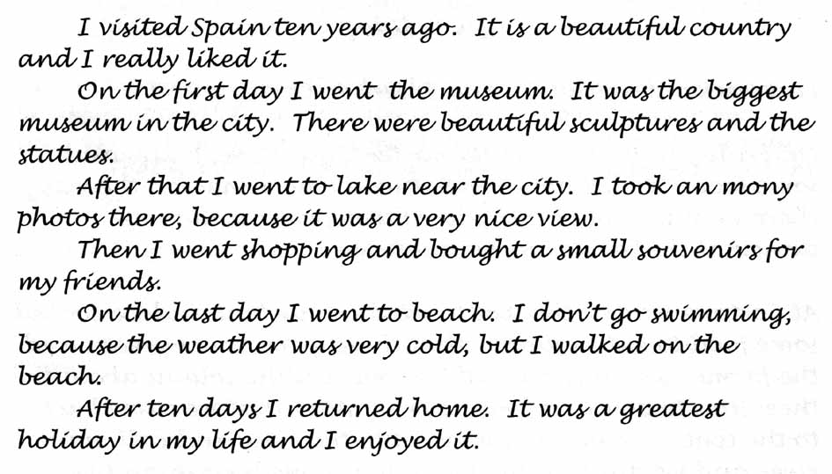
According to the assessment booklet, this text achieved all the assessment conditions for the learning outcome, except for variety of conjunctions and punctuation.

Sample of student performance in Reading-to-Learn story writing
Below is a sample of a story written independently by a student undertaking the Certificate II in Spoken and Written English. It was collected at the end of a course in which the student had engaged with the Reading-to-Learn strategies. The text was written after detailed reading of a model story. It uses many of the language patterns from the model text, but the events, setting, characters, their reactions and choice of wordings are entirely original and independent. This sample is representative of student writing in this class at the end of the course.
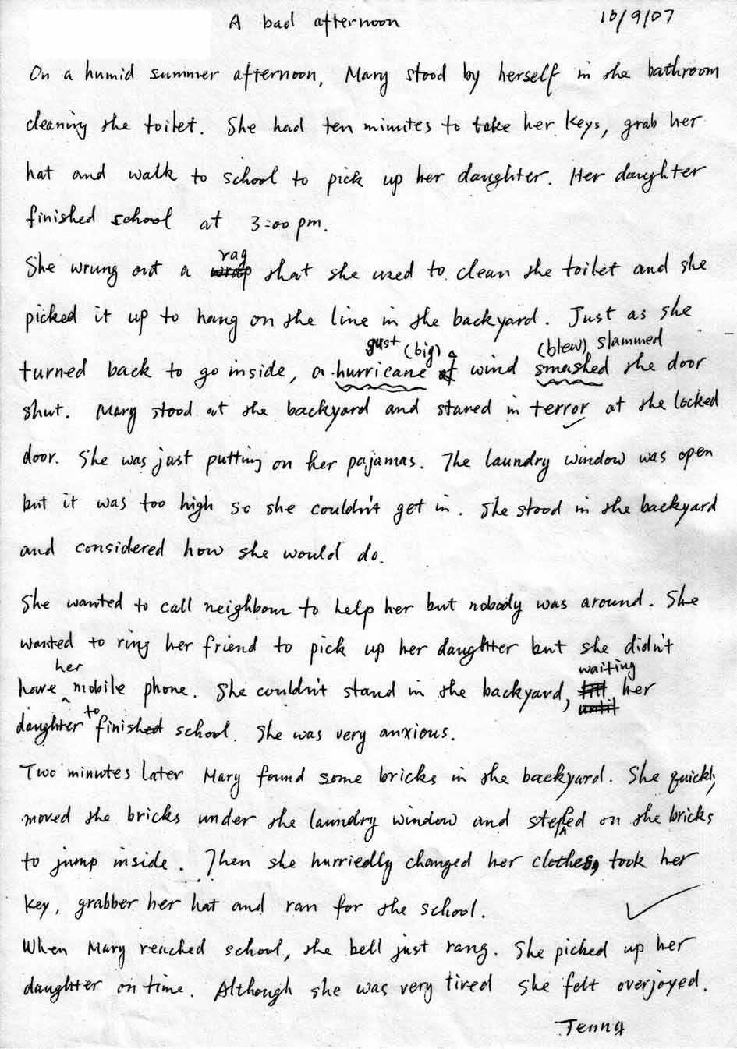

Analysis
The analysis in table 3 compares the recount from the Certificate II in Spoken and Written English assessment booklet and the Reading-to-Learn writing sample, in terms of 14 criteria, at the levels of genre, register, discourse, grammar and graphic features. To produce a scaled comparison, each criterion is given a score between 0 and 3, with the certificate II sample as a baseline with average scores of 1–2. This assessment has been developed in the Reading-to-Learn program.
Table 3 Comparative analysis of student story text performances
 | CSWE II sample recount |  | Student sample
Purpose | simple personal recount | 2 | successful narrative, resolving complicating events | 3
Staging | orientation, record of events | 2 | orientation, complication, resolution | 3
Field | events and places in personal travel experience | 2 | imaginative, intricate plot | 3
Tenor | some feelings and appreciation of places | 1 | engages with series of problems and reactions | 3
Mode | simple spoken English, few written features | 2 | more written features, elaborations, variety of sentence structures | 3
Phases | series of episodes in tour | 2 | series of problems within complication-—building tension | 3
Lexis | common lexis of places—Spain, country, museum, city, sculptures, statues, lake, view | 2 | rich lexis building field—humid summer afternoon, wrung-out rag, turned back to go inside … | 3
Conjunction | simple succession—on the first day, after that, then, on the last day plus cause because | 2 | variety of time resources—ten minutes, just as, two minutes later, quickly, on time | 3
Reference | simple reference to self and preceding things—I, it | 1 | variety of reference to people and things | 2
Appraisal | common feelings and appreciation—beautiful, liked, biggest, very nice, greatest | 1 | appraisal used to build problems and reactions—stared in terror, very anxious, hurriedly, overjoyed | 2
Grammar | problems with number and tense—an mony photos, small souvenirs, I don’t go swimming | 2 | few problems, variety of sentence structures used creatively | 3
Spelling | one error, mony | 2 | accurate spelling of infrequent words | 3
Punctuation | accurate sentence punctuation | 2 | accurate sentence punctuation | 2
Presentation | uses paragraphs for each episode | 2 | uses paragraphs for stages, title, fair handwriting | 2
Total | 25 |  | 38
This analysis illustrates how far student competence in story writing had progressed beyond the expected outcomes for their level, following implementation of the Reading-to-Learn pedagogy. The writing of all students in this class was within this range—ten or more points above the expected average standard for the level.

Benchmark performance in factual writing
Another learning outcome of the Certificate II in Spoken and Written English is ‘Can write a short information report’. The following is a sample of student factual writing from the Certificate II in Spoken and Written English assessment booklet. According to the assessment booklet, this text achieved all the assessment conditions for writing an information report at Certificate II in Spoken and Written English level.


Sample of Reading-to-Learn student performance in factual writing
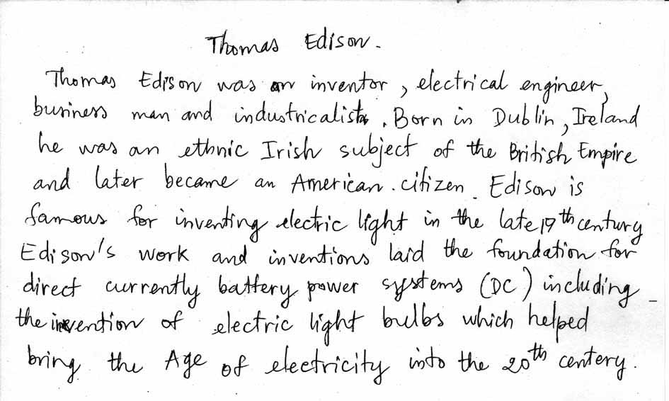
Below is a sample of students’ independent writing of a factual text, following application of the Reading-to-Learn strategies. The text has been written after detailed reading of a biography and notes made of key information.
Table 4 compares the sample text from the Certificate II in Spoken and Written English assessment booklet and the Reading-to-Learn writing sample.
Table 4 Comparative analysis of student information text performances
 | CSWE II sample |  | Student sample
Purpose | describes geographic feature—geographic report | 2 | recount major life events and achievements—brief biography | 2
Staging | description (no classification) | 2 | orientation (no further life stages) | 2
Field | describes location, significance and features of Huangshan Mountain | 2 | describes achievements of Thomas Edison | 2
Tenor | appropriate appreciation of place, but many errors | 1 | appropriately objective | 2
Mode | written features appropriate for genre, but many errors in translation | 1 | written features appropriate for genre | 2
Phases | location, topography, flora, heritage | 2 | roles, nationality, achievements | 2
Lexis | often appropriate lexis, but many problems from using thesaurus e.g. savageness | 1 | rich lexis appropriate to field—inventor, electrical engineer, business man, industrialist … | 3
Conjunction | logical sequence between sentences, but some problems e.g. already became splendous? | 2 | logical sequence between sentences | 2
Reference | simple reference It, with some problems | 1 | clear reference to people and things, and classifying—an inventor, an ethnic Irish subject | 3
Appraisal | appreciation of place—many errors e.g. world’s spectacle, splendous, emblematize | 1 | little explicit appraisal—appropriate for factual genre | 2
Grammar | mostly appropriate grammar, but many problems e.g. final nominal group | 1 | variety of sentence structures and nominal groups—one problem direct currently battery power systems | 2
Spelling | some errors—splendous, spirngs, matural, plantses | 2 | accurate spelling of infrequent words | 3
Punctuation | some punctuation problems | 2 | accurate sentence punctuation | 2
Presentation | uses paragraphs | 2 | one paragraph, title, fair handwriting | 2
Total | 21 |  | 31
Again this student’s writing is ten points above the expected average standard for the Certificate II in Spoken and Written English. The writing of all the students in this class was within this range, illustrating how far student competence in factual writing had progressed beyond the expected outcomes for their level following implementation of the Reading-to-Learn methodology.

4 What changes in teacher attitudes and practices are necessary to implement a more intensive and scaffolded approach to the teaching of reading?
In general terms, the implementation of the Reading-to-Learn approach requires teachers to embrace a new focus on reading in their programs and to undertake training in identifying the ways meanings and wordings pattern and relate in texts and in how to guide and scaffold all their students so that they fully comprehend texts. At a more detailed level, the pedagogy requires changes in the ways teachers engage with students in their classes, requiring teachers to learn new protocols to ensure that all students are able to participate successfully. Teachers also have to understand the importance of constant and meaningful praise in response to the successes that students continually achieve in reading and understanding. Observations and teacher reports identified a number of changes in practices as the project progressed.

Attention to students
Teachers reported that they were paying more attention to all students in the class, especially those for whom the reading was most challenging. They also noted that they found themselves praising students more frequently.

Developing knowledge about language
Developing knowledge about language was an essential component of the training workshops. Teachers were provided with the necessary knowledge to enable them: to select appropriate well-constructed texts; to identify key phases of texts; to prepare texts for the approach; and to manage the exchanges that enable students to connect meanings and wordings. The project workshops provided evidence of the teachers’ developing awareness of language and the implications of this developing knowledge for teaching. Teachers commented on the strengthening of their professional knowledge, and on changes in their practice, in terms of clearer and more conscious planning processes.

Impact on colleagues
Teachers also commented on the impact that their participation had on their colleagues and centre management.
A number of observations were made about the ways in which teacher practices might need to change to ensure an effective implementation of the Reading-to-Learn pedagogy.

Estimating reading abilities and choosing texts
Teachers frequently underestimate the reading abilities of students, and initial reading assessments generally do not challenge students sufficiently. This was evident in the kinds of texts that were chosen for the project implementation. This underestimation of student abilities may be, in part, a response to the fact that little attention has been given to the explicit teaching of reading over recent years. In contexts where reading tasks require students to read whole texts, those texts which students cannot already read are avoided, as they would then not be able to accomplish the tasks set for such texts. This was something teachers became more aware of as the project progressed, and they were developing more confidence in being able to work with challenging texts, as were their students.

Ensuring teaching is not just testing
A key tenet of the Reading-to-Learn approach is to ensure adequate teacher preparation before each learning task, thus guaranteeing that all students are given the means to address the task successfully. Simply testing must be avoided. The notion of task applies from the macro-level of lesson activities, to the very micro-level of responding to teacher questions, for example, by identifying wordings in a text. It was apparent from the classroom data that asking questions to test students’ understanding and abilities is a difficult habit to break. Teachers in the project only became aware of this entrenched practice when they viewed themselves on video.

Sticking to the methodology
It is important to maintain the integrity of the Reading-to-Learn pedagogy, which relies on both careful attention to wording and meaning relations within texts and to scaffolding interactions with students. While teachers are accustomed to adapting and making on-the-go decisions about what to do next in the classroom, they should be cautious in innovating when they are learning to use the Reading-to-Learn approach. Where teachers do see a need to adapt the pedagogy, this is best discussed with the trainer, and then monitored in terms of impact. During the project, discussions about tried or potential variations proved fruitful in clarifying theoretical reasoning in the design of the Reading-to-Learn pedagogy. Such discussions also generated ideas for further trialling, especially in relation to joint reading aloud and to the potential for the reading pedagogy to generate more effective pedagogies for developing spoken language.

Managing time
In the early stages of the project teachers often experienced difficulties in managing the class time effectively, feeling a tension between finishing the sequence of tasks with the texts they had chosen and a concern that their students were losing the ability to concentrate. All teachers reported marked improvement in this regard the more they used the approach. As one teacher commented:
It gets better because I get better. I think I get quicker. I’m definitely quicker. And I find that when I’m reading other texts, even though I haven’t prepared any cues, I’m starting to cue myself anyway.
As the project progressed the teachers had an improved ability to identify appropriate sections of texts to use for detailed reading and were able to accomplish necessary text preparation more efficiently. The latter was greatly enhanced through the training sessions on the structure and language of different genres.

5 What is the best means to train practising adult English for speakers of other languages and adult basic education teachers to implement a more intensive and scaffolded approach to the teaching of reading?
Given the characteristics of the adult learning sector—which can impair effective implementation of new pedagogies—organisations introducing the Reading-to-Learn approach should apply rigorous processes when selecting teachers for the training program. Participants need to commit, by signing a learning contract, to the full range of training activities, including attendance at workshops, preparation of tasks, classroom observations, videotaping of classes and peer-reflection and self-reflection on taped lessons.
This project was limited to six teachers, who completed all training and implementation phases of the course. The results, in terms of student achievement and teacher professional development, indicate that the Reading-to-Learn pedagogy can be very effective in the context of adult literacy teaching. If the pedagogy is to be disseminated more broadly in the adult literacy sector, then the creation of an online teaching reading community, such as that developed by Catholic Education in Victoria, would enable the posting of professional development readings, assessment data collection and teachers exchanging ideas and experiences.

Implications
This project demonstrated that the Reading-to-Learn approach had positive results in increasing teacher knowledge about language and reading processes. It also helped the teachers become more systematic in their lesson planning. Students responded positively to a more explicit pedagogy as demonstrated by improved attendance and improved reading and language skills.
Introducing an innovative pedagogy such as Reading-to-Learn to the adult literacy sector requires the commitment of time and funds. It is important to target centres or locations that already have well-established literacy strategies and supportive senior staff and program managers. Ongoing institutional support is needed to ensure that teachers have the opportunity to work consistently on the pedagogy with groups of learners over more than one course. Such support is necessary to ensure that teachers are released for planned workshops and that teamwork is facilitated. Head teachers and program leaders should undertake the training alongside teachers to encourage wider participation and support.
It is important when introducing the Reading-to-Learn approach into the sector to work initially with full-time teachers who volunteer and commit to the period of training, implementation and evaluation. This requires organisations to commit funds to employ expert, trained teachers or consultants and to release teachers for eight to ten days of professional training in the pedagogy.
The pedagogy is a precise approach supported by detailed training resources that need to be revised for adult contexts, and the materials need to make links to specific adult literacy and language curricula outcomes. This means developing resources and planning documents to support general adult literacy programs, as well as developing specific resources for specific courses and learning outcomes. The project has produced a professionally filmed and edited DVD showing a teacher using the pedagogy in an adult literacy classroom; this can be incorporated into revised materials.
The project has revealed a tendency by reading teachers in adult literacy contexts to choose texts that students can already read, rather than those that extend the students’ reading skills. Reading-to-Learn training in adult contexts needs to give greater emphasis to criteria for text selection and assessment processes, such as miscue analysis, as a means of developing an awareness of issues in text difficulty.
Sporadic attendance patterns, course non-completion and mid-course commencements all presented major challenges to the implementation of the approach. The nature of the sector means that students are very often experiencing work and family stress, and attendance and enrolment patterns in the sector must be taken into account in planning a wider implementation. However, in one case in this limited study the implementation of the pedagogy was seen as responsible for marked improvement in student attendance patterns.

Professional development issues for the adult reading classroom
In the final workshop teachers and researchers reviewed the issues that the project had highlighted about the teaching of reading to adults with English as a second language.

Spoken versus written language
In the adult classroom, spoken language is used as a way into literacy, on the assumption that spoken language is more accessible. However, spoken language generates texts that are transient and more abstract than written language. A written text is fixed and available to all students over the course of the lesson. Therefore, to generate talk around a text would seem to provide a more concrete focus for classroom discourse.

Source of language
In the adult classroom, the question must be asked about where talk comes from. Most language comes from the teacher, and students must translate this to their own language. There is often a flood of teacher talk, which develops from teachers explaining and reiterating these explanations, often many times, to ensure that students understand. The amount of teacher talk is more controllable if it is directed towards a text that the students can refer to.

Providing key words
In the adult classroom, teachers often write key vocabulary items that students will encounter in a text on the board, with the aim of preparing students for reading, on the assumption that meaning is carried in individual words. However, words only make sense in context and it would seem that a more effective way of providing meaning would be to address the words as they occur in the reading of texts.

Use of visuals
In the adult classroom where English as a second language is taught, teachers often provide visuals, particularly for low-level students, on the assumption that talking about pictures is easier than talking about texts. This often means students are presented with a sequence of pictures as a lead-in to such texts as recounts or narratives. Often students do not have the vocabulary to talk about the pictures and the teacher must supply this. The assumption that talking about pictures is easier needs to be questioned. Whether a direct focus on an end-point written text might be more productive and less demanding of students should be considered.

Knowledge about texts and choosing texts to challenge
In teacher training not a great deal of time is spent on considering the nature of written texts and understanding how written genres enable people to achieve real-world tasks through written language. Figure 1 provides a basis for the selection of texts in adult literacy classrooms.
Another issue is concerned with knowing how to make texts accessible to students. There is a gap in teacher training in relation to choosing texts that challenge but do not frustrate students. Teachers need to understand what constitutes complexity in texts.
The issues highlighted above need to be addressed through research and professional development in adult literacy contexts.
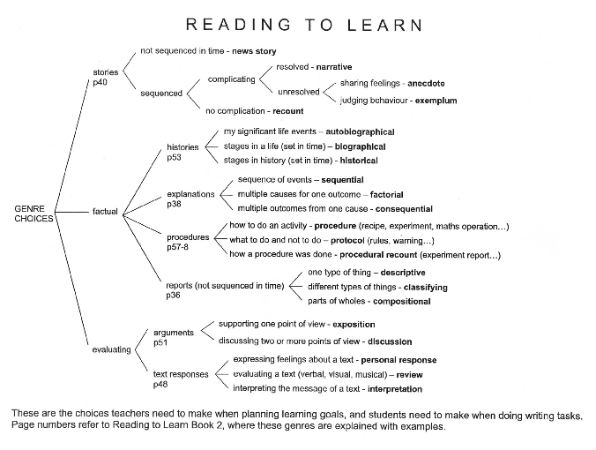
Figure 1 Typology for the selection of texts in adult literacy contexts
Source: Based on Rose (2007).

References
Barton, D & Ivanic, R (eds) 1991, Writing in the community, Sage Publications, London.
Baynham, M 1995, Literacy practices, Longman, London.
Burns, A & de Silva Joyce, H (eds) 2000, Teachers’ voices 5: A new look at reading practices, National Centre for English Language Teaching and Research, Sydney.
——2005, Teachers’ voices 8: Explicitly supporting reading and writing in the classroom, National Centre for English Language Teaching and Research, Sydney.
Culican, S 2006, Learning to read: Reading to learn: A middle years literacy intervention research project: Final report
2003–04, Catholic Education Office, Melbourne.
Freebody, P & Luke, A 1990, ‘Literacies programs: Debates and demands in cultural context’, Prospect, vol.5, no.3, pp.7–16.
Gee, J 1990, Social linguistics and literacies: Ideology in discourses, Farmer Press, London.
Goodman, KS 1968, ‘The psycholinguistic nature of the reading process’, in The psycholinguistic nature of the reading process, ed. KS Goodman, Wayne State University, Detroit.
Heath, SB 1983, Ways with words, Cambridge University Press, Cambridge.
Hood, S, Solomon, N & Burns, A 1996, Focus on reading, new edn, National Centre for English Language Teaching and Research, Sydney.
Joyce, H 1992, Workplace texts in the language classroom, NSW AMES, Sydney.
Kress, G 1989, Linguistic processes in sociocultural practice, Oxford University Press, Oxford.
McRae, D, Ainsworth, G, Cumming, J, Hughes, P, Mackay, T, Price, K, Rowland, M, Warhurst, J, Woods, D & Zbar, V 2000, What has worked (and will again), Department of Education, Science and Training, Canberra.
Nicholson, T 1993, ‘The case against context’, in Reading acquisition processes, eds GH Thompson, WE Tunmer and T Nicholson, Multilingual Matters, Clevedon, England.
Perfetti, CA, 1995, ‘Cognitive research can inform reading education’, Journal of Research in Reading, vol.18, pp.106–11.
Rose, D 2004, ‘Sequencing and pacing in the hidden curriculum: How Indigenous children are left out of the chain’, in Reading Bernstein, researching Bernstein, eds J Muller, A Morais & B Davies, Routledge Falmer, London.
——2007, ‘A reading based model of schooling’, Pesquisas em Discurso Pedagógico, vol.4, no.2, viewed 8 September 2008, <http://www.maxwell.lambda.ele.puc-rio.br/cgi-bin/db2www/PRG_0452. D2W/INPUT>.
Rose, D, Lui-Chivizhe, L, McKnight, A & Smith, A 2003, ‘Scaffolding academic reading and writing at the Koori Centre’, Australian Journal of Indigenous Education, vol.32, pp.41–9, viewed 8 September 2008, <http://www.atsis.uq.edu.au/ajie/docs/2003324149.pdf>.
Rose, D, Rose, M, Farrington, S & Page, S (forthcoming), ‘Scaffolding literacy for indigenous health sciences students’, Journal of English for Academic Purposes, viewed 8 September 2008, <http://www.readingtolearn. com.au>.
Rumelhart, D 1977, ‘Towards an interactive model of reading’, in Attention and performance, ed. S Dornic, vol.VI, Academic Press, New York.
Smith, F 1971, Understanding reading: A psycholinguistic analysis of reading and learning to read, Holt, Rinehart and Winston, New York.
Stanovich, K 1980, ‘Towards an interactive compensatory model of individual differences in the development of reading fluency’, Reading Research Quarterly, vol.16, pp.32–71.
Wallace, C 1992, Reading, Oxford University Press, Oxford.

<http://www.cecv.melb.catholic.edu.au/Research and Seminar Papers>.

