

Recognition of prior learning:
At a glance

Jo Hargreaves
Recognition of prior learning (RPL) is a process whereby people are provided with an opportunity to have the skills and knowledge they have developed outside the formal education system assessed and valued against qualifications frameworks. This publication gives an overview of recent research into RPL within the Australian vocational education and training (VET) system.

Key messages
- Recognition of prior learning is a widely supported concept, although the available statistics suggest that the level of participation in RPL in vocational education and training has not been as great as had been anticipated.
- Recent research has found, however, that RPL may be a much more pervasive characteristic of the VET system and within enterprises than is suggested in official statistics and earlier research. This is because RPL can be defined in a number of ways, some of which are not recorded in official statistics. In addition, neither industry nor individuals consider that RPL is always the best option, even when the person is eligible for RPL.
- No single significant barrier has been identified to effective implementation of RPL. Instead there are several factors which, in some contexts, act as deterrents. More and effective RPL requires:
- greater promotion, using clear, concise and jargon-free language
- recognition that RPL is a valuable learning experience in its own right
- improved support and approaches to assist students to gather evidence
- experienced professional assessors
- continued efforts to achieve cost-efficient RPL
- promotion of the numerous practical case studies and strategies that now exist, a guide to which is provided in this At a glance.

Introduction
It is over ten years since recognition of prior learning (RPL) was introduced into Australian education policy as part of the Australian Qualifications Framework (AQF). It is now firmly entrenched in the national vocational education and training (VET) system, being written into the Australian Quality Training Framework (AQTF) charter and into the standards for registered training organisations (RTOs) delivering accredited vocational training.
Since its inception RPL has carried with it the promise and potential for recognising the life and work experience of those who may not have participated in formal learning. Recent research has focused on whether the expected benefits have been realised. Some studies have concluded that RPL has failed to fulfil its promised potential. To paraphrase a common theme:
… there is a gap between the promise and rhetoric of RPL and the actual reality.
(Cameron & Miller 2004)
While conclusions such as these are a sobering reminder of the extent and complexity of the challenges of RPL, there is also evidence that presents a more positive view. A number of studies point to the diversity of RPL being conducted, suggesting that it is a more important and pervasive characteristic of the training system and workplace training activity than is suggested by the official statistics (Bowman et al. 2003; Smith 2004; Dyson & Keating 2005). Many studies also provide practical guidance on how to implement RPL successfully.

Benefits of recognition of prior learning
Recognition of prior learning has been identified as a powerful tool for bringing people into the learning system—it reassures them that they don’t have to start from scratch and that the skills they already have are valuable (National Marketing Strategy for VET, ANTA 2000). The growing body of research on the subject has revealed evidence that RPL has many benefits.
Individuals use recognition of prior learning because it:
- saves time because they do not have to repeat learning for skills or knowledge they already have
- allows fast-tracking to recognised qualifications
- allows for employment-related gains and career development opportunities
- can have a significant impact on self-esteem and motivation
- can satisfy industry licensing arrangements.
Who needs RPL?
One example is people who may have administrative, clerical and financial management skills as a result of helping to run a family business, yet have no formal business management qualifications. They may want these skills recognised by a formal qualification in order to expand their career options.
Employers encourage recognition of prior learning because it:
- provides a way of more effectively and efficiently utilising skills already in the workforce
- allows fast-tracking, which means employees can become fully competent as quickly as possible
- enables skill gaps to be identified, providing a sound basis for training needs analysis and career planning
- fosters a learning culture, since it builds confidence to undertake further education and training
- motivates employees.
What does industry want?
Commitment by all to RPL:
- to facilitate the up-skilling of existing skills in mature-aged workers realistically
- for training only to develop skills that are missing—at a reasonable cost.
Registered training organisations offer recognition of prior learning because it:
- meets the requirements of the Australian Quality Training Framework
- meets the wishes of employers and individuals
- is a potentially efficient and time-saving process; only training that adds value is required to be delivered
- can assist the development of learner and employer-centred training programs
- has genuine and valuable learning outcomes in its own right, regardless of whether recognition is awarded.
Recognition of prior learning can have a significant impact on learner confidence and motivation. Through the RPL process people realise how much they already know and can do. As a result of this confidence boost, they may ‘try, with enthusiasm, a qualification or training program that they otherwise might not have attempted, or at least would have approached with trepidation’ (Smith 2004).
Researchers in Britain have also been highlighting the transformative aspects of RPL.
The value of RPL as an educative process in its own right
The value assigned to the APEL [that is RPL] process should not be restricted to its use as a springboard into more formal learning. The personal value of engaging in the APEL process in terms of confidence-building and promoting self-direction should be emphasized as a key, rather than secondary outcome. The APEL process provides a basis for enhancing self-knowledge in a way which encourages personal development and prepares learners not only for further learning, but also for the labour market.
(Whittaker et al. 2002, p.6, cited in Cameron 2004a)

Defining recognition of prior learning
Smith (2004) argues:
… there is no clear agreement regarding what RPL is, does or encompasses. Views vary from quite tightly defined notions of RPL as access to a training program or qualification, through to conceptions of RPL as a reflective process that can directly impact on the nature of learning and the process of training.
Some of the confusion that has surrounded definitions of RPL can be attributed to the concept of credit transfer. Credit transfer is an administrative process whereby, based on previous successful studies and qualifications, credit is allocated towards a new qualification.
Recognition of prior learning, on the other hand, involves determining what credit/formal education certification to give through an assessment process of the individual’s previously unrecognised skills and knowledge, regardless of how or where acquired.
Recognition of prior learning means recognition of competencies currently held, regardless of how, when or where the learning occurred, so that they may be counted towards the achievement of a qualification. Under the Australian Quality Training Framework, competencies may be attained in a number of ways. This includes through any combination of formal or informal training and education, work experience or general life experience.
(ANTA 2001, p.9)
Recognition of prior learning normally occurs before actual tuition begins, but in some instances the recognition process takes place after enrolment and commencement of the training program—when it becomes clear that the person has the required knowledge and skills and does not need to undertake the entire subject/course. This process is often referred to as ‘accelerated learning or progression’, and is a practice adopted by some providers. This type of recognition is hidden in the VET statistics. As an assessment coordinator in a public registered training organisation and cited in Bowman et al. (2003, p.20) noted:
… we encourage people to do skills recognition as part of normal delivery … it is not a formal application, they simply enrol in the subject and are given the opportunity to accelerate through if they believe they have got the skills … or they can have challenge testing … it is much simpler than someone going off and getting a portfolio of evidence. It is simpler, quicker for the client and it proves to us that they have the skills …
A further concept integral to the larger notion of RPL is recognition of current competence, or RCC, a term that industry people mainly use to cover reassessments of competency at varying intervals after the original qualification has been obtained.
Figure 1 identifies the various concepts of RPL, and table 1 contains the recently agreed definitions for each of these terms for the purpose of record-keeping by VET providers/assessors.
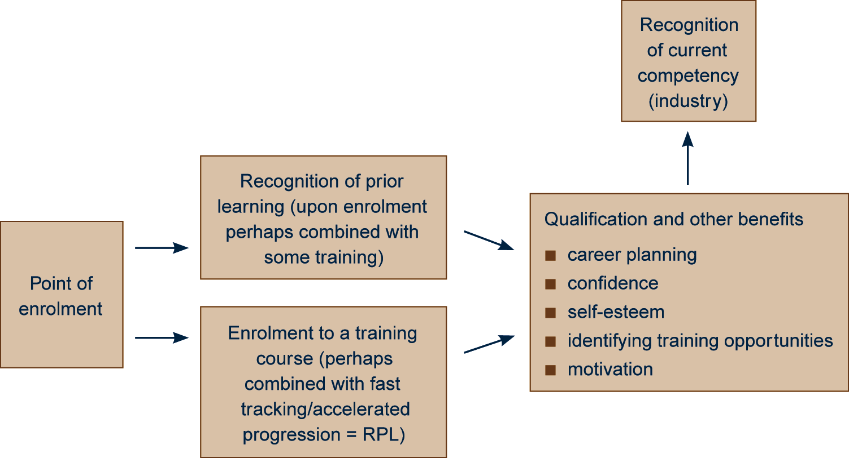
Figure 1: Diagrammatic representation of RPL concepts
Table 1: RPL definitions in Australian VET
RPL Is an assessment process that assesses the individual’s non-formal and informal learning to determine the extent to which that individual has achieved the required learning or competency outcomes. For national reporting, RPL does not include any additional training at the unit of competency or module level (NCVER [forthcoming]).
RPL as Is a practice adopted by some providers whereby the student enrols in the course proper but
accelerated receives some RPL as they progress towards a pass in the course. This type of recognition of prior
progression learning is hidden in VET statistics.
RCC Is a term particularly used by industry and employers who regard the process as assessing and recognising a person’s current capacity to perform.
It applies if a client has previously successfully completed the requirements for a unit of competency or a module and is now required to be reassessed to ensure that the competence is being maintained. In this case no extra skill or competencies are nationally recognised (NCVER [forthcoming]).
From 2007 this type of recognition will apply in the VET statistics.

How much RPL is occurring?
The Australian Quality Training Framework has made it mandatory for VET providers to offer RPL to individuals upon enrolment in a training course. The result of this assessment, if successful, is recorded in the national VET statistics. That is, only RPL that occurs upon enrolment and is successful is recorded. The national aggregate figure for successful ‘up-front’ RPL is around 4%.
However, this figure understates the real picture. As already outlined, more RPL is occurring than this, in the form of accelerated learning or progression.
In addition, RPL apparently is not equally applicable to all learners and circumstances. Underlying the national aggregate figure of 4% is considerable variation in use of recognition of prior learning among client groups, and by Australian qualifications level (Bateman & Knight 2002; Bowman et al. 2003; Smith 2004).
Recorded RPL trends
Establishing trends in RPL over time is problematic because of data limitations for earlier years. The information we do have suggests that RPL usage has grown consistently between 1995 and 1999. Thereafter the rate for RPL upon enrolment in a training course stabilised at around 4% but declined slightly to 3.6% in 2004.
In 2004 the highest rates of RPL uptake were among students in the 25 to 39-years age range (4.4%) and those seeking to gain higher-level qualifications. At diploma and above, 10% of students received some RPL in 2004 compared with 1.8% at Australian Qualifications Framework (AQF) levels I and II, and virtually none for students in non-AQF programs (see figures 2 and 3).
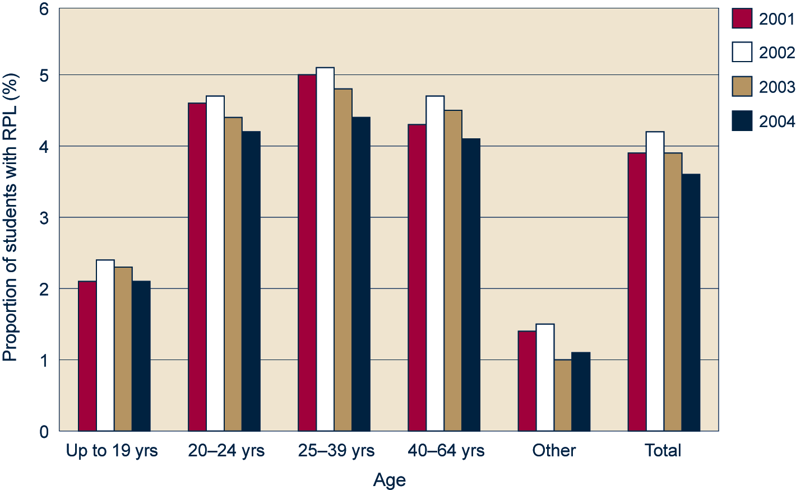
Figure 2: Vocational students and percentage with an RPL outcome by age level for Australia 2001–04
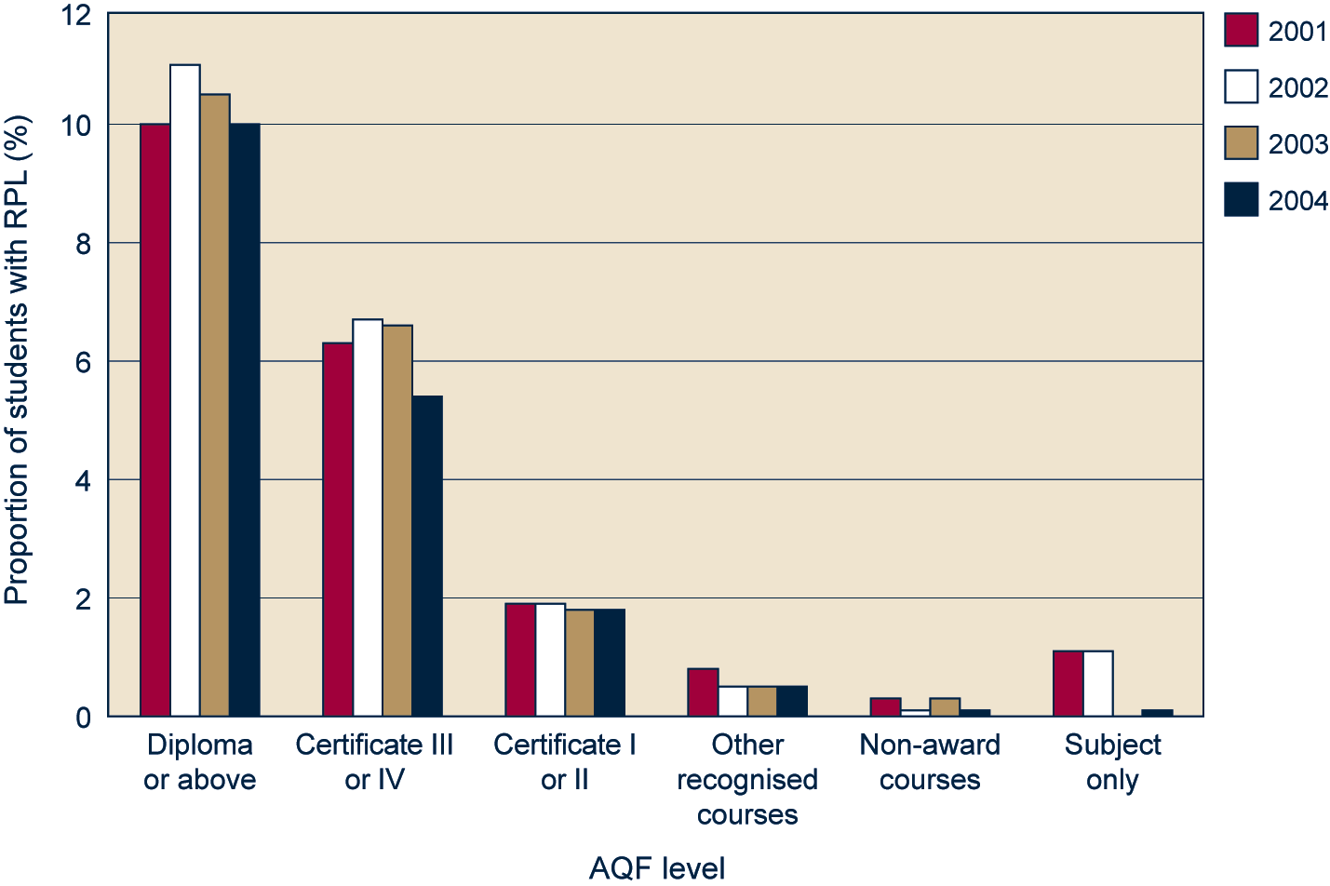
Figure 3: Vocational students and percentage with an RPL outcome by major qualification level for Australia 2001–04
Given the underlying principles of RPL, this is perhaps not surprising. Cameron (2004b) suggests those most likely to use RPL are students who work full-time, are established in the workforce and already have significant educational capital to draw from. Cameron identified RPL’s lack of relevance to those who have not been in the paid workforce for lengthy periods, or who have not engaged in formal learning for some time. The official statistics also show RPL uptake among students in various access and equity groups is mixed and, in many cases, lower than among students overall (Bowman et al. 2003).

Of course … RPL is not always the best option
An interesting finding is that RPL is not always considered to be the best option, even when the person is eligible. Both individuals and employers have reasons for not undertaking RPL in all circumstances.

Why not RPL? Individual responses
Many people, including members of recognised equity groups, prefer to participate in the training program for the learning experience and social interactions with peers, even when eligible for recognition of prior learning. The benefits to be gained through the training program are perceived to be greater than those to be gained from undertaking RPL.
Why not RPL? Individual perspective
It is not uncommon for people to go through the whole process of skills recognition and then not go forward with it, even when they are granted a significant amount of RPL. They are provided with details about the evidence that they need and they take considerable time and care about collecting all of their evidence together. They present the portfolio and we conduct the assessments. But when it comes to it, they decide that it would be good to learn with the group. They like the idea of the social interaction and they feel that they can still learn a lot. They say that things have probably changed—particularly in relation to legislation and the like. We put in the time and the effort to give them a positive RPL outcome. But they see other benefits and choose to go through all the learning again. It can be disappointing for us, but it is obviously confirming for these women who may have been in the industry for years. What it all costs, however, is another issue. (Assessor, NSW Community Services and Health)

Why not RPL? Industry responses
It may also be the case that employers require their employees to undertake training instead of using RPL. Training is a form of insurance that their employees have the required skills.
There is also some concern regarding the ‘shelf life’ of the qualifications and experience used for RPL purposes. In some industries the extent and depth of change is so profound that even quite recently acquired skills and experience may no longer reflect accepted industry practice or standards. Consequently, RPL may not be appropriate.
Why not RPL? Industry perspective
Recent research on the recognition of skills and training needs of personal care workers in the residential aged care sector of the community services industry has found that personal care workers have poor uptake of RPL, even amongst workers with substantial experience in the industry, because they have a preference for undertaking the training instead [in order] to learn the theory behind their practices. Their managers also favour training over existing skills recognition as a vehicle for workplace culture change. The aged care industry is attempting to implement major change, including in response to changes in legislation, and managers see training rather than RPL as the best approach to introducing and supporting new work processes and procedures. (Booth et al. 2005)

Barriers to more effective RPL
No single significant barrier has been identified to the effective implementation of RPL. However, several factors have been found that affect implementation and use of RPL. These include individuals’ lack of awareness and understanding of RPL, providers’ concerns about the practice of RPL and its costs vis-a-vis funding arrangements (Bowman et al. 2003, p.16).

Individual awareness and understanding of RPL
Some individuals do not take up RPL because they do not know about it. As one building and construction employee explains:
I was not aware of RPL till the boss here told me. A lot of people don’t know about it, and TAFE did not go out of their way to tell anyone. If people knew it could cut your time in half, a lot more would go for qualifications. (Mawer & Jackson 2005, p.22)
Also, and importantly, the recognition process may deter those individuals who have had limited interaction with formal education and who lack the confidence to go through what appears to be a highly confusing process—as a result of the complex language being used (Bowman et al. 2003). For the individual:
The paradox of RPL is that it is assessing an individual’s learning that has occurred mostly outside formal education and training, but it requires high levels of knowledge of these formal education and training contexts and the structure of qualifications and language used in education, to prepare a successful RPL application. (Wheelahan et al. 2003, p.29)
The overall lack of awareness of the availability and nature of recognition processes has been a major barrier. It is apparent that the promotion of RPL needs to address both its benefits and issues relating to eligibility in a way that can be readily understood by potential applicants.

Provider issues
Some of the key barriers identified by providers include:
- that RPL has high associated risks
- a perception that it is not worth the effort to promote RPL because of the amount of paperwork needed to fulfil the requirements of the Australian Quality Training Framework auditors
- inconsistencies in assessments which have led to extremes of both evidence overload and lack of rigour in RPL assessment
- a lack of confidence that the assessment outcomes from RPL are of a similar standing to those achieved through training, caused in part by past funding arrangements.
Assessment can be a risky business
An assessor must infer from a sample of evidence whether that person is competent or not. With RPL, assessors are required to evaluate evidence generally gained through a mix of training, work and life experience over a period of years and various contexts. Because of this, the assessment can involve a greater degree of risk than those made as part of formal training, whereby the trainer/assessor can gain ‘knowledge’ of the student as they go. The impact of making an invalid judgement can be quite high, particularly where there are workplace health and safety issues. RPL becomes a major concern for registered training organisations when the individual is seeking a significant amount of recognition towards a qualification and/or recognition of skills and knowledge at higher levels of the AQF. The perceived ‘risks’ in these cases are such that registered training organisations might discourage RPL.

Funding and costs
There has been a history of variability in the amount of funding provided for RPL. Funding arrangements for RPL have differed between state/territory jurisdictions, and within state jurisdictions, across provider types and programs. In addition, national funding accountability arrangements for RPL have given more credit to an enrolment in the training program than for RPL.
The uneven funding arrangements may have influenced the uptake and perceived parity of esteem of RPL as a component in the training pathway to the same qualification. More recently however, there has been a common trend towards funding RPL at the same rate as for the equivalent training program. Most jurisdictions have implemented this parity of funding approach (see Bowman et al. 2003). At the national level this will also occur from 2006. To encourage greater use of RPL, the national formula for counting RPL as activity effort has been reviewed by the National Training Statistics Committee and, from 1 January 2006, states and territories have been able to claim 100% of the nominal hours for all competencies awarded to students through RPL (National Training Statistics Committee meeting paper 2, December 2005, agenda item 5).
With funding disincentives largely removed, the challenge ahead is for providers to continue their efforts to achieve cost-efficient and client-responsive approaches to RPL.
Enterprise based RPL
While RPL can be accessed by individuals through a TAFE institute or a private RTO, this can be a very expensive and time-consuming process. Enterprise RPL processes can reduce the time involved in making RPL assessments, provide assessment on-site and, therefore, reduce the costs both to the employer and the employees while still retaining a rigorous and consistent process. Recent research reports on models of enterprise based RPL processes, and identifies the opportunities and inhibitors of enterprises working in partnership with RTOs to recognise the current competency of their workers. (ANTA 2005)

The way forward
In response to discussions about the apparent poor rates of RPL and real or perceived barriers, much work has been done nationally and in jurisdictions to identify and target areas of concern.
In June 2004 the Australian Qualifications Framework Advisory Board (AQFAB) endorsed the National Principles and Operational Guidelines for RPL, formulated to guide the four sectors of post-compulsory education and training (senior secondary school, adult and community education, vocational education and training, and higher education). Principles and guidelines have also been developed to provide information to individuals and organisations about the policies and methodologies used by institutions to implement RPL and to promote greater awareness and understanding of RPL and its use (see <http://www.aqf.edu.au/rplnatprin.htm>).

Improved information and support to students
One jurisdiction has developed an RPL module to ensure that students receive the close support required in preparing for RPL (case study 1); the module highlights that RPL is a learning process in its own right.
CASE STUDY 1
A modular approach to supporting RPL applicants and teachers effort
One registered training organisation offers students the opportunity to enrol in a module, Preparation for skills recognition, to provide them with extensive support in preparing their RPL application. The module is additional to a student’s program of study. A teacher is allocated to the module as a facilitator and support person, and the hours are counted as part of the teacher’s annual load. Students learn skills of self-assessment as well as the skills and knowledge they need to understand VET, particularly in terms of the qualification for which they are seeking recognition. On completion of the module, students submit their completed RPL application and are granted recognition on the basis of it. This approach gives teachers the time to deliver the skills and knowledge required for students to successfully understand the RPL concept and the evidence requirements. (Bowman et al. 2003)
To address the need for information on RPL many providers are establishing ‘one-stop shop’ facilities, as illustrated in case study 2.
CASE STUDY 2
Acknowledging the need for quality information
A large public registered training organisation has developed a website to offer a ‘one-stop shop’ that will be the single, authoritative source of RPL information, not only for their students, but also for their staff. The site includes an online help facility, and is seen as a means of improving the efficiency with which such information is disseminated. The institute’s call centre is equipped to deal with enquiries by being provided with a list of frequently asked questions. All course documentation refers to the provision of recognition services, as do introductory information sessions. In class, students acknowledge having received information relating to assessment, including recognition. The institute’s investment in the production of quality recognition materials, including support materials for educational staff, is regarded as a means of saving time and reducing the costs involved. As the institute’s manager of RPL said, ‘recognition takes a long time if either party doesn’t have the right materials!’
Individual trainers, industry organisations or registered training organisations can boast many positive developments. In addition, other initiatives, including those in Western Australia, Queensland (see case study 3) and South Australia, have adopted a systemic and strategic approach.
CASE STUDY 3
RPL action—a Queensland case study
In response to the 2003 research by NCVER and AQFAB into the recognition of prior learning in the vocational education and training sector, Queensland is moving toward making RPL a more central part of learning and advisory services. The Department of Employment and Training has developed a framework for moving forward in an integrated way to address poor RPL rates, quality, audit and funding issues simultaneously. The framework will:
- reposition RPL within the suite of training and assessment and ancillary support services delivered by the public provider
- situate RPL discussions within a skills formation strategy agenda for individuals, industries and the Queensland economy
- redefine the roles of critical stakeholders in quality RPL
- place public providers at the forefront of client-oriented services delivery for RPL
- increase awareness and positive perception of RPL by trainers, management, employers, and the general community.
Some feature activities of the framework include:
- developing and delivering client-friendly, less paper-based RPL processes within the public provider in the areas of horticulture, maritime and community services
- developing and implementing RPL as an upfront and actively encouraged part of integrated, planning and progression for individual students
- coordinating the development of proactive client-friendly advice to registered training organisations, audit and industry stakeholders
- implementing a state-wide communication strategy for industry, employer and employee groups. (Queensland Department of Employment and Training 2003)

Experienced professional assessors and cost-effective RPL
Assessment in general requires experienced professionals confident about making necessary judgements. The maintenance of industry standards, the credibility of qualifications and the reputation of training organisations are very much dependent upon assessors having the skills and knowledge to identify and manage the risks associated with assessment. With RPL, this ability is critical.
An interesting observation by Smith (2004) identifies the need for Australian Quality Training Framework auditors to receive professional development on RPL to enable them to better understand the many approaches that can be taken; they therefore won’t act as barriers to cost-efficient RPL themselves.
Various resources have been developed to help registered training organisations, and many case studies are now available that show how cost-efficient RPL can be achieved (see case study 4; ANTA 2005; Cameron 2004b; Smith 2004; Dyson & Keating 2005).
CASE STUDY 4
Information resource for RTO staff
Recognition of prior learning: Your first step … is designed for all staff in registered training organisations involved in RPL. This interactive resource includes:
- case studies
- examples and activities in RPL practice
- links to further reading and resources
- an individualised learning journal and action planner
Download the free resource from <resourcegenerator.gov.au/loadpage.asp?Page=RPL.htm>.

Conclusion
It is clear that there has been a commitment to ensuring that RPL is accessed and utilised more effectively in the Australian VET system than it has been since its inception just over a decade ago.
The most common features of RPL claimed by individuals, providers, assessors, enterprise registered training organisations and industry as likely to improve and encourage the RPL process are summarised in table 2. Research indicates that RPL can work, but that there is no ‘one size fits all’ strategy.
Table 2: Strategies for effective implementation of RPL
Stakeholder Features that improve or encourage RPL
Individuals More client-friendly and less paper-based approaches; i.e. access to online support, telephone access to assessors, group processes and information sessions or workshops
An accurate indication of time and costs
A single one-stop shop for all applicants
Pre-assessment interviews with direct assistance and advice for evidence-gathering
Support materials, including assessment plans and checklists, that reflect workplaces and real work tasks, not simply elements and units of competency (provided early in the process)
Awareness that training, study, work and life experience can all be used
Public and A range of flexible processes and strategies to support applicants of all ages through the
private providers information and application stages (i.e. print-based, online, face-to-face, information sessions or workshops)
Jargon-free information, checklists and strategies for the conduct of the process to be comprehensive and accessible to all
Provision of guides and exemplars for the types of evidence required and models for collecting and storing recognition information to help students in the process
A module to provide support for students in preparing an RPL application, and also acknowledging the value of RPL in its own right
Provision of training and retraining for assessors and auditors
Establishment of partnerships involving industry, so that the training, assessment and RPL processes are linked to workplace needs
Understanding and recognition of the time and support required by trainers and assessors in the process
Assessors Collaborative assessment and decision-making (i.e. delegating some of the initial assessment to workplace supervisors)
Arrangement of and participating in internal moderation activities
Provision of alternative approaches to traditional evidence-gathering, such as portfolios, taking a more holistic approach to assessment
Use of more observation, general questioning and third parties for verification of evidence
Tailoring of assessment to the individual or the needs of the particular work group—flexible models are the key
Enterprise registered Support services needed similar to those required by public and private training providers,
training organisations including qualified assessors
Improved support from all stakeholders, particularly from middle management
Industry A clear purpose for implementing an RPL system
A compatible registered training organisation with whom to design and apply an RPL process specific to the organisation in order to recognise the existing (and developing) skills and knowledge of the workforce—remember RPL can be done before training starts and also throughout the process
Active encouragement of RPL as part of an integrated planning and career progression pathway
Processes implemented, understood and accepted by the major stakeholders
Recognition of the potential barriers to successful RPL, and close liaison with the registered training organisation to ensure that business/industry needs are met
Implementation to be cost- and time-effective, while being fair
Post-assessment processes carefully planned, negotiated, fair and equitable, while review processes are representative of stakeholders
Acknowledgement that a ‘one size fits all’ approach is often not appropriate
Source: Various reports listed in the reference list

References
ANTA (Australian National Training Authority) 2000, ANTA national marketing strategy for VET: Meeting client needs, June 2000, ANTA, Brisbane.
——2001, Evidence guide for registered training organisations and auditors, ANTA, Brisbane.
——2002, Findings from the Reframing the Future Policy Engagement Forum on RPL, Melbourne September 2002, viewed November 2005, <http://www.reframingthefuture.net>.
——2005, Enterprise RPL Project final report, viewed November 2005, <http://www.cecc.com.au/ programs/resource_manager/accounts/ssv/Enterprise_RPL.pdf?view_file_btn=+View>.
AQF (Australian Qualifications Framework) Advisory Board 2004, National principles and operational guidelines for recognition of prior learning, AQF, viewed December 2005, <http://www.aqf.edu.au/rplnatprin.htm>.
Bateman, A & Knight, B 2003, Giving credit: A review of RPL and credit transfer in the vocational education and training sector, 1995 to 2001, NCVER, Adelaide.
Blom, K, Clayton, B, Bateman, A, Bedggood, M, Hughes E, 2004, What’s in it for me? Recognition of prior learning in enterprise-based registered training organisations, NCVER, Adelaide.
Booth, R, Roy, S, Jenkins, H, Clayton, B, Sutcliffe, S 2005 Workplace training practices in the residential aged care sector, NCVER, Adelaide.
Bowman, K, Clayton, B, Bateman, A, Knight, B, Thomson, P, Hargreaves, J, Blom, K & Enders, M 2003, Recognition of prior learning in the vocational education and training sector, NCVER, Adelaide.
Cameron, R 2004a, Recognition of prior learning in 2004: A snapshot, Adult Learning Australia, Melbourne.
——2004b, RPL and mature age job seekers: Stage one, a survey of providers of training and labour market programs to mature age job seekers, and stage two, case studies, Adult Learning Australia, Melbourne.
Cameron, R & Miller, P 2004, ‘RPL: Why has it failed to act as a mechanism for social change?’, Social change in the 21st century, October 2004, Centre for Social Change, Queensland University of Technology, Brisbane.
Dyson, C & Keating, J 2005, Skills, knowledge and employability—Recognition of prior learning policy and practice for skills learned at work, International Labour Organisation, Geneva.
Mawer, G & Jackson, E 2005, Training of existing workers: Issues, incentives and models, NCVER, Adelaide.
NCVER (forthcoming), Australian Vocational Education and Training Management Information Statistical Standard (AVETMISS) data element definition National Senior Officials Committee (NSOC) endorsed draft – edition 1 (2006), NCVER, Adelaide.
Queensland Department of Employment and Training 2003, RPL action: Toward more Queenslanders’ skills becoming recognised, recorded and rewarded, DET, Brisbane.
Smith, L 2004, Valuing recognition of prior learning: Selected case studies of Australian private providers of training, NCVER, Adelaide.
Wheelahan, L, Dennis, N, Firth, J, Miller, P, Newton, D, Pascoe, S & Veenker, P 2002, Recognition of prior learning: Policy and practice in Australia, AQF Advisory Board , viewed November 2005, <http://www.scu.edu.au/research/rpl/research_report.pdf>.

For further guidance on RPL
ANTA (Australian National Training Authority) 2001, Recognition resource, Guide 3 in the Training Package Assessment Materials kit. Available from Australian Training Products. This excellent resource provides extensive information on all aspects of RPL.
——2005, Valuing Australia’s older workers—Meeting the challenges of Australia’s changing workforce, <www.valuingolderworkers.gov.au>. A professional development kit for registered training organisations; includes RPL case studies.
Information on RPL is also available on the Resource Generator at <http://resourcegenerator.gov.au/loadpage.asp?Page=RPL.htm>.
National principles and operational guidelines for recognition of prior learning (RPL) is available on the Australian Qualifications Framework website <http://www.aqf.edu.au/rplnatprin.htm>. This document sets out the 17 principles that underpin quality RPL.
A number of Reframing the Future community of practice projects comprise research around RPL. For further information visit <http://www.reframinghtefuture.net>.
© Australian Government, 2006
This work has been produced by the National Centre for Vocational Education Research (NCVER) on behalf of the Australian Government, and state and territory governments, with funding provided through the Department of Education, Science and Training. Apart from any use permitted under the Copyright Act 1968, no part of this publication may be reproduced by any process without written permission. Requests should be made to NCVER.
The views and opinions expressed in this document are those of the author/project team and do not necessarily reflect the views of the Australian Government or state and territory governments.
The National Vocational Education and Training Research and Evaluation (NVETRE) Program is coordinated and managed by NCVER, on behalf of the Australian Government and state and territory governments, with funding provided through the Department of Education, Science and Training. This program is based upon priorities approved by ministers with responsibility for vocational education and training (VET). This research aims to improve policy and practice in the VET sector. For further information about the program go to the NCVER website <http://www.ncver.edu.au>.
An At a glance is a synthesis of research focused on a particular topic of interest, drawing on information from various sources.
ISBN 1 921169 33 8 print edition
1 921169 39 7 web edition
TD/TNC 85.03
Published by NCVER
ABN 87 007 967 311
Level 11, 33 King William Street, Adelaide SA 5000
PO Box 8288 Station Arcade, Adelaide SA 5000, Australia
ph +61 8 8230 8400 fax +61 8 8212 3436
email ncver@ncver.edu.au
<http://www.ncver.edu.au>

Recognition of prior learning—an assessment resource for VET practitioners, published by the Western Australia Department of Education and Training 2005, viewed December 2005, <www.VETInfoNET.det.wa.edu.au>.

