DEVELOPING AND SUSTAINING SUCCESSFUL PARTNERSHIPS BETWEEN EMPLOYERS AND TRAINING PROVIDERS

INTRODUCTION

The nature of partnerships between public and private registered training organisations (RTOs) and employers has changed over time, from a relationship primarily based on provision of particular services to one based on longer- term mutual collaborations.

RTOs work directly with employers to help meet a range of business needs and provide expert guidance to the employer in navigating the vocational education and training (VET) system. RTOs are a significant and important source of information for employers on nationally recognised training.

This good practice guide provides insights into developing and sustaining successful partnerships and identifies the potential benefits and challenges of these partnerships. It provides valuable information for both training providers and employers seeking to establish or strengthen a partnership arrangement.

The findings are based on an extensive research project with employers and training providers: Continuity and change: employers’ training practices and partnerships with training providers by Erica Smith, Andy Smith and Jacqueline Tuck from Federation University and Victor Callan from the University of Queensland. In the study, surveys of employers and of RTOs were carried out, augmented by sets of matched-pair interviews with both parties engaged in employer—RTO partnerships.

The research report and associated support document on which this good practice guide is based, are available at www.ncver.edu.au.

WHY DO EMPLOYERS TRAIN?

The research confirmed that employers’ training decisions are affected by a number of factors, including:
- a desire to improve the quality of their goods and
services
- the need to comply with industry or licensing
requirements and regulations, particularly those relating to workplace health and safety
- the introduction of new technology or business
strategies
- the availability of a public subsidy to training, which
particularly influences whether firms engage in nationally accredited training including full qualifications
- the quality and flexibility of training providers
- the availability of reliable information relating to the
training market
- the benefits derived from enhanced performance,
productivity and profitability — value-adding for the organisation and for staff retention.
The availability of government funding remains a key reason for employers using nationally recognised training, and changes in funding over recent years at both Commonwealth and state/territory levels have complicated the picture. Indeed, the research confirmed employers’ perceptions of the complexity in the VET system.

EMPLOYERS USING NATIONALLY RECOGNISED TRAINING

Organisations which choose to make nationally recognised training part of their training repertoire display particular features. They tend to:
- have more sites than other companies
- have a more diverse employment structure
- be more affected by regulation and licensing
- be expanding their operations
- be located in industries where technology use is
increasing rapidly.
Nationally recognised training offers clear benefits in these areas: it allows systematisation across sites and employees; it offers assurance about quality; and, it provides upskilling and multiskilling for expansion.

In addition, many employers expect that nationally recognised training will enhance their competitiveness by improving quality. Enterprises gain significant benefits from providing such training. These include the ability to attract high-quality staff (that is, as ‘employer of
choice’), access to government funding to cover the costs of training provision, the possibility of integrating training with everyday work, and the confidence that workers are trained to a recognised standard.

The adoption of this training by employers conforms to a continuum, whereby the employer may initially
engage at a small scale with a pilot program of training and, following the success of the training, the employer may then extend the use of nationally recognised training to other groups of employees. At the final stage, advanced users of nationally recognised training make a commitment to the training being sustained, by building training into broader aspects of workforce development strategies. Where such training is used, employers may enter into formal partnerships with RTOs.

HOW ARE TRAINING PARTNERSHIPS CLASSIFIED?

Partnership arrangements can be classified according to three main domains: the nature of the partnership,
the coverage of training and training delivery (figure 1). For each item within each domain, a more traditional partnership is signified by its proximity to the left-hand side of each continuum, and a more innovative partnership by its proximity to the right-hand side of each continuum.

Figure 1 Nature of training partnerships between employers and RTOs

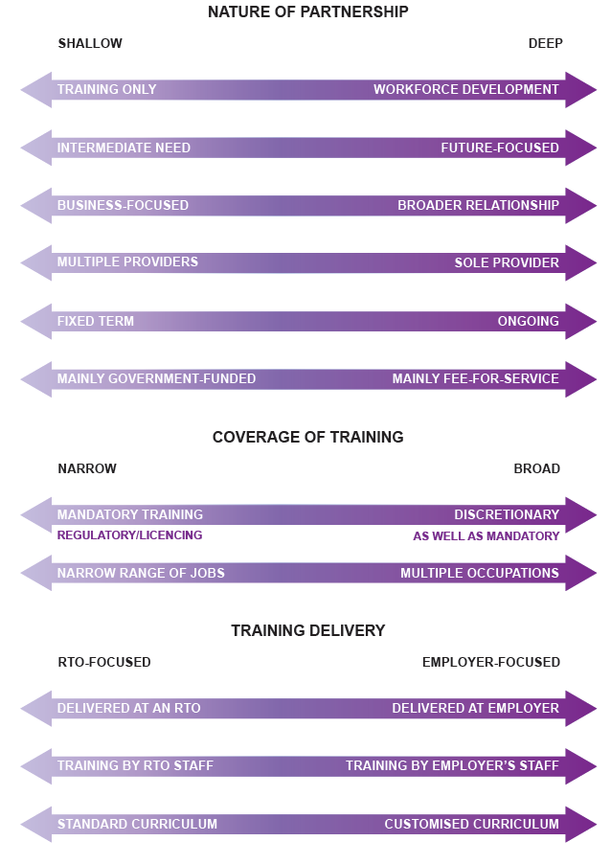
RRICULUM

WHAT MAKES PARTNERSHIP ARRANGEMENTS SUCCESSFUL?

Both traditional and innovative types of partnerships exist and may be successful.

Partnerships involve considerable investment of time on both sides. Partnership success is determined by whether the nature of the partnership and the training delivery are fit for purpose and meet employer expectations.

A number of factors typify successful RTO—employer partnerships. Some of the factors may be specific to the delivery of training, while many characterise successful business relationships more generally.

The partnership success factors listed to the right were derived from the interviews conducted for the project.

Many successful partnerships involve senior RTO staff who have previously worked in industry, or senior staff on the employer side who have worked in RTOs. In this way each party has a deep understanding of both the benefits of working together and the challenges that arise.

Examples of successful industry partnerships

There are a wide range of diverse and successful partnerships with associated benefits to both the training provider and the industry partner.

Table 1 includes some examples from the survey of the ways RTOs described their partnerships.

PARTNERSHIP SUCCESS FACTORS

Values alignment: the RTO and the employer share a set of values, which enables the parties to communicate well and understand each other’s expectations.

Trust: trust is typically built up over a long period of time and is a particular characteristic of
long-term partnerships.

Personal connections: the establishment of trust in a partnership is often the result of personal connections between key players.

Communication: a key element is regular communication between the RTO and the employer. This communication does not generally need to be formalised.

Single point of contact: it is critical that there are clear channels of communication between the two players and that, preferably, a single major point of contact is established by each partner.

Flexibility: this refers to the willingness of the RTO to alter delivery methods and to customise content to suit the specific needs of the employer.

Understanding of business needs: RTO staff need to know about the employer’s industry and
be keen to learn more about the business. Improving understanding of the business is also considered by many RTOs to be an invaluable source of development for their staff involved in training.

Government funding: funding facilitates partnerships in the initial stages, although it appears to become less important over time. Generally, employers affected by funding reductions try to maintain the partnership through self-funding, but this may prove difficult.

Table 1 Example of successful industry partnerships as described by RTOs
What is the partnership about? | How did it come about? | What benefits does it bring to your RTO? | What benefits does it bring to the industry partner?
TAFE institute  As always, meeting the training requirements of an employer aligned to their work environment and ensuring that they meet their statutory, compliance and WHS obligations. | Employer dissatisfied with training outcomes from attendance at a campus. | Access to equipment donations, premium client to assist with positioning in  the marketplace, currency of teachers, increased number of apprentices, first option to any fee-for-service training. | Training is completely contextualised to the practices and equipment used in their workplace, less time away from the workplace, improved productivity, greater value  for their training dollar by leveraging off government funding sources.
For-profit RTO  Training the whole workforce in safety. | Approached by industry/ employer. | Ongoing/annual training provided and the company uses us for other training also. | The learnings from this partner- ship also impact on the content of other training programs delivered to industry; content targets current needs/issues.
Non-profit RTO  To deliver timely and relevant training where gaps exist. | By direct approach to industry where partnership funding arose. | Keeping up to date with industry needs. | A better skilled and job-ready workforce.

What factors create and sustain partnerships?

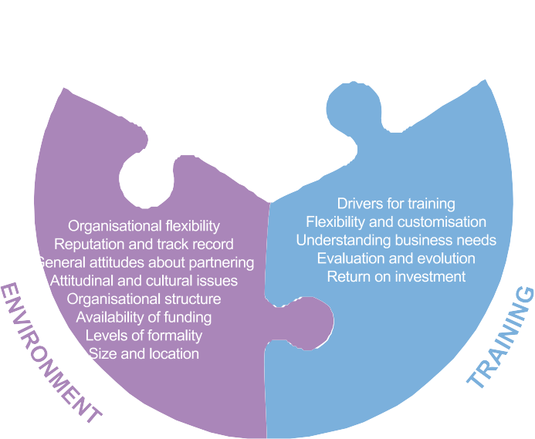Partnerships may start through a variety of means including:
- third party referral
- professional and personal relationships
- existing networks
- RTO prestige and reputation for building trust with
industry.

Direct contact may be initiated by the employer or the RTO, or there may be a formal tendering process.

The three key elements of environment, training and people determine the development and success of partnerships. These elements are each outlined in figure 2.

Figure 2 Key elements of a partnership

THE KEY PLAYER: FROM ‘VET CHAMPION’ TO ‘VET SYSTEM NAVIGATOR’
The nature of partnerships between RTOs and employers has changed over the years, from a relationship based on fee-for-service provision to one based on long-term collaboration.

There has also been a major change in the key players. In earlier studies, the important figure was a ‘VET champion’, most often located with the employer. Now, the important figure and key element in the use of nationally recognised training is the existence of a ‘navigator’, someone who explains and guides the employer through the complexities of the VET system.

This navigator might well be someone external to the organisation, such as an RTO or other partner. The navigator may not receive financial benefit from interactions relating to the assistance provided.

What are the drivers and benefits in a partnership? For training providers
Training providers are involved in partnerships with
industry or employers for a range of reasons, which can vary depending on the type of provider. The main drivers are identified in table 2.

‘Other’ reasons (see table 3) identified by RTOs fall into the three main categories of ‘growing the RTO/
competitive edge’, ‘community and industry service’ and ‘training quality’.

Financial benefits include increased revenue, revenue stabilisation, repeat business, and the associated indirect financial benefits such as reputation, credibility, brand recognition and awareness, all of which could be leveraged to attract other partners. The revenue helps to assure RTO viability, although it rarely offers more than a modest profit.

The non-financial benefits tend to focus on RTO staff development, such as exposure to industry and current industry practices, industry experience and partnership management experience, access to equipment, student placement opportunities and job outcomes for graduates.

For employers

In addition to meeting immediate workforce needs through training, a number of other direct and indirect benefits accrue for industry when partnering with a registered training organisation.

Direct benefits include:
  - having access to flexible and customised training, and a
customer-focused service from a training provider
  - being able to rely and depend on the RTOs to deliver
training that addresses the needs of the business,
because of longevity, mutual trust and respect
  - tapping into the expertise developed by the RTO staff
over a period of time
  - using the RTO as a navigator for the company around
the VET system, providing advice and alerting the company to possibilities for government funding.
Indirect benefits include:
  - having the opportunity to upskill and develop their
employees, sometimes beyond training that was strictly
necessary
  - experiencing enhanced professional development for
trainers and managers
  - being an employer of choice through investing in staff
training.

From a broader company/organisational perspective, the benefits include enhanced performance, productivity and profitability, which represents value-adding for the organisation and for staff retention.

HOW DO EMPLOYERS RATE THEIR SATISFACTION WITH TRAINING PROVIDERS?

The research for this project showed that employer satisfaction with the training provider they conduct most of their business with can be quite high, with overall satisfaction at 67% or above for nearly all items detailed in table 4. The only items scoring lower than this were: the RTO’s openness to experimentation (60.5%) and the RTO’s willingness to make changes to the nature of the off-the- job training (63.3%). It was notable, however, that RTOs’ self-rating was in nearly all cases higher than employers’ rating of RTOs’ performance. In other words, RTOs thought they did better than employers did.

Table 2 Drivers for RTO involvement in industry partnerships
Per cent who agreed | TAFE | For-profit | Non-profit | All RTOs
To maintain relevance/alignment with industry needs/requirements | 100.0 | 91.1 | 86.2 | 91.3
To keep up to date with industry needs/requirements | 100.0 | 86.7 | 86.2 | 89.1
Industries/employers have requested that we assist them | 94.4 | 77.7 | 82.8 | 82.6
To bring in additional revenue | 100.0 | 77.7 | 65.5 | 78.3
To give staff stronger links with industry | 88.9 | 75.5 | 75.9 | 78.3
To build extra capability within our staff | 94.4 | 68.8 | 69.0 | 73.9
To find future employers for our students | 88.9 | 55.5 | 69.0 | 66.3
If we did not get involved in the partnering, another organisation would have taken the opportunity | 83.3 | 45.4 | 51.7 | 54.9

Notes: 1. Q 11: ‘What are the main drivers for your organisation’s involvement in industry/employer partnerships?’.
2. Agreed: rated 4, 5 or 6 on a scale of 1 (strongly disagree) to 6 (strongly agree).

Table 3 RTO ‘other’ reasons for partnering with industry

Growing RTO/competitive edge | Community/industry service | Training quality
To gain access to state of the art equipment. Maintain our presence within the market force. | To assist the community. | To keep our industry partners up to date with standards/WHS requirements.
To develop our reputation within industry as a valuable training partner that adds real value to industry's profitability. | To provide training for the rural and remote agricultural industries, where access is extremely limited and no other opportunities for training services are offered. | To deliver industry-relevant educational outcomes.
To increase customer loyalty and longevity. | To support the economic development of this state and Australia overall. | Collaboration to influence design of new  training and curriculum.
Provides professional development opportunities. | To assist the industry to maintain a pool  of qualified staff for seasonal work. | To support employers to realise efficiencies and improvements through high-quality, well-designed training solutions.

Table 4 Employer satisfaction with training provider performance %

Partnership ‘process’ items: satisfied | Partnership ‘operational’ items: satisfied
Quality of RTO’s communication with us: 73.4 | RTO’s willingness to customise training to meet our needs: 72.2
Commitment shown by RTO’s staff to make the partnership a success: 72.1 | RTO’s flexibility in providing different delivery modes for the  training: 71.3
RTO’s willingness to adopt a long-term perspective on judging the success of the partnership: 71.8 | RTO’s willingness to make changes to the nature of the on-the-job training they deliver: 69.7
RTO’s ability to establish trust: 70.6 | RTO’s flexibility with staffing arrangements: 68.8
RTO’s level of planning within the partnership: 70.4 | RTO’s success in customising the training: 67.5
The administrative arrangements the RTO puts in place to manage the day-to-day issues arising in the partnership: 69.1. | RTO’s willingness to make changes to the nature of the off-the-job training: 63.3
RTO’s openness to experimentation: 60.5.

Notes: 1. Q 5.5: ‘Thinking about the training provider with which you have done most of your training business] please rate … your level of satisfaction with the performance of your training provider partner in the following aspects’.
2. Satisfied: rated 4, 5 or 6 on a scale of 1 (highly dissatisfied) to 6 (highly satisfied).

WHAT ARE SOME OF THE CHALLENGES ASSOCIATED WITH EMPLOYER–TRAINING PROVIDER PARTNERSHIPS?

Both perspectives

The timing and scheduling of training can be a challenge for both providers and employers, in particular, finding a suitable day and/or time for training, ensuring staff are available to attend training, minimising disruption to work schedules, meeting deadlines for training and minimising training days. Other challenges relate to communication between the partners. It is important for employers to keep providers updated with changes in company policies and procedures and with the recruitment of new trainees.

Building a new partnership takes time. Reviving an earlier partnership that may have broken down requires a rebuilding of trust between the two organisations. The
effort required to develop a good relationship provides an insight into the work needed to develop and maintain long-term partnerships.

The administrative processes for employers and for RTOs associated with the delivery of nationally recognised training have resource implications. Changes in national or state/territory policy and funding arrangements affect the training that can be offered. The frequency of changed funding arrangements causes special difficulties for partnerships. In addition, these constant changes mean that employers are especially reliant upon RTOs to interpret the system for them and make them aware of alternative funding opportunities.

Provider perspective

Some providers face considerable challenges around staff flexibility, compliance and meeting their partners’
training requirements. Being able to provide flexible training arrangements requires a culture shift within a training organisation. TAFE in particular faces challenges in balancing its role as a government provider with its attendant industrial relations limitations, while providing
training for an employer who has specific demands in terms of training needs, delivery site, delivery times and short timeframes.

Employer perspective

The challenges to partnerships can vary considerably. Organisational culture can also be an issue from an employer perspective. A training culture may already be embedded for some employers, but for others there may be a reluctance within the organisation to recognise the value of training and the need for change. Resistance from employees to embrace training and assessment as part of their roles may also be an issue.

Even if the relationship with an RTO is good, another challenge may be becoming too reliant on a single or preferred provider. Over time the relationship may become unsatisfactory or the RTO may no longer be as flexible as previously, leading to a situation where the employer needs to end the partnership.

REFERENCES

Callan, V & Ashworth, P 2004, Working together: industry and VET provider training partnerships, NCVER, Adelaide.

Smith, E, Smith, A, Tuck, J & Callan, V 2017, Continuity and change: employers’ training practices and partnerships with training providers, NCVER, Adelaide.

© Commonwealth of Australia, 2017

This work has been produced by the National Centre for Vocational Education Research (NCVER) under the National Vocational Education and Training Research (NVETR) Program, which is coordinated and managed by NCVER on behalf of the Australian Government and state and territory governments. Funding is provided through the Department of Education and Training.

TD/TNC 127.04

Published by NCVER ABN 87 007 967 311
Level 5, 60 Light Square, Adelaide 5000
PO Box 8288, Station Arcade, Adelaide SA 5000, Australia
P +61 8 8230 8400 E ncver@ncver.edu.au
W www.ncver.edu.au

twitter.com/ncver www.linkedin.com/company/ncver

