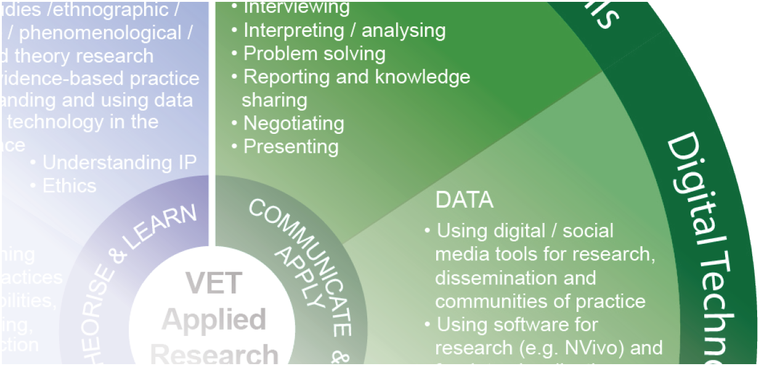
Explaining the VET applied research developmental
framework

Linda Simon and Francesca M Beddie

INTRODUCTION
This document explains the VET Applied Research Developmental Framework, created as part of a project that explored how the vocational education and training (VET) sector could broaden its engagement in Australia’s research and development (R&D) and innovation systems. Achieving this engagement will rely significantly on building the capabilities of VET educators and other professionals to undertake applied research and manage innovation projects.
The sort of research we are talking about has a strong focus on solving real-world problems in industry. Such activity can create new knowledge, and/or use existing knowledge in new and creative ways; it can also contribute to the development of ‘specialist pedagogy for industry expertise’ (Corbel et al. 2014), an important element in building a workforce capable of innovation.
Our project has concluded that a distinguishing characteristic of applied research in VET is the sector’s potential to bring together research and innovation, with the dual aims of investigating industry’s problems and bringing about change in the workplace. While research and innovation are not synonymous, the skills required to create and diffuse knowledge overlap. Both call for inquiry, reflective practice, communication and collaboration. These facets of activity underpin the framework and are explained below.
Another feature of VET applied research is the close link between research and efforts to improve VET pedagogy. These endeavours can lead to innovative thinking, new teaching practices and training products, and ultimately more creative graduates.
1 We build the case for developing this potential in the accompanying documents (VET applied research: driving VET’s role in the innovation system and
Developing VET applied research: steps towards enhancing VET’s role in the innovation system, available at <https://www.ncver.edu.au>).

Figure 1 VET applied research: a missing piece in the innovation system
Pure basic research
Scholarly practice
Interactive research/ Application
Use-inspired basic research
Solving enterprise problems
Inquiry evaluation
Experimental development
Knowledge translation &
dissemination
CONTENTS
Professional development Using the framework
Explaining the VET applied research developmental framework
Conclusion
References
3
4
6
14
15

The framework described here has a specific application to the VET sector, in that it draws on the skills and capabilities identified by participants in this research project — VET professionals, researchers, policy advisors and industry representatives — and on the skills identified in VET training packages. Examples of where applied research is practised in the VET system are presented in the boxes below.
We have also consulted other frameworks, such as Willison (2015), who articulated the steps that need to be achieved during the phases of the research process:
- embark and clarify
- find and generate
- evaluate and reflect
- organise and manage
- analyse and synthesise
- communicate and apply.

Currently, the success of applied research activity often depends on the enthusiasm, industry knowledge and contacts of a particular teacher or team. While individuals will continue to be the drivers of research, institutional and system-wide support will be needed to embed research in VET practice. How to develop appropriate high- level cognitive, research and management skills for a greater number of educators and other professionals must be addressed. This will require time, money and leadership. But the foundations exist.
The framework draws on the literature on research and innovation skills, as well as on our analysis of the
skills described in units of various current VET qualifications, in particular, the baseline qualifications for VET educators, the Certificate IV and Diploma in Training and Assessment (TAE). As is shown below, these entry-level qualifications do include skills and capabilities useful in applied research, which can be built on to ensure that all VET professionals have the high-level skills and knowledge they require.
Kemmis, Hodge and Bowden (2014) list the competencies needed for innovation as: self-management, initiative and enterprise, problem-solving, planning and organising, teamwork and communication. These could also be said to embrace the entrepreneurial skills relevant to innovation capacity. Beddie (in Curtin, Stanwick & Beddie 2011) notes that such capacity depends not on a specific set of ‘innovation’ skills but on the actual and differing skills needed in certain phases of the innovation cycle — pure research at the beginning, and adaptation to the market later on — or to fulfil the functions required to innovate in a specific industry, for example, marketing or accounting skills in one context, and IT or laboratory skills in another.
This framework is one way for VET educators and other professionals to determine the levels of research and innovation literacy they hold and how these might be further developed. It is not intended as a tick-and-flick form, but rather as a tool to map and build capacity, through qualifications and the practice of applied research within the curriculum and with industry partners. In breaking down the tasks and skills inherent in the terms ‘research’ and ‘innovation’, the framework seeks to make the task of developing applied research capabilities less daunting. The danger, however, in any schematic formula of the research process is that it cannot convey the ‘messiness’ of research and innovation, especially when conducted in real-world settings.

PROFESSIONAL DEVELOPMENT

In thinking about what skills and capabilities VET educators and other professionals need to undertake applied research, we took as our starting point the notion of the continuum of research; that is, from basic research, to commercialisation, usually conducted as a team effort, with a combination of skills and knowledge. This points to another continuum: of learning about research from the beginning of a career as a VET teacher/trainer, to arrive at the position of an accomplished partner in research and innovation, a process underpinned throughout by professional development activities. This is not a hierarchy; rather, it represents the elements that build research capability and a research culture. This idea of a continuum for professional development (figure 2) suggests that research should become a more explicit part of the suite of skills that all VET educators acquire, starting from entry-level qualifications.

Figure 2 A professional development continuum
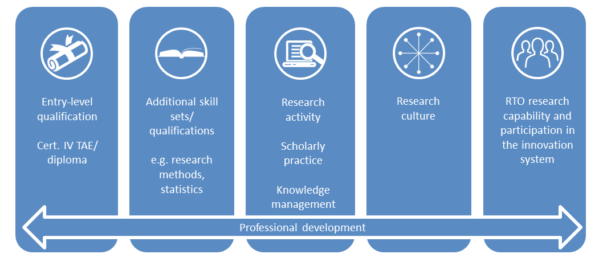

USING THE FRAMEWORK

The framework is relevant to individuals and teams undertaking or planning to undertake VET applied research, as well as to managers wanting to build organisational capability and human resources staff who are recruiting or designing professional development programs.
Not all individuals or teams will require all of the skills shown in the framework on all occasions, but in considering future staffing needs or professional development plans, it is useful to have an overview of the skills needed, along with those that should be developed.

Specific uses for the framework
- It can assist in planning the professional development of VET educators and other professionals. The registered training organisation (RTO) or individual can select domains/sub-domains, skills and capabilities that require cultivation and seek relevant qualifications or other means of upskilling.
- The framework can help in aligning professional development and applied research projects to a capability framework. For example, a capability framework might include an applied research section that draws on the skills and capabilities we have identified, thereby flagging it as an important area for continued professional development in this RTO.

TAFE Queensland’s educator capability framework
The TAFE Queensland Learning and Teaching Framework has adopted an applied research approach to investigating ways to improve the student experience and teaching. Its Educator Capability Framework includes the core skills of applied research and inquiry to guide the
development of educators (RedSpace 2016).

- The framework could be used as a tool to inform strategic planning and workforce development in an RTO. It can also help to build understanding within the VET workforce and among employers about the research process and the skills involved in research.
- Through careful mapping against the framework, an applied research team can highlight their value to the RTO and the utility of a particular project for the RTO’s operation, for example, reasons for attrition and factors for student success.
The importance of research being relevant
‘While undertaking national research projects has always been of considerable importance to me
personally, I have also recognised one very important fact. If I am unable, as a researcher, to prove the value of the research to the organisation that employs me, the likelihood of continued support
for any form of research may well be in jeopardy. National research must have the potential to be
relevant and useful at a local level – it must highlight problems and produce solutions. The power of such work cannot be understated’ (Berwyn Clayton, 2012).

h

- Individuals can use it to demonstrate their currency and meet the Australian Quality Training Framework (AQTF) and registered training organisation ongoing professional development requirements.
- As an audit tool, it can be used prior to convening a research project team or as part of a team’s assessment of its own capability to undertake a specific piece of work, the skill gaps that might exist and how these can be filled.
- As a pedagogical tool, the framework can help in the design of applied research projects for students and in assembling teams in ways that will best develop students’ skills and encourage peer learning.
- Industry partners can identify the skills and capabilities they potentially bring to the project, along with those they might expect VET educators to possess.
- In analysing the framework through the mapping to VET qualifications, individuals and RTOs can identify the skills and capabilities they may use through their training and assessment qualifications, and other training packages and units they may teach.
TAFE NSW Higher Education: articulating learning outcomes from research projects
The learning outcomes for students undertaking applied research projects as part of their higher education studies at TAFE NSW are clearly set out in their project briefs. For those working
with Hunter Water, the outcomes to be achieved align with skills in the VET applied research developmental framework:

- engage with ‘hands on’ industry-related work, build research and inquiry-related skills

- develop skills in data collection, analysis and reporting

- apply project management processes to a group project having specific outcomes and timeframe (TAFE NSW Higher Education 2016, p.10).

EXPLAINING THE VET APPLIED
RESEARCH DEVELOPMENTAL FRAMEWORK

Figure 3 The VET applied research developmental framework

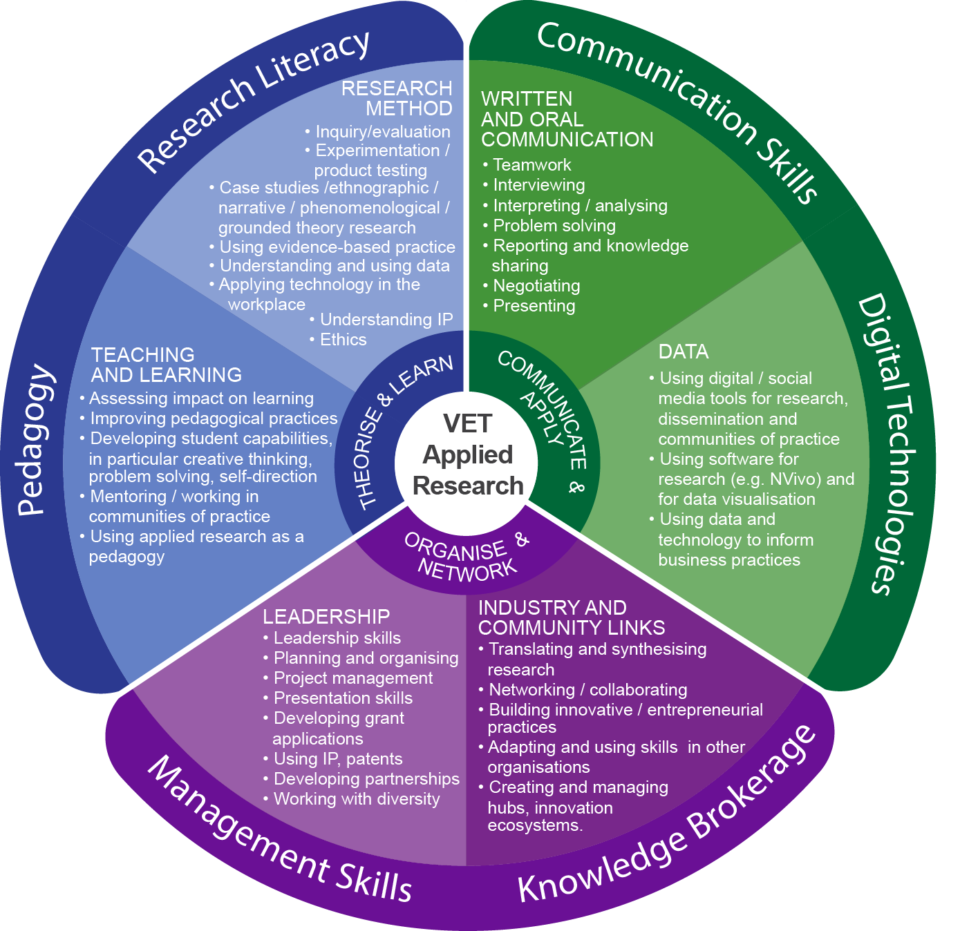

The VET applied research developmental framework recognises that skills/capabilities are needed in three areas. These skills have application beyond research but are necessary for conducting applied research projects with a real-world focus. A single person is unlikely to master all the skills in the framework: the type of research undertaken in VET will often be a team effort.
Each of the three differently coloured segments consists of two domains that contain the skills we identified in our research. The outer circle specifies the broad category of skills that make up the suite of VET applied research capability, categorised in the three sets of activity (theorise and learn; communicate and apply; and organise and network) involved in the research process.
In explaining the framework, we start in the centre sector of the green segment, moving in a clockwise direction to the purple and blue segments. This sequence moves from generic skills to specialised skills, with many in the latter group applicable to both teaching and undertaking research.

Communicate and apply
This area identifies the communication skills required thoughout the research process:
- working in teams
- interviewing research partners and subjects
- interpreting and analysing a range of documents and data
- problem-solving
- writing and reporting to others and sharing knowledge
- negotiating on outcomes
- presenting findings.

Those involved in research and dissemination also need to be able to use different communication tools, including digital technologies and social media.

Organise and network
Given that a specific goal for undertaking applied research in VET is its relevance to end-users, VET educators and
other professionals need to be knowledge brokers, which calls for skills in:
- translating and synthesising the research so that it is relevant to others
- networking and collaborating with industry and community groups, as well as colleagues
- building innovative practices
- adapting and using these skills in other projects
- creating sustainable practices through hubs and innovation ecosystems.

The focus of this segment is industry and community, recognising again that one of the differentiating aspects of VET applied research is its work with its partners in training. None of this is achievable without effective
leadership, planning and work organisation, which points to a further set of skills required in an RTO. Members of the team must be able to:
- manage a research project through its different phases
- present the work effectively
- apply for funding
- manage intellectual property (IP) requirements and apply for patents if appropriate
- develop partnerships with a range of stakeholders
- work with diverse groups of people and conduct evaluations.

All this effort has to be endorsed and supported by the leadership and mentored by research experts.

Theorise and learn
VET applied research is important in changing both VET pedagogical and industry practices. Many projects involve students or have an impact on future training. Skills in this domain include being able to:
- improve enterprise practices, including by the uptake of technology
- develop the capabilities of students, especially in those areas identified by employers
- assess the impact on learning or work processes
- mentor others and work effectively in sustainable communities
- use applied research as a pedagogy.

A full range of academic research skills may not be required to work in applied research projects; however, VET educators and other professionals should hold a measure of what we are terming ‘research literacy’. This includes inquiry, evaluation and reflection at an entry level; that is, people:
- working towards being able to apply evidence and technology to change products and processes
- having some qualitative and quantitative research skills
- experimenting with and testing products where necessary
- ensuring that work follows ethical guidelines
- understanding IP requirements.

Some VET educators and other professionals will go on to develop expertise in research methodologies.

The next section presents the units from current training packages that correspond to these skills (see
<www.training.gov.au>) to demonstrate where these research and innovation skills can be acquired in the VET system.

The mapping exercise
Two pieces of mapping were undertaken to identify whether VET educators and other professionals already possessed research capabilities and skills. These are presented below and are grouped according to the segments in the framework.
The first exercise mapped the VET applied research developmental framework to the Training and Education (TAE) Training Package, given that VET educators are expected to hold the certificate IV or a higher qualification in adult education. We wanted to see if this training package contained units that aligned with the framework. The competencies we identified were primarily in the ‘Communicate and apply’ segment. We identified electives from other training packages, mostly from the Business Services Training Package, corresponding to skills in
the framework, again mainly in the ‘Communicate and apply’ segment, but also in the ‘Organise and network’ segment.
The second piece of mapping was a broader scan of the Business Services Training Package, Creative Arts and Culture Training Package, Public Sector Training Package, Community Services Training Package and ICT Training Package, our aim being to identify other units and skills sets that mirrored skills in the framework. The scan indicated that many VET educators should already have some of the skills and capabilities included in the framework, and that additional skills could be gained via VET qualifications. This does not imply that these skills are immediately transferable to applied research projects: acquiring them may involve further professional development, including mentoring and access to expert support. More advanced research training would require postgraduate study.

Communication skills – Written and oral communication

The importance of communication skills in undertaking applied research and working with the stakeholders in that research cannot be underestimated. The framework assumes that educators generally possess good oral and written communication skills. It therefore singles out those skills needing refinement and adaptation to the research task.
- Teamwork
- Interviewing
- Interpreting/analysing
- Problem-solving
- Reporting and knowledge sharing
- Negotiating
- Presenting.

Alignment with current training packages:
- TAE40116 — Certificate IV in Training and Assessment: electives from the Business Services Training Package:
- BSBCMM401 — Make a presentation
- BSBLED401 — Develop teams and individuals
- BSBRES401 — Analyse and present research information.

- TAE10 Training package skill set:
— TAESS0007 — Enterprise Trainer — Presenting skill set.
- Other training packages: the following skills sets and units were identified as providing communication
training:
- Teamwork: BSBSS00063 — Team Leader skill set
- Interviewing: Creative Arts and Culture CUAAIR401 — Conduct interviews
- Interpreting/analysing: BSB42415 or BSB52415 — Certificate IV or Diploma in Marketing and
Communication, or BSBRES401 — Analyse and present research information
- Problem-solving skills: a range of qualifications and units, but examples are BSBCRT101 — Apply critical
thinking techniques; BSBCRT301 — Develop and extend critical and creative thinking skills
- Reporting and knowledge sharing: BSBWRT — Write complex documents, BSB42415 or BSB52415 Certificate IV or Diploma in Marketing and Communication and BSBWRT501 — Write persuasive copy
- Negotiating skills: BSB42015 or BSB51915 Certificate IV or Diploma in Leadership and Management
- Presenting projects: TAESS00014 — Enterprise Trainer — Presenting skill set.

Digital technologies – Data

- using data/social media tools for research, dissemination and communities of practice
- using software for research (for example, NVivo) and for data visualisation
- using data and technology to inform business practices.
N
Vivo research software

NVivo is software that supports qualitative and mixed methods research. Its role is to assist in the organisation and analysis of data from interviews, open-ended survey responses, articles, social media and web content.

Alignment with current training packages:
- The TAE10 Training Package:
— TAE80316 — Graduate Certificate in Digital Education. However, this is very education-focused and other qualifications such as the Graduate Certificate in Digital Media might be of more use.
- Other training packages: the following skills sets and units were identified as providing training in digital technologies:
- BSB42415 or BSB52415 — Certificate IV or Diploma in Marketing and Communication
- BSB42115 or BSB52115 — Certificate IV or Diploma in Library and Information Services
- BSBSS00061 — Cloud Computing and Digital Skills for Business skill set
- BSBSS00071 — Digitisation skill set.

Knowledge brokerage skills – Industry and community links

- translating and synthesising research
- networking/collaborating
- building innovative/entrepreneurial practices
- adapting and using skills in other organisations
- creating and managing hubs, innovation ecosystems.

Alignment with current training packages:

- TAE40116: Certificate IV in Training and Assessment electives:
- BSBMKG413 — Promote products and services
- BSBREL402 — Build client relationships and business networks.
- TAE50116: Diploma of Vocational Education and Training electives:
- TAETAS501 — Undertake organisational training needs analysis
- TAEICR501— Work in partnership with industry, enterprise and community groups.
- TAE10 Training Package skill set:
— TAESS00012: Enterprise and Industry Engagement skill set is also useful.
- Other training packages: the following skills sets and units are pertinent to knowledge brokerage:
- BSB41515 or BSB51415: the Certificate IV or Diploma in Project Management provides many industry skills, including in exploring relationships or projects, testing them and considering the risks involved both for business success and for successful educational outcomes
- Skills for partnerships and collaboration are identified in:
  - PSPGEN016 — Address client needs
  - BSB2015 or BSB51915 — Certificate IV or Diploma in Leadership and Management
  - BSBCRT402 — Collaborate in a creative process
  - AHCCCF405A — Develop community network
  - BSBREL401 — Establish networks
  - BSBREL402 — Build client relationships
  - CHCCDE003 — Work within a community development framework.
- Researching and product design is included in CUADES402 — Research and apply techniques in product design.

Management skills – Leadership

Project management skills are needed from the very beginning of an applied research project. As well as having good planning and organisational ability, researchers need to be able to present ideas for research and innovative projects to a variety of groups, along with the skills to write up research outcomes and disseminate findings for maximum impact.
Throughout our research, leadership was highlighted as critical to the success of projects. This embraces leadership at an RTO/faculty level and leadership of the applied research project, involving planning, organising and project management skills, as well as understanding intellectual property and other legal matters. Leaders must recognise the value of the research to the RTO, allow researchers to test ideas and take risks. This requires the incorporation of projects into business plans, such that good ideas become implemented projects. Leadership is also required at jurisdictional and national levels.
- leadership
- planning and organising
- project management
- presentation skills
- developing grant applications
- using intellectual property and patents
- developing partnerships
- working with diversity.

Alignment with current training packages:
- Business Services Training Package: this package in particular, but a range of training package qualifications and competencies are relevant in this area, including:
- BSB41515 or BSB51415 — Certificate IV or Diploma of Project Management
- BSBPMG410 — Apply project management techniques
- BSBPMG512 — Manage project time
- BSBPMG517 — Manage project risk
- BSBPMG601 — Direct the integration of projects.
- Working with diversity: relates to a variety of qualifications and units with clients and other stakeholders, including:
- BSBSS00076 — Conduct community liaison to promote association skill set
- BSBSS00035 — Copyright skill set
- BSBSS00048 — Patent skill set
- CUACMP301 or CUACMP501 — Implement copyright arrangements and Manage copyright arrangements.

Pedagogy – Teaching and learning

Apart from its orientation towards problem-solving, VET applied research emphasises the impact of research on teaching and learning. This occurs through the involvement of students in the research process or because the outcomes will lead to changes in training products. Having research capability assists in the assessment of the impact of teaching practices, as well as in the development of student skills.
o
H
lmesglen TAFE

One output from a project in the building and construction faculty using new technology will be a report on how this innovation will affect training packages.

In Holmesglen’s Health Faculty evidence informs professional education and clinical practice.

Alignment with current training packages:
- TAE40116 — Certificate IV in Training and Assessment electives:
- TAEDEL310 — Provide work skill instruction
- TAEDEL404 — Mentor in the workplace.
- TAE10 Training Package skill set:
— TAESS00017 — Workplace Supervisor skill set.

While educators are expected to have strong pedagogical skills and maintain their currency in both their industry and teaching and learning, not all will find the relationships between their work in applied research and their pedagogy easy to make. How skills from one project are applied to another can be a challenge and is a process not easily taught but is helped by being made explicit. Mentors, communities of practice and research experts can provide support in making the transition.

Research literacy – Research method
- inquiry/evaluation
- experimentation/product testing
- case studies/ethnographic/narrative/phenomenological/grounded theory research
- using evidence-based practice
- understanding and using data
- applying technology in the workplace
- understanding intellectual property
- ethics.

Alignment with current training packages:
- TAE40116 — Certificate IV in Training and Assessment elective:
— BSBRES401 — Analyse and present research information.
- TAE50116 — Diploma of Vocational Education and Training elective:
— TAERES501 — Apply research to training and assessment practice.
- Business Services Training Package: qualifications in this package are relevant in this area, including:
- BSBSS00059 — Workplace Planning and Development skill set
- BSBSS00046 — Managing Innovation skill set
- BSBSS00041 — Innovation Practice skill set
- BSBIPR601 or BSBIPR501 — Develop and implement strategies for intellectual property management
- BSBRES401 — Analyse and present research
- BSBCRT101 — Apply critical thinking techniques
- BSBCRT301 — Develop and extend critical and creative thinking skills.

CONCLUSION

VET teaching is a complex profession because it must embrace the skills and knowledge of both an industry and pedagogy. It is this very feature that should give VET a leading edge in industry innovation. As Wheelahan and Moodie (2010) pointed out, the nature of VET teaching also calls for a more comprehensive approach to VET teacher qualifications — beyond the mandated Certificate IV Training and Assessment — towards higher- level credentialled study, as teachers and trainers progress in their careers. Their model suggests a suite of
VET, undergraduate and postgraduate qualifications. Many VET educators have the basis on which to build their research capabilities, either from their TAE qualifications or from university qualifications and, in those RTOs delivering higher education, more are undertaking postgraduate study, including at PhD level.
The use of this framework to articulate the foundations of the VET sector’s applied research and innovation capability, and to build on these, will help to position the VET workforce more strategically in Australia’s innovation system.

REFERENCES

Brennan Kemmis, R, Hodge, S & Bowden, A 2014, ‘Transferable skills in technical and vocational education and training (TVET): implications for TVET teacher policies in Australia’, TVET@Asia, no.3, 13p., viewed 07 Aug 2017, <http://www.tvet-online.asia/issue3/brennan-kemmis_ etal_tvet3.pdf>.
Clayton, B 2012, ‘Starting from scratch: teacher to researcher and back again’, 2011 keynote address to National VET Research Conference (No Frills), NCVER, Adelaide, paper presented at the 20th National Vocational Education and Training Research Conference, viewed 16 April 2017, <https://www.ncver.edu.au/publications/2472.html>.
Corbel, C, Wheelahan, L, Forward, P & Darwin, S 2014, Building future capabilities for vocational education: why high-level teaching qualifications matter for TAFE teachers, Australian Education Union, Southbank, viewed 16 April 2017, <http://www.aeufederal.org.au/ application/files/9214/4538/1999/BuildingFutureCapabilities2014.pdf>.
Curtin, P, Stanwick, J & Beddie, F (eds) 2011, Fostering enterprise: the innovation and skills nexus — research readings, NCVER, Adelaide, viewed 16 April 2017, <https://www.ncver.edu.au/publications/publications/all-publications/fostering-enterprise-the-innovation-and- skills-nexus-research-readings>.
RedSpace 2016, PRAXIS 2016, Improving practice through action research, TAFE Queensland,Brisbane.
TAFE NSW Higher Education 2016, ‘Applied Research: Guidelines for developing a project brief and a project report’, unpublished. Wheelahan, L & Moodie, G 2010, The quality of teaching in VET: final report and recommendations, RMIT University, Melbourne. Willison, J 2015, Researcher skills development, University of Adelaide, viewed 28 April 2017, <http:www.rsd.edu.au>.

© Commonwealth of Australia, 2017

With the exception of the Commonwealth Coat of Arms, the Department’s logo, any material protected by a trade mark and where otherwise noted all material presented in this document is provided under a Creative Commons Attribution
3.0 Australia <http://creativecommons.org/licenses/by/3.0/au> licence.
The details of the relevant licence conditions are available on the Creative Commons website (accessible using the links provided) as is the full legal code for the CC BY 3.0 AU licence <http://creativecommons.org/licenses/by/3.0/ legalcode>.
The Creative Commons licence conditions do not apply to all logos, graphic design, artwork and photographs. Requests and enquiries concerning other reproduction and rights should be directed to the National Centre for Vocational Education Research (NCVER).
This document should be attributed as Simon, L & Beddie, F 2017, Explaining the VET applied research developmental framework, NCVER, Adelaide.
This work has been produced by NCVER on behalf of the Australian Government and state and territory governments. Funding is provided through the Australian Government Department of Education and Training.

The views and opinions expressed in this document are those of the author/project team and do not necessarily reflect the views of the Australian Government, state and territory governments or NCVER.
IMAGES: GETTY IMAGES/ISTOCK ISBN 978-1-925173-95-6
TD/TNC 129.13

Published by NCVER ABN 87 007 967 311
Level 5, 60 Light Square, Adelaide SA 5000
PO Box 8288, Station Arcade, Adelaide SA 5000, Australia P +61 8 8230 8400
E ncver@ncver.edu.au W www.ncver.edu.au
twitter.com/ncver www.linkedin.com/company/ncver

