NCVER_Floating_Mono

Completion rates for group training organisations and direct employers: how do they compare?

Support document: literature review and other appendices

Lisel O’Dwyer  
National Centre for Vocational Education Research

This document was produced by the author(s) based on their research for the report *Completion rates for group training organisations and direct employers: how do they compare?,* and is an added resource for further information. The report is available on NCVER’s Portal: <<http://www.ncver.edu.au>>.

### Publisher’s note

The views and opinions expressed in this document are those of the authors and do not necessarily reflect the views of the Australian Government or state and territory governments. Any errors and omissions are the responsibility of the author(s).

**© Commonwealth of Australia, 2019**

CC BY logo

With the exception of the Commonwealth Coat of Arms, the Department’s logo, any material protected by a trade mark and where otherwise noted all material presented in this document is provided under a Creative Commons Attribution 3.0 Australia <http://creativecommons.org/licenses/by/3.0/au> licence.

The details of the relevant licence conditions are available on the Creative Commons website (accessible using the links provided) as is the full legal code for the CC BY 3.0 AU licence <http://creativecommons.org/licenses/by/3.0/legalcode>.

The Creative Commons licence conditions do not apply to all logos, graphic design, artwork and photographs. Requests and enquiries concerning other reproduction and rights should be directed to the National Centre for Vocational Education Research (NCVER).

This document should be attributed as O’Dwyer, Lisel 2019, *Completion rates for group training organisations and direct employers: how do they compare? Support Document: Literature reviews and other appendices,* NCVER, Adelaide.

This work has been produced by NCVER on behalf of the Australian Government and state and territory governments, with funding provided through the Australian Government Department of Employment, Skills, Small and Family Business.

Published by NCVER, ABN 87 007 967 311

Level 5, 60 Light Square, Adelaide, SA 5000  
PO Box 8288 Station Arcade, Adelaide SA 5000, Australia

**Phone** +61 8 8230 8400 **Email** [ncver@ncver.edu.au](mailto:ncver@ncver.edu.au)

**Web** <https://www.ncver.edu.au> <<http://www.lsay.edu.au>>

**Follow us:**  <https://twitter.com/ncver>  <https://www.linkedin.com/company/ncver>

Contents

Introduction 5

Literature review 6

Overview of method and findings 6

Background 6

Apprenticeship commencement, completion and cancellation 8

GTO and private employer practices 13

Legislative frameworks 16

References 24

Appendix 26

Timing of Commonwealth and state policies, programs and   
events with apprenticeship commencements, cancellations   
and completions by state, 2000–17 26

# Tables and Figures

## Tables

1 Main reason for not completing an apprenticeship, 2008 and   
2010, trade occupations 10

2 Practice differences and similarities between GTOS and   
private employers 13

## Figures

1 Number of apprenticeship commencements, cancellations   
and completions by state, 1997—2017 15

2 Number of commencements, cancellations and completions   
and timing of policy changes, 2007—17, Australia 17

A1 Number of commencements, cancellations and completions and   
timing of policy changes, New South Wales, 2007—17 26

A2 Number of commencements, cancellations and completions and   
timing of policy changes, Victoria, 2007—17 27

A3 Number of commencements, cancellations and completions and   
timing of policy changes, Queensland, 2007—17 27

A4 Number of commencements, cancellations and completions and   
timing of policy changes, South Australia, 2007—17 27

A5 Number of commencements, cancellations and completions and   
timing of policy changes, Western Australia, 2007—17 27

A6 Number of cancellations and completions and timing of policy   
changes, Tasmania, 2007—17 27

A7 Number of commencements, cancellations and completions,   
Northern Territory, 2007—17 27

A8 Number of commencements, cancellations and completions,   
Australian Capital Territory, 2007—17 27

# Introduction

This supporting document contains details of two research elements undertaken for the report *Completion rates for group training organisations and direct employers: how do they compare?*

* A literature search was conducted to establish the existing evidence on apprentice and trainee completion rates, with a specific focus on evidence for group training organisations.
* A review of comparative legislative frameworks and reporting practices was conducted. As part of this review, data from the NCVER (2017) *Historical time series of apprenticeships and traineeships in Australia* were plotted by state for 1997—2017 (figure 1), and also overlaid with the timing of major policy initiatives or changes for 2007—17 (see figure 2 and figures A1—A8 in the appendix).

# Literature review

## Overview of method and findings

A literature search was conducted using VOCEDplus and other sources for all forms or resource types (that is, reports, peer-reviewed journal articles, statistical reports, websites and conference papers) dated within the last five years (2012 to March 2018). Keywords including ‘apprentice’, ‘completion’, ‘Australia’, ‘policy’, ‘group training’, ‘attrition’ and ‘rates’ were used in various combinations to search abstracts. The project advisory group was also asked to suggest any other publicly available sources that may not be identified via a traditional database literature search. This strategy identified 84 items: 55 reporting research findings, 18 policy or legislation documents and 11 websites with information about group training organisations (GTOs), and the Australian apprenticeship system, both national and state-based.

The reasons for cancellations are reasonably well documented in the literature covered. The literature has been concerned with cancellations and completion rates in general rather than breaking it down by GTO vs direct employer, and so a gap remains for a further analysis of differences in outcomes for the two types of employers. A further gap is that the GTO can be particularly helpful to small and medium-sized businesses that find committing to an apprenticeship difficult, lack the resources to manage an apprentice, or are unable to provide the full on-the-job training required for an apprenticeship. In considering the comparisons, it should be acknowledged that many direct employers also provide pastoral care and support to their apprentices, but this provision is often more difficult for small direct employers in particular. Given that GTO apprentices and trainees are generally placed with small or medium host employers, we should compare their completion rates with those of small or medium direct employers. In sum, the literature tells us *why* apprentices may not complete but further investigation that accounts for these gaps can establish clearer evidence on whether the GTO is a negative, mitigating, neutral or positive factor in apprentice and trainee completion rates.

## Background

High rates of non-completion among apprentices and trainees are an enduring concern among governments, employers, GTOs and vocational education and training (VET) providers because of the level of public investment in apprenticeships and traineeships and consequent shortages of skilled workers in many industries.

The original objective for group training was to provide a legitimate framework for employers to participate in the training of apprentices when they were willing but not able to commit to taking on an apprentice directly for various reasons such as having insufficient work. By employing apprentices and trainees and placing them with employers, GTOs are responsible for ensuring the wellbeing of apprentices and trainees and that they receive suitable training and experience, including provision for rotation between employers, if necessary. Part of this role includes providing the additional care and ongoing support necessary for the apprentice to complete the training contract. In this context, group training continues to play an important role today. Compared with traditional apprenticeships, group training provides many benefits for apprentices, such as rigorous recruitment practice, structured programs, the provision of varied work, and formal support and mentoring. Group training operates in challenging environments. Firms that engage group training may not have the skills or capacity to manage the apprentice relationship. Coverage extends across regional, rural and remote areas, including Indigenous communities. GTOs have a significant community service element to their operations. GTOs also often cross-subsidise the more challenging, resource-intensive parts of their operations from other commercial activities. This function, with its strong social and community focus, is one that would not be absorbed by the private sector, without significant additional offsets. GTOs are currently involved in about 12% of apprenticeships and traineeships (NCVER 2018).

However, despite the strengths of group training organisations, Bednarz (2014) found that the completion rates of GTO apprentices are not significantly higher than those of private employers. She suggested that future research should investigate why GTOs do not seem to experience higher completion rates. The pattern has become known as the ‘group training paradox’ (Bednarz 2014, p.24).

A range of possible factors potentially influences the reported, or actual, completion rates of apprentices in GTOs when compared with the rates for apprentices with private (direct) employers. First, the profiles of apprentices in GTOs and apprentices with private employers may be different. Couldrey and Loveder (2016) report that GTOs often engage with a more disadvantaged cohort of apprentices than private employers, who are more selective. GTOs must manage an inherently higher risk of non-completion related to individuals’ prior education levels, career aspirations and social networks and support. These differences add complexity to the apprenticeship operating model.

Reporting differences may also contribute to the comparative completion rates. For example, GTOs are legally required to register an apprentice before being placed with a host employer, but private employers are not. If private employers take a new apprentice on but dismiss them before registration occurs, the dismissed individuals are not captured in the current data collection system as either commencing apprentices or non-completions, unlike apprentices in GTOs. Further, apprentices can resign from their position with a GTO to commence work with a new employer, represented by a cancellation of the contract with the GTO and commencement (and eventual completion) with the new employer. Conversely, private employers are not obligated to report a cancelled contract.

Legislative and practice differences between GTOs and private employers may differentially influence completion rates. For example, GTOs are more readily able than private employers to supply apprentices and report benchmarks.

GTOs’ attrition rates may not necessarily represent a failure to complete. Some apprentices (particularly school-based apprentices and trainees) may leave a GTO to take up work with a private employer and complete their apprenticeship with that employer. Such completions are not attributed to the GTO even though they may have supported the apprentice through most of their training.

While GTOs operate under approved national standards, they have different profiles and activities across jurisdictions. Time series data show differences across jurisdictions in rates of apprentice and trainee completion and attrition/withdrawal numbers, so analyses of GTOs vs non-GTOs must consider completions in the context of jurisdictional policy and not assume national uniformity.

Based on trends in employer demand for apprentices since 2012, Karmel (2017) argues that the traditional apprenticeship model is not universally highly valued by employers, and that employer support seems to be on the decline in many occupations. If so, the role of GTOs is likely to become more important if Australia is to produce sufficient qualified workers in vocational fields, and therefore we must explore mechanisms underlying completion rates.

This review is the first stage of the wider project on why completion rates for apprentices employed by GTOs are not significantly higher than for those employed by private employers. It compares the practices of GTOs and private employers and jurisdictional legislative frameworks, drawing on publicly available literature and information to understand the structures within which GTOs and private employers of apprentices operate, and how these potentially influence apprenticeship completion rates.

## Apprenticeship commencement, completion and cancellation

### Individual-level factors influencing apprenticeship rates

This section gives a brief overview of the recent literature on known factors influencing apprenticeship success and attrition, given that these factors appear to affect apprentices in both GTOs and direct employers. A considerable amount of literature dating back 10 years or more also exists (for example, Ball 2005; Karmel & Virk 2006; Snell & Hart 2008). Commencements have also been attracting recent attention from both researchers and the media, given the downturn since 2013 in most jurisdictions and have an obvious flow-on effect on absolute numbers of completions, but the focus of this section is on the comparative rate of completions.

The review found considerable overlap and consistency of findings, although most research has not explicitly compared GTOs and direct employers to investigate whether apprentices in GTOs and direct employers are affected differently. For example, Zoellner, Brearley and Oppermann (2017), Zoellner (2017) and Karmel and Roberts (2012) address total apprenticeships (that is, not distinguishing between GTO based apprenticeships and others); Pearce (2017) examines apprenticeships in GTOs only (focusing on the apprentices themselves rather than the GTO as an employer); and the Office of the Fair Work Ombudsman (2017) investigates apprenticeships with private employers only. Also, the Australian National Audit Office (2017) considers alternative arrangements for apprenticeship training via a pilot program.

### Factors contributing to apprenticeship and traineeship completions

Pearce’s (2017) study of successful apprenticeships within the Australian building and construction industry employed by a GTO in the Australian Capital Territory identifies:

* positive influence of family and friends who place value on vocational education and training opportunities as a worthwhile occupational choice
* past experiences with work including prior work experience, either voluntary, part-time, full-time employment and work experience initiatives at secondary school and prior unemployment evoking realisation of the need for a qualification
* high expectancy of completion based on personal belief that completion of a trade qualification was not only valuable but also achievable
* sponsorship and informal support of a more experienced ‘other’ who has both a professional and personal interest in the apprentice’s development. Sponsors manage the apprentices’ learning environment and serve as a knowledgeable and credible resource, assisting apprentices to normalise expectations throughout their apprenticeship
* development of self-directed learning enables apprentices to meet the minimum occupational standards (competence), but also develop high levels of discretion in their learning, greater autonomy and responsibility, and enhanced capacity for reflection (especially critical reflection) throughout their careers
* non-technical attributes such as punctuality, effective communication, and the willingness to accept direction and to learn is prioritised by employers over pre-existing technical or trade skills and knowledge.

Nelms et al.’s (2017) review identified the supply-side factors (characteristics of apprentices), while Karmel (2017) identified the demand side.

Apprentice characteristics associated with completion include:

* older age apprentices aged mid-30s and older are more likely to complete their training contract
* gender: male apprentices more likely to complete than female apprentices, but female trainees are more likely to complete than male trainees
* disadvantage: being Australian-born, of English-speaking background and not Indigenous; higher commencement rates of apprenticeships and traineeships among young Indigenous persons in 2014 compared with non-Indigenous persons but also higher attrition rates; no disability (but low observations for apprentices with disabilities means a large statistical error)
* rural location: apprentices and trainees in rural areas are more likely to complete their contract than those in capital cities or remote locations
* pre-apprenticeship course completion is not consistent across all occupations
* exposure to trades work gives a high degree of familiarity with trades and tradespeople gave apprentices interest in the work
* intrinsic motivation as an inherent drive and personal interest in the work and control over work.

### Factors that affect apprenticeship and traineeship completions

Some of the factors identified by different researchers are linked. For example, the factor ‘found the study too difficult’ (Bednarz 2014) may be interchangeable with or linked to ‘low educational attainment’ (Nelms et al. 2017); a ‘high expectancy of completion’ (Pearce 2017) may be analogous to ‘intrinsic motivation’ (Nelms et at. 2017). Some factors are opposite sides of the same coin — younger apprentices were less likely to complete than older apprentices (Pearce 2017; Nelms et al. 2017), while older apprentices were more likely to complete (NCVER 2017a).

Bednarz (2014) used findings from surveys undertaken by NCVER and other national surveys, industry studies and research papers to compile a list of 16 possible reasons for not completing an apprenticeship, as reported by apprentices (table 1). These reasons can be summed up as ‘related to the employment experience’, ‘personal reasons’, and ‘other’.

Table 1 Main reason for not completing an apprenticeship, 2008 and 2010, trade occupations1

|  |  |  |  |
| --- | --- | --- | --- |
| **Main reason** | **2008** | **2010** |  |
| (n = 429) | (n = 1154) |  |
| (%) | (%) |  |
| Did not get on with boss or other people at work | 16.2 | 10.2 |  |
| Did not like the type of work | 10.2 | 8.3 |  |
| Other reasons | 10.2 | 1.5\* |  |
| Personal reasons2 | 10.0 | 15.7 |  |
| Left job or changed career | 9.4 | 12.5 |  |
| Lost job or made redundant | 8.9 | 26.8 |  |
| The pay was too low | 8.7 | 4.7 |  |
| Was not happy with the on-the-job training | 5.4\* | 1.9 |  |
| Not happy with the job prospects in the industry | 3.6\* | 4.2 |  |
| Got offered a better job | 3.3\* | 2.2 |  |
| Apprenticeship/traineeship cancelled or discontinued | 3.2\* | 3.8 |  |
| Poor working conditions | 3.1\* | 3.1 |  |
| Changed to another apprenticeship/traineeship | 3.1\* | 1.1\* |  |
| Left to study elsewhere | 1.9\* | 0.8\* |  |
| Found the study too difficult | 1.4\* | 1.6 |  |
| Was not happy with the off-the-job training | 1.4\* | 1.6\* |  |
| **Total** | **100.0** | **100.0** |  |

Notes: \* indicates that the estimate has a relative standard error greater than 25% and therefore should be used with caution.

The table is sorted by the main reason in 2008.

1 The last Apprentices and Trainees Destination Survey was 2010; this table cannot be updated.

2 ‘Personal reasons’ includes the following: family reasons, illness, lack of time, moved, problems with travelling/transport.

Source: Apprentice and Trainee Destinations Survey (NCVER 2010, p.10), in Bednarz 2014, p.13).

Other supply-side characteristics associated with failing to complete apprenticeships, as reported by Nelms et al. (2017) include:

* low socioeconomic status family background
* part-time work status
* low qualification level.

Apprentices undertaking higher qualification levels (certificate III or IV) are almost twice as likely to complete as those doing certificate I or II.

Karmel (2017) reports on demand-side factors affecting withdrawals or cancellations including:

* losing the job or being made redundant (this factor generally correlates with economic activity)
* size of the company (with a positive relationship between size and completion rates)
* employer type — government employers have higher rates of apprenticeship completions than private employers

Adult trade apprentice completion rates have steadily increased over time, while younger trade apprentice completion rates are on a slow but steady decline. NCVER data show clear differences between younger and older apprentices. For adult apprentices, the most prevalent reasons for non-completion are family or personal (both trade and non-trade apprenticeships), followed by a change in their job situation. For younger apprentices, the most prevalent reason is a change in their job situation (Hargreaves, Stanwick & Skujins 2017).

Zoellner, Brearley and Oppermann (2017) posit that apprentices in hotter parts of Australia are less likely to complete their training due to the extreme climatic conditions. We would expect this factor to affect GTO apprentices and direct employer apprentices in the same areas equally, unless there is some unlikely systematic difference between the physical constitutions of the two groups, or if GTOs provide markedly different physical environments from direct employers.

Completion rates hovered at just over 50% of commencement rates for most jurisdictions until 2012, albeit with some fluctuation in the smaller jurisdictions and Victoria in 2003. At the time of writing, the most recent rate for Australia as a whole is 55.2% (NCVER 2017b). Commentators unanimously agree that these rates are low relative to commencement rates (Stromback & Mahendran 2010). Stromback and Mahendran (2010) attribute low completion rates to:

* legally binding contracts not enforced due to changing community values
* declining status of tradespersons.

They suggest that this change in the status of tradespersons is due to the labour market becoming less structured. Other commentators point to secondary schools and parents nudging students toward higher education, seeing VET training as inferior (McEwen 2015; Hargreaves & Osborne 2017). Workman and Luciani (2017) also point out that young people generally have no opportunity to research, trial and experience a range of vocational options before having to commit to a three- to four-year qualification. They have no option but to rely on school, family or friends for initial career direction. A pilot project to enable young people to trial different vocational roles before making a career choice is currently underway, involving GTOs (Workman & Luciani 2017).

Mangan and Trendle (2017) argue that some of the concern about the reduced completion rate for apprentices is unnecessarily pessimistic because many individuals who withdraw from an apprenticeship do so only temporarily and return later to complete the apprenticeship with the same or another employer. Using Direct Entry Level Training Administration (DELTA) data for Queensland, they tracked 317 individuals who had cancelled up to three times over five years and found:

* The probability of a first cancellation rises sharply in the initial 20—30 months, while first returns peak slightly later.
* Being Indigenous is found to increase the risk of the transition to the first cancellation by 41.1%. This is also associated with a decline in the probability of returning to training after a first cancellation (40.6% less likely than non-Indigenous to make this transition), while Indigenous persons are 52.7% more likely to make a second cancellation after returning to training.
* Having a disability or speaking a language other than English at home is associated with increases in the risk of first cancellations of 26.4% and 30.6%. A non-English speaking background does not affect the probability of completing after returning once or withdrawing and returning twice.
* High school education level is inversely associated with the probability of cancelling. Leaving before the completion of Year 10 sees the probability of making the transition from enrolment to first cancellation increase by 9.8%, while completing Year 11 or Year 12 sees the risk of making this transition fall by 6.4% and 28.5%, respectively.
* Cancelling more than once occurs at much lower frequencies.
* Gender was not associated with cancellations.
* A positive relationship exists between accessibility and probability of withdrawing the first time.
* An inverse relationship exists between income level and probability of the first withdrawal.
* An increase in income is also associated with a decrease in the probability of making the second transition (enrolment to completion).
* Higher levels of education are associated with a decline in the risk of cancellation and an increase in the probability of a return to training for those who did cancel.

These results suggest a need for targeted policy interventions to reduce the incidence of cancellation and encourage a return to training for those who do quit. Mangan and Trendle (2017) suggest that the inverse relationship between income and withdrawals may be explained by apprentices in higher income trades being in greater demand and more likely to change employer (which would be recorded as a withdrawal).

Gambin and Hogarth’s (2016) study of apprentices in England also found no gender effects except for in certain sectors and that local unemployment rates had a negative effect on lower-level apprenticeship completion rates (although a positive effect on higher apprenticeship completion rates). They conclude that non-completion is not reducible to a single cause and that large-scale failure to complete apprenticeships may point to a skills mismatch between the individual, employer and apprenticeship. The role of policy and legislation in comparing England’s completion rates with those of other countries was not considered.

It is worth noting that research has found that some GTOs and private employers (as well as unions and association members) felt that there was too much concern about attrition. They argue that some attrition is useful because it removes unsuitable individuals. Attrition is also to be expected with Generation Y’s characteristic mobility (Walker & Powers 2009, in Bednarz 2014). However, attrition still represents wasted time and resources and implies a need for better recruitment processes. Costs are borne by the individual non-completer, employers, state and territory governments and the Australian Government. Deloitte Access Economics (2011) estimated that non-completion represented a cost of $149 million (unadjusted) between 2010 and 2020 in New South Wales alone. The associated costs not included in this figure include a multiplier effect on the forgone productivity for the state and Australian economies, additional government transfer payments to non-completers between leaving the apprenticeship and gaining other employment, forgone revenue to the state governments in the form of concessions (transport and payroll tax etc.) and additional outlays by government and employers for individuals moving between apprenticeship contracts (Deloitte Access Economics 2011).

## GTO and private employer practices

Successful GTOs and private employers share many of the same practices. The focus below (table 2) is on practices generally used in one and not the other.

Table 2 Practice differences and similarities between GTOs and private employers

|  |  |  |
| --- | --- | --- |
| **Practice** | **GTO** | **Private employer** |
|  |  |  |
| Not-for-profit | C:\Program Files (x86)\Microsoft Office\MEDIA\OFFICE14\Bullets\BD21301_.gif (mostly) |  |
| Workers’ compensation premiums | C:\Program Files (x86)\Microsoft Office\MEDIA\OFFICE14\Bullets\BD21301_.gif (State differences (e.g. NSW has higher costs than other states; SA is exempt) |  |
| Various forms (size, scope, structure, governance) | C:\Program Files (x86)\Microsoft Office\MEDIA\OFFICE14\Bullets\BD21301_.gif | C:\Program Files (x86)\Microsoft Office\MEDIA\OFFICE14\Bullets\BD21301_.gif |
| Requirement to provide evidence for continuous improvement processes |  |  |
| Recruitment process including assessment of LLN | C:\Program Files (x86)\Microsoft Office\MEDIA\OFFICE14\Bullets\BD21301_.gif | C:\Program Files (x86)\Microsoft Office\MEDIA\OFFICE14\Bullets\BD21301_.gif |
| Active participation in RTO training plan | C:\Program Files (x86)\Microsoft Office\MEDIA\OFFICE14\Bullets\BD21301_.gif |  |
| Mentoring/pastoral care, monitoring and supporting apprentices to completion | C:\Program Files (x86)\Microsoft Office\MEDIA\OFFICE14\Bullets\BD21301_.gif | May be provided by training organisation rather than employer. Available from some employers but not all |
| Required to demonstrate good governance and administration | C:\Program Files (x86)\Microsoft Office\MEDIA\OFFICE14\Bullets\BD21301_.gif |  |
| Funding for cost of apprentice | C:\Program Files (x86)\Microsoft Office\MEDIA\OFFICE14\Bullets\BD21301_.gif |  |
| Clear information on obligations in one document | C:\Program Files (x86)\Microsoft Office\MEDIA\OFFICE14\Bullets\BD21301_.gif |  |
| Comparatively onerous administrative requirements | C:\Program Files (x86)\Microsoft Office\MEDIA\OFFICE14\Bullets\BD21301_.gif |  |
| Flexibility about timing and delivery of training | C:\Program Files (x86)\Microsoft Office\MEDIA\OFFICE14\Bullets\BD21301_.gif |  |
| Optimise time of attendance at college while supplying host employer with another apprentice | C:\Program Files (x86)\Microsoft Office\MEDIA\OFFICE14\Bullets\BD21301_.gif |  |
| Able to provide full range of skills to work in the industry | C:\Program Files (x86)\Microsoft Office\MEDIA\OFFICE14\Bullets\BD21301_.gif |  |

|  |  |  |
| --- | --- | --- |
| Tax incentives | (for GTOs which are registered charities in some states) |  |

|  |  |  |
| --- | --- | --- |
| Subsidy for disadvantaged apprentices (disabilities, Indigenous, rural areas etc.) |  |  |
| Cash incentives to take on apprentice |  |  |
| Subsidy for occupations on national Skills Needs List |  |  |
| Able to move apprentices to different host employers |  |  |
| Cash incentives for employers whose apprentices complete |  |  |

Source: Literature review

Some commentators argue that only a relatively small proportion of employers will increase the provision of apprenticeships in response to financial incentives (for example, Kuczera 2017). Conversely, Pfeifer (2016) found withdrawal of subsidies led to a decline in apprenticeship provision in sectors where employers could not count on the long-term benefits from apprenticeships. These employers were not able to break even by the end of the program without the subsidy. Kuczera (2017) argues that financial incentives for apprenticeships are likely to have modest effects (see further detail in the section on apprentice incentives) and will usually involve substantial deadweight (i.e. they subsidise apprenticeships that would have been provided anyway). There are also risks of unintended effects, such as encouraging the engagement of employers who are more interested in subsidies than skills development. Incentives should be used with caution and their impact should be evaluated carefully, including displacement effects (Kuczera 2017).

Apprenticeship commencements, cancellations and completions patterns over the last 17 years by jurisdiction often show similar patterns, indicating that legislation and wider economic or social conditions may have more impact on completion rates than individual-level factors (figure 1). All states except the Northern Territory have peaks in commencements in 2012 (the Northern Territory peaked in 2010), followed by sharp declines in commencement rates. Before 2012 the jurisdictions generally showed a gradual increase in commencement rates. Since 2012, there have been several reductions in the incentives paid to employers, which appear to have influenced commencements and completions of apprenticeships and traineeships (Atkinson and Stanwick 2016, p24). Although there are many similarities, the differences between the jurisdictions may reflect the impact of different state-based legislative frameworks, policy initiatives, and local industry conditions, as well as the jurisdictional profile of the mix of trade and non-trade, employer characteristics and apprentice and trainee characteristics.

Figure 1 Number of apprenticeship commencements, cancellations and completions by state and territory, 1997–2017

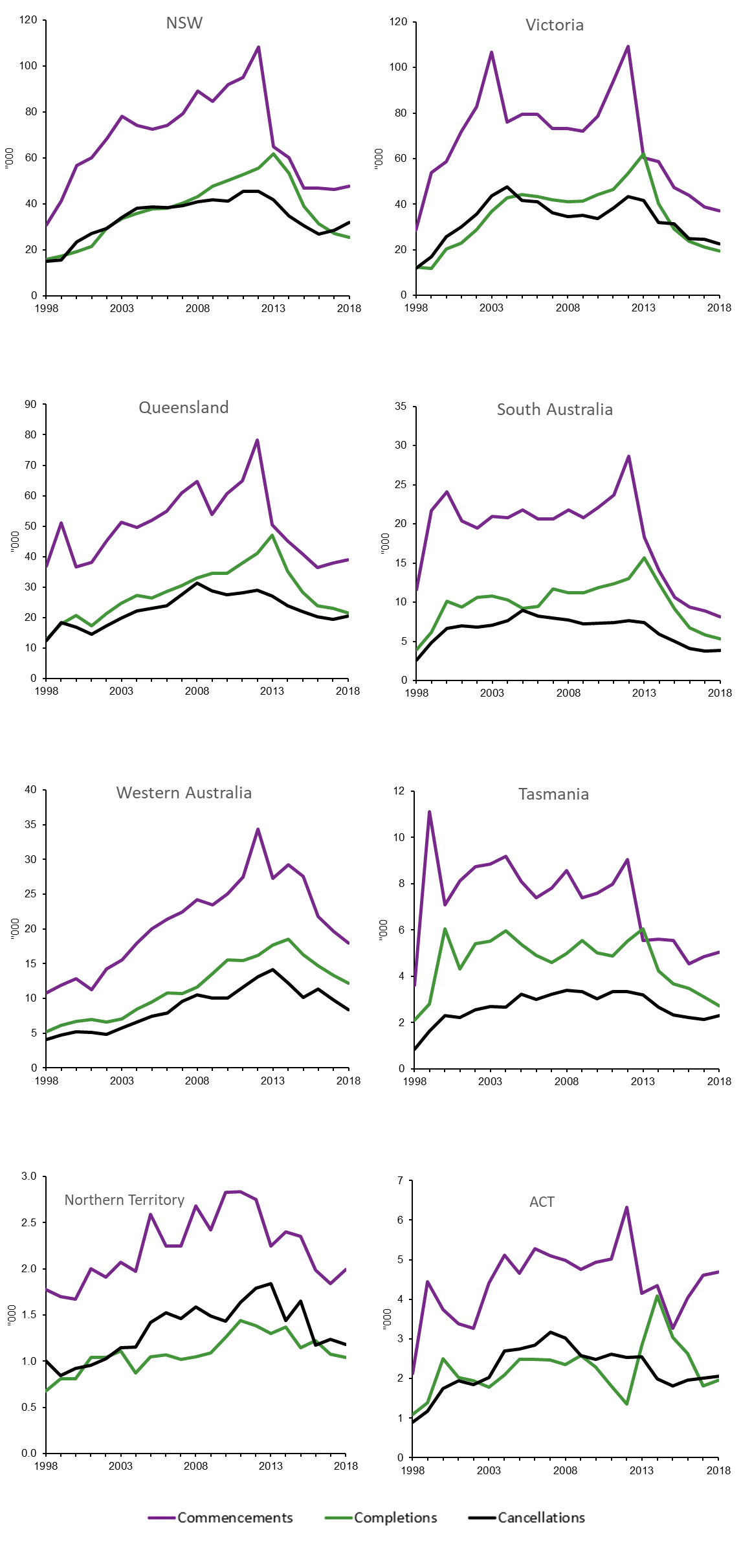

Source: National Apprentices and Trainees Collection 1997–2017.

## Legislative frameworks

GTOs’ administrative costs were funded jointly by the Commonwealth Government and state governments, beginning in 1981. The Joint Group Training program was introduced in 2003 to replace the Joint Policy Program of the late 1990s but ceased in 2016. These changes occurred within the wider context of funding cuts to VET in general (Burke 2018; also see Fowler 2018 for the reasons for the cuts), including the apprenticeship and traineeship sector. Expenditure on VET peaked at $7.2 billion in 2012, declined to $5.7 billion in 2016 and rose slightly to $6.1 billion in 2017 (Productivity Commission 2019).

The NCVER Timeline of Australian VET policy initiatives: 1998-2018 ([<http://www.voced.edu.au/vet-knowledge-bank-timeline-australian-vet-policy-initiatives](http://www.voced.edu.au/vet-knowledge-bank-timeline-australian-vet-policy-initiatives-1998-2017)) was used to identify the timing of both Commonwealth and state VET apprenticeship-related policies, as well as a range of other relevant policies, programs or wider events, against patterns in apprenticeship commencements, completions and cancellations. They are categorised as:

* significant reforms to the VET sector, such as introduction of student loans and demand-driven models of training
* regulations, legislation, funding and other government-driven impacts on the VET sector
* initiatives that were aimed to increase participation in VET
* social initiatives with a social inclusion element, for example, initiatives to support disadvantaged learners
* direct impact on commencement and completion of apprenticeships or traineeships
* VET in Schools focused on VET undertaken at school, such as part of the senior secondary certificate or a school-based apprenticeship or traineeship
* economic objective initiatives focused on improving labour market outcomes in a local area, such as skills shortages and retrenched workers
* broad-ranging events with a significant impact on the economy nationally or for the jurisdiction.

Figure 2 shows patterns in apprenticeship commencements, cancellations and completions by state for 1997—2017, while figures A1—A8 in the appendix show the underlying policies, programs or events that coincided with or pre-empted a major change in any, or all, of these rates for each state individually, for 2000—17. Not all policies are listed, especially if they were targeted at small groups of workers or did not coincide with any significant changes in completion, cancellation or commencement rates.

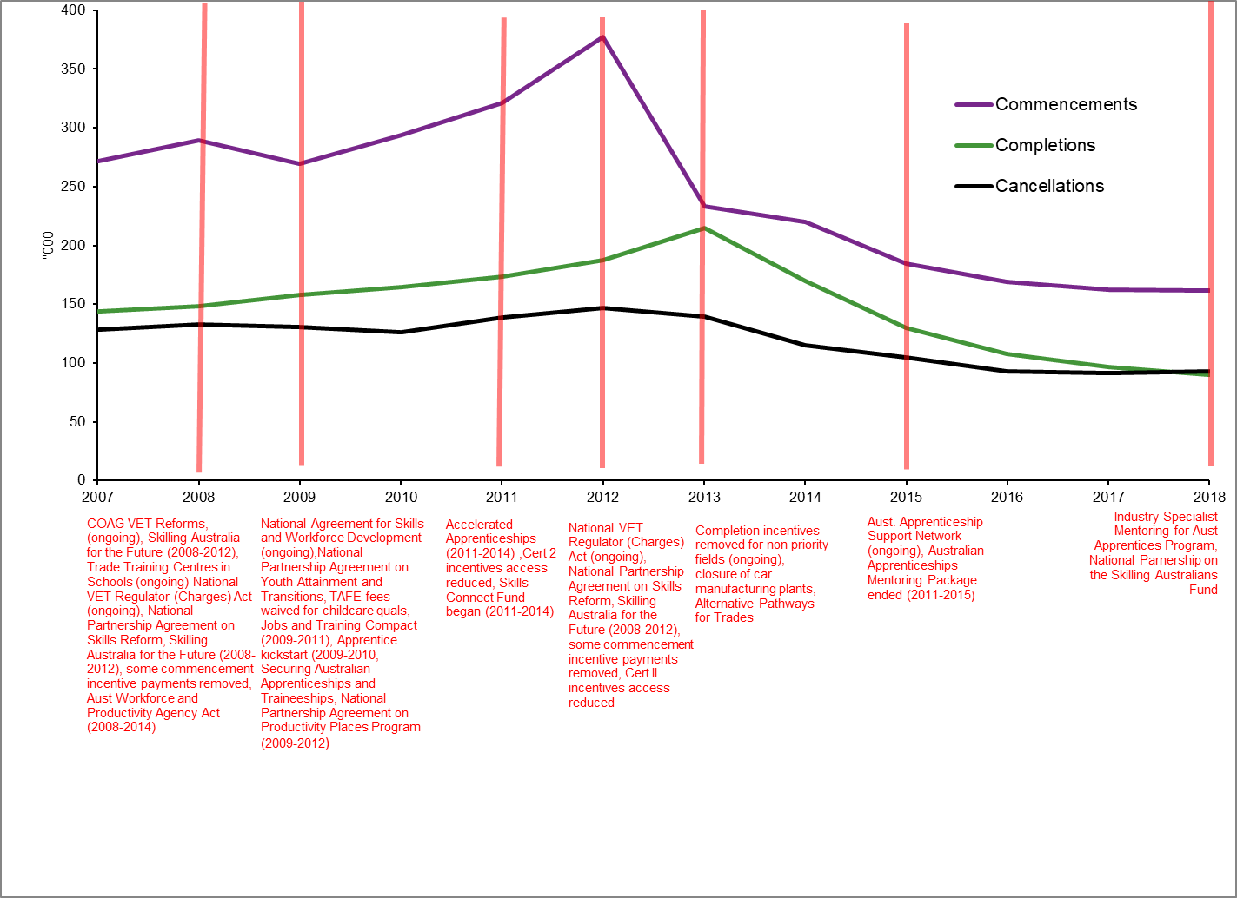

Source: NCVER Timeline of Australian VET policy initiatives: 1998-2018 and Historical time series of apprenticeships and traineeships in Australia from 1963.

Figure 2 Number of commencements, cancellations and completions and timing of policy changes, 2007–17, Australia

All jurisdictions showed a high and then a sharp decline in commencements in 2012 (figure 2), followed by a similarly pronounced but lagged peak and decline in completions in 2013 onward (although the decline in both was not as pronounced for Western Australia and the Northern Territory). Four Commonwealth-based changes or initiatives occurred or ceased at the time of the peak in commencements.

1. The new regulatory policies were:

* The National VET Regulator (Charges) Act 2012 (ongoing). This Act imposes charges in relation to matters such as registration fees and audit expenses, under the *National Vocational Education and Training Regulator Act 2011.*
* National Partnership Agreement on Skills Reform (2012—17). The Council of Australian Governments (COAG) endorsed a set of reforms to the national training system in April 2012. The National Partnership Agreement on Skills Reform (NPASR) committed states and territories to achieving reform directions agreed under the National Agreement for Skills and Workforce Development.

2. A participation initiative ceased:

* Skilling Australia for the Future (2008—12)
* A $1.9 billion dollar package announced in the 2008—09 Budget, comprising the following five elements: $884.6 million to provide an additional 238 200 VET places to people currently outside the workforce; $704.6 million to provide an additional 391 800 places for people within the workforce; $242.2 million for an additional 85 000 Australian apprenticeship places; $83.2 million for strengthened industry skills councils; $4.1 million for skills and training information centres. An additional $98.1 million was provided for grants for Year 9—12 students to participate in on-the-job training.

3. A program supporting general economic objectives ceased:

* National Partnership Agreement on Productivity Places Program (2009—12)
* Part of the Australian Government’s ‘Skilling Australia for the future’ initiative, this program aimed to provide targeted training to support the development of skills in Australia to meet existing and future industry demands by funding training places for job seekers and existing workers in identified areas of skill shortages.

4. A significant change in apprentice and trainee support was:

* Removal of commencement incentive payments for some fields of study (2012 continuing)
* Commencement incentives for existing worker apprenticeships and traineeships not on the National Skills Needs List (NSNL) were removed from 1 July 2012. Commencement and completion incentives for diploma and advanced diploma qualifications not leading to aged care, child care or enrolled nursing were removed from 23 October 2012. Commencement incentives for part-time apprenticeships and traineeships were removed from 23 October 2012. The following cohorts were unaffected: part-time, certificate III/IV qualifications on NSNL, school-based apprenticeships and traineeships, and part-time diploma and advanced diploma qualifications leading to aged care, child care or enrolled nursing.

Other legislative, policy or program changes also occurred in 2012 but were unlikely to have had a noticeable effect on national commencement, cancellation and completion rates on a national scale; for example, the Productive Ageing Through Community Education program began in 2012 (and ended in 2014) but would have no real impact on apprenticeship completions, given the relatively young age profiles of apprentices. However, the Indigenous Youth Careers Pathway Program (2012, ongoing) may have contributed to reducing the impact of other national policy changes on both commencements and completions in the Northern Territory.

Other Commonwealth actions immediately preceding the 2012 peak in commencements and likely to have supported the increase in commencements between 2009 and 2012 (along with the mining boom[[1]](#footnote-1)) and completions in 2011—13 included:

* supporting Adult Australian Apprentices (2010—2015: weekly payments to apprentices ceased in 2015 but employers still received a one-off lump sum of $4000).
* Building Australia’s Future Workforce (a VET reform initiative) (2011—14)
* This package aimed to upskill Australian workers (especially those in industries facing structural change), engage people outside the labour market and break the intergenerational transmission of disadvantage in some of the most disadvantaged locations across the country.
* National Agreement for Skills and Workforce Development (2009, ongoing)
* An agreement between the Commonwealth of Australia and the states and territories that defines objectives, outcomes, outputs and performance measures, and clarifies roles and responsibilities to guide the Commonwealth and states and territories in the delivery of services across the skills and workforce development sector.
* National Partnership Agreement on School Pathways Programs (2009—16)
* An agreement between the Commonwealth, and the states of Western Australia and South Australia to implement School Pathway Programs (SPP). The SPPs addressed skills shortage in the defence industry by increasing the pool of young people ready to move from school into further education and apprenticeships/internships, or scholarships and part-time work/study combinations in the defence industry. They were also intended to increase employer awareness of options for recruiting young people and the value to business of doing so. The SPPs focused on advanced manufacturing, maritime and technology skills. The original agreement expired on 30 June 2014. A new agreement was signed in 2015 and expired in 2016. The program was also part of the Industry Skilling Program Enhancement (ISPE) initiative. The full text of this agreement may be found at: <http://hdl.voced.edu.au/10707/439706>.
* Apprentice Kickstart (2009—10)
* This was designed to maintain the increase in commencements of young people in traditional trade apprenticeships with skills shortages as the Australian economy recovered from the impact of the global recession. An extension of the Kickstart bonus to include enterprises that employed new apprentices over the period 12 May 2010 to 12 November 2010 was announced in the May 2010 Budget.
* securing Australian Apprenticeships and Traineeships (2009—10)
* Provided financial support to employers who took on out-of-trade apprentices and trainees, or who had completing apprentices or trainees at the certificate III or IV level in skills shortage trades or in selected diploma or advanced diploma level qualifications. The initiative came to an end in 2010.
* National Partnership Agreement on Pre-Apprenticeship Training (2010—11)
* Contributed to increasing the number of pre-apprenticeship training opportunities, thereby resulting in an increased number of better-prepared individuals taking up formal Australian apprenticeship training in traditional trade occupations. The full text of this agreement may be found at: <http://hdl.voced.edu.au/10707/448389>.
* Australian Apprenticeships Mentoring Package (2011—15)
* Aimed to increase the retention rates of Australian apprentices, particularly in the first 12 months of training, to improve completion rates and support the supply of skilled workers in sectors and occupations where there were current or emerging skills needs. It comprised two grant programs: the Australian Apprenticeships Mentoring Program and the Australian Apprenticeships Advisors Program.

Completion rates declined markedly in all states except the Northern Territory and to a lesser extent in Western Australia in 2013. Changes in the Commonwealth policy environment included the cessation of:

* National Partnership Agreement on Youth Attainment and Transitions (2009—13)
* An agreement between the Commonwealth and states and territories aimed at improving outcomes in educational attainment, engagement of young people aged 15—24 with education, training and employment, and the transitions of young people from school to further education, training or employment. The agreement expired on 31 December 2013.
* Completion incentive payments in some areas (2013, ongoing)
* Completion incentives for existing worker apprenticeships and traineeships not on the National Skills Needs List were removed from 3 August 2013 (priority occupations such as aged care, child care, disability care and enrolled nurses were exempt from the change).

Changes in the wider economic environment:

* end of the mining boom (2003—13)
* collapse of the automotive industry (2013—17)
* although concentrated in Victoria and South Australia, the patterns for both commencements and completions for these two states were similar to those of other states, suggesting that state-based policies may have prevented greater declines.

On 9 May 2017 in its 2017—18 Budget, the Australian Government announced the new Skilling Australians Fund (an estimated $1.5 billion over four years with matching funds from the states and territories). Also announced was a new $60 million Industry Specialist Mentoring for Australian Apprentices program, which will provide support to apprentices and trainees, particularly during their first two years, to improve retention rates. The impact of these initiatives will be measured in future analyses.

Figures A1—A8 in the appendix identify possible key policy impacts on the apprenticeship commencement, cancellation and completion rates for each jurisdiction, based on the NCVER Knowledge Bank Policy Timeline of Australian VET Policy Initiatives: 1998-2018 [(<http://www.voced.edu.au/vet-knowledge-bank-timeline-australian-vet-policy-initiatives>).](file:///C:\Users\liselodwyer\AppData\Roaming\OpenText\DM\Temp\(%3chttp:\www.voced.edu.au\vet-knowledge-bank-timeline-australian-vet-policy-initiatives%3e))

The Northern Territory was the only jurisdiction to show a marked decrease in cancellations in 2014, followed by a strong upsurge the following year (figure A7), coinciding with Commonwealth actions in 2014 and 2015 including:

* cessation of Building Australia’s Future Workforce (2011—14)
* COAG VET reforms announced (ongoing)
* *Australian Workplace and Productivity Agency Act* ended (2008—14)
* TAFE childcare qualification fee waived (2009—14)
* closing of Skills Connect Fund (2011—14)
* cessation of Tools for Your Trade (2005—14)
* cessation of Accelerated Australian Apprenticeships (2011—14)
* increases to pay rates (ongoing)
* introduction of Trade Support Loans (ongoing)
* closure of National Workforce Development Fund (2011—14)
* closure of Critical Skills Investment Fund (2011—14)
* closure of Training for Employment Scholarships and Youth Employment Pathways (2014—17)
* closure of Industry Skills Fund (2015—16)
* cessation of Australian Apprenticeships Mentoring Package (2011—15).

Conversely, the Northern Territory was less affected than all other jurisdictions by Commonwealth actions in 2012.

Legislative changes in New South Wales largely emanated from the Commonwealth until 2011. At that time, new state-based policies appeared during the high rate of commencements but changed after all rates fell between 2013 and 2015. From 2013 onward, the rate of cancellations as a proportion of commencements was much higher than in preceding years, despite positive state-based changes including:

* Apprenticeship Compact (2015, ongoing)
* An industry consortium forming part of the NSW Government’s Reskilling NSW plan. It includes the Australian Constructors Association, Australian Industry Group, Civil Contractors Federation, Housing Industry Association, Master Builders Association, Motor Traders Association and the NSW Business Chamber.
* Smart and Skilled (2015, ongoing)
* Provides eligible students with an entitlement to government-subsidised training up to and including certificate III and government funding for higher-level courses (certificate IV and above) in targeted priority areas.
* Reskilling NSW
* $48 million for fee-free scholarships for 200 000 concession-eligible 15 to 30-year-olds to undertake government-subsidised VET certificate courses
  + Priority to concession eligible social housing residents
  + $27 million for workplace learning for over 40 000 government school students
  + $8 million to provide viable pathways into education, training and employment for young people in regional areas.
* Fee-free pre-apprenticeships (ongoing)
* Enables individuals to undertake an introductory unit to get a taste of the trade or industry. If the individual likes the work, they are already on their way to studying for a full qualification.
* Fees capped
* Student fees for traineeships capped at $1000 as part of VET reform package. Fees for apprentices have been capped at $2000 since Smart and Skilled commenced.
* GTO Pre Training Partnering Program
* Provides eligible students with government-subsidised training up to and including certificate III and government funding for higher-level courses (certificate IV and above) in targeted priority areas.
* Apprenticeship Completion Incentive Program
* Payment of $1000 for each apprenticeship completion (up to a maximum cap for the GTO for each year of the program).

Coinciding with a steep decline in commencements and a peak in cancellations in 2004, Victoria enacted the *Education Workplace Learning Act* to make further provision for learning in the workplace. Other than programs aimed at migrants (Victoria’s skilled migration strategy and Global skills for Victoria), there were no Victorian-based initiatives specifically affecting apprenticeships between 2004 and 2009. In 2009 the Victorian Training Guarantee was phased in to begin deregulation of VET in Victoria and move into a demand-driven system. It entitled eligible individuals to access government-subsidised training places in accredited qualifications through a range of providers. While no longer called the Victorian Training Guarantee, the entitlement to a government training place is guaranteed under the Victorian *Education and Training Reform* *Act* *(2010 amendments)* for students up to 20 years of age, or those who are studying a higher qualification than they already hold. Commencement and completion rates both immediately increased, and cancellation rates declined slightly, although the latter rose again in 2010 and peaked in 2012.

All jurisdictions except the Northern Territory showed a sharp peak in commencements in 2012, followed by a steep decline in 2013, whether or not there were new state-based initiatives or conditions at the time. Both Commonwealth and state-based changes in 2012 occurred across New South Wales, Victoria, Queensland and South Australia. The other jurisdictions had no state-based activity. The Commonwealth changes were:

* *National VET Regulator (Charges) Act* (ongoing)
* National Partnership Agreement on Skills Reform
* Skilling Australia for the Future (2008—12)
* removal of some commencement incentive payments.

The patterns were similar, regardless of whether the state initiatives were supportive of apprenticeships: New South Wales introduced the Public Sector Apprenticeship Strategy and South Australia introduced Skills for All, the *Vocational Education & Training (Commonwealth Powers Act) (SA)*, *TAFE SA Act 2012* *(current)*, the Return To Work SA apprentice incentive and the Critical Skills Investment program; or unhelpful: Victoria cut budgets to TAFE and the Skills Reform policy ceased, and in Queensland the Community Literacy Program, Training Initiatives for Regional and Remote Indigenous Adults and Toward Q2: Tomorrow’s Queensland, Skilling Queenslanders for Work and First Start programs all ceased. However, cancellation rates were relatively unresponsive.

Finally, the Northern Territory is the only jurisdiction where cancellations were greater than completions over most of the 2000—17 period. The Northern Territory was more responsive to Commonwealth policy changes in 2014 than any of the other jurisdictions, which were unaffected. Some changes were ostensibly progressive, while others may have had a negative impact on apprenticeships, perhaps resulting in a net pattern of no change in jurisdictions other than the Northern Territory. They include:

* cessation of Building Australia’s Future Workforce (2011—14)
* COAG’s VET reforms (2014, ongoing)
* cessation of *Australian Workforce and Productivity Act* (2008—14)
* waiving fees for TAFE childcare qualifications (2009—14)
* closure of the Skills Connect Fund (2011—14)
* cessation of Tools for Your Trade (2005—14)
* cessation of Accelerated Australian Apprenticeships (2011—14)
* increases to pay rates (ongoing)
* introduction of Trade Support Loans (ongoing)
* cessation of National Workforce Development Fund (2011—14)
* cessation of the Critical Skills Investment Fund (2011—14)
* introduction of the Training for Employment Scholarships and Youth Employment Pathways (2014—17).

# References

Atkinson, G & Stanwick, J 2016, Trends in VET: policy and participation, NCVER, Adelaide.

Australian National Audit Office 2017, *Apprenticeship training: alternative delivery pilots,* ANAO, Canberra, <https://www.anao.gov.au/work/performance-audit/apprenticeship-training-alternative-delivery-pilots>.

Australian National Training Authority 2017, *Revised* *National Standards for Group Training Organisations,* ANTA, Brisbane, <https://www.australianapprenticeships.gov.au/sites/ausapps/files/publication-documents/ed18-0014\_group\_training\_national\_standards\_acc.pdf>.

Ball, K, NCVER, 2005, *Factors influencing completion of apprenticeships and traineeships,* NCVER, Adelaide, <http://hdl.voced.edu.au/10707/97715>.

Bednarz, A 2014, *Understanding the non-completion of apprentices,* NCVER, Adelaide, <http://www.ncver.edu.au/publications/2706.html>.

Burke, G, 2018, *Changes in funding in Australian vocational education and their effects, vocational education for the 21st century: a series of policy discussion papers*, LH Martin Institute, University of Melbourne, Melbourne, <https://melbourne-cshe.unimelb.edu.au/\_\_data/assets/pdf\_file/0010/2845774/Burke-Changes-in-funding-in-Australian-vocational-education-and-their-effects\_.pdf>.

Couldrey, M & Loveder, P 2017, *The future of Australian apprenticeships: report of the stakeholder forum,* NCVER, Adelaide, <https://www.ncver.edu.au/publications/publications/all-publications/the-future-of-australian-apprenticeships-report-of-the-stakeholder-forum>.

Deloitte Access Economics 2011, *The cost of apprenticeship non-completion in NSW,* NSW Board of Vocational Education and Training, Sydney, <http://www.skillsboard.nsw.gov.au/sites/default/files/DAE\_BVETReport.pdf>.

Fowler, C 2018, ‘VET funding within the tertiary system: five policy reasons driving cost shifting’, *Campus Review*, <https://www.campusreview.com.au/2018/08/vet-funding-within-the-tertiary-system-five-policy-reasons-driving-cost-shifting/>.

Gambin, L & Hogarth, T 2016, ‘Factors affecting completion of apprenticeship training in England’, *Journal of Education and Work*, vol.29, no.4, pp.470—93, <https://doi.org/10.1080/13639080.2014.997679>.

Group Training Association of NSW and ACT 2014, *Group training pre-apprenticeships: helping young people get into the right career,* Group Training Association of NSW and ACT, Homebush, viewed 16 Mar 2018, <http://www.gtana.com.au/sb\_cache/associationnews/id/195/f/GTA%20Pre%20Apprenticeships%20report\_ONLINE\_3.pdf>.

Hargreaves, J & Osborne, K 2017, *Choosing VET: aspirations, intentions and choice,* NCVER, Adelaide, <https://www.ncver.edu.au/publications/publications/all-publications/choosing-vet-aspirations,-intention-and-choice>.

Hargreaves, J, Stanwick, J & Skujins, P 2017, *The changing nature of apprenticeships: 1996—2016,* NCVER, Adelaide,viewed 05 Apr 2018, <https://www.ncver.edu.au/publications/publications/all-publications/the-changing-nature-of-apprenticeships-1996-2016>.

Harvey, B, 2010, *Apprentice and trainee statistics: estimation of contract completion and attrition rates*, viewed 16 Mar 2018, <https://www.ncver.edu.au/research-and-statistics/publications/all-publications/apprentice-and-trainee-statistics-estimation-of-contract-completion-and-attrition-rates>.

Karmel, T 2017, ‘Part II: Demand-side factors affecting apprenticeships and traineeships’*, in Research Report 3/2017 Factors affecting apprenticeships and traineeships*, viewed 05 Apr 2018, <https://www.fwc.gov.au/documents/sites/wagereview2017/research/apprenticetrainee.pdf>.

Karmel, T & Roberts, D 2012, *The role of ‘culture’ in apprenticeship completions,* NCVER, Adelaide, viewed 21 Mar 2018, <http://www.ncver.edu.au/publications/2498.html>.

Karmel, T & Virk, G 2006, *What is happening to traditional apprentice completions?* NCVER occasional paper NCVER, Adelaide, https://vital.voced.edu.au/vital/access/services/Download/ngv:39057/SOURCE2?view=true

Kuczera, M 2017, ‘Incentives for apprenticeship’, *OECD Education Working Papers*, no.152, 0\_1, <http://www.nebhe.org/info/pdf/events/meetings/commission/041217/OECD\_Incentives\_for\_Apprenticeship.pdf>.

Mangan, J & Trendle, B 2017, ‘Attrition and retention of apprentices: an exploration of event history data using a multi-state modelling framework’, *Education Economics*, vol.25, no.4, pp.1—12, <https://doi.org/10.1080/09645292.2016.1213795.

McEwen, M 2015, *Developmental research for promotion of the vocational education and training sector,* NCVER, Adelaide, <https://www.ncver.edu.au/publications/publications/all-publications/vocational-education-and-training-literacy-and-numeracy-review-of-research>.

NCVER (National Centre for Vocational Education Research) 2017a, *Australian vocational education and training statistics: apprentices and trainees 2016: annual,* NCVER, Adelaide, <https://www.ncver.edu.au/publications/publications/all-publications/apprentices-and-trainees-2016-annual>.

——2017b, *Australian vocational education and training statistics: completion and attrition rates for apprentices and trainees 2016,* NCVER, Adelaide, <https://www.ncver.edu.au/publications/publications/all-publications/completion-and-attrition-rates-for-apprentices-and-trainees-2016>.

——2017c, ‘Completion and attrition rates for apprentices and trainees 2016’, <https://www.ncver.edu.au/data/data/all-data/completion-and-attrition-rates-for-apprentices-and-trainees-2016-state-and-territory-data-tables>.

——2018 National Apprentice and Trainee Collection, collection no. 95, unpublished data.

——2019 Timeline of Australian VET policy initiatives 1998-2018, <https://www.voced.edu.au/vet-knowledge-bank-timeline-australian-vet-policy-initiatives>, viewed August 2019

Nelms, L, Yuen, K, Pung, A, Farooqui, S, Walsh, J & Karmel, T 2017, ‘Part I: Background and supply-side factors affecting commencement and completion of apprenticeships and traineeships’, in *Research report 3/2017, Factors affecting apprenticeships and traineeships*, Melbourne, <https://www.fwc.gov.au/documents/sites/wagereview2017/research/apprenticetrainee.pdf>.

Office of the Fair Work Ombudsman 2017, *Fair trades: outcomes from the Fair Work Ombudsman’s National Apprenticeship Campaign 2015,* Office of the Fair Work Ombudsman, Sydney, <http://asofia.com.au/wp-content/uploads/2017/04/National-Apprenticeship-Campaign-Report-March-2017.pdf>.

Pearce, D 2017, *Successful apprenticeships: observations from an Australian study,* 2017, Washington, USA, <http://www.inap.uni-bremen.de/dl/inap%20conference%20proceedings%202017.pdf#page=120>.

Pfeifer, H 2016, *Firms’ motivation for training apprentices: an Australian-German comparison,* NCVER, Adelaide, <https://www.ncver.edu.au/publications/publications/all-publications/firms-motivation-for-training-apprentices-an-australian-german-comparison>.

Productivity Commission 2019, *Report on government services,* 2019, <https://www.pc.gov.au/research/ongoing/report-on-government-services/2018/child-care-education-and-training/vocational-education-and-training>.

Snell, D & Hart, A 2008, ‘Reasons for non-completion and dissatisfaction among apprentices and trainees: a regional case study’, *International Journal of Training Research*, vol.6, no.1, pp.44—73, <https://doi.org/10.5172/ijtr.6.1.44>.

Stromback, T & Mahendran, A 2010, 'An analysis of factors contributing to apprenticeship and traineeship completion' International Journal of Training Research, vol.8, no.1, 63-79, https://doi.org/10.5172/ijtr.8.1.63>.

Workman, G & Luciani, D 2017,’Australian multi-industry pilot programs support better apprenticeship completion rates and employer engagement’, paper presented at *Modern apprenticeships: widening their scope, sustaining their quality*, Proceedings of the Seventh Research Conference of the International Network for Innovative Apprenticeships, <http://www.inap.unibremen.de/dl/inap%20conference%20proceedings%202017.pdf>.

Zoellner, D 2017,’Asking different questions of national VET data: identifying a new factor contributing to apprenticeship non-completions’, paper presented at the *JVET 2017: Journal of Vocational Education and Training 12th International Conference*, <http://hdl.voced.edu.au/10707/446034>.

Zoellner, D, Brearley, M & Oppermann, E 2017, ‘Regional disparities in apprentice attrition rates: heat and quarter four’s significance in northern Australia’, *International Journal of Training Research*, vol.15, no.2, pp.179—95, <https://doi.org/10.1080/14480220.2017.1312694>.

# Appendix

## Timing of Commonwealth and state policies, programs and events with apprenticeship/traineeship commencements, cancellations and completions by state, 2007–17

Note that completion rates for 2013—17 are projected rates, not actual rates. See Harvey (2010) for details on estimation methods for completion rates.

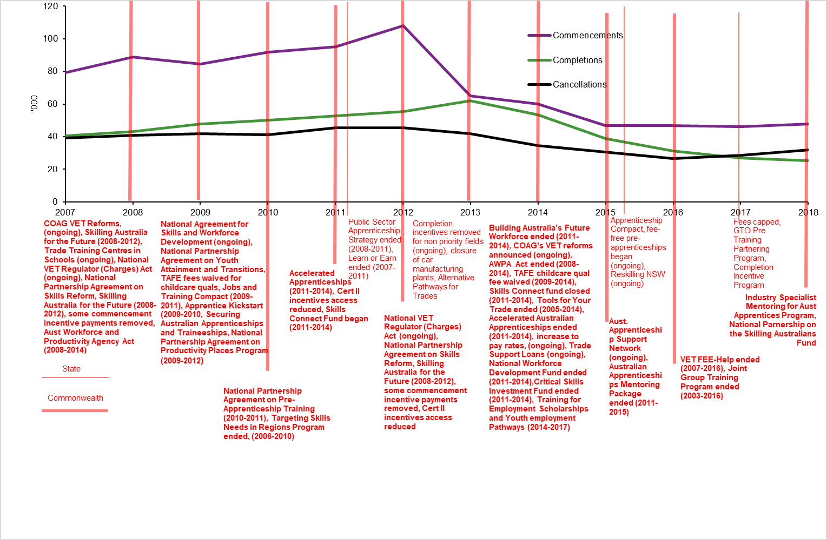

Source: NCVER Timeline of Australian VET policy initiatives: 1998-2018 and Historical time series of apprenticeships and traineeships in Australia from 1963.

Figure A1 Number of commencements, cancellations and completions and timing of policy changes, New South Wales, 2007—17

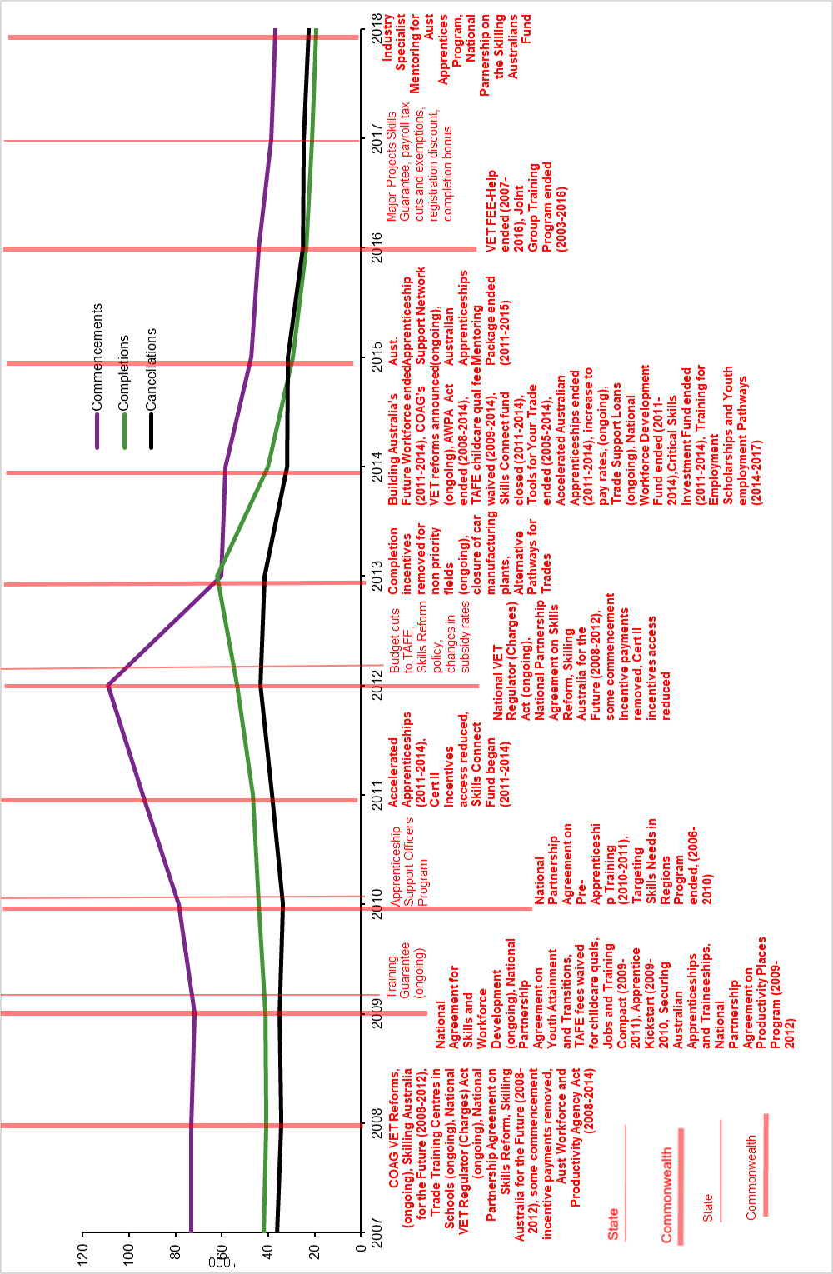

Source: NCVER Timeline of Australian VET policy initiatives: 1998-2018 and Historical time series of apprenticeships and traineeships in Australia from 1963.

Figure A2 Number of commencements, cancellations and completions and timing of policy changes, Victoria, 2007—17

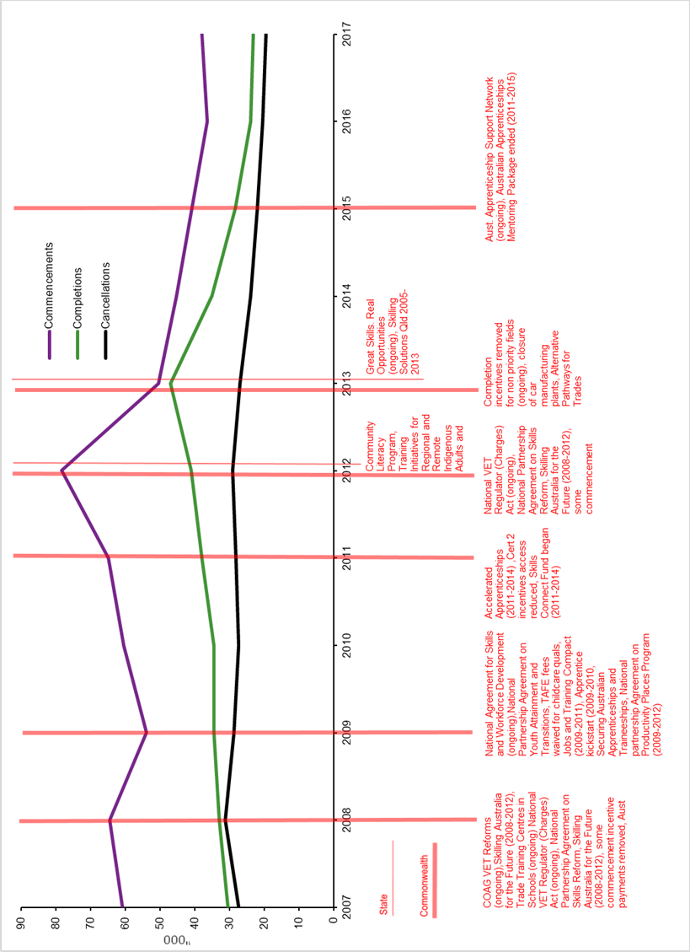

Source: NCVER Timeline of Australian VET policy initiatives: 1998-2018 and Historical time series of apprenticeships and traineeships in Australia from 1963.

Figure A3 Number of commencements, cancellations and completions and timing of policy changes, Queensland, 2007—17

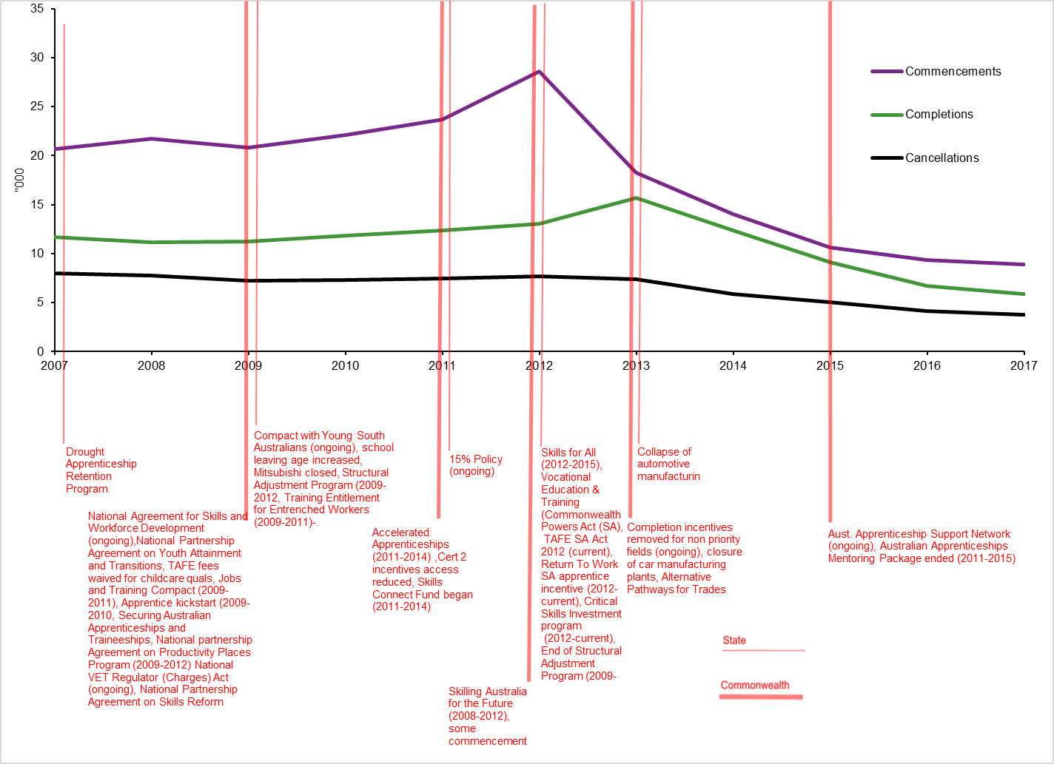

Source: NCVER Timeline of Australian VET policy initiatives: 1998-2018 and Historical time series of apprenticeships and traineeships in Australia from 1963.

Figure A4 Number of commencements, cancellations and completions and timing of policy changes, South Australia, 2007—17

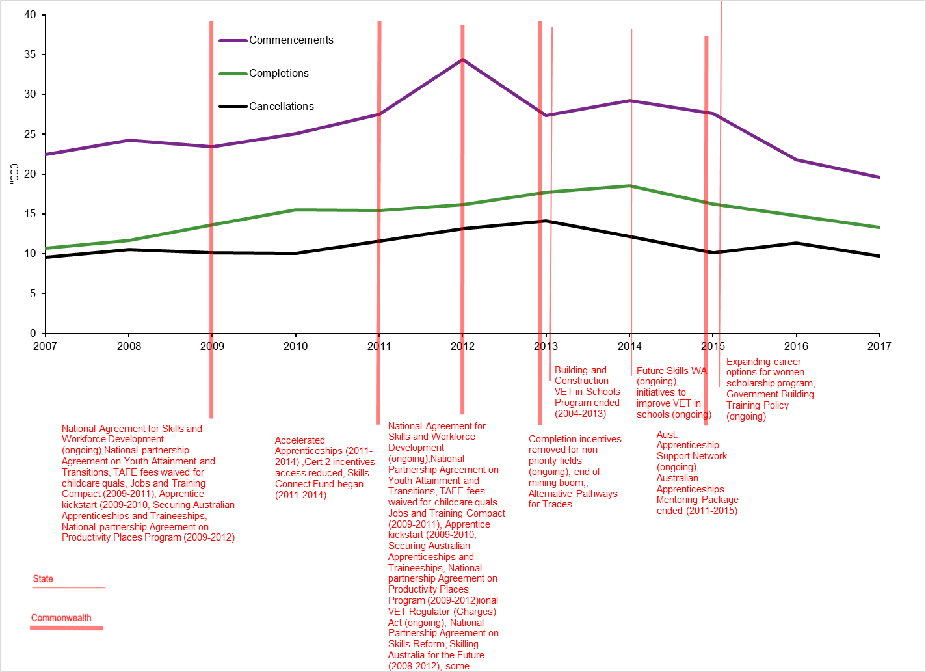 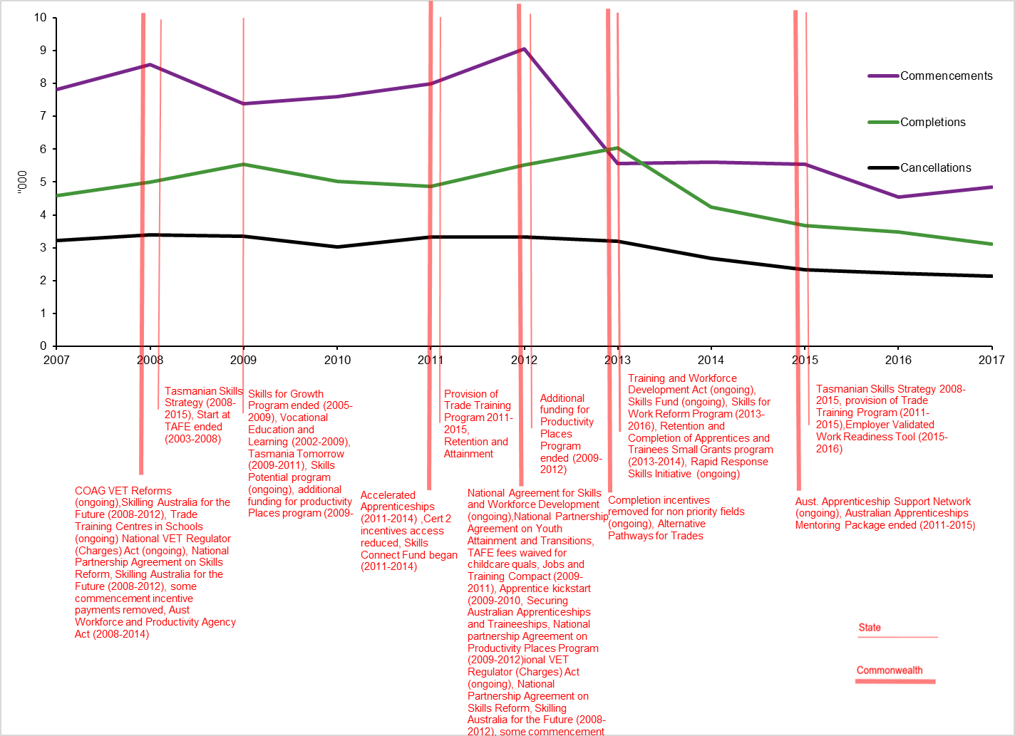

Source: NCVER Timeline of Australian VET policy initiatives: 1998-2018 and Historical time series of apprenticeships and traineeships in Australia from 1963.

Figure A5 Number of commencements, cancellations and completions and timing of policy changes, Western Australia, 2007—17

Source: NCVER Timeline of Australian VET policy initiatives: 1998-2018 and Historical time series of apprenticeships and traineeships in Australia from 1963.

Figure A6 Number of cancellations and completions and timing of policy changes, Tasmania, 2007—17

Figure 7. Tasmania

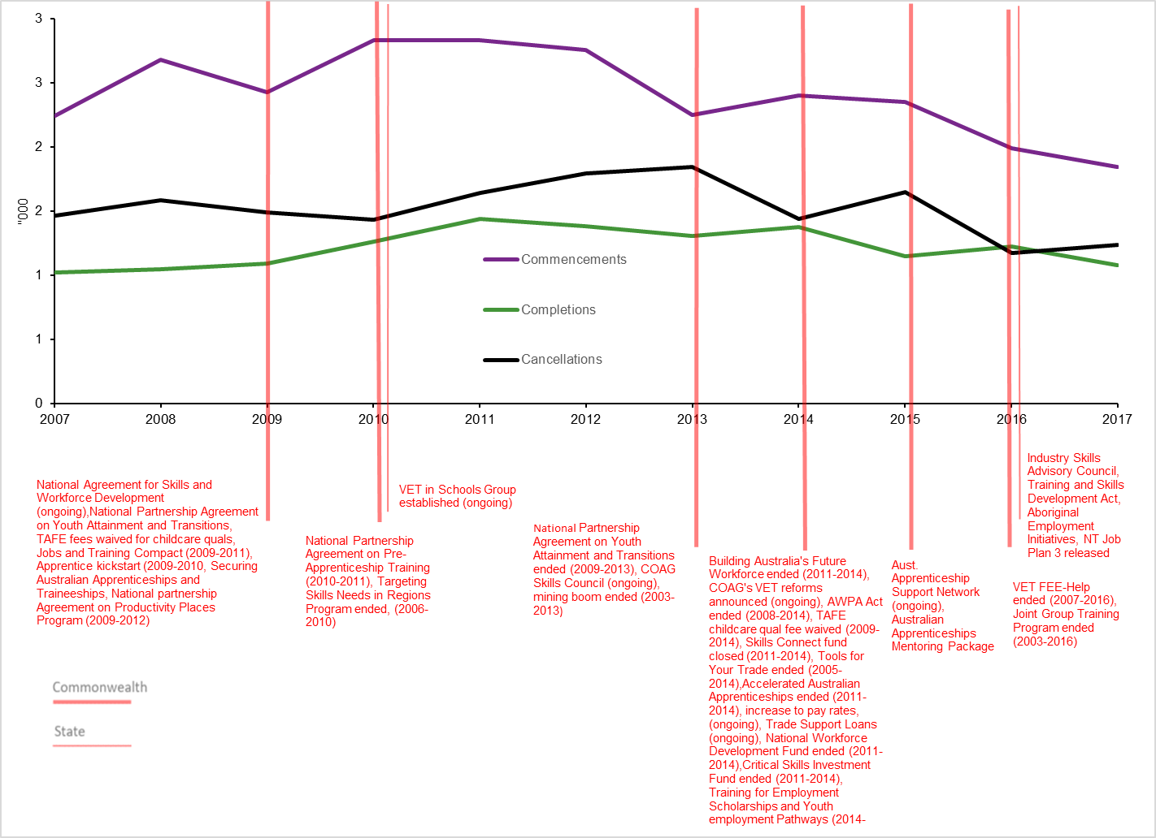

Source: NCVER Timeline of Australian VET policy initiatives: 1998-2018 and Historical time series of apprenticeships and traineeships in Australia from 1963.

Figure A7 Number of commencements, cancellations and completions, Northern Territory, 2007—17

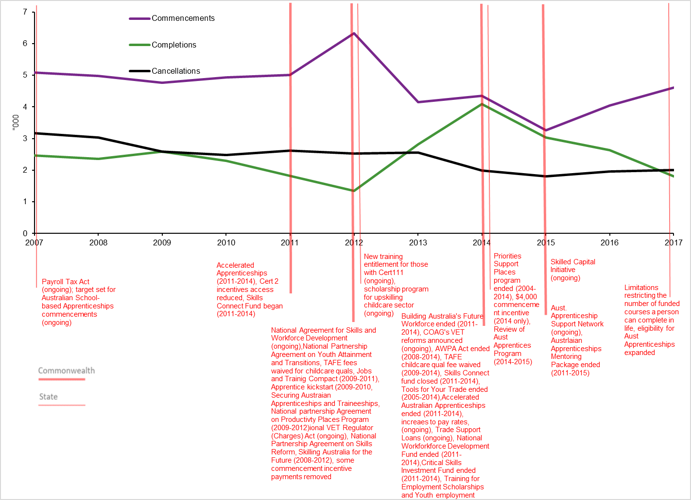

Source: NCVER Timeline of Australian VET policy initiatives: 1998-2018 and Historical time series of apprenticeships and traineeships in Australia from 1963.

Figure A8 Number of commencements, cancellations and completions, Australian Capital Territory, 2007-17

1. The Western Australian mining boom peaked in July 2012, which no doubt had an effect on numbers at this time. [↑](#footnote-ref-1)