NCVER_Floating_Mono

Skilling the Australian workforce for the digital economy

Support document 2: case studies and survey findings

Victor Gekara

Alemayehu Molla

Darryn Snell

Stan Karanasios, RMIT University

Amanda Thomas, AIS

This document was produced by the author(s) based on their research for the report *Skilling the Australian workforce for the digital economy,* and is an added resource for further information. The report is available on NCVER’s Portal: <<http://www.ncver.edu.au>>.

### Publisher’s note

The views and opinions expressed in this document are those of the author/project team and do not necessarily reflect the views of the Australian Government, state and territory governments or NCVER. Any errors and omissions are the responsibility of the author(s).

**© Commonwealth of Australia, 2019**

G:\pub_prod\PublicationComponents\logos\Creativecommons\CC BY logo.eps

With the exception of the Commonwealth Coat of Arms, the Department’s logo, any material protected by a trade mark and where otherwise noted all material presented in this document is provided under a Creative Commons Attribution 3.0 Australia <http://creativecommons.org/licenses/by/3.0/au> licence.

The details of the relevant licence conditions are available on the Creative Commons website (accessible using the links provided) as is the full legal code for the CC BY 3.0 AU licence <http://creativecommons.org/licenses/by/3.0/legalcode>.

The Creative Commons licence conditions do not apply to all logos, graphic design, artwork and photographs. Requests and enquiries concerning other reproduction and rights should be directed to the National Centre for Vocational Education Research (NCVER).

This document should be attributed as Gekara, V, Snell, D, Molla, A, Karanasios, S & Thomas, A 2019, *Skilling the Australian workforce for the digital economy: support document 2 − case studies and survey findings,* NCVER, Adelaide.

This work has been produced by NCVER on behalf of the Australian Government and state and territory governments, with funding provided through the Australian Government Department of Education and Training.

Published by NCVER, ABN 87 007 967 311

Level 5, 60 Light Square, Adelaide, SA 5000  
PO Box 8288 Station Arcade, Adelaide SA 5000, Australia

**Phone** +61 8 8230 8400 **Email** [ncver@ncver.edu.au](mailto:ncver@ncver.edu.au)

**Web** <https://www.ncver.edu.au> <<http://www.lsay.edu.au>>

**Follow us:**  <https://twitter.com/ncver>  <https://www.linkedin.com/company/ncver>

Contents

Tables and figures 4

Tables 4

Figures 4

Introduction 5

Project background 5

Study 1: Sector case studies 7

Introduction 7

Aims 7

Method and procedures 7

Workplace technological changes 8

Impact on workforce skills 12

Employer approaches for meeting digital skill needs 15

Conclusions 20

Study 2: Survey of human resource, skills and training decision makers 24

Introduction 24

Aims 24

Method and procedures 24

Survey respondents profile 27

Digital disruption and its impact 29

Digital technologies and skill requirements 29

Digital technologies and the labour market 31

Digital skills needs and competence 35

Challenges and approaches in meeting digital skills requirements 38

Digital skills development self-assessment 40

Employer evaluation of VET programs and government investment in digital skills 43

Conclusions 45

References 46

Appendix 1: Interview and industry workshop questions 48

Appendix 2 : Survey questionnaire 49

# Tables and figures

## Tables

1 Categories based on level of technological adoption and general view of digital skills 22

2 Job title and year of service in current role 27

3 Extent and impact of digitalisation (n = 371) 29

4 Digital technologies with greatest impact on skill requirements by organisation size 30

5 Digital technologies with greatest impact on skill requirements by industry 32

6 Shortage of digital skills and its impact (n = 371) 36

7 Differences in digital skills needs and competences (n = 371) 37

8 Digital skills development self-assessment 42

9 Digital skills development self-assessment scores by industry and organisation size 43

## Figures

1 Descriptive representation of dominant technologies 10

2 Concentration of technological adoption 11

3 Categories of workforce digital skills 12

4 Respondent breakdown by industry (n = 371) 28

5 Organisational size breakdown of respondents (n = 371) 28

6 Digital technologies with greatest impact on skill requirements (n = 371) 30

7 Need for IT professionals (n = 371) 33

8 Difficulty in finding digital skills due to digitalisation (n = 371) 33

9 Frequency of refreshing digital skills (n = 371) 34

10 Digital skill supply in the Australian labour market (n = 371) 34

11 Skills that respondents are having the biggest difficulty finding 35

12 Digital skill needs by occupation (n = 244) 36

13 Digital skill shortage by occupation (n = 216) 38

15 Approaches to meet digital skills requirements (n = 288) 40

16 Evaluation of government investment in the development of digital skills 44

# Introduction

This support document provides findings from two field studies. The first study draws from semi-structured interviews conducted with selected Australian industry sector case study stakeholders. The second study presents findings from a survey of human resources, skills and training (HRST) decision makers from a cross-section of Australian organisations with specific attention to the skills impact of digitalisation.

As Australia steadily advances towards a digital economy, industry is experiencing significant digital disruption with major transformations underway in production methodologies and business practices. The field studies reported here provide contextualised evidence of the extent of digitalisation and nuanced differences among organisations across industries; how Australian organisations interpret the changing nature of skills demand as work becomes increasingly digitised; how employers are going about meeting their digital skill needs; and practices and indicators that can be used to identify, evaluate and develop digital skills.

The evidence obtained from the two field studies will be used to develop (a) insights about the specific ways in which new technologies are changing the nature of digital skills demand in Australian industry and their supply, and (b) a Digital Skills Framework suited to the Australian context presented in the Final Report on the Project. Together, it is hoped that these outputs inform sound policy and best practice in skills formation and workforce planning.

## Project background

The focus of this NCVER project is on the digital skills of the workforce that is not directly employed in Information and Communications Technology (ICT) roles, but which is increasingly expected to effectively use digital systems, technology and processes in emerging highly digitalised and mechanised systems of work. The field studies reported here build on the investigation of digital skills demand reported in Gekara et al. (2017), which was limited to job vacancies and training packages analyses, and the review of digital skills frameworks reported in Support Document 1.

As reported in Gekara et al. (2017), both employers and training package developers seem to have a basic and generic view of digital skills but frame these differently. Whereas employers tend to define skills from a tools perspective, the training packages seem to provide a highly open-ended and broad layout of the training needed to equip people to work in a digital economy.

The review of digital skills frameworks (see Support Document 1) shows both lack of consensus on the definition of digital skills and a specific framework that exclusively focuses on evaluating and developing digital skills of the general workforce. The review also resulted in a working definition of digital skills as a combination of the following elements, which workers need to muster and demonstrate in the digital age:

* digital knowledge (theoretical comprehension and understanding);
* cognitive knowhow (involving the use of logical, intuitive, innovative and creative thinking in the digital space);
* practical knowhow (including the use of digital tools such as hardware, software, information and security systems);
* competence (ability to learn, adapt and apply digital knowledge in a new setting); and
* attitude (value and beliefs).

This definition together with the key themes identified from the review of frameworks and analysis of job advertisements and training packages are used to help frame interview and survey questions. Further, based on the review, the structure of a Digital Skills Framework was identified as consisting of three levels of scope and five degrees of proficiency. The evidence from the two field studies will provide knowledge to identify the skills needed to populate the framework and how the framework could support development of digital skills.

# Study 1: Sector case studies

## Introduction

As in other parts of the world, technological change is having a profound impact on Australian workplaces with the demand for particular occupations and associated skills being affected (Foundation for Young Australians, 2016; Hajkowicz et al., 2016). Some industries, workplaces and occupations are being impacted more rapidly than others and, while some employers are pursuing ‘first-mover’ advantages through rapid technological uptake, many are taking a much more cautious and gradual approach. Study one focuses on the perceptions and experiences of industry employers and other key industry stakeholders to explore how workforce skills, capabilities and training interacted with technological adoption decisions.

## Aims

The aims of this study are to:

* Investigate employer and key industry stakeholder perceptions and experiences of the specific technological changes and how they are impacting the nature of skills requirements within particular industries;
* Explore how managers and employer organisations define and understand digital skills based on the context within which the skills are required and applied; and
* Identify how employers are addressing their digital skill needs and their key challenges.

## Method and procedures

The study focused on two sector case studies (Transport and Logistics and Public Safety and Correctional Services) from two industries. According to the Australian and New Zealand Standard Industrial Classification (ANZSIC 2006)[[1]](#footnote-1), the sector cases fall within the Transport, Postal and Warehousing and Public Administration and Safety industries. For the purpose of this report, we adopted the ANZSIC nomenclature to refer to the two industry sector case studies. As reported in Gekara et al. (2017), we focused on these two industry sectors for the following reasons:

1. Past industry research specifically focusing on these sectors has revealed the growing need for digital skills and highlighted the threat to performance and productivity if the workforce is not adequately equipped with these skills (Government Skills Australia, 2015; Transport and Logistics Industry Skills Council, 2015).
2. Their significance to the economy and society in terms of national revenue and essential public service provision (Government Skills Australia, 2015; Transport and Logistics Industry Skills Council, 2015).
3. Their emergence as major current and future employers in the ongoing economic transformation (Fairbrother et al., 2012; Snell, Gekara & Gatt, 2016).
4. The high rate of workplace technological innovation and operations mechanisation as a way of enhancing efficiency and productivity and mitigating operations costs (Transport and Logistics Industry Skills Council, 2015; Government Skills Australia, 2015).
5. Experience of persistent skills and workforce challenges, including recruitment and retention difficulties, general skill shortages and a rapidly ageing workforce (Gekara, Snell & Chherti 2015; Government Skills Australia, 2015; Transport and Logistics Industry Skills Council, 2015).

The data were collected through two methods:

1. Interview data was collected from representatives of different organisations from the two industry sectors. In total 25 interviews, each lasting one hour on average, were conducted with a variety of industry stakeholders, including employers, policy makers, training providers and unions. The interviews were digitally recorded, formally transcribed and thematically coded in NVivo[[2]](#footnote-2) for analysis.
2. Second, two industry workshops were organised through our industry partner, the (AIS).[[3]](#footnote-3) The workshops, referred to as the AIS Skills Forum and the Supply Chain Skills Industry Roundtable, were held in Melbourne on the 31st August 2017 and 27th September 2017 respectively. They brought together roughly 60 participants each, including AIS Industry Reference Committee members, industry HR and Training managers and a few academic researchers. Summary findings from our survey were presented to the groups for deliberation and comment as a way of verifying the data and formed the basis for the discussions on industry digital skills requirements and the challenges in meeting them. The two workshops therefore provided an important platform for further deliberation and verification of the interview data findings.

The interviews were conducted between March and June 2017 while the industry stakeholder workshops were held in the months of August and September 2017. Appendix 1 contains the interview and industry forum questions. These data were collated and analysed separately in the first instance and then analysed jointly to develop a consolidated body of findings, which are summarised below.

## Workplace technological changes

Although Australian industry is certainly set to take-off towards a digital economy (Deloitte Access Economics, 2016), the participants in the interviews described different approaches adopted to workplace technological change and expressed different views on the technological impacts on their workforce and associated skill requirements. Unsurprisingly, the majority of the technology is aimed at enhancing service delivery efficiency and knowledge capture and management and is therefore mostly related to computerisation of business processes and the implementation of extensive Information and Communication Technology (ICT). Thus, there is increasing computerisation of routine and predictable processes, for example replacing manual paper-based delivery worksheets for truck drivers with digital tablet worksheets and the replacement of manual delivery route planning with digital route planning systems. The various technologies were therefore generally described as tools of work, on the one hand, and systems for work on the other. The tools ranged from highly generic devices like mobile phones, digital tablets, digital notebooks, computers and GPS devices, to those that were more particular to specific industries, for example RF scanners, biometrics kits, CCTV, Radio, x-ray machines and cameras. These tools and devices were used within much more complex systems such as Transport Management Systems, Warehouse Management Systems, Terminal Management Systems, Radio Dispatch Systems and Security Monitoring Systems. The following two interview extracts describe some of these technologies from the two case sectors:

From the IT group, we design and implement and maintain the transport management systems and warehouse management systems. So that software side is quite a big part of our business. And then there’s all of the modelling systems and so, that’s all there. In terms of how we use technology to get our work done. So a lot of our operating systems sit with SAP [Systems, Applications and Products - A German software company whose products allow businesses to track customer and business interactions]. So Payroll, Human Resources (HR), Transport Management, Warehouse Management; and then we have about maybe 50 other systems. So Expense Management Tools, things like that (Transport, Postal and Warehousing).

I'm talking in terms of the most basic technologies of smartphones, tablets, that sort of integration and that sort of blurring the lines between what is a personal device and what's a policing device is becoming much more the norm. Policemen understand how important social media is for instance, not just for keeping in contact with the community but for the members themselves, their cross communication (Public Administration and Safety).

There were also more generic systems mentioned, such as Enterprise Resource Planning Systems, E-learning Systems, and Learning Management Systems. At the workshops, it was further highlighted that these last two systems had become important as organisations increasingly provide in-house online training for their workers. Because the systems are often highly complex and widely applied, they often encompass, and work through and/or with, the different digital tools, programs and software. As discovered in the earlier analysis of job advertisements (Gekara et al., 2017), digital tools (e.g. software packages, digital devices, etc.) were often used by employers during interviews as a proxy for digital skills. Text cloud analysis of the employer interviews reveals the frequency in which certain technologies were mentioned among the research participants (Figure 1).

Figure 1 Descriptive representation of dominant technologies

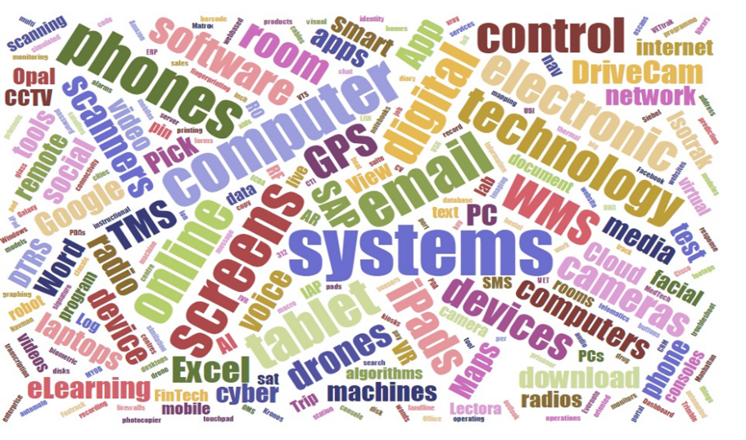

Source: Generated from interview data analysis

Although organisations represented among the two case study industry sectors had implemented varying degrees of digital technologies, from basic computer data entry and retrieval to highly advanced and sophisticated programs and systems, the interpretation and analysis of interview data represented in Figure 1 suggests greater recognition of basic computer tools than for more advanced systems. The interviews also show that many of the organisations participating in the study maintained dual manual/electronic operations and were hesitant to roll out full digitalisation of operations. At one organisation, for example, manual and digital truck scheduling and route planning operations were concurrently in use because only a few of the workers were able to and/or comfortable and confident enough to use the electronic systems. However, middle to senior management staff were expected to work more with digital systems, as well as management support staff. The team that interacted the most with a wide variety of digital devices and systems, ranging from basic to highly advanced ones, was the ICT staff. These teams existed, in one form or another and in varying sizes, across a large number of the participating organisations. At one of the organisations, for example, there was extensive and advanced use of ICT technology but mostly in within a specialised section which was responsible for ‘designing, implementing and maintaining’ various operating systems.

Advanced level digital skills, therefore, tended to be concentrated among a small group of highly skilled workers within specialised ICT units within organisations. One observation in this particular organisation was that a digital divide had emerged in which the ICT group was quite advanced while the core operations workforce continued to use manual or very basic level digital devices for data capture and entry. Manual worksheets were in dominant use as well as manual delivery schedules and route planning, for example. Similar contradictions were described by other organisations, particularly in the Transport, Postal and Warehousing sector. Others described situations in which little other than very basic computer technologies had been implemented. It therefore seems that, although there is great optimism regarding an emerging digital economy, technological adoption is more gradual in these industries. Five explanations were given for this situation:

1. Many organisations are hesitant to implement wholesale technological transformation of their operations because of awareness of a shortage of adequately skilled people to manage and work with the technologies.
2. There is resistance from the existing workforce, particularly the older workers, towards such transformation of the nature of their work.
3. There is also great resistance from workers and the unions to such large-scale transformation for fear of job loss and employment displacement.
4. Many organisations, based on the scale and scope of their operations, found it unnecessary to implement such extensive and rapid transformation because of, as one respondent said, ‘the anticipated productivity gains are not large enough to justify the cost and effort’ (Transport, Postal and Warehousing).
5. Many organisations were prevented from undertaking comprehensive digital transformation because of a lack of similar developments across the majority of their supply chain collaborating partners, especially in the Transport, Postal and Warehousing companies. This would lead to detrimental misalignment of operations.

When asked to rank the above explanations, the senior managers at the workshops consistently ranked 1, 2, and 5 as the most influential explanations but acknowledged that all of them applied with significant impact. Employer resistance was particularly emphasised but linked to a lack of skills, lack of confidence and the unwillingness to deviate from established ways of working, especially when it required substantial new learning. Many organisations therefore tend to approach technological adoption and digital transformation with a degree of caution informed by deliberate cost vs. benefit considerations as well as the surrounding political and socio-economic conditions. This perhaps explains why, according to the interviewees, the level of technology use at most organisations within the case sectors remains basic, which is also likely to be instructive when looking in the next section at the changes taking place at the workplace and in skills demand.

Figure 2 Concentration of technological adoption

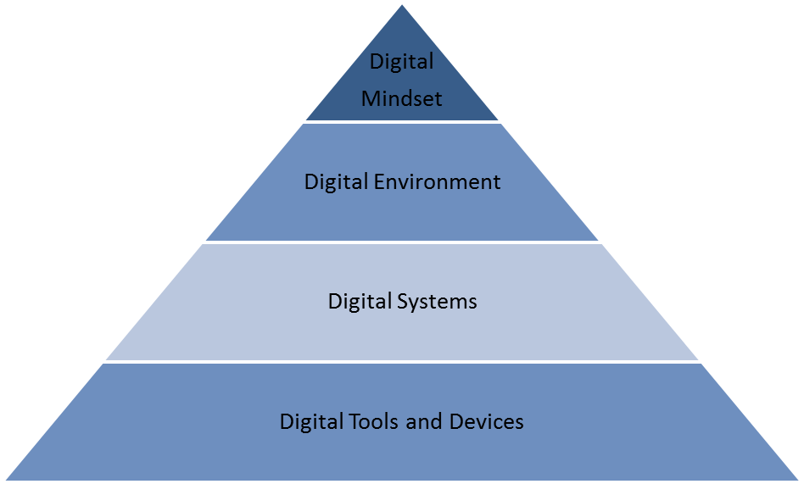

### 

Figure 2, based on our analysis of the descriptors and descriptions of the kinds of technologies adopted across the two case sectors, shows that the managers interviewed talked more about digital tools and devices and progressively less about systems, a digital environment and a digital mindset. The emphasis on digital tools and devices is reinforced by the job vacancy advertisement analysis findings conducted in the earlier stage of this research (Gekara et al., 2017) and further illustrates the point that, for a variety of reasons, most organisations in the sectors studied were operating at a basic level of workplace digitalisation.

## Impact on workforce skills

Whereas the digital tools and systems identified above tend to be widely available and commonplace, it is important to examine the impact of their implementation with regard to skills requirement. The demand for digital skills among the workforce and the level of such skills varied across different organisations depending on the usage of the particular tools and systems. These differences influenced how employers understood and defined digital skills and these varied on a wide scale of basic understanding and operation of digital tools and devices to more advanced levels of evaluation, analysis and creation. Four broad levels (Figure 3) of skills are detected in the interviews and workshop deliberations:

* **Level one** refers to basic understanding and operation of digital devices to search, capture, retrieve and transmit data and information.
* **Level two** refers to understanding and applying digital knowledge to the management and application of digital systems to process, analyse and manage data and information in order to facilitate efficient organisational operations.
* **Level three** refers to the innovative use of digital technologies to create and enhance organisational systems and capabilities.
* **Level four** represents a broad and general digital culture and mindset to operate confidently, comfortably and safely within an entrenched digital environment.

Figure 3 Categories of workforce digital skills

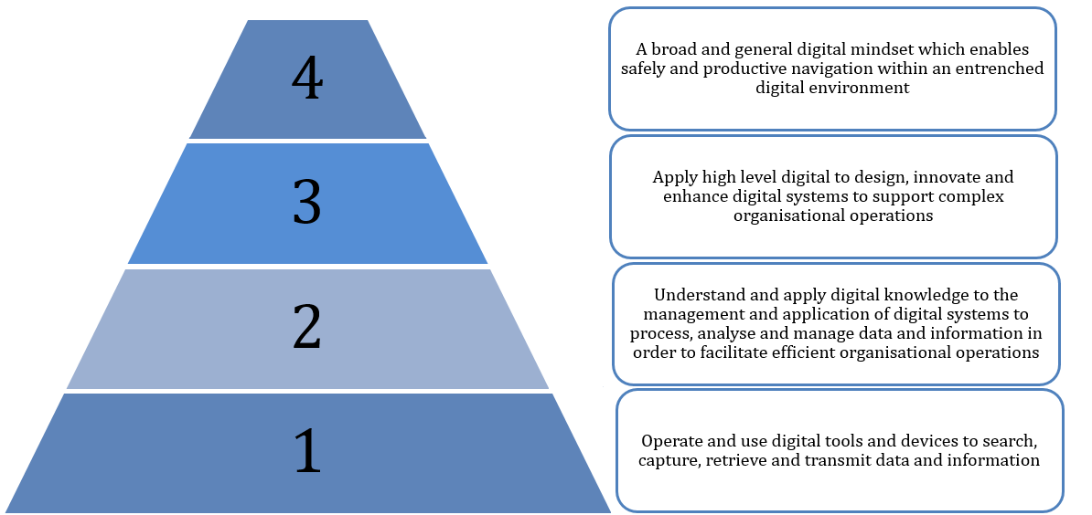

There was broad consensus, both in the interviews and at the industry workshops, that at the most basic level, digital skills meant one’s ability to understand and use various technologies to fulfil specific job tasks. This seemed to be the dominant participants’ view of digital skills across all sectors. Thus, most participants defined digital skills as the ability to use devices, such as iPads and smartphones and handheld scanners, and applications such as emails and Microsoft Office programs within workplace computerised systems in order to perform day-to-day work activities. The industry specific technologies and digitalised systems were identified and commonly referred to as a way of defining the context within which digital skills were required and applied, for example security monitoring systems (Public Administration and Safety), in-cab monitoring systems (Transport), warehouse management systems (Warehousing) and Enterprise Resource Planning (ERP). To illustrate this basic and widely applied view of digital skills, one participant spoke about them as being those ‘generic or life skills you need digitally just to get by’ [Maritime Transport Company].

At the second level, participants introduced the concept of manipulation and analysis of information by digital means in order to create meaning for operational purposes. For this purpose, workers need to have a more in-depth understanding of the devices in relation to the job tasks, and to utilise this knowledge to perform more complex tasks like data analysis and management and problem solving. One participant from the Public Administration and Safety industry, for example, related digital skills to being ‘…able to find information and analyse it to understand what the organisation did and make decisions about how to enhance performance…’. A requirement for analysis skills was mentioned by other participants, referring to one’s ability to use a variety of computer programs and systems to locate, manage and analyse information and data in order to inform appropriate decisions and action. Another participant from the Public Administration and Safety industry explained that, ‘…being able to interpret data on a screen…’ was important when, for example, using x-ray machines ‘…to scan what was coming into prisons…’. This aspect of digital skills requires employees to draw upon other types of skills (e.g. management, analytical, decision making) when making use of these technologically enhanced systems and operations.

The third level referred to the dual nature of digital skills, that is, not only being able to use various devices but also having sufficient understanding of digital technologies to enable reflection, adaptability and innovativeness in using them to deliver the desired outcomes more effectively, as well as understanding the wider implications of digital technology use. At some of the organisations represented, there were teams of highly skilled ICT staff who were responsible for developing and installing systems and providing support for the rest of the organisation. This category of digital skills was mostly found among ICT personnel and less with the general workforce. In this regard, there appears to be a ‘digital divide’ occurring in many organisations whereby the general workforce is trained to use basic computers and handheld devices while specialised workers perform the more analytical and knowledge management related functions required for maintaining and utilising digital systems and operations.

The fourth level emerged as a much more generic and ‘grey’ space expecting people to possess a digital mindset and be able to comfortably, confidently and securely navigate within a digital culture environment. Thus, some participants talked of the importance of a digital safety and security mindset. One participant representing a mail and parcel company spoke about digital disruption and digital skills, being both a mindset about innovation and entrepreneurship. The following interview extract expresses this high-level of digital skills:

Digital skills is not just about technology. It’s not just about, … ‘do I know how to click a button or use an iPad or…’ whatever it happens to be. In my mind, digital means new business models, new ways of working, new ways of creating that isn’t necessarily the norm of organisations today. So an entrepreneurial mindset and an experimental mindset and a commercialisation mindset – it requires a cultural change, a cultural shift which is very, very different to the types of skills that we traditionally see in workers [Transport, Postal and Warehousing].

This level of skills was mostly expected among people in high managerial and decision-making positions but also expected across all levels of occupations in different forms. As one participant representing a Transport, Postal and Warehousing company explained, the future of work will require people to fully understand the use and implications of digital technologies. He described a situation where workers speak ‘a digital language and think digital…’. This last category seems to suggest that digital skills are not just confined to the work space but rather meant for broader work and life situations, particularly with reference to ‘…think digital…’ and ‘…digital mindset…’; it suggests a cultural shift in which people are aware and interact naturally with their environment digitally. From these interviews, this level appears as an aspirational goal, at the current state of Australia’s digital transformation.

This analysis seems to support the wider literature which suggests that workforce digital skills must be understood according to levels on a graduating scale of competence; from the lowest level of mechanical device operation to the highest cognitive levels of analysis synthesis and creation utilising digitally enhanced systems and operations. It also aligns with the World Economic Forum (2016)’s conceptualisation of digital skills, which identifies different digital skill domains. Yet, the majority of employers, according to the interviews conducted, seem to interpret organisational skills requirements at the lowest levels; a finding which is corroborated in our earlier analysis of the skills employers tend to require of new workers, conducted in the first stage of the study using Seek job vacancy advertisement data. We found that even in occupation types and levels where one would expect a high and more sophisticated requirement for digital skills, job vacancy advertisements were either completely silent or specified basic levels of competency (see Gekara et al., 2017).

### Exploring the relationship between technological innovation and digital skill demand

As discussed above, the relationship between technological innovation and digital skills demand is not always straightforward. Technological change impacts industries, occupations and workforces in different types of ways. As the evidence from this study indicates, employers are embracing technological change in different ways, often through a very gradual process of technological adoption that requires only basic digital competencies among their general workforce. In interviews with employers across the two industries, many tend to think about technological innovation and its implications for their workforce digital skills requirements in three ways:

1. Some employers have not yet fully appreciated the rate at which new technologies may impact productivity and thus see little need to bring about changes to their current and immediate operations and skills needs;
2. Employers are fully aware of the true extent and levels of the emerging digital skills requirement but are prevented from implementing a radical workforce skills restructure by various obstacles (e.g. costs of upskilling the workforce or recruiting new workers with required skills, resistance from existing workforce, etc.); and
3. Many employers are sceptical about, and/or dismissive of any immediate-future radical change in digital skills requirement and the impact on firm performance.

These different explanations were examined in-depth through employer interviews, which reveal that, whereas employers acknowledge that the nature of skills requirements at the workplace is changing, the majority feel that a lot of the work people do only require basic digital skills. When put to the industry workshop participants, although there was agreement on the three ways identified from interviews, the majority pointed to the second, which is consistent with their earlier ranking of the dominant explanations for failure to implement extensive digitalisation of. We now turn to how employers come to address these basic digital skills needs.

## Employer approaches for meeting digital skill needs

In interviews with key stakeholders across the two sectors, many employers discussed the challenges in meeting their digital skills needs and how they approached skills acquisition and human resource development in their organisations. Five general approaches to addressing digital skill needs were identified in the analysis, including:

1. External recruitment of digitally skilled and experienced workers;
2. In-house on-the-job training to develop essential skills among the workforce;
3. Establishing specialised digital support units to support the wider workforce;
4. Contracting out of certain tasks for which recruiting or internally developing skills would be costly; and
5. International recruitment.

Groups of companies adopt and combine these approaches differently depending on what their business is, where they are located and how extensive and comprehensive their digitalisation agenda is. Three different situations were identified and are outlined in Table 1.

### Aggressive technology adopters with aggressive workforce digital skills development agenda

Companies which have pursued aggressive technological innovation and therefore view digital skills as absolutely essential and critical to their work tend to pursue a wide range of approaches in their digital skills acquisition. Mostly, however they seem to pursue an equally aggressive external recruitment as well as internal skill development strategy. In the former, they target highly qualified and experienced workers from the open labour market. The following quotes from two such firms illustrate how technological advancement and the associated digital skills demand and targeted staff recruitment become interrelated:

…we’ve deliberately hired in and brought in new blood, new skills, new ways of thinking, that’s permeated through the organisation and you will find more and more people pushing new ways of working, new technologies to apply [Transport, Postal and Warehousing].

We’re advertising for a position right now which I was interviewing, and that was one of the big focuses on their ability to use different systems – in getting data from them, analysing data. And that’s a low level administrator…and they need really good IT skills [Transport, Postal and Warehousing].

Although in-house training was adopted across all organisations to varying degrees, those organisations with aggressive digitalisation programs are identified as providing much more comprehensive and continuing training for new staff as well as existing staff for the purposes of, according to an interviewee from such a company in the Transport, Postal and Warehousing industry:

… mak[ing] sure that we maintain a certain level of competency in our company… we must have well trained people in order to maintain our standards and reputation with our clients.

In-house training, which tended to be mostly on-the-job, occurred in a number of ways: (1) through in-house and on-the job training provided by company trainers, (2) a mix of in-house and externally provided training, and (3) purely external training provided at VET training institutions but paid for by the employer. The following quotes illustrate these different training types:

For the digital training – we'll deliver components of it in house but we engage the services of external providers regularly to assist in that delivery. So for example we send our staff on Word, Excel and other Microsoft application-based training because we're not experts in that field. We engage services of someone outside. We seek assistance of third party consultants regularly to develop training content and then train our trainers to train our staff [Public Administration and Safety].

We actually provide some training on IT for the particular systems and then some of them; they just have to learn as they go [Transport, Postal and Warehousing].

The simulator is a classic example of that. Here they are being introduced to a whole new gamut of operations through a simulator. So your training staff had to be upskilled in computer and data technology to be able to operate systems, so that they can get the best outcome for the operations [Transport, Postal and Warehousing].

Some firms even invested in costly training assets like simulators. These, however, tended to be those that specialised in the provision of high-end services within the selected sectors and whose growth and competitiveness was technology driven.

In their staff recruitment, these companies in this category tended to be much more explicit about the types and levels of skills desired for jobs they advertised, as explained below by a representative of a Public Administration and Safety organisation:

…we have an expectation that they have those skills before they come to us, particularly because the Certificate III in Correctional Practice is linked to their first 13 weeks of training and in the Centre Management Units, in the Certificate III, they’ve got to have Oral Communication at Level 4 and Written Communication at Level 4, so we have to test those extensively during our recruitment process and if people don’t make them, we don’t employ them [Public Administration and Safety].

These ‘aggressive technology adopter’ firms were mostly located at the high-end of business, particularly in the Transport, Postal and Warehousing industry, that is, they commanded greater market share and tended to have a stronger capital base. They were therefore much more advanced in their workplace digitalisation than the rest. Clearly, not only do they have a clear idea of the skills new employees should have they also are clear on what qualifications they should be able to produce. The position description for their recruitment would therefore be specific in the requirement for not only digital skills, but specific levels of performance depending on the jobs. It is these organisations which aimed to attract already trained and appropriately qualified workers by projecting an ‘employer of choice’ image. It was expected that the applicants would come from the existing general pool of trained college graduates but preferably from other companies whereby they will have gained practical experience in addition to their education and training qualifications:

We look for college graduates or any properly trained and qualified people…. But we rather, even better if they have working, industry experience, that is very important [Transport, Postal and Warehousing].

There was also a general expectation that if people possessed higher qualifications, they would have a good standard of computer literacy.

However, even in these broad categories of firms, it was common that the workforce was divided into units whose work required higher-level digital competency and those where only the basic level skills were necessary. For example, one large transport firm was clear on the essential role of technology and digital skills in their future competitiveness but seemed to put different levels of pressure at different occupational levels and different occupational units. In this regard the manager said the following with regard to truck drivers:

With the technology that’s out there now, there’s no rush to go out – for the driver’s, I’m talking about – there’s probably not a rush to go there and advertise for computer literate truck drivers, but you’ll probably see it at some stage… It’s probably not such a tick in the box if they don’t have certain digital skills. You just want to employ them so they can drive the truck – that’s the main thing. But I don’t think it’s a deal breaker if they came in and they don’t have computer skills and things like that, no. That can be developed when they come in [Transport, Postal and Warehousing].

### Keen technology adopters with a cautious workforce digital skills development agenda

Some employers seemed to recognise that rapid technological change was occurring within their industry resulting in competitive pressures for their organisations to adopt new technologies and upgrade skills but, unlike those identified above, they were taking a cautious approach to technological change due to internal dynamics within their operations.

The dominant explanation provided for this more gradual approach to technological change was that the introduction of radical changes to the technologies might jeopardise their current productivity due to an overall shortage of people with the digital skills required to implement such change and still maintain high productivity and competitiveness. Instead they maintained production processes with minimal essential technologies, which explains their basic, low level view of digital skills requirement. When recruiting new workers, these organisations did not impose a digital skills requirement, apparently, because as explained by one interviewee, such a requirement might discourage applicants from their traditional recruitment socio-demographic catchments. Furthermore, they were hesitant to introduce radical changes to workplace technologies for fear of provoking techno-resistance from their existing workforce who possessed little or no digital skills. The strategy for these organisations was to undertake slow and gradual change while ensuring that current productivity levels were not seriously undermined and at the same time educating their workforce about the importance of new workplace technologies with the aim of introducing cultural change.

In such discussions, reference was regularly made to what might be described as the typical employee at these organisations. Some of the key features presented included age, that the majority of the workforce were older workers who had stayed at the organisation for a long time and established a particular way of working. According to employer interviews, these workers tended to present the greatest resistance to new technologies and rapid and radical transformation to the way of working. The following quotes illustrate this issue:

The area that we do struggle with is the bigger trucks and the older drivers, so guys post 40 years old. We’ve found there have been issues around them actually just having no frickin’ idea what to do with even a smartphone [Transport, Postal and Warehousing].

Any form of cultural change is difficult. You’re trying to change the old guard right? Change the old ways of doing things…We have all manner of challenges that you can imagine, ranging from first of all convincing people that the change is even necessary [Transport, Postal and Warehousing].

There was a little bit of hesitation from the workforce to embrace (the use of tablet devices). We’ve got a lot of our aging workforce in the driver teams, the average age is 54 years, so there’s a lot of hesitation to use the tablet, but it was just excuses [Transport, Postal and Warehousing].

Another feature was their level of formal education. Interviewees explained that the majority of these older workers had commenced work at an early stage as unskilled workers with very little formal education or qualifications. This, according to the managers, meant that they were less adaptable to the kinds of changes involved in workplace digitalisation. For the majority of their workforce, i.e. for their core operations, these organisations (mostly in the Transport, Postal and Warehousing industry) still depended on young, unskilled/semi-skilled labour, thus continuously reproducing the low-skill workforce situation. Other studies have also found that the Transport, Postal and Warehousing industry struggles to attract and retain younger, educated individuals because of a professional image issue (e.g. Gekara et al., 2014). Their concern, and source of hesitation towards rapid and extensive digital transformation, was therefore that they won’t be able to draw upon their traditional recruitment pool and also will not be able to attract the digitally skilled young workers, which could lead them to a situation in which they confront acute workforce shortages and a negative impact on their operations and productivity.

Technological obsolescence, however, was often an ongoing concern for these types of firms. In some cases, firms had sought to introduce technological improvements while relying on the existing skill sets of their workforce but creating new roles and expertise to support them in the transition to new technologies. For example, at one organisation an external support team was set up to provide continuous technical directions and support to workers out in the field. One participant from the Transport, Postal and Warehousing industry described how a new role had been created to help drivers and signal technicians resolve IT related faults. When a problem occurred, a driver could contact a member of the ‘asset health team’ who would then assist over the phone:

One new job we've created, possibly about 15 months ago… it might have even been two years, is something that we call asset health. As opposed to asset management which is obviously maintaining the assets. The asset health team sit in the control centre and they have access to all the procedures and all the manuals and they're briefed and trained on all the common faults. Because the more software, the more technology you have the more little glitches that can happen where you have to reset that circuit breaker or press that button or leave it for 30 seconds. For a signal tech or a driver to remember all of that is quite prohibitive and overwhelming. So they've now got [this] call centre, where they can call and go, ‘hey I've had this ATP error code, blah, blah, blah fault. How do I fix it?’ and someone in Perth talks them through how to fix it [Transport, Postal and Warehousing].

The driver and the signal operator are therefore not expected to possess a technical understanding of the operations behind the digital technology. According to the interviewee, the driver can then focus on the core job of driving and not get ‘bogged down with all the digital mumbo jumbo’ [Transport, Postal and Warehousing].

In this example, the driver was not expected to resolve such issues. In some cases, this was presented as a way of circumventing the problem of older, techno-resistant workers:

But from a driver perspective if the skills aren't there these things can be taught very quickly. If they can drive a truck and they can tie a load, they're far more valuable to me [Transport, Postal and Warehousing].

### Slow technology adopters with lax workforce digital skills development agenda

The third approach adopted by employers is one which they pursue digital transformation of their organisations with an appreciation of the growing need for digital skills among the general workforce but, from a recruitment and skill development perspective, they adopt the view that these skills are easily acquired through on-the-job and off-the-job experiences in working with digital technologies. There is also a tendency among this group of employers to expect new recruits have these skills before they come to them (i.e. ‘digital ready’).

To a great extent these employers shared the view, with the second group, that most of what the workforce needed were ordinary, basic device operations skills. Thus, interviewees talked of their expectation that people’s ordinary usage of digital devices such as smartphones and digital tablets are easily transferrable to the workplace. On the other hand, this group also resembled those in the first group in that they recognised that digital skills of a higher level were becoming increasingly critical. Their difference, however, was that they were not prepared to invest in workforce training. Instead, they were more interested in, as one interviewee explained, ‘attracting the best digital minds by being an employer of choice’ (Transport, Postal and Warehousing). Considering that these were generally slow adopters, what the interviewer means by ‘best digital minds’ most likely refers to the skills they need at the particular time for a particular purpose, thus not exactly in the sense as used by the first group. These employers tended to specify certain levels of digital skills in their recruitment with the expectation that they will attract appropriately trained and qualified people:

We want to attract the best people, with the right skills… we pay well and treat our people well and provide opportunities for development… we get people with the right skills because we are an employer of choice [Transport, Postal and Warehousing].

An additional skills strategy for organisations pursuing slow digital transformation was to rely on contract firms for certain activities and tasks which required a higher level of digital skills than the company was able to recruit and retain in-house. For example, in port operations, certain aspects of delivery and collection scheduling were outsourced to an independent external ‘one-stop solutions’ company. This means that those sets of skills did not have to be developed and maintained internally and could be acquired immediately. In the longer-term, however, firms pursuing such a strategy will need to invest in training and the digital upskilling of their workforce in order to develop internal capabilities.

Note, however, that while it was possible to make these broad distinctions in the skill acquisition approaches at different groups of companies (aggressive, keen and slow), the situation is far more complex and less clear cut. The boundaries between the three approaches identified were not always straightforward, with some employer approaches cutting across these different categories and adopting various combinations of approaches. Furthermore, the approach adopted was also determined by what occupational type and levels the companies were recruiting for.

Nevertheless, although the three broad approaches are apparent in the employer interviews, the majority of the organisations aligned with the second and third approaches. This was also evident in the industry workshops where most of the participants explained that the Australian industry context was not yet set for a massive take-off of digital technologies, largely because of the perception that what was mostly needed for industry operations were rather basic levels of technology. What this means is that the majority of employers were cautious about extensive digitalisation of their workforce and therefore did not insist on digital skills when recruiting workers. Reasons were varied, including they did not see digital skills as essential, they assumed that people would have the basic necessary competencies, or they deliberately chose to develop them in-house. Thus, where they specified digital skills as necessary criteria, it was mostly in the basic levels of competency.

## Conclusions

This part of the study examined technological innovation among firms in the Transport, Postal and Warehousing and the Public Administration and Safety industries and considered how workforce skills, capabilities and training interacted with technological adoption decisions.

Whereas most of those interviewed, as well as industry workshop participants, acknowledge that technologies are having a significant impact on organisations’ skills demand, when asked about the types of skills that they require for their general operational workers, they mainly described basic digital literacy attributes. Employers in these industry sectors expect no more from the majority of the workforce than to basically operate digital devices to capture, store and transmit information. However, there seems to be much more consideration of higher order skills for managerial occupations where it was expected that managers should be able to use advanced digital skills, such as data analysis for effective problem solving and decision-making. Only a few technologically advanced organisations expected all of their workers to have advanced digital skills. Seemingly, therefore, industry’s definition of digital skills is highly limited and seems to focus on the lower end of the spectrum established in our working definition.

Consequently, there were mixed messages regarding challenges in the acquisition of digital skills. Whereas there are strong concerns about the future availability of digital skills, employers in the study do not seem overly concerned about a lack of digital skills at the present moment. This is largely because (1) they do not seem to expect more than the very basic digital literacy of their workers, and (2) they expect that people already have these basic skills from their ordinary use of digital devices in their personal lives. Once again, the few companies that described difficulties in obtaining digital skills in the open labour market were those organisations already identified as tech-intensive with an aggressive digitalisation agenda.

The analysis suggests that companies use a range of strategies to meet their digital skills needs. These strategies include:

1. Open market targeted recruitment of highly skilled people;
2. Internal training of existing staff;
3. Outsourcing of certain tasks for which skills were not available internally and would be costly to develop and retain;
4. Establishment of central digital support units to support a largely unskilled workforce; and
5. General labour market recruitment with expectation that people already possessed the minimum required skills.

Table 1 Categories based on level of technological adoption and general view of digital skills

| Category | Range of Technology | View of Digital Skills (representative interview quotes) |
| --- | --- | --- |
| Aggressive Technology Adopters  3 organisations in this category | Wide implementation of basic IT software i.e. Microsoft Suite  High Level of Biometrics - Facial Recognition  Cloud Services  Automation  Virtual Reality  Database  Drones  Robotics  SAP  Real Time Technology  Digital Identity | Digital skills are not just about the ability to use day to day technologies such as iPad, iPhones or telephones. Digital skills mean new business models, new ways of working, new ways of creating that isn’t necessarily the norm of organisations today. Digital skills are about the actual technology that's now appearing in the work place and interfaces that people have to work with, multiple screens and the layers of screens in their spaces. It also includes creativity, entrepreneurial, experimental and commercialisation mindset – it requires a cultural change, a cultural shift which is very, very different to the types of skills that we traditionally see in workers. |
| Keen Technology Adopters  3 organisations in this category | Medium to Wide implementation of basic IT software i.e. Microsoft Suite  Online Learning Centres  Various Control Systems i.e. Warehouse, Transport Systems  Virtual Reality  Handheld Scanners  GPS Trackers  Computers  Tablets  Radios | Digital skills are the skillsets required around information management, ability to handle the required devices during the automation process. For example, warehouse operators are expected to be able to use handheld scanners and voice picking hardware; while salaried workforce should be able to use computers and Microsoft Suite. From logistics point of view, digital skills include using warehouse management systems. |
| Slow Technology Adopters  7 organisations in this category | Early implementation of basic IT software i.e. Microsoft Suite  Email  Digital tablets, Smartphones  GPS Technologies  In Vehicle Cameras  Biometrics - Fingerprint Scanner | Digital skills refer to the ability to deal with basic technology that is part of day to day life, such as phones, computers, tablets and using the internet. It also includes the ability to apply basic technology into workplace, to record, communicate and analyse information. |

Others used a combination of these methods. Surprisingly, out of these approaches, the mostly prevalent were (5) and (2). This is also consistent with the above findings regarding the kinds and levels of skills competence required of the general workforce. Seemingly, most employers expect people to possess the basic digital skills and where they do not, the organisations are willing to provide tailored in-house training to equip them with the minimum digital skills required to operate specific tools and equipment. Only a few top-end and tech intensive organisations maintained a comprehensive multi-approach recruitment strategy, including mostly (1), (2) and (4).

These findings suggest that many employers are not thinking strategically about the kinds and levels of skills required to maintain productivity and competitiveness into the future. In a global economy characterised by intense competition and increasing digitalisation, this is not a good sign. Not only do employers need to think about how to recruit digitally competent workers, they need to plan how to upskill their existing workforce in order to enhance the overall digital skills level within their organisation. In a rapidly changing digital economy a high-level of proactivity is required, particularly with regard to workforce planning. This is difficult given that many industries also struggle with shortages of non-digital skills. As the study highlights, in some situations, employers appear hesitant to introduce the kinds of technological change that would likely improve the productivity of their organisation, as a consequence of the particularities of their workforce and their lack of basic digital skills. Digital skills training and upskilling of the workforce may address this predicament. While this could be considered an undesirable cost to employers in the short term, it is likely to be important to the viability of their organisations in the longer term.

The key message to emerge from this part of the study, therefore, which could be extrapolated to other industries, is that, for the Australian economy to successfully transition and compete effectively in a global digital business environment, organisations will need to be more strategic in their workforce planning, particularly with regard to developing digital skills. Study 2 is therefore designed to not only further examine the findings from the qualitative survey, but also to establish the extent to which the observations from the two sector case studies can be extrapolated to other industries.

# Study 2: Survey of human resource, skills and training decision makers

## Introduction

The insights obtained based on Study 1 are limited to the case study organisations interviewed from the two industries – Transport, Postal and Warehousing and Public Administration and Safety. After conducting and analysing preliminary interview material, in order to strengthen the evidence base and identify broadly applicable generalisations about the changing skills requirements due to the digitalisation across Australian industries, we have undertaken a survey of human resource, skills and training (HRST) decision makers.

## Aims

The aims of the survey are to:

* investigate the extent of industry digitalisation and how they are impacting the nature of skills requirements;
* examine the extent of digital skills needs vis-à-vis the skills level of the current workforce and thereby develop indicators for a digital skills framework; and
* identify how employers are addressing their digital skill needs and their key challenges.

## Method and procedures

The design of the survey was guided by our working definition of digital skills as well as insights obtained from our job advertisements and Training Package analysis (Gekara et al., 2017), review of literature and analysis of the first six interviews conducted with industry stakeholders. The stakeholder interviews reconfirmed the findings from the review of frameworks (Support Document 1) that in addition to the use of digital tools and systems, digital skills need to cover entrepreneurial and innovative dimensions as well as recognition of the implication of safety, security and privacy in the increasingly digitalised work place.

### Questionnaire design

The survey questionnaire (see Appendix 2) was developed to cover the following areas:

1. Digital technologies with implications to skills and the future of work. Emerging digital technologies are expected to shape both the future of work and the type of skills required to be productive. We identified a list of 14 current and future wave of technologies from Deloitte Access Economics (2016), Deloitte Access Economics (2017), Australian Industry Standards (2017) and Hajkowicz et al. (2016) and asked respondents to select all that apply.
2. The impact of digital disruption on skills, future skills requirements, and ability to acquire those skills from the market. These were evaluated based on questions used in the Canada’s Skills in the Digital Economy report (Asliturk, Cameron & Faisal 2016).
3. Digital skills gap. To assess the digital skills gap, which we defined as the extent of discrepancy between the level of digital skills in demand by organisations and the level acquired by their workforce, we developed 17 questions (see parts F and H of Appendix 2) based on the findings from our job advertisements and Training Packages analysis (Gekara et al., 2017), extensive literature review (Support Document 1) and analysis of the first six industry interviews. To assess demand, a five point Likert scale ranging from ‘no priority’ to ‘very high priority’ was used. The acquired digital skill capability were evaluated based on a five point Likert scale ranging from ‘very low’ to ‘very high’.
4. Digital skills challenges and approaches. Economic, sectoral, and organisational challenges in developing a digitally savvy workforce were assessed through questions that we developed for this survey. Additionally, the survey items related to approaches to meet digital skills requirements were adapted from Capgemini’s (2013) digital talent report.
5. Strategies for digital skill development. In order to get a sense of how Australian enterprises are going about developing digital skills, we adopted Capgemini’s (2013) instrument for digital skills development self-assessment. The original model has four areas of focus: vision and leadership, as-is assessment, investment and plugging the skills gap. In addition, it has 11 indicators scored on the scale of 1 to 7. In this study we adopted the four areas of focus but slightly adapted some of the indicators.

### The survey sample

The survey was administered to a sample of HRTS decision makers from a cross section of Australian industries through two different platforms. The first was through the Australian Industry Standards (AIS)[[4]](#footnote-4) and targeted relevant respondents in their database of Transport, Postal and Warehousing and Public Administration and Safety HRTS stakeholders. The second one was administered by Qualtrics, targeting a panel of HRTS decision makers from other industries. Before taking the survey, potential participants were required to confirm that they met the sampling criteria as per the following screening statement:

‘The ideal person to answer this survey is a senior Human Resources, Training and Development and Workforce Skills manager in an Australian organisation familiar with the skills implications of digital technologies and digitalisation, existing industry practices and employer strategies for developing a digitally skilled workforce through both internal skilling mechanisms and Vocational Education and Training (VET) system. Do you confirm that you have the required profile to participate in this survey?’

Unique digital identifiers (such as respondent ID tokens, IP addresses, and latitude and longitude geo-locations) were used to avoid duplication. In addition, we compared the responses and checked for any statistically significant differences between the AIS and Qualtrics samples prior to combining the data for analysis. In total, the survey reached 454 decision makers of which 371 complete and usable responses were collected. The data were collected between May and Jun 2017.

## Survey respondents profile

### Job profile and year of service

The HRST decision makers belong to different occupational levels, with more than 60% being CEO/Directors and HR or Training and Development Managers (Table 2), about 25% supervisors and the rest belonging to a variety of other occupations and levels such as General Manager, Communications Director, Operations Director and Manager of Quality and Safety Training. Nearly 60% had worked at their current role for over 6 years while less than 6% had been with their companies for less than one year (Table 2).

Table 2: Job title and year of service in current role

|  |  |  |  |
| --- | --- | --- | --- |
| Category | Item | Frequency | Percentage |
| Job title | CEO/Director | 93 | 25% |
| Human Resources Manager | 59 | 16% |
| Training & Development Manager | 81 | 22% |
| Supervisor | 89 | 24% |
| Other | 49 | 13% |
| Total | 371 | 100% |
| Respondents’ number of years in role | <1year | 23 | 6% |
| 1-5 years | 140 | 38% |
| 6-10 years | 100 | 27% |
| >10 year | 108 | 29% |
| Total | 371 | 100% |

### Industry profile of respondents

Respondents to the survey were from a range of industries, but mostly from Transport, Postal and Warehousing (30%)(Figure 4). For the purpose of the analysis in this report, based on the Australian and New Zealand Standard Industry Classification (ANZSIC), we grouped them into seven broad groups: Public Administration and Safety; Transport, Postal and Warehousing[[5]](#footnote-5); Education and Training; Agriculture, Forestry, Fishing and Mining; Manufacturing and Construction; Information, Media and Telecommunications; and Services (financial, administrative, healthcare) and Trade.

The majority (nearly 30%) were from Transport, Postal and Warehousing industry, which reflects the composition of the AIS stakeholder database that we used as a sample frame. Another 37% were from a number of different Services and Trade industries. The primary industry of Agriculture, Forestry, Fishing and Mining yielded 2% each, while Education and Training and Public Administration and Safety had 8% each and the Manufacturing and Construction industries had 4% each. The remaining 6% comprised representatives from other industries including some non-profit organisations.

Figure 4 Respondent breakdown by industry (n = 371)

### 

### Organisational size breakdown of respondents

The HRST decision makers that responded to the survey worked for different sized organisations (Figure 5): 35% were from large organisations employing 200 or more employees; 33% were from small to medium businesses (20-99 employees); 19% were from medium to large organisations (100-199 employees), while 13% came from small business organisations (1-19 employees).

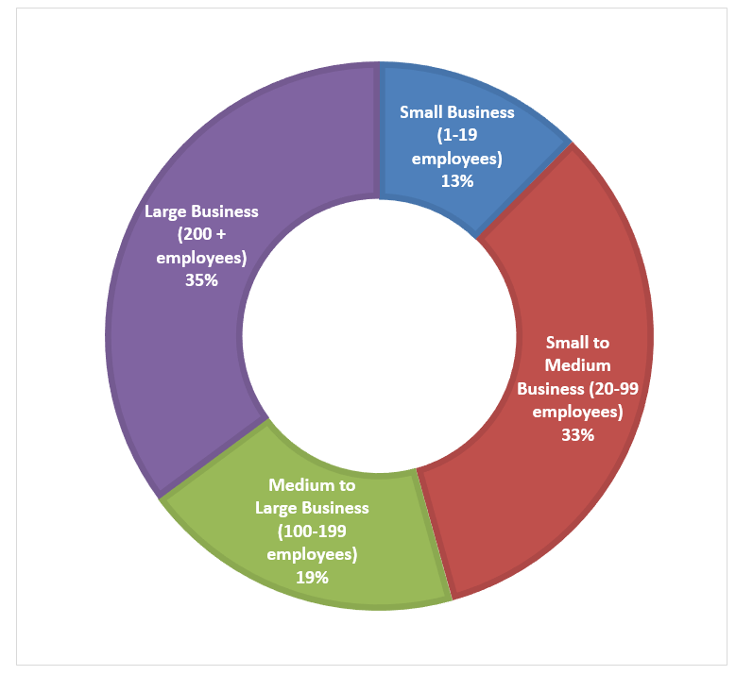Figure 5 Organisational size breakdown of respondents (n = 371)

## Digital disruption and its impact

Digital disruption is rapidly breaking down long established business models and blurring lines between companies and industries. In doing so, it alters organisational processes, traditional ways of operating and delivering goods and services and the workforce needs, knowledge, skills and capabilities of the past.

Consequently, many (71%) of the survey respondents recognised that their industry is being disrupted by the digital technologies that have infiltrated most aspects of work (Table 3). This is also expressed by the majority (73%) in terms of an increasing demand for digital skills among the general workforce outside ICT departments. Thus, as indicated in the 2016 Australia’s Digital Pulse report (DAE, 2016), developing the digital skills of the broader Australian workforce is an important strategy to overcome the potential shortfall in essential skills for the future and to ensure that Australian enterprises have adequate access to a digitally skilled workforce.

Table 3 Extent and impact of digitalisation (n = 371)

|  |  |  |
| --- | --- | --- |
| Question (five point Likert scale ranging from strongly disagree to strongly agree) | Respondents that either ‘somewhat agree’ or ‘strongly agree’ | |
| Percentage | Frequency |
| Our industry is affected by digital disruption | 71% | 265 |
| The impact of digital technologies is now felt across the entire organisation | 80% | 295 |
| We have an increasing demand for digital skills outside the ICT department | 73% | 272 |

## Digital technologies and skill requirements

We asked survey respondents to identify, from a set of current and future waves of digital technologies (Deloitte Access Economics 2016), those technologies that were expected to have the greatest impact on their skill requirements. Mobile (51%), cloud (40%), automation (36%), big data analytic applications (30%) and Internet of Things (30%) were the technologies expected to have the greatest impact on the skill requirements of the organisations across all industries (Figure 6).

Less than one fourth of respondents included emerging digital technologies such as drones, wearable technology, self-driving vehicles and augmented and virtual reality in the list of those expected to make the greatest impact. However, Deloitte’s 2016 Digital Pulse Report shows that although these emerging technologies are not currently diffused within Australian economy, the increasing trend of their commercial applications could lead to significant impact across many industries, not only in terms of changing ‘knowledge jobs’ but also ‘muscular power jobs like manufacturing and construction’ (DAE 2016, p.12).

*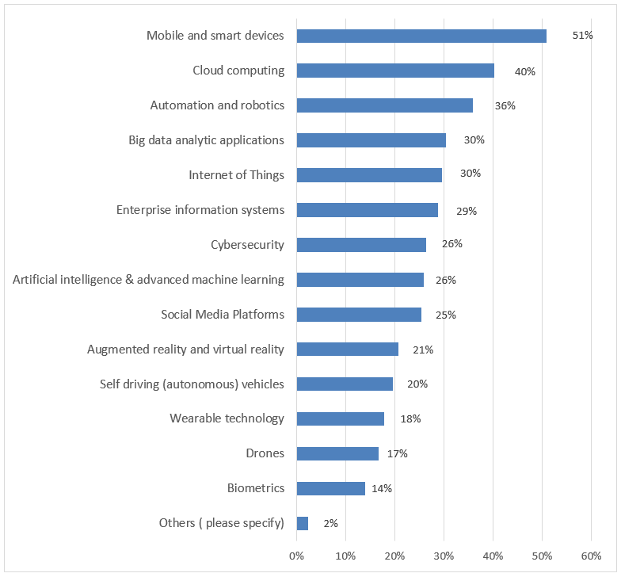*Figure 6 Digital technologies with greatest impact on skill requirements (n = 371)

The survey data also shows that there are differences based on organisational size in terms of which digital technologies are likely to have significant impact on skills requirements (Table 4). Mobile, automation and cloud computing appear in the top five categories across different sizes of enterprises, while social media seems to be rated highly mostly by respondents from small business organisations (28%). For small to medium organisations employing between 20-99 workers, Internet of Things (31%) and cyber security (28%) are important, whereas for medium to large and large enterprises, big data analytics and artificial intelligence are expected to have a much bigger impact on skills requirements.

Table 4 Digital technologies with greatest impact on skill requirements by organisation size

|  |  |  |  |  |
| --- | --- | --- | --- | --- |
|  | Small  (1-19 employees) | Small-Medium  (20-99) | Medium-large  (100-199) | Large  (>= 200 employees) |
| Mobile and smart devices | 70% | 46% | 37% | 58% |
| Enterprise information systems | 30% |  | 37% | 33% |
| Social Media Platforms | 28% |  |  |  |
| Automation and robotics | 28% | 37% | 38% | 36% |
| Cloud computing | 28% | 41% | 54% | 36% |
| Internet of Things |  | 31% |  |  |
| Cybersecurity |  | 28% |  |  |
| Artificial intelligence and advanced machine learning |  |  | 44% |  |
| Big data analytic applications |  |  | 42% | 36% |

Although the impact of the current wave of digital technologies, such as mobile and cloud computing are felt across all industries (Table 5), there are industry specific differences. For instance, drones have been identified as important by 48% and 38% of respondents from Public Administration and Safety, Defence and Agriculture, Forestry and Mining industries respectively. Among respondents from Public Administration and Safety and Defence, 38% identified augmented and virtual reality as one of the top most important technologies affecting skills requirements. Transport, Postal and Warehousing respondents were the only ones who expect self-driving vehicles to be one of the top five technologies to significantly affect their skills requirements. Social media was nominated by respondents in the Education and Training industry only.

As also found in Deloitte Access Economics (2016), it seems digital disruption will affect skills demand in a wide range of industries. Nevertheless, as indicated by the European Centre for the Development of Vocational Training, digital advance:

…is not a zero sum game, but widespread transformation of the world of work [that] poses challenges to policy-makers, who need to help those adversely affected by technological disruption, particularly low-skilled people. Not every lorry driver will, or needs to, become a computer programmer. Perhaps in the future, former drivers will use technology to guide and monitor self-driving vehicles or drones to deliver goods. (CEDEFOP, 2017, p 2).

## Digital technologies and the labour market

According to recent CSIRO scenario modelling, the accelerating diffusion of digital technologies and the digitalisation of economic and social activities will continue to affect ‘labour markets, employment models and jobs beyond 2020’ (Hajkowicz et al., 2016, p 19). Digital technologies are expected to have a polarising effect on the labour market. They will create demand for both high skilled and well-paying jobs at one end of the spectrum and low-skilled, low pay jobs at the other end of the spectrum (CEDEFOP, 2017). They will continue to substitute the need for technical skills by displacing humans by Artificial Intelligence (AI) or robots in the workplace at one end of the scale and make access to digitally skilled talent critical to economic growth at the other (Asliturk, Cameron & Faisal, 2016; Deloitte Access Economics, 2016). This polarisation is also suggested in our survey in terms of the growing need for professionals working in ICT specific roles (i.e., IT professionals), market supply and the ease/difficulty of finding required skills and frequency of reskilling (Figures 6-8).

Figure 7 shows that over the past five years, the need for IT professionals has increased at most of the survey responding enterprises (77%). This is consistent with the projected average annual growth of 2% for the Australian IT workforce from 600,000 workers in 2014 to 722,000 workers by 2022, which is higher than the 1.4% average annual growth for the rest of the workforce (Deloitte Access Economics, 2017, p.1). This, coupled with the increasing demand for digital skills outside the IT department (Figure 6), indicate the importance of digitalisation for Australian enterprises and the pressure this puts on the labour market.

|  |  |  |  |  |  |  |  |  |
| --- | --- | --- | --- | --- | --- | --- | --- | --- |
|  | Public Administration, Safety | Transport, Postal & Warehousing | Education & Training | Agriculture, Forestry & Fishing | Manufacturing & Construction | Information Media & Telecom | Services | Others |
| Mobile and smart devices | **66%** | **65%** | 37% | **54%** | 48% |  | 43% | **54%** |
| Drones | 48% |  |  | 38% |  |  |  |  |
| Augmented reality and virtual reality | 38% |  |  |  |  |  |  | 38% |
| Cloud computing | 34% | 30% | **43%** |  | **59%** | 57% | **46%** | 42% |
| Enterprise information systems | 34% | 32% |  |  |  | 43% |  |  |
| Automation and robotics |  | 44% |  | 31% | 38% | 50% | 35% | 38% |
| Self-driving vehicles |  | 30% |  |  |  |  |  |  |
| Cybersecurity |  |  | 37% |  | 41% |  |  |  |
| Internet of Things |  |  | 33% |  | 38% |  | 36% |  |
| Social Media Platforms |  |  | 33% |  |  |  |  |  |
| Big data analytic applications |  |  |  | 31% |  | 43% | 39% | 50% |
| Artificial intelligence |  |  |  | 31% |  | **57%** |  |  |

Table 5 Digital technologies with greatest impact on skill requirements by industry

Figure 7 Need for IT professionals (n = 371)

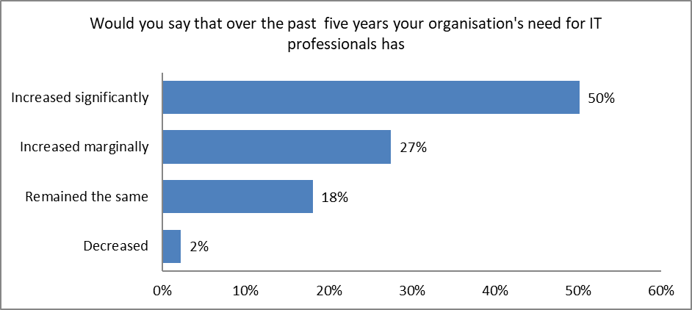

The data also shows that the adoption of digital technologies by Australian enterprises have made the required digital skills more difficult to find for some enterprises (36%), while other employers (41%) have found it easier than previously (Figure 8).

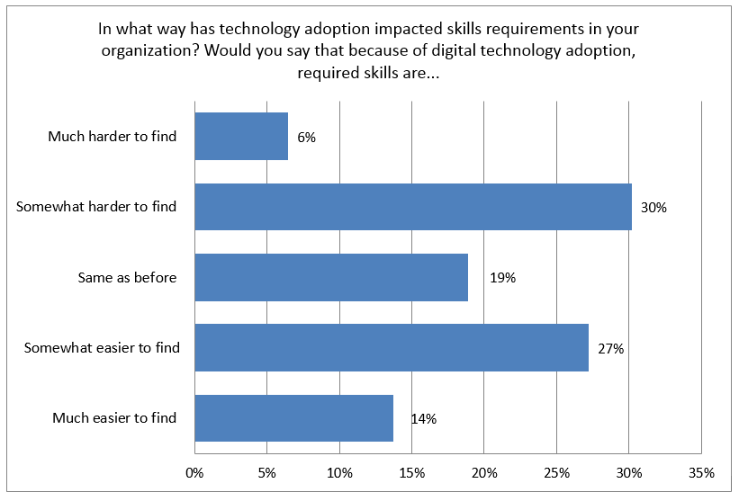Figure 8 Difficulty in finding digital skills due to digitalisation (n = 371)

However, according to the majority of HRST decision makers (64%), their current workforce has to frequently refresh their digital skills (Figure 9). This provides additional evidence to the assessment in the Deloitte’s 2016 Digital Pulse Report, which indicates that the implementation of new and emerging digital technologies ‘will impact upon the existing workforce, as employees will be required to have the skills necessary for integrating technologies such as artificial intelligence and the Internet of Things (IoT) into businesses’ products, operations and processes’ (Deloitte Access Economics, 2016, p.12).

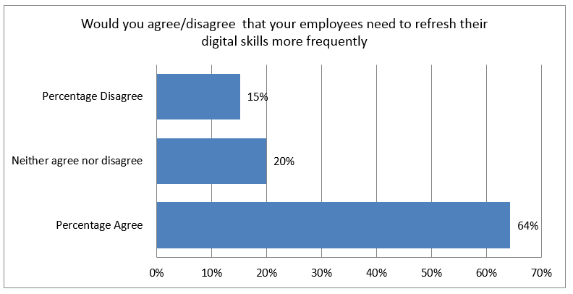Figure 9 Frequency of refreshing digital skills (n = 371)

Similar to the findings in Deloitte Access Economics (2016, 2017), the overall perception (as reported by 61% of respondents) is that there is a shortage of digital skills in the current Australian labour market (Figure 10).

Figure 10 Digital skill supply in the Australian labour market (n = 371)

This is reinforced further by the responses to the open-ended question asking survey participants to list three skills (not just digital related) that they were having the biggest difficulty in finding. The HRST decision makers identified various skills including coding, big data, cyber security, creative mind, effective communication and even common sense. A text analysis of the responses (Figure 11) suggests that digital related skills dominate the list of skills that employers are experiencing difficulty in finding. This may be due, at least in part, to the question being asked in the context of a survey on digital skills.

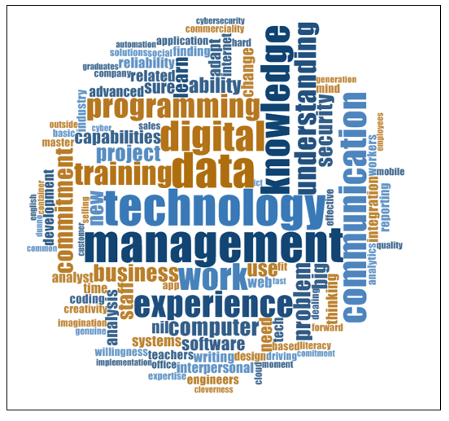Figure 11 Skills that respondents are having the biggest difficulty finding

## Digital skills needs and competence

Digital skills are critical for driving innovation in the economy. Understanding digital skills gaps is therefore particularly important in light of the digital disruption of work, which creates new occupations while transforming others (Beblavý, Fabo & Lenaerts, 2016; Burning Glass Technologies, 2015). Different macro level studies identified a digital skills gap as one of the key hurdles that will affect Australia’s digital economy growth and as a significant challenge that needs to be overcome through innovative policies. For example, CSIRO’s analysis shows that a gap in analytical skills is a major challenge, which undermines organisations’ ability to maximise use of increasing volumes, variety and velocity of data (big data) (Hajkowicz et al., 2016, p.35). Digital skills gaps have also been identified as one of the significant barriers for increasing the adoption rate of digital technologies across several economies (CEDEFOP, 2017, p.3; World Economic Forum, 2016, p.6). The issue of a skills gap has also been captured in academic research, with consistent reports of digital skills gaps in different aspects. This includes age related digital skills gaps, that is, a widening gap between younger and older people, and in tasks that emphasize creativity and critical thinking (Eshet-Alkalai & Chajut, 2010, p.173), digital marketing (Royle & Laing, 2014), and in worker displacement as well as reemployment (Peng, 2017). Likewise, more than two thirds of survey respondents have indicated that they experience a shortage of digital skills in their current workforces and suggested that this problem will be a key hurdle to their future strategy (Table 6).

Table 6 Shortage of digital skills and its impact (n = 371)

|  |  |  |
| --- | --- | --- |
| Question (five point Likert scale ranging from strongly disagree to strongly agree) | Respondents that either ‘somewhat agree’ or ‘strongly agree’ | |
| Percentage | Frequency |
| There is a shortage of digital skills in our current workforce | 72% | 266 |
| Lack of digital skills will be a key hurdle to our future strategy | 72% | 266 |

Based on the Australian and New Zealand Standard Classification of Occupations (ANZSCO) major groups, respondents were asked to identify the occupations in which they are experiencing the greatest need for digital skills. Most respondents indicate great need for digital skills in the Managers, Professionals and Technicians and Trade workers occupational groups (Figure 12). Perhaps as an indication of the digitalisation of manual work, the HRST decision makers indicated that their need for digital skills in the Labourers, Machinery Operators and Drivers occupational groups is slightly more than in Sales Workers and Community and Personal Service Workers groups.

*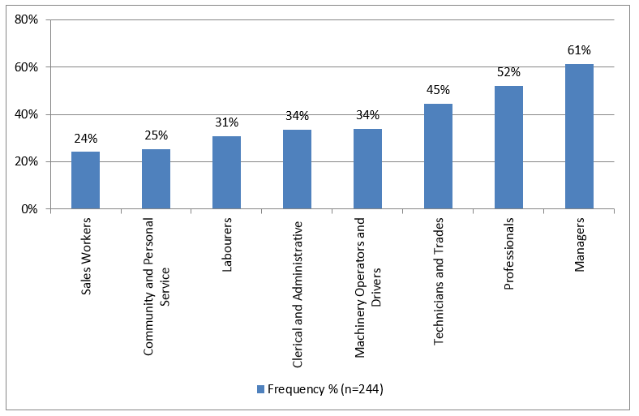*Figure 12 Digital skill needs by occupation (n = 244)

In order to facilitate the digital transformation of Australian enterprises and accelerate Australia’s digital economy, both public and private enterprises have to be cognisant of the digital competencies of their workforce and decide whether and to what extent there are digital skill gaps (Deloitte Access Economics 2016, p 5). Digital skills gap analysis is therefore a useful technique for identifying skills mismatch across enterprises (Asliturk, Cameron and Faisal, 2016; Beblavý, Fabo and Lenaerts, 2016). Generally, a skills gap analysis involves an evaluation of employees’ acquired skills against the current and future skills needs of an organisation or the skills employees need for career progression (Asliturk, Cameron and Faisal, 2016, p 36).

Using the seventeen digital skills indicators, derived as described in the methods (and shown in Appendix 2, parts F and H), we asked the HRST decision makers to assess both their digital skills need (on a five-point scale ranging from no priority, low priority, some priority, high priority, to very high priority) as well as the digital skills competence levels acquired by their current employees (on a five point scale ranging from very low, low, moderate, high to very high).

The findings (Table 7) show that a high proportion of the respondents (>80%) indicated that they attach significant priority to all the 17 digital skills needs (Table 7, 2nd column). Of these, ‘Understand the importance of privacy in handling data and information’, ‘Use advanced features of digital technologies with confidence for communication, cooperation and collaboration’, and ‘Trouble-shoot/solve problems that arise when using digital technologies’ topped the list with more than 90% of respondents identifying these skills as a priority. To the contrary, less than 48% of respondents rate their current workforces’ competence across the 17 digital skills as high or very high (Table 7, 3rd column). In particular, only about one third of respondents rate as either high or very high their employees skills to ‘analyse digital risks to identify cyber-security threats and vulnerabilities’, ‘ability to extract insight from data analytics systems, engines and dashboards’ and ‘ability to gather and analyse big data’.

Table 7 Differences in digital skills needs and competences (n = 371)

|  |  |  |
| --- | --- | --- |
| Digital Skills Indicators | % of respondents indicating need priority | % of respondents reporting high or very high competence |
| Understand the importance of privacy in handling data and information | 94% | 47% |
| Use advanced features of digital technologies with confidence for communication, cooperation and collaboration | 91% | 34% |
| Troubleshoot/solve problems that arise when using digital technologies | 91% | 33% |
| Confidently operate industry (job) specific digital technologies | 90% | 44% |
| Effectively search, find, retrieve, process and communicate information from a variety of digital sources and in a variety of formats | 90% | 35% |
| Comply with organisational policies to protect hardware, software, information and systems | 90% | 41% |
| Recognise workplace problems and needs in the digital environment and propose innovative solutions | 90% | 35% |
| Successfully use different enterprise information systems to complete complex transactions | 89% | 32% |
| Learn and adapt quickly to nascent and emerging technologies (such as Social, Mobile, Internet of Things, Apps, Robotics, artificial intelligence etc.) | 88% | 37% |
| Creativity and experimental mindset in the digital workplace environment | 88% | 33% |
| Analyse digital risks to identify cyber security threats and vulnerabilities | 87% | 32% |
| Ability to extract insight from data analytics systems, engines and dashboards | 86% | 31% |
| A mindset to function with an increasingly digitised workplace | 85% | 32% |
| Understand the positive and negative environmental impacts of digital technologies | 85% | 34% |
| Ability to gather and analyse big data | 83% | 30% |
| Entrepreneurial and commercialisation mindset in the digital workplace environment | 83% | 31% |
| Highly proficient keyboard skills (keyboard dexterity) | 78% | 35% |

In terms of occupational differences in digital skills shortage, most respondents rank the Professional and Managers occupational category highest (Figure 13), as a reflection of the knowledge and information intensive nature of jobs in this group (Beblavý, Fabo & Lenaerts, 2016; Burning Glass Technologies, 2015). Digitalisation is driving the need for higher order skills in manufacturing, transport and logistics industries. As the business application of the Internet of Things, automation and robotics accelerates in these industries, employers will face shortages of digital skills. Thus, more than one third of respondents have indicated that they are experiencing digital skills shortage in the Machinery Operators and Drivers occupations. About one fourth of respondents expressed digital skills shortage among Sales workers, Labourers and Clerical and Administrative occupations, and another 30% in the Community and Personal Service and Technician and Trades workers. Similar to the findings in the Burning Glass Technologies Report (Burning Glass Technologies, 2015, p.1), which show that jobs that do not demand digital skills are fast disappearing in the United States (US), in Australia it seems clear that most occupations are rapidly shifting towards digitalised occupations.

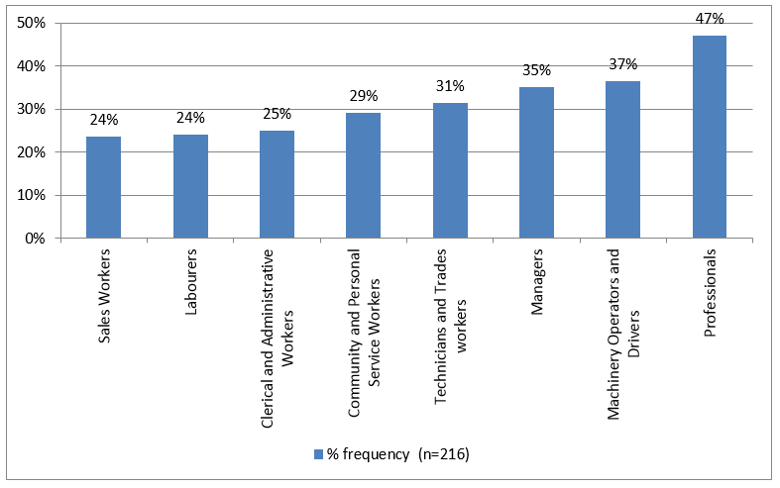Figure 13 Digital skill shortage by occupation (n = 216)

## Challenges and approaches in meeting digital skills requirements

The surveyed HRST decision makers identified a number of digital skill related challenges facing their organisations (Figure 14). The most frequently mentioned challenges were: finding employees with both technical and business-interpersonal skills, training for new technology skills, attracting and recruiting digitally skilled employees (skills shortage) and retaining digitally skilled employees (Figure 13). Other challenges include the ageing workforce and lack of experience based skills.

Employers’ need for hybrid skills (those combining technical, business and soft interpersonal skills) is a persistent and continuous trend (Hajkowicz et al., 2016). Although both vocational and higher education programs have attempted to respond to this demand by incorporating work-ready skills in their curriculums, it remains a recruitment challenge for most industries. Multidisciplinary skills combining digital, business domain and generic skills will continue to dominate the skill demand in the future workforce.

**Figure 14 Top digital skills challenges (n = 288)**

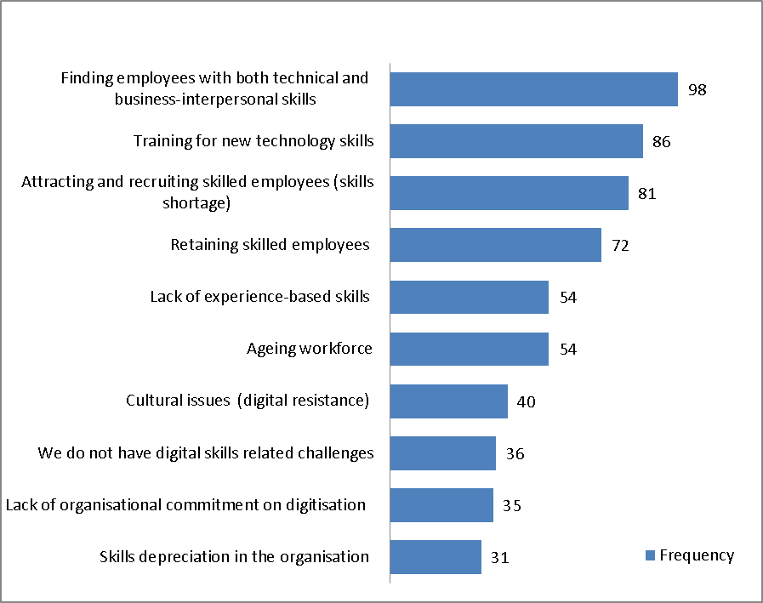

*Note. Respondents could nominate as many challenges as necessary.*

Enterprises facing increasing demand for digital skills and affected by skills shortages and challenges need to use both traditional and innovative approaches to address these issues and continuously prepare and upgrade the capability of their workforce (Capgemini, 2013). While the HRST decision makers are using a number of approaches to meet their digital requirements (Figure 14), similar to the findings in Capgemini’s Digital Talent Gap report (Capgemini, 2013), the most preferred option to meet digital skills in Australian enterprises is internal employee training and development programs. However, only 36% expressed agreement to our survey question ‘*we spend more than 20% of our training budget on digital skills*’. Other widely used approaches include outsourcing, and focused recruitment followed by external training and the use of overtime.

Australian enterprises are also beginning to use innovative methods that provide new ways of addressing digital skills requirements (Figure 15) (see also Capgemini, 2013). For example, about 60% of the respondents indicated that they were using targeted company acquisition, partnerships with boot camps and rapid skills development vendors, and skills incubator and accelerator programs to meet their digital skills requirements.

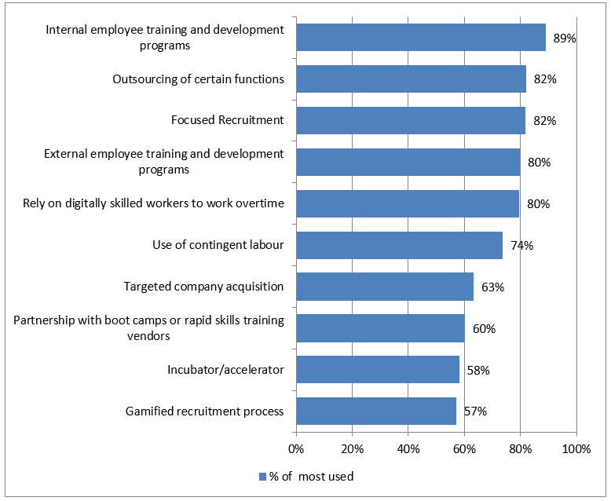Figure 15 Approaches to meet digital skills requirements (n = 288)

As the millennial generation enters the labour market, enterprises have to look for cutting edge methods to attract, recruit and retain them. Gamified recruitment, which is the use of game mechanisms in recruitment process (Saha & Pandita, 2017), offers one of such innovative approaches to contextualise employers’ needs and engage the millennials, many of whom would have spent thousands of hours of gaming by the time they seek jobs, in a familiar environment. Interestingly, 57% of the respondents reported using gamified recruitment processes. This is nearly three times the number of companies that were using innovative methods of assessing and acquiring digital skills in the Capgemini (2013) study.

## Digital skills development self-assessment

Ensuring adequate supply of digital skills through a combination of skilled migration and local education and training programs is important to address the skills shortages that many Australian employers encounter (Deloitte Access Economics, 2017). In view of technological advancements, enterprises that are facing digital disruption and undergoing digital transformation need a concerted and strategic response that goes beyond occasional training provision to develop digital skills. As our survey findings indicate, Australian organisations, because of industry and size differences, vary both in their digital skills needs and the competency levels required. In addition, the digital trajectory, agenda and strategy of enterprises, as well as their resources, vary across different organisations. Of the 371 survey respondents, 273 completed the digital skills development self-assessment, which was based on Capgemini’s (2013) instrument (refer to the study design section for further details). The findings (Table 8) suggest that Australian enterprises have a long way to go in developing digital skills. In particular:

* **Vision**: most participating enterprises have yet to develop a clear vision on the skills that they need in order to meet their digital goals and a passion for digital needs to be cultivated among top level managers to define future skills requirements.
* **Skills gap analysis**: consistent with the digital skills gap findings reported earlier in this report, some of the participating enterprises have adequate digital skills in some areas and face gaps in other areas.
* **Digital skills investment**: Less than half of the participating enterprises have recognised and initiated actions for developing digital skills through strong programs of investment and processes to periodically identify key digital skills areas, in line with the pace of technology development.
* **Digital skills plugging**: Australian enterprises need to step up the pace of digital skills acquisition. There are a number of options including partnering with niche digital technology firms, dedicating sufficient budget towards the development of digital skills, and scaling up the innovative recruitment ways to gaining digital skills.

Table 8 Digital skills development self-assessment

|  |  |  |  |  |
| --- | --- | --- | --- | --- |
| Focus Area | For each answer record a score between 1 and 5 (1=Strongly Disagree, 3=Neutral and 5= Strongly agree) | Possible score | Australia score (n = 273) | Benchmark (adapted from Capgemini (2013, p 10)/ Australian performance in bold and italic |
| Digital skills vision | We include digital skills as a key component in our workforce plan  We have committed leadership at the top for driving digital skills  We have a clear vision of the skills we need in order to meet our larger digital transformation goals | 0-15 | 10.0 | • > 13 Leadership has a strong vision on digital skills  • 11 < X < 13 Top management has to be sensitized on the need for a top-down approach  • ***<11 A passion for digital needs to be injected at the very top of the enterprise*** |
| Digital skills as is assessment | We have the requisite digital skills in-house to successfully drive digital transformation  We have a clear view of the type of employees and their digital persona (which employee has what type of digital skill?) | 0 - 10 | 6.5 | • > 8 Enterprise knows where it stands and what skills it has in-house  • ***6 < X < 8 Enterprise has pockets of digital skills in the targeted areas***  • < 6 initiate digital skills analysis of existing employees |
| Digital skills investment | We have a strong program of investment in digital skills development  We have a process to periodically identify key digital skills areas, in line with the pace of technology development | 0- 10 | 6.3 | • >8 Enterprise has recognised and initiated actions for developing skills  • ***6<X<8 Identify areas that need specific attention of leadership focus***  • <6 Need to actively consider impact and role of digital skills on your organisation |
| Digital skills plugging | We are comfortable with the pace of our training programs on digital skills  We have partnered with some of the best niche digital technology firms  We have a dedicated and sufficient budget towards the development of digital skills  We are using innovative recruitment ways as an effective way to develop digital skills  We are innovating in our approach to gaining digital skills (incubators/usage of expert networks) | 0-25 | 15.4 | • >20 Enterprise is on the right track to acquiring digital skills  • 16<X<20 Enterprise needs to ensure to spread its best practices across all areas of digital skills  ***• <16 Enterprise need to step up the pace of digital skills acquisition*** |

There are significant differences between large and small to medium enterprises and between the Public Administration, Defence and Safety and other industry respondents in digital skills development self-assessment scores. Overall, respondents from the Public Administration, Defence and Safety and small enterprise score their digital skills development lower than the rest of respondents. Table 9 highlights these differences.

Table 9 Digital skills development self-assessment scores by industry and organisation size

|  |  |  |  |  |  |
| --- | --- | --- | --- | --- | --- |
| Organisation size |  | Digital skills vision | Digital skills as is assessment | Digital skills investment | Digital skills plugging |
| Score range | 0-15 | 0-10 | 6-10 | 0-25 |
| Small | 9.0 Injected passion for digital at the top of enterprise | 5.7 Initiate digital skills analysis | 5.0 Consider impact and role of digital skills | 12.0 Step up the pace of digital skills acquisition |
| Small to Medium Business | 10.2 Injected passion for digital at the top of enterprise | 6.6 Digital skills in targeted areas exist | 6.3 Identify areas need attention or leadership focus | 15.9 Step up the pace of digital skills acquisition |
| Medium to Large Business | 10.2 Injected passion for digital at the top of enterprise | 6.8 Digital skills in targeted areas exist | 6.6 Identify areas needing attention or leadership focus | 16.4 Spread best practices across all areas of digital skills |
| Large | 10.0 Injected passion for digital at the top of enterprise | 6.5 Digital skills in targeted areas exist | 6.1 Identify areas needing attention or leadership focus | 14.8 Step up the pace of digital skills acquisition |
| Industry sector | Public Admin, Defence & Safety | 8.6 Injected passion for digital at the top of enterprise | 5.0 Initiate digital skills analysis | 4.6 Consider impact and role of digital skills | 12.3 Step up the pace of digital skills acquisition |
| Transport, Logistics, Postal & Warehousing | 9.5 Injected passion for digital at the top of enterprise | 6.3 Digital skills in targeted areas exist | 5.8 Consider impact and role of digital skills | 13.6 Step up the pace of digital skills acquisition |
| Others | 10.3 Injected passion for digital at the top of enterprise | 6.7 Digital skills in targeted areas exist | 6.5 Identify areas need attention or leadership focus | 16.1 spread best practices across all areas of digital skills |

## Employer evaluation of VET programs and government investment in digital skills

The Australian Government’s approach to investment in education in general and in Science Technology, Engineering and Mathematics (STEM) will have a significant impact on addressing skills needs of the workforce and digital skills supply into the future. We sought the HRST decision makers’ perceptions of Australian government investment in the development of workforce digital skills. The survey participants were divided on this issue. A little over one third perceive that the government’s investment is sufficient. A quarter of the respondents believe that the investment is insufficient and the rest were uncertain (Figure 16).

Figure 16 Evaluation of government investment in the development of digital skills

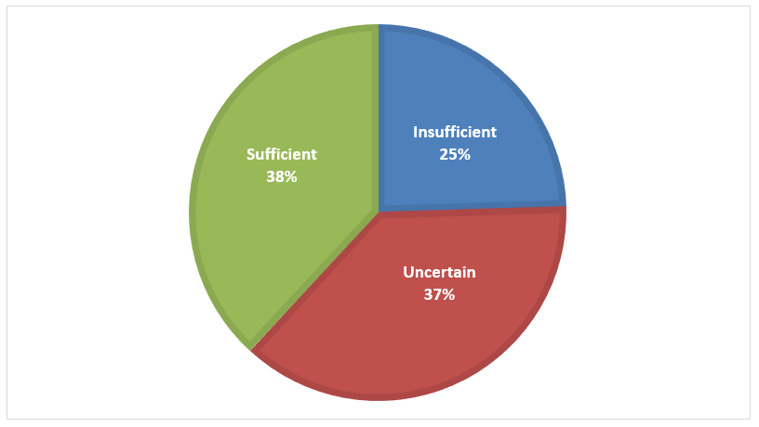

To what extent VET programs satisfy the skill needs of industries has mixed findings. Although not focused on digital skills, a recent Australian study reported that ‘VET graduations are significantly correlated with job vacancies, suggesting that the VET sector is addressing skills shortages in the economy’ (Reeson et al., 2016, p.2). On the other hand, a Finnish study of around 4500 adults indicates that two-third of adults ‘with vocational education and training have either weak skills or lack the skills in solving problems in technology-rich environments’ (Hämäläinen et al., 2015, p.38).

Against this backdrop, we asked the HRST decision makers to evaluate the digital skills of VET graduates recruited from the market and the currency of VET training packages and qualifications to meet industry digital skill requirements using five point Likert scales (Appendix 2, Part G and question 18). The findings (n = 371) indicate that:

* 45% of the respondents are either ‘satisfied’ or ‘very satisfied’ with the digital skills of VET graduates recruited from the market;
* 42% respond as either ‘appropriate’ or ‘absolutely appropriate’ to the question of that evaluates the currency of VET Training Package and qualification to meet industry digital skill requirements; and
* 37% either ‘strongly’ or ‘somewhat agree that experience with the digital skills of VET graduates is better than expected.

These findings imply that there is need for significant improvement in the sector.

## Conclusions

With regard to access to and recruitment of people with appropriate digital skills, the majority of firms describe a shortage of digital skills within their workforce, yet only 36% of the respondents describe difficulties in finding adequately skilled people in the open market to drive effective digital transformation. However, these difficulties are experienced differently across different occupations and occupational levels. For example, firms seem to be more concerned about digital skill shortages at the supervisory and managerial occupational levels than the lower operational occupations. Furthermore, in the hierarchy of digital skills levels from basic device operations, such as keyboard operations to higher order skills of complex problem solving, cyber-security, innovation and design, employers seem to have greater concern with the latter than the former. This could be because the majority of the workforce already possess, or are assumed to possess, the basic level skills but not the higher order ones.

Technology’s impact on the demand for workforce skills also seems to be experienced differently across organisations based on firm size. First, respondents from larger firms expressed greater concern about digital skills gaps than their smaller counterparts. At the same time, smaller firms were more concerned about lower level digital skills while the larger ones spoke of growing demand for higher order skills. Currently, different organisations adopt different strategies to meet their digital skills requirements, including internal employee training programs, outsourcing of certain functions which require certain digital skills, focused recruitment from the general labour market, external training programs of existing employees and increasing overtime. Although these tend to be reasonably equally adopted across the responding organisations, the most popular include employer sponsored training using both in-house and external training programs, outsourcing of tasks and open market recruitment and increasing overtime.

Overall, however, the key message is that a large number of adequately trained people will be required in the workforce to drive the transition to a globally competitive digital economy. Unfortunately, survey results indicate that the majority of employer do not seem to have great confidence in the capacity of the existing VET system to supply appropriate and adequate digital skills.

# References

Australian Industry Standards 2017, *Transport and Logistics Skills Forecast 2017*, viewed August 2018, <<http://www.australianindustrystandards.org.au/wp-content/uploads/2016/08/Transport-and-logistics-IRC-Skills-Forecast-V1.pdf>>.

Australian Industry Standards 2018, *Australian Industry Standards*, viewed October 2018, < https://www.australianindustrystandards.org.au/>.

Asliturk, E, Cameron, A & Faisal, S 2016, *Skills in the Digital Economy: Where Canada Stands and the Way Forward*, Information and Communications Technology Council, Ottawa, Canada.

Beblavý, M, Fabo, B & Lenaerts, K 2016, *Demand for Digital Skills in the US Labour Market: The IT Skills Pyramid (No. 12055)*. Centre for European Policy Studies, viewed August 2018, https://www.ceps.eu/system/files/SR154%20IT%20Skills%20Pyramid\_0.pdf.

Burning Glass Technologies 2015, *Crunched by the Numbers: The Digital Skills Gap in the Workforce, Burning Glass Technologies Report, March 2015*, viewed August 2018, <http://burning-glass.com/wp-content/uploads/2015/06/Digital_Skills_Gap.pdf>.

Capgemini 2013, *The Digital Talent Gap: Developing Skills for Today’s Digital Organisations*, viewed August 2018, https://www.capgemini.com/wp-content/uploads/2017/07/the\_digital\_talent\_gap27-09\_0.pdf.

CEDEFOP (European Centre for the Development of Vocational Training) 2017, People, Machines, Robots and Skills; Briefing Note, ISSN 1831-2411, viewed October, 2017, http://www.cedefop.europa.eu/en/publications-and-resources/publications/9121.

Deloitte Access Economics (DAE) 2016, *Australia’s Digital Pulse: Developing the Digital Workforce to Drive Growth in the Future, Australian Computer Society*, viewed August 2018, <https://www.acs.org.au/content/dam/acs/acs-documents/PJ52569-Australias-Digital-Pulse-2016_LAYOUT_Final_Web.pdf>.

Deloitte Access Economics (DAE) 2017, *Australia’s Digital Pulse 2017: Policy Priorities to Fuel Australia’s Digital Workforce Boom*, Australian Computer Society, viewed August 2018, <https://www.acs.org.au/content/dam/acs/acs-publications/Australia's%20Digital%20Pulse%202017.pdf>.

Eshet-Alkalai, Y & Chajut, E 2010, ‘You can teach old dogs new tricks: The factors that affect changes over time in digital literacy’, *Journal of Information Technology Education: Research*, vol.9, no.1, pp. 173-181.

Fairbrother, P, Snell, D, Bamberry, L, Condon, L, McKenry, S, Winfree, T, Stroud, D & Blake, J 2012, *Jobs and Skills Transition for the Latrobe Valley, Final Report for Department of Education, Employment and Workplace Relations (DEEWR*), RMIT University/Swinburne University, Melbourne.

Foundation for Young Australians 2016, *The New Mindset*, Foundation for Young Australians, Sydney.

Gekara, V, Snell, D & Chhetri, P 2015, ‘Are older workers ‘crowding out’ the young? A study of the Australian transport and logistics labour market’, *Labour and Industry*, vol.25, no.4, pp.321-36.

Gekara, V, Snell, D, Chherti, P & Manzoni, A 2014, ‘Meeting skill needs in a market-based training system: a study of employer perceptions and responses to training challenges in the transport and logistics industry’ *Journal of Vocational Education and Training*, Vol. 66, no. 4, pp. 491-505

Gekara, V, Molla, A, Snell, D, Karanasios, S & Thomas, A 2017, *Developing Appropriate Workforce Skills for Australia’s Emerging Digital Economy: A Working Paper*, NCVER, Adelaide, August 2018, https://researchbank.rmit.edu.au/view/rmit:45298

Government Skills Australia 2015, *2015 E-Scan report*, GSA, viewed Nov 2016, http://governmentskills.com.au/usercontent/documents/Escans/Escan\_2015\_book\_04DD.pdf.

Hajkowicz, SA, Reeson, A, Rudd, L, Bratanova, A, Hodgers, L, Mason, C & Boughen, N 2016, *Tomorrow’s Digitally Enabled Workforce: Megatrends and Scenarios for Jobs and Employment in Australia over the Coming Twenty Years,* CSIRO, Brisbane, viewed August 2018, https://publications.csiro.au/rpr/pub?pid=csiro:EP161054.

Hämäläinen, R, De Wever, B, Malin, A & Cincinnato, S 2015, ‘Education and working life: VET adults' problem-solving skills in technology-rich environments’, *Computers & Education*, vol.88, pp. 38-47.

Peng, G 2017, ‘Do computer skills affect worker employment? An empirical study from CPS surveys’, *Computers in Human Behaviour*, vol.74, pp. 26-34.

Reeson, A, Mason, C, Sanderson, T. Bratanova, A & Hajkowicz, S 2016, *The VET Era: Equipping Australia’s Workforce for the Future Digital Economy. Report for TAFE Queensland*, viewed August 2018, <http://docplayer.net/21896305-The-vet-era-equipping-australia-s-workforce-for-the-future-digital-economy.html>.

Royle, J & Laing, A 2014, ‘The digital marketing skills gap: Developing a Digital Marketer Model for the communication industries’, *International Journal of Information Management*, vol.34, no.2, pp. 65-73.

Saha, MD, & Pandita, D 2017, ‘Digitalizing human resources through gamification for employee engagement’, Presented at the4th International Human Resources Conference, 10th to 11th November, Hyderabad, Telengana, India.

Snell, D, Gekara, V & Gatt, K 2016, *Cross-Occupational Skill Transferability: Challenges and Opportunities in a Changing Economy*, NCVER, Adelaide.

Transport and Logistics Industry Skills Council 2015, *2015 E-Scan report*, TLSC, viewed Dec 2016, http://tlisc.org.au/wp-content/uploads/TLISC\_134\_E-Scan\_lores\_singlepages\_FA.pdf.

World Economic Forum 2016, *The Future of Jobs: Skills and Workforce Strategy for the 4th Industrial Revolution*. World Economic Forum, Geneva, Switzerland.

# Appendix 1: Interview and industry workshop questions

**INTERVIEW QUESTIONS**

1.    In what ways have digital technologies contributed to changes in the nature of work and skills demand in your organisation?

* 1. Which technologies have been the most disruptive?

1. Over the past five years, has the need for digital skills in your firm changed? If so, in what ways?
2. Which occupations in your firm require high levels of digital proficiency?
3. How is your firm meeting its digital skill requirements?
4. Are the digital skills of certain cohorts of your employees better than others (e.g. young versus old, male versus female, etc.).  If yes, how do you address this situation?
5. Do you consider digital skills as ‘core’ skills or ‘technical/hard’ skills? Discuss
6. When selecting new staff members, how important are digital skills in determining your recruitment decisions?
7. In your view is the training system sufficiently equipped to deliver the needed digital skills of the future? If not, why do you think this is the case and what needs to be done to address the problem?
8. In your view, do you think the digital skills of young people are being sufficiently developed through primary and secondary schooling?
9. Which digital skills are most in demand in your organisation?
10. Does the lack of digital skills in your workforce hold back your organisation?
11. Do you consider that the shortage of digital skill will be an issue for your organisation in the next five years? Are there plans to address this?
12. Do you offer in-house digital skills training to staff / do you support staff to undertake digital skills training?
13. Do you undertake (digital) skills assessment of staff? If so, how often?
14. Is digital skills and digital transformation a priority for your organisation?

**INDUSTRY WORKSHOP GUIDE QUESTION**

1. There is an increasing rate of workplace technological innovation and operations mechanisation as a way of enhancing efficiency and productivity and mitigating operations costs. What are the persistent skills and workforce challenges, including recruitment and retention difficulties, general skill shortages and a rapidly ageing workforce?
2. Industry research has revealed the growing need for digital skills and highlighted the threat to performance and productivity if the workforce is not adequately equipped with these skills. What is the significance of this to the economy and society in terms of national revenue and essential public service provision
3. For the Australian economy to take full advantage of the opportunities presented by new technologies, the workforce must be equipped with digital skills. What national framework can be developed for addressing the digital gap for the wider economy?

# Appendix 2 : Survey questionnaire

PICF

**INVITATION TO PARTICIPATE IN A RESEARCH PROJECT**

Project Title: Developing Appropriate Workforce Skills for Australia’s Emerging Digital Economy

[**You are invited to participate in a research project being conducted by RMIT University staff. The information provided in Survey Participant Information Sheet2.pdf describes the project. Please read this information carefully and be confident that you understand its contents before deciding whether to**](https://rmit.au1.qualtrics.com/CP/File.php?F=F_en5Fq2z4WIlqS0Z) **participate.**

**The ideal person to answer this survey is a senior Human Resources, Training and Development and Workforce Skills manager in an Australian organisation familiar with the skills implications of digital technologies and digitisation, existing industry practices and employer strategies for developing a digitally skilled workforce through both internal skilling mechanisms and Vocational Education and Training (VET) system**

**I confirm that I have the required profile to participate in this survey I do not have the required profile to participate in this survey**



Part A: Respondent profile

* 1. **What type of organisation are you reporting from?**

AGRICULTURE, FORESTRY AND FISHING



MINING



MANUFACTURING



ELECTRICITY, GAS, WATER AND WASTE SERVICES



CONSTRUCTION



WHOLESALE TRADE



RETAIL TRADE



ACCOMMODATION AND FOOD SERVICES



TRANSPORT, LOGISTICS POSTAL AND WAREHOUSING



INFORMATION MEDIA AND TELECOMMUNICATIONS



FINANCIAL AND INSURANCE SERVICES



RENTAL HIRING AND REAL ESTATE SERVICES



PROFESSIONAL, SCIENTIFIC AND TECHNICAL SERVICES



ADMINISTRATIVE AND SUPPORT SERVICES



PUBLIC ADMINISTRATION, DEFENSE AND SAFETY



EDUCATION AND TRAINING



HEALTH CARE AND SOCIAL ASSISTANCE



ARTS AND RECREATION SERVICES



Others (Please Specificy)



Part B Organisation Profile

* 1. **What is your current job title?**

CEO/Director



Human Resources Manager



Training and Development Manager



Supervisor



Other (please specify)



* 1. **How many years have you been working in your current role?**

Less than one year



1- 5 years



6-10 years



More than 10 years



***3.2.* What is the size of your organisation? (*Number of full time equivalents who work in your organisation including yourself, contractors and consultants*)**

Small Business (1-19 employees)



Small to Medium Business (20-99 employees)



Medium to Large Business (100-199 employees)



Large Business (200 + employees)



Part C: Digital Impact

* 1. **In your opinion, which of the following digital technologies are expected to have the greatest impact on skill requirements in your industry? ( Please select all that apply)**

Automation and robotics



Artificial intelligence and advanced machine learning



Augmented reality and virtual reality



Biometrics



Big data analytic applications



Cloud computing



Cybersecurity



Drones



Enterprise information systems



Internet of Things



Mobile and smart devices



Self-driving (autonomous) vehicles



Social Media Platforms



Wearable technology



Others (please specify)



* 1. **Would you say that because of digital technology adoption, required skills are:**

Much easier to find



Somewhat easier to find



Same as before



Somewhat harder to find



Much harder to find



Do not know



* 1. **Would you say that over the past five years your organisation's need for IT professionals has:**

Increased marginally



Increased significantly



Remained the same



Decreased



Do not know



Not applicable



Part D: Digital Skills Self-Assessment

*5.1.* Please indicate the extent to which you agree or disagree with each of the following statements

|  |  |
| --- | --- |
|  | Strongly Somewhat Neither agree Somewhat Strongly agree agree nor disagree disagree disagree |
| Our industry is affected by digital disruption  The impact of digital technologies is now felt across the entire organisation  There is a shortage of digital skills in the current market place  We have an increasing demand for digital skills outside the IT department  There is a shortage of digital skills in our current workforce Lack of digital skills will be a key hurdle to our future strategy |  |

Part F: Digital Skills Demand

* 1. **Which of the following skills are in demand in your organisation? *(There are three sections related to this question and this is section 1/3)***

|  |  |
| --- | --- |
|  | Very Not a Low Some High high priority priority priority priority priority |
| A mindset to function with an increasingly digitised workplace Highly proficient keyboard skills (keyboard dexterity)  Use advanced features of digital technologies with confidence for communication, cooperation and collaboration  Confidently operate industry (job) specific digital technologies  Learn and adapt quickly to nascent and emerging technologies ( such as Social, Mobile, Internet of Things, Apps, Robotics, artificial intelligence etc )  Troubleshoot/solve problems that arise when using digital technologies |  |

* 1. **Which of the following skills are in demand in your organisation? ( Section 2/3)**

|  |  |
| --- | --- |
|  | Very Not a Low Some High high priority priority priority priority priority |
| Effectively search, find, retrieve, process and communicate information from a variety of digital sources and in a variety of formats  Successfully use different enterprise information systems to complete complex transactions Ability to gather and analyse big data  Ability to extract insight from data analytics systems, engines and dashboards  Comply with organisational policies to protect hardware, software, information and systems Analyse digital risks to identify cyber security threats and vulnerabilities |  |

* 1. **Which of the following skills are in demand in your organisation? ( Section 3/3)**

|  |  |
| --- | --- |
|  | Very Not a Low Some High high priority priority priority priority priority |
| Understand the importance of privacy in handling data and information  Understand the positive and negative environmental impacts of digital technologies Recognise workplace problems and needs in the digital environment and propose innovative |  |

solutions



Entrepreneurial and commercialisation mindset in the digital workplace environment Creativity and experimental mindset in the digital workplace environment



Part G: Evaluation

* 1. **How do you evaluate the Australian government investment in the development of digital skills?**

Totally unacceptable Unacceptable Not sure Acceptable Perfectly acceptable



* 1. **How do you evaluate your organisation’s commitment to the development of workforce digital skills?**

Absolutely terrible Terrible Not sure Delighted Absolutely delighted



* 1. **How do you evaluate the digital skills of VET graduates recruited from the market?**

Very dissatisfied Dissatisfied Not sure Satisfied Very satisfied



* 1. **How do you evaluate your employees’ ability to learn new digital skills?**

Very weak Weak Not sure Strong Very strong



* 1. **How current are the VET Training Package and qualification to meet industry digital skill requirements?**

Absolutely inappropriate Inappropriate Not sure Appropriate Absolutely appropriate



Part H: Digital Skills Acquisition

* 1. **Please rate the digital capabilities of your workforce that is not directly employed in an Information Technology role *(The following two sections are also asking about digital capabilities and this is section 1/3)***

|  |  |
| --- | --- |
|  | Very low Low Moderate High Very high |
| Mindset to function with an increasingly digitised work place Proficient keyboard skills (keyboard dexterity)  Use advanced features of digital technologies with confidence for communication, cooperation and collaboration  Operate industry (job) specific digital technologies  Ability to learn and adapt quickly to nascent and emerging technologies ( such as Social, Mobile, Internet of Things, Apps, Robotics, artificial intelligence etc )  Troubleshoot/solve problems that arise when using digital technologies |  |

* 1. **Please rate the digital capabilities of your workforce that is not directly employed in an Information Technology role (Section 2/3)**

|  |  |
| --- | --- |
|  | Very low Low Moderate High Very high |
| Effectively search, find, retrieve, process and communicate information from a variety of digital sources and in a variety of formats  Use different enterprise information systems to complete complex transactions  Gather and analyse big data  Extract insight from data analytics systems, engines and dashboards |  |



Very low

Low

Moderate

High

Very high

Comply with organisational security policies to protect hardware,

software, information and systems

* 1. **Please rate the digital capabilities of your workforce that is not directly employed in an Information Technology role (Section 3/3)**



Very low

Low

Moderate

High

Very high

Analyse digital risks to identify cyber security threats and

vulnerabilities

Understand the importance of privacy in handling data and information

Understand the positive and negative environmental impacts of digital technologies

Recognise workplace problems and needs in the digital environment and propose innovative solutions

Entrepreneurial and commercialisation mindset in the digital workplace environment

Creativity and experimental mindset in the digital workplace environment

Additional profile

1. **What is your region?**

NSW VIC QLD WA ACT TAS NT SA



1. **What is your highest educational qualification?**

High school



Vocational Education (VET)



University diploma/advanced diploma



University first degree



University postgraduate degree



Other ( please specify)



1. **Sector**

Public Private Non-profit Other



Top digital skill challenges

1. **Which of the following are the top digital skill related challenges facing your organisation (Please select all that apply)?**

We do not have digital skills related challenges



Finding employees with both technical and business-interpersonal skills



Attracting and recruiting skilled employees (skills shortage)



Training for new technology skills



Ageing workforce



Cultural issues (digital resistance)



Retaining skilled employees



Lack of experience-based skills



Skills depreciation in the organisation



Lack of organisational commitment on digitisation



Don’t know



Others ( please specify)



Three skills

1. **List the three skills that you are having the biggest difficulty finding?**

1.

2.

3.

Must have digital skills

1. **Based on your experience, which of the following skills are going to be needed to succeed in the future workplace? Please rank in order of priority: 1=Highest... 8=Lowest.**

Hard technical skills needed to operate digital devices, software and systems Interpersonal/soft/social skills

Cognitive skills to work in an increasingly data and information intensive environment Analytic skills

Business/entrepreneurial skills

Ethical skills pertaining to online security, safety and privacy Societal skills pertaining to social and environmental sustainability Creativity and innovation skills

Meet skills requirement *16.*

How does your organisation go about meeting its digital skills requirements?

|  |  |
| --- | --- |
|  | Almost every  Never Almost never Sometimes time Every time |
| Internal employee training and development programs External employee training and development programs Rely on digitally skilled workers to work overtime Outsourcing of certain functions  Use of contingent labour Focused Recruitment  Partnership with bootcamps or rapid skills training vendors  Targeted company acquisition Incubator/accelerator Gamified recruitment process |  |

Digital Skills Self assessment 2

1. **Please indicate to what extent you agree or disagree with each of the following statements**

|  |  |
| --- | --- |
|  | Neither  Strongly Somewhat agree nor Somewhat Strongly Not agree agree disagree disagree disagree applicable |
| We include digital skills as a key component in our workforce plan We are investing in the necessary digital skills  We spend more than 20% of our training budget on digital skills  We have an increasing demand for digital skills outside the IT department  We have committed leadership at the top for driving digital skills  We have a clear vision of the skills we need in order to meet our larger digital transformation goals  We have the requisite digital skills in-house to successfully drive digital transformation  We have a clear view of the type of employees and their digital persona (which employee has what type of digital skill?)  We have a strong program of investment in digital skills |  |

development



We have a process to periodically identify key digital skills areas, in line with the pace of technology development



agree

disagree

disagree

disagree

We are comfortable with the pace of our training programs on

digital skills

We have partnered with some of the best niche digital technology firms

We have a dedicated and sufficient budget towards the development of digital skills

We are using innovative recruitment ways as an effective way to develop digital skills

We are innovating in our approach to gaining digital skills (incubators/usage of expert networks)

1. **Please indicate to what extent you agree or disagree with each of the following statements**

|  |  |
| --- | --- |
|  | Neither  Strongly Somewhat agree nor Somewhat Strongly Not agree agree disagree disagree disagree applicable |
| Our employees have adequate digital skills for the jobs that they perform  Our employees need to refresh their digital skills more frequently  Our experience with the digital skills of VET graduates is better than what we expected  Our company has a digital strategy  Our training efforts are aligned with our digital strategy  Our HR managers are actively involved in digital skills development  Our HR managers are equipped to bring innovative solutions to address our digital skills needs |  |

Digitisation benefit

1. **How has digitisation (technology adoption) benefited your organisation ?**

|  |  |
| --- | --- |
|  | To some To a great Do not Not at all Slightly extnet Fairly well extent know |
| Reduced operating cost Increased productivity  Increased access and information generation in real time Enhanced innovation  Increased company’s attractiveness to talent Increased employee efficiency and effectiveness  Improved attraction and reach to a larger pool of talent Improved offsite engagement  Increased customer experience Introduce behavioural changes Other benefit (please specify) |  |

Occupational skills

1. **Using the sliders, please estimate the percentage breakdown of your organisation’s workforce employed in the following Australian and Zealand Standard Classification of Occupations** [**(http://www.abs.gov.au/ANZSCO)**](http://www.abs.gov.au/ANZSCO)) **major occupational groups?**

0 10 20 30 40 50 60 70 80 90 100

Managers

Managers

|  |  |  |  |  |  |  |  |  |  |  |  |  |  |  |  |  |  |  |  |  |  |
| --- | --- | --- | --- | --- | --- | --- | --- | --- | --- | --- | --- | --- | --- | --- | --- | --- | --- | --- | --- | --- | --- |
|  | |  | |  | |  | |  | |  | |  | |  | |  | |  | |  | |
| Professionals | |  | |  | |  | |  | |  | |  | |  | |  | |  | |  | |
| Technicians and Trades workers | |  | |  | |  | |  | |  | |  | |  | |  | |  | |  | |
| Community and Personal Service  Workers | |  | |  | |  | |  | |  | |  | |  | |  | |  | |  | |
| Clerical and Administrative  Workers | |  | |  | |  | |  | |  | |  | |  | |  | |  | |  | |
| Sales Workers | |  | |  | |  | |  | |  | |  | |  | |  | |  | |  | |
| Machinery Operators and  Drivers | |  | |  | |  | |  | |  | |  | |  | |  | |  | |  | |
| Machinery Operators and  Drivers | |  | |  | |  | |  | |  | |  | |  | |  | |  | |  | |
| Labourers | |  | |  | |  | |  | |  | |  | |  | |  | |  | |  | |

Total:

1. **Please answer the following question with respect to your workforce that is not directly employed in Information Technology roles. (Please select all that apply in both columns)**



Which occupational category are

you experiencing the greatest need for new digital skills?

Need for new digital skills

Which occupational category are you

experiencing digital skill shortages?

Shortage of digital skills

Managers

Professionals

Technicians and Trades workers Community and personal services workers Clerical and Administrative Workers Sales workers

Machinery operators and drivers Labourers

Others ( please specify

Australian Workforce Digital Skills

1. [↑](#footnote-ref-1)
2. A qualitative data analysis software package. [↑](#footnote-ref-2)
3. Australian Industry Standards (AIS) is a government-funded not-for-profit organisation that develops skills standards across a range of Australian industries (AIS, 2018). [↑](#footnote-ref-3)
4. Australian Industry Standards (AIS) is a government-funded not-for-profit organisation that develops skills standards across a range of Australian industries, <<http://www.australianindustrystandards.org.au/about-us/>>. [↑](#footnote-ref-4)
5. Note that based on feedback from the AIS, and for better identification, on the survey, instead of Transport, Postal and Warehousing we used Transport, Logistics, Postal and Warehousing. Instead of Public Administration and Safety, we used Public Administration, Defence and Safety. For the sake of consistency, we use the ANZSIC classification in this report. [↑](#footnote-ref-5)