

**RESEARCH REPORT**



**Completion rates for group training organisations and direct employers: how do they compare?**

**Lisel O’Dwyer and Patrick Korbel**National Centre for Vocational Education Research

### Publisher’s note

The views and opinions expressed in this document are those of the author/project team and do not necessarily reflect the views of the Australian Government, state and territory governments or NCVER. Any interpretation of data is the responsibility of the author/project team.

Additional information relating to this research is available in *Completion rates for group training organisations and direct employers: how do they compare?: support document.* It can be accessed from NCVER’s Portal <https://www.ncver.edu.au>.

To find other material of interest, search VOCEDplus (the UNESCO/NCVER international database <<https://www.voced.edu.au>>) using the following keywords: apprentice; apprenticeship; completion; dropout; group training; outcomes; trainee; traineeship; vocational education and training.

P:\PublicationComponents\logos\Social Media\Twitter_blackbox.pngP:\PublicationComponents\logos\Social Media\InBug-16px_0.png

**© Commonwealth of Australia, 2019**

G:\pub_prod\PublicationComponents\logos\Creativecommons\CC BY logo.eps

With the exception of the Commonwealth Coat of Arms, the Department’s logo, any material protected by a trade mark and where otherwise noted all material presented in this document is provided under a Creative Commons Attribution 3.0 Australia <http://creativecommons.org/licenses/by/3.0/au> licence.

The details of the relevant licence conditions are available on the Creative Commons website (accessible using the links provided) as is the full legal code for the CC BY 3.0 AU licence <http://creativecommons.org/licenses/by/3.0/legalcode>.

The Creative Commons licence conditions do not apply to all logos, graphic design, artwork and photographs. Requests and enquiries concerning other reproduction and rights should be directed to the National Centre for Vocational Education Research (NCVER).

This document should be attributed as O’Dwyer, L & Korbel, P 2019*,* *Completion rates for group training organisations and direct employers: how do they compare?* NCVER, Adelaide.

This work has been produced by NCVER on behalf of the Australian Government and state and territory governments, with funding provided through the Australian Government Department of Employment, Skills, Small and Family Business.

COVER IMAGE: GETTY IMAGES

ISBN 978-1-925717-38-9

TD/TNC 137.03

Published by NCVER, ABN 87 007 967 311

Level 5, 60 Light Square, Adelaide SA 5000  
PO Box 8288 Station Arcade, Adelaide SA 5000, Australia

**Phone** +61 8 8230 8400 **Email** [ncver@ncver.edu.au](mailto:ncver@ncver.edu.au)   
**Web** <https://www.ncver.edu.au> <<https://www.lsay.edu.au>>

**Follow us:** <https://twitter.com/ncver> <https://www.linkedin.com/company/ncver>

# About the research

Completion rates for group training organisations and direct employers: how do they compare?

### Lisel O’Dwyer and Patrick Korbel, NCVER

Australia has two main types of employers of apprentices and trainees: ‘direct employers’, which are businesses that directly employ an apprentice or trainee; and group training organisations (GTOs), whose role is to employ apprentices and trainees and place them with host businesses.

Under the latter arrangement, GTOs are responsible for selecting and recruiting apprentices and trainees, matching them to host businesses and taking responsibility for meeting all employer obligations, including paying wages and entitlements, arranging formal training and assessment, and providing pastoral care and support throughout the contract of training.

Group training can be particularly helpful to small and medium-sized businesses, which often find making a commitment to an apprenticeship difficult, in that they lack the resources to manage an apprentice or trainee, or are unable to provide the comprehensive on-the-job training required for an apprenticeship or traineeship.

This study compares the contract completion rates of apprentices and trainees attached to GTOs with those attached to direct employers. Overall, completion rates with GTOs are similar to those of direct employers; however, further examination reveals that completion rates are dependent on a range of attributes relating to the employer and the apprentice or trainee, and these need to be considered to make meaningful comparisons. In particular, employer size and apprentice demographics are the key characteristics of the likelihood of apprentices completing.

After accounting for the different demographic profiles of GTO apprentices and trainees and employer size, the study shows that GTO completion rates for all apprentices and trainees are substantially higher than for small and medium direct employers. For *trade* apprentices and trainees, GTO completions are higher than for small and medium employers. For *non-trade* apprentices and trainees, GTO completion rates are higher than the rates for both small and medium, *and* large direct employers.

Simon Walker  
Managing Director, NCVER

P:\PublicationComponents\Icons\Intro_Green.emfP:\PublicationComponents\Icons\References_Green.emfP:\PublicationComponents\Icons\PaperClip_Purple.emfP:\PublicationComponents\Icons\ExecutiveSummary.emfContents

Executive summary 7

Introduction 9

Comparing commencements and completions 12

Comparison of commencing cohorts 12

Comparison with small and medium direct employers 14

Comparing completion rates for equivalent demographic groups 15

Transfers to direct employers 16

GTO case study: East Coast Apprenticeships, Queensland 18

Profiles of completed and cancelled apprentices 18

Completion status of apprentice and traineeships 20

Comparison of completed GTO apprentices with apprentices   
completing with or transferring to direct employers 23

Views on issues underlying completion rates 25

Likelihood of completing 26

Factors in completions 26

Literacy and numeracy 27

Motivation 28

Advantages of GTO system for apprentices 29

Disadvantages of GTOs for apprentices and trainees 30

Transfers from GTOs to direct employers 31

Changes in organisational policies, processes or procedures 32

The role of rotations between host employers in GTOs 34

References 35

Appendix 36

A National Apprentice and Trainee Collection and   
 breakdown by jurisdictions 36

B Description of GTO case study data 47

C Interviews with GTOs, direct employers and apprentices 49

# Tables and figures

## Tables

1 Profile of commencing apprentices and trainees by employer type, 2012 and 2017 13

2 Proportion of GTO contract commencements resulting in transfers to direct employers by state/territory 17

3 ECA completion status by location for apprentices commencing in 2008—16 20

4 Location of ECA apprentices by completion status for apprentices commencing in 2008—16 21

5 ECA cancellations and completion rates by selected parameters 2008—16 22

C1 State and location of GTO and direct employer interviewees 49

## Figures

1 Apprentice and trainee completion rates by employer type, Australia, 2002—12/13 10

2 Completion rates of apprentices and trainees by employer type 2002—13, major events and economic activity indicators, Australia, 2002—18 11

3 Completion rates for groups known to be at higher risk of non-completion 12

4 Contract completion rates for apprentices and trainees in non-trade occupations by employer type and size and commencing year, 2010—14 (%) 14

5 Contract completion rates for apprentices and trainees in trade occupations by employer type and size and commencing year, 2010—13 (%) 15

6 Contract completion rates for the comparison group in non-trade occupations by employer type and size and commencing year, 2010—14 (%) 16

7 Contract completion rates for the comparison group in trade occupations by employer type and size and commencing year, 2010—14 (%) 16

8 Average age when commencing apprenticeship with ECA by completion status, 2003—16 19

9 Distribution of ECA apprentices by trade for apprentices who commenced during the period 2008—16 by completion status 20

10 ECA apprentice mean age when started by host type, 2009—15 23

11 Trades of apprentices who transferred and those who stayed with ECA, 2008—15 24

A1 Apprentice and trainee completion rates by employer type, trade status and state or territory, 2002—13 37

A2 Completion rates by employer type 2002—12 and economic activity indicators, states and territories, Australia, 2002—18 38

A3 Contract completion rates for apprentices and trainees in non-trade occupations by employer type and size and commencing year, states and territories, 2010—14 (%) 43

A4 Contract completion rates for apprentices and trainees in trade occupations by employer type and size and commencing year, states and territories 2010—13 (%) 44

A5 Contract completion rates for the comparison group in non-trade occupations by employer type and size, commencing year and state, 2010—14 (%) 45

A6 Contract completion rates for the comparison group in trade occupations by employer type and size, commencing year and state, 2010—14 (%) 46

## 

# P:\PublicationComponents\Icons\ExecutiveSummary.emf Executive summary

Maximising apprenticeship and traineeship completion rates is a longstanding concern for governments, in that they represent the return on significant government investment in training. One way of maximising completion rates is to use group training organisations (GTOs) to employ apprentices and trainees and place them with host businesses. GTOs represent one of two main types of employers of apprentices and trainees in Australia. The other category is ‘direct employers’, which are businesses that directly employ an apprentice or trainee.

Part of a GTO’s role is to provide the additional care and ongoing support necessary for apprentices and trainees to successfully complete their training contract, thus maximising completion rates. This type of support is not always easily provided by a direct employer, particularly small to medium enterprise (SME) employers.

This study investigates the impact of GTO’s additional support services on training contract completion rates and how these compare with the rates for apprentices and trainees placed with direct employers. Many direct employers also provide pastoral care and support to their apprentices, but such provision is often more difficult for small direct employers in particular.

We compare the completion rates of apprentices and trainees employed by GTOs and those employed by direct employers, accounting for employer size and different demographic profiles of the apprentices and trainees with GTOs and those with direct employers. Given that GTO apprentices and trainees are generally placed with small or medium host employers, we compare their completion rates with those of apprentices and trainees with small or medium direct employers. Using data from a single GTO, we also compare the outcomes and characteristics of apprentices and trainees who stay and complete their apprenticeship with the GTO with those who cancel completely or cancel and recommence with direct employers. We then present the results of interviews with GTOs, direct employers and apprentices, together with a separate review of comparative legislative frameworks and reporting practices (see support document).

## Findings

An analysis of NCVER’s National Apprentice and Trainee Collection shows clear differences in the profile of GTO apprentices and trainees compared with direct employer apprentices. GTO apprentices and trainees are younger, more likely to be in the trades, more likely to be new rather than existing workers, and more likely to be Indigenous.

Although there are no comprehensive data on the size of GTO host employers, it is generally accepted that small to medium-size employers make up a significant proportion of all GTO host employers. Accounting for the differing demographic profiles of GTO apprentices and trainees, and for employer size, reveals that GTO completion rates are substantially higher than for small and medium direct employers. For non-trade apprentices and trainees, GTO completions are higher than the rates for both small and medium, and large direct employers.

Exploring the characteristics of apprentices and trainees who complete and those who cancel at a single GTO in Queensland revealed that apprentices and trainees most likely to cancel are those employed under incentive schemes (additional to the Australian Apprenticeships Incentives Programme), while part-time apprentices and trainees and those who had completed a prevocational course had the highest completion rates. There was no difference in the markers of disadvantage between those who completed with the GTO and those who transferred to direct employers.

The interviews with 15 GTOs revealed no consistent pattern in their experiences with completion rates over the last five to 10 years. Respondents with improved completion rates attributed their improved rates to:

* weekly site visits with individual apprentices and trainees
* pre-training, such as VET in Schools and prevocational courses
* improved working conditions and support including long-term staff for stability of pastoral care relationships
* cessation on involvement in industries with low retention rates (such as hairdressing and hospitality).

Those GTOs with declines spoke of losing more people in the first six months of the apprenticeship or traineeship than previously experienced (although NCVER data show that attrition rates for apprentices and trainees with GTOs over this period have generally been stable), due to:

* increasing incidence of mental health issues in apprentices and trainees
* a crowded marketplace (increasing competition for apprentices and trainees from other employers)
* increased number of apprentices and trainees from disadvantaged backgrounds
* for GTOs in rural areas, the impact of drought.

The consulted GTOs identified lesser recognised advantages, including their:

* approach to apprentices and trainees as clients rather than as employees or students
* ability to act as neutral third parties in conflict resolution and provision of timely access to services
* capacity to arrange access to industry experts
* ability to make good matches between apprentices and trainees with hosts through their familiarity with the needs of the host
* access to jobs not publicly visible
* capacity to foster relationships with schools to impart insights into trades and non-trades careers to potential apprentices and trainees.

Most direct employer respondents were unfamiliar with the concept of group training and how GTOs operate.

# P:\PublicationComponents\Icons\Intro_Green.emfIntroduction

### Group training organisations as apprentice and trainee employers

The concept of group training entails an organisation — a group training organisation — employing apprentices and trainees under contracts of training with the various state and territory governments and placing them with host employers. The GTO is the legal employer of the apprentice or trainee and is responsible for selecting and recruiting them, matching them to host businesses, meeting all employer obligations, including paying wages and entitlements, arranging formal training and assessment, and providing pastoral care and support throughout the engagement. Group training organisations accounted for 8.3% of apprentices in training in the December quarter of 2018 (NCVER 2018b).

A distinguishing feature of GTOs is the provision of additional care and ongoing support, which is necessary for the apprentice or trainee to successfully complete the training contract, such as rotation between, or transfers to, different host employers, as well as the close monitoring of apprentices’ and trainees’ progress. These types of supports are not always easily provided by small to medium enterprises, although many large employers and government employers have the capacity to provide them. The GTO approach is intended to facilitate apprenticeship and traineeship completion rates, successful completion being an issue of enduring concern among governments, employers, GTOs and vocational education and training (VET) providers. As a result, we focus in this report on exploring the factors underlying completion rates.

We compare the contract completion rates of apprentices and trainees employed by GTOs and those employed by direct employers, and then take into account employer size and the differing demographic profiles of apprentices and trainees between GTOs and direct employers. Given that GTO apprentices and trainees are generally placed with small or medium host employers, we compare their completion rates with those of small or medium direct employers. Using data for a single GTO, we also examine the outcomes and characteristics of apprentices and trainees who stay and complete their apprenticeship or traineeship with the GTO, as well as those of apprentices and trainees who cancel completely or cancel and recommence with direct employers. We then present the results of interviews with GTOs, direct employers and the apprentices and trainees themselves, together with a separate review of comparative legislative frameworks and reporting practices (see support document).

### Background

Based on 2007 data in Karmel and Roberts (2012, p.13), Bednarz (2014) described the relative completion rates of GTOs as surprising, because they were only marginally higher than those with direct employers, despite rigorous recruitment practices, structured programs, provision of varied work, and support and mentoring at GTOs (group training and private direct employer completion rates were 52.0% and 49.1% respectively). It was suggested that further research should investigate why GTOs do not appear to experience substantially higher completion rates than direct employers (Bednarz 2014, p.24).

The most recent available completion rates for GTOs show an increase since 2012 relative to the rate for direct employers for non-trades[[1]](#footnote-1) (figure 1; also see figure A1 in appendix A for breakdown by jurisdiction), although the rates for trades have reversed over time, with GTOs experiencing higher completion rates until 2007 compared to direct employers. Figure 2 also shows the overall rate (that is, combining trades and non-trades) for GTOs and direct employers over time. To show the most recent trends, we present data for the most recent five years for non-trades and four years for trades.[[2]](#footnote-2) We also report in a subsequent chapter the views of GTOs and direct employers on workplace practices to investigate their roles in completion rates.

Figure 1 Apprentice and trainee completion rates2 by employer type, Australia, 2002−13/14

Note: Refers to the proportion of apprentices and trainees who have commenced a contract in a given period and who have since completed the requirements of training for that contract (NCVER 2018a). See also footnote 1 below.

Source: NCVER National Apprentice and Trainee Collection, unpublished data.

To understand the overarching factors that could potentially affect the reported, or actual, completion rates of apprentices and trainees, we examine the effects of overall economic conditions and the regulatory operating environments of GTOs and direct employers. Major economic and political events affecting Australia in the period 2002−18 include the global financial crisis (GFC), the end of the mining boom and the collapse of automotive manufacturing. Figure 2 uses an extended time period showing commonly used indicators of economic activity, major relevant events and GTO and direct employer completion rates.

At the national level, apprenticeship and traineeship completion rates have not been directly affected by major events. The GFC had a clear and immediate impact on unemployment rates and gross domestic product (GDP) but less effect on completion rates.

Figure 2 Completion rates of apprentices and trainees by employer type 2002−13, major events and economic activity indicators, Australia, 2002−181

Note: Although final completion rates data for 2013 onwards are not yet available by employer type, the data for economic indicators are included for 2013−18 to suggest possible patterns for completions in the context of the relationships between 2002 and 2012.

Source: NCVER National Apprentice and Trainee Collection, unpublished data; ABS Australian national accounts, cat.no.5220.0; ABS labour force cat.no.6202.0.

### Commencement and completion rates data from the National Apprentice and Trainee Collection

We compare the characteristics of commencements for GTOs and direct employers using the National Apprentice and Trainee Collection[[3]](#footnote-3) to determine whether particular characteristics can help to explain differences between employer types. We analysed data for the period 2010−13 for trades and 2010−14 for non-trades. At the time of writing, completion rates are not available for commencing cohorts later than 2013 for trades and 2014 for non-trades. The analyses compare data for apprentices and trainees with GTOs with those with direct employers in December 2018 (91.7% of all apprentices and trainees in training were with direct employers, which comprise private and government employers). On average, 3.9% of apprentices and trainees were employed with government employers (NCVER 2018b).

# Comparing commencements and completions

## Comparison of commencing cohorts

Previous research work identified particular characteristics associated with completion rates (see literature review in support document). Figure 3 shows the completion rates for selected groups known to have a high risk of non-completion. Newly commencing workers, workers in trades and Indigenous workers in particular have consistently lower completion rates of around ten percentage points.

Figure 3 Completion rates for groups known to be at higher risk of non-completion

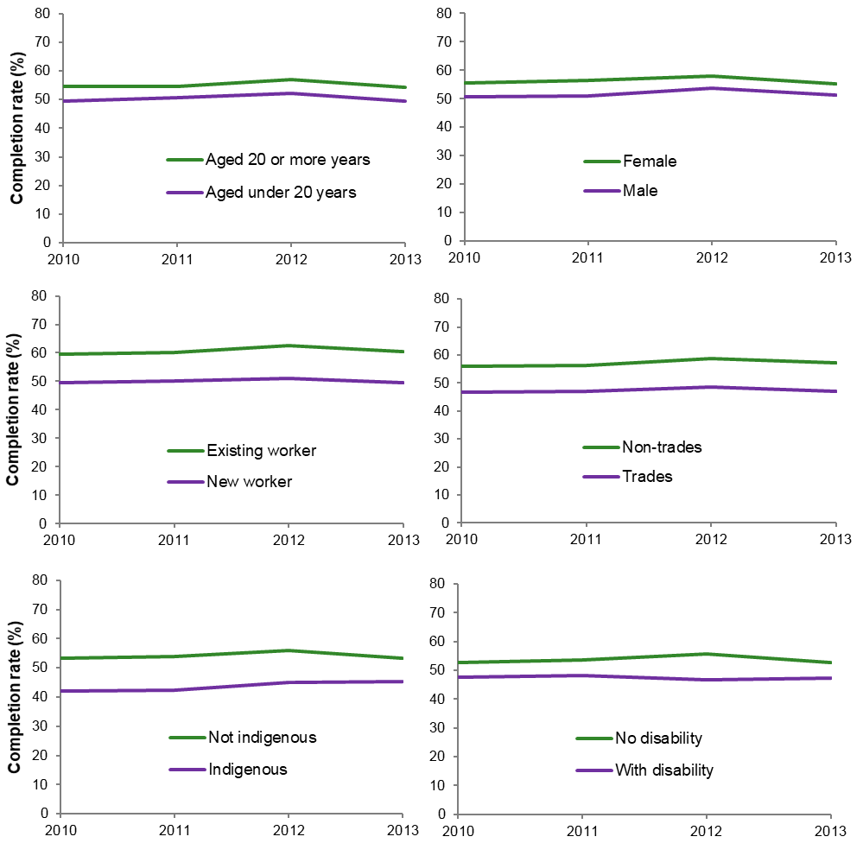

Commencement year

Source: NCVER National Apprentice and Trainee Collection no. 95, unpublished data.

To provide a brief overview of the characteristics of apprentices and trainees with GTOs and direct employers and how they have changed, we compared the 2012 and 2017 cohorts of commencements (table 1).

Compared with those commencing with direct employers, apprentices and trainees commencing in 2012 and 2017 with GTOs were more likely to be:

* younger (aged under 20 years)
* newly commencing workers (who have not worked continuously for more than three months full-time or 12 months casual or part-time, or a combination of both, immediately before the commencement date of the training contract)
* in trade-related occupations
* school-based
* indigenous (although school-based and Indigenous were still a minority of all apprentices and trainees in both employer types).

The profile of GTO apprentices and trainees shows little change since 2012, but apprentices and trainees with direct employers display marked increases in some of these characteristics. For example, the proportion of newly commencing worker apprentices and trainees with direct employers increased from 58.7% to 87.1% but was stable for GTO apprentices and trainees. Even with these increases, direct employers still have relatively smaller proportions of disadvantaged or ‘high risk’ cohorts commencing apprenticeships and traineeships. Data for each state and territory are presented in appendix A (table A1).

Table 1 Profile of commencing apprentices and trainees by employer type, 2012 and 2017

|  |  |  |  |  |  |  |
| --- | --- | --- | --- | --- | --- | --- |
|  | 2012 | | | 2017 | | |
| Characteristic |  | GTOs | Direct employers | | GTOs | Direct employers |
|  |  | % | % |  | % | % |
| Male |  | 66.9 | 56.2 |  | 68.2 | 65.3 |
| Aged under 20 years |  | 71.6 | 30.1 |  | 71.1 | 44.7 |
| Newly commencing worker |  | 96.9 | 58.7 |  | 98.9 | 87.1 |
| School-based |  | 19.5 | 5.4 |  | 17.2 | 10.0 |
| Trade occupations |  | 49.7 | 27.7 |  | 50.3 | 44.1 |
| Indigenous |  | 11.8 | 3.6 |  | 13.1 | 6.1 |
| With a disability |  | 2.3 | 1.6 |  | 2.8 | 2.1 |
| Located in major city |  | 59.2 | 68.4 |  | 63.8 | 63.5 |
| Starting AQF cert. III\* |  | 76.5 | 63.4 |  | 79.2 | 80.6 |

\* Apprentices and trainees may undertake certificate II, III or IV depending on industry.

Note: The total number of cases for each characteristic vary slightly due to ‘not-stated’ data. See table A1 in appendix A for total numbers for each characteristic under ‘Australia’.

Source: NCVER National Apprentices and Trainees Collection no. 95, unpublished data.

## Comparison with small and medium direct employers

Given that GTO apprentices and trainees are generally placed with small or medium host employers, we now compare their completion rates with those with small or medium direct employers. The comparisons of completion rates and commencements shown earlier are between GTOs and all direct employers. However, the structure of group training was primarily designed to assist small and medium businesses. Small and medium businesses are more likely to require the administrative and pastoral care support that GTOs provide than large businesses, which may have their own support structures in place (ACIL Allen Consulting 2014).

We use Australian Bureau of Statistics (ABS) definitions for employer size: small businesses are defined as employing fewer than 20 persons (including non-employing businesses); medium businesses employ between 20 and 199 persons; and large businesses 200 or more persons.[[4]](#footnote-4)

Completion rates for non-trade apprentices and trainees at GTOs have been higher than those at small and medium direct employers in recent years (figure 4). Completion rates for non-trades apprentices and trainees with GTOs were similar to large direct employers until 2012, diverging slightly in 2013 then further for the 2014 commencing cohort, when rates for large direct employers declined from 59.5% (2013 cohort) to 54.9% (2014 cohort). During this time rates for GTOs remained relatively stable at around 62-64%. See figure A3 in appendix A for breakdown by jurisdictions.

Figure 4 Contract completion rates for apprentices and trainees in non-trade occupations by employer type and size and commencing year, 2010−14 (%)

Note: Employer size for Queensland was not reported, so these contracts are not included in small and medium, or large direct employer groups. Data for completion rates are not yet available after 2013 for trades and 2014 for non-trades.

Source: NCVER National Apprentices and Trainees Collection, no. 95.

Completion rates for trade apprentices and trainees at GTOs have also been consistently above small and medium direct employers, but well below large direct employers   
(figure 5). See figure A4 in appendix A for breakdown by jurisdictions.

Figure 5 Contract completion rates for apprentices and trainees in trade occupations by employer type and size and commencing year, 2010−13 (%)

Note: Employer size for Queensland was not reported, so these contracts are not included in small and medium, or large direct employer groups. Data for completion rates are not yet available after 2013 for trades and 2014 for non-trades.

Source: NCVER National Apprentices and Trainees Collection, no. 95.

## Comparing completion rates for equivalent demographic groups

The profile analyses show that GTOs have more young and new worker apprentices and trainees than direct employers. If the differing demographic profiles of the GTO and direct employer cohorts explain the difference in completion rates, then comparisons of ‘like-for-like’, that is, the same demographic group within each employer type, should show similar completion rates. We thus combine these groups of young and new worker apprentices and trainees (excluding school-based apprentices and trainees) and define them as the comparison group, and then compare the completion rates for this comparison group for each employer type. In effect, this comparison controls for these differences in the demographic profiles of the two employer types (young and new worker differences).

Completion rates for GTO apprentices and trainees in the comparison group in non-trade occupations have been consistently higher than with small and medium, and large direct employers (figure 6). For trade occupations, the completion rate at GTOs was higher than small and medium direct employers, but still well below that of large direct employers (figure 7). See figures A5 and A6 in appendix A for breakdown by jurisdictions.

Figure 6 Contract completion rates for the comparison group in non-trade occupations by employer type and size and commencing year, 2010−14 (%)

Note: Employer size for Queensland was not reported, so these contracts are not included in small and medium, or large direct employer groups. Rates for all GTOs except those in Queensland are reported. Data for completion rates are not yet available after 2013 for trades and 2014 for non-trades.

Source: NCVER National Apprentices and Trainees Collection, no. 95.

Figure 7 Contract completion rates for the comparison group in trade occupations by employer type and size and commencing year, 2010−14 (%)

Note: Employer size for Queensland was not reported, so these contracts are not included in small and medium, or large direct employer groups. Rates for all GTOs except those in Queensland are reported. Data for completion rates are not yet available after 2013 for trades and 2014 for non-trades.

Source: NCVER National Apprentices and Trainees Collection, no. 95.

## Transfers to direct employers

We examine the incidence of transfers from GTOs to direct employers because the recording system can artificially reduce completion rates for the GTO; that is, although the apprentice or trainee may complete with a direct employer, the GTO must report a cancellation for that individual. Table 2 shows indicative estimates (which must be viewed with caution; see the detailed note on their construction on the following page), suggesting that the incidence of apprentices and trainees who commenced with a GTO but completed with a direct employer in the same occupation is modest but material in size; the average is 7% of GTO apprentices and trainees, with variations by state, ranging from 4% in South Australia to 9% in New South Wales and the Northern Territory. For Australia, the proportion transferring from GTOs to direct employers is higher than for any other type of transfer, although in absolute terms the numbers moving between the two employer types are similar (this is often the case for most jurisdictions but with some exceptions).

Note that these data cannot identify the circumstances of the transfers; for example, where a direct employer offers an individual apprentice or trainee better conditions, such as higher wages, to leave the GTO and continue with them, or transfers for other reasons. The interview results later in this report shed more light on these aspects of transfers.

Table 2 gives an approximation intended to show the order of magnitude of the number of transfers occurring in the 2013 commencing cohort. This approximation used the following steps:

* All records of an apprentice or trainee commencing or recommencing a contract in 2013 were selected by employer type.
* Those records were linked by client identifier with all records of the apprentice or trainee completing a contract with a different employer in 2013 or later, which may include the same employer type.
* All cases in which the commencing or recommencing contract and the completed contract had the same intended occupation were counted.

The approximation does not account for cases where more than one transfer is made by the same individual in various other permutations, such as transferring from a GTO to a direct employer and back to the GTO, or GTO to GTO to direct employer and so on.

Table 2 Proportion of GTO contract commencements in 2013‡ resulting in transfers to direct employers by state/territory

|  |  |  |  |  |
| --- | --- | --- | --- | --- |
|  | | | | |
| State | GTO to direct employer (%) | Direct employer to GTO (%) | GTO to GTO (%) | Direct employer to direct employer (%) |
| NSW | 9 | 0.3 | 3 | 7 |
| VIC | 5 | 0.3 | 1 | 5 |
| QLD | 7 | 0.4 | 4 | 6 |
| SA | 4 | 0.3 | 1 | 2 |
| WA | 7 | 0.3 | 4 | 4 |
| TAS | 5 | 0.3 | 6 | 7 |
| NT | 9 | 0.2 | 2 | 6 |
| ACT | 7 | 0.2 | 21 | 16 |
| Australia | 7 | 0.3 | 3 | 6 |
| Number of transfers | 1 267 | 849 | 547 | 13 852 |

‡ Most recent year for finalised completion rates at time of writing.

Note: 1. An apprentice or trainee can be counted multiple times if they commenced or recommenced multiple   
 contracts or completed multiple contracts.

2. The apprentice or trainee may have initially transferred to another employer before completing with a   
 direct employer.

3. This does not take into account at what stage of the contract the apprentice or trainee transferred.

Source: NCVER Apprentices and Trainees Collection, no. 95.

# GTO case study: East Coast Apprenticeships, Queensland

This case study explores the data on cancellations and completions in a single GTO. GTO apprentice and trainee outcomes can differ according to location, industry, industry engagement and management practices, but their fundamental operations are similar. Using the East Coast Apprenticeships (ECA) records of cancellations and completions, we have the opportunity to further explore the characteristics of a specific GTO but within the broader context of GTOs. ECA is a Queensland-based GTO employing apprentices and trainees in all industry areas, with a focus on the traditional trades. Focusing on a single GTO controls for the influence of available supports on the observed outcomes, as the supports described can be reasonably assumed to be available for all apprentices and trainees in the same organisation, including those who complete and those who cancel. Any differences between the two groups can thus be more reasonably attributed to factors other than those associated with the strategies of the GTO.

The ECA dataset includes details for apprentices and trainees who commenced with ECA, but then cancelled and completed with another employer or are still continuing the apprenticeship or traineeship with another employer. Their completion status was recorded by ECA using the Direct Entry Level Training Administration (DELTA) database, the Queensland Department of Employment, Small Business and Training's database of registered apprentices and trainees. The dataset does not include apprentices and trainees currently employed by ECA. Individual-level data for cancellations of apprentices and trainees commencing in the period 2008−16 (1009 in total) and completions for apprentices and trainees commencing in the period 2003−16 (1529 in total) were supplied for a total of 2536 cases (plus two cases with commencement year missing). Not all fields are available for the whole period and these are noted in the text where relevant. See appendix B for a detailed description of the data. Due to the structure of the dataset, with some missing data for all commencements and no data on cancellations of transferred contracts, ECA completion rates over time could not be computed using the NCVER methodology (see Harvey 2010).

## Profiles of completed and cancelled apprentices and trainees

### Age and gender

The mean age of cancelled apprentices and trainees by year of commencement for the period 2008−16 was 19.1 years (19.0 years for males and 19.4 years for females; the latter represented 27.8% of those who cancelled). For completed apprenticeships and traineeships that commenced in the same period, the mean age was 19.9 years (20.2 years and 19.4 years for males and females respectively, with females comprising 1.7% [10 in total] of completed apprentices and trainees in 2008−16). Apprentices and trainees who cancelled were almost one year younger when commencing than those who completed. There was no difference in age between female apprentices and trainees who cancelled and those who completed.

Figure 8 shows the age by completion and cancellation status and year of commencement for the range of available data. There is an upward trend in the average age of commencement for both cancellations and completions (see dotted lines). The average age of apprentices and trainees who cancel is increasing at a faster rate based on the trendline, suggesting that age may no longer be a predictor of cancellation within the next few years if current trends continue.

Figure 8 Average age when commencing apprenticeship or traineeship with ECA by completion status, 2003−16†

† Average age at commencement for completed apprentices and trainees was not computed for 2016 due to insufficient data.

Source: East Coast Apprenticeships, 2018.

### Trade of apprenticeships and traineeships

Figure 9 shows few differences between the proportions of completions and cancellations of ECA apprentices and trainees, who commenced during 2008−16[[5]](#footnote-5) in the trades. The greatest differences where cancellations exceeded completions were for Food and Cooking and Interior Construction, while Cabinetry and Carpentry, and Engineering showed the greatest differences for completions exceeding cancellations.

Figure 9 ECA trade apprentices and trainees who commenced during 2008-16, by completion status

Data for cancelled apprentices and trainees available only for 2008−16.

Source: East Coast Apprenticeships, 2018.

## Completion status of apprenticeships and traineeships

### Location

Table 3 shows that completion status is not strongly influenced by location. The share of apprentices and trainees who completed while living in a major city was similar to that for other completion statuses.

Table 3 ECA completion status by location for apprentices and trainees commencing in 2008−16

|  |  |  |  |  |  |  |
| --- | --- | --- | --- | --- | --- | --- |
| Completion status | Major metropolitan | Inner regional | Outer regional | Remote/very remote | Total | Number of cases |
| Completed | 83.0 | 16.0 | 0.5 | 0.5 | 100 | 605 |
| Did not complete | 85.0 | 14.0 | 0.4 | 0.6 | 100 | 487 |
| Completed with direct employer | 83.2 | 15.0 | 0.9 | 0.9 | 100 | 220 |
| Continuing with direct employer | 86.7 | 13.3 | 0.0 | 0.0 | 100 | 196 |
| Withdrawn (and cancelled) | 84.5 | 15.5 | 0.0 | 0.0 | 100 | 97 |
| Number of apprentices and trainees | 1 351 | 239 | 7 | 8 | 1 605 |  |

Data 2008−16 due to information for cancellations available only for 2008−16.

Source: East Coast Apprenticeships, 2018.

Apprentices and trainees who lived in major cities were no more likely to complete than those located in inner regional areas (table 4). Apprentices and trainees in regional areas were slightly more likely to complete than apprentices and trainees in other areas and slightly more withdrew or cancelled in outer regional and remote areas, but the number of cases in these areas was very small (15).

Table 4 Location of ECA apprentices and trainees by completion status for those commencing in 2008−16

|  |  |  |  |
| --- | --- | --- | --- |
|  | Major city | Inner regional | Outer regional, remote, very remote |
| Completed | 37.2 | 40.6 | 40.0 |
| Did not complete | 30.6 | 28.5 | 33.3 |
| Completed with direct employer | 13.5 | 13.8 | 26.7 |
| Continuing with direct employer | 12.6 | 10.9 | 0.0 |
| Withdrawn (and cancelled) | 6.1 | 6.3 | 0.0 |
| Total | 100 | 100 | 100 |
| Number of apprentices and trainees | 1 351 | 239 | 15 |

Data 2008−16 due to information on cancellations available only for 2008−16.

Source: East Coast Apprenticeships, 2018.

### Disadvantage

The number of cases of apprentices and trainees with individual markers of disadvantage such as disabilities, non-English speaking backgrounds and Indigenous status was too small to discern any patterns, so a composite indicator of disadvantage was constructed. ‘Disadvantage’ is defined here as one or more of the following characteristics:

* disability
* non-English speaking background
* Indigenous
* located in outer regional, remote or very remote areas
* female in traditional trade.

Table 5 presents completion rates by the aggregated disadvantaged measure, as well as the individual factors, along with other parameters associated with cancellation and completion rates. The worst outcomes were experienced by apprentices and trainees employed under a training incentive that is additional to the Australian Apprenticeships Incentives Programme[[6]](#footnote-6) (of those who started between 2008[[7]](#footnote-7) and 2016, only 1.3% completed, and none transferred to another employer). Female apprentices and trainees and Indigenous apprentices and trainees had poorer outcomes (3.4% and 5.9% completed respectively), although 33.3% of female apprentices and trainees completed or actively continued with a direct employer. Apprentices and trainees who were mature-aged or female were most likely to complete with another employer (32.7% and 23.7% respectively). The highest completion rates were experienced by apprentices and trainees with a disability (but note that this percentage is based on only 19 cases for the whole period), followed by those who were part-time (54.8%) or who had completed a prevocational course (46.5%). Apprentices and trainees who began in the earlier period appear more likely to have completed, but this is merely an artefact of the data collection; completions of those who started after 2013 are not included in the dataset.

Table 5 ECA cancellations and completion rates by selected parameters 2008−16\*

|  |  |  |  |  |  |  |  |  |  |  |  |
| --- | --- | --- | --- | --- | --- | --- | --- | --- | --- | --- | --- |
| Characteristic | Did not complete or withdrawn (and cancelled) | | Completed | | Completed with direct employer | | Continuing with direct employer | | Total | | Number of cases† |
| Disabled | 26.3 | 63.2 | | 5.3 | | 5.3 | | 100 | | 19 | |
| Disadvantaged | 51.5 | 32.7 | | 9.9 | | 5.9 | | 100 | | 101 | |
| Female | 63.2 | 3.4 | | 23.7 | | 9.6 | | 100 | | 291 | |
| Females in traditional trade | 51.1 | 26.7 | | 11.1 | | 11.1 | | 100 | | 45 | |
| Indigenous | 52.9 | 5.9 | | 0.0 | | 41.2 | | 100 | | 17 | |
| Located in outer, remote or very remote area | 34.5 | 40.4 | | 14.9 | | 10.2 | | 100 | | 255 | |
| Mature | 52.4 | 9.3 | | 32.7 | | 5.6 | | 100 | | 557 | |
| Non-English speaking background | 63.2 | 15.8 | | 5.3 | | 15.8 | | 100 | | 19 | |
| Part-time | 25.0 | 54.8 | | 16.9 | | 3.2 | | 100 | | 124 | |
| Completed prevocational course | 24.9 | 46.5 | | 14.1 | | 14.5 | | 100 | | 125 | |
| School-based | 57.1 | 28.6 | | 14.3 | | 0.0 | | 100 | | 14 | |
| Started 2008−12 | 30.3 | 47.2 | | 19.7 | | 2.8 | | 100 | | 861 | |
| Started 2013−16 | 43.6 | 26.5 | | 7.0 | | 22.8 | | 100 | | 754 | |
| Employed under training incentive‡ | 98.7 | 1.3 | | 0.0 | | 0.0 | | 100 | | 312 | |
| Overall total | **36.5** | **37.5** | | **13.8** | | **12.1** | | **100** | | **1 615** | |

\* Although data for completions is available for apprentices and trainees who commenced from 2003 and then cancelled, we use commencement data for 2008-2016 for comparability with the time period for apprentices and trainees who cancelled (i.e. 2008-2016).

† Many apprentices and trainees may have more than one of the listed characteristics, and so the numbers in each group are not mutually exclusive.

‡ These training incentives are additional to the Australian Apprenticeships Incentives Programme.

Source: East Coast Apprenticeships, 2018.

## Comparison of completed GTO apprentices and trainees with those completing with or transferring to direct employers

Of the 1009 apprentices and trainees whose contracts with ECA were cancelled, cross-checking conducted by ECA with the Queensland Government’s (DELTA) showed that 22.1% completed with another employer and 19.4% were still actively continuing with another employer.

### Age

On average, and based on the period 2009−15,[[8]](#footnote-8) completing apprentices and trainees who stayed with ECA were 10.6 months older than those who completed with another employer when they began their apprenticeship or traineeship,[[9]](#footnote-9) and this difference is statistically significant.[[10]](#footnote-10) The difference in apprentice and trainee age was not consistent for each year during the period 2009−15: transferred apprentices and trainees were always younger on average, but the difference varied from 3.1 years in 2011 to negligible (0.2 years) in 2015 (figure 10). There has been a slight upward trend in age at the time of commencement for transferred apprentices and trainees: in 2009 the average age was 18.4, but by 2015 it was 19.3. Both groups had older ages at commencement in 2011, but the pattern for age at commencement for apprentices and trainees who completed with ECA is erratic.

Figure 10 ECA apprentice and trainee mean age when started by host type, 2009−15

Note: Insufficient data are available for transferred apprentices/trainees prior to 2009, while those who started after 2015 are assumed to have not yet completed and are not included in the dataset.

Source: East Coast Apprenticeships, 2018.

### Gender

Of the 282 female apprentices and trainees commencing with ECA, 24.5% completed with another employer. Just under one-third (31.4%) of apprentices and trainees who transferred were female, compared with 1.6% of all apprentices and trainees who completed with ECA, and an additional 15.4% transferred and were continuing with another employer. These patterns could be interpreted in several ways. One is that females are concentrated in trades that are in higher demand and thus more likely to be sought by direct employers; another is that the conditions offered by direct employers are more attractive to females than males. The reasons for such preferences might be associated with the GTO environment or with the individual. There was no significant difference in age between females who transferred and those who did not,[[11]](#footnote-11) but those who transferred were more likely to work in cabinetry and carpentry (37.5% of transferring female apprentices and trainees worked in this field, compared with 23.1% of female apprentices and trainees who completed with ECA), and they were less likely to work in automotive and food and cooking (2.1% vs 9.7% and 6.3% vs 11.3% for these trade respectively).

### Disadvantage

The level of disadvantage in the two groups for the period 2009—15[[12]](#footnote-12) was comparable, at 5.3% (total of 491) for apprentices and trainees who completed with ECA and 4.5% (total of 223) for those completing with another employer, for all cases in the dataset. The small number of cases precluded a time series analysis.

### Trades

Figure 11 shows no major differences in any particular trade for the propensity to transfer to a different employer, although transfers were least likely in engineering.

Figure 11 Trades of apprentices and trainees who transferred and those who stayed with ECA, 2009–15

Note: see footnote 12, below.

Source: East Coast Apprenticeships, 2018.

# Views on issues underlying completion rates

To gain a more in-depth understanding of the factors influencing completion rates, qualitative telephone interviews were conducted with 15 GTOs and nine direct employers in rural and metropolitan areas in New South Wales, Victoria, Queensland, South Australia and Western Australia.[[13]](#footnote-13) Details of how the interview participants were selected for the study and their locations, together with the interview schedule, are provided in appendix C.

Most of the participating GTOs provided training in a range of trades and non-trades occupations. The numbers of apprentices and trainees employed by the participating GTOs ranged from 85 to 700 in a large range of trades and non-trades. Eight of the 15 GTOs had more than 300 apprentices or trainees. Apprentices outnumbered trainees in all GTOs except one based in a rural area, which had an equal balance. Almost all (more than 90%) of the apprentices and trainees were undertaking a certificate III, with a few doing certificates II and IV.

Among the participating direct employers, one had no apprentices or trainees at the time of the interview but expected to have 35 in 2019, and had employed apprentices in the past. None of the other participants had more than five apprentices or trainees: six had only one or two, one had four, and one had five, and these numbers had not changed much over the previous five years. This pattern is consistent with the pattern reported by Karmel and Roberts (2012), who found that 63% of employers have only one apprentice or trainee; 20% had two apprentices or trainees, and just 17% had three or more apprentices or trainees. Thus many of the questions asked of the GTOs did not apply to the direct employers who did not have large groups of apprentices and trainees, and they were unable to make generalisations about trends or describe patterns. Instead, the responses themselves have been aggregated. All apprentices and trainees were completing certificate III.

The themes summarised here contribute additional insights by employer type. They are consistent with previous research (for example, Bender 2003; Karmel & Misko 2009; Karmel & Roberts 2012; Bednarz 2014; Couldrey & Loveder 2017; Nelms et al. 2017) on the motivations, supports, workplace cultures, and individual-level disadvantages for apprentices and trainees in general.

## Likelihood of completing

### GTOs

The GTOs interviewed showed no consistent pattern in completion rates over the last five to 10 years. Improvements in completions were viewed as due to weekly site visits with individual apprentices and trainees; apprentices and trainees having undertaken pre-training, such as participation in VET in Schools and prevocational courses; improved working conditions and support for apprentices and trainees, including the consistency and stability provided by long-term staff; GTOs no longer being involved in industries with low retention rates (such as hairdressing and hospitality); and booming economic activity. Declines were attributed to losing more people in the first six months of the apprenticeship or traineeship than previously experienced,[[14]](#footnote-14) increasing incidence of mental health issues among apprentices and trainees, lack of economic recovery, a crowded marketplace with increased competition for apprentices and trainees from other employers, more apprentices and trainees from disadvantaged backgrounds, and, for those in rural areas, the impact of drought.

### Direct employers

The opinions from direct employers were based more on their perceptions of the characteristics of their individual apprentices or trainees rather than on past experiences of completion rates. Most direct employer respondents expected their current apprentices and trainees to complete.

## Factors in completions

Both employer types referred to drive, resilience and motivation, and the support offered by social networks and connections to the workplace as contributing to completions.

### GTOs

Interviewees from GTOs claimed that apprentices and trainees who had undertaken prevocational training and VET in Schools were less likely to drop out, while participation in such courses improved their confidence and enabled them to become familiar with VET jargon and terminology. These earlier VET offerings gave potential apprentices and trainees insights into what could be expected from VET study and allowed them to ‘test the water’. The recruitment practices adopted by GTOs, along with the age and maturity of the apprentice or trainee were also important.

Reasons for non-completion included:

* Non-completers included transient workers who are able to leave and find work elsewhere when unemployment rates are low (that is, a tendency to select short-term gains over long-term outcomes).
* The non-completers had unrealistic or naive expectations or lack of prior knowledge of what is actually involved.
* They didn’t enjoy the work.
* Some had mental health issues, while others displayed a lack of resilience and had issues with communication and generational differences.
* Some of the older-aged non-completers (that is, at a later stage of life course) withdrew at commencement, citing their need for a higher income.
* GTOs were competing with universities for students.

Two GTOs referred to ‘late transfers’ to direct employers; that is, transfers towards the end of the apprenticeship or traineeship, which they termed ‘poaching’. Similar findings have been previously reported by others (see literature review in support document).

### Direct employers

Only four of the nine direct employer respondents had employed apprentices or trainees in the past who had successfully completed. They identified the following factors as associated with successful completions:

* good mentors, who nurture the apprentices and trainees, given that nurturing is necessary due to the level of maturity and life experience of young people
* good relationships with TAFE, including informing the employer about apprentices’ and trainees’ progress
* the extent of apprentices’ and trainees’ ability to think independently and on the spot
* apprentices and trainees equipped with a long-term outlook.

One direct employer respondent felt that personal characteristics were the most important factor.

## Literacy and numeracy

Both groups saw literacy and numeracy levels as problematic, but some GTOs saw no link with completion rates.

### GTOs

GTOs responded that poor literacy and numeracy have always been prevalent in particular fields, particularly hospitality. Vocabulary, verbal communication skills and handwriting may also have deteriorated. That said, GTOs did not necessarily see a relationship between poor literacy and numeracy and completion levels, because problems were identified at the application or recruitment stage, meaning that support and counselling were offered at that point. Some noted that applications were not necessarily a good indicator of literacy because parents sometimes wrote the applications on behalf of the potential apprentice or trainee.

Several GTOs emphasised that support training is made relevant to the workplace, which is a key difference in the way literacy and numeracy are taught in schools.

Poorer verbal and written communication skills were attributed by some to generational differences between workplace supervisors and GTO apprentices and trainees. Also, the most literate and numerate individuals (who may also possess higher academic ability) often choose higher education.

Not all GTO respondents had observed declining levels of literacy and numeracy. Some saw no change, or even claimed that levels had improved, which they attributed to apprentices and trainees now being generally older and usually having completed Year 12.

### Direct employers

Numeracy rather than literacy was the main focus for most direct employer respondents. Two reported that they look at school results to gauge literacy and numeracy.

Other key points made by direct employers included:

* Literacy and numeracy problems were more common with males (employer with horticulture apprenticeships).
* Computer literacy had been problematic in the past for older trainees (although traineeships are no longer offered in that organisation).
* Problems lie not only with apprentices and trainees but also with qualified tradespeople.

These patterns are likely to be shared by both employer types.

## Motivation

GTOs and direct employers agreed that motivation was very important for apprentices and trainees and had observed differing levels of motivation among their apprentices and trainees, depending on type of work and contract duration. Both also noted that external factors, such as prevailing economic conditions, rather than intrinsic motivation, can also motivate apprentices and trainees to keep going, especially if few other employment options are available. This is particularly pertinent to the period since 2002, which encompassed the GFC, the end of the mining boom and the collapse of the Australian car manufacturing industry.

### GTOs

Very few GTO apprentices and trainees were *not* motivated. ‘Unmotivated’ apprentices and trainees are less likely to stay in the industry, often only completing their training to have a qualification under their belt.

Differences in the presence or degree of motivation mean that training must be customised to the individual and that GTO field officers need to meet with some more often than others.

Several respondents pointed out that motivation is difficult to measure and can waver during the four years. Keeping this demographic group engaged and motivated for this length of time can be a challenge. Motivation levels of GTO trainees were generally not perceived as a problem as they are in training for a shorter period.

The main means of maintaining motivation was mentoring, including face-to-face site visits with a ‘personal touch’, with the aim of building a trusted relationship between the field officer and the apprentice or trainee.

The GTO apprentice reported several factors that contributed to his personal motivation: he had heard good things about this particular GTO from his social network, including that it had a good range of options for apprenticeships in different areas and provided good support; the variety of tasks available appealed to him, meaning that he was never bored; and he had the opportunity to learn about things he would otherwise never have known.

### Direct employers

One respondent in local government with five horticulture apprentices described their motivation during the apprenticeship as:

some rough patches, but generally, they want to be there. They can see outcomes for previous apprentices who are now working with the Council. They know they have a chance in the organisation. Trainees in the past are now in more senior roles and set an example for others to do traineeships too.

The role of social networks as a source of motivation was seen to work both ways.

The directly employed respondents reported slightly different motivations for undertaking their apprenticeships: one wanted to ‘get his life started’ in the sense of having an income and the privileges of being an independent adult, while another already had an interest in gardening and liked being outside. In both cases, they were encouraged by their parents. Social networks played a strong role in their decisions (or opportunities) to work for this particular organisation. One knew a mate already working there, and the other ‘knew one of the bosses’. Other factors contributing to continuing motivation were friendly relationships with co-workers (‘being around the boys’), suitable hours, having a rostered day off every two weeks and the opportunity to spend time outside.

## Advantages of GTO system for apprentices and trainees

### GTOs

The main advantages of employment and work placement through a GTO included security of employment (and correct rates of payment), support from field officers or mentors, flexibility in contract arrangements such as suspensions and the ability to move apprentices and trainees to different host employers, and the ability to gain a range of skills and experiences.

One respondent also commented that ‘parents love the safety net of the GTO’. This statement implies that parents also have a strong influence on whether apprentices and trainees undertake their qualification through a GTO rather than a direct employer — and therefore perhaps on completion rates via their support.

The GTO apprentice felt that his employment arrangement offered good security and provided a good variety of work.

### Direct employers

Only two of the nine direct employer respondents were familiar with the concept of GTOs and how they operate. Those who were previously unfamiliar with GTOs suggested that apprentices and trainees are likely to get better training with a direct employer, that they can be pushed harder and can be offered incentives such as higher wages.

A local government direct employer (with more than 700 employees) acknowledged that most private enterprises are SMEs and may not have the range of experiences or opportunities that are available through a GTO. Several direct employers observed that some apprentices and trainees end up with ‘shoddy’ and ‘shonky’ employers, who treated them as cheap labour and prevented them from undertaking their off-the-job training. Direct employer respondents acknowledged that direct employers generally do not have the time to provide one-on-one attention, even when they only have one or two apprentices or trainees.

## Disadvantages of GTOs for apprentices and trainees

### GTOs

Interview respondents felt that the advantages of training through GTOs far outweighed the disadvantages. They also emphasised that most of the disadvantages were experienced by the GTO itself rather than the GTO apprentices and trainees. The disadvantages as perceived for apprentices and trainees included:

* disconnection or disengagement from host employer if treated like a contractor rather than an employee
* a sense that they are not fully employed by the host company they are working for, even when treated as an employee day to day; some GTO apprentices and trainees fear that they may not receive the same benefits as other employed workers such as long service and sick leave accrual
* confusion over who their legal employer is
* generally not being paid above the minimum award wage (although GTOs can also pay above-award wages), while above-award rates are more frequently paid by host employers
* GTOs being unable to offer the same incentives as direct employers (for example, bonuses, free lunches)
* being under constant observation or monitoring from GTO administrators, which may be distracting or stressful for some GTO apprentices and trainees
* the obligation to comply with safety regulations when hosts do not (for example, the requirement for long sleeves in hot weather)
* some older workers in host employers, who are not up to date with new work methods (although this concern is not specific to group training, and GTO field officers can help bridge any gaps)
* poor continuity if rotations are frequent.

Disadvantages for the GTOs were identified as:

* being ‘stuck’ with problem apprentices and trainees
* frequent auditing and associated administrative burden, given that GTOs are required to report on their operations and outcomes more frequently than direct employers and meet registration requirements against national standards
* perceptions amongst some direct employers that the cost of hosting GTO apprentices and trainees is too expensive.

### Direct employers

Direct employers had no views on the disadvantages of the GTO system for apprentices and trainees.

## Transfers from GTOs to direct employers

Three of the 16 GTO respondents mentioned apprentices and trainees who were close to completion transferring to direct employers, which they termed ‘poaching’. It is difficult for GTOs to know whether transferred apprentices and trainees actually complete. The movements of apprentices and trainees between two or more employers (for example, between a GTO and a direct employer) may also artificially reduce apparent completion rates. An individual apprentice may have two (or more) contracts recorded, with only one showing a completion and the other showing a cancellation rather than a transfer; that is, the completion is recorded as part of the contract with the direct employer, while the record of the contract with the GTO shows a cancellation.[[15]](#footnote-15)

It was reported by these respondents that some private enterprises[[16]](#footnote-16) see the GTO as a recruitment service or a pool of new or continuing apprentices and trainees. The rate of these types of transfers was viewed by respondents as corresponding with demand in the industry, so that industry booms lead to increased transfers, often of the most promising apprentices and trainees.

Transfers of apprentices and trainees is a risk managed by all GTOs: how the risk is managed is determined by individual GTOs through their business model or contractual arrangements with host businesses.

## Changes in organisational policies, processes or procedures

### GTOs

#### Constant change

Respondents were keenly aware that in their industry the ‘goal posts are always moving’, so that improvement measures and review of practice must be continuous and ongoing. These goal posts include standards of best practice, performance management, quality assurance and completion rates. Unlike private enterprises, GTOs are regularly audited, and so high completion rates (the most easily quantified and comparable measures) are important in demonstrating the GTO program’s value for money. A range of strategies to improve completion rates with GTOs are reported immediately below.

#### Recruitment, marketing and promotion of GTOs and stakeholder relationships

##### Recruitment

Most respondents identified improved recruitment methods as an example of a strategy for improving completion rates. The rigour of GTOs’ recruitment processes was described as equal to those of any other employer. These recruitment processes did not necessarily disadvantage individuals needing extra appropriate and sufficient support.

Liaising with high schools was a common means of recruitment and communication with prospective apprentices and trainees, where the benefits of GTOs over direct employers is emphasised. GTOs claimed that visiting schools offered an important opportunity to counteract the limited and often poor-quality career advice given at schools.

##### Stakeholder relationships

GTOs maintained good relationships with schools and school leavers, career changers, employment service providers, unemployed persons and registered training organisations (RTOs). Relationships with host employers are particularly important for GTOs in rural areas, where there are fewer options.

#### Promote interest, engagement and life skills

Activities to build teamwork, engagement, enjoyment and even excitement may be more suited to some work areas than others. Fields such as plumbing, warehousing or bricklaying may be less amenable to a competitive prize or event approach, but creative alternatives supported by the GTO may be possible.

Respondents all had a keen understanding of the effect of being young and an individual’s lifestyle on life and career decisions, recognising that young people today face different issues and have different characteristics from those of previous decades. GTOs offer the following supports:

* the option to suspend training rather than cancel the apprenticeship or traineeship if an individual needs several months to recover from a mental health incident
* life skills programs, addressing finance/budgeting, communication, drugs and alcohol, conflict resolution, dealing with difficult people, mental health and use of IT (familiarity with mobile phones does not necessarily translate to proficiency with other forms of IT)
* updates in life skills training throughout the apprenticeship or traineeship
* clear, plain language policies on employee conduct
* access to employee assistance programs.

Many respondents mentioned the need for (and lack of) resilience amongst the current generation of apprentices and trainees, compared with those of the past. At least two attributed this change to modern parenting styles involving insufficient accountability and lack of consequences.

Support for literacy and numeracy deficits is provided in the form of special classes or tutorials, usually provided by the GTO but also by some host employers. Several respondents pointed out that individuals with low literacy and numeracy fare better with face-to-face teaching, and that online training is an unsatisfactory solution because it requires some existing literacy.

#### Communication and staff training

Communication and pastoral care were very important in supporting GTO apprentices’ and trainees’ employment and training experiences and thus for maximising completion rates. Many noted the importance of timely intervention at earlier stages, which had not occurred in the past.

Many GTOs have adapted their communication processes to make use of social media and online technology, given their use by younger generations, such as using Twitter, Instagram and Facebook. Conversely, some GTOs found that personal interaction rather than other forms of communication is preferable, ‘because people are social beings’.

Some GTOs invested in training for mentors, such as training on non-emotional bias and body language. GTOs have found that investment in staffing in areas such as cultural awareness and psychological first aid leads to increased completion rates.

#### Monitoring schedule and support

GTOs reported that the frequency and timing of schedules for monitoring apprentices and trainees is a key strategy in assisting to maximise retention. The first six and 12 months are important for identifying problems early on and for building rapport. Increased engagement was also said to be necessary at the five to 11-month mark, a time when some apprentices and trainees become overconfident. Performance appraisal documents are continuously updated rather than fixed or intermittent. Some GTOs track reasons for cancellations and use exit surveys as a way to improve their support processes.

Some GTOs expressed the view that, in the past, mental health and drugs and alcohol issues often led to cancellations. These GTOs said they are now more likely to suspend training contracts so that individuals can recover and recommence.

#### Incident reporting and OHS

A few respondents mentioned that their improved OHS processes have helped to increase completion rates. The increased attention to health and safety, which includes good incident-reporting processes, regular toolbox meetings and updated checklists, has resulted in better employee confidence and fewer injuries. Most respondents did not refer to changes in OHS as a factor in completions, possibly because existing measures have been in place for some time.

### Direct employers

The question on changes in organisational policies, processes or procedures over time was phrased slightly differently for direct employers, with their responses also implying that, although they would like to make changes, they were constrained by regulations, red tape and costs. The small number of apprentices and trainees with most direct employers made it difficult for them to discern any long-term or wide-ranging patterns.

## The role of rotations between host employers in GTOs

The aim of the practice of rotating GTO apprentices between different host employers is to provide the apprentice with a well-rounded training and employment experience and to keep the apprentices in work, with both of these elements promoting retention and completion (trainees are less commonly rotated because of the shorter length of the training contract and so this section generally applies to apprentices only). Other reasons for the use of rotations include exposure to different units of competency and skill sets through different workplaces, lack of work at a host employer, workplace health and safety (OHS) issues, personal issues for the GTO apprentice, and other unforeseen challenges for the host business that have made hosting an apprentice difficult.

The practice of rotations for apprentices differs between GTOs. Many GTOs did not rotate at all; some rotated every six months and some four or five times per year. Whether rotations are used and the frequency and benefits of rotation depend on the particular industry and the needs of individual apprentices. GTOs with apprentices in hospitality, construction, carpentry and electrical tend to use frequent rotation.

The practice of rotation has both advantages and disadvantages for apprentices. Some apprentices dislike rotation because of the disruption to established workplace routines and also because they are forced to work with new people. Several GTOs reported that minimising rotation has helped with completion rates by preventing apprentices from becoming disengaged. One respondent commented that rotation — along with greater support and mentoring — in instances of poor performance or workplace conflict prevents around 60% of these apprentices from leaving, so its effect on completion rates can work both ways.

Even when activity is quiet, some workplaces prefer to continue to host-employ the GTO apprentice and their own staff due to the difficulty of replacing them later. Rotations can be helpful when the fit between the apprentice and host employer does not work. GTOs in rural areas noted that they do not have the same opportunities to rotate as in the city.

Other important points were that rotation is difficult when the industry is busy and is very time-consuming for the GTO. A further difficulty is having to pay fourth-year rates to fourth-year apprentices who have not had four years of experience on the new task.

# P:\PublicationComponents\Icons\References_Green.emf References

ACIL Allen Consulting 2014, *Review of JGTP and group training: the Joint Group Training Program and role of group training*, ACIL Allen Consulting, Melbourne, viewed 1 April 2019, <http://www.acilallen.com.au/cms\_files/ACILAllen\_JointGroupTrainingProgram.pdf>.

ABS (Australian Bureau of Statistics) 2013, *Australian and New Zealand Standard Classification of Occupations version 1.2*, cat.no.1220.0, viewed 6 August 2019, <http://www.abs.gov.au/AUSSTATS/abs@.nsf/Lookup/1220.0Main+Features12013,%20Version%201.2?OpenDocument>.

Australian Government 2017, Revised National Standards for Group Training Organisations, <<https://www.australianapprenticeships.gov.au/sites/d8ausapps/files/2019-05/National%20Standards%20for%20GTOs.pdf>>.

Australian Department of Industry, Innovation and Science 2019, *Overview of the Australian Apprenticeships Incentives Programme*, viewed 6 August 2019, <<https://www.business.gov.au/assistance/australian-apprenticeships-incentives-programme>>.

Bednarz, A 2012, *Lifting the lid on completion rates in the VET sector: how they are defined and derived*, NCVER, Adelaide.

——2014, *Understanding the non-completion of apprentices*, NCVER, Adelaide.

Bender, A, 2003, 'Factors influencing completions in Australia’s apprenticeship system', paper to the Sixth Australian VET Research Association conference: the changing face of VET, Nowra, <<https://www.avetra.org.au/data/Conference_2003_pres./37_Axel_Bender.pdf>>.

Couldrey, M & Loveder, P 2017, *The future of Australian apprenticeships: report of the stakeholder forum*, NCVER, Adelaide.

Harvey, B, 2010, *Apprentice and trainee statistics: estimation of contract completion and attrition rates*, NCVER, Adelaide.

Karmel, T & Misko, J 2009, *Apprenticeships and traineeships in the downturn*, NCVER occasional paper, NCVER, Adelaide.

Karmel, T & Roberts, D 2012, *The role of ‘culture’ in apprenticeship completions*, NCVER, Adelaide.

NCVER (National Centre for Vocational Education Research) 2018a, *Apprentices and trainees — terms and definitions*, [Adelaide.](https://www.ncver.edu.au/__data/assets/pdf_file/0021/2903403/Terms-and-definitions.pdf)

——2018b, ‘National Apprentice and Trainee Collection no. 99, December quarter’, unpublished data, Adelaide.

Nelms, L, Yuen, K, Pung, A, Farooqui, S, Walsh, J & Karmel, T 2017, *Factors affecting apprenticeships and traineeships*, Research report no. 3/2017, Fair Work Commission, Melbourne, viewed 6 August 2019, <https://www.fwc.gov.au/documents/sites/wagereview2017/research/apprenticetrainee.pdf>.

# 

# P:\PublicationComponents\Icons\PaperClip_Purple.emf Appendix

## Appendix A: National Apprentice and Trainee Collection and breakdown by jurisdictions

The National Apprentice and Trainee Collection (NATC) provides data on all persons employed under a training contract and includes both apprentices and trainees. Data are collected from state training authorities on training activity in apprenticeships and traineeships in Australia, including information on training rates and duration of training. The records submitted include information on the following:

* people who have participated in an apprenticeship/traineeship training contract[[17]](#footnote-17), including their demographics, schooling and prior education and cultural and language attributes
* all training contract transactions, including each commencement, cancellation, withdrawal, completion or expiry associated with the life of the apprenticeship/traineeship training contract
* each employer participating in an apprenticeship/traineeship training contract
* each program undertaken as part of the apprenticeship/traineeship training contract
* each RTO associated with an apprenticeship/traineeship training contract.

Each state training authority collects information from the apprenticeship/traineeship training contract, which was completed by the employer and apprentice or trainee. The training authority then supplies the data to NCVER.

Figure A1 shows that trades completion rates for GTOs and direct employers varied in most states, although were similar for New South Wales, Western Australia and Tasmania. Completion rates were markedly higher for GTOs in non-trades than for direct employers in non-trades in South Australia between 2002 and 2007 and from 2011.

Figure A1 Apprentice and trainee completion rates by employer type, trade status and state or territory, 2002–13/14

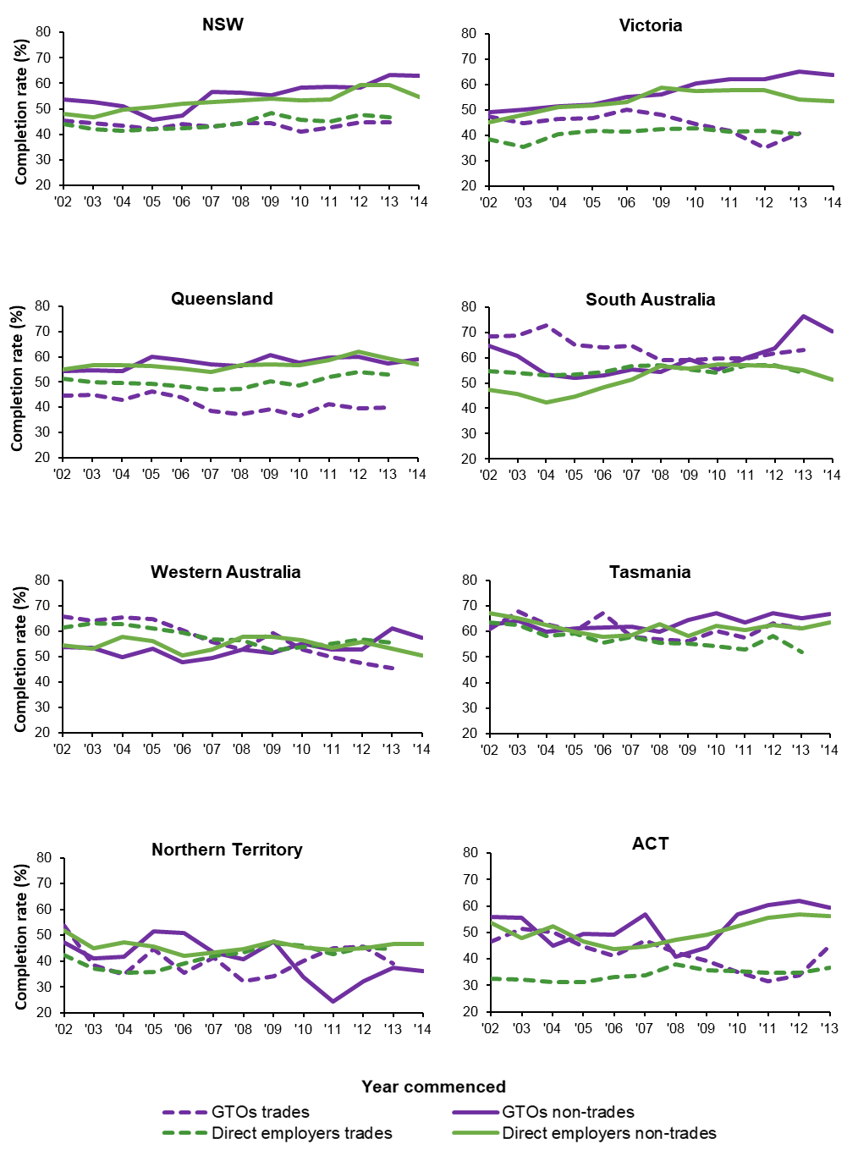

Source: NCVER National Apprentices and Trainees Collection, no. 95 unpublished data.

The patterns for the states and territories other than New South Wales (figure A2) vary in the timing of peaks and troughs but show a clearer relationship with unemployment than with growth in gross state production (GSP).

Figure A2 Completion rates by employer type 2002–13 and economic activity indicators, states and territories, Australia, 2002–18

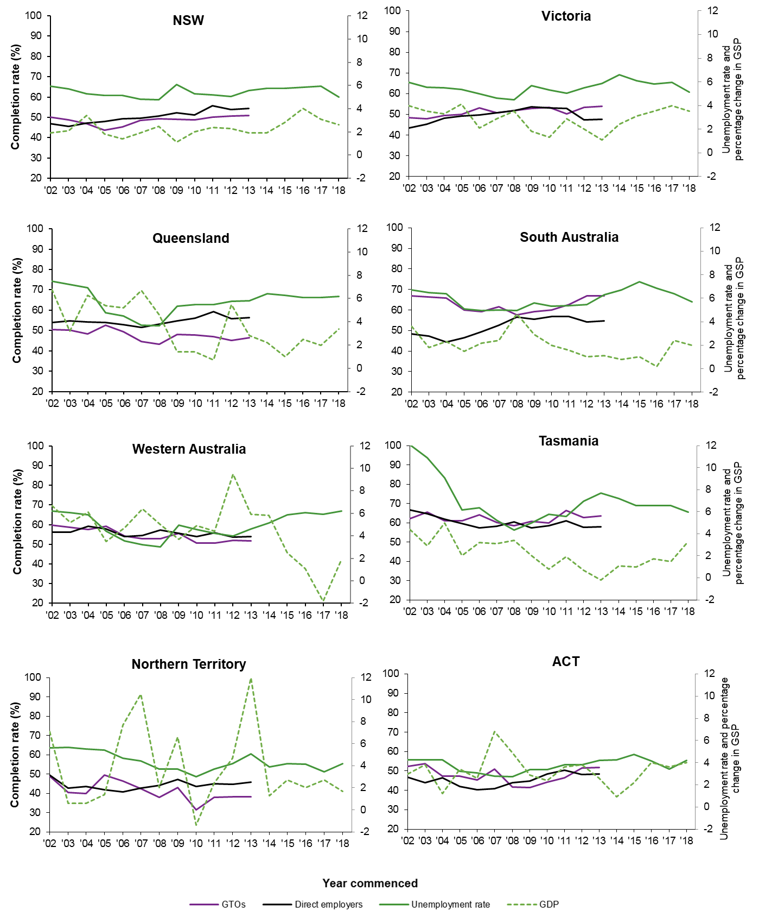

Source: NCVER National Apprentices and Trainees Collection, unpublished data; ABS Australian national accounts, cat.no.5220.0; ABS Labour force, cat.no.6202.0.

In 2012 GTOs in Victoria and Tasmania had the most balanced gender distribution for GTOs, both with approximately 57% males, and South Australia had the most unbalanced ratio with 80% males (table A1). The gender balances for GTOs in these states had not changed much by 2017, but Western Australia and the Northern Territory became more balanced. Conversely, the gender balance for direct employers was relatively balanced in 2012 in all states and territories and became less so by 2017 in all.

The Northern Territory had the lowest proportion of younger (aged under 20) apprentices and trainees with GTOs in both 2012 and 2017. The age structure was much older for direct employers in all states and territories in 2012 but more balanced in 2017.

There was little variation between the states and territories in the proportion of new workers with GTOs in 2012, with all exceeding 90% (except for Tasmania, at 84.6%). In 2017, all states exceeded 90%, with most close to 99%. The proportion of new workers with direct employers in 2012 varied from 46.9% in South Australia to over 70% in the Northern Territory. In 2017, over 75% of apprentices with direct employers were new workers in most states, excepting Tasmania and the Australian Capital Territory with 64.2% and 69.4% respectively.

The proportions of GTO apprentices and trainees in school-based VET varied widely between states in 2012, ranging from 5.2% in Tasmania to 42.9% in the Australian Capital Territory. They increased in some states and fell in others by 2017. For direct employers, proportions of school-based apprentices and trainees increased markedly in all states between 2012 and 2017.

In 2017, commencement patterns by trade/non-trade status were similar to those of 2012 for GTOs, except for the Northern Territory markedly decreasing its proportion of trades. In 2017, the proportions of trades apprentices with direct employers increased in all states except Western Australia and the Northern Territory, which were stable.

The proportion of Indigenous apprentices and trainees with GTOs in 2012 ranged from just under 6% in Victoria and the Australian Capital Territory to 52.4% in the Northern Territory and these were relatively stable over time except for increases in Western Australia and the Australian Capital Territory (from 18.8% to 26.7% and 5.6% to 13.5% respectively). Direct employers had smaller proportions of Indigenous apprentices and trainees than GTOs, which increased over time, especially in the Northern Territory (25.9% in 2012 and 34.2% in 2017).

The proportions of apprentices and trainees with disabilities were generally similar for GTOs and direct employers in 2012 and 2017.

Apprentices and trainees with GTOs were less likely than those with direct employers to be located in major cities in 2012 but by 2017 GTOs in all states except Victoria had slightly increased their proportions in major cities, with Queensland increasing from 50% to 65.9%. Direct employers’ shares declined slightly in all states.

The proportion of GTO apprentices and trainees completing a certificate III with GTOs in 2012 ranged from 53.5% in Western Australia to 89.8% in South Australia. The proportions for direct employers were lower (except in Western Australia) and did not vary as markedly. The proportions in 2017 for GTOs increased by more than five percentage points in some States (South Australia, Tasmania and the Northern Territory) but had increased markedly for direct employers in all states except Western Australia, the Australian Capital Territory and the Northern Territory where the increase was not as pronounced.

Table A1 Characteristics of commencing apprentices and trainees by employer type and state and territory, 2012 and 2017

|  | 2012 | | | | 2017 | | | |
| --- | --- | --- | --- | --- | --- | --- | --- | --- |
| Characteristic | GTO | | Direct employer | | GTO | | Direct employer | |
|  | % | n† | % | n† | % | n† | % | n† |
| Male |  |  |  |  |  |  |  |  |
| NSW | 69.1 | 4 703 | 54.7 | 88 202 | 72.4 | 4 038 | 65.5 | 43 073 |
| Vic. | 57.2 | 4 571 | 56.5 | 87 634 | 61.6 | 3 801 | 68.3 | 32 908 |
| Qld | 70.1 | 3 697 | 55.9 | 66 296 | 72.5 | 2 983 | 64.9 | 36 848 |
| SA | 80.0 | 1 613 | 58.0 | 24 050 | 80.2 | 1 488 | 62.3 | 7 208 |
| WA | 69.0 | 2 964 | 60.8 | 30 608 | 59.1 | 1 921 | 65.3 | 17 519 |
| Tas | 57.1 | 480 | 51.9 | 7 272 | 56.2 | 406 | 60.8 | 4 450 |
| NT | 60.9 | 253 | 55.9 | 2 410 | 52.3 | 149 | 62.3 | 1 687 |
| ACT | 69.4 | 392 | 50.0 | 5 488 | 71.6 | 380 | 55.6 | 4 154 |
| Australia | 66.9 | 18 673 | 56.2 | 311 960 | 68.2 | 15 166 | 65.3 | 147 847 |
| Aged under 20 | | |  |  |  |  |  |  |
| NSW | 70.9 | 4 703 | 27.3 | 88 202 | 67.5 | 4 038 | 46.6 | 43 073 |
| Vic. | 70.5 | 4 571 | 32.3 | 87 634 | 68.6 | 3 801 | 47.0 | 32 908 |
| Qld | 76.1 | 3 697 | 34.1 | 66 296 | 76.9 | 2 983 | 48.6 | 36 848 |
| SA | 66.7 | 1 613 | 25.4 | 24 050 | 72.5 | 1 488 | 51.1 | 7 208 |
| WA | 72.5 | 2 964 | 27.5 | 30 608 | 72.9 | 1 921 | 31.5 | 17 519 |
| Tas. | 68.1 | 480 | 28.8 | 7 272 | 72.7 | 406 | 34.0 | 4 450 |
| NT | 56.1 | 253 | 32.8 | 2 410 | 59.1 | 149 | 38.7 | 1 687 |
| ACT | 79.3 | 392 | 28.9 | 5 488 | 76.1 | 380 | 30.6 | 4 154 |
| Australia | 71.6 | 18 673 | 30.1 | 311 960 | 71.1 | 15 166 | 44.7 | 147 847 |
| New workers |  |  |  |  |  |  |  |  |
| NSW | 98.7 | 4 703 | 62.9 | 88 202 | 99.9 | 4 038 | 97.6 | 43 073 |
| Vic. | 97.8 | 4 571 | 57.4 | 87 634 | 99.5 | 3 801 | 87.7 | 32 908 |
| Qld | 96.3 | 3 697 | 56.9 | 66 296 | 97.6 | 2 983 | 84.9 | 36 848 |
| SA | 93.4 | 1 613 | 46.9 | 24 049 | 99.1 | 1 488 | 86.3 | 7 208 |
| WA | 97.6 | 2 964 | 62.8 | 30 608 | 99.3 | 1 921 | 75.6 | 17 519 |
| Tas. | 84.6 | 480 | 53.6 | 7 272 | 91.1 | 406 | 64.2 | 4 450 |
| NT | 95.3 | 253 | 71.1 | 2 410 | 94.6 | 149 | 80.5 | 1 687 |
| ACT | 96.4 | 392 | 64.8 | 5 488 | 98.9 | 380 | 69.4 | 4 154 |
| Australia | 96.9 | 18 673 | 58.7 | 311 959 | 98.9 | 15 166 | 87.1 | 147 847 |
| School-based VET | |  |  |  |  |  |  |  |
| NSW | 8.7 | 4703 | 1.6 | 88 202 | 6.9 | 4 038 | 3.8 | 43 073 |
| Vic. | 19.9 | 4571 | 3.2 | 87 634 | 20.5 | 3 801 | 7.6 | 32 908 |
| Qld | 24.1 | 3697 | 14.0 | 66 296 | 17.1 | 2 983 | 19.8 | 36 848 |
| SA | 11.1 | 1613 | 7.7 | 24 050 | 6.9 | 1 488 | 18.1 | 7 208 |
| WA | 34.6 | 2964 | 1.4 | 30 608 | 37.6 | 1 921 | 6.6 | 17 519 |
| Tas. | 5.2 | 480 | 7.3 | 7 272 | 7.6 | 406 | 9.6 | 4 450 |
| NT | 13.8 | 253 | 5.7 | 2 410 | 22.8 | 149 | 8.9 | 1 687 |
| ACT | 42.9 | 392 | 6.1 | 5 488 | 37.9 | 380 | 7.3 | 4 154 |
| Australia | 19.5 | 18673 | 5.4 | 311 960 | 17.2 | 15 166 | 10.0 | 147 847 |
| Trades |  |  |  |  |  |  |  |  |
| NSW | 55.4 | 4 701 | 26.6 | 88 200 | 57.5 | 4 038 | 46.8 | 43 073 |
| Vic. | 39.6 | 4 571 | 25.3 | 87 634 | 35.8 | 3 801 | 54.1 | 32 908 |
| Qld | 56.6 | 3 697 | 30.8 | 66 296 | 58.2 | 2 983 | 39.4 | 36 848 |
| SA | 66.9 | 1 613 | 21.9 | 24 050 | 74.4 | 1 488 | 39.5 | 7 208 |
| WA | 41.8 | 2 964 | 36.2 | 30 608 | 37.0 | 1 921 | 33.9 | 17 519 |
| Tas. | 37.5 | 480 | 26.3 | 7 272 | 42.1 | 406 | 35.0 | 4 450 |
| NT | 37.5 | 253 | 36.4 | 2 410 | 19.5 | 149 | 36.8 | 1 687 |
| ACT | 47.4 | 392 | 22.3 | 5 488 | 52.4 | 380 | 41.4 | 4 154 |
| Australia | 49.7 | 18 671 | 27.7 | 311 958 | 50.3 | 15 166 | 44.1 | 147 847 |
| Indigenous |  |  |  |  |  |  |  |  |
| NSW | 11.7 | 4638 | 4.0 | 85 611 | 12.3 | 3 771 | 6.7 | 40 981 |
| Vic. | 5.5 | 4539 | 1.2 | 86 570 | 7.3 | 3 500 | 2.1 | 30 853 |
| Qld | 13.0 | 3679 | 4.9 | 65 785 | 14.2 | 2 889 | 8.0 | 35 830 |
| SA | 9.5 | 1601 | 2.2 | 23 590 | 6.1 | 1 425 | 3.6 | 6 749 |
| WA | 18.8 | 2934 | 5.1 | 30 088 | 26.7 | 1 848 | 5.6 | 16 268 |
| Tas. | 10.3 | 476 | 5.3 | 7 213 | 11.4 | 396 | 6.9 | 4 355 |
| NT | 52.4 | 252 | 25.9 | 2 392 | 52.4 | 145 | 34.2 | 1 615 |
| ACT | 5.6 | 390 | 5.1 | 5 432 | 13.5 | 370 | 5.9 | 4 047 |
| Australia | 11.8 | 18509 | 3.6 | 306 681 | 13.1 | 14 344 | 6.1 | 140 698 |
| Disability |  |  |  |  |  |  |  |  |
| NSW | 2.4 | 4 612 | 2.0 | 84 884 | 2.8 | 3 808 | 3.0 | 41 053 |
| Vic. | 4.0 | 4 571 | 2.1 | 87 634 | 4.4 | 3 801 | 3.3 | 32 908 |
| Qld | 0.2 | 3 697 | 0.3 | 66 296 | 0.1 | 2 983 | 0.2 | 36 848 |
| SA | 3.0 | 1 589 | 2.6 | 23 529 | 4.6 | 1 398 | 3.2 | 6 835 |
| WA | 1.9 | 2 913 | 1.7 | 29 988 | 2.7 | 1 768 | 1.7 | 16 047 |
| Tas. | - | 480 | 0.0 | 7 272 | - | 405 | 1.1 | 4 450 |
| NT | - | 253 | 0.1 | 2 410 | - | 149 | 0.1 | 1 687 |
| ACT | 3.1 | 392 | 2.9 | 5 488 | 8.4 | 379 | 4.3 | 4 150 |
| Australia | 2.3 | 18 507 | 1.6 | 307 501 | 2.8 | 14 691 | 2.1 | 143 978 |
| Located in major city | | |  |  |  |  |  |  |
| NSW | 63.6 | 4 680 | 70.7 | 87 932 | 69.1 | 4 036 | 67.0 | 43 005 |
| Vic. | 59.3 | 4 555 | 73.0 | 87 210 | 56.5 | 3 790 | 68.3 | 32 775 |
| Qld | 50.0 | 3 651 | 63.0 | 65 337 | 65.9 | 2 968 | 57.1 | 36 438 |
| SA | 65.0 | 1 573 | 70.7 | 23 752 | 68.1 | 1 487 | 64.2 | 7 201 |
| WA | 70.0 | 2 958 | 74.9 | 30 559 | 73.1 | 1 916 | 73.6 | 17 492 |
| Tas. | 1.0 | 480 | 0.5 | 7 267 | - | 406 | 0.1 | 4 447 |
| NT | - | 229 | 0.0 | 2 211 | - | 124 | - | 1 490 |
| ACT | 90.6 | 384 | 93.8 | 5 412 | 91.3 | 379 | 92.2 | 4 140 |
| Australia | 59.2 | 18 510 | 68.4 | 309 680 | 63.8 | 15 106 | 63.5 | 146 988 |
| Certificate III |  |  |  |  |  |  |  |  |
| NSW | 79.8 | 4 703 | 63.8 | 88 202 | 83.5 | 4 038 | 82.6 | 43 073 |
| Vic. | 79.9 | 4 571 | 66.5 | 87 634 | 76.2 | 3 801 | 86.6 | 32 908 |
| Qld. | 82.7 | 3 697 | 62.3 | 66 296 | 83.1 | 2 983 | 80.8 | 36 848 |
| SA | 89.8 | 1 613 | 56.8 | 24 050 | 97.0 | 1 488 | 84.6 | 7 208 |
| WA | 53.5 | 2 964 | 62.1 | 30 608 | 57.2 | 1 921 | 69.2 | 17 519 |
| Tas. | 70.0 | 480 | 61.3 | 7 272 | 81.3 | 406 | 71.4 | 4 450 |
| NT | 74.7 | 253 | 66.0 | 2 410 | 82.6 | 149 | 69.4 | 1 687 |
| ACT | 68.4 | 392 | 58.3 | 5 488 | 72.6 | 380 | 64.6 | 4 154 |
| Australia | 76.5 | 18 673 | 63.4 | 311 960 | 79.2 | 15 166 | 80.6 | 147 847 |

† ‘n’ represents the sum of all apprentices, i.e. those with the characteristic and those without.

Source: NCVER National Apprentices and Trainees Collection, no. 95.

The pattern for the states and territories also shows that GTO completion rates for non-trades are generally higher than for small and medium direct employers, except in the Northern Territory, where they are lower and South Australia where they were similar until 2012 and were then somewhat higher than for all other states and territories (figure A3).

Figure A3 Contract completion rates for apprentices and trainees in non-trade occupations by employer type and size and commencing year, states and territories, 2010–14 (%)†

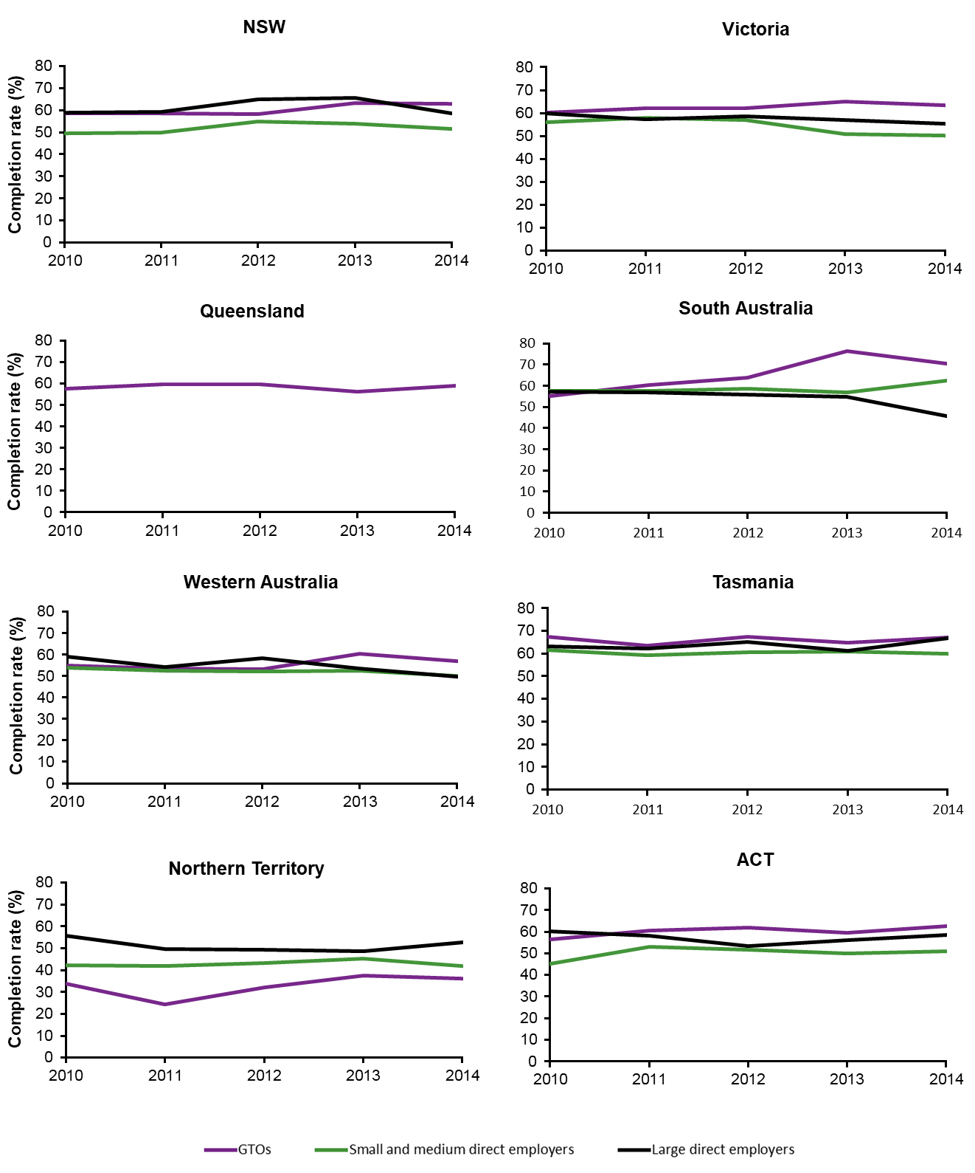

† Employer size for Queensland was not reported.

Source: NCVER National Apprentices and Trainees Collection, no. 95.

Trades apprentice and trainee completion rates for GTOs were generally stable except in Tasmania, the Northern Territory and the ACT, while rates for larger direct employers were slightly more variable in the smaller states and territories (figure A4). Completion rates for GTO trades apprentices and trainees were consistently close to those for large employers in South Australia.

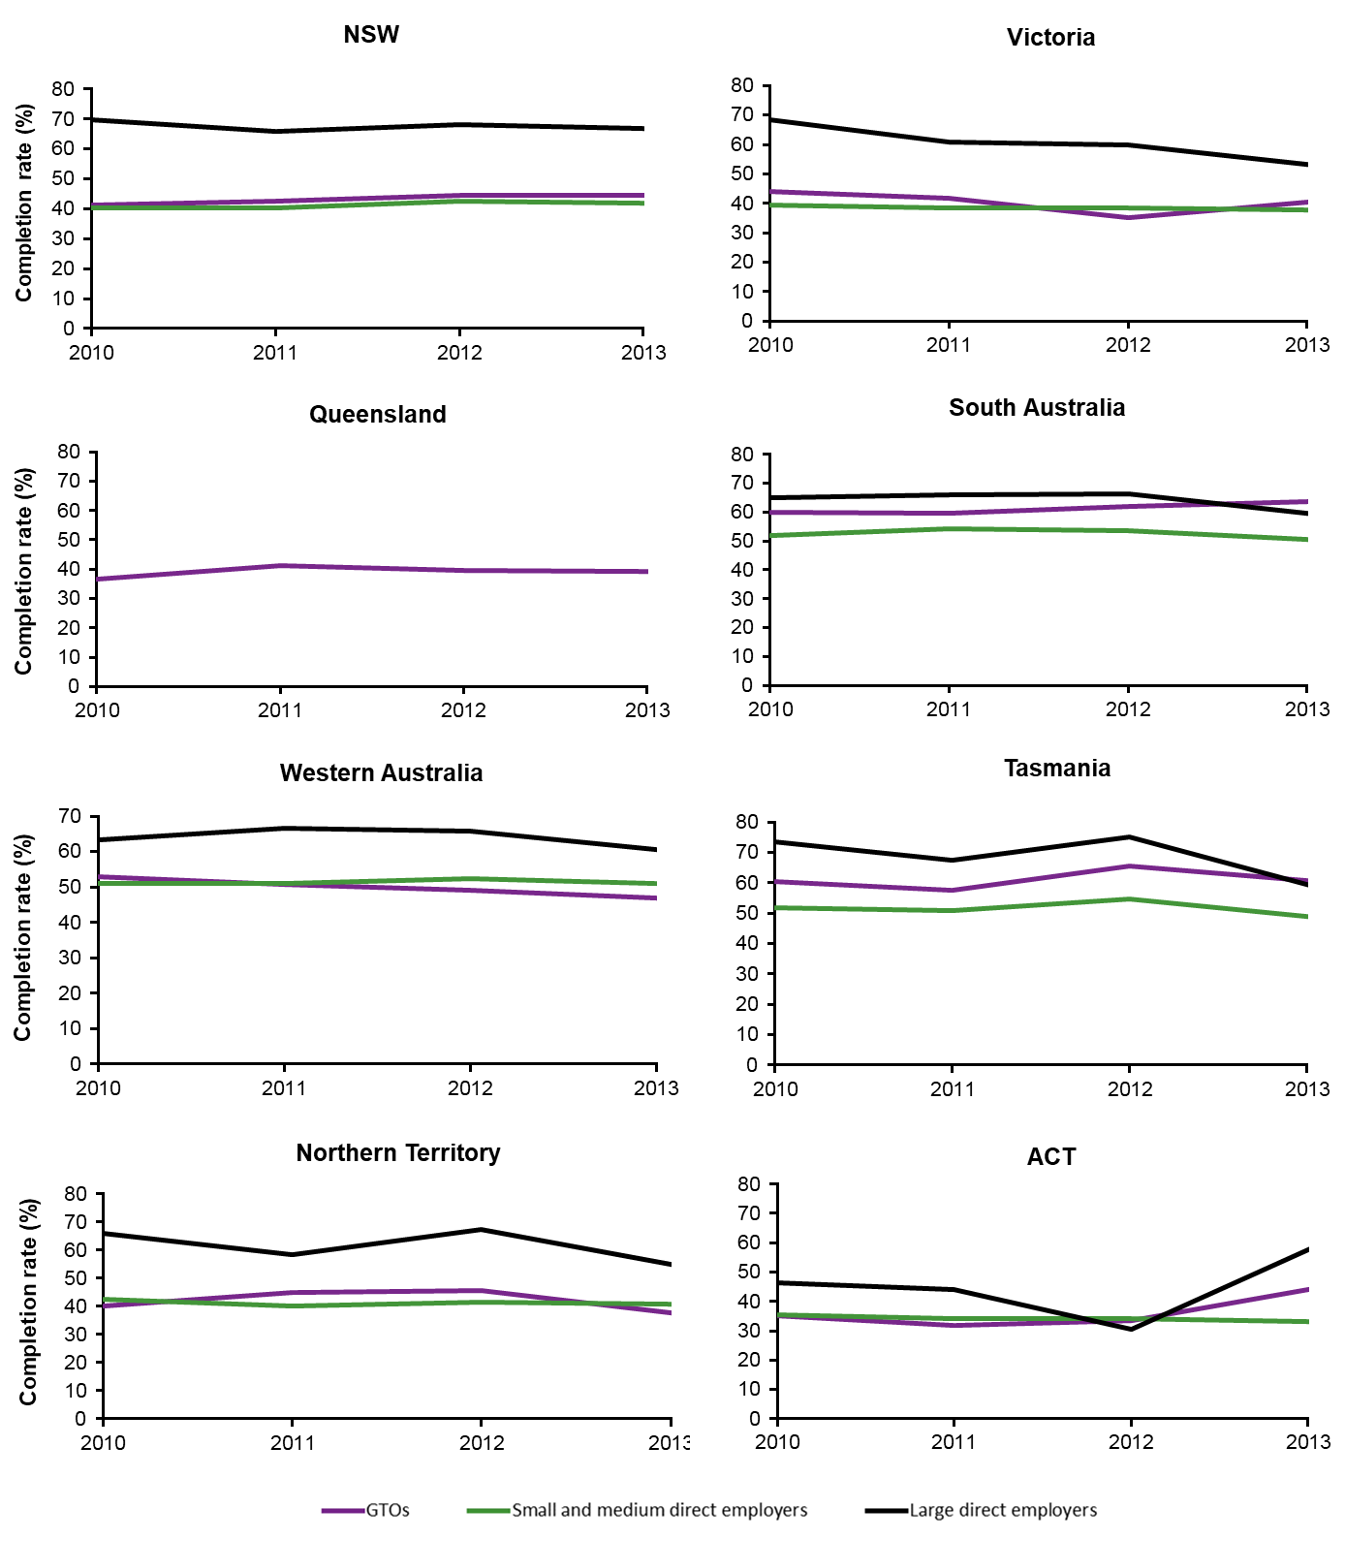Figure A4 Contract completion rates for apprentices and trainees in trade occupations by employer type and size and commencing year, states and territories, 2010–13 (%)‡

‡ Employer size for Queensland was not reported.

Source: NCVER National Apprentices and Trainees Collection, no. 95.

Figure A5 shows that completion rates in non-trades for GTOs are slightly higher than for the other two direct employer size groups in New South Wales, Victoria and Tasmania (except in 2012) and markedly higher in South Australia. The Australian Capital Territory shows a more erratic pattern than the other states: completion rates were much higher than for direct employers until 2013, when there was a large decline. The rate has since increased but is still below the rate for small and medium direct employers.

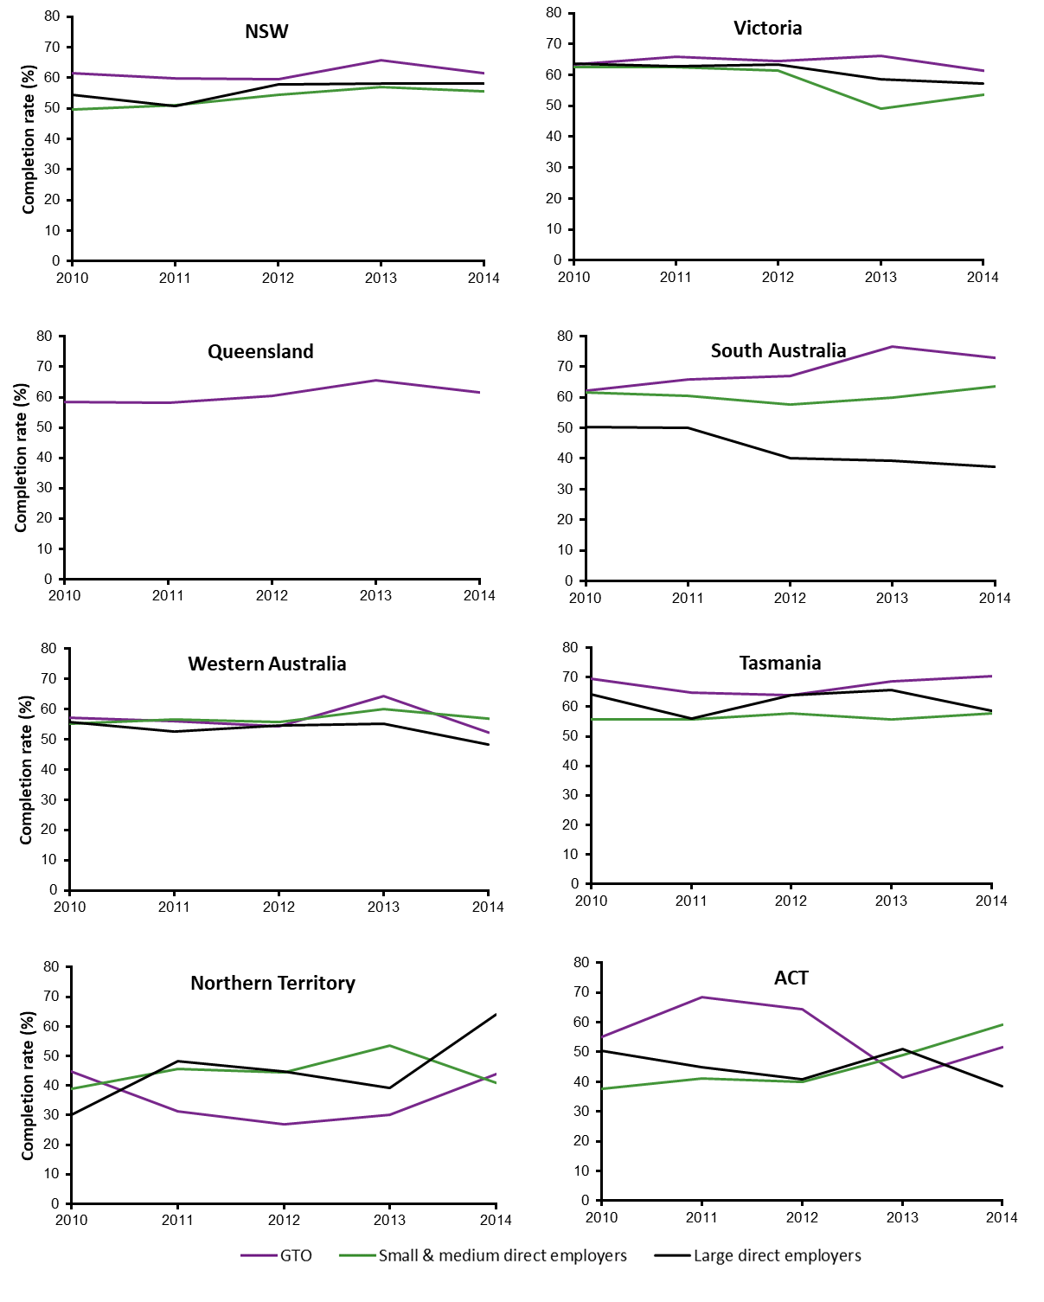Figure A5 Contract completion rates for the comparison group in non-trade occupations by employer type and size, commencing year and state, 2010–14 (%)†

† Employer size for Queensland was not reported.

Source: NCVER National Apprentices and Trainees Collection, no. 95.

Completion rates for trades apprentices and trainees in the GTO comparison group (figure A6) were consistently above those for small and medium direct employers in New South Wales, South Australia and Tasmania but dipped in 2012 for Victoria (where rates for GTOs and large direct employers were on a gradual downward trend). Rates for GTOs and small and medium direct employers in Western Australia, the Northern Territory and the Australian Capital Territory were similar over most of the 2010-2013 period, although the GTO rate surpassed small and medium direct employers in the Australian Capital Territory in 2013.

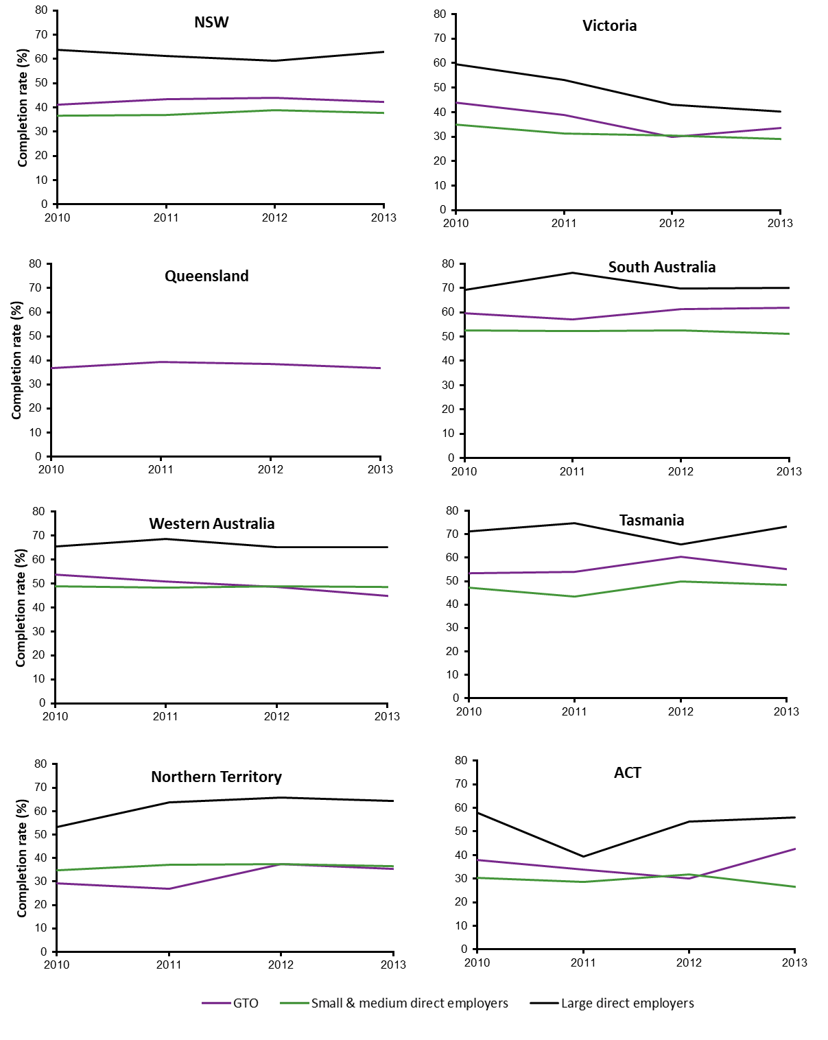Figure A6 Contract completion rates for the comparison group in trade occupations by employer type and size, commencing year and state, 2010–14 (%)‡

‡ Employer size for Queensland was not reported.

Source: NCVER National Apprentices and Trainees Collection no. 95.

## Appendix B: Description of GTO case study data

Unit record data on cancellations for the apprentices commencing in the period 2008—16 (n = 1009) and completions for apprentices commencing in the period 2003—16 (n = 1529) were supplied for a total of 2536 cases. This dataset includes the following fields for each apprentice:

* age
* start date (commencement) of apprenticeship
* completion status (cancelled, completed with ECA, completed with another employer, withdrawn, actively continuing with another employer)
* trade (66 trades grouped into 11 categories)

1. Engineering (advanced, boiler making, electrical/electronic, fitter and turner, mechanical fitter, vehicle building, production, engineering tradesperson (fabrication), higher engineering), n = 184
2. Automotive (bus, truck and trailer, diesel fitter, heavy vehicle mechanic, light vehicle mechanic, parts interpreting, retail, service and repair, tyre fitter, vehicle painting), n = 86
3. Food and cooking (bread baking, pastry cooking, commercial cookery, retail operations, hospitality), n = 110
4. Building and construction (bricklayer, roof tiler, stonemason), n = 102
5. Cabinetry and carpentry (including off-site joinery, shopfitter, wood machinist), n = 1300
6. Electrical (assembly and service, data and voice, electrician, instrumentation), n = 235
7. Interior construction (fibrous plasterer, floor furnishing, glass and glazing, painter and decorator, solid plasterer, tiler), n = 241
8. Horticulture (horticulture, landscape construction, parks and gardens), n = 70
9. Plumbing (including roof plumber), n = 143
10. Powered equipment and appliances (appliance servicing, outdoor power equipment, refrigeration and airconditioning, saw doctoring), n = 51
11. Other (aged care, business administration, hairdressing, library and information, printing and graphic art, signwriter, warehousing), n = 14

* gender
* a flag for females in traditional trades (e.g. plumbing, electrical or automotive)
* whether an apprentice training incentive was used (dating from 2014 only)
* Indigenous status
* mature-age status
* school-based status
* disability status
* non-English speaking background status
* whether the apprentice had completed prevocational training
* full-time or part-time status
* qualification level and code
* location (rural, regional or metropolitan), based on ARIA classification of suburb of residence.

Not all fields were available for the whole period and these are noted in the text where relevant.

# Appendix C: Interviews with GTOs and direct employers

## Data collection strategy

A random sample of GTOs and direct employers (including private enterprises and government organisations) was drawn from NCVER’s National Apprentice and Trainee Collection for the period 1 January 2013 to December 2017, which gave a total of 246 356 records. The records were stratified by state, employer type (GTO and other) and location (metropolitan and other). Using a random number generator, 130 records were randomly selected from all states. The random selection approach from this number of cases ensured that employers from a range of different industries, including both trade and non-trade, were included. Telephone, postal and email contact details for each employer were then identified using the search function for RTOs on the training.gov.au website or a Google search. Where contact details could not be found for an employer (usually because they were no longer operating, but sometimes because their legal names and trading names may be different), replacement records were randomly selected.

The selected employers were sent hard-copy letters explaining the research and inviting respondents to participate in a telephone interview. The letters were followed up by emails and telephone calls. (More than 20 letters were returned to sender as unclaimed, indicating that the company was no longer operating.) This strategy yielded 15 interviews with GTOs and nineinterviews with direct employers. The GTO and direct employer respondents representing their organisations were asked to forward information about the research via a flyer or email to their apprentices. All interviewees agreed to pass on interview requests to their apprentices and trainees, but only three participated.

The location of the participating GTOs and direct employers is shown in table C1.

Table C1 State and location of GTO and direct employer interviewees†

|  |  |  |  |  |
| --- | --- | --- | --- | --- |
| State/territory | Metropolitan | | Rural | |
|  | GTO | Direct employer | GTO | Direct employer |
| NSW | 2 | 3 | 1 | 3 |
| VIC | 6 | 1 | 1 |  |
| QLD | 2 |  | 1 | 1 |
| SA | 1 | 1 |  | 1 |
| WA | 1 |  |  |  |

† One NSW direct employer operated in both metropolitan and regional areas, so shows twice in the table.

## Interview schedule

### GTOs

1. How many apprentices and trainees does your organisation employ?
2. What training program are they undertaking? (for example, plumbing and gasfitting, hospitality, commercial cookery, construction)
3. What AQF levels are they undertaking?
4. In your opinion what proportion of these will complete their training?
5. What is the proportion of completions among past apprentices and trainees?
6. What are the main reasons for past non-completers not completing their training?
7. What do you think are the key factors that have helped past completers to complete their training?
8. What role is played by apprentices and trainees going on workplace rotations with a variety of host employers?
9. What role do literacy and numeracy skills play in completions?
10. How important is motivation to completion?
11. In comparison with apprentices and trainees that are employed with direct employer employers, what do you see as the key advantages for GTO apprentices and trainees?
12. In comparison with apprentices and trainees that are employed with direct employer employers, what do you see as the key disadvantages for GTO apprentices and trainees?
13. What are some of the ways that you have changed your structures to improve the completion rates of your apprentices and trainees?

### Non-GTO direct employers

1. How many apprentices and trainees does your company (*or government organisation*) employ?
2. What training program are they undertaking? (for example, plumbing and gas-fitting, hospitality, commercial cookery, construction)
3. What qualification are they undertaking? (cert. III, diploma, cert. IV, cert. II etc.)
4. In your opinion what proportion of these will complete their training?
5. What is the proportion of completions among past apprentices and trainees?
6. What have been the main reasons for past non-completers not completing their training?
7. What do you think are the key factors that helped past completers to complete their training?
8. What role do literacy and numeracy skills play in completions?
9. How important is motivation to completion?
10. In comparison with apprentices and trainees that are employed with GTOs, what are the advantages for apprentices and trainees employed by private companies (*or government organisations*) like yours?
11. In comparison with apprentices and trainees that are employed with GTOs, what are the disadvantages for apprentices and trainees employed by other private companies (*or government organisations*) like yours?
12. In hindsight how would you have changed your structures to improve the completion rates of your apprentices and trainees?

### Apprentices and trainees

Note: questions 4—6 were not found to be applicable to any respondents.

1. What training program are you doing? (for example, plumbing and gas-fitting, hospitality, commercial cookery, construction)
2. Why did you decide to get an apprenticeship or traineeship? Did anyone encourage you to do so?
3. Before commencing with this company did you start an apprenticeship with a company that was/was not a group training company?
4. Were you formally registered as an apprentice by that company that was a non-group training company?
5. What made you decide to work for this company?
6. Was the experience with the direct employer the reason for moving to this GTO?
7. What are the main things you like about your job?
8. What are the main things you dislike about your job?
9. What are the main things you like about your training?
10. What are the main things you dislike about your training?
11. Do you know any other apprentices or trainees that did not complete their training?
12. Why do you think these apprentices and trainees did not stay to complete their training?
13. What (if anything) would make you decide to quit your training?
14. Do you think it is good to work for a group training company/non-GTO and why?
15. What is the best thing about your job?
16. What is the worst thing about your job?
17. Would you tell anyone else to undertake an apprenticeship or traineeship?
18. What are the main things you would use to encourage them to pursue an apprenticeship?



**National Centre for Vocational Education Research**

Level 5, 60 Light Square, Adelaide, SA 5000  
PO Box 8288 Station Arcade, Adelaide SA 5000, Australia

**Phone** +61 8 8230 8400 **Email** [ncver@ncver.edu.au](mailto:ncver@ncver.edu.au)   
**Web** <https://www.ncver.edu.au> <https://www.lsay.edu.au>

**Follow us:** <https://twitter.com/ncver> <https://www.linkedin.com/company/ncver>



1. Note that NCVER uses a ‘trade/non-trade’ categorisation in the National Apprentices and Trainees Collection, with ‘Trades’ classified as all occupations listed under ANZSCO major group ‘3 − Technicians and trades workers’ and ‘Non-trades’ classified as all other major occupations, groups 1−2 and 4−8 (ANZSCO, version 1.2). This nomenclature is used because occupations approved to be under an apprenticeship or traineeship training contract are not consistent across all jurisdictions. [↑](#footnote-ref-1)
2. Data for completion rates are not yet available after 2013 for trades and 2014 for non-trades. Most apprenticeships (usually in trades) are not completed for approximately four years after commencement; and there is a lag between completion and the submission of completion records from employers, compounded by some apprenticeships taking longer than four years to complete (Harvey 2010). Traineeships (usually non-trades) generally take two years or fewer and so rates can be computed for more recent years. That is, apprentices who commenced in or after 2013 and trainees who commenced in or after 2014 and have not withdrawn are still active or have only very recently completed at the time of writing. [↑](#footnote-ref-2)
3. For more information see <https://www.ncver.edu.au/\_\_data/assets/pdf\_file/0036/6481935/A-and-T-rates-Terms\_and\_definitions\_2018.pdf>. [↑](#footnote-ref-3)
4. <http://www.abs.gov.au/ausstats/abs@.nsf/products/F3614B9BB5A9F1DDCA256BD000287CA7?OpenDocument>. [↑](#footnote-ref-4)
5. 2008 is the first year that cancellations information is available. [↑](#footnote-ref-5)
6. Examples include the national incentive provided by the Australian Brick and Blocklaying Training Foundation for brickies and the state-based incentive from Construction Skills Queensland for carpenters (note that this incentive is no longer available). [↑](#footnote-ref-6)
7. 2008 is the first year that cancellations information is available. [↑](#footnote-ref-7)
8. Insufficient data are available for transferred apprentices and trainees prior to 2009, while apprentices and trainees who started after 2015 are assumed to have not yet completed and are not included in the dataset. [↑](#footnote-ref-8)
9. Mean 19.9 years, standard deviation 3.9, when they began their apprenticeship or traineeship compared with those who completed with another employer (mean 19.0 years, standard deviation 2.3). [↑](#footnote-ref-9)
10. t(1422) = 4.19, p<0.0001. [↑](#footnote-ref-10)
11. Mean 19.1 years, standard deviation 3.2 compared with those who did not (mean 19.5, standard deviation 3.3). t(279) = 1.01, p = 0.32. [↑](#footnote-ref-11)
12. Insufficient data are available for transferred apprentices and trainees prior to 2009, while apprentices and trainees who started after 2015 are assumed to have not yet completed and are not included in the dataset. [↑](#footnote-ref-12)
13. The GTO and direct employer respondents representing their organisations were asked to forward information about the research via a flyer or email to their apprentices and trainees. Only one apprentice from a GTO and two from direct employers responded. Consequently, this part of the qualitative study is reported only as vignettes. [↑](#footnote-ref-13)
14. NCVER’s data on withdrawals as a percentage of commencements in the first six months of the contract for the period 2012—17 show no real change for Australia as a whole, but New South Wales and South Australia experienced a slight general increase, Victoria, Western Australia and the Australian Capital Territory a general decline, while Queensland, Tasmania and the Northern Territory were generally stable (NCVER 2018b). [↑](#footnote-ref-14)
15. Not all non-completions equate to no job, a situation that can artificially reduce apparent completion rates. Note, however, that NCVER merges two or more contracts where apprentices or trainees are known to have transferred to another employer and commenced a new contract. This measure helps to reduce the number of contracts used as the basis for computing completion rates, resulting in more realistic (and slightly higher) rates. [↑](#footnote-ref-15)
16. Non-GTOs that are members of a trade association. [↑](#footnote-ref-16)
17. A contract of training is a legal agreement between an employer and an apprentice or trainee which defines the rights and responsibilities of each party. These include the employer guaranteeing to train the apprentice or trainee in the agreed occupation or training area and to allow time off work to attend any required off-the-job training; and the apprentice or trainee agreeing to learn all aspects of the occupation or training area and to work for the employer for a specified period. It supersedes the indenture system. [↑](#footnote-ref-17)