NCVER_Floating_Mono

International approaches to employer engagement in quality vocational education and training

Francesca Beddie

Francesca M Beddie and Associates

This document was produced by the author(s) based on their research for the report *Begin with the end:* *RTO practices and views on independent validation of assessment*, and is an added resource for further information. The report is available on NCVER’s Portal: <<https://www.ncver.edu.au>>.

### ­

### 

### Publisher’s note

The views and opinions expressed in this document are those of the author/project tea and do not necessarily reflect the views of the Australian Government, state and territory governments or NCVER. Any errors and omissions are the responsibility of the author(s).

**© Commonwealth of Australia, 2021**

G:\pub_prod\PublicationComponents\logos\Creativecommons\CC BY logo.eps

With the exception of the Commonwealth Coat of Arms, the Department’s logo, any material protected by a trade mark and where otherwise noted all material presented in this document is provided under a Creative Commons Attribution 3.0 Australia <http://creativecommons.org/licenses/by/3.0/au> licence.

The details of the relevant licence conditions are available on the Creative Commons website (accessible using the links provided) as is the full legal code for the CC BY 3.0 AU licence <http://creativecommons.org/licenses/by/3.0/legalcode>.

The Creative Commons licence conditions do not apply to all logos, graphic design, artwork and photographs. Requests and enquiries concerning other reproduction and rights should be directed to the National Centre for Vocational Education Research (NCVER).

This document should be attributed as Beddie, F 2021, *International approaches to employer engagement in quality vocational education and training,* NCVER, Adelaide.

This work has been produced by NCVER on behalf of the Australian Government and state and territory governments, with funding provided through the Australian Government Department of Education, Skills and Employment.

Published by NCVER, ABN 87 007 967 311

Level 5, 60 Light Square, Adelaide, SA 5000  
PO Box 8288 Station Arcade, Adelaide SA 5000, Australia

**Phone** +61 8 8230 8400 **Email** [ncver@ncver.edu.au](mailto:ncver@ncver.edu.au)

**Web** <https://www.ncver.edu.au>

**Follow us:**  <https://twitter.com/ncver>  <https://www.linkedin.com/company/ncver>

Contents

Tables and figures 4

Figures 4

Validation as a part of quality assurance: other countries’ experience 5

Europe 6

Germany 7

The United Kingdom 8

New Zealand 13

Implications for Australia 14

References 15

# Tables and figures

## Figures

1 External Quality Assurance eight-step framework and process (Institute for Apprenticeships   
and Technical Education 2020) 9

# Validation as a part of quality assurance: other countries’ experience

A review of international efforts to improve the quality of vocational training through independent validation of assessment, with the involvement of employers, reveals the challenges and complexity of this task.

Commonalities that emerged from the experiences in Europe, the United Kingdom and New Zealand are:

* Cooperation with employers is required from the design to the certification of learning. The initial development of standards must involve employers. Engaging employers can be challenging.
* What is being assessed must be clear in those standards: to the trainees, assessors and employers.
* Likewise, the transparency of assessment procedures is important for fairness, consistency and reliability.
* Quality assurance should be aimed at continuous improvement in assessment procedures, and at ensuring that what is being taught is relevant and results in vocational competence.
* National standards with adequate flexibility to cater to local conditions, different types of learners and sites of learning are needed and may best be achieved by restricting the number of qualifications.
* An important principle, articulated particularly strongly in the German system, is that those who teach do not examine. This means that final examinations are often run externally, with independent assessors, and involve employers.
* Assessors require training in assessment and industry currency because the system relies on their professional judgement as well as standards and processes.
* Validation costs money, with funding coming from various sources: government, providers, industry and students.

# Europe

Much of the recent work being undertaken across Europe focuses on how to ensure that learning outcomes from a variety of pathways (formal and informal) and learning systems are certified in a way that increases employer confidence in the qualifications. An extensive CEDEFOP study of 12 European countries, *Ensuring the quality of certification in vocational education and training* (2015) found that (p.13):

* Feedback from representatives of the world of work is very useful, for example in terms of identifying mismatches between competences acquired by students and those required at the workplace and that the assessment should focus on competences needed in professional practice.
* Very few countries use this feedback to improve initial vocational education and training (IVET).
* The position of certification processes in the feedback-loop between vocational education and training (VET) and labour market needs to be strengthened. Later, the study observes (Cedefop (2015, p.53) that external, independent verification of assessment increases trust in the certification process but that the data from such processes is not used systematically to renew standards and curricula and to improve training process.

It suggested (Cedefop 2015, p.47) that joint assessment conducted by different stakeholders could be a powerful driver for the quality of assessment in many countries. The study recommended that:

Integrating different stakeholder groups (e.g. teachers, workplace instructors, professional experts) in examination boards offers the possibility to receive different views on the candidates’ performance, to ensure reliability and impartiality of assessment, and to check if gained competences comply with labour market needs (p.49).

Another point gleaned from a case study in the German dual system is that final practical assessments need to be holistic, meaning that they do not rely on the competence-oriented descriptions in the training regulations but are based on assessor’s judgment that the trainee can undertake an occupation-typical task (Cedefop 2015, p.62). Moreover, the learning outcomes need to be couched in the language of company representatives involved in assessment (p.64).

Several of the study’s recommendations (pp.76-78) may be relevant to Australia:

* Ensure the appropriate definition and use of learning outcomes-based standards …There needs to be an adequate balance between descriptions that can be used as clear reference points nationally but leave sufficient room for flexibility locally (i.e. for being adapted to learners’ needs and to the local context). There is no perfect way of formulating and presenting learning outcomes; they must fit the context in which they are used. To facilitate the definition and understanding of learning outcomes used in certification, instructions and guidelines should be prepared and made available at national level. The learning-outcomes-based descriptions also need to be updated regularly to adapt to changes in the working life.
* Strengthen the involvement of labour market stakeholders in certification and relevant quality assurance processes …They should be involved from formulating qualification requirements to participating in joint assessment processes, thereby increasing the credibility of certification processes and trust in qualifications. This approach can also be used to gain feedback on the candidate’s achieved learning outcomes and the teaching and learning approach used to achieve these learning outcomes. This requires measures to motivate employers, trade union representatives and other professional experts to take part in the certification process.
* Support the development of a common understanding of certification requirements among stakeholders … including teachers/trainers, workplace instructors, assessors and learners.
* Ensure assessors are competent and trained … awarding bodies, national VET institutes, VET providers or professional teachers and trainers’ associations can develop handbooks and guidelines to support assessors in their tasks and enhance the quality of the certification processes. They should promote sharing of experiences between assessors to help them consistently implement prescribed assessment procedures and to meet legal regulations and standards.
* Strengthen evaluation and review in certification … national VET institutes with a monitoring and evaluation role should systematically collect and analyse results from certification processes and feedback from all stakeholders involved. The information gained should be used to decide on any changes required in relation to learning outcomes, teaching, learning and assessment methods and procedures or quality assurance arrangements.

## Germany

The OECD’s 2008 review of Australia recommended a common national assessment, citing national external examinations in Germany as a successful model:

Germany combines local and national assessment methods. This makes it possible to take account of local variations of VET programmes while securing minimum standards and comparability of certificates by combining three final certificates obtained from the employer, the VET school, and through external national examinations. The employer certificate is a work reference based on what the individual did in the work situation measured against the relevant occupational and training standards. The school certificate represents continuous assessment of the student by the local educational institution; each state has its own requirements for this certificate. The external national examination, which counts most of the three, is a uniform test developed by the employer associations of each sector, administered to all applicants and aims to assess minimum competencies (OECD 2008, pp. 38-39).

More than a decade later, the system continues. The final examination leads to the awarding of a certificate by the ‘competent body’ in charge of training, usually a chamber of commerce or a guild. (All companies in a particular sector must belong to the relevant chamber and pay dues.) The chambers run vocational training committees, governed by the federal Vocational Training Act, which also sets out what these ‘competent bodies’ must do:

* Supervise vocational training preparation, vocational training and retraining.
* Maintain a register of training contracts.
* Employ training counsellors that advise the enterprises in all training issues.
* Run a register of trained training staff.
* Assess the quality of the training facility.
* Conduct the intermediate and final examinations or journeyman examinations.
* Monitor and support learning exchanges abroad for apprentices and learners.

The examination procedure is regulated in the Vocational Training Act or, for the crafts, in the Trade and Crafts Code. The content and method of examination are described in the training regulations of the occupation.

The competent body is legally required to set up an independent examination committee for each training occupation. The committee comprises the same number of competent employer and employee representatives and at least one teacher from a vocational school. This activity is undertaken on an honorary basis.

After the successful completion of the apprenticeship, apprentices receive three different certificates:

* the examination certificate of the competent body (usually the chamber)
* the leaving certificate of the vocational school
* the reference of the training company. (Apprenticeship Toolbox, 2019)

A 2014 analysis (Fürstenau, Pilz and Gonon, pp.432-33) pointed out that, particularly in medium and small enterprises, a weakness of the system is the amount of time and expertise trainers, who are full-time employees not dedicated trainers, can devote to the trainees. In cases where companies cannot offer full apprenticeships, because they do not have enough trainers or sufficient technical resources, parts of the apprenticeship can be relocated from the individual company to an inter-company vocational training centre, or to an apprenticeship network, where several companies jointly take care of an apprentice.

The analysis explained that companies were still prepared to offer apprenticeships because they saw it as an investment in securing skilled workforce. Their costs included apprentice wages, a proportion of their trainers’ labour costs, capital and material expenditures, and other costs such as examination fees. The benefits they derived are productive work of apprentices, savings for external recruitment and avoiding employing people with inadequate or inappropriate skills, and the social kudos the company accrues from its involvement in vocational training.

Germany is facing a demand for higher skills and drift away from the dual system to higher education, which has put the spotlight on the quality of training in initial and continuing vocational education. Some argue that the focus on the company’s central role has compromised cooperation with vocational schools and educators (Gessler 2017). Improving training quality is on the agenda. For example, enhancing the ability of in-house trainers in small and medium-sized enterprises and communication with trainees and educators were strong messages coming out of the German Federal Institute of Vocational Education and Training (BIBB) pilot program, *Quality development and quality assurance in in-company initial vocational education and training* (Gaylor, C, Follner, M et al. 2015).

## The United Kingdom

Following a review in 2012 (the Richards Review), the UK Government set about to introduce an employer-led system of apprenticeships in England. This included a system of external quality assurance (EQA) of all end-point assessments (EPAs) of apprentices. This EQA monitors the final assessment that apprentices undertake to ensure that it is fair, consistent and robust across different apprenticeship standards and between different assessment organisations. It also ensures that the independent organisations registered to undertake the end-point assessment (EPAOs) (and chosen by the apprentice’s employer) all work to a high standard and that an apprentice would get the same result from their EPA regardless of the EPAO. EQA also ensures the apprenticeship standard and end-point assessment plan are fit-for-purpose and actually deliver the outcomes that are required. While not long in place, the system has come under criticism, with doubts about the capability of some EPAOs. This led to a House of Commons inquiry that recommended Ofqual (the Office of Qualifications and Examinations Regulation) should be given responsibility for the external quality assurance of all end-point assessments (Great Britain, 2018).

While the government did not accept this recommendation, it did acknowledge that ‘we should expect external quality assurance (EQA) of all end-point assessments to be consistent, robust and reliable, and noted that the Institute (the Institute for Apprenticeships and Technical Education) ‘is currently strengthening a common framework for all EQA providers to follow’.

The Institute put out a draft of a revised framework for the External Quality Assurance (EQA) for consultation in February 2020, noting that Ofqual will act as the EQA provider for the majority of apprenticeship standards. The approach set out in the paper presents details of the roles of the regulators, employer representatives and external assessors. The system has been designed to give employers confidence that anyone completing an apprenticeship is competent in the occupation for which they have been trained. The EQA is seen ‘as fundamental to the credibility of apprenticeships. It is to be used to: a. improve apprenticeship standards and assessment plans; b. raise any other aspect of apprenticeship quality; and c. form a view of risk that is specific to apprenticeship assessment and provides the basis for a risk-based approach to quality assurance’ (pp.4-5). It has an eight-step framework and a process for addressing issues uncovered during the quality assurance to create a feedback loop.

Figure 1: External Quality Assurance eight-step framework and process (Institute for Apprenticeships and Technical Education 2020)

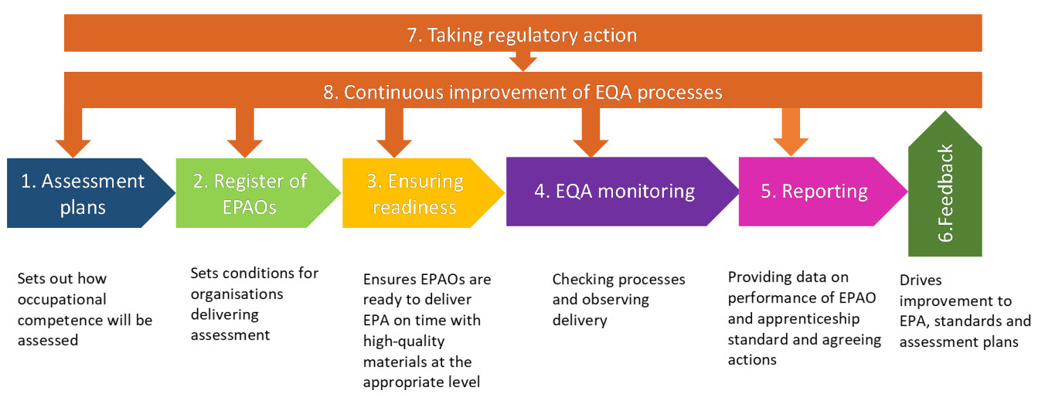

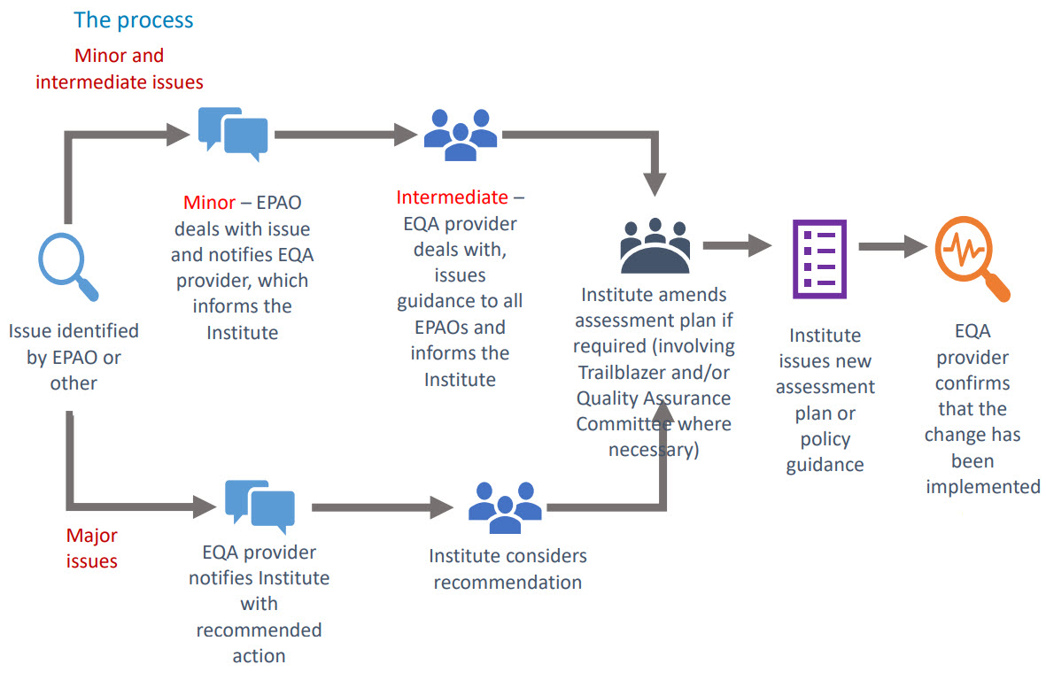

While one player that appears to be absent from this feedback loop is the training provider, the role of professional and employer-led bodies is spelled out in the draft (Institute 2020, p.21−23):

Ofqual and OfS will draw on the occupational expertise of relevant professional and employer‐led bodies…, where it is deemed that there is a suitable body. The Institute will ask each trailblazer group [ed. an employer group (‘trailblazer group’) designs the apprenticeship standard and assessment plan] to nominate an appropriate organisation that will give employers in their sector assurance that the EPA remains a relevant and reliable test of occupational competence, where one exists. The Institute will maintain a register of these organisations which Ofqual and OfS will then draw from in undertaking their annual programme of EQA activity.

The types of employer groups envisaged as suitable bodies to assist with quality assurance are:

* organisations regulating entry to, and exit from, a particular profession
* trade associations made up (and funded by) members who are employers in a given sector
* chartered Institutes, whose members are individual professionals in a given sector
* guilds or livery companies
* organisations with an established industry levy
* intermediary bodies, widely recognised to represent a given sector, with a focus on supporting skills development
* professional membership bodies widely recognised as setting standards for that profession.

Each standard is to have an external quality assessment (EQA) at least once every three years, and in some cases more frequently depending on the level of risk posed. The evaluation of risk will be a multi‐dimensional process and will encompass:

* the level of risk considered to be posed by a particular EPAO
* the risks associated with delivering a particular standard (numbers of students, for example)
* the results of Ofqual/OfS monitoring and apprentice feedback.

The EQAs will involve desk‐based reviews and input of professional and employer‐led bodies as appropriate. They will be able to access some documentation from the Institute’s digital system, as well as documentation from EPAOs, which may include:

* policy documents (application to the specific standard)
* assessment materials
* strategy for internal quality assurance (IQA)
* data on EPA including, registrations, pass rates and distribution of grades
* CVs, qualifications, performance reports and CPD records for assessors
* feedback from stakeholders, including apprentices, training providers and employers on the relevance and reliability of assessments delivered
* records of IQA activities, including standardisation and moderation
* records of any reasonable adjustments or special considerations granted and evidence behind these decisions.

Visits and observations of end-point assessments will be done by reviewers with assessment and industry expertise able to judge whether the assessment is truly assessing occupational competence. Evidence sought may include observations of a sample of assessments, including live assessments, that check the content and context of assessments are occupationally relevant and may consist of:

* observation of assessor standardisation or moderation meetings
* review of training materials
* review of physical or digital versions of documents, including marked assessment materials from apprentices
* interviews with assessors and other EPAO staff
* feedback from apprentices and employers to check how well the end-point assessment is meeting their needs, including how well it relates to current business practice
* checks on IT systems, security and record storage
* accessibility of assessment including any language bias and reasonable adjustments
* following up on previous actions and recommendations.

The paper shows (pp.24−27) how each aspect will generally be reviewed either by a desk‐based audit or during a visit and whether an aspect of the assessment will be reviewed by Ofqual or the appropriate professional or employer‐led body for the standard in question.

While the results of the consultation were not yet known at the time of writing (the period was extended because of COVID-19), a June 2020 publication gives some indication of how this EQA will be used to improve assessment. Technical evaluations look at whether the EPA, which is developed by EPAOs, to see if it reflects the employer-set assessment plan and the clarity and sufficiency of assessment tasks. Ofqual analysed the results from technical evaluations over the last two years of the first wave of 50 end-point assessments (EPAs). The report made the point that:

a considerable amount of what is required for valid assessment in EPAs has already been identified by employers in the assessment plan. The plan outlines what an apprentice needs to demonstrate; the length and nature of the related assessments (such as a written test, an observation or a discussion); and what level of performance is needed for each grade.

The review identified issues in three categories that affect over half of the EPAs examined:

1. Insufficient assessor guidance — unclear task requirements.
2. Insufficient assessor guidance — little or no exemplification of grading criteria or performance requirements.
3. General errors, contradictions and inaccuracies in materials.

Further issues identified in over a quarter of the EPAs reviewed:

1. Assessment/performance requirements differ from the assessment/grading criteria set out in the assessment plan.
2. Lack of clarity around the task requirements for the apprentice.
3. Not all Knowledge, Skills and Behaviours (KSBs) are covered.
4. More than one correct answer in Multiple Choice Questions (MCQs).
5. EPA not meeting the requirements of the assessment plan. (Ofqual 2020 p.7)

These findings point to the value of external validation of assessment tools and practice.

# New Zealand

The New Zealand government is reforming vocational education so that the system has a stronger focus on employers, delivering the skills they need, providing more support for their employees, and ensuring greater consistency in vocational education across the country. In May 2020, the government announced a trades training package that included the fast-tracking of six Workforce Development Councils (WDCs) to help support New Zealand’s COVID-19 recovery. These WDCs are to formulate a strategic view of the future skills needs of industries, as well as set standards, develop qualifications and help shape the curriculum of vocational education. They will moderate assessments against these industry standards and, where appropriate, set and moderate capstone assessments at the end of a qualification. Unlike in the past, the WDCs will not be involved in arranging apprenticeships and other on-the-job training, which will sit with training providers.

The New Zealand Qualifications Authority has responsibility for assuring national consistency of graduate outcomes for qualifications at levels 1 to 6 listed on the New Zealand Qualifications Framework. It is working to determine the quality assurance systems and measures for the New Zealand Institute of Skills and Technology (NZIST) and Workforce Development Councils (WDCs) during the transition and in the longer term. The current system includes national external moderation systems to ensure that assessment decisions about assessment standards are consistent nationally for which it charges a fee for each graduate.

In this context, the term ‘moderation’ is used differently in New Zealand, as it is a process that occurs after the assessment is complete, not as a process to check the assessment before it is concluded. Post-moderation, whether paper-based or through observation, involves checking the accuracy of assessment decisions, the quality of the assessments and the degree to which trainees are meeting the requirements. It has been seen as ‘an opportunity for a learning conversation that professionally develops assessors and grows assessment capability’ (Alkema and McDonald 2016 p.18) and has also involved employers, managers or supervisors in workplaces making judgements about trainees’ competence. Specialist staff and professional development have both been features of the system.

# Implications for Australia

The current VET infrastructure in Australia for designing qualifications (the Australian Qualifications Framework) and training packages (Industry Reference Committees and Skills Standards Organisations) and regulating quality (Australian Skills Quality Agency) is somewhat in flux. Nevertheless, it would seem it would provide the mechanisms to introduce learnings from the international experience, namely:

* to continue to involve employers in determining the vocational competencies required in the labour market
* to ensure final assessments before qualifications are to be awarded are undertaken by independent, highly trained assessors, including where feasible, employers
* to ensure external validation processes involve the cooperation of all parties — employers, employee representatives where relevant, independent assessors, learners — with feedback into training providers about training and assessment practices as well as to industry reference committees about the continuing relevance of training and certification to occupational needs.

# References

Alkema, A, McDonald, H 2016, Principles of on-job assessment for industry training, Ako Aotearoa (National Centre for Tertiary Teaching Excellence), Wellington, viewed 28 Jul 2020, <<https://ako.ac.nz/KnowledgeCentreSearch?term=assessment%20industry%20training>>.

Apprenticeship Toolbox 2019, viewed 29 July <<https://www.apprenticeship-toolbox.eu/standards-matching/examination-certification/90-examination-certification-in-germany>>.

Cedefop (2015). Ensuring the quality of certification in vocational education and training. Luxembourg: Publications Office. Cedefop research paper; No 51. Viewed 24 July 2020 <<http://dx.doi.org/10.2801/25991>>.

[Fürstenau](https://www.researchgate.net/profile/Baerbel_Fuerstenau), B, Pilz M,Gonon, P 2014, ‘The Dual System of Vocational Education and Training in Germany – What Can Be Learnt About Education for (Other) Professions’ in  [Billett, S, Harteis, H.C. & Grubern, H. (Eds). International Handbook of Research in Professional Practice-based Learning,Springer.](https://www.researchgate.net/publication/270589064_Lehtinen_E_Hakkarainen_K_Palonen_T_2014_Understanding_Learning_for_the_Professions_How_theories_of_learning_explain_coping_with_rapid_change_In_S_Billett_H_C_Harteis_Grubern_H_Eds_International_Handbo)

Gaylor, C, Follner, M et al. 2015, Compendium: quality of in-company vocational education and training, Federal Institute for Vocational Education and Training, Bonn, viewed 29 Jul 2020, <https://www.deqa-vet.de/\_media/PDF\_allgemein/compendium\_quality-vet\_en.pdf>.

Gessler, M 2017, 'Collaboration between companies and schools in the German Dual Apprenticeship System [keynote address]', in Modern apprenticeships: widening their scope, sustaining their quality: proceedings of the seventh research conference of the International Network for Innovative Apprenticeships, eds R I Lerman & E A Okoli, [International Network on Innovative Apprenticeship], [Washington], viewed 29 Jul 2020, <http://www.inap.uni-bremen.de/dl/inap%20conference%20proceedings%202017.pdf#page=11>.

Great Britain Parliament House of Commons Education Committee 2018, The apprenticeships ladder of opportunity: quality not quantity, House of Commons, London, viewed 28 Jul 2020, <https://www.parliament.uk/business/committees/committees-a-z/commons-select/education-committee/inquiries/parliament-2017/apprenticeships-and-skills-training-inquiry-17-19/>.

Great Britain Parliament House of Commons Education Committee 2018, The apprenticeships ladder of opportunity: quality not quantity: Government Response to the Committee’s Sixth Report of Session 2017–19 viewed 28 Jul 2020 <<https://publications.parliament.uk/pa/cm201719/cmselect/cmeduc/1814/181402.htm>>.

Institute for Apprenticeships and Technical Education 2020, EQA Framework August 2020, viewed 3 May 2021, <https://www.instituteforapprenticeships.org/media/4424/eqa-framework-august-2020.pdf>.

New Zealand Qualifications Authority, <<https://www.nzqa.govt.nz/about-us/our-role/legislation/fees/other-tertiary-education-fees/>>.

Ofqual 2020, Findings from Ofqual’s technical evaluation of apprenticeship End-Point Assessment materials Information to support awarding organisations’ delivery of End-Point Assessments, viewed 28 July 2020, <<https://assets.publishing.service.gov.uk/government/uploads/system/uploads/attachment_data/file/895234/Technical_Evaluation_findings_-_EPA_Materials_25.06.2020.pdf>>.

Organisation for Economic Co-operation and Development (OECD) 2008, Learning for jobs: OECD reviews of vocational education and training: Australia, OECD reviews of vocational education and training, OECD, Paris, viewed 1 Jul 2020, <http://www.oecd.org/edu/skills-beyond-school/41631383.pdf>.

Watters, E, Hanf, G (eds) 2017, Promoting quality assurance in vocational education and training: the ETF approach, European Training Foundation, Turin, viewed 29 Jul 2020, <http://www.etf.europa.eu/webatt.nsf/0/B77049AC22B5B2E9C125820B006AF647/$file/Promoting%20QA%20in%20VET.pdf>.