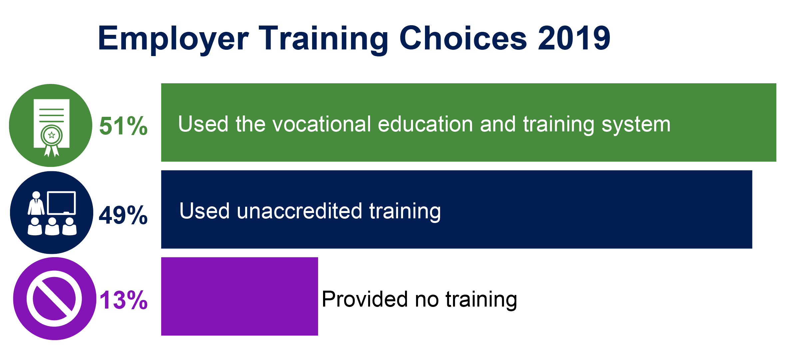
<<DATE>>

<<Barcode>>
Attention: NAME COMPANY ADDRESS1 ADDRESS2
SUBURB, STATE, PCODE

How do you meet your skills needs? – A Survey of Australian Employers

The National Centre for Vocational Education Research (NCVER) and Wallis Social Research (Wallis) are conducting a survey on behalf of the Australian Government Department of Education, Skills and Employment to find out how employers meet their skill needs. We are also interested in understanding how the COVID-19 pandemic has affected the way you train your staff and your future training plans.

The best person to fill out this survey would be the person who manages employment and training for your organisation.

The survey takes about 10 minutes to complete. The enclosed brochure contains information to help you complete the survey.

You can either complete the survey:
online by visiting: wmsr.com.au/seuvxxxxxx; OR scan the QR code
Project Ref: 4787
ID Number: <<WID>>

or over the phone. An interviewer from Wallis will contact you shortly and will ask to speak to the person responsible for employing or arranging training for staff in your organisation. If this is not you, please pass this letter on to the correct person.

Participation in the survey is voluntary and your information will remain confidential. The data you provide does not identify you in any way, and your responses are compiled anonymously. For more information, see our Privacy Notice at www.ncver.edu.au/employerviews/privacynotice.

If you have any questions about the survey, contact Wallis on 1800 113 444 or email seuv@wallisgroup.com.au quoting your ID number <<WID>> and the project number 4787.

Thank you for your participation in this important study. Results from previous surveys can be found on the NCVER’s website (see www.ncver.edu.au/employerviews).

Yours sincerely,
Funded by

Simon Walker

Managing Director, NCVER

