NCVER_Floating_Mono

Beyond the standard: motivators of high-performing RTOs – support document

Joanne Waugh

NCVER

This document was produced by the author(s) based on their research for the report *Beyond the Standard: motivators of high-performing RTOs*, and is an added resource for further information. The report is available on NCVER’s Portal: <<https://www.ncver.edu.au>>.

### ­

### 

### Publisher’s note

The views and opinions expressed in this document are those of NCVER and do not necessarily reflect the views of the Australian Government and state and territory governments. Any errors and omissions are the responsibility of the author(s).

**© Commonwealth of Australia or National Centre for Vocational Education Research, 2023**

G:\pub_prod\PublicationComponents\logos\Creativecommons\CC BY logo.eps

With the exception of the Commonwealth Coat of Arms, the Department’s logo, any material protected by a trade mark and where otherwise noted all material presented in this document is provided under a Creative Commons Attribution 3.0 Australia <http://creativecommons.org/licenses/by/3.0/au> licence.

The details of the relevant licence conditions are available on the Creative Commons website (accessible using the links provided) as is the full legal code for the CC BY 3.0 AU licence <http://creativecommons.org/licenses/by/3.0/legalcode>.

The Creative Commons licence conditions do not apply to all logos, graphic design, artwork and photographs. Requests and enquiries concerning other reproduction and rights should be directed to the National Centre for Vocational Education Research (NCVER).

This document should be attributed as Waugh, J 2023, *Beyond the standard: motivators of high-performing RTOs — Support document,* NCVER, Adelaide.

This work has been produced by NCVER on behalf of the Australian Government and state and territory governments, with funding provided through the Australian Government Department of Employment and Workplace Relations.

Published by NCVER, ABN 87 007 967 311

Level 5, 60 Light Square, Adelaide, SA 5000  
PO Box 8288 Station Arcade, Adelaide SA 5000, Australia

**Phone** +61 8 8230 8400 **Email** [ncver@ncver.edu.au](mailto:ncver@ncver.edu.au)

**Web** <https://www.ncver.edu.au>

**Follow us:**

 <<https://twitter.com/ncver>>

<<https://www.linkedin.com/company/ncver>>



 <https://www.facebook.com/ncver.au>

Contents

Tables and figures 4

Tables 4

Figures 4

Beyond the standard 5

Highlights 5

Methodology 5

Results 9

What is high performance? 10

What motivates you to pursue high performance? 12

How is high performance embedded in RTO practices? 14

How do students/employers know you are high performance? 21

How do you measure RTO performance? 22

Appendix A: Data themes and codes 26

References 33

# Tables and figures

## Tables

Table 1 Training packages delivered by participating RTOs 6

## Figures

Figure 1 De-identified participant characteristics. 6

Figure 2 Concept map: What is high performance? 10

Figure 3 Concept map: What motivates you to pursue high performance? 12

Figure 4 Concept map: How is high-performance embedded in RTO practices? 15

Figure 5 Concept map: How do students/employers know your RTO is high-performance? 21

Figure 6 Concept map: How do you measure high performance. 23

# Beyond the standard

The quality of registered training organisations (RTOs) remains a topic of great interest to users of both vocational education and training (VET) and governments as the VET sector adapts to deliver on forecast workforce and skilling needs. All RTOs must adhere to minimum quality standards, but some deliver above and beyond those standards. This research builds upon the work of Guthrie and Waters (2021, 2022) to examine what motivates such RTOs to pursue high performance.

State and territory governments were asked to nominate RTOs that are considered to deliver outstanding outcomes for students and/or industry. From the nomination list, high-performing RTOs operating in a variety of settings were invited to participate. The leaders of the RTOs were interviewed to explore their understanding of high performance, what motivates them to pursue high performance, how it is embedded into business practices and how they determine whether they are high performers.

## Highlights

* Altruistic intentions and business security motivations were the key drivers of high performance among the RTOs in this study. These motivations reflect the challenge of balancing interests in RTO operations: impact versus financial sustainability.
* RTO leaders view strong relationships with students and employers as vital to high performance and prioritise resources to ensure open communication and to create safe environments for students and staff.
* Leadership style appears to drive the way in which motivations are translated into action, with a transformational leadership style encouraging leaders to prioritise inclusive and supportive practices for staff, students and employers alike. Targeted guidance and professional development support for RTO leaders may improve provider performance.
* Some RTOs may welcome resources and reliable guidance on ways to pursue high performance and to assess their efforts, but they see no requirement for further regulation in this area.
* RTOs’ own definitions of high performance included not only measurable outcomes, such as completion rates, but just as often their aspirations for the organisation. RTOs considered that evidence of established responsive student support, along with mechanisms for ensuring industry knowledge; for developing excellent trainers; and for dedicating resources for engagement with industry, defines an RTO as high-performing.

## Methodology

This research sought to understand the motivators of RTO high performance and so used a qualitative research methodology. Motivators are the factors that drive a person to pursue a course of action and can be understood by understanding a person’s beliefs and observing their actions. The researcher conducted interviews with RTO leaders to understand their views and attitudes and how they embed the pursuit of high performance into their RTO’s practices.

State and territory governments were asked to supply a list of high-performing RTOs in their jurisdictions to participate in the project. All states except Victoria and Tasmania did this. For these states, nominees and winners of state training awards were included. Sixty-nine RTOs were selected to participate in the study, for which 21 interviews were conducted during August and September 2022, resulting in a response rate of 30.4%.

### Participants

The study recruited 21 participants from a range of regions, RTO sizes and with different scopes of delivery. Table 1 provides an overview of the participant characteristics and table 2 shows the range of training packages on the scope of the participating RTOs. It should be noted that, at the time of undertaking these interviews, NCVER was also recruiting RTOs for interviews for three other projects, which did limit the number of nominated high-performing large RTOs that could be contacted for this project to address the risk of response fatigue.

Figure 1 De-identified participant characteristics.

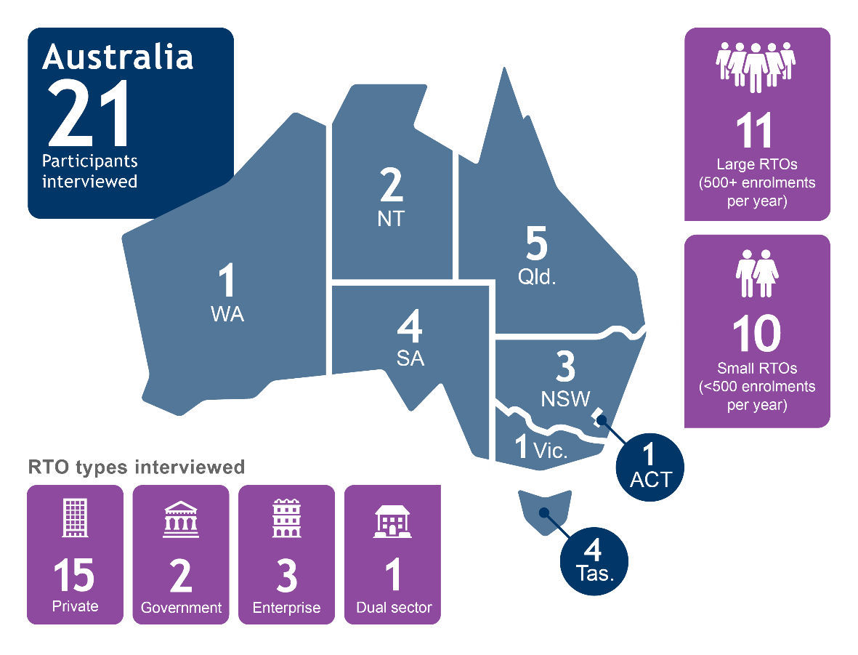

Table 1 Training packages delivered by participating RTOs

| Training packages | Delivered by an RTO in this study |
| --- | --- |
| ACM Animal Care and Management |  |
| AHC Agriculture, Horticulture and Conservation and Land Management | ✓ |
| AMP Australian Meat Processing | ✓ |
| AUM Automotive Industry Manufacturing |  |
| AUR Automotive Industry Retail, Service and Repair | ✓ |
| AVI Aviation |  |
| BSB Business Services | ✓ |
| CHC Community Services | ✓ |
| CPC Construction, Plumbing & Services Integrated Framework | ✓ |
| CPP Property Services | ✓ |
| CSC Correctional Services |  |
| CUA Creative Arts and Culture | ✓ |
| DEF Defence |  |
| FBP Food, Beverage and Pharmaceutical |  |
| FNS Financial Services | ✓ |
| FSK Foundation Skills | ✓ |
| FWP Forest and Wood Products |  |
| HLT Health | ✓ |
| ICP Printing and Graphic Arts |  |
| ICT Information and Communications Technology | ✓ |
| LGA Local Government |  |
| MAR Maritime | ✓ |
| MEA Aeroskills | ✓ |
| MEM Metal and Engineering | ✓ |
| MSA07 Manufacturing |  |
| MSF Furnishing |  |
| MSL Laboratory Operations |  |
| MSM Manufacturing |  |
| MSS Sustainability | ✓ |
| MST Textiles, Clothing and Footwear |  |
| NWP Water |  |
| PMA Chemical, Hydrocarbons and Refining | ✓ |
| PMB Plastics, Rubber and Cablemaking |  |
| POL Police |  |
| PPM Pulp & Paper Manufacturing |  |
| PSP Public Sector | ✓ |
| PUA Public Safety | ✓ |
| RGR Racing Industry |  |
| RII Resources and Infrastructure | ✓ |
| SFI Seafood Industry | ✓ |
| SFL Floristry | ✓ |
| SHB Hairdressing and Beauty Services | ✓ |
| SIF Funeral Services |  |
| SIR Retail Services | ✓ |
| SIS Sport, Fitness and Recreation | ✓ |
| SIT Tourism, Travel and Hospitality | ✓ |
| TAE Training and Education | ✓ |
| TLI Transport and Logistics | ✓ |
| UEE Electrotechnology | ✓ |
| EUG Gas Industry |  |
| UEP Electricity Supply Industry |  |
| UET Transmission, Distribution and Rail | ✓ |
| **Total** | **30** |

### Procedure

In August 2022, the researcher sent an invitation email and privacy notice to RTO leaders using either the contact details provided by state and territories or via contacts listed on the National Register of VET (training.gov.au). If an RTO responded to the invitation, the researcher set up a 30-minute online interview on Microsoft Teams. All interviews were completed by the end of September 2022.

Instructions to the participants were minimal. Unless they asked, participants were not sent the questions in advance in order to decrease the impact of participant bias (social desirability effect). To further promote openness from participants, their anonymity was guaranteed. Interviews were recorded and transcribed, and then de-identified. The recordings have been deleted and the transcriptions will not be shared outside the NCVER research team. Characteristics relating to RTO size, scope, length of operation and location were retained, but where this may result in identification of the RTO those characteristics have not been shared in this report.

At the start of the interview, RTO participants were asked for permission to be recorded. After permission was granted, the researcher asked five demographic questions and up to five open-ended research questions. The questions were semi-structured to allow flexibility based on the RTO’s circumstances. For example, the question on how prospective students and employers knew they were high-performing was not as relevant to enterprise RTOs.

When researchers are undertaking a thematic analysis, it is important that they maintain an audit trail, which documents their thoughts and perspectives on the data as they are collected. The interviewer kept an audit trail that included reflections on the content of participants’ responses, ideas to improve questioning, areas for further interrogation and reflections on how their own experience may have impacted on the interpretation of the data.

Braun and Clarke (2006) six-stage guide for undertaking thematic analysis was followed. The stages are not necessarily linear, with a researcher able to move back to a previous stage where data complexity demands or where new themes are suggested. The steps involved becoming familiar with the data; generating initial codes; searching for themes; reviewing themes; defining themes; and writing up the analysis. For this study, the data were reviewed and coded using NVivo on PC. This software allowed the coding and thematisation of data and enabled queries to be run that would check patterns in the code by RTO characteristic.

For this study, a theoretical thematic analysis was used, with the analysis guided by the parameters of a specific research question. Only data that were relevant to the research questions were captured in codes. Open coding was used, whereby codes are generated and modified as the data are reviewed, rather than having set codes to populate at the start of the analysis. In this way, the analysis of the RTO data was open to capturing whatever the participants shared, rather than focused on identifying existing paradigms and ideas.

### Limitations

This study used qualitative research methods to understand the views and attitudes of RTO leaders towards performance. Such qualitative methods are not intended to be ‘representative’ in the same manner as quantitative research. Rather, the aim is to deeply explore material that cannot be easily measured. To understand whether any of the views reported by the participants are unique to high-performing RTOs, research would benefit from comparison with lower-performing RTOs. However, approaching RTOs to inform them they are low-performing would undoubtedly not be welcomed and unlikely to result in strong participation.

Participation in this study was voluntary and therefore the findings may be skewed by the self-selection of RTO leaders with greater altruistic motivations. While there was a broad representation   
of RTO participants from across Australia, the states and territories was not equally represented in   
the distribution of RTOs. As indicated in the introduction, there is no fair way to quantify high-performance, so the invitation list of RTOs may have excluded providers that fit the definition, or included some that did not.

## Results

The thematic analysis of the data created 126 codes, which the researcher collapsed into 25 themes across the five areas of enquiry into high performance from the interviews. All themes, codes and example quotations can be found in appendix A: Data themes and codes.

Participants were able to articulate their own definitions of high performance and readily identified how their RTO sought to fulfil its aspirations about performance. Several participants reported that they had enjoyed the interview as it had given them a chance to reflect on what they were doing and how they approached performance. Participants expressed a great deal of pride when talking about what their RTO was doing for their students, industry and community.

There was no evidence that any participants were reluctant to share information about how they operated or what they thought about high performance. Very little of the information shared by participants could be characterised as negative or critical of either the sector or their operations as an RTO, with two exceptions: the risk that audits by regulators posed to innovation in RTOs; and the difficulty of balancing financial viability with the expense of pursuing high performance.

The analysis identified themes under five areas of questioning:

* What is high performance?
* How do you embed high performance into RTO operations?
* How do you measure high performance?
* How do others know that your RTO is high-performing?
* What motivates your RTO to pursue high performance?

**Do motivations and practices vary by RTO size?**

RTOs of all sizes touched on similar motivating factors and implementation strategies. However, some differences emerged in approaches between small and large RTOs.

Small RTOs more often reported:

- using more informal methods of collecting feedback

- cultivating a flat management structure and consulting staff.

Participants from large RTOs more often reported:

- defining high performance by satisfaction of stakeholders

- being motivated by accountability

- using internal KPIs and targets and data reports to measure performance.

## What is high performance?

Participants shared their definitions of high performance as an RTO and the analysis of their responses identified four themes: satisfied stakeholders; measurable outcomes; public good; and effort. Figure 1 shows the relationship between these themes and the codes they comprise. Two broad approaches to defining high performance emerged: output-based and intentions-based.

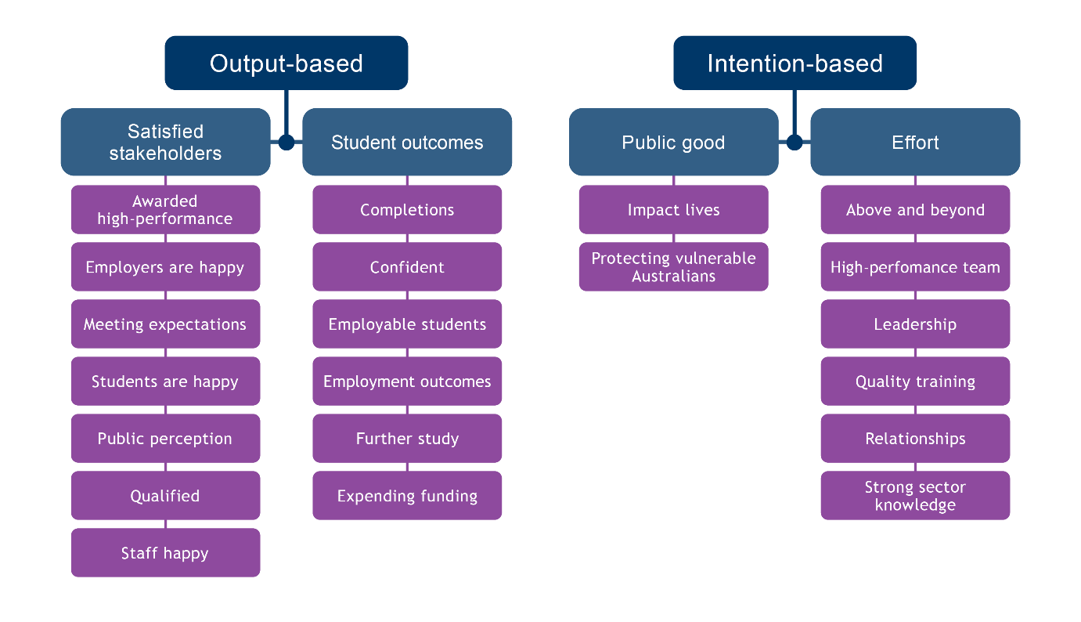Figure 2 Concept map: What is high performance?

### Satisfied stakeholders

This output-based theme encapsulates participants who defined high-performing RTOs as those who can satisfy their stakeholders. Stakeholders could be students or employers and industry.

They look not only to student achievement but to student satisfaction and enjoyment:

‘We are very much student-centric, ensuring that they have a really good journey’ (P #55).

Employer happiness and satisfaction also defined high performance:

‘A high-performing RTO does that for both the student and also for the industry that the student is looking for employment in’ (P #42).

Participants considered that being high-performing was about producing students that were appropriately qualified to work in the sector for which they had been trained:

‘We need them [students] to be able to understand what we’re delivering and implement it in   
the workplace’ (P #26).

### Student achievement

Participants also defined high performance by the achievement of quantifiable outcomes for their students. This included data on completion rates and employment outcomes:

‘I’d probably say successful completions’ (P #12).

‘Successful outcomes means we’ve actually done our job and that would mean a high employment rate at the end’ (P #19).

The confidence of their students was cited as an indicator of high performance, above the completion rate metric:

‘We really need a clear picture of confidence, so that’s extremely important for us as the RTO’ (P #18).

Students going on to enrol in further study was another indicator of high performance for some:

‘And I guess spark, spark a curiosity to go further’ (P #60).

### Public good

Some participants viewed RTO high performance as contributing to the bigger picture through service to the community and protecting vulnerable people. In this case, the intention of the RTO is important to its designation as high value:

‘So high performance for us is that we know there’s a vulnerable person on the end of what our education training achieves, so that vulnerable person needs quality and safe supports’ (P #62).

### Effort

This theme is generated from the high-effort actions and activities that RTOs say define high performance. Going ‘above and beyond’ entails having a strong knowledge of the sector in which they operate, showing leadership within the sector, having appropriately qualified staff and high-quality training, and developing strong relationships with employers, students and all other parties to the training:

‘We always think about in terms of the fact that we go above and beyond’ (P #7).

Other participants believed that forming relationships with stakeholders and acting as a leader in the sector makes an RTO stand out above others:

‘We do take a leadership position because we have a philosophy that education should be about leadership’ (P #62).

‘It’s not hard to be successful if your kids, your students, are coming back to you and your employers are feeling like you’re contactable and you’re informing them of any issues before they become big issues’ (P #2).

For other participants, RTO high performance could be identified through the quality of training delivery and training staff, which was seen as a result of the deliberate choice by an RTO to invest in its staff:

‘If an RTO doesn’t have good trainers, then it’s not a high-performing RTO, I don’t care what measure you use’ (P #60).

## What motivates you to pursue high performance?

Participants reported that they were motivated by a range of factors, many of which were intrinsic to the individual participants who led the RTO. Business interests were also cited as motivators, although these had less influence in the pursuit of high performance than altruism and other personal traits. Six themes were identified: accountability, altruism, business security, personal traits, relationships and servicing needs.

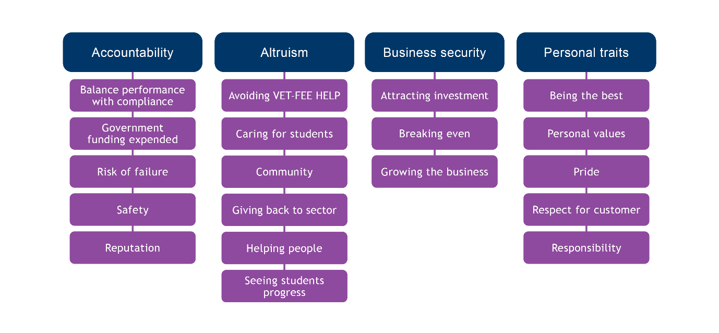Figure 3 Concept map: What motivates you to pursue high performance?

### Accountability

Participants from large RTOs said that ensuring their RTO delivered on its promises and obligations was a key motivating factor. This included addressing the tension between wanting to deliver at a high level and being restricted by the budgetary concerns of running a sustainable business:

‘Having said that, if you don’t profit and have a decent margin, you cannot invest in the future and you cannot change, so it must be commercially sustainable … It’s been a total struggle’ (P #62).

One participant discussed their concern about ensuring the government funding they received was well used:

‘So we want to be sure that you know the government is happy and at the end of the day, it’s the taxpayers’ money that’s getting involved when it comes to government contracts’ (P #3).

Some participants mentioned their awareness of their RTO’s role in delivering core or essential skills, which industry relied upon for productivity and safety. Safety and reducing risk to workers were key concerns for participants with qualifications for high-risk trades or working with vulnerable people on scope:

‘We work in a high-risk environment where pretty much any job that we go to has the potential to kill’ (P #18).

‘I see a vulnerable person at the end of every training session they deliver. So they’re very conscious and they don’t want to let their students go if they feel as though they’re not going to provide at least safe support’ (P #62).

### Altruism

By far the most common motivators mentioned by participants from large and small RTOs fell under the sub-theme of altruism. Sixteen of the 21 participants talked about how they cared for students, the community, giving back to the sector and wanting to help or inspire people:

‘I think we do have that care factor … I love it, we get very attached to the students. They are our family now so I think we want to we treat them as if they are family’ (P #22).

The connection between the RTO and the community was very apparent for some participants and they took their role seriously due to an awareness that the community would reap what they sowed:

‘The line between [RTO name] and the rest of the world does, you know, there’s no [division], just one student makes a difference and everybody in the RTO carries that around with them … we are the community, we’re all the same’ (P #44).

Others talked about wanting to improve the training offering to their sector, or to make a difference to the sector by producing high-quality workers:

‘I guess it’s coming from industry 20-odd years ago and being shocked at what I saw was being presented and trained and what kids were being asked to do with trade school’ (P #2).

Seeing their students’ progress, whatever that progression looked like, was another motivating factor and one which some RTOs chose to deliberately celebrate with graduation ceremonies:

‘You see the direct outcome of what you’re trying to do and then you see it through the different stages of their careers as well and that’s really rewarding … so that’s one thing that really does motivate us’ (P #27).

‘For graduation, we do the cap, we do the gown, we do everything you know, and it’s beautiful. The pride that these guys have and some of them have never anything past year 10, so it’s beautiful … And yeah, that’s all you need’ (P #64).

### Business security

Ensuring that their RTO could continue to operate into the future was a motivating factor for a minority of RTOs. Attracting investment, building the business and breaking even were cited as reasons to pursue high performance:

‘if you don’t profit and have a decent margin, you cannot invest in the future and you cannot change, so it must be commercially sustainable’ (P #62).

‘It [high performance] then gives the business confidence to invest in us. So when we seek funding for additional resources or we need to uplift in any way that business is happy to invest in our growth’ (P #27).

### Personal traits

For a quarter of the participants it was their own personality or characteristics that made them want to pursue high performance. This did not vary by RTO type. Personally valuing high performance and wanting to ‘be the best’ as an individual motivated participants to channel that into their RTO:

‘I’ve been high performing myself. So for me, if I’m controlling the ship, I need to ensure that it’s the high performance’ (P #3).

‘We’re a bit competitive. We’re pretty feisty, and we like to punch above our weight’ (P #44).

Participants displayed a great deal of pride in their role as an RTO and in what their RTO achieved. This pride drove them to pursue high performance because they had respect for their customers, an awareness that their reputation was on the line, and they did not want to be revealed to be less than excellent. In this way, this sub-theme is linked to reputation in the relationships sub-theme.

‘We don’t want to take people’s money for something that they don’t need and then have them feel, you know, [being taken advantage of]’ (P #17).

RTOs that operated in smaller communities were highly aware that their reputation was at stake and pride motivated them to do their best:

‘It’s all about pride as well, you know … Rural people do not suffer fools very well’ (P #12).

Participants had an awareness of the reputation of their RTO and that drove them to want to deliver to a high standard for all stakeholders. There was no difference between participants from small and large RTOs for this sub-theme:

‘Obviously the quality of the student coming out at the end: this student went to [RTO name], he’s got good quality skills, good training skills … this one went to another provider and he is not so good and such’ (P #2).

The relationship with stakeholders played into the reasons for pursuing high performance too; one participant was highly aware of needing to face up to their performance when dealing with customers:

‘I think it’s about relationships at, at the end of the day. For us, the relationships are a key part of what makes us a high-performing provider’ (P #7).

## How is high performance embedded in RTO practices?

Participants shared many ways by which they believed their RTO practices helped them to become high-performing training providers. Six themes were identified that capture the different approaches to embedding the pursuit of high performance: RTO values, student support, staffing, quality assurance (QA), teaching and learning, and employer relationships.

RTOs may have taken one or more of these approaches — it was often a combination. The quality assurance, staffing and student support themes were mentioned in 19 of 21 interviews, while the teaching and learning theme arose in 10 of 21 interviews.

Although the interview questions did not enquire about barriers, some participants shared their thoughts on the things that inhibited or deterred them from pursuing high performance.

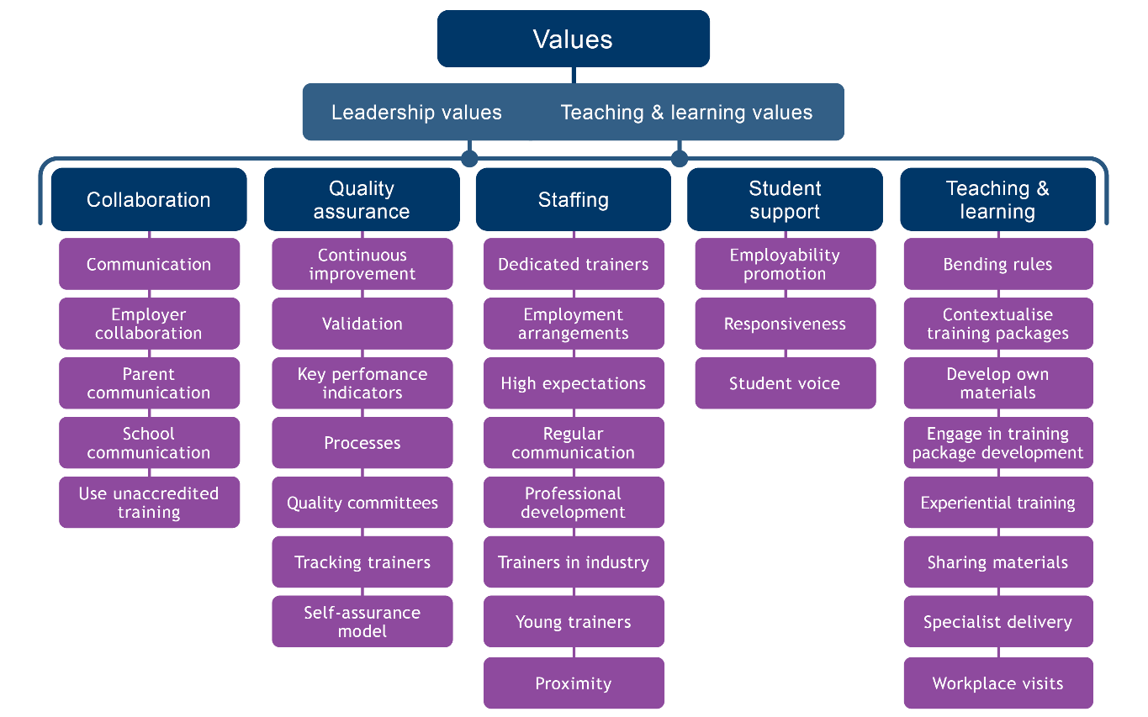Figure 4 Concept map: How is high-performance embedded in RTO practices?

### Values

Participants spoke of the impact they believed RTO leadership, teaching and learning values had on performance. Leadership values were seen to have a strong influence over the ultimate impact of an RTO as they framed goals and provided the motivation. But leadership values also facilitated a lot of the activity that participants believed promotes high performance, such as trusting staff and giving them autonomy.

#### Leadership values

Providing trainers with the autonomy and trust to do their jobs was cited as a key factor in high performance. This factor was raised by participants from large and small RTOs equally:

‘It’s probably giving them a little bit of autonomy on what they do and trusting them to make the right decision when they’re delivering their training’ (P #26).

The leadership having a strong mission statement or values statement that guided the RTO staff at every step of their jobs was another way in which high performance was embedded into operations:

‘I think that really does give our people a really clear purpose of what they’re doing, why they’re doing so. Our vision is very strong’ (P #55).

Participants sometimes expressed that they felt a culture of pursuing high performance was ‘just there’, but after reflection revealed that it was deliberately woven into how they approached each aspect of the business.

‘We overtly cultivate [high performance] from the strategic plan down through because we’ve got our values embedded in our strategic plan’ (P #44).

Leaders with close relationships with operational staff was a feature of participants’ explanation for how they pursued high performance. Leaders saw this close social proximity in the management of their RTOs as important for building trust with staff and ensuring they were kept appraised of events that could inform an improvement or prevent issues from developing:

‘So yes, we do have a lot of one-on-one conversations with me being the owner and with all my staff, they’ve got direct access to me’ (P #3).

Another aspect of leadership values that participants believed contributed to high performance was prioritising the mental health of staff and students. By being aware of mental health and proactively monitoring and reaching out to provide help, RTOs could ultimately deliver on their performance goals:

‘We’ve had a big thing on mental health. We gave our trainers are mental health week and a week off and our students a week off to reassess and think … We got somebody to come in and go through some strategies for them [trainers] … we know that sometimes you know the students can offload problems and trainers don’t always know how to deal with those. And you know, it’s difficult, so we thought that would help them as well. So yeah, we’re big advocates for mental health and looking after people’ (P #22).

#### Teaching and learning values

Participants also expressed a belief that an RTO’s teaching and learning values can contribute to how it performs. The most common values that participants talked about were flexibility and an investment mindset.

The vital role of flexibility in designing and delivering training and in interactions with students, employers and other stakeholders was mentioned by half the participants:

‘It’s just embedded in our culture … we do go the extra mile in the sense that we’re perhaps a bit more flexible. So we don’t bend the rules, but we try and find ways to accommodate … for a number of our employers, not all of them, but for a number of them, I tend to go and see them and meet with them. I tend to do things because it’s a good thing’ (P #60).

One participant talked about their focus on retraining staff out of a completions focus and into their own culture of prioritising competency over completions:

‘We’ve had trainers come from bigger RTOs and they’re like, “So what’s the number of units I need to get completed this week?” It’s not about the number of units that they need to do, it’s about making sure that knowledge transfers there. So our whilst we do have targets, it’s generally, the focus is on can the student do the job’ (P #26).

Participants also mentioned that pursuing high performance could be an investment, financially and in terms of time spent, but that it was vital to achieving the standard of training delivery they sought:

‘So, what we do is to everything that we train and deliver is to support our people and that’s fully contextualised to our cohort. It’s customised to our businesses … We’ve invested a lot of money to do that, but it gets the outcomes that we need’ (P #26).

This acknowledgement of the investment and expense that pursuing high performance can incur was also acknowledged in commentary on the barriers to performing in accordance with the values of the RTO.

### Student support

This theme comprises three sub-themes, each of which offer student support for different purposes. Workforce preparation was generated from codes related to preparing students to enter the workforce and includes actions such as career education, work placements, developing close relationships with trainers through frequent contact, and close contact.

#### Employability promotion

Embedding career education was another component of student support, which included preparing students for the workforce and for job hunting as part of their training:

‘We have … a subject for students, so we actually take a proactive approach and we manage the system with the online portfolios, their resumes, we actually do mock interviews as well for the students’ (P #19).

Another approach was to set up a job noticeboard and develop relationships with industry to facilitate job placements for students and alumni:

‘And I have one [Facebook group] actually dedicated just in [city] on Facebook. It’s a closed group, it’s for our graduates and any jobs that come through, I’ll post up in there’ (P #18).

‘I think we’re kind of like a placement centre for our students as well. We like to have that kind of collaboration with the industry’ (P #22).

#### Responsiveness

Participants talked about the importance of understanding and responding to students’ learning and teaching needs. They considered that high-performance outcomes could not be met without paying close attention to students. They achieved this by having a student-centric approach to the development of processes and procedures, engaging in face-to-face training wherever possible, maintaining a one-on-one trainer—student ratio or high staff numbers, and conducting pre-enrolment checks to ensure students are a good fit for the course:

‘We got a bit of a reputation as being a quality provider and we do a lot of face-to-face training. So we also think that really connects us with our students and the students connect as a class’ (P #17).

There was recognition that one-on-one student support was expensive but worth it, and participants believed that it promoted completions that might not otherwise be achieved:

‘If you leave the student on their own and you are expecting them to try and figure out things means they will be a few motivated students who will try and work around the challenges that come across. But a lot of time, times people will just give up. So we try and give them that one-on-one support’ (P #3).

Providing sufficient staff and trainers to develop relationships with students that allowed them to keep abreast of not only students’ progress but also their emotional and practical needs was considered vital to high performance by many participating RTOs:

‘I think the other thing that’s really important about trainers is that they keep the finger on the pulse in terms of what their students’ needs are’ (P #42).

#### Student voice

Some participants placed students at the centre of their practice by setting up a student representative body, consulting students to assess their community and cultural needs, and actively celebrating their achievement through graduation ceremonies:

‘We also do graduate showcases at the end of second year where industry are invited to see all of the outcomes of the students’ work’ (P #19).

‘The SRC, our Student Representative Committee, is a really important body that we are engaging, as is our course advisory and learning and teaching committees … we’ve had class managers for well over 10 years and they are elected by students nominated, nominated by staff or students, but elected by students and then appointed by our executive committee for a period of 12 months minimum and … it’s very democratic insofar as we put a call out, we ask who wants to be of service. It’s an opportunity for students to do more. It’s a voluntary position’ (P #42).

### Teaching and learning

Participants from large RTOs in particular said that they embed high performance by focusing on teaching and learning processes and materials. This can be achieved by taking care to contextualise the training package on scope based on consultation with or feedback from employers:

‘Yeah, we can contextualise it because sometimes you look at the training package and our trainers will go: “Oh gosh, that’s so old fashioned and that’s gonna really turn the kids off”, so we manipulate it within the rules and regulations to keep them engaged, etc. … because we’ve got such good links with industry’ (P #22).

Developing their own training and assessment materials is another way that RTOs pursue high performance and maintain control over what they are offering to students and employers:

‘So the way we plan and schedule our resources is we always have what we call a review day at the end of a unit for the trainers. And that review day is not only used for marking the assessments, but it’s also used for the trainer to conduct a review of the materials and make notes of any changes that are required and tweaks that are required to improve the course’ (P #27).

One participant talked about being involved in the training package development process as useful to their own high performance, by having some input into the content they would have to deliver. Several participants talked about the challenge of ‘bending the rules’ to deliver training that met the qualification rules but was also useful to students and industry:

‘We constantly look at ways to bend the rules, you know, to customise, to meet what a student comes to us with, all kinds of different situations. So we often have to look at things in an individual way and say right, “What does this particular person need?”, because the box may not, they may not fit in the box’ (P #42).

### Staffing

Many participants shared the belief that maintaining a staff of highly dedicated and skilled trainers was essential to high performance as an RTO:

‘The staff have got to be the most important thing that you can have. All the whizbang gear and equipment in the world, and we certainly want that, but the reality is that the single most important thing is staff that are like-minded’ (P #2).

The development of a high-performance training team was attributed to various strategies that leaders could influence, and in this way this theme is related to the leadership values sub-theme. Making professional development to trainers a regular and easily accessible resource was highlighted:

‘I think that probably one of the most valuable things about a trainer is when they’re doing further study themselves, because they both understand … [the] students’ position, but also because they’re continuing to develop themselves in really comprehensive sort of steps’ (P #42).

Giving consideration to the arrangements under which trainers are employed and how that fed into the continuity of trainers for students was another issue raised. Some RTOs had difficulty either attracting or retaining trainers and were aware this was due to their inability to provide secure, ongoing employment:

‘They’re working with us for that whole period and employed with us for that whole time, so we’ve got stability’ (P #7).

‘The trainers and assessors build very strong relationships with their students’ (P #7).

Regular and intentional communication with trainers was another regularly cited factor in high performance. Participants had a variety of strategies for this, which suited their own operational environment and relationship with the staff, for example, a daily face-to-face meeting, a one-on-one relationship with each trainer, establishing a WhatsApp group for trainer communications, using an LSM or SMS to gather trainer insight on students, and leadership being out on the ‘floor’ of the training rooms to say hello and learn names:

‘A very quick a brief over meeting to discuss the plans of the day and how we can support each other if need be’ (P #1).

Directing efforts at explicitly motivating staff was another strategy, which included traditional approaches such as offering a reward for meeting targets to more strategic approaches like committing to an organisation-wide adoption of a growth mindset perspective on staff management:

‘Our people come with a very strong growth mindset engaged in, you know, of course we’re not perfect … mistakes that can happen … but it’s very much around learning from those mistakes and people feeling confident that if they make a mistake, that mistake can be fixed and they learn from it’ (P #55).

Ensuring the trainers keep their professional skills up to date with regular practice is another aspect contributing to high performance:

‘I think one of the most important things about the trainer is ensuring that when we talk about meeting industry currency and demonstrating industry currency’ (P #42).

### Quality assurance processes

Deliberate quality assurance activities and processes were a key component of pursuing high performance for many RTOs. For every participating RTO, this took the form of planning against targets or a performance goal; instituting processes for staff to follow to ensure expectations were met; and providing consistent service to stakeholders:

‘We designed a trainer manual in the very early stages so that everybody was singing off the same hymn sheet’ (P #22).

‘So I think our systems and processes again a are a big part of why we … perform at a … high level intent’ (P #7).

Processes weren’t always seen as formalised or ‘strict’, but still provided a framework for expectation   
of performance:

‘We keep things pretty simple here; we’re not top heavy, heavy with bureaucracy’ (P #2).

Establishing regular reviews of performance and quality through quality committees was a   
common approach:

‘So [we’ve] established seven reference groups, so they’ll be covering the text and they ask [about] standards and sort of follow the student journey. And from that, you know, they look at risk, they look at areas that we’re doing well’ (P #44).

Systems to track trainer performance contributed to high performance for some participants. Such a system could be used in different ways to track trainer performance against performance indicators such as completion numbers and progression:

‘We’ve got a tracking system when it comes to the efficiency of our trainers. So we know exactly whose performance is good and whose performance is not so good’ (P #3).

Or to monitor the quality of the trainers’ delivery and student experience and ensure targets weren’t driving trainer behaviour:

‘We’ve had to monitor them very closely to ensure that the quality standard that we require was delivered because there was definitely a feeling on their part that the sooner they got people signed off, the sooner they’d get paid’ (P #51).

Using internal data from systems to monitor performance was one quality assurance tool in high performance. The training-activity data they were required to gather and send to NCVER was cited, but some RTOs also developed their own analytics to keep track of how they were performing:

‘So there’s all these reports and data that’s constantly being created and shared and visualised, whether it’s scope and products and curriculum or student statistics and satisfaction and employer satisfaction and feedback and engagement and all that sort of stuff. So there’s this constant awareness of where we’re at against different aspects of it’ (P #44).

The use of a student management system or learner management system was common, with participants saying it was key to communicating with each other and any third parties, such as employers or schools, for discussions about students and keeping track of progress. The sophistication of such systems was generally greater in larger RTOs:

‘For the learner side, I guess we definitely track their performance against the qualification and we have some software that helps us to do that’ (P #51).

### Employer relationships

Participants across all RTO types felt that establishing and maintaining relationships with employers was essential to high performance:

‘We actually have the conversations with the workplace to make sure that you know, this is our commitment to delivering, but this is also your commitment as a workplace and a learner as well. So we’re all on, you know, got that information up front’ (P #55).

Close collaboration with employers enabled RTOs to support at-risk students and understand what the employers’ skills needs are:

‘But we communicate very closely with our employers. We’ve got students that are at risk for certain reasons and, yeah, the employer has been in consultation with what we’ve put in place to help that student at risk’ (P #2).

‘It’s consultation with industry about their needs and then it’s taking those additional steps to address those needs that sit outside of the day-to-day training package delivery’ (P #42).

Being deliberate about which employers they worked with was another strategy discussed that could promote high performance. Values alignment between the RTO and their clients was seen as instrumental to a good outcome:

‘I will not “work” in inverted commas with employers that I feel like [are] just in it for a financial outcome because it tends to lead to very bad results’ (P #60).

Planned and documented communication with employers and all other parties to the training was seen as important to collaboration and informed high performance. That included looping in schools and parents where relevant:

‘It’s all planned, scheduled, recorded. The communication with the apprentice, their team leader. We’ve got a field coach in field supporting both the team leader and the apprentice’ (P #58).

### Barriers

Participants were generally positive about their ability to pursue high performance and demonstrated strong investment in activities that would lead to fulfilment of whatever represented their own version of ‘good outcomes’. However, some participants did mention the frustrations they felt in attempting to do what they felt was the ‘ideal’ while constrained by the realities of financial solvency:

‘I get frustrated at times and some of the things I want to do, which is usually because of financial constraints’ (P #2).

‘We are a not-for-profit organisation but we do need to break even, that’s all our board expects. So it’s a balance of, again, that quality [vs] compliance’ (P #55).

Some participants acknowledged that their own operational circumstances made it easier to pursue high-performance than for other RTOs:

‘And then the other one with the high-performing RTO is, which does come at an expense — which I feel sorry for the smaller RTOs from the compliance side — is doing those health checks once a year’ (P #58).

Additionally, participants indicated that they found it hard to understand whether what they were doing was ‘beyond’ the standard, or just typical. Participants reported that collaboration and consultation with other RTOs was rare, and that few resources were available to help them to understand what they could do to go beyond meeting the *Standards for RTOs*:

‘I’ve been in VET for a long time. Umm, I think that there is generally a reluctance to exchange information and to be supportive of each other in a in a sort of in a deeper way within the VET sector’ (P #42).

## How do students/employers know you are high performance?

Participants answered this question very similarly and their responses were categorised into two themes: government recognition and reputation.

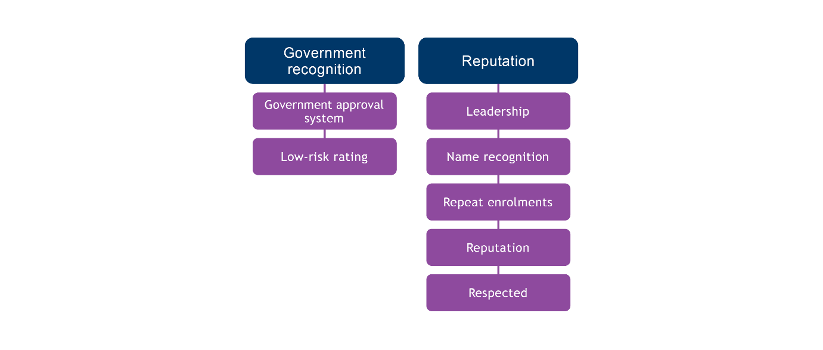Figure 5 Concept map: How do students/employers know your RTO is high-performance?

What stood out was the absence of the traditional promotional techniques that a business might take to attract business, specifically advertising. In fact, several participants noted that they do not advertise because they don’t need to — their reputation stands for itself:

‘We don’t spend money on advertising’ (P #42).

### Government recognition

Having their RTO recognised through either a government award for high-performing or quality RTOs, or having been provided with a low-risk rating from the Australian Skills Quality Agency (ASQA) was mentioned by two participants as the way by which they believed potential students or employers knew they were high-performing:

‘We do have a low-risk rating … our registration is currently low risk so and that’s purely based on those quality indicators that we do meet every year’ (P #27).

### Sought after

Participants overwhelmingly believed that word of mouth was the most common way by which potential students and employers knew they were a high-performing RTO. This was reflected through various markers, such as being viewed as a lead RTO in their sector and in name recognition:

‘Our brand. And I suppose there’s definitely one thing which gives us a massive boost. Obviously if you want to learn [the job] and you’d go to the [RTO name] if you want to learn here you go to the [RTO name]’ (P #22).

Repeat enrolments from the same employer or same students was seen as confirmation that their reputation was good:

‘They are now starting to send their own apprentices to us … obviously there’s a faith there if they’re sending their apprentices back to us, that experience they had with us is great’ (P #2).

The phrase ‘word of mouth’ was used by 15 of the 21 participants when explaining how people knew they were high-performing. The reputation of the RTO was considered highly valuable to their success and security in business operations:

‘It’s word of mouth’ (P #1).

Part of the reputation-building that acted as free advertising for the RTO was linked to the relationship-building activities raised in the relationships theme. Ensuring that past students and employers have had a good experience and pursuing a working relationship with them was reported to be beneficial due to the custom that their positive recommendations would reap:

‘And so really what we’ve done over a period of time is build up a cohort or network of companies that come back to us to do more of our programs and encourage other companies to get involved as well’ (P #51).

## How do you measure RTO performance?

Participants used a variety of ways to measure their own performance, with these categorised into five themes: business indicators, employer feedback, government feedback, student feedback and public perception.

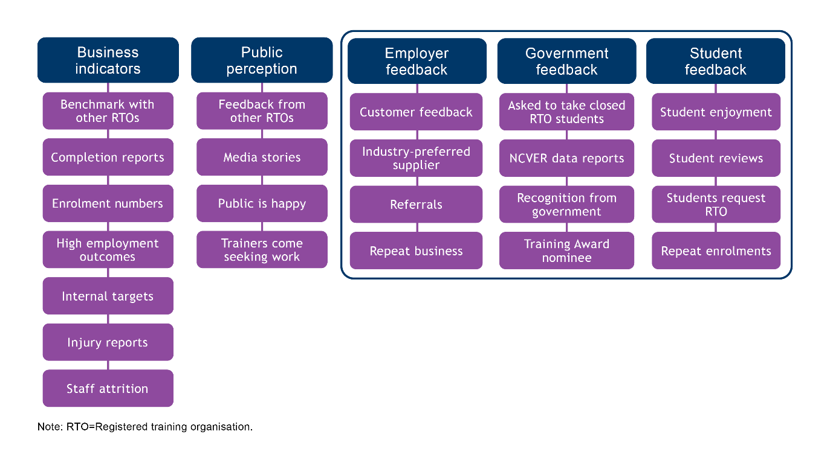Figure 6 Concept map: How do you measure high performance.

### Business indicators

Participants indicated that they use business indicators such as data and reports on business health and performance from HR to determine how they are performing. There was no evident difference in the RTO characteristics of the participants who cited these methods of tracking their performance.

Completion-rate reports were the most common form of data tracking cited for checking how their RTO was performing. It was mentioned that this was a requirement of RTO data reporting, thus providing an ready assessment tool.

‘Obviously we use completion data’ (P #60).

Enrolment numbers and post-study employment rates were also used to tack performance by RTOs of all sizes, locations and scope. Participants used internal targets related to their own definition of high performance and those related to demonstrating compliance with the *Standards for RTOs*:

‘It’s continual measurement against the targets of what we’re trying to achieve’ (P #44).

‘Ultimately, if we’re doing our job the way that we want and we’re achieving what we need, which is students completing their qualifications successfully and gaining meaningful employment’ (P #42).

‘Statistical stuff like number of withdrawals, fallouts non-completions, that sort of stuff’ (P #4).

Enterprise RTOs were most likely to report that they used human resource indicators of business performance to determine whether they were delivering high performance. These included injury reports, evidence that the business was building or growing, and staff attrition rates:

‘Safety performance-wise and organisationally, we measure on our safety and report on safety and … and down in the training centre we report all of our safety things through that’ (P #27).

### Employer feedback

Most participants stated they used feedback from employers to determine whether they were high-performing. This feedback tended not to be gathered in a formalised way but came in the form of employers contacting their RTO for the purpose of training their workers and referring other business to them:

‘I think also the workplaces that are actually knocking at our door and wanting their learners to be trained by us’ (P #55).

Another way that participants judged employers’ satisfaction was if they continued to return over a number of years:

‘Employers that we’ve been working with over the last 10 years here at [RTO name] trainers that … have basically been continually sending students back to us because they like what we do’ (P #2).

### Student feedback

Student feedback was the most commonly reported measure used by participants to determine whether they were high-performing. Most gathered that feedback deliberately via surveys:

‘Feedback, because the students are feeling more comfortable that the feedback one is [anonymous]’ (P #18).

Some participants also relied on in-person feedback and the sense they got from students that they were happy with the training or feeling good about their experience at the RTO:

‘But they come and tell me, I’ve got an open-door policy and if the student’s not happy, they will, if they’re ballsy enough to walk into my office and tell me’ (P #2).

With regard to the surveys that RTOs are mandated to undertake, participants found them useful as a starting point but insufficient for their own continuous-improvement purposes:

‘I mean we have our ordinary feedback processes that we administer over and above the standard NCVER collection, which doesn’t tell you much. I mean, gives you a lot of stark, raw data, but … one thing is we do have our own surveys, which we give to students and send to students’ (P #60).

Other indicators of student satisfaction mentioned were students’ connection to trainers, for example, through the desire to give a gift:

‘I can tell you names of people that were set on quitting three to four times and they’ve completed the qualification and said, “Can I give the trainer a gift?”’ (P #60).

### Government feedback

Participants realised that their RTOs were high-performing because governments had recognised their activities in some way. One common way in which RTOs received feedback from governments was having their RTO nominated for a training award:

‘We’re an award-winning RTO. We’ve won small training provider, we’ve been a finalist in small training provider and we’ve been a finalist nationally so we do have a good reputation and we work really hard to have that reputation’ (P #64).

Another avenue for receiving feedback on high performance from governments was inclusion on specific funding lists based on their reputation for delivering high-quality training, or being awarded with ‘high performing’ status by certain government programs:

‘I don’t know if you know [state] has a thing called [policy name], which is state government funding. And they have a category of supply that they call the “high performing provider” and we’ve been judged as [a] high-performance provider’ (P #4).

However, participants who had been selected as high-performing suppliers by a government program expressed that they were not confident that the criteria for the award reflected their own definition of high performance:

‘So to me it’s more a, “Are you meeting the requirements?”, and then are you producing statistical stuff in the high band for whatever your comparison group is … Completions mean jack-shit’ (P #4).

### Public perception

A minority of participants talked about public perception being a marker of their performance as an RTO. All the participants who mentioned this were from large RTOs. This perception was reflected in media stories, a sense that the public was happy with them, feedback from another RTO and finding themselves sought after as an employer of industry-skilled trainers:

‘I’ve got kids that have followed me from those days through with the work we did there and I brought a core of teachers across with me when as we started and so, yeah, that’s probably the best measure for me’ (P #2).

# Appendix A: Data themes and codes

| Theme | Sub-theme | Code | Example quote |
| --- | --- | --- | --- |
| **How do RTOs define high performance?** | | | |
| Effort |  | Above and beyond | ‘They actually go above and beyond’ (P#55). |
|  |  | High-performing team | ‘The bottom line for me is that a high-performing RTO is an outcome of a high-performing team led by talented and committed leaders. I simply couldn’t see how you’d achieve an HP RTO with a team satisfied with mediocrity’ (P#58). |
|  |  | Leadership | ‘We do take a leadership position because we have a philosophy that education should be about leadership’ (P#62). |
|  |  | Quality training delivery | ‘If an RTO doesn’t have good trainers, then it’s not a high-performing RTO I don’t care what measure you us’ (P#60). |
|  |  | Relationships | ‘It’s not hard to be successful if your kids, your students are coming back to you and your employers are feeling like you’re contactable and you’re informing them of any issues before they become big issues’ (P#2). |
|  |  | Strong sector knowledge | ‘We are all qualified and [have] vast experience in the knowledge of obviously [area of delivery] as one and also being able to, and training and assessing … qualifications’ (P#1). |
| Measurable outcomes |  | Completions | ‘Students getting through courses … completing’ (P#17). |
|  |  | Confident | ‘People that come out you know being confident about what they understand’ (P#60). |
|  |  | Employable students | ‘They are coming out being better prepared for work than then when they came in’ (P#60). |
|  |  | Employment outcome | ‘High employment rate at the end’ (P#19). |
|  |  | Further study | ‘You know [the] number of students that go on to further study’ (P#19). |
|  |  | Reaching funding targets | ‘There’d be an expectation of efficiency. So the cost to revenue relationship would be considered a part of the high-performing nature of the RTO as well’ (P#44). |
| Public good |  | Impact lives | ‘We can really engage and influence and impact people’s lives’ (P#60). |
|  |  | Protecting vulnerable Australians | ‘So high performance for us is that we know there’s a vulnerable person on the end of what our education training achieves, so that vulnerable person needs quality and safe supports’ (P#62). |
| Satisfied stakeholders |  | Awarded high-performing RTO status | ‘We’ve just … recently done our high-performing provider application and, and I guess when you talk … about high-performing we always think about in terms of the fact that we go above and beyond right?’ (P#7). |
|  |  | Employers are happy | ‘High-performance RTOs intimately understand the most important relationship in VET is the ‘employer organisation’ (P#62). |
|  |  | Meeting expectations | ‘Good customer service. If [you’re] not providing that service that they want or pay for, they will not return. Ultimately that is the measure’ (P#5). |
|  |  | Public perceptions | ‘That’ll also be the public’s perception of having a skilled workforce that is capable’ (P#18). |
|  |  | Qualified appropriately (Employers are happy) | ‘We’re producing safe, effective, efficient workers in in our industry’ (P#27). |
|  |  | Staff are happy | ‘We obviously want to make sure that the trainers are happy. The admin staff is happy’ (P#3). |
|  |  | Students are happy | ‘Making sure … that the learner experience and the training experience is a really good experience throughout the course’ (P#27). |
| **How are motivations embedded in RTO operations?** | | | |
| Collaboration |  | Communication | ‘We’ve got what we call a contact note that is electronically done through our SMS system so whenever a student … is seen we write a contact note, so if it’s an apprentice, as soon as the apprentice is seen, this documents what happened in the session’ (P#22). |
|  |  | Employer collaboration | ‘But we communicate very closely with our employers. We’ve got students that are at risk for certain reasons and yeah, the employer has been in consultation with what we’ve put in place to help that student at risk’ (P#2). |
|  |  | Parent communication | ‘If there are any problems … that then is sent to the student, the salon owner and either [colleague] or myself, and to the parent if the student is under 18, so everybody has a copy of it. And the school if it’s a school-based apprentice so that everybody is in the loop of exactly what is happening’ (P#22). |
|  |  | School communication | ‘Just giving the customer what they want is driving … the quality side of things and … we communicate very well with our employers and schools’ (P#2). |
|  |  | Use unaccredited training | ‘So 50% of our work would be within accredited training … and 50% of our work would be outside of that because it’s more specific to industry and accredited training doesn’t provide that’ (P#62). |
| Quality assurance |  | Continuous improvement | ‘So there’s been a lot of improvements all throughout even today. I mean we’re always reviewing the way we do our assessment, evidence gathering processes’ (P#3). |
|  |  | KPIs | ‘We’ve got pretty explicit KPIs that we’re measuring against’ (P#44). |
|  |  | LMS or SMS | ‘We have a student management system (SMS) … we use … all the notes go in there … so everyone can read them … all the staff can read’ (P#1). |
|  |  | Processes | ‘You’ve got policies and then you’re coming down to procedures and work instructions and then just the day-to-day operations’ (P#44). |
|  |  | Quality committees | ‘So we have a governance management team that meets every month and we’ve got, you know very, we sort of very disciplined with working through how are we doing this’ (P#58). |
|  |  | Self-assurance | ‘Sort of a self-assurance approach. So there are seven established reference groups, so they’ll be covering the text and they ask with standards and sort of follow the student journey’ (P#44). |
|  |  | Tracking trainers | ‘We have the training and assessment occurs within the training centre and the RTO and those people go out in field and then we have a team who goes out and checks that the work is being performed in accordance with the training that occurred in accordance with the standards’ (P#58). |
|  |  | Validation | ‘As well having the scan and doing those external validations means we can put those out there and look we even, even at the time of when we did a big part of the development, we put together an industry reference group as well with people from industry’ (P#7). |
| Staffing |  | Dedicated trainers | ‘The staff have got to be the most important thing that you can have. All the whizbang gear and equipment in the world, and we certainly want that, but the reality is that the single most important thing is staff that are like-minded’ (P#2). |
|  |  | Employment arrangements | ‘They’re working with us for that whole period and employed with us for that whole time, so we’ve got stability I think in that way. I think that again is what … makes us be able to do what we do in the way that we do it and build the relationships that we do. … Once they’ve been with us for three years, they go on to permanent … as in no more contracts’ (P#7). |
|  |  | High expectations | ‘We do have high expectations, but our high expectations are realistic within our sector’ (P#55). |
|  |  | Professional development | ‘So we have an annual performance development review system that every [trainer] goes through where they look at the capability framework and they look at their position profile and identify gaps for PD opportunities and seek them out’ (P#44). |
|  |  | Proximity | ‘So for every single trainer we have a WhatsApp group, which is connected with our admin team, and I’m included as part of that group’ (P#3). |
|  |  | Regular communication with trainers | ‘We have what we call huddle sessions, so [colleague] will have sessions, 15 minutes, maybe even 10-minute sessions with our trainers every week’ (P#22). |
|  |  | Trainers in industry | ‘Seeking industry experienced trainers – they come from the trade and have current knowledge’ (P#5). |
|  |  | Young trainers | ‘We’ve also mentored a couple of young trainers into the business, and they’ve just come in with a breath of fresh air, new ideas’ (P#2). |
| Student support | Employability programs | Career education | ‘A subject for students, so we actually take a proactive approach and we manage the system with the portfolios, online portfolios, their resumes, we actually do mock interviews as well for the students’ (P#19). |
|  |  | Employment placements | ‘So we took on 24 unemployed people and we offered … an employment program with a unit of competency that was transferable across different qualifications because this was like a try-before-you-buy-scenario and out of that 16 people were offered employment opportunities within our service and are still training with us today’ (P#55). |
|  |  | Promote job opportunities | ‘We promote job opportunities’ (P#44). |
|  | Responsiveness | Continuity in trainers | ‘We tend to try and have trainers that stick to different regions, so there’s that continuity of the relationship’ (P#26). |
|  |  | Face-to-face training | ‘We do a lot of face to face and I think that actually reflects being [a] high-performing provider, the fact that we do stuff face to face which has the connection which you don’t get sometimes’ (P#17). |
|  |  | High staff numbers | ‘We probably overload our programs with, SMEs and instructors. So that there’s lots of eyes there to eyeball students who may be falling behind’ (P#18). |
|  |  | Pre-enrolment evaluation | ‘We also assess their readiness for the course because in some instances they might have young families, so it’s not appropriate. So everything that we do is about ensuring that the students are ready to come into that vocational journey’ (P#64). |
|  |  | Trainer reports on progress | ‘The other thing is we have apprentice field officers that are out there talking to the apprentices, talking to the supervisors on a weekly’ (P#27). |
|  |  | One-on-one training | ‘Each of our students are allocated one training officer, so that’s that same person that they’re gonna sort of grow those connections with and they have that relationship with’ (P#7). |
|  |  | Student contact | ‘I think the other thing that’s really important about trainers is that they keep the finger on the pulse in terms of what their students’ needs are’ (P#42). |
|  | Student voice | Celebrating achievement | ‘We also do a graduate showcase at the end of second year where industry are invited to see all of the outcomes of the students work’ (P#19). |
|  |  | Responsive to cultural and community needs | ‘But even a program like that we’re doing that program to make sure that there’s Aboriginal educators in services because we know that for Aboriginal children and families, that that’s an important thing’ (P#7). |
|  |  | Safe environment | ‘It’s ensuring that they’ve got cultural mentors and that they understand that, you know, if they’re unsure, if they’re uncertain, then they refer to the manager or they refer to one of their Aboriginal colleagues’ (P#64). |
|  |  | Student representation | ‘The SRC, our Student Representative Committee is a really important body that we are engaging … It’s an opportunity for students to do more’ (P#42). |
| Teaching and learning |  | Develop own materials | ‘We’ve developed it for the cohort, we’ve made it relevant for community and then they they’re seeing kind of the outcomes that we’re getting from that and they wanna be a part of it as well’ (P#26). |
|  |  | Engage in training package development | ‘We’ve worked with our previous, or the current training package that’s been transitioned, like our CEO and myself were on the subject matter expert groups, so like it gives us the ability to import and we know that by sort of threading through students, they’re going to have the best experience‘ (P#7). |
|  |  | Experiential delivery | ‘I suppose we’re very practical based here, so our campus is set up like an actual shop or a [redacted]’ (P22). |
|  |  | Sharing materials | ‘We put together an industry reference group as well with people from industry to be able to review the resources … We’re also pretty happy to share most things’ (P#7). |
|  |  | Specialist delivery | ‘Probably another thing is what makes us high-performing is that we are a specialised RTO. So we only have qualifications on scope that relate to [area of delivery]’ (P#7). |
|  |  | Workplace visits | ‘We go to them in their workplace, and so I’ve got a trainer and assessor manual [where] everything is listed step by step and, you know, if those steps aren’t completed, then really you don’t get to the quality outcome because you know if they’re not getting on site at least four times a year’ (P#12). |
| Values | Leadership values | Autonomy and ownership | ‘It’s probably giving them a little bit of autonomy on what they do and trusting them to make the right decision when they’re delivering their training’ (P#26). |
|  |  | Core values embedded | ‘Probably embedding the core values of the business feeds down’ (P#27). |
|  |  | Culture | ‘We overtly cultivate through from the strat [sic] plan down … because we’ve got our values embedded in our strategic plan’ (P#44). |
|  |  | Mental health focus | ‘The students can offload problems and trainers don’t always know how to deal with those. And you know it’s difficult so we thought that would help them as well’ (P#22). |
|  |  | Mission statement | ‘There’s the company mission, the company value statement that gets the CEO talk[ing] to everyone during induction about this is what we stand for, this is what we do’ (P#26). |
|  |  | Selective re clients | ‘I will not “work” in inverted commas with employers that I feel [are] like just in it for a financial outcome because it tends to l[ead] to very bad results’ (P#60). |
|  |  | Social distance low | ‘So organisations, they’re really connected, we’re not separating them off saying you just do this function, we tie them into the different parts of how we operate and how the business operates’ (P#27). |
|  | Teaching and learning values | Competency over progress | ‘We’ve had trainers come from bigger RTOs and they’re like so what’s the number of units I need to get completed this week? It’s so it’s not about the number of units that they need to do, it’s about making sure that knowledge transfers there. So our whilst we do have targets. It’s generally, the focus is on can the student do the job’ (P#26). |
|  |  | Flexible delivery | ‘To customise, to meet what a student come to us with — all kinds of different situations. So we often have to look at things in an individual way and say what does this particular person need because the box may not, they may not fit in the box’ (P#42). |
|  |  | Investment | ‘So what we do is to everything that we train and deliver is to support our people and that’s fully contextualised to our cohort. It’s customised to our businesses. So it’s like we’ve invested a lot of money to do that, but it gets the outcomes that we need’ (P#26). |
| **How is the RTO identified as high-performing by prospective clients?** | | | |
| Government recognition |  | Government approval system | ‘So that’s where the high-performing provider things and the training awards are important like so that others so that people do know where you know what you’re about’ (P#7). |
|  |  | Low-risk rating | ‘That we do have a low-risk rating with us … as our registration is currently low risk and that’s purely based on those quality indicators that we do meet every year’ (P#27). |
| Sought after |  | Don’t advertise | ‘We don’t spend money on advertising’ (P#42). |
|  |  | Name recognition | ‘Our brand and I suppose there’s definitely one thing which gives us a massive boost. Obviously if you want to learn [trade] and you’d go to the [RTO name] if you want to learn here you go to the [RTO name]’ (P#22). |
|  |  | Repeat enrolments | ‘We actually do have 60% of our full time students have already done a certificate with us while they’re at school, so they do already know how we work, whether or not we can, I suppose, bring the goods’ (P#19). |
|  |  | Reputation | ‘It’s just word-of-mouth that’s getting the students’ (P#2). |
|  |  | Respected | ‘Employers go elsewhere and find the offering doesn’t compare’ (P#5). |
| **How do RTOs measure their own performance?** | | | |
| Business indicators |  | Benchmark with other RTOs | ‘We’re able to benchmark against other RTOs because we facilitate a trainer and assessor network’ (P#7). |
|  |  | Completion reports | ‘Obviously we use completion data’ (P#60). |
|  |  | Enrolment numbers | ‘Enrolment numbers dropping off that. People talk with their feet’ (P#44). |
|  |  | High employment outcomes | ‘Ultimately, if we’re doing our job the way that we want and we’re achieving what we need, which is students completing their qualifications successfully and gaining meaningful employment’ (P#42). |
|  |  | Injury reports | ‘As well, from the safety performance-wise and to organisationally, we measure on our safety and report on safety’ (P#27). |
|  |  | Internal targets and data – general | ‘We have our internal health check’ (P#58). |
|  |  | Staff attrition | ‘How staff turnover is on a daily, weekly, monthly, yearly, but I imagine that would be the kind of thing that would raise a red flag if there was a big exodus’ (P#27). |
| Employer feedback |  | Customer feedback | ‘[We] do a little scratch survey on how did the student go today from your point of view … how did they go today, did we train them well enough or is there more that we could do?’ (P#4). |
|  |  | Industry-preferred supplier | ‘I think also the workplaces that are actually knocking at our door and wanting their learners to be trained by us’ (P#55). |
|  |  | Referrals | ‘Referrals is a massive one. So we get a lot of referrals from facilities, organisations and now and job providers as well’ (P#17). |
|  |  | Repeat business | ‘We do get a lot of repeat business. So that clearly tells you that obviously the customers are happy and the clients are happy’ (P#3). |
| Government feedback |  | Asked to take on closed RTO students | ‘RTOs have closed and they’ve asked us to take on their student load’ (P#7). |
|  |  | NCVER data report | ‘Looking at NCVER data to determine market share’ (P#5). |
|  |  | Recognition from government | ‘So those peak bodies and the departments and the government-funded funding bodies that come to us across the three states that we work with that keep coming back to us, that’s an indication as well for us’ (P#7). |
|  |  | Training Award nominee | ‘We’ve also won a few training awards as well and on a national level’ (P#27). |
| Student feedback |  | Student enjoyment | ‘Learning engagement is a good measure that the training course is, the curriculum, or the design is suited, and the delivery is suited, then what we’re teaching him is relevant for the job that they have or for the skills that they need’ (P#27). |
|  |  | Student reviews | ‘What do you, what are you liking about the course? What’s challenging you? What are things that we can improve on? You know, all those kind of things and that’s good raw data, which is not so much quantitative that’s more qualitative’ (P#560). |
|  |  | Students request RTO | ‘We’ve got students that maybe have been with another RTO, then they come to us or their employer might have wanted them to use someone specific, and you know, and they come back to us’ (P#7). |
|  |  | Repeat enrolments | ‘The progression through qualifications so where student finishes, say, a certificate I or certificate II, then they wanna progress into the next one and through the next one’ (P#26). |
| Public perception |  | Feedback from other RTOs | ‘There’s recognition that we do, a good job, like we know from what other people say back to us, that you know what we’re doing is above and beyond’ (P#7). |
|  |  | Media stories | ‘Good news stories, even in the media outlets, the papers’ (P#18). |
|  |  | Public is happy | ‘You know the public seems to be happy with how things are operating within the community’ (P#18). |
|  |  | Trainers come seeking work | ‘We’ve actually had staff leave and gone and work in the industry and then they’ll come back and they’ll start teaching again for a few years and they’re our biggest advocates’ (P#19). |
| **What motivates the RTO to be high-performing?** | | | |
| Accountability |  | Government money spent | ‘So we want to be sure that you know the government is happy and at the end of the day, it’s the taxpayers money that’s getting involved when it comes to government contracts’ (P#3). |
|  |  | Reputation | ‘We’ve always said it since day one, we just want people to leave here and when they’ve got their certificate, uhm, they people walk past and go, “Oh wow, yeah you went there”, yeah, “I’ve heard they’re amazing”’ (P#22). |
|  |  | Risk of failure | ‘Can you imagine if we were not re-registered, the fallout? Or, if a student we had trained make a mistake that harmed a patient? There are serious consequences to [RTO name] not doing a good job’ (P#4). |
|  |  | Safety | ‘I see a vulnerable person at the end of every training session they deliver’ (P#62). |
| Altruism |  | Avoiding VET-FEE HELP disaster | ‘We were there when VET-FEE HELP got the … when things went bad and we knew a lot of those …students personally, like they had our personal numbers and the amount who were breaking down like they’ve said their families were ruined and, oh it’s awful’ (P#22). |
|  |  | Caring for students | ‘I’ve got into training because I want to make a difference and let’s make a difference to some young kid like [student name]’ (P#2). |
|  |  | Community | ‘The line between [RTO name] and the rest of the world does, you know, there’s no [line], it’s just one student makes a difference and everybody in the RTO carries that around with them’ (P#44). |
|  |  | Giving back to sector | ‘To think that I can make a contribution like that, and particularly in our sector’ (P#62). |
|  |  | Helping people | ‘It’s very much about helping people’ (P#62). |
|  |  | Seeing students progress | ‘To see where they come from and how they’ve succeeded in the business. And now we look up to them as our mentors is, is just really great’ (P#27). |
| Business security |  | Attracting investment | ‘It [high performance] then gives the business confidence to invest in us. So when we [are] seeking funding for additional resources or we need to uplift in any way that business is happy to invest in our growth’ (P#27). |
|  |  | Breaking even | ‘If you don’t profit and have a decent margin, you cannot invest in the future and you cannot change, so it must be commercially sustainable’ (P#62). |
|  |  | Growing the business | ‘My goal is to actually reach a point where we have 50 to 100 people working for the organisation’ (P#3). |
| Personal traits |  | Being the best | ‘But what motivates me for the high performance is I’d like to be the best, I don’t like losing’ (P#2). |
|  |  | Personal values | ‘We’re a bit competitive. You’re pretty feisty and we like to … punch above our weight’ (P#44). |
|  |  | Pride | ‘Pride and wanting to do a good job for own reputation’ (P#5). |
|  |  | Respect for customer | ‘Rural people do not suffer fools very well’ (P#12). |
|  |  | Responsibility | ‘And the big driver is the fact that we are the only RTO in [state] with the qualifications on scope to have … workers. There is no other RTO in [state], so from a business perspective it is critical, absolutely critical, that we maintain our RTO status now also only leads to [a] licenc[ing] outcome’ (P#58). |

# References

Braun, V & Clarke, V 2006, 'Using thematic analysis in qualitative research' *Qualitative Research in Psychology*, vol.3, no.2, 77-101, viewed

Guthrie, H & Waters, M 2021, *Unpacking the quality of VET delivery*, NCVER, Adelaide, viewed 7 December 2022, <<https://www.ncver.edu.au/research-and-statistics/publications/all-publications/unpacking-the-quality-of-vet-delivery>>.

-- 2022, *Delivering high-quality VET: what matters to RTOs?*, NCVER, Adelaide, viewed 3 December 2022, <<https://www.ncver.edu.au/research-and-statistics/publications/all-publications/delivering-high-quality-vet-what-matters-to-rtos>>.