



**RESEARCH report**

**Apprentices and trainees 2020:**

**impacts of COVID-19 on training activity**

**Michelle Hall**

National Centre for Vocational Education Research

****

### Publisher’s note

The views and opinions expressed in this document are those of NCVER and do not necessarily reflect the views of the Australian Government, or state and territory governments. Any interpretation of data is the responsibility of the author/project team.

To find other material of interest, search VOCEDplus (the UNESCO/NCVER international database <[http://www.voced.edu.au](http://www.voced.edu.au/)>) using the following keywords: Apprentice; Apprenticeship; Apprenticeship contract; Completion; Dropout; Employers; Financial aid; Government role; Industry; Outcomes; Participation; Statistics; Trainee; Traineeship; Trend; Vocational education and training.

# P:\PublicationComponents\logos\Social Media\InBug-16px_0.pngP:\PublicationComponents\logos\Social Media\Twitter_blackbox.pngAbout the research

**© National Centre for Vocational Education Research, 2021**

G:\pub_prod\PublicationComponents\logos\Creativecommons\CC BY logo.eps

With the exception of the Commonwealth Coat of Arms, the Department’s logo, any material protected by a trade mark and where otherwise noted all material presented in this document is provided under a Creative Commons Attribution 3.0 Australia <http://creativecommons.org/licenses/by/3.0/au> licence.

The details of the relevant licence conditions are available on the Creative Commons website (accessible using the links provided) as is the full legal code for the CC BY 3.0 AU licence <http://creativecommons.org/licenses/by/3.0/legalcode>.

The Creative Commons licence conditions do not apply to all logos, graphic design, artwork and photographs. Requests and enquiries concerning other reproduction and rights should be directed to the National Centre for Vocational Education Research (NCVER).

This document should be attributed as Hall, M 2021, *Apprentices and trainees 2020: impacts of COVID-19 on training activity,* NCVER, Adelaide.

This work has been produced by NCVER on behalf of the Australian Government and state and territory governments, with funding provided through the Australian Government Department of Education, Skills and Employment.

COVER IMAGE: GETTY IMAGES/iStock

ISBN 978-1-925717-77-8

TD/TNC 144.16

NCVER, ABN 87 007 967 311

Level 5, 60 Light Square, Adelaide SA 5000  
PO Box 8288 Station Arcade, Adelaide SA 5000, Australia

**Phone** +61 8 8230 8400 **Email** [ncver@ncver.edu.au](mailto:ncver@ncver.edu.au)   
**Web** <https://www.ncver.edu.au> <<http://www.lsay.edu.au>>

**Follow us:** <https://twitter.com/ncver> <https://www.linkedin.com/company/ncver>

Apprentices and trainees 2020: impacts of COVID-19 on training activity

### Michelle Hall, National Centre for Vocational Education Research

The COVID-19 pandemic caused widespread disruption to economic and educational activity in Australia during 2020, due largely to the restrictions imposed on businesses and individuals to mitigate the health impacts of COVID-19. Given the heavy emphasis on workplace-based training in apprenticeships and traineeships, the impacts on apprentices and trainees in 2020 were significant.

This research report explores trends in the number of apprentice and trainee commencements, suspensions, cancellations and withdrawals, and completions over the course of 2020, to provide insights into the consequences of the pandemic for this segment of the vocational education and training (VET) sector.

Key messages

* Compared with the same period in 2019, the number of contract commencements showed marked declines in April and May 2020, coinciding with the imposition of national restrictions designed to slow the spread of the pandemic. Commencement numbers were turbulent in the middle of the year as states and territories faced stark differences in restrictions. In the latter months of the year, commencement numbers recovered dramatically, driven strongly by the Boosting Apprenticeship Commencements wage subsidy scheme, which was announced as part of the 2020−21 federal Budget.
* The number of contracts suspended over the course of 2020 was also a dramatic marker of the impacts of the pandemic on apprentices and trainees. Increases of more than 650% relative to 2019 were seen in March and April of 2020, with almost 300% in May of 2020.
* Declines were seen in the number of contract cancellations and withdrawals, as well as in the number of contract completions, from April 2020. These declines were less pronounced and less sensitive to the dynamics of the pandemic over the course of the year than the changes seen for commencements and suspensions.
* The industries that experienced some of the most substantial disruption to contract commencements in 2020 included Administrative and support services; Transport, postal and warehousing; and Information, media and telecommunications. The industries that experienced the most prominent increases in contract suspensions in the first half of 2020 included Arts and recreation services; Accommodation and food services; Transport, postal and warehousing; Retail trade; and Agriculture, forestry and fishing.
* Medium and large employers generally experienced more prominent disruption to commencements and suspensions than micro and small employers.

Simon Walker  
Managing Director, NCVER

# Acknowledgements

I would like to thank Ben Bardon from the National Australian Apprenticeships Association for providing valuable feedback on an earlier version of this report. I would also like to thank colleagues from NCVER for their feedback.

# Contents

P:\PublicationComponents\Icons\ExecutiveSummary.emf

Executive summary 7

Introduction 9

Key events of the COVID-19 pandemic in 2020 9

Implications for apprentices and trainees 9

Government support for apprentices and trainees 10

Impacts on apprentices and trainees: Australia in summary 11

Commencements 11

Suspensions 12

Cancellations and withdrawals 13

Completions 14

Industry trends 15

Commencements 15

Suspensions 16

Cancellations and withdrawals 17

Impacts on key attributes 19

Age and gender 19

Trade and non-trade occupations 19

Workplace remoteness 20

Employer size 20

Employer type 20

References 22

Appendix A 23

The National Apprentice and Trainee Collection 23

Source data for this report 23

Appendix B 24

Apprentice and trainee activity metrics by industry 24

Appendix C 28

Apprentice and trainee activity metrics by selected key statistics 28

# Tables and figures

## Tables

B1 Contract activity by industry, Australia, March quarter, 2019 and 2020 24

B2 Contract activity by industry, Australia, June quarter, 2019 and 2020 25

B3 Contract activity by industry, Australia, September quarter, 2019 and 2020 26

B4 Contract activity by industry, Australia, December quarter, 2019 and 2020 27

C1 Contract activity by selected key statistics, Australia, March quarter,

2019 and 2020 28

C2 Contract activity by selected key statistics, Australia, June quarter,

2019 and 2020 29

C3 Contract activity by selected key statistics, Australia, September quarter,

2019 and 2020 30

C4 Contract activity by selected key statistics, Australia, December quarter,

2019 and 2020 31

## Figures

1 Contract commencements, Australia, January−December 2019 and 2020 11

2 Contract suspensions, Australia, January−December 2019 and 2020 12

3 Contract cancellations/withdrawals, Australia, January−December 2019 and 2020 13

4 Contract completions, Australia, January−December 2019 and 2020 14

5 Trends in quarterly year-on-year change in contract commencements by industry,

Australia, 2019 to 2020 15

6 Quarterly year-on-year change in contract suspensions by industry, Australia,

2019 to 2020 16

7 Quarterly year-on-year change in contract cancellations and withdrawals by industry, Australia, 2019 to 2020 17

# P:\PublicationComponents\Icons\ExecutiveSummary.emfExecutive summary

The COVID-19 pandemic caused significant economic disruption in Australia during 2020, including to businesses, education and training, and individuals. This report focuses on the impacts on apprentices and trainees, by exploring data trends in monthly training activity in 2020, by comparison with training activity prior to the onset of the pandemic in 2019. The analysis investigates monthly trends in contract commencements, suspensions, cancellations and withdrawals, and completions, as well as quarterly impacts by industry, by attributes of the apprentice/trainee, including age and gender, and by attributes of the training contract, including workplace remoteness and employer type.

Importantly, this report focuses on data trends over the course of 2020 only. At the time of writing, the COVID-19 pandemic is having ongoing impacts in Australia well into 2021, which are not considered in this report.

Following the national restrictions introduced in March 2020, the first indications in the data of disruption to apprentices and trainees were dramatic increases in contract suspensions. The number of suspensions increased by more than 650% in March and April 2020, and by almost 300% in May 2020 compared with the same period in 2019. By September 2020, the number of contracts put on suspension was approximately 10% lower than it had been in September 2019.

The second prominent indication of disruption to training activity was a marked decline in new contract commencements in April and May 2020. Commencements, which have historically been sensitive to changing economic conditions (for example, Hurley 2020; Karmel & Misko 2009), were turbulent between June and September 2020, a period during which different states and territories had vastly different levels of restrictions on business and personal activities. Commencements rebounded strongly in October 2020, however, with the introduction of the Australian Government’s Boosting Apprenticeship Commencements wage subsidy program, along with a number of state and territory government initiatives, and remained above 2019 levels in November and December.

Whereas contract suspensions and contract commencements were highly responsive to the dynamics of the pandemic in Australia, including to the outbreak in Victoria in the latter half of 2020, the impacts on contract cancellations and withdrawals, and contract completions were steady and less pronounced. For both metrics, the prominent impacts became noticeable in April 2020 as declines on 2019 levels. In the case of cancellations and withdrawals, this is likely attributable to a combination of government support measures, which kept apprentices and trainees in jobs, and a hesitation on the part of apprentices and trainees to seek other employment opportunities, given the poor employment outlook during most of 2020.

In the case of completions, declines on 2019 levels are likely due to a combination of factors. Independent of the COVID-19 pandemic, declines in the number of contract *commencements* in recent years has exerted flow-on effects on the number of contract *completions*, particularly for contracts in trade occupations, which typically take around four years to complete. In terms of the proximal impacts of the pandemic, delays in apprentices and trainees progressing with their training due to restrictions on attending work are likely also contributing to delays in completions. This is consistent with the dramatic increases in contract suspensions. The decline in completions in 2020 is not associated with an increase in attrition at this stage, as cancellations and withdrawals − the key indicator of attrition − have not increased relative to 2019. The monthly number of cancellations and withdrawals had largely returned to 2019 levels by October 2020, whereas declines in contract completions persisted throughout 2020.

The report also explores quarterly data trends according to the main industry of the employer. Industries with prominent increases in suspensions in the March and June quarters of 2020, by comparison with 2019, were Arts and recreation services; Accommodation and food services; Transport, postal and warehousing; Retail trade; and Agriculture, forestry and fishing. Many of these were increases of 500% or greater by comparison with the same period in 2019. Some industries continued to experience increases in suspensions in the September and December quarters of 2020, including Information, media and telecommunications; Professional, scientific & technical services; and Accommodation & food services.

The industries experiencing the most substantial disruption to commencements in the June quarter of 2020 were Administrative and support services[[1]](#footnote-1) (down almost 70%); Transport, postal and warehousing (down almost 65%); and Information, media and telecommunications (down almost 60%).

Other industries experienced minimal disruption to commencement numbers in 2020, including Agriculture, forestry and fishing; Rental, hiring and real estate services; and Health care and social assistance.

Following the analysis on industry trends, the report finishes by examining the impacts of the pandemic on selected characteristics of the apprentice/trainee and the training contract. Impacts to commencements and suspensions in the first half of 2020 tended to be more pronounced for females than for males; for contracts in non-trade occupations than for contracts in trade occupations; and for contracts with medium (20−199 employees) and large (more than 199 employees) employers than for contracts with micro (0−4 employees) and small (5−20 employees) employers.

# Introduction

The COVID-19 pandemic caused significant disruption to economic activity and to daily life in Australia during 2020. This report explores the impacts of the COVID-19 pandemic on trends in apprentice and trainee training activity in 2020. The focus of this report is on contract commencements, suspensions, cancellations and withdrawals, and completions.

The data presented in this report are point-in-time counts of events, as reported to the National Apprentice and Trainee Collection. They are intended to provide an indication of the trends in training activity in 2020, by comparison with 2019, and may not represent the final number of contracts events that occurred in each time period. For an overview of the National Apprentice and Trainee Collection, as well as technical details of the data used in this report, refer to appendix A.

At the time of writing, the COVID-19 pandemic continues to have effects on apprentices and trainees, and impacts will no doubt persist into the future. Some aspects of apprentice and trainee activity, such as contract completions, are also likely to have protracted impacts and may take some time to emerge   
in data.

## Key events of the COVID-19 pandemic in 2020

The first case of COVID-19 to be confirmed in Australia was on 25 January 2020, with case numbers initially peaking in late March 2020[[2]](#footnote-2). This first wave prompted national restrictions, which prevented many Australians from attending work, study, or training, and forced many businesses to close. From 23 March 2020, national restrictions were imposed on businesses, including closure of pubs, licensed clubs and hotels (excluding accommodation), places of worship, gyms, indoor sporting venues, cinemas and casinos, with takeaway service only for restaurants and cafes[[3]](#footnote-3). National restrictions on individuals came into effect on 30 March 2020, including stay-at-home orders (essential shopping, medical care and exercise, with travelling to work and education excepted). These national restrictions were eased throughout May 2020 at the discretion of state and territory governments.

The second wave of cases predominantly affected the state of Victoria, with daily case numbers peaking in early August 2020. In response to this outbreak, restrictions were implemented state-wide and continued until late October 2020.

## Implications for apprentices and trainees

The COVID-19 pandemic has exerted profound impacts on vocational education and training (VET) in Australia and around the world (for example, OECD 2021; White 2021). The apprenticeship system is closely linked to labour market conditions, making apprentices and trainees particularly vulnerable when economic conditions are uncertain (Atkinson & Stanwick 2016; Karmel & Misko 2009; Hurley 2020). A major reason for this vulnerability in the context of the COVID-19 pandemic is that an emphasis on work-based education is one of the defining characteristics of apprenticeships and traineeships. In 2020, business closures meant that work-based education was not possible in many cases, and digital learning alternatives are not practical for many aspects of practical training (OECD 2021). Research has also shown that declines in contract commencements are tightly associated with economic uncertainty (Karmel & Misko 2009), in part due to the commitment imposed by the contract of training between the employer and the apprentice or trainee. In the case of trade occupations, the duration of contracts of training is typically four years. For non-trade occupations, most contracts of training are completed within three years.

From an economic perspective, declines in contract commencements associated with economic uncertainty have important ramifications for future skills supply (Karmel & Misko 2009). From the perspective of pathways to employment for individuals, there are clear implications in terms of reduced opportunities, particularly for school leavers and youth (Waugh & Circelli 2021).

## Government support for apprentices and trainees

The Australian Government announced several economic support packages over the course of 2020, their aim being to alleviate disruption to apprentices and trainees and their employers.

* The *JobKeeper* wage subsidy program, announced on 30 March 2020, aimed to keep Australians in jobs and to support businesses affected by the pandemic. The scheme was initially estimated to cost $130 billion but was revised down by $60 billion in May 2020. In the first phase of JobKeeper, from 30 March 2020 to 27 September 2020, the scheme covered $1500 per fortnight of an eligible employee’s wages. The scheme was extended from 28 September 2020 to 28 March 2021, but at reduced rates, and was targeted to businesses that continued to experience significant impacts.
* The *Supporting Apprentices and Trainees* wage subsidy program was announced on 12 March 2020, estimated at $1.3 billion, and was expanded by $1.5 billion as part of the JobTrainer skills package, announced on 16 July 2020. The program provided financial support to small and medium-sized businesses to enable them to retain their existing apprentices and trainees, and to new employers of any size if they re-engaged an apprentice or trainee who had been displaced from a small or medium-sized business. The program provided a wage subsidy of 50% of the eligible apprentice or trainee’s wages paid between 1 January 2020 and 31 March 2021, up to a maximum of $7000 per quarter.
* The *Boosting Apprenticeship Commencements* wage subsidy program was announced as part of the 2020−21 federal Budget, with a $1.2 billion allocation over four years, originally capped at 100 000 places. This scheme supports employers and group training organisations who engaged a new apprentice or trainee on or after 5 October 2020. The wages of eligible apprentices and trainees are subsidised by 50% for a 12-month period from the date of commencement between 5 October 2020 and 30 September 2021, up to a maximum of $7000 per quarter. In March 2021, the program was extended to remove the 100 000 cap on places and provide support for up to 12 months. The program was further extended in the federal budget with a further $2.7 billion announced to cover new commencements until 30 March 2022.
* The *Apprentice and trainee re-engagement register* was developed to connect potential employers with apprentices and trainees who had lost their job. The register is open to apprentices and trainees who were in a training contract with a small business on 1 March 2020 and subsequently lost their job. It was later expanded to include those who were in a training contract at 1 July 2020 and subsequently lost their job, along with apprentices from medium sized businesses.

State and territory governments also implemented a range of support measures in addition to those provided at the federal level[[4]](#footnote-4).

# Impacts on apprentices and trainees: Australia in summary

This section describes the data trends that emerged throughout 2020 by comparison with 2019, on the key metrics of commencements, suspensions, cancellations/withdrawals, and completions.

## Commencements

Contract commencements are an important indicator of the health of the apprentice and trainee system. They are sensitive to labour market conditions, often demonstrating an inverse relationship with unemployment rates (Atkinson & Stanwick 2016; Hurley 2020), and place an upper limit on the upcoming supply of skilled graduates (Karmel & Misko 2009; OECD 2021).

The 2019 trend line for contract commencements, given in figure 1, shows a typical seasonal trajectory, with commencements at their highest in January and with a smaller spike in July coinciding with mid-year intakes. Although the 2019 data shows typical seasonal trends, it is important to note that commencement numbers have been declining steadily in recent years (NCVER 2020).

Figure 1 Contract commencements, Australia, January−December 2019 and 2020

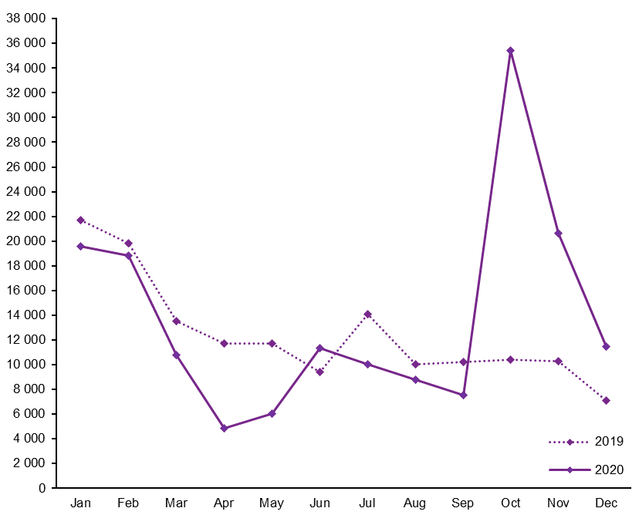

Note: The dark-grey shaded area indicates months when national restrictions were in place; the light-grey shaded area indicates months when restrictions were in place in Victoria; the red line indicates the introduction of the Boosting Apprenticeship Commencements support package in October 2020.

Source: National Apprentice and Trainee Collection nos 103 and 107 (March 2020 and March 2021 counts).

The pattern of commencements in 2020 is dramatically distorted compared with the typical seasonal pattern, highlighting the turbulence faced by apprentices and trainees during the COVID-19 pandemic. The largest declines relative to 2019 figures were in April and May, when lockdowns were having significant impacts on apprentices’ and trainees’ ability to attend work and training, and confidence was low for prospective employers.

Commencements rose above 2019 levels in June, potentially reflecting a recovery. However, the restrictions in Victoria associated with the second wave of cases of COVID-19 coincided with declines in commencements between July and September of 2020. The impact on commencements may reflect more direct impacts in Victoria, as well as weakened confidence in other metropolitan regions.

Commencement numbers rose dramatically in October of 2020, coinciding with the introduction of the *Boosting Apprenticeship Commencements* wage subsidy program. While this support package was undoubtedly a major contributor to the boost in commencements in the latter months of the year, other factors may also have contributed, such as an underlying employer need for apprentices and trainees to avoid future shortages.

## Suspensions

Contract suspensions[[5]](#footnote-5) were another key indicator of disruption to apprenticeships and traineeships in 2020. The 2019 trend, in figure 2, shows that the number of suspensions is typically stable across the year, with fewer than 500 suspension events per month.

Figure 2 Contract suspensions, Australia, January−December 2019 and 2020

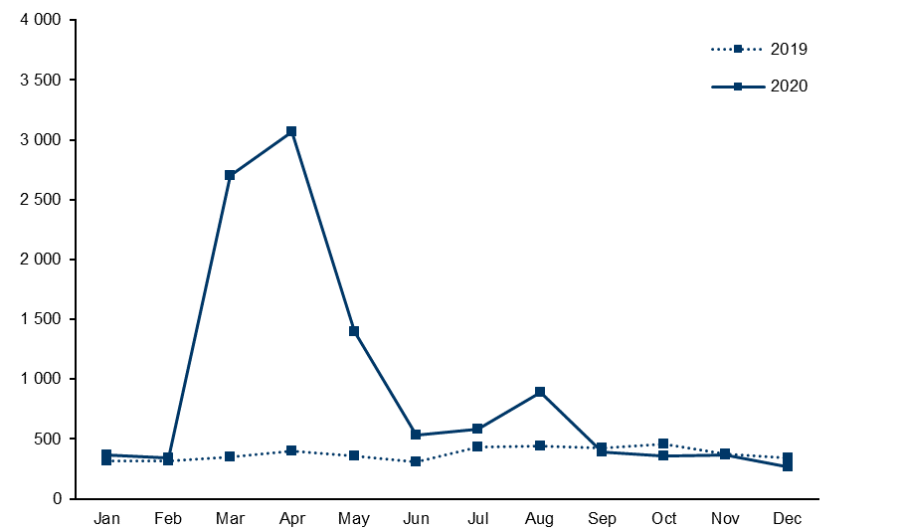

Note: The dark-grey shaded area indicates months when national restrictions were in place in 2020; the light-grey shaded area indicates months in 2020 when restrictions were in place in Victoria.

Source: National Apprentice and Trainee Collection nos 103 and 107 (March 2020 and March 2021 counts).

One of the most pronounced impacts on apprentices and trainees in 2020 was the spike in contract suspensions, particularly in March, April, and May. The number of suspensions in April 2020 was an increase of more than 650% compared with April 2019. A second, smaller, spike in suspensions occurred in August, when restrictions were in place in Victoria; the count of suspensions in August 2020 was almost double that of 2019.

The spikes in contract suspensions are not surprising, given business closures during lockdowns and other disruptions to work-based learning (OECD 2021). The scale of the increase is stark, however. Contracts that are suspended will eventually result in either a successful completion, be cancelled or withdrawn, or become expired.[[6]](#footnote-6) This leads to the expectation that cancellations and withdrawals, as well as contract completions, will be delayed. The duration of each suspension event is not readily available from the data, meaning that the extent to which cancellations/withdrawals and completions will be delayed is difficult to anticipate.

## Cancellations and withdrawals

Cancellations and withdrawals of training contracts are another metric that does not typically show strong seasonality, as shown in the 2019 trend line in figure 3.

Figure 3 Contract cancellations/withdrawals, Australia, January−December 2019 and 2020

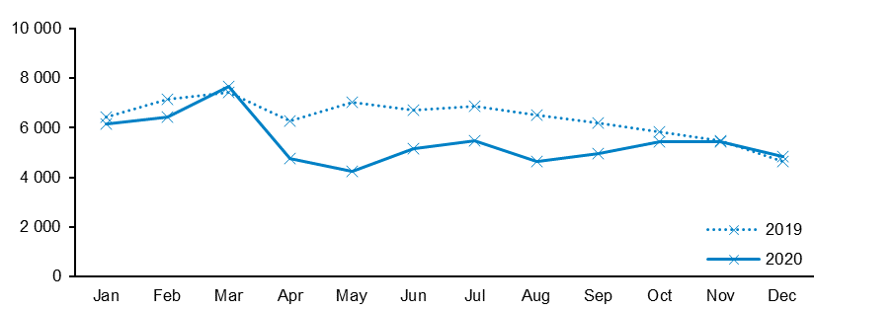

Note: The dark-grey shaded area indicates months when national restrictions were in place in 2020; the light-grey shaded area indicates months in 2020 when restrictions were in place in Victoria.

Source: National Apprentice and Trainee Collection nos 103 and 107 (March 2020 and March 2021 counts).

The disruption caused by the COVID-19 pandemic had (and still has) the potential to cause large-scale job losses among apprentices and trainees. However, this is not reflected in the data to date. Instead, *fewer* contracts were cancelled or withdrawn in 2020 by comparison with 2019, particularly between April and September.

Unlike commencements and suspensions, which have been highly reactive to changing circumstances during 2020, the changes in the number of apprentices and trainees cancelling or withdrawing from their training in 2020 have been more consistent and less pronounced. The JobKeeper and Supporting Apprentices and Trainees wage subsidy programs are relevant here, as they provided financial assistance to employers with the aim of reducing redundancies and job losses. However, the number of cancellations and withdrawals was not only maintained at 2019 levels but was reduced. This is consistent with training behaviour during previous economic downturns, where poor labour market conditions prompted apprentices and trainees who may otherwise have pursued other employment options to remain in their contract (Karmel & Misko 2009). Apprentices and trainees who were unsatisfied but persisted with their training in 2020 may yet withdraw from their training when their employment prospects strengthen, raising the possibility of a correction to the data trends in the future.

## Completions

Contract completions are another key indicator of the health of the apprentice and trainee system, this time reflecting outflows from training and, hence, reflecting skills supply. Completions tend to have less pronounced seasonality than commencements, as can be seen in the 2019 trend line in figure 4.

Figure 4 Contract completions, Australia, January−December 2019 and 2020

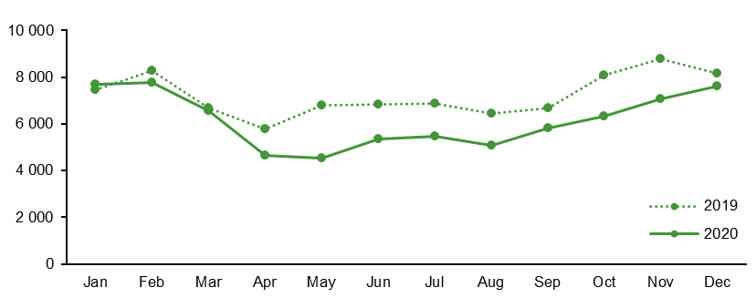

Note: The dark-grey shaded area indicates months when national restrictions were in place in 2020; the light-grey shaded area indicates months in 2020 when restrictions were in place in Victoria.

Source: National Apprentice and Trainee Collection nos 103 and 107 (March 2020 and March 2021 actuals).

As for cancellations and withdrawals, the disruption to completions in 2020 was more consistent and less pronounced than the disruption to commencements and suspensions. The disruption to completions was characterised by a protracted decrease from 2019 levels, which emerged in April and persisted throughout the year.

It is important to note that these data show *counts* of contract completions and do not provide an indication of the completion *rates* for the cohorts who commenced at a particular time. For this reason, recent trends in contract *commencements* must be acknowledged: because commencements have been declining in recent years (NCVER 2020), some subsequent decline in contract completions is to be expected. This is because commencements are a direct determinant of the number of contracts in training and therefore place an upper limit on the number of contracts that *have the potential to* complete.

To date, the declines in completions observed in 2020 have not been associated with increased attrition. However, contracts of training can take some time to complete, particularly for those in trade occupations. It may therefore be some time before the full extent of the impacts of the pandemic are evident in completions data for cohorts who were in training in 2020.

# Industry trends

As has been the case with previous periods of economic disruption, the effects of the COVID-19 pandemic have hit some industry groups harder than others (Karmel & Misko 2009). This section presents quarterly data for commencements, suspensions, and cancellations and withdrawals according to the main industry of the employing business.

The underlying data are provided in appendix B. Caution should be used when interpreting relative changes between 2019 and 2020, as the number of contract events varies by industry, and relative changes can be inflated for small counts and appear understated for large counts.

Completions are not discussed at the level of industry breakdowns because it is assumed that effects on completions will be more protracted than other metrics.

## Commencements

Figure 5 shows the relative change from 2019 to 2020 in the number of contract commencements, by industry group, for the March, June, September, and December quarters.

Figure 5 Trends in quarterly year-on-year change in contract commencements by industry, Australia,   
2019 to 2020

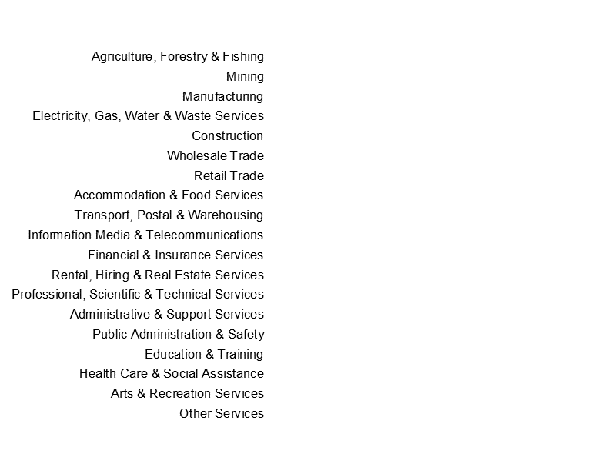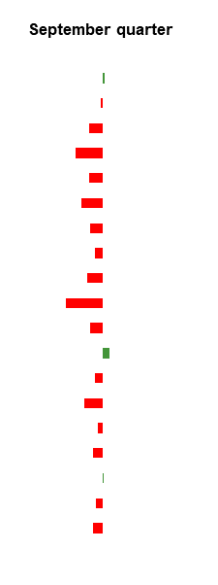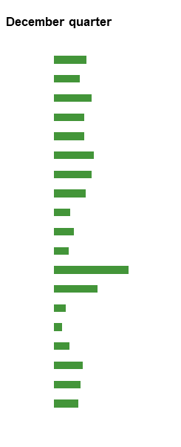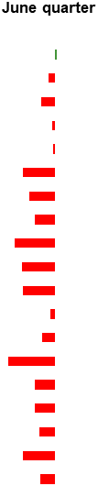

Note: The data presented in this chart are intended to convey general relative changes by industry and are shown on a log scale[[7]](#footnote-7) to mitigate distortions in changes for smaller industries. Underlying data are provided in appendix B.

Source: National Apprentice and Trainee Collection nos 100 and 104 (June 2019 and 2020 actuals for March quarter); nos 101 and 105 (September 2019 and 2020 actuals for June quarter); nos 102 and 106 (December 2019 and 2020 actuals for September quarter); and nos 103 and 107 (March 2020 and 2021 actuals for December quarter).

As noted from the monthly national data trends, although the number of contract commencements was lower in the first three months of 2020 than in the first three months of 2019, the most prominent declines were in April and May. This is consistent with the data trends presented in figure 5, where commencements in the June quarter of 2020 were down for all industries except Agriculture, forestry and fishing.

The industries experiencing the most substantial disruption to commencements in the June quarter were Administrative and support services (down almost 70%); Transport, postal and warehousing (down almost 65%) and Information, media and telecommunications (down almost 60%). The impact on commencements in Information, media and telecommunications persisted in the September quarter (again, down almost 60%).

Other industries experienced minimal disruption to commencement numbers in 2020. Agriculture, forestry and fishing was the only industry to experience increases, albeit minimal, in the March, June, and September quarters. Rental, hiring and real estate services and Health care and social assistance experienced modest increases in the March and September quarters, and Mining showed only modest declines in the first three quarters. In Construction, one of the largest industries employing apprentices in traditional trades (Misko 2020), declines in commencements were also modest.

In the December quarter, coinciding with the introduction of the Boosting Apprenticeship Commencements wage subsidy scheme, all industry groups experienced increases in commencements by comparison with 2019. The most substantial increases in the December quarter were for Rental, hiring and real estate services and Professional, scientific and technical services, noting that these are two industry groups that had relatively small intakes of apprentices and trainees in the December quarter of 2019.

## Suspensions

Figure 6 shows the relative change from 2019 to 2020 in the number of contracts that were suspended, by industry group, for the March, June, September, and December quarters.

Figure 6 Quarterly year-on-year change in contract suspensions by industry, Australia, 2019 to 2020

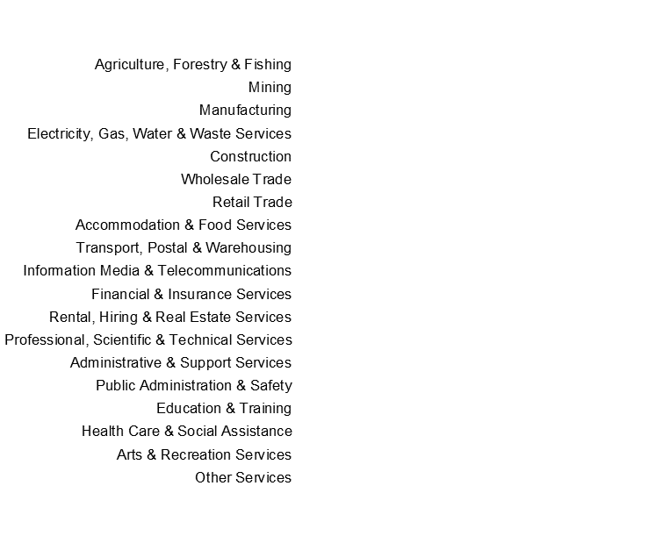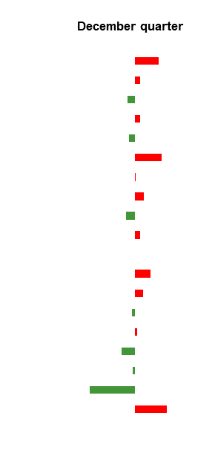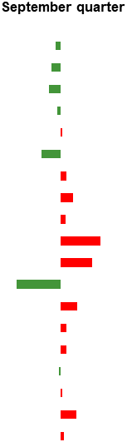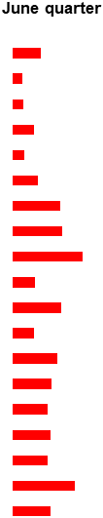

Note: The data presented in this chart are intended to convey the general relative changes by industry and are shown on a log scale to mitigate distortions in changes for smaller industries. Underlying data are provided in appendix B.

Source: National Apprentice and Trainee Collection nos 100 and 104 (June 2019 and 2020 actuals for March quarter); nos 101 and 105 (September 2019 and 2020 actuals for June quarter); nos 102 and 106 (December 2019 and 2020 actuals for September quarter); and nos 103 and 107 (March 2020 and 2021 actuals for December quarter). Due to differences in reporting, suspension counts for New South Wales that contribute to the figure above are based on earlier collections.

Industries with prominent increases in suspensions in the March and June quarters of 2020, by comparison with 2019, were Arts and recreation services; Accommodation and food services; Transport, postal and warehousing; Retail trade; and Agriculture, forestry and fishing. Many of these showed increases of 500% or greater by comparison with the same period in 2019.

Some industries continued to experience increases in suspensions in the September and December quarters, including Information, media and telecommunications; Professional, scientific & technical services; and Accommodation & food services.

Industries with less pronounced impacts on suspensions in 2020 included Construction; Mining; Manufacturing; Electricity, gas, water and waste services; and Wholesale trade.

## Cancellations and withdrawals

Figure 7 shows the relative change from 2019 to 2020 in the number of contracts that were cancelled or withdrawn, by industry group, for the March, June, September, and December quarters.

Figure 7 Quarterly year-on-year change in contract cancellations and withdrawals by industry, Australia, 2019 to 2020

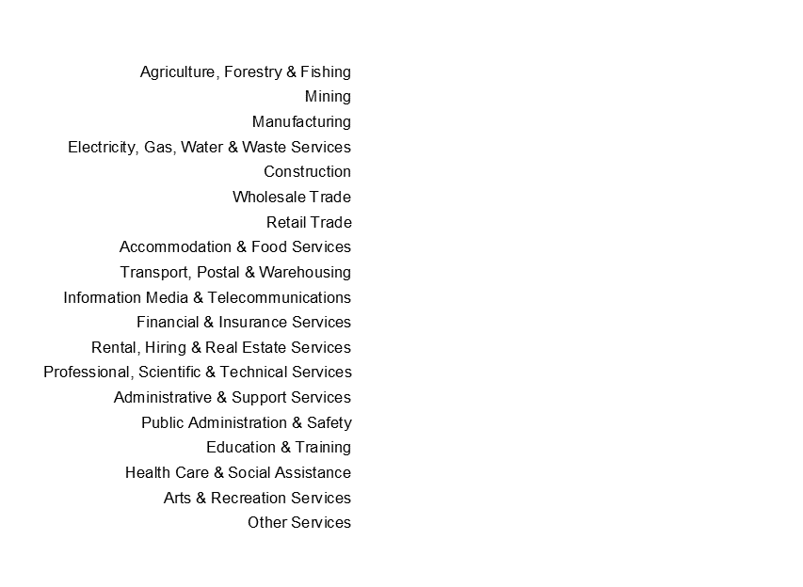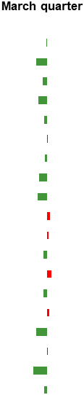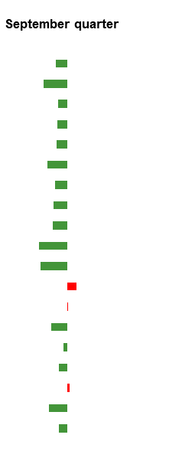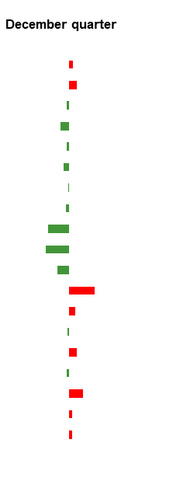

Note: The data presented in this chart are intended to convey the general relative changes by industry and are shown on a log scale to mitigate distortions in changes for smaller industries. Underlying data are provided in appendix B.

Source: National Apprentice and Trainee Collection nos 100 and 104 (June 2019 and 2020 actuals for March quarter); nos 101 and 105 (September 2019 and 2020 actuals for June quarter); nos 102 and 106 (December 2019 and 2020 actuals for September quarter); and nos 103 and 107 (March 2020 and 2021 actuals for December quarter). Due to differences in reporting, suspension counts for New South Wales that contribute to the figure above are based on earlier collections.

The most prominent changes in counts of cancellations and withdrawals were the declines on 2019 counts that occurred in the June and September quarters of 2020. In the June quarter, all industry groups experienced declines. Perhaps more meaningful are the industries where cancellations and withdrawals began to *increase* on 2019 counts, in the September and December quarters. Declines in cancellations and withdrawals have been attributed to fewer apprentice and trainees choosing to leave a training contract when alternative employment prospects are poor (Hurley 2020). An optimistic view, then, is that increases in cancellations and withdrawals may reflect signs of recovery in certain industries, where alternative employment opportunities are available for apprentices and trainees. On the other hand, increases in cancellations and withdrawals may reflect displacement of apprentices and trainees from their training contracts.

In the September quarter of 2020, Rental, hiring and real estate services had the most prominent increase in cancellations and withdrawals. Health care and social assistance and Professional, scientific and technical services also experienced higher attrition than in the same period in 2019.

In the December quarter, more industries experienced increases in cancellations and withdrawals. Rental, hiring and real estate services; Health care and social assistance and Professional, scientific and technical services were again prominent, along with Public administration and safety and Mining. Agriculture, forestry and fishing; Arts and recreation services; and Other services[[8]](#footnote-8) also experienced modest increases.

# Impacts on key attributes

This section presents insights from the quarterly data for commencements, suspensions, and cancellations and withdrawals, providing comparisons across selected attributes of the apprentice/trainee and the training contract. These trends should be interpreted carefully, as some of attributes are interrelated, while other underlying factors, not presented here, may also contribute to the observed patterns. The underlying data are provided in appendix C. Trends in contract completions are not discussed, based on the assumption that the effects on completions will be more protracted than other metrics.

## Age and gender

During the first three quarters of 2020, declines in commencements relative to 2019 were similar, regardless of the age of apprentices and trainees. In the December quarter, however, coinciding with the introduction of the Boosting Apprenticeship Commencements support package, increases in commencements were most pronounced for apprentices and trainees aged 45 years and older (an increase of more than 300% from the December quarter of 2019) and least pronounced for apprentices and trainees aged 19 years and under (an increase of more than 80% from the December quarter of 2019). The patterns of suspensions and cancellations/withdrawals in 2020 by comparison with 2019 were similar across age groups.

Contract commencements declined to a similar extent for males and females in the first three quarters of 2020. Increases in commencements in the December quarter were also similar for males and females.

Suspensions increased by nearly 600% for females in both the March and June quarters of 2020. Increases in suspensions for males were also high, between 200 and 300%. This gender difference in suspensions was no longer evident in the September and December quarters, when increases in suspensions had largely subsided.

Changes in cancellations and withdrawals in the December quarter also differed according to gender: the number of cancellations and withdrawals increased marginally for females relative to 2019, but declined marginally for males.

## Trade and non-trade occupations[[9]](#footnote-9)

The declines in commencements were more pronounced for contracts in non-trade occupations than for contracts in trade occupations in the June quarter 2020, at around 45% and around 20%, respectively. However, the recovery in the December quarter 2020 was stronger for non-trades than for trades, at around 150% compared with around 130% as compared with the same period in 2019.

In relation to suspensions, non-trade occupations also experienced more pronounced increases than trade occupations (around 700% for non-trades compared with around 160−240% for trades) in the March and June quarters of 2020. In general, trade businesses faced fewer restrictions during this period than non-trade businesses (for example, beauty salons and restaurants).

These patterns of training activity for contracts in trade occupations and non-trade occupations were similar to those for males and females, potentially reflecting, in part, the gendered nature of the occupations (Atkinson & Stanwick 2016). Contracts of training in trade occupations also tend to be associated with qualifications at higher skills levels and with longer durations than contracts of training in non-trade occupations (Knight 2012).

## Workplace remoteness

Declines in commencements were most pronounced for major cities in the June and September quarters of 2020 − around 30−40% by comparison with 2019. This is consistent with the higher health risk posed by the COVID-19 pandemic in major cities, which likely affected employer confidence. In line with the increased health risk, lockdowns were implemented on a more local scale in metropolitan areas as the pandemic progressed over the course of 2020 (by comparison with the national and statewide restrictions imposed earlier in the year). In the December quarter, commencements increased for all workplace remoteness categories, in line with the national trends. However, the increase was least pronounced for workplaces in the very remote category, at around 80%. Increases were around 140−150% for major cities, inner regional, outer regional, and remote workplaces. This is consistent with greater underlying need for apprentices and trainees in metropolitan areas persisting from earlier months.

In the December quarter of 2020, cancellations and withdrawals increased by around 20−30% for contracts in remote and very remote workplaces, increased by less than 5% for contracts in workplaces in inner and outer regional areas, and decreased by less than 5% for contracts in workplaces in major cities.

## Employer size

By comparison with 2019, the decrease in commencements in the June quarter of 2020 was notable for medium (20−199 employees) and large (more than 199 employees) employers, at around 50%. The decline for small (5−19 employees) employers was around 10%, while micro (0−4) employers experienced an increase in commencements in the June quarter of around 5%. In the December quarter, the increase in commencements was least pronounced for large employers, at around 90%, and largest for small employers, at around 200%.

Differences in suspensions according to employer size were most pronounced in the June quarter, when large employers experienced increases of around 500%, while increases for micro employers were the least pronounced, at around 160%.

## Employer type

In the June quarter of 2020, declines in commencements were largest for group training organisations (around 60%), followed by private sector employers (around 35%), with the smallest for government employers (around 25%). In the December quarter, the largest increases in commencements were for employers in the private sector, at around 160%. This contrasted with government employers and group training organisations, where commencements increased around 25% and around 40%, respectively.

With respect to suspensions, the largest increases in the first two quarters of 2020 were for government employers, followed by private sector employers. Increases in suspensions for government employers persisted throughout the second half of the year, albeit on a much smaller scale.

The patterns of cancellations and withdrawals also differed according to employer type. Whereas government employers experienced small increases in cancellations and withdrawals in all quarters except the June quarter, group training organisations experienced the most prominent declines in cancellations and withdrawals (almost 50% in the June quarter, compared with around 30% for private sector employers and around 20% for government employers).

# References

ABS (Australian Bureau of Statistics) 2013, ANZSCO — *Australian and New Zealand Standard Classification of Occupations,* version 1.2, cat.no.1220.0, ABS, Canberra, viewed 9 June 2021, <https://www.abs.gov.au/AUSSTATS/abs@.nsf/allprimarymainfeatures/4AF138F6DB4FFD4BCA2571E200096BAD?opendocument>.

Atkinson, G & Stanwick, J 2016, *Trends in VET: Policy and participation*, NCVER, Adelaide,viewed 16 July 2021, <http://hdl.voced.edu.au/10707/408606>.

Harvey, B 2010, *Estimation of apprentice and trainee statistics*, NCVER, Adelaide,viewed 12 April 2021, <<https://www.ncver.edu.au/research-and-statistics/publications/all-publications/estimation-of-apprentice-and-trainee-statistics>>.

Hurley, P 2020, *The impact of coronavirus on apprentices and trainees*, Mitchell Institute for Education and Health Policy, Victoria University, Melbourne,viewed 9 July 2021, <http://hdl.voced.edu.au/10707/541089>.

Karmel, T & Misko, J 2009, *Apprenticeships and traineeships in the downturn*, NCVER, Adelaide,viewed 13 July 2021, <https://www.ncver.edu.au/\_\_data/assets/file/0012/10731/apprenticeships-and-traineeships-in-downturn-2197.pdf>.

Knight, B 2012, *Evolution of apprenticeships and traineeships in Australia*, NCVER, Adelaide,viewed 16 July 2021, <https://www.ncver.edu.au/\_\_data/assets/file/0010/4132/2444.pdf>.

Misko, J 2020, *Traditional trade apprenticeships: training activity, employer incentives and international practice*, NCVER, Adelaide,viewed 13 July 2021, <https://www.ncver.edu.au/\_\_data/assets/pdf\_file/0030/9463422/Traditional\_trade\_apprenticeships\_\_training\_activity\_employer\_incentives\_and\_international\_practice.pdf>.

NCVER (National Centre for Vocational Education Research) 2020, *Historical time series of apprenticeships and traineeships in Australia: infographic*, NCVER, Adelaide, viewed 16 July 2021 <https://www.ncver.edu.au/research-and-statistics/infographics/historical-time-series-of-apprenticeships-and-traineeships-in-australia-infographic-1963-to-2020>.

OECD (Organisation for Economic Co-operation and Development) 2021, *Implications of the COVID-19 pandemic for Vocational Education and Training*, OECD, Paris, viewed 8 July 2021 <oecd.org/education/implications-of-the-covid-19-pandemic-for-vocational-education-and-training-55afea00-en.htm>.

Waugh, J & Circelli, M 2021, *What VET can offer to COVID-19 youth unemployment recovery*, NCVER, Adelaide,viewed 15 July 2021, <https://www.ncver.edu.au/\_\_data/assets/pdf\_file/0041/9665717/57063\_What-VET-can-offer-Covid-19-youth-unemployment-recovery\_Research\_Summary.pdf>.

White, I 2021, *VET student outcomes 2020: impact of COVID-19 on domestic students*, NCVER, Adelaide,viewed 9 July 2021, <https://www.ncver.edu.au/research-and-statistics/publications/all-publications/vet-student-outcomes-2020-impact-of-covid-19-on-domestic-students>.

# Appendix A

## The National Apprentice and Trainee Collection

The National Apprentice and Trainee Collection contains data records that capture the history of apprentice and trainee contracts of training. Data are submitted every quarter and contain the most recent information on the current and previous quarters.

Information about contract events takes some time to appear in the National Apprentice and Trainee Collection. The two key reasons for this are:

* Reporting delays: delays in reporting contract events to NCVER after they occur
* Time delays: following commencement, the time taken for other contract events to occur, such as suspensions, cancellations/withdrawals, and/or completions.

For more information on how the data accumulates in the National Apprentice and Trainee Collection, refer to <<https://www.ncver.edu.au/__data/assets/pdf_file/0017/431621/Estimation-of-Apprentice-and-Trainee-Statistics.pdf>>. For technical detail and definitions refer to <https://www.ncver.edu.au/research-and-statistics/collections/apprentices-and-trainees-collection>.

## Source data for this report

The standard quarterly release of apprentice and trainee data uses weighted *estimates* to account for lags in the processing of contract events to NCVER. The estimates methodology is based on past trends, so may not be reliable, given the dramatic changes in activity due to COVID-19. The data reported here are therefore based on *actual* counts of the contract events that occurred in 2020.

The counts of events presented in this report are intended to provide an indication of the trends in training activity and may not be the final number of contracts events that occurred in each time period.

The monthly data presented in this report for 2020 activity are sourced from the latest National Apprentice and Trainee Collection (no.107, March 2021 reporting), which was compiled under the Australian Vocational Education and Training Management Information Statistical Standard (AVETMISS) for Apprentice and Trainee Collection Specifications, Release 7.0, October 2015. The monthly data presented for 2019 are sourced from the same period of the corresponding year.

The quarterly data presented in this report are sourced from the various National Apprentice and Trainee Collections:

* for March quarter activity, collection no.104, June 2020 reporting
* for June quarter activity, collection no.105, September 2020 reporting
* for September quarter activity, collection no.106, December 2020 reporting
* for December quarter activity, collection no.107, March 2021 reporting.

The data presented for 2019 are sourced from the same period of the corresponding year.

The raw data presented in this report therefore differ from the estimates presented in other NCVER products. This is to enable like-for-like comparisons with the previous quarter and the previous year, even though the numbers presented in this report are not the final measures of training activity. The additional training activity not reported in the most recent collection period may be reported in future quarterly collections.

# Appendix B

## Apprentice and trainee activity metrics by industry

The following tables provide counts of contract commencements, suspensions, and cancellations and withdrawals by industry, for 2019 and 2020. Tables are provided for quarterly periods.

The data presented in these tables are intended to provide an indication of trends in training activity and may not be the final number of contracts events that occurred in each time period.

### March quarter

Table B1 Contract activity by industry, Australia, March quarter, 2019 and 2020

|  |  |  |  |  |  |  |  |  |  |  |
| --- | --- | --- | --- | --- | --- | --- | --- | --- | --- | --- |
|  | **Commencements** | | | **Suspensions** | | | **Cancellations and withdrawals** | | | |
|  | *2019* | *2020* | *% change* | *2019* | *2020* | *% change* | | *2019* | *2020* | *% change* | |
| Agriculture, forestry & fishing | 762 | 780 | 2.4% | 1 | 12 | 1100.0% | | 152 | 149 | -2.0% | |
| Mining | 1 593 | 1 586 | -0.4% | 30 | 58 | 93.3% | | 527 | 400 | -24.1% | |
| Manufacturing | 4 259 | 3 834 | -10.0% | 66 | 133 | 101.5% | | 1 188 | 1 076 | -9.4% | |
| Electricity, gas, water & waste services | 983 | 883 | -10.2% | 22 | 19 | -13.6% | | 210 | 168 | -20.0% | |
| Construction | 13 257 | 12 193 | -8.0% | 189 | 321 | 69.8% | | 5 194 | 4 870 | -6.2% | |
| Wholesale trade | 900 | 689 | -23.4% | 5 | 4 | -20.0% | | 293 | 295 | 0.7% | |
| Retail trade | 2 215 | 1 608 | -27.4% | 20 | 132 | 560.0% | | 738 | 706 | -4.3% | |
| Accommodation & food services | 4 447 | 3 479 | -21.8% | 57 | 679 | 1091.2% | | 2 082 | 1 711 | -17.8% | |
| Transport, postal & warehousing | 1643 | 1 124 | -31.6% | 28 | 97 | 246.4% | | 526 | 415 | -21.1% | |
| Information, media & telecommunications | 662 | 648 | -2.1% | 4 | 6 | 50.0% | | 246 | 268 | 8.9% | |
| Financial & insurance services | 570 | 486 | -14.7% | 2 | 6 | 200.0% | | 170 | 176 | 3.5% | |
| Rental, hiring & real estate services | 293 | 389 | 32.8% |  | 4 |  | | 127 | 117 | -7.9% | |
| Professional, scientific & technical services | 745 | 750 | 0.7% | 8 | 10 | 25.0% | | 187 | 211 | 12.8% | |
| Administrative & support services | 7 274 | 6 095 | -16.2% | 351 | 1 470 | 318.8% | | 2 410 | 2 206 | -8.5% | |
| Public administration & safety | 2 220 | 2 122 | -4.4% | 11 | 39 | 254.5% | | 261 | 277 | 6.1% | |
| Education & training | 2 560 | 2 233 | -12.8% | 27 | 149 | 451.9% | | 433 | 333 | -23.1% | |
| Health care & social assistance | 3 716 | 3 805 | 2.4% | 60 | 251 | 318.3% | | 928 | 946 | 1.9% | |
| Arts & recreation services | 638 | 431 | -32.4% | 6 | 238 | 3866.7% | | 144 | 103 | -28.5% | |
| Other services | 5 072 | 4501 | -11.3% | 110 | 484 | 340.0% | | 2 130 | 1 992 | -6.5% | |
|  |  |  |  |  |  |  | |  |  |  | |

Note: Due to differences in reporting, suspension counts for New South Wales that contribute to the table above are based on earlier collections.

Source: National Apprentice and Trainee Collection nos 100 and 104 (June 2019 and June 2020 actuals).

### June quarter

Table B2 Contract activity by industry, Australia, June quarter, 2019 and 2020

|  |  |  |  |  |  |  |  |  |  |
| --- | --- | --- | --- | --- | --- | --- | --- | --- | --- |
|  | **Commencements** | | | **Suspensions** | | | **Cancellations and withdrawals** | | |
|  | *2019* | *2020* | *% change* | *2019* | *2020* | *% change* | *2019* | *2020* | *% change* |
| Agriculture, forestry & fishing | 384 | 403 | 4.9% | 2 | 7 | 250.0% | 167 | 127 | -24.0% |
| Mining | 1 253 | 1 079 | -13.9% | 31 | 48 | 54.8% | 452 | 368 | -18.6% |
| Manufacturing | 2 403 | 1 719 | -28.5% | 52 | 84 | 61.5% | 1 336 | 897 | -32.9% |
| Electricity, gas, water & waste services | 324 | 303 | -6.5% | 25 | 66 | 164.0% | 186 | 137 | -26.3% |
| Construction | 5 329 | 5 140 | -3.5% | 198 | 333 | 68.2% | 5 310 | 3 514 | -33.8% |
| Wholesale trade | 625 | 276 | -55.8% | 5 | 16 | 220.0% | 311 | 171 | -45.0% |
| Retail trade | 1 909 | 1 001 | -47.6% | 21 | 183 | 771.4% | 685 | 474 | -30.8% |
| Accommodation & food services | 4 098 | 2 447 | -40.3% | 44 | 417 | 847.7% | 1 866 | 980 | -47.5% |
| Transport, postal & warehousing | 1 483 | 532 | -64.1% | 8 | 197 | 2362.5% | 642 | 343 | -46.6% |
| Information, media & telecommunications | 589 | 257 | -56.4% | 4 | 11 | 175.0% | 326 | 194 | -40.5% |
| Financial & insurance services | 502 | 223 | -55.6% | 1 | 9 | 800.0% | 162 | 89 | -45.1% |
| Rental, hiring & real estate services | 279 | 249 | -10.8% | 3 | 8 | 166.7% | 102 | 86 | -15.7% |
| Professional, scientific & technical services | 454 | 331 | -27.1% | 4 | 31 | 675.0% | 177 | 144 | -18.6% |
| Administrative & support services | 4 695 | 1 421 | -69.7% | 378 | 2 181 | 477.0% | 2 267 | 1 971 | -13.1% |
| Public administration & safety | 1 649 | 983 | -40.4% | 17 | 83 | 388.2% | 403 | 234 | -41.9% |
| Education & training | 999 | 598 | -40.1% | 46 | 255 | 454.3% | 439 | 259 | -41.0% |
| Health care & social assistance | 2 732 | 1 853 | -32.2% | 76 | 372 | 389.5% | 932 | 820 | -12.0% |
| Arts & recreation services | 323 | 143 | -55.7% | 6 | 101 | 1583.3% | 118 | 63 | -46.6% |
| Other services | 2 264 | 1 583 | -30.1% | 116 | 635 | 447.4% | 2 071 | 1 434 | -30.8% |
|  |  |  |  |  |  |  |  |  |  |

Note: Due to differences in reporting, suspension counts for New South Wales that contribute to the table above are based on earlier collections.

Source: National Apprentice and Trainee Collection nos 101 and 105 (September 2019 and September 2020 actuals).

### September quarter

Table B3 Contract activity by industry, Australia, September quarter, 2019 and 2020

|  |  |  |  |  |  |  |  |  |  |
| --- | --- | --- | --- | --- | --- | --- | --- | --- | --- |
|  | **Commencements** | | | **Suspensions** | | | **Cancellations and withdrawals** | | |
|  | *2019* | *2020* | *% change* | *2019* | *2020* | *% change* | *2019* | *2020* | *% change* |
| Agriculture, forestry & fishing | 349 | 364 | 4.3% | 8 | 6 | -25.0% | 166 | 128 | -22.9% |
| Mining | 1 048 | 1 010 | -3.6% | 60 | 37 | -38.3% | 646 | 370 | -42.7% |
| Manufacturing | 2 500 | 1 796 | -28.2% | 104 | 57 | -45.2% | 1 262 | 1 024 | -18.9% |
| Electricity, gas, water & waste services | 477 | 250 | -47.6% | 18 | 15 | -16.7% | 196 | 155 | -20.9% |
| Construction | 7 813 | 5 578 | -28.6% | 206 | 225 | 9.2% | 5 341 | 4 127 | -22.7% |
| Wholesale trade | 523 | 309 | -40.9% | 16 | 6 | -62.5% | 325 | 203 | -37.5% |
| Retail trade | 1 575 | 1 153 | -26.8% | 31 | 41 | 32.3% | 750 | 565 | -24.7% |
| Accommodation & food services | 3 588 | 2 948 | -17.8% | 57 | 105 | 84.2% | 1 890 | 1 358 | -28.1% |
| Transport, postal & warehousing | 1 069 | 728 | -31.9% | 29 | 37 | 27.6% | 529 | 378 | -28.5% |
| Information, media & telecommunications | 617 | 250 | -59.5% | 4 | 31 | 675.0% | 298 | 154 | -48.3% |
| Financial & insurance services | 359 | 266 | -25.9% | 1 | 5 | 400.0% | 200 | 107 | -46.5% |
| Rental, hiring & real estate services | 263 | 307 | 16.7% | 10 | 1 | -90.0% | 91 | 113 | 24.2% |
| Professional, scientific & technical services | 472 | 387 | -18.0% | 10 | 23 | 130.0% | 195 | 198 | 1.5% |
| Administrative & support services | 4 179 | 2 677 | -35.9% | 452 | 608 | 34.5% | 2 310 | 1 599 | -30.8% |
| Public administration & safety | 1 397 | 1 235 | -11.6% | 20 | 27 | 35.0% | 270 | 250 | -7.4% |
| Education & training | 942 | 748 | -20.6% | 49 | 45 | -8.2% | 418 | 347 | -17.0% |
| Health care & social assistance | 3 145 | 3 218 | 2.3% | 99 | 108 | 9.1% | 971 | 1 029 | 6.0% |
| Arts & recreation services | 264 | 224 | -15.2% | 5 | 11 | 120.0% | 139 | 91 | -34.5% |
| Other services | 3 065 | 2 415 | -21.2% | 128 | 149 | 16.4% | 2 039 | 1 689 | -17.2% |
|  |  |  |  |  |  |  |  |  |  |

Note: Due to differences in reporting, suspension counts for New South Wales that contribute to the table above are based on earlier collections.

Source: National Apprentice and Trainee Collection nos 102 and 106 (December 2019 and December 2020 actuals).

### December quarter

Table B4 Contract activity by industry, Australia, December quarter, 2019 and 2020

|  |  |  |  |  |  |  |  |  |  |
| --- | --- | --- | --- | --- | --- | --- | --- | --- | --- |
|  | **Commencements** | | | **Suspensions** | | | **Cancellations and withdrawals** | | |
|  | *2019* | *2020* | *% change* | *2019* | *2020* | *% change* | *2019* | *2020* | *% change* |
| Agriculture, forestry & fishing | 371 | 1 038 | 179.8% | 1 | 4 | 300.0% | 128 | 139 | 8.6% |
| Mining | 707 | 1 589 | 124.8% | 31 | 41 | 32.3% | 385 | 459 | 19.2% |
| Manufacturing | 2 120 | 7 022 | 231.2% | 77 | 50 | -35.1% | 1 141 | 1 079 | -5.4% |
| Electricity, gas, water & waste services | 305 | 796 | 161.0% | 6 | 8 | 33.3% | 171 | 139 | -18.7% |
| Construction | 5 653 | 14 688 | 159.8% | 170 | 120 | -29.4% | 4 708 | 4 464 | -5.2% |
| Wholesale trade | 430 | 1 528 | 255.3% | 5 | 24 | 380.0% | 279 | 246 | -11.8% |
| Retail trade | 1 229 | 4 079 | 231.9% | 29 | 30 | 3.4% | 684 | 675 | -1.3% |
| Accommodation & food services | 3 636 | 10 042 | 176.2% | 31 | 52 | 67.7% | 1 719 | 1 598 | -7.0% |
| Transport, postal & warehousing | 1 089 | 1 816 | 66.8% | 22 | 13 | -40.9% | 537 | 327 | -39.1% |
| Information, media & telecommunications | 333 | 620 | 86.2% | 3 | 4 | 33.3% | 278 | 162 | -41.7% |
| Financial & insurance services | 377 | 605 | 60.5% | 2 | 2 | 0.0% | 146 | 111 | -24.0% |
| Rental, hiring & real estate services | 185 | 2 022 | 993.0% | 2 | 5 | 150.0% | 83 | 152 | 83.1% |
| Professional, scientific & technical services | 312 | 1 261 | 304.2% | 10 | 16 | 60.0% | 171 | 199 | 16.4% |
| Administrative & support services | 3 799 | 5 462 | 43.8% | 487 | 411 | -15.6% | 2 081 | 2 009 | -3.5% |
| Public administration & safety | 965 | 1 249 | 29.4% | 21 | 24 | 14.3% | 222 | 265 | 19.4% |
| Education & training | 1 129 | 1 828 | 61.9% | 76 | 34 | -55.3% | 398 | 380 | -4.5% |
| Health care & social assistance | 2 267 | 5 632 | 148.4% | 94 | 80 | -14.9% | 839 | 1 163 | 38.6% |
| Arts & recreation services | 373 | 871 | 133.5% | 87 | 6 | -93.1% | 125 | 135 | 8.0% |
| Other services | 2 510 | 5 393 | 114.9% | 10 | 65 | 550.0% | 1 864 | 2 011 | 7.9% |
|  |  |  |  |  |  |  |  |  |  |

Note: Due to differences in reporting, suspension counts for New South Wales that contribute to the table above are based on earlier collections.

Source: National Apprentice and Trainee Collection nos 103 and 107 (March 2020 and March 2021 actuals).

# Appendix C

## Apprentice and trainee activity metrics by selected key statistics

The following tables provide counts of contract commencements, suspensions, and cancellations and withdrawals by various factors, for 2019 and 2020. Tables are provided for quarterly periods.

The data presented in these tables are intended to provide an indication of trends in training activity and may not be the final number of contracts events that occurred in each time period.

### March quarter

Table C1 Contract activity by selected key statistics, Australia, March quarter, 2019 and 2020

|  |  |  |  |  |  |  |  |  |  |
| --- | --- | --- | --- | --- | --- | --- | --- | --- | --- |
|  | **Commencements** | | | **Suspensions** | | | **Cancellations and withdrawals** | | |
|  | *2019* | *2020* | *% change* | *2019* | *2020* | *% change* | *2019* | *2020* | *% change* |
| **Age group** |  |  |  |  |  |  |  |  |  |
| 19 years and under | 29 859 | 26 437 | 11.5% | 364 | 1 639 | 350.3% | 6 765 | 6 162 | -8.9% |
| 20−24 years | 10 021 | 9 027 | -9.9% | 356 | 1 356 | 280.9% | 5 887 | 5 337 | -9.3% |
| 25−44 years | 11 323 | 9 827 | -13.2% | 230 | 913 | 297.0% | 4 353 | 4 143 | -4.8% |
| 45 years and over | 2 366 | 2 139 | -9.6% | 45 | 192 | 326.7% | 854 | 695 | -18.6% |
| **Gender** |  |  |  |  |  |  |  |  |  |
| Males | 36 360 | 32 129 | -11.6% | 714 | 2 149 | 201.0% | 12 612 | 11 448 | -9.2% |
| Females | 17 455 | 15 512 | -11.1% | 284 | 1 964 | 591.5% | 5 340 | 4 975 | -6.8% |
| **Occupation** |  |  |  |  |  |  |  |  |  |
| Trade | 28 307 | 25 443 | -10.1% | 718 | 1 868 | 160.2% | 10 337 | 9 699 | -6.2% |
| Non-trade | 25 505 | 22 198 | -13.0% | 280 | 2 245 | 701.8% | 7 615 | 6 721 | -11.7% |
| **Workplace remoteness** |  |  |  |  |  |  |  |  |  |
| Major cities | 31 232 | 27 607 | -11.6% | 673 | 2 821 | 319.2% | 11 767 | 10 809 | -8.1% |
| Inner regional | 13 724 | 12 156 | -11.4% | 188 | 704 | 274.5% | 3 947 | 3 542 | -10.3% |
| Outer regional | 6 656 | 5 920 | -11.1% | 100 | 435 | 335.0% | 1 677 | 1 554 | -7.3% |
| Remote | 1 215 | 1 141 | -6.1% | 22 | 60 | 172.7% | 283 | 284 | 0.4% |
| Very remote | 675 | 566 | -16.1% | 9 | 69 | 666.7% | 184 | 151 | -17.9% |
| **Employer size** |  |  |  |  |  |  |  |  |  |
| Micro (0−4 employees) | 6 876 | 6 164 | -10.4% | 74 | 230 | 210.8% | 2 401 | 2 236 | -6.9% |
| Small (5−19 employees) | 11 838 | 11 757 | -0.7% | 147 | 471 | 220.4% | 4 678 | 4 495 | -3.9% |
| Medium (20−199 employees) | 14 144 | 11 459 | -19.0% | 267 | 914 | 242.3% | 4 762 | 4 459 | -6.4% |
| Large (200+ employees) | 19 988 | 17 069 | -14.6% | 484 | 2 377 | 391.1% | 5 825 | 4 977 | -14.6% |
| **Employer type** |  |  |  |  |  |  |  |  |  |
| Government | 2 864 | 2 834 | -1.0% | 10 | 183 | 1730.0% | 288 | 320 | 11.1% |
| Private sector | 45 120 | 39 900 | -11.6% | 553 | 2 842 | 413.9% | 15 959 | 14 686 | -8.0% |
| Group training scheme | 5 830 | 4 906 | -15.8% | 435 | 1 088 | 150.1% | 1 704 | 1 417 | -16.8% |
|  |  |  |  |  |  |  |  |  |  |

Note: Due to differences in reporting, suspension counts for New South Wales that contribute to the table above are based on earlier collections.

Source: National Apprentice and Trainee Collection nos 100 and 104 (June 2019 and June 2020 counts).

### June quarter

Table C2 Contract activity by selected key statistics, Australia, June quarter, 2019 and 2020

|  |  |  |  |  |  |  |  |  |  |
| --- | --- | --- | --- | --- | --- | --- | --- | --- | --- |
|  | **Commencements** | | | **Suspensions** | | | **Cancellations and withdrawals** | | |
|  | *2019* | *2020* | *% change* | *2019* | *2020* | *% change* | *2019* | *2020* | *% change* |
| **Age group** |  |  |  |  |  |  |  |  |  |
| 19 years and under | 13 096 | 8 303 | -36.6% | 393 | 2 117 | 438.7% | 6 516 | 4 191 | -35.7% |
| 20−24 years | 7 145 | 4 470 | -37.4% | 361 | 1 651 | 357.3% | 5 848 | 3 985 | -31.9% |
| 25−44 years | 9 335 | 6 087 | -34.8% | 246 | 1 056 | 329.3% | 4 487 | 3 411 | -24.0% |
| 45 years and over | 2 501 | 1 532 | -38.7% | 35 | 194 | 454.3% | 1 012 | 655 | -35.3% |
| **Gender** |  |  |  |  |  |  |  |  |  |
| Males | 19 722 | 13 276 | -32.7% | 704 | 2 750 | 290.6% | 12 697 | 8 470 | -33.3% |
| Females | 12 575 | 7 265 | -42.2% | 333 | 2 287 | 586.8% | 5 258 | 3 838 | -27.0% |
| **Occupation** |  |  |  |  |  |  |  |  |  |
| Trade | 11 631 | 9 167 | -21.2% | 708 | 2 404 | 239.5% | 10 382 | 6 854 | -34.0% |
| Non-trade | 20 663 | 11 374 | -45.0% | 329 | 2 633 | 700.3% | 7 573 | 5 453 | -28.0% |
| **Workplace remoteness** |  |  |  |  |  |  |  |  |  |
| Major cities | 20 341 | 12 328 | -39.4% | 673 | 3 451 | 412.8% | 11 911 | 7 917 | -33.5% |
| Inner regional | 7 213 | 4 975 | -31.0% | 193 | 931 | 382.4% | 3 844 | 2 611 | -32.1% |
| Outer regional | 3 438 | 2 284 | -33.6% | 124 | 474 | 282.3% | 1 656 | 1 255 | -24.2% |
| Remote | 665 | 492 | -26.0% | 20 | 70 | 250.0% | 291 | 280 | -3.8% |
| Very remote | 390 | 338 | -13.3% | 21 | 69 | 228.6% | 172 | 136 | -20.9% |
| **Employer size** |  |  |  |  |  |  |  |  |  |
| Micro (0−4 employees) | 2 470 | 2 620 | 6.1% | 85 | 221 | 160.0% | 2 372 | 1 599 | -32.6% |
| Small (5−19 employees) | 6 062 | 5 394 | -11.0% | 149 | 589 | 295.3% | 4 752 | 3 399 | -28.5% |
| Medium (20−199 employees) | 9 637 | 5 137 | -46.7% | 237 | 1 059 | 346.8% | 5 095 | 3 329 | -34.7% |
| Large (200+ employees) | 13 343 | 6 532 | -51.0% | 547 | 3 103 | 467.3% | 5 450 | 3 763 | -31.0% |
| **Employer type** |  |  |  |  |  |  |  |  |  |
| Government | 1 922 | 1 407 | -26.8% | 14 | 205 | 1364.3% | 339 | 269 | -20.6% |
| Private sector | 27 714 | 18 145 | -34.5% | 534 | 3 225 | 503.9% | 15 903 | 11 122 | -30.1% |
| Group training scheme | 2 661 | 989 | -62.8% | 489 | 1 607 | 228.6% | 1 712 | 917 | -46.4% |
|  |  |  |  |  |  |  |  |  |  |

Note: Due to differences in reporting, suspension counts for New South Wales that contribute to the table above are based on earlier collections.

Source: National Apprentice and Trainee Collection nos 101 and 105 (September 2019 and September 2020 counts).

### September quarter

Table C3 Contract activity by selected key statistics, Australia, September quarter, 2019 and 2020

|  |  |  |  |  |  |  |  |  |  |
| --- | --- | --- | --- | --- | --- | --- | --- | --- | --- |
|  | **Commencements** | | | **Suspensions** | | | **Cancellations and withdrawals** | | |
|  | *2019* | *2020* | *% change* | *2019* | *2020* | *% change* | *2019* | *2020* | *% change* |
| **Age group** |  |  |  |  |  |  |  |  |  |
| 19 years and under | 13 401 | 10 967 | -18.2% | 464 | 517 | 11.4% | 6 303 | 4 929 | -21.8% |
| 20−24 years | 8 130 | 5 891 | -27.5% | 423 | 591 | 39.7% | 6 028 | 4 553 | -24.5% |
| 25−44 years | 9 622 | 7 162 | -25.6% | 339 | 374 | 10.3% | 4 632 | 3 604 | -22.2% |
| 45 years and over | 2 268 | 1 681 | -25.9% | 77 | 49 | -36.4% | 963 | 721 | -25.1% |
| **Gender** |  |  |  |  |  |  |  |  |  |
| Males | 21 752 | 15 975 | -26.6% | 904 | 1 029 | 13.8% | 12 631 | 9 529 | -24.6% |
| Females | 11 896 | 9 897 | -16.8% | 404 | 508 | 25.7% | 5 409 | 4 357 | -19.4% |
| **Occupation** |  |  |  |  |  |  |  |  |  |
| Trade | 15 676 | 11 424 | -27.1% | 830 | 995 | 19.9% | 10 440 | 8 092 | -22.5% |
| Non-trade | 17 932 | 14 448 | -19.4% | 477 | 542 | 13.6% | 7 601 | 5 793 | -23.8% |
| **Workplace remoteness** |  |  |  |  |  |  |  |  |  |
| Major cities | 21 231 | 15 478 | -27.1% | 826 | 1 050 | 27.1% | 11 917 | 8 868 | -25.6% |
| Inner regional | 7 707 | 6 422 | -16.7% | 257 | 255 | -0.8% | 3 843 | 3 179 | -17.3% |
| Outer regional | 3 558 | 3 083 | -13.4% | 146 | 165 | 13.0% | 1 669 | 1 399 | -16.2% |
| Remote | 613 | 507 | -17.3% | 41 | 32 | -22.0% | 311 | 271 | -12.9% |
| Very remote | 343 | 317 | -7.6% | 31 | 29 | -6.5% | 203 | 140 | -31.0% |
| **Employer size** |  |  |  |  |  |  |  |  |  |
| Micro (0−4 employees) | 3 921 | 3 177 | -19.0% | 118 | 108 | -8.5% | 2 405 | 1 902 | -20.9% |
| Small (5−19 employees) | 7 760 | 6 629 | -14.6% | 185 | 205 | 10.8% | 4 822 | 4 091 | -15.2% |
| Medium (20−199 employees) | 9 098 | 6 784 | -25.4% | 368 | 394 | 7.1% | 4 795 | 3 655 | -23.8% |
| Large (200+ employees) | 12 021 | 8 335 | -30.7% | 603 | 783 | 29.9% | 5 721 | 3 942 | -31.1% |
| **Employer type** |  |  |  |  |  |  |  |  |  |
| Government | 1 563 | 1 499 | -4.1% | 27 | 63 | 133.3% | 322 | 341 | 5.9% |
| Private sector | 29 696 | 22 392 | -24.6% | 715 | 842 | 17.8% | 16 170 | 12 457 | -23.0% |
| Group training scheme | 2 389 | 1 982 | -17.0% | 566 | 632 | 11.7% | 1 549 | 1 088 | -29.8% |
|  |  |  |  |  |  |  |  |  |  |

Note: Due to differences in reporting, suspension counts for New South Wales that contribute to the table above are based on earlier collections.

Source: National Apprentice and Trainee Collection nos 102 and 106 (December 2019 and December 2020 counts).

### December quarter

Table C4 Contract activity by selected key statistics, Australia, December quarter, 2019 and 2020

|  |  |  |  |  |  |  |  |  |  |
| --- | --- | --- | --- | --- | --- | --- | --- | --- | --- |
|  | **Commencements** | | | **Suspensions** | | | **Cancellations and withdrawals** | | |
|  | *2019* | *2020* | *% change* | *2019* | *2020* | *% change* | *2019* | *2020* | *% change* |
| **Age group** |  |  |  |  |  |  |  |  |  |
| 19 years and under | 13 615 | 24 706 | 81.5% | 481 | 301 | -37.4% | 5 882 | 5 742 | -2.4% |
| 20−24 years | 5 507 | 13 400 | 143.3% | 393 | 400 | 1.8% | 5 270 | 5 121 | -2.8% |
| 25−44 years | 6 879 | 22 302 | 224.2% | 241 | 248 | 2.9% | 3 969 | 4 029 | 1.5% |
| 45 years and over | 1 628 | 6 534 | 301.4% | 46 | 36 | -21.7% | 765 | 756 | -1.2% |
| **Gender** |  |  |  |  |  |  |  |  |  |
| Males | 17 316 | 41 042 | 137.0% | 743 | 643 | -13.5% | 11 175 | 10 503 | -6.0% |
| Females | 10 476 | 26 502 | 153.0% | 421 | 346 | -17.8% | 4 786 | 5 215 | 9.0% |
| **Occupation** |  |  |  |  |  |  |  |  |  |
| Trade | 11 842 | 26 997 | 128.0% | 713 | 660 | -7.4% | 9 229 | 9 000 | -2.5% |
| Non-trade | 15 947 | 40 547 | 154.3% | 449 | 329 | -26.7% | 6 732 | 6 718 | -0.2% |
| **Workplace remoteness** |  |  |  |  |  |  |  |  |  |
| Major cities | 17 812 | 42 921 | 141.0% | 686 | 622 | -9.3% | 10 404 | 9 970 | -4.2% |
| Inner regional | 6 442 | 16 133 | 150.4% | 257 | 180 | -30.0% | 3 540 | 3 640 | 2.8% |
| Outer regional | 2 714 | 6 875 | 153.3% | 154 | 122 | -20.8% | 1 519 | 1 580 | 4.0% |
| Remote | 439 | 1 041 | 137.1% | 37 | 30 | -18.9% | 254 | 327 | 28.7% |
| Very remote | 223 | 403 | 80.7% | 21 | 32 | 52.4% | 140 | 163 | 16.4% |
| **Employer size** |  |  |  |  |  |  |  |  |  |
| Micro (0−4 employees) | 2 836 | 7 192 | 153.6% | 74 | 77 | 4.1% | 2 131 | 2 103 | -1.3% |
| Small (5−19 employees) | 5 826 | 17 332 | 197.5% | 164 | 159 | -3.0% | 4 254 | 4 529 | 6.5% |
| Medium (20−199 employees) | 8 186 | 21 593 | 163.8% | 306 | 200 | -34.6% | 4 350 | 4 096 | -5.8% |
| Large (200+ employees) | 10 289 | 19 516 | 89.7% | 601 | 516 | -14.1% | 4 984 | 4 687 | -6.0% |
| **Employer type** |  |  |  |  |  |  |  |  |  |
| Government | 1 189 | 1 488 | 25.1% | 24 | 41 | 70.8% | 266 | 309 | 16.2% |
| Private sector | 24 297 | 62 845 | 158.7% | 628 | 520 | -17.2% | 14 355 | 13 970 | -2.7% |
| Group training scheme | 2 306 | 3 209 | 39.2% | 512 | 428 | -16.4% | 1 340 | 1 439 | 7.4% |
|  |  |  |  |  |  |  |  |  |  |

Note: Due to differences in reporting, suspension counts for New South Wales that contribute to the table above are based on earlier collections.

Source: National Apprentice and Trainee Collection nos 103 and 107 (March 2020 and March 2021 counts).

P:\PublicationComponents\logos\NCVER LOGOS\WMF - word\No lines\NCVER_Floating_Blue.wmf

**National Centre for Vocational Education Research**

Level 5, 60 Light Square, Adelaide, SA 5000  
PO Box 8288 Station Arcade, Adelaide SA 5000, Australia

**Phone** +61 8 8230 8400 **Email** [ncver@ncver.edu.au](mailto:ncver@ncver.edu.au)   
**Web** <https://www.ncver.edu.au> <<http://www.lsay.edu.au>>

**Follow us:**  <<https://twitter.com/ncver>>  <https://www.linkedin.com/company/ncver>

1. Administrative and support services includes services mainly engaged in performing routine support activities for the day-to-day operations of other businesses or organisations. The services provided by group training organisations are included in this industry division. [↑](#footnote-ref-1)
2. <https://www.abs.gov.au/articles/one-year-covid-19-aussie-jobs-business-and-economy> [↑](#footnote-ref-2)
3. <https://www.australia.gov.au/news-and-updates/march-2020-news-archive> [↑](#footnote-ref-3)
4. Details can be found at <https://www.voced.edu.au/vet-knowledge-bank-timeline-australian-vet-policy-initiatives>. [↑](#footnote-ref-4)
5. The data show the number of contracts that initiated a suspension in each month. From the available data, the duration of suspension is not known, nor if or when contracts return to an active status. [↑](#footnote-ref-5)
6. Where the expected term of a contract has been reached without being reported as completed, cancelled/withdrawn or suspended. [↑](#footnote-ref-6)
7. Log change is calculated as: log10 (count for 2020 − count for 2019) [↑](#footnote-ref-7)
8. Other services includes services mainly engaged in providing a range of personal care services, such as hair, beauty, diet and weight-management services; providing death-care services; promoting or administering religious events or activities; or promoting and defending the interests of their members. [↑](#footnote-ref-8)
9. As the vocations approved to be under an apprenticeship or traineeship training contract are not consistent across all jurisdictions, NCVER has adopted a Trade/Non-trade categorisation for the purpose of the National Apprentices and Trainees Collection with ‘Trades’ classified as all occupations listed under ANZSCO major group ‘3-Technicians and trades workers’ and ‘Non-trades’ classified as all other major occupations groups 1—2 and 4—8 (ABS 2013). [↑](#footnote-ref-9)